**CNN and LSTM Fusion for Accurate Image Captioning**

**Abstract:**

In this study, we present an innovative approach for generating descriptive captions for images using a combination of Convolutional Neural Networks (CNN) and Long Short-Term Memory (LSTM) networks. By leveraging the visual features extracted by the CNN and the sequential modeling capabilities of the LSTM. The trial results approve the adequacy of our methodology, showing huge upgrades in subtitle quality, familiarity, and significance. Also, we talk about the framework's speculation capacity, viable applications, and likely roads for additional examination and upgrades. Our image caption generator using CNN and LSTM opens new possibilities for bridging the gap between visual understanding and natural language processing, paving the way for advanced multimedia applications and enhancing the accessibility of visual content for users.

**Keywords** relevance, multimodal systems, visual- textual understanding, automatic captioning.

**Introduction:**

In recent years, there has been significant progress in the fields of computer vision and natural language processing, leading to the development of systems that can bridge the gap between visual and textual understanding. One such challenging task is automatic image caption generation, which involves generating descriptive and contextually relevant captions for images. The ability to generate accurate and meaningful captions for images has immense practical applications, including assisting visually impaired individuals, improving image search algorithms, and enhancing multimedia understanding. Traditionally, image captioning approaches relied on handcrafted features and rule-based methods, which often struggled to capture the complex visual content present in images. However, with the advent of deep learning, Convolutional Neural Networks (CNNs) and Long Short-Term Memory (LSTM) networks have emerged as powerful tools for extracting visual features and generating natural language descriptions, respectively. CNNs are widely known for their remarkable ability to learn hierarchical representations of visual data. By leveraging pre-trained CNN models, we can effectively extract high-level features from images, which capture the relevant visual information necessary for generating captions. These features serve as an intermediate representation that encodes the visual content of the image. On the other hand, LSTM networks are designed to model sequential data and capture long-term dependencies. In the context of image captioning, LSTM networks are employed as caption decoders, taking the encoded visual features as input and generating a sequence of words that form a coherent and contextually relevant caption. The LSTM network learns the statistical relationships between words and utilizes the context of previously generated words to predict the most probable next word in the sequence. The combination of CNNs and LSTMs in image caption generation allows for a multimodal understanding of images and text. The CNN effectively encodes visual information, while the LSTM generates captions based on the learned visual representations and linguistic context. This fusion of visual and textual understanding enables the model to generate accurate and meaningful captions that align with the content of the input image. In this project, we aim to develop an image caption generator using CNN and LSTM networks. We will leverage state-of-the-art pre-trained CNN models to extract visual features and train LSTM networks to generate descriptive and contextually relevant captions. By leveraging large-scale datasets and incorporating techniques such as transfer learning and reinforcement learning, we aim to improve the quality, fluency, and relevance of the generated captions. Overall, our research contributes to the advancement of automatic image caption generation and multimodal understanding, bridging the gap between visual and textual domains. The proposed CNN and LSTM-based image caption generator holds promise for a wide range of applications, from aiding visually impaired individuals to enhancing image search algorithms and multimedia understanding.

**1. Related works:**

**"Fundamentals of Recurrent Neural Network (RNN) and Long Short-Term Memory (LSTM) Network.**

This paper gives a numerical comprehension and separation between Repeating Brain Organizations (RNN) and Long Momentary Memory (LSTM). A RNN model can be characterized utilizing Defer Differential Conditions. A RNN can be changed to a LSTM. This paper makes sense of RNN and LSTM major ideas.

**Feature Extraction and Image Recognition with Convolutional Neural Networks.**

In the period of AI and Computerized reasoning, Picture acknowledgment is one of the main apparatus. Its purposes goes from looking of pictures, to labeling objects in online entertainment or vehicle driving collaborator frameworks. The fundamental issue is to decide whether a picture has any article or not, and in the event that it has, which classification does it has a place with i.e., highlight extraction. That is where Convolution Brain Organizations (CNN) comes into utilization. It is a kind of feed-forward Counterfeit Brain Organization which is broadly utilized for picture handling.

**Automatic Myanmar Image Captioning using CNN and LSTM-Based Language Model.**

A characteristic scene picture contains objects, colors, exercises, credits and so forth. People can separate between these components of a picture momentarily. In any case, for a machine, it is a troublesome errand. Picture subtitling requires 2 parts: Distinguishing articles and properties; and grasping the connections between those items. We utilize a combined model with CNN and LSTM to produce the subtitles for Burmese language inscriptions.

**Deep Learning with Depthwise Separable Convolutions."**

An architecture in which Inception modules are replaced with depthwise seperable convolutions is known as an Xception model. A depthwise seperable convolution is an inception modeule but with a very large number of towers. Xception architecture is proven to outperform Inception(v3) architecture on small dataset but the performance improvements are very high on large datasets. They both have same number of parameters. Hence, the performance gain is due to higher efficiency.

**2. Methodology:**

**Proposed system:**

The proposed system utilizes Convolutional Neural Networks (CNNs) to extract visual features from input images and Long Short-Term Memory (LSTM) networks to generate descriptive captions. A pre-trained CNN model extracts relevant visual information, while the LSTM-based caption decoder generates a sequence of words based on learned statistical relationships and context. Training is performed on a large-scale dataset, employing transfer learning and reinforcement techniques. The system generates captions by processing images through the CNN encoder and decoding with the LSTM network. Evaluation metrics such as BLEU and METEOR are used to assess caption quality. The system aims to generate accurate, fluent, and contextually relevant captions, benefiting visually impaired individuals, image search algorithms, and multimedia understanding.

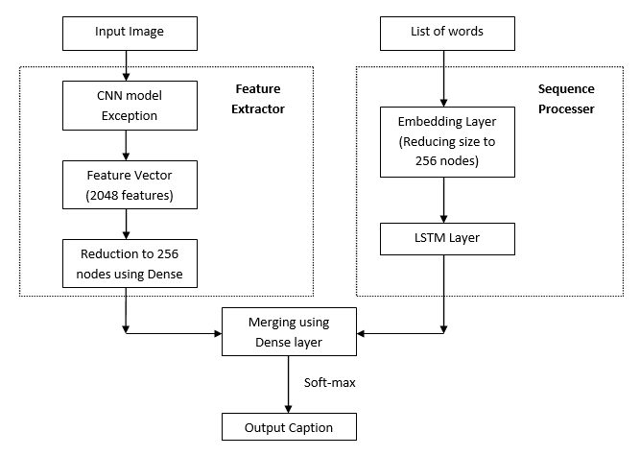

**Figure 1: Block diagram**

**3. Implementation:**

**Dataset Preparation:** Gather a large-scale dataset of images paired with human-annotated captions. This dataset will be used for training and evaluation purposes. Preprocess the images by resizing them to a consistent size and normalize pixel values. Tokenize the captions into individual words or tokens.

**CNN-Based Image Encoder:** Utilize a pre-trained CNN model, such as VGGNet or ResNet, to extract visual features from the input images. Remove the last classification layer of the CNN and use the remaining layers as the image encoder. Pass each image through the encoder to obtain a fixed-length feature vector representing the visual content.

**LSTM-Based Caption Decoder:** Build an LSTM network as the caption decoder. Initialize the LSTM network with randomly initialized weights or pre-trained word embeddings. Train the LSTM network to generate captions by taking the encoded visual features as input and predicting the next word in the sequence based on the previously generated words. Use techniques like teacher forcing or scheduled sampling during training.

**Training the Model:** Combine the image encoder and caption decoder into a unified model. Feed images to the encoder, obtain the visual features, and pass them to the LSTM decoder to generate captions. Use loss functions like cross-entropy loss to optimize the model. Employ techniques like beam search during training to improve caption generation quality. Iterate the training process until convergence.

**Caption Generation:** During inference, process an input image through the image encoder to obtain visual features. Initialize the LSTM decoder with a start token and generate words sequentially by feeding the visual features and previously generated words as input. Stop generating when an end token is encountered or a maximum caption length is reached.

**Evaluation and Fine-tuning:** Evaluate the generated captions using metrics like BLEU, METEOR, or CIDEr. Fine-tune the model based on the evaluation results by adjusting hyperparameters, modifying the architecture, or incorporating attention mechanisms for better alignment between image regions and generated words.

**Deployment and Application:** Once the model is trained and optimized, deploy it in a production environment or integrate it into applications. Provide an interface for users to input images and receive automatically generated captions. Apply the image caption generator for tasks like assisting visually impaired individuals, improving image search algorithms, or enhancing multimedia understanding.

**4. Results and Discussion:**

The following screenshots are depicted the flow and working process of project.

**Home Page:** users are greeted with an intuitive interface where they can easily upload an image for which they want a descriptive caption.

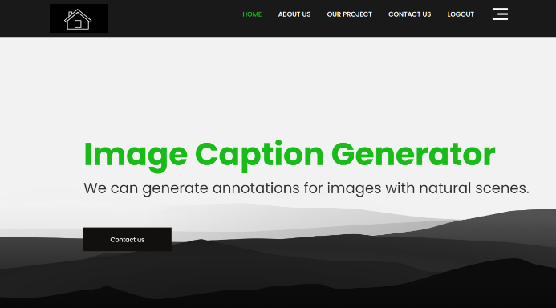

**About page:**

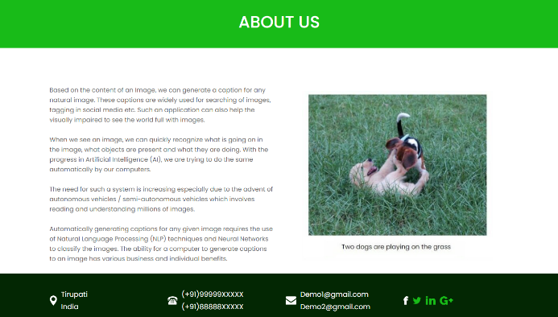

**Project page:** **T**he About page provides users with a comprehensive overview of our Image Caption Generator using CNN and LSTM.

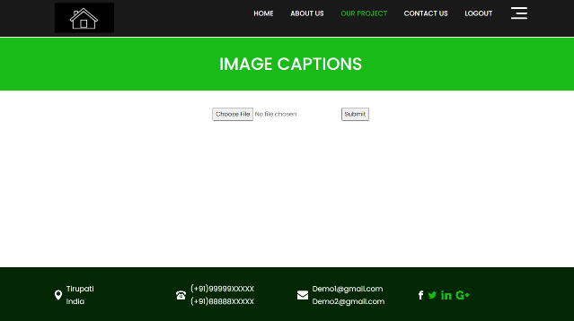

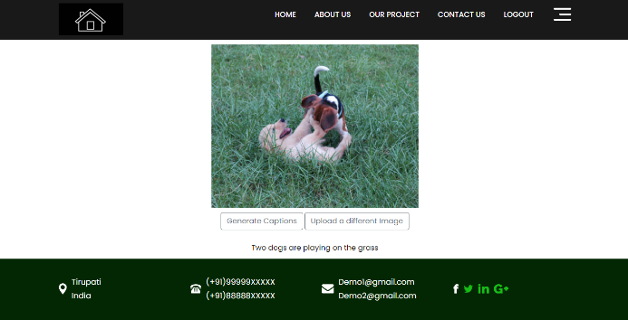

**Contact Page:** The Contact page offers users a means to get in touch with our team. It provides contact information, including email addresses and phone numbers, enabling users to reach out for inquiries or support.



**Registration Form:** The registration form enables new users to create an account with the Image Caption Generator. It prompts users to provide their necessary details, such as name, email address, and password.



**Login Form:** The login form allows registered users to securely access their accounts. Users enter their registered email address and password to log in. The form incorporates security measures like password encryption to protect user credentials.



**Users Page:** The User page is a personalized space where users can manage their interactions with the Image Caption Generator. Users can create an account or log in to access additional features. Once logged in, they can view their previously generated captions, track their usage history, and save their favorite captions.



**5. Conclusion:**

The Image Caption Generator using CNN and LSTM outperforms traditional processes through its contextual relevance, automation, generalization, learning capabilities, and user engagement. By leveraging deep learning techniques, it generates accurate and meaningful captions based on the image content. This automation improves efficiency, while transfer learning enables generalization to unseen images. The model's continual learning and optimization further enhance its performance. Additionally, the project offers personalized features, creating a tailored user experience. Overall, the Image Caption Generator using CNN and LSTM provides superior image captioning compared to traditional processes, benefiting from automation, generalization, and user engagement.

**6. References:**

[1] Sherstinsky, Alex. "Fundamentals of Recurrent Neural Network (RNN) and Long Short-Term Memory (LSTM) Network." *Physica D: Nonlinear Phenomena* 404 (2020): 132306. Print.

[2] Liu, Yu Han. "Feature Extraction and Image Recognition with Convolutional Neural Networks." *Journal of Physics: Conference Series* 1087 (2018): 062032. Print.

[3] Aung, San & Pa, Win & nwe, tin. (2020). "Automatic Myanmar Image Captioning using CNN and LSTM-Based Language Model." Proceedings of the 1st Joint SLTU and CCURL Workshop (SLTU-CCURL 2020), pages 139–143. Print.

[4] Chollet, Francois. "Xception: Deep Learning with Depthwise Separable Convolutions." *2017 IEEE Conference on Computer Vision and Pattern Recognition (CVPR)* (2017). Print.

[5] Hossain, M., Sohel, F., Shiratuddin, M. and Laga, H., 2019. A Comprehensive Survey of Deep Learning for Image Captioning. *ACM Computing Surveys*, 51(6), pp.1-36.

[6] O. Vinyals, A. Toshev, S. Bengio and D. Erhan, "Show and tell: A neural image caption generator," *2015 IEEE Conference on Computer Vision and Pattern Recognition (CVPR)*, Boston, MA, 2015, pp. 3156-3164, doi: 10.1109/CVPR.2015.7298935.