Computer Networks Practice
Lab exercise-6

QUESTION:
Write a Client and Server program to send a BITMAP image file from client to server in a binary encoded form. It means you have to transform the Image into binary bit-stream and send it through Client socket. At the Server side same bit stream you have to store into a file with same file extension (Bitmap). After completing the program in TCP/UDP, you have to analyse the performance in terms of Latency between the binary encoded text file and bitmap image file.

In this exercise the following were done to send a bitmap file:
- Server-client connection is made initially.
- Client reads the bitmap file and sends it to receiver as a bit stream.
- Server receives the bitstream sent by client and writes them into another bitmap file.
- The latency is then calculated.

TCP CODE:
SERVER SIDE CODE
#include<stdio.h>
#include<stdlib.h>
#include<sys/socket.h>
#include<sys/types.h>
#include<netinet/in.h>
#include<string.h>
#include<unistd.h>
int main()
{
int s_sock,c_client;
char buf[100];
char buf2[100];
s_sock=socket(AF_INET,SOCK_STREAM,0);
struct sockaddr_in server,other;
memset(&server,0,sizeof(server));
memset(&other,0,sizeof(other));
server.sin_family=AF_INET;
server.sin_port=htons(9009);
server.sin_addr.s_addr=INADDR_ANY;
socklen_t addr_size;
bind(s_sock,(struct sockaddr*)&server,sizeof(server));
listen(s_sock,5);
addr_size=sizeof(other);
c_client=accept(s_sock,(struct sockaddr*)&other,&addr_size);

FILE *fp;
fp=fopen("bitmap_copy.bmp","wb");
int ch[1];
read(c_client,ch,sizeof(ch));
while(ch[0]!=EOF)
{
fputc(ch[0],fp);
read(c_client,ch,sizeof(ch));
}
printf("\nfile received successfully\n");
printf("data copied into file bitmap_copy.bmp\n");
fclose(fp);
close(s_sock);
return 0;
}

CLIENT SIDE CODE
#include<stdio.h>
#include<stdlib.h>
#include<sys/socket.h>
#include<sys/types.h>
#include<netinet/in.h>
#include<string.h>
#include<unistd.h>
#include<time.h>

int main()
{
int c_sock;
char buf[100];
char bufr[100];
c_sock=socket(AF_INET,SOCK_STREAM,0);
struct sockaddr_in client;
memset(&client,0,sizeof(client));
client.sin_family=AF_INET;
client.sin_port=htons(9009);
client.sin_addr.s_addr=INADDR_ANY;

if(connect(c_sock,(struct sockaddr*)&client,sizeof(client))==-1)
{
printf("server is busy\nconnection failure");
return 0;
}
FILE *fp;
fp=fopen("bitmap_img.bmp","rb");;
if(fp==NULL)
{
printf("\nfile doesnot exist!\n");
exit(1);
}
int ch[1];
clock_t start,end;
double cpu_time_used;
start= clock();
while((ch[0]=fgetc(fp))!=EOF)
{
write(c_sock,ch,sizeof(ch));
}
ch[0]=EOF;
write(c_sock,ch,sizeof(ch));
printf("\nfile sent successfully\n");
end=clock();
cpu_time_used=((double)(end-start))/CLOCKS_PER_SEC;
printf("Time taken for file transfer %f\n",cpu_time_used);
fclose(fp);
close(c_sock);
return 0;
}

OUTPUT:
Time taken for bmp file: 0.041433
=1.524 micro seconds per byte

For text file,

Time taken for txt file: 0.035135
= 1.289 micro seconds per byte

LATENCY:

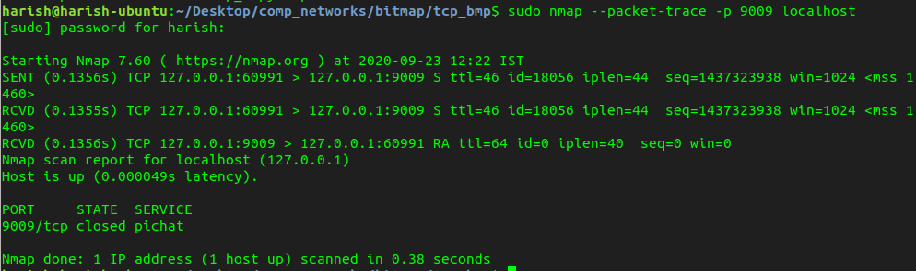
0.000049 seconds latency

Using ping,

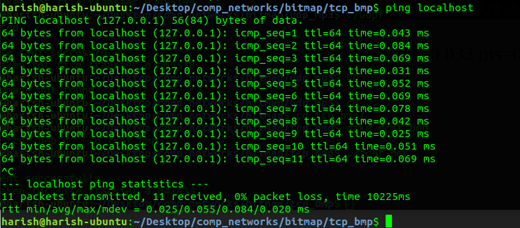
Avg Round trip time=0.025ms

UDP CODE:
SERVER SIDE CODE
#include<stdio.h>
#include<stdlib.h>
#include<sys/socket.h>
#include<sys/types.h>
#include<netinet/in.h>
#include<string.h>

int main()
{
int s_sock,c_client;
char buf[20];
char buf2[20];
s_sock=socket(AF_INET,SOCK_DGRAM,0);
struct sockaddr_in server,other;
server.sin_family=AF_INET;
server.sin_port=htons(9009);
server.sin_addr.s_addr=INADDR_ANY;
int k=bind(s_sock,(struct sockaddr*)&server,sizeof(server));
if(k==-1)
{
printf("connection failed!\n");
exit(0);
}
socklen_t add;
add=sizeof(other);
int n=recvfrom(s_sock,buf,sizeof(buf),0,(struct sockaddr*)&other,&add);
printf("msg from client: %s\n",buf);

FILE *fp;
fp=fopen("bitmap_copy.bmp","wb");
int ch[1];

n=recvfrom(s_sock,ch,sizeof(ch),0,(struct sockaddr*)&other,&add);
while(ch[0]!=EOF)
{
fputc(ch[0],fp);
n=recvfrom(s_sock,ch,sizeof(ch),0,(struct sockaddr*)&other,&add);
}
printf("\nfile received successfully\n");
printf("data copied into file bitmap_copy.bmp\n");

fclose(fp);

return 0;
}

CLIENT SIDE CODE
#include<stdio.h>
#include<stdlib.h>
#include<sys/socket.h>
#include<sys/types.h>
#include<netinet/in.h>
#include<string.h>
#include<unistd.h>
#include<time.h>
int main()
{
int c_sock;
char buf[50];
char bufr[20];
c_sock=socket(AF_INET,SOCK_DGRAM,0);
struct sockaddr_in client;
client.sin_family=AF_INET;
client.sin_port=htons(9009);
client.sin_addr.s_addr=INADDR_ANY;

FILE *fp;
fp=fopen("bitmap_img.bmp","rb");;
if(fp==NULL)
{
printf("\nfile doesnot exist!\n");
exit(1);
}
strcpy(buf,"connected\nwait;sending in process\n");
printf("connected\n");
sendto(c_sock,buf,sizeof(buf),0,(struct sockaddr*)&client,sizeof(client));

int ch[1];
clock_t start,end;
double cpu_time_used;
start= clock();
while((ch[0]=fgetc(fp))!=EOF)
{
sendto(c_sock,ch,sizeof(ch),0,(struct sockaddr*)&client,sizeof(client));
sleep(0.01);
}
ch[0]=EOF;

sendto(c_sock,ch,sizeof(ch),0,(struct sockaddr*)&client,sizeof(client));
printf("\nbitmap file sent successfully\n");
end=clock();
cpu_time_used=((double)(end-start))/CLOCKS_PER_SEC;
printf("Time taken for file transfer %f\n",cpu_time_used);
fclose(fp);

return 0;
}

OUTPUT:

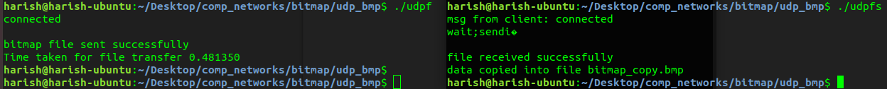

Time taken for bmp file: 0.481350
=1.7704 micro seconds per byte

for text file,

Time taken for txt file: 0.466861
=1.7201 micro seconds per byte

LATENCY:

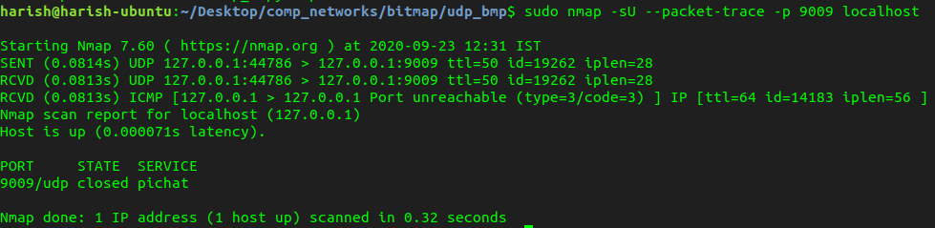
0.000071 seconds latency.

