Computer Networks Practice
Huffman coding

Approach:

Variable length Huffman:

Client Server socket is created and connection is extablished.Client is asked to enter a string which is encoded using huffman variable encoding.

There are mainly two major parts in Huffman Coding
1)Build a Huffman Tree from input characters.
2)Traverse the Huffman Tree and assign codes to characters.

Steps to build Huffman Tree
Input is an array of unique characters along with their frequency of occurrences and output is Huffman Tree.
1.Create a leaf node for each unique character and build a min heap of all leaf nodes (Min Heap is used as a priority queue. The value of frequency field is used to c ompare two nodes in min heap. Initially, the least frequent character is at root)

2.Extract two nodes with the minimum frequency from the min heap.

3.Create a new internal node with a frequency equal to the sum of the two nodes frequencies. Make the first extracted node as its left child and the other extracted node as its right child. Add this node to the min heap.

4.Repeat steps#2 and #3 until the heap contains only one node. The remaining node is the root node and the tree is complete.

Output:
CLIENT SIDE:
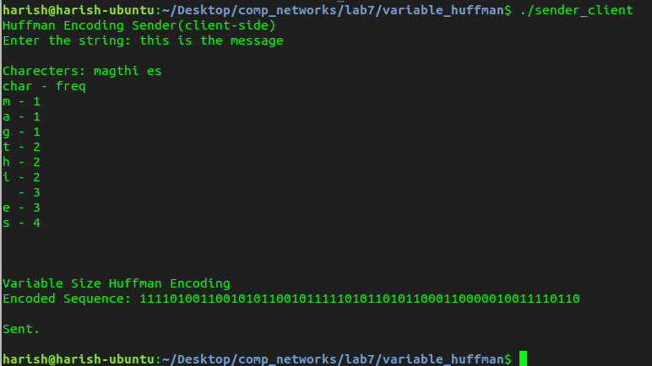
SERVER SIDE:
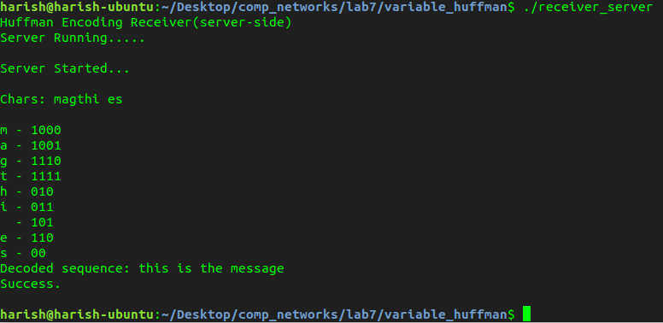
Constant length encoding:
Unlike variable coding,here tree creation is not required as the length is constant and which will be equal to log (n) base 2 where n is number of unique characters.
Each unique character is assigned a code of constant length which is stored in lookup table. Decoding happens in the same way in both schemes by looking at lookuptable.

CLIENT SIDE:
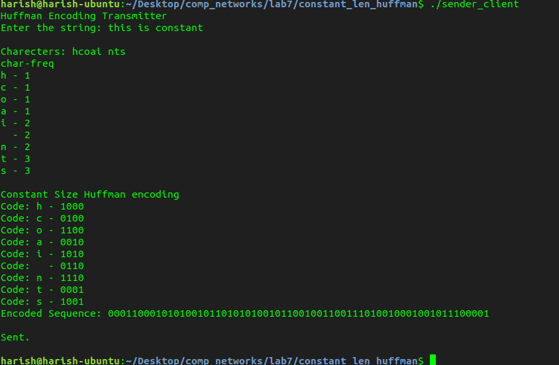
SERVER SIDE:
