Operating System
Assignment-2
Fork Practice Set

1.

Code:

#include<stdio.h>
#include<sys/types.h>
#include<unistd.h>
int main()
{
pid_t pid;
pid=fork();
if (pid!=0)
fork();
fork();
printf("Count \n");
return 0;
}

Output:

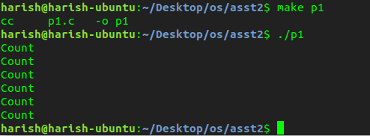
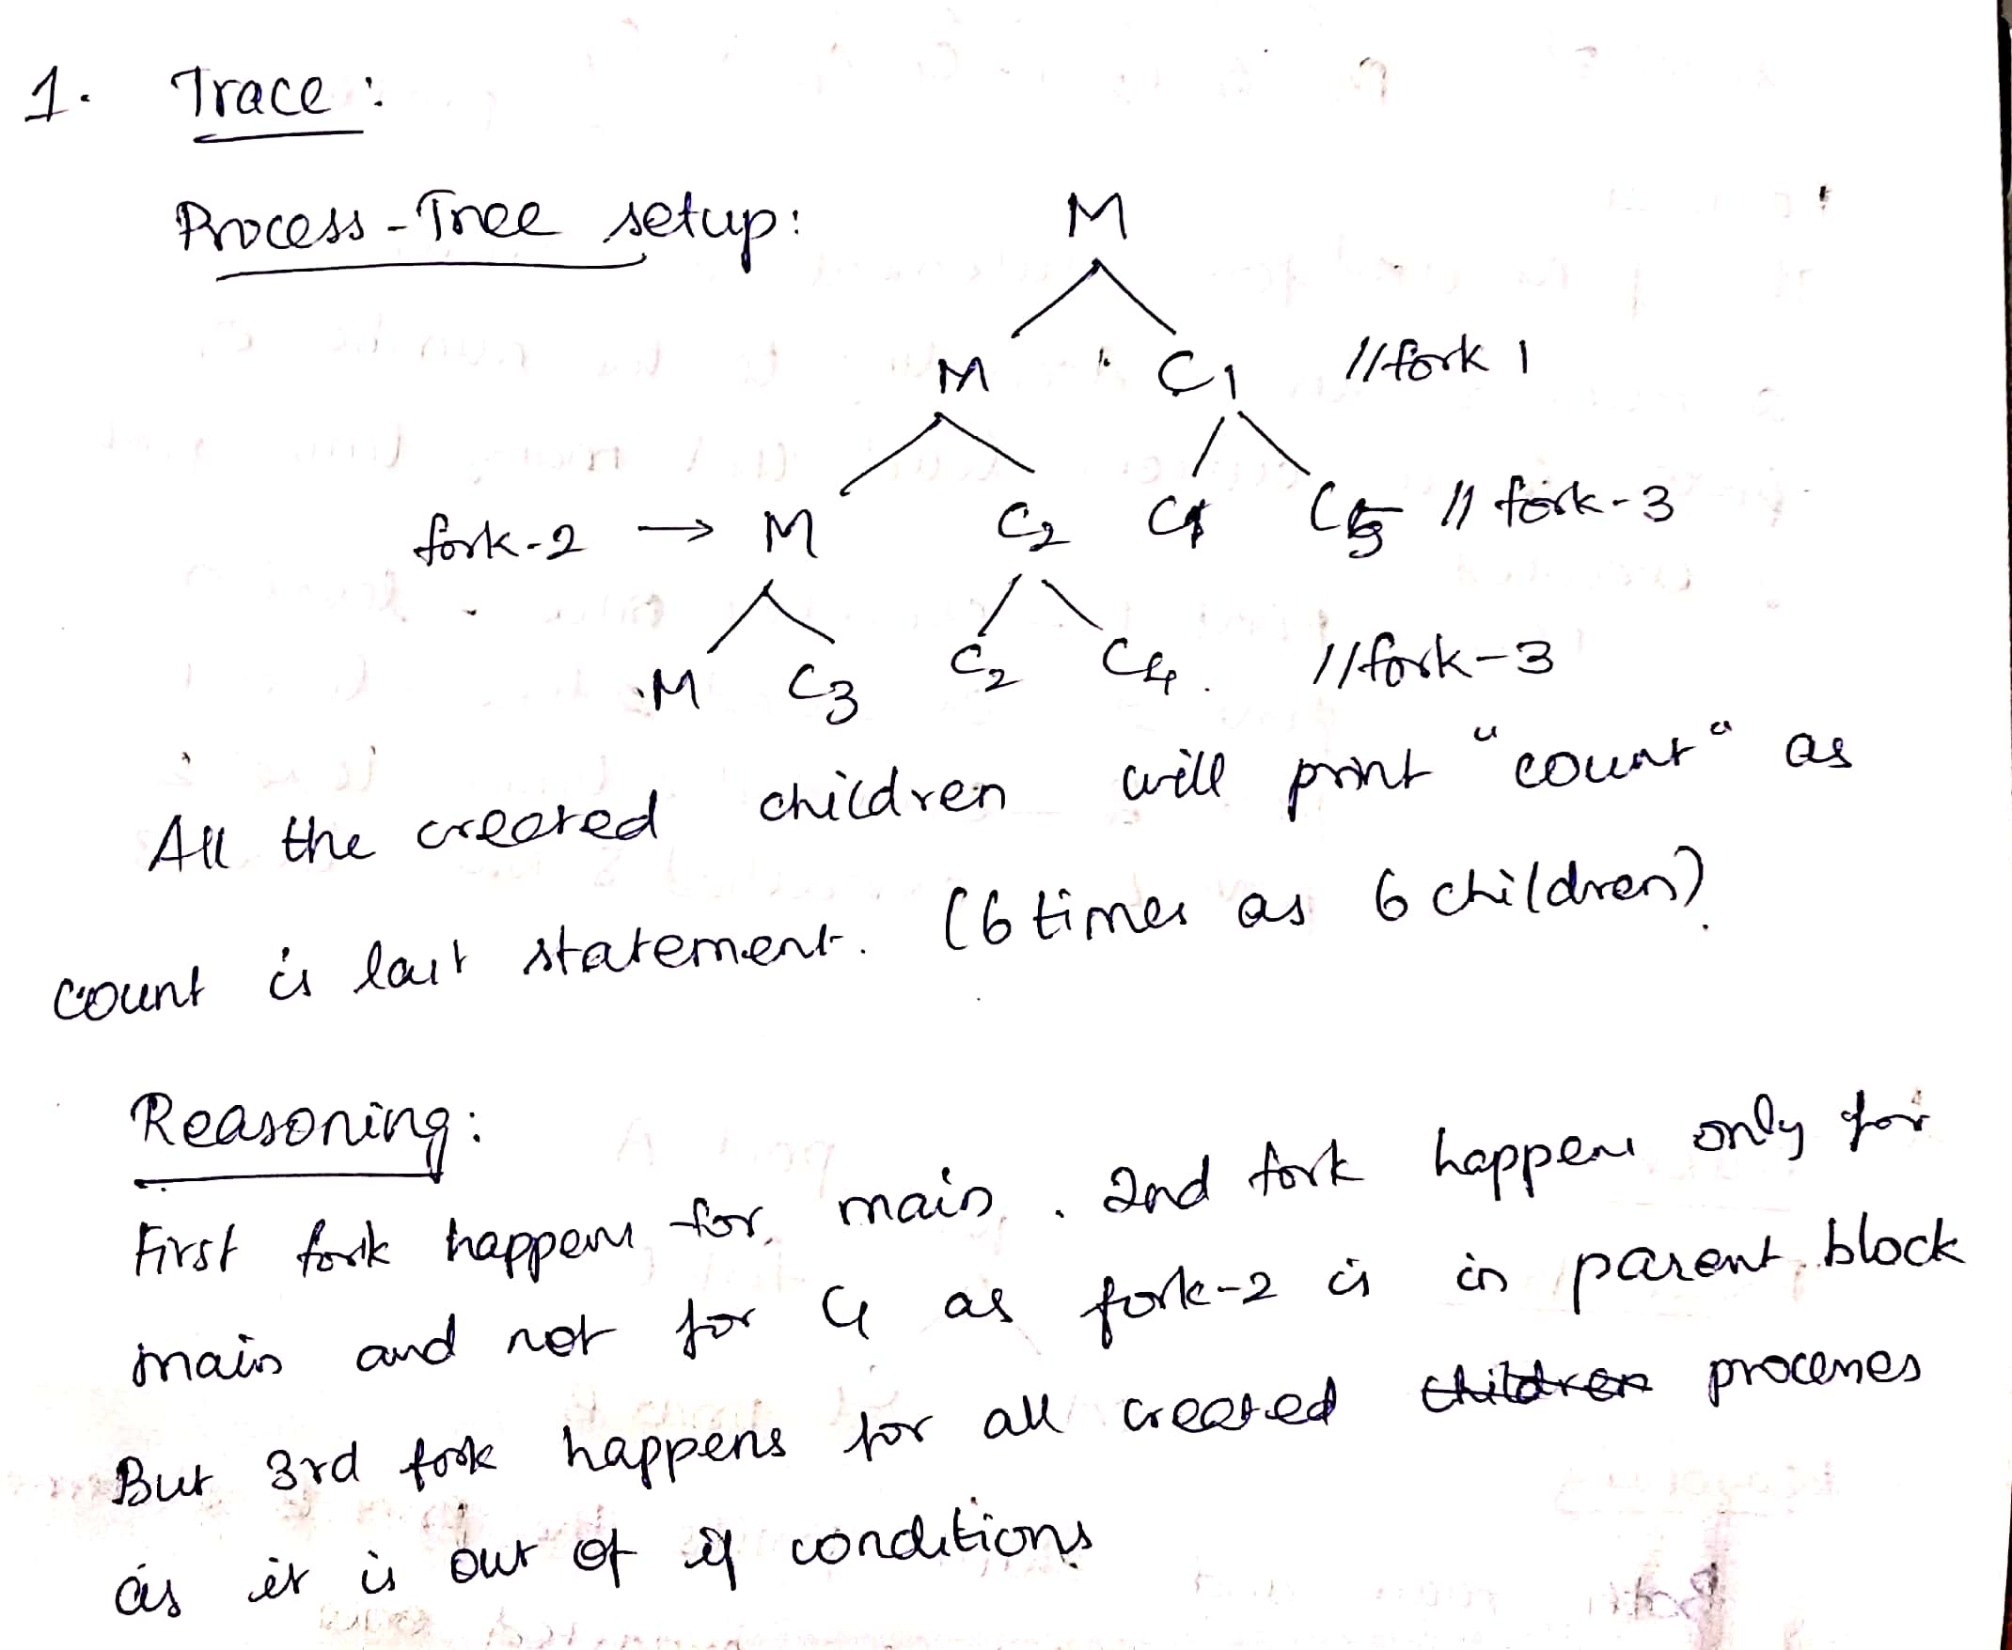

2.

Code:

#include<stdio.h>
#include<sys/types.h>
#include<unistd.h>
int main()
{
printf("OS \n");
fork();
fork();
fork();
}

Output:

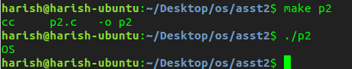

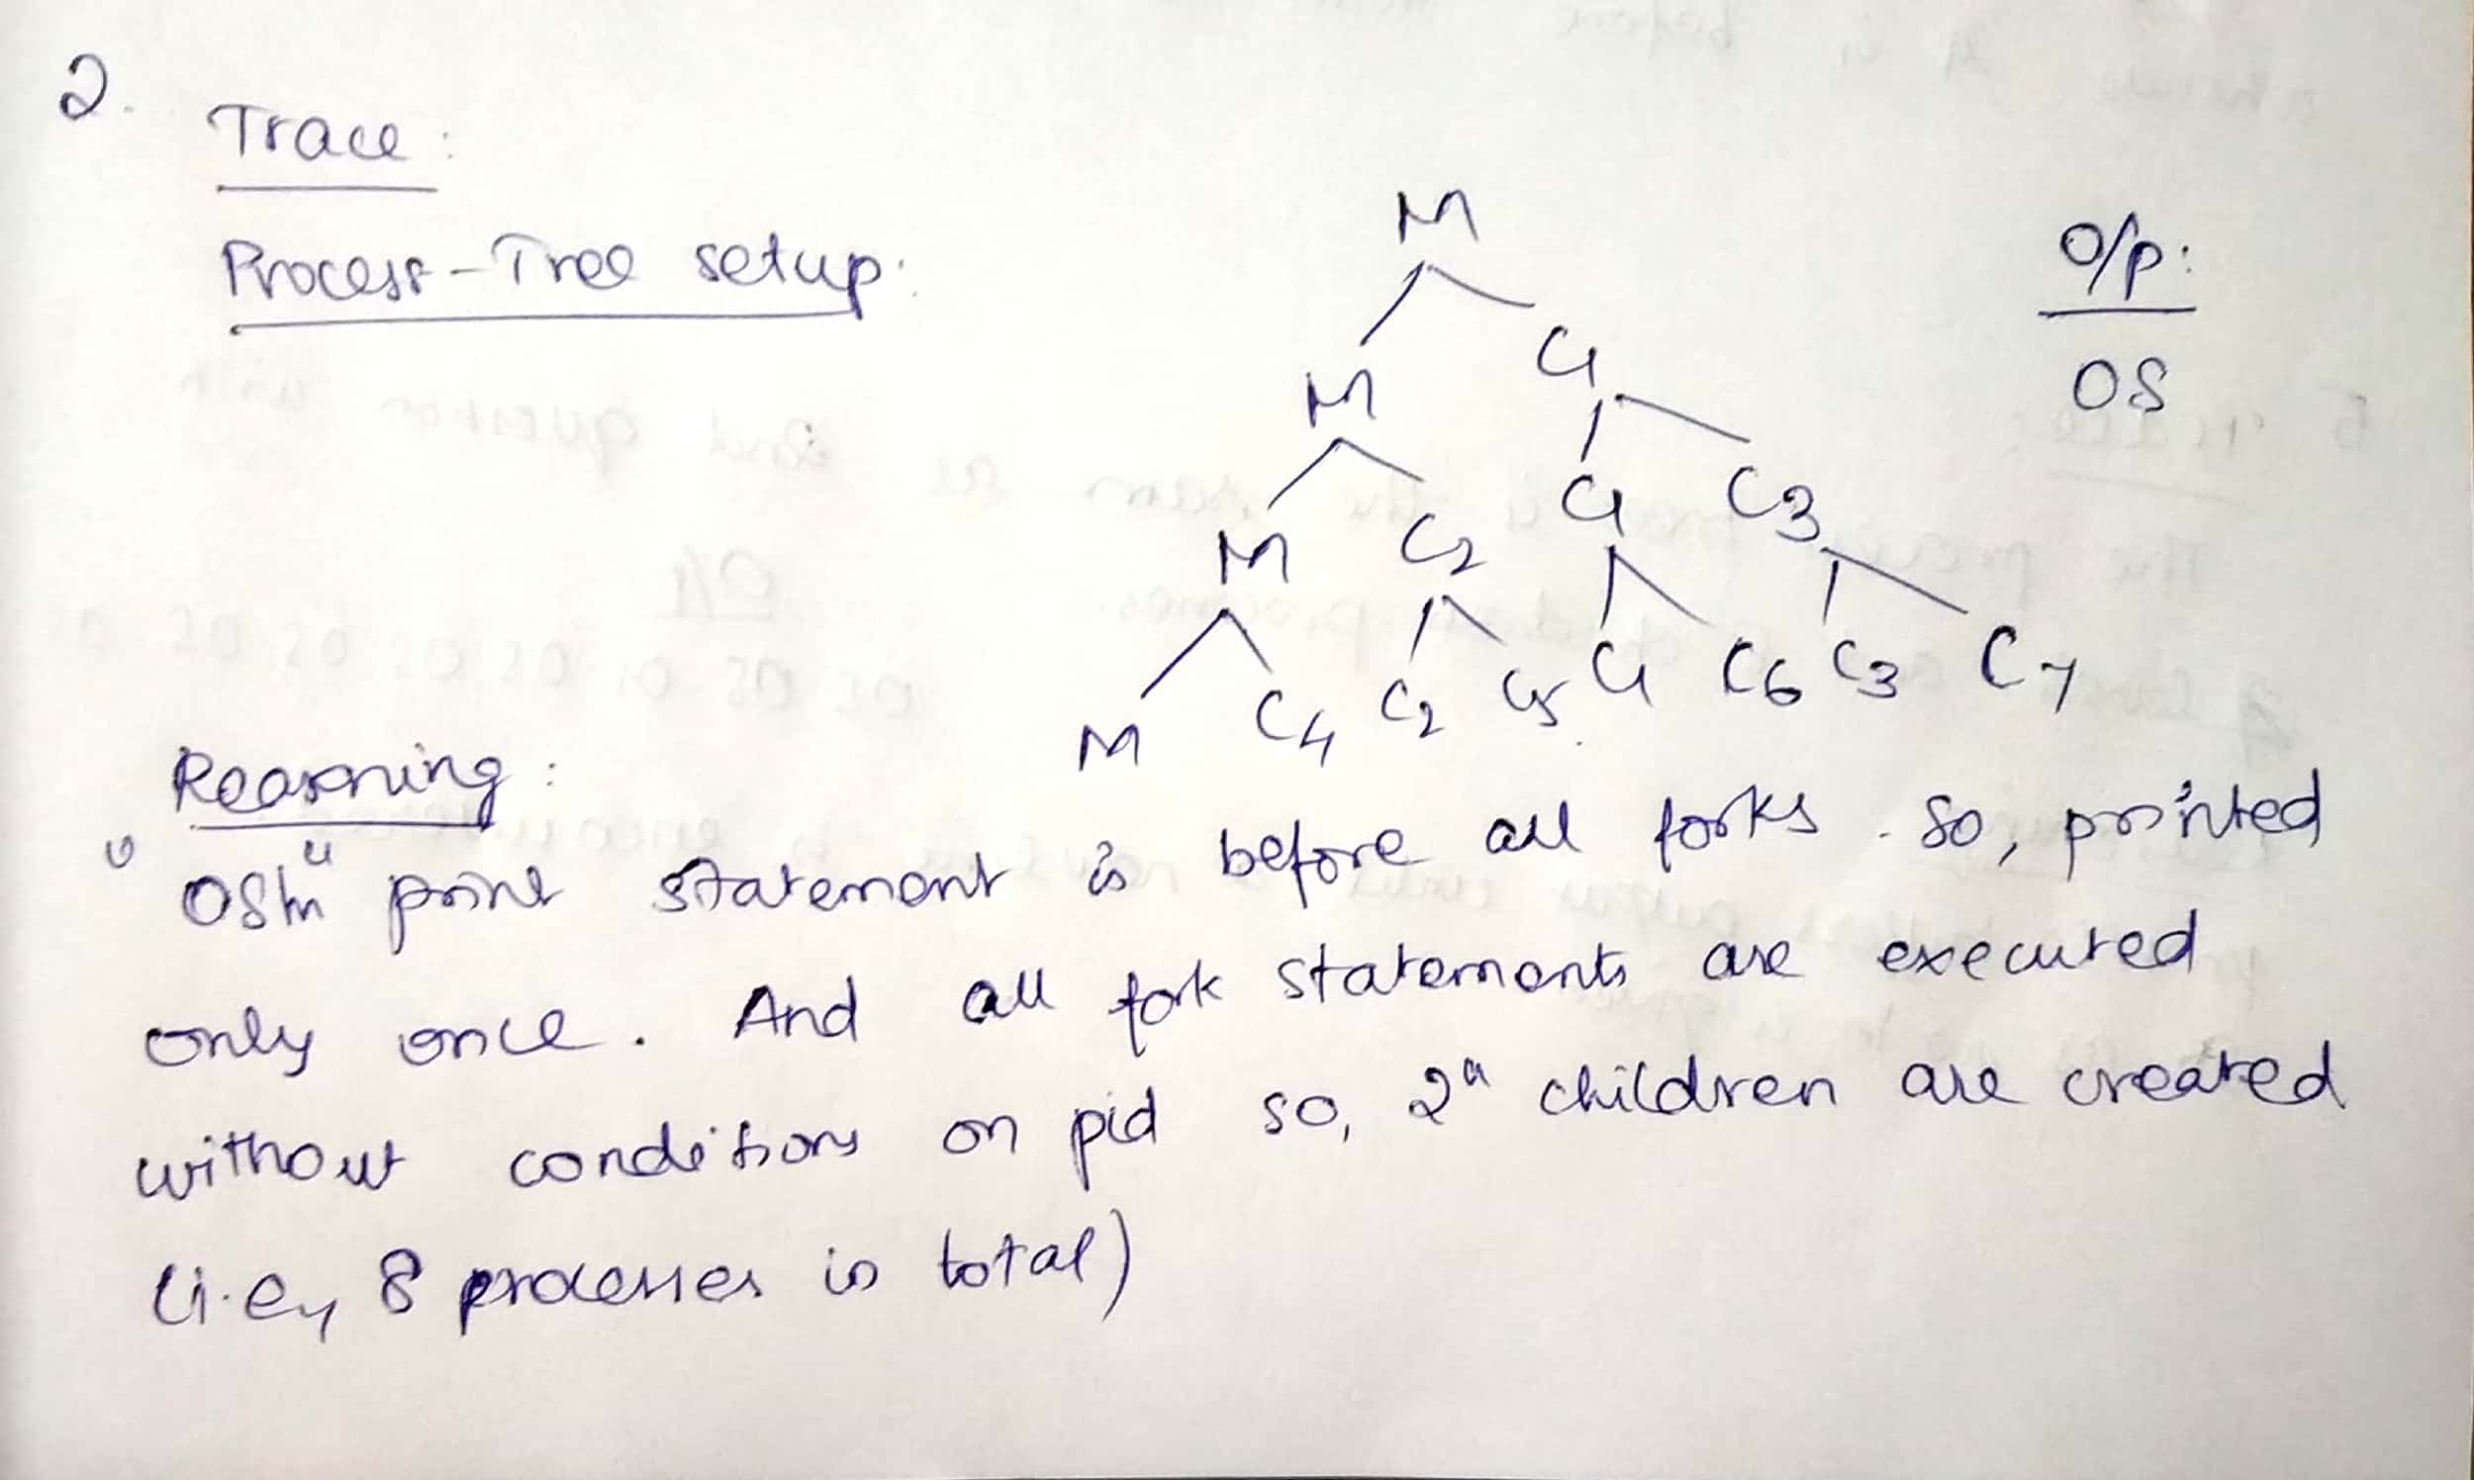

3.
Code:
#include<stdio.h>
#include<sys/types.h>
#include<unistd.h>
int main ()
{
printf("This will be printed ?.\n");
fork();
printf("This will be printed ?.\n");
fork();
printf("This will be printed ? .\n");
fork();
printf("This will be printed ?\n");
return 0;
}

Output:

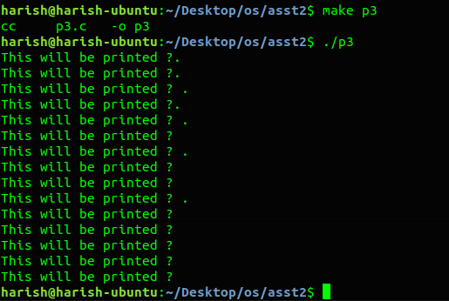

For more clarity, I print the output along with its respective level number in tree diagram:

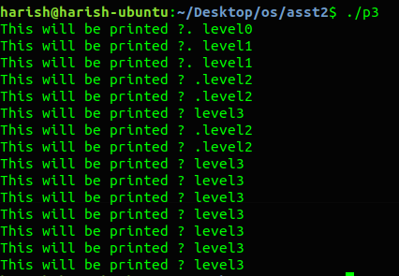

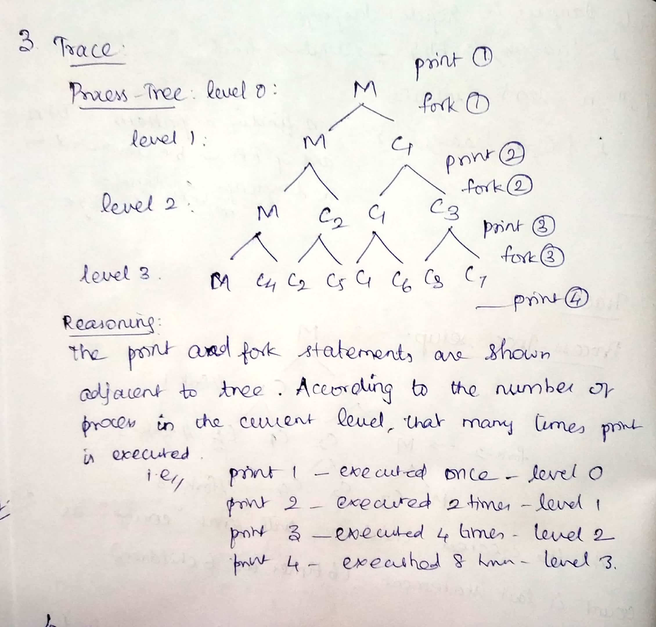

4.
Code:
#include<stdio.h>
#include<sys/types.h>
#include<unistd.h>
int main ()
{
printf(“A \n”);
fork();
printf(“B\n”);
return 0;
}

Output:

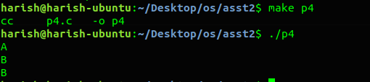

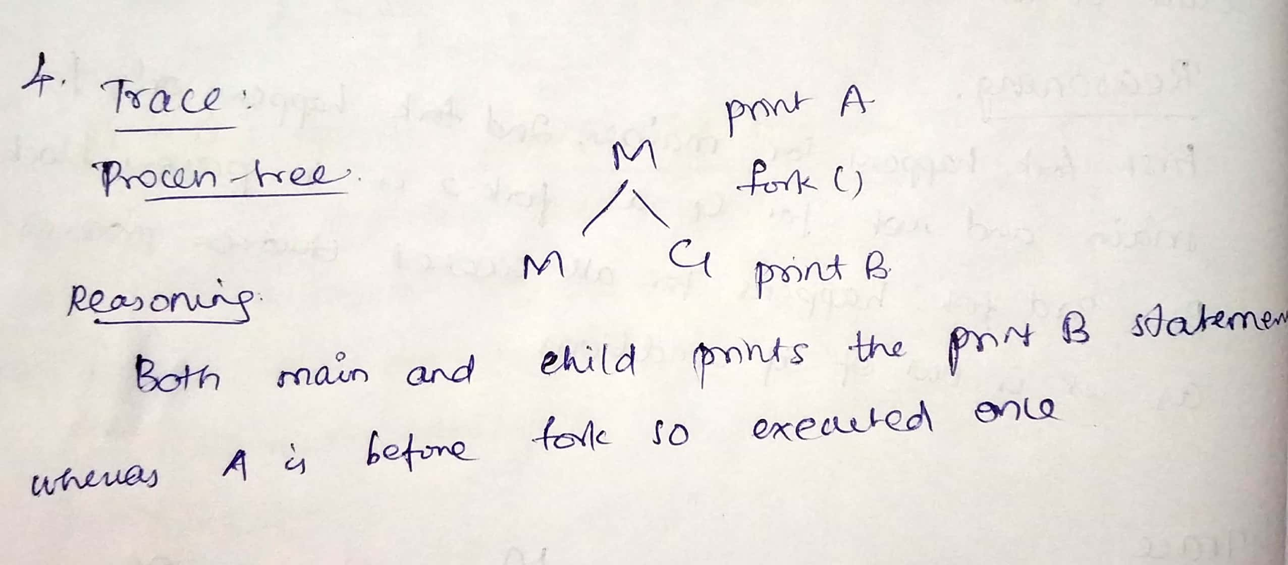

5.
Code:

#include<stdio.h>
#include<sys/types.h>
#include<unistd.h>
int main()
{
printf(“OS ");
fork();
fork();
fork();
}

Output:
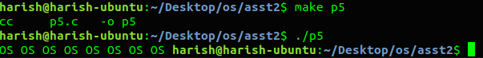
Trace:

The process tree setup is same as question 3 with 8 processes in total.
But here the the printf statement doesnot end with a \n.
Reasoning:

printf()buffers output until a newline is encountered. So the \n-less version stuffs OS into the output buffer, forks.They now both have an output buffer that contains OS.
The execution continues and both the processes fork again twice creating in a total of 8 processes.All processes then exit, causing a flush of the output buffer, which prints OS 8 times, once for each process.

6.
Code:

#include<stdio.h>
#include<sys/types.h>
#include<unistd.h>
int main ()
{
printf(“A”);
fork();
printf(“B”);
return 0;
}

Output:
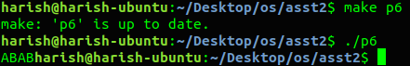

Trace:

The process tree setup is same as question 4 with 2 processes in total.
But here the printf statement doesnot end with a \n.

Reasoning:

printf()buffers output until a newline is encountered. So the \n-less version stuffs OS into the output buffer, forks.They now both have an output buffer that contains A.
The execution continues and B is sent to buffer by both the processes.Both processes then exit, causing a flush of the output buffer, which prints AB 2 times, once for each process.

7.
Question:
Express the following in a process tree setup and also write the C code for the same setup
1 forks 2 and 3
2 forks 4 5 and 6
3 forks 7
4 forks 8
5 forks 9
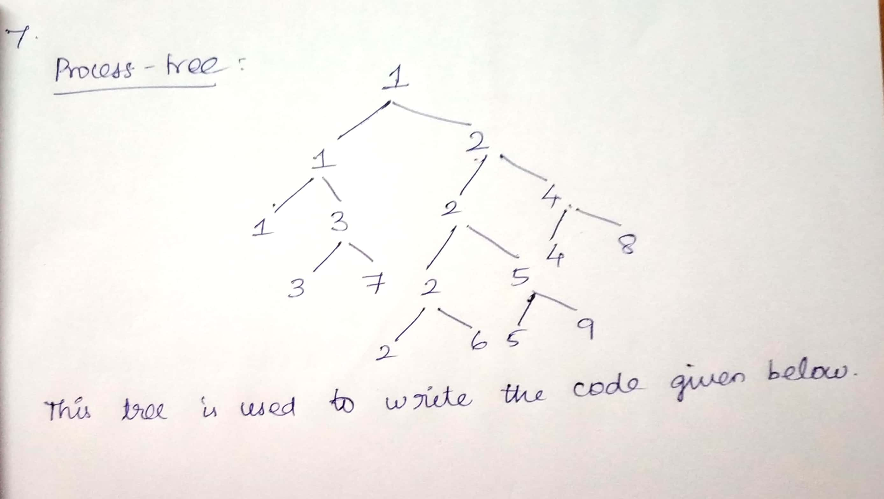

Code:

#include<stdio.h>
#include<sys/types.h>
#include<unistd.h>
int main()
{
pid_t pid[10];
pid[2]=fork();//1 forks 2

if (pid[2]>0)
{
pid[3]=fork();//1 forks 3
if(pid[3]==0)
{
printf("1 forked 3\n");
pid[7]=fork();//3 forks 7
if(pid[7]==0)
{
printf("3 forked 7\n");
}
}
}
else if(pid[2]==0)
{
printf("1 forked 2\n");
pid[4]=fork();//2 forks 4
if(pid[4]>0)
{
pid[5]=fork();//2 forks 5
if(pid[5]>0)
{ pid[6]=fork();//2 forks 6

if(pid[6]==0)
{
printf("2 forked 6\n");
}
}
else if(pid[5]==0)
{
printf("2 forked 5\n");
pid[9]=fork();//5 forks 9
if(pid[9]==0) printf("5 forked 9\n");
}
}
else if(pid[4]==0)
{
printf("2 forked 4\n");
pid[8]=fork();//4 forks 8
if(pid[8]==0) printf("4 forked 8\n");
}
}
return 0;
}

Output:

