**Advanced Software Engineering**

**Lab Assignment**

**Harish Kolla**

**Class Id:44**

**Smart Watch Application (City Time):**

**Wireframes:**

**Home page:**

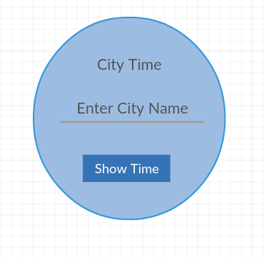

**Output Page:**

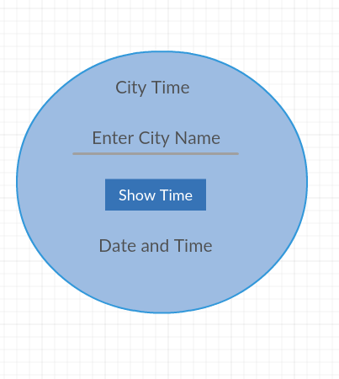

**Video Application:**

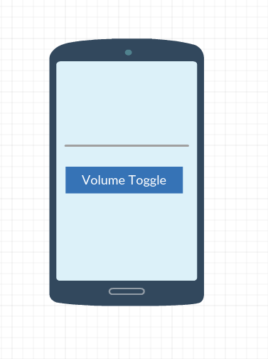

**Smart Watch Application (City Time):**

This application is used to find the local date and time of a city. It consists of a text field to enter the city name and after clicking the button it shows the local date and time of the city.

**Home Page:**

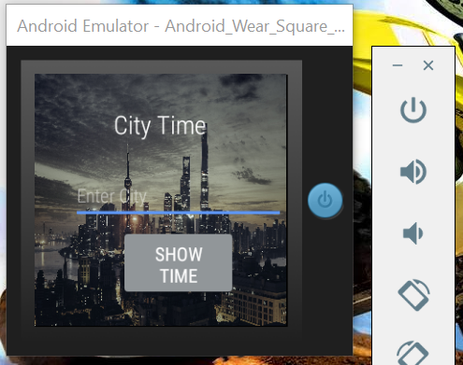

**Details Page:**

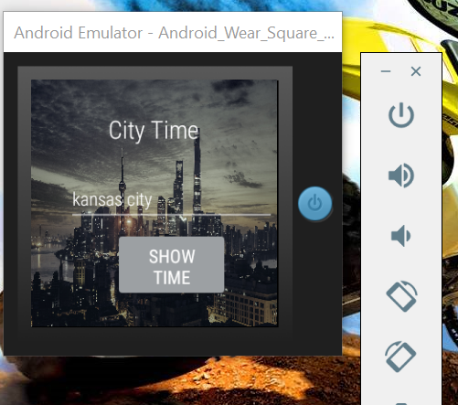

**Video Application(Spatial audio):**

This feature of spatial audio is used to control user attention. One can present sounds from any direction to draw a listener's attention and give them cues on where to look next.

