**Blue_infinity 11-7-18**



**Blue_infinity Board dimension queries**

1. **Board how much is the board cut for USB in that dimention does the micro USB fit??**

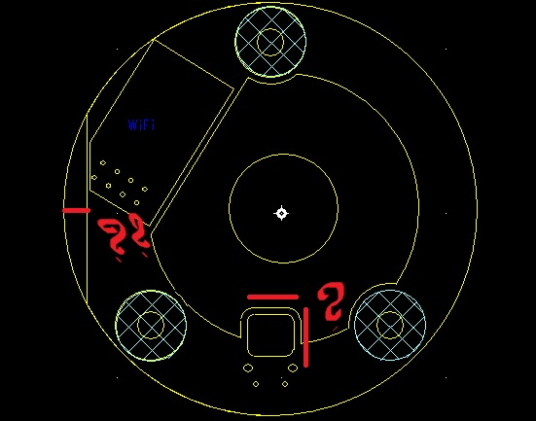

**2.Dimention of the sensor wire PCB cut ??**

**3.Connector from USB Board to dc jack??**

**4.How the to USB connectors Stand on one by one in usb board ??**

**5.Top side Board dimention not clear ??**

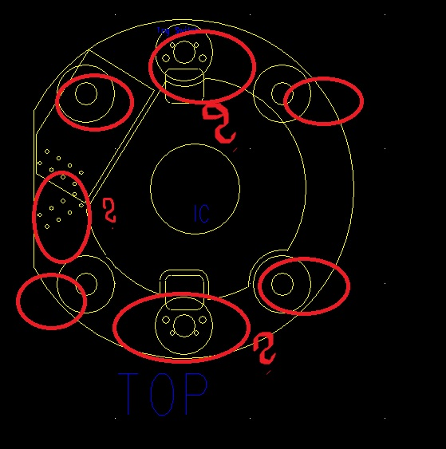

**6.Number of mounting holes??3**