Pipeline:

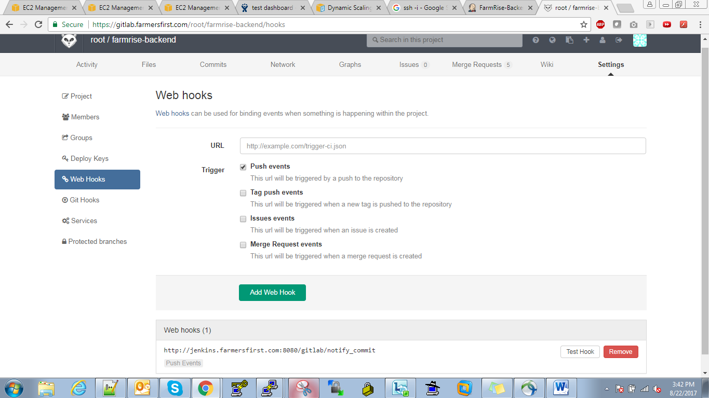

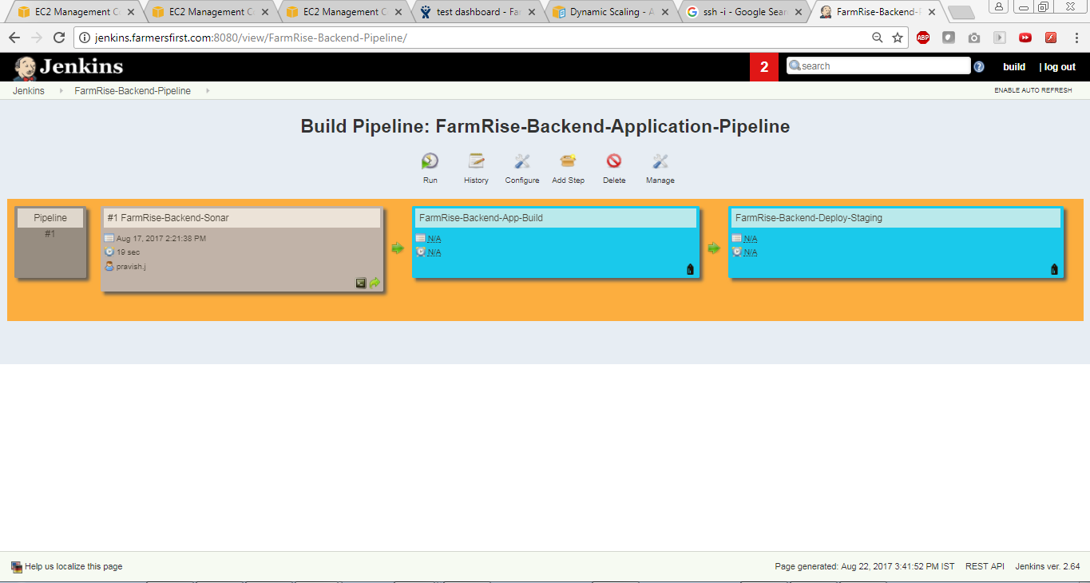

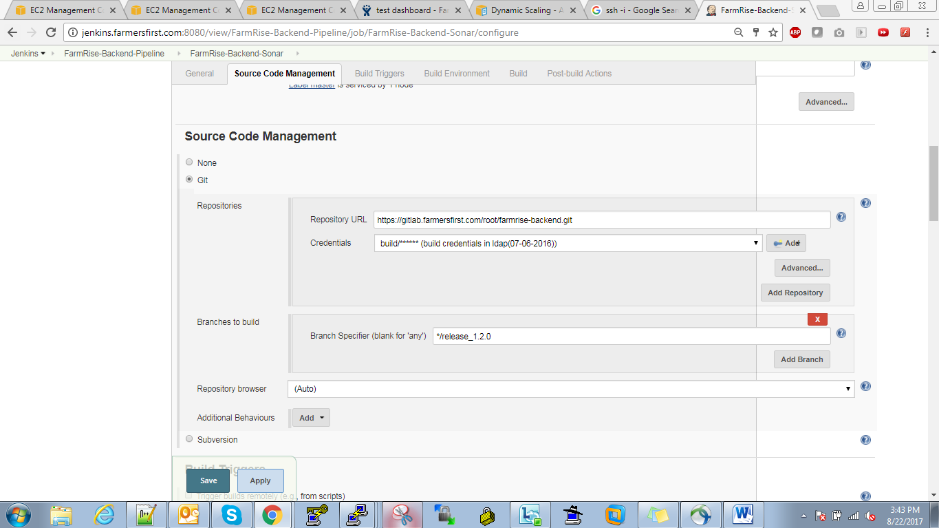

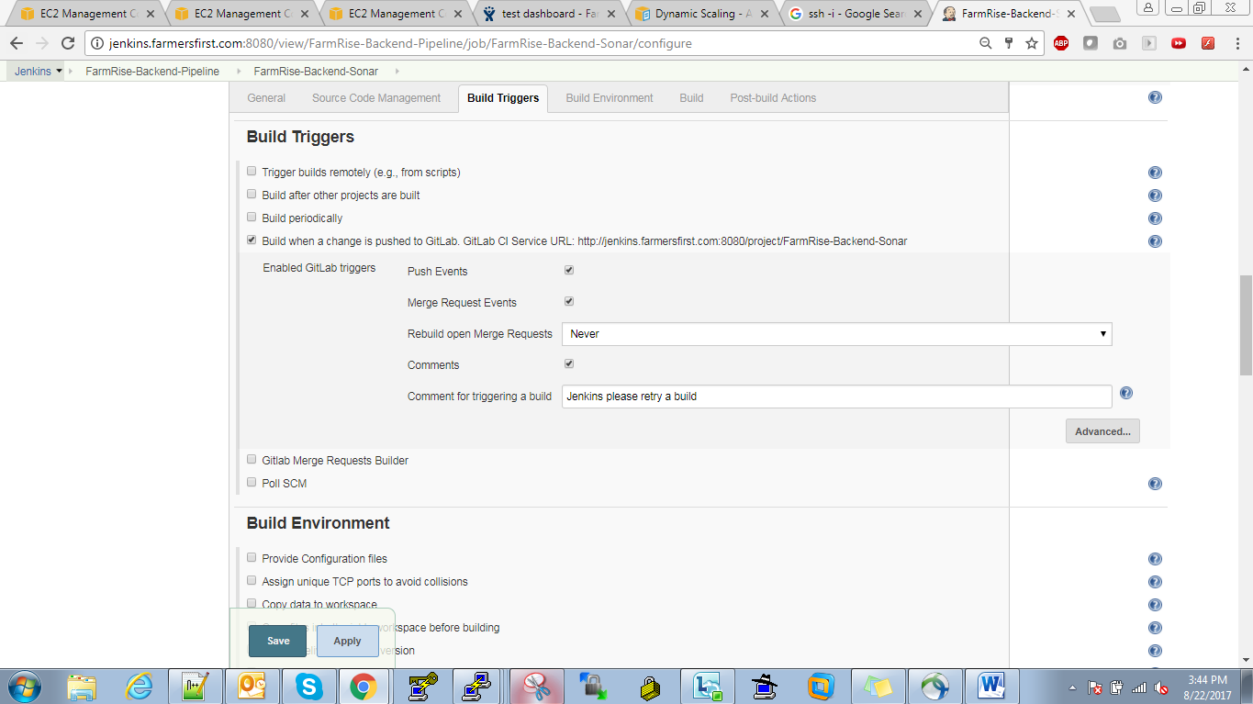

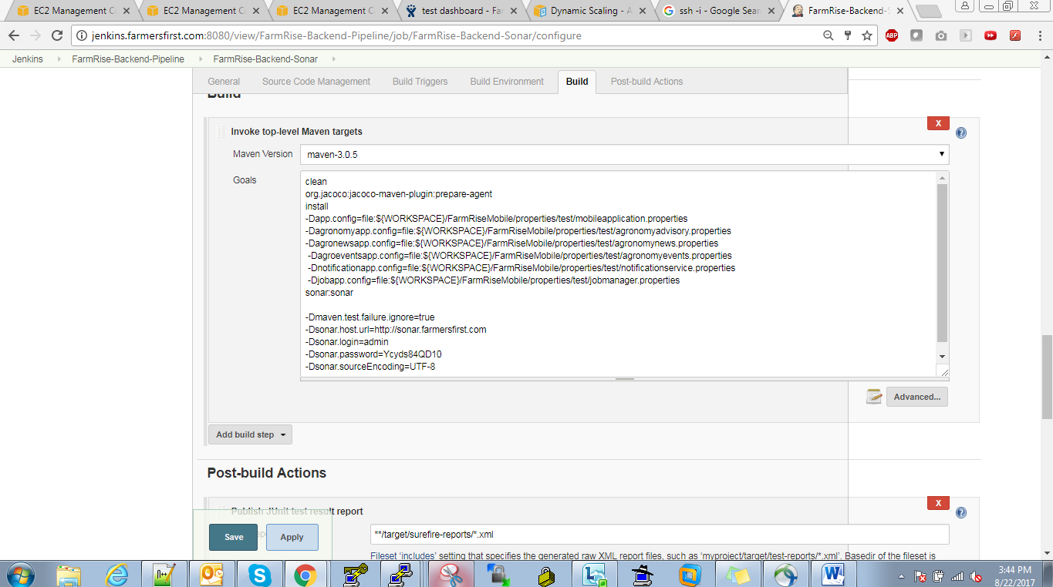

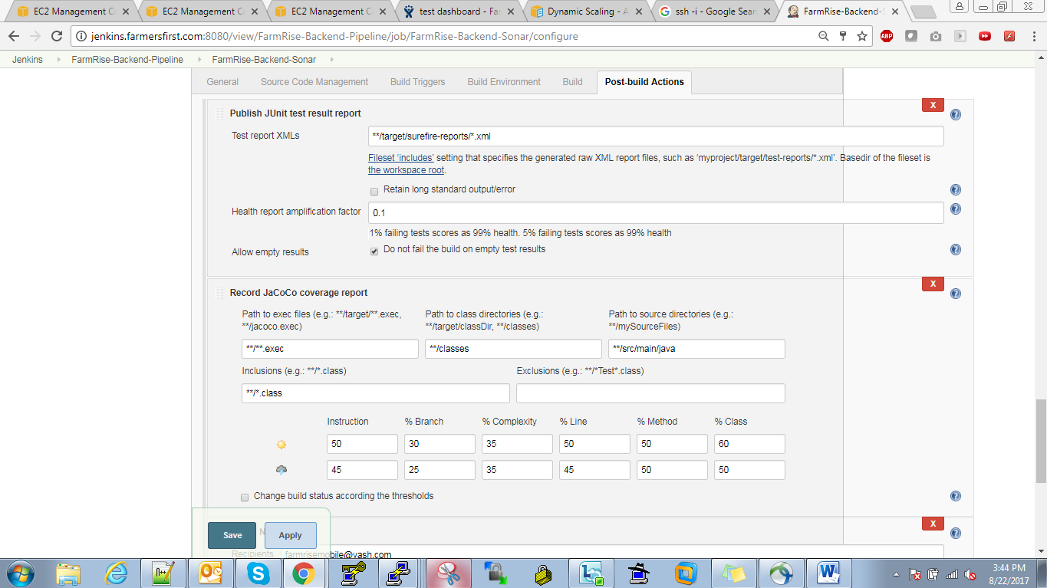

Next job

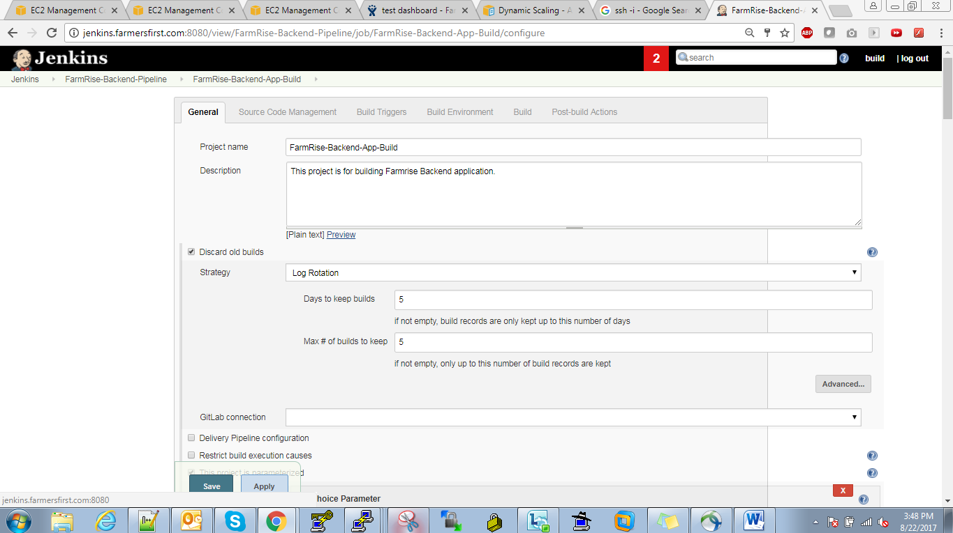

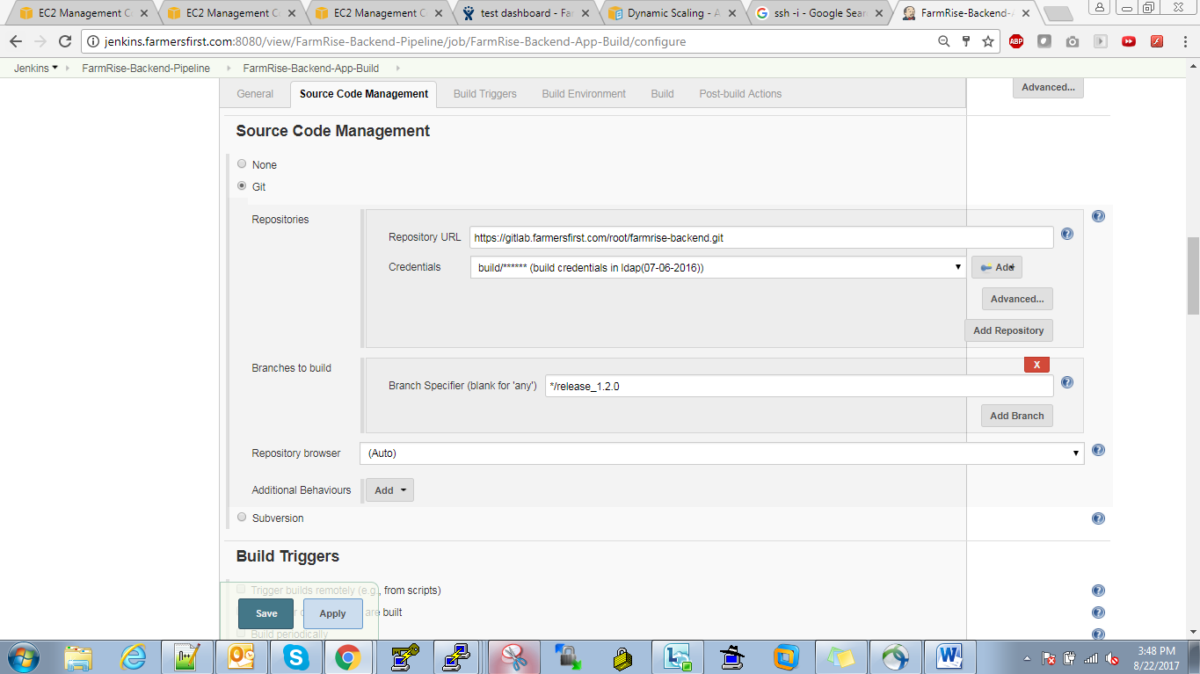

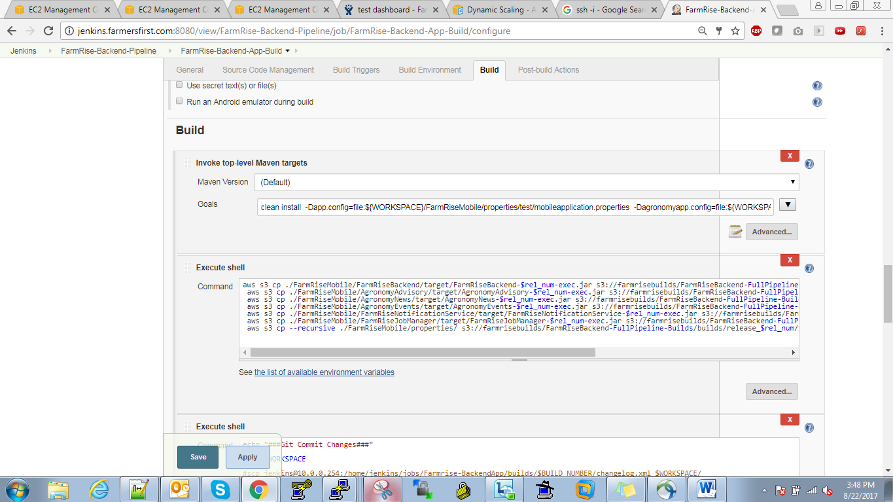

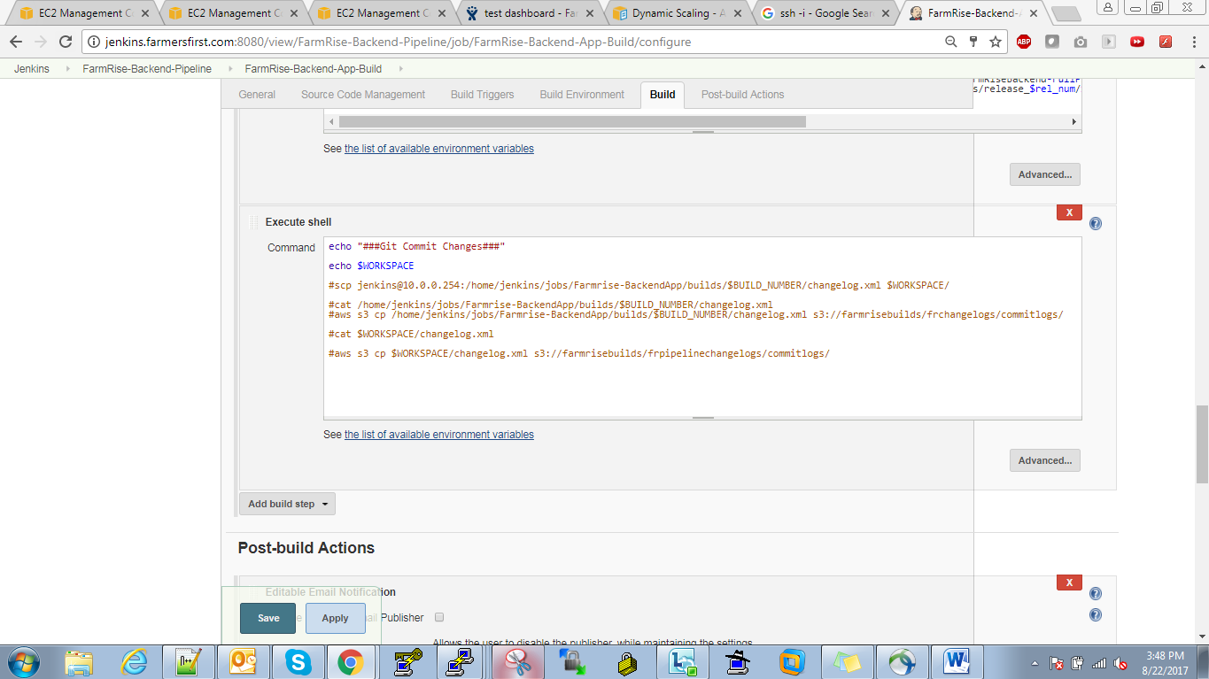

Next job for deployment:

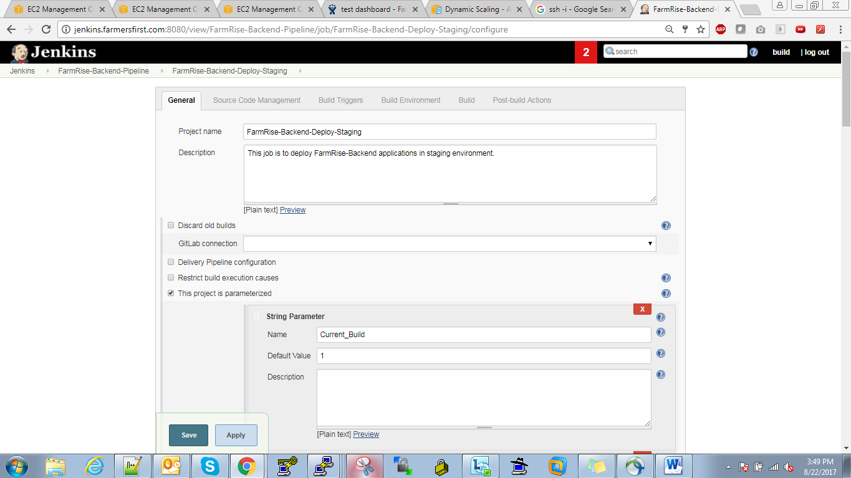

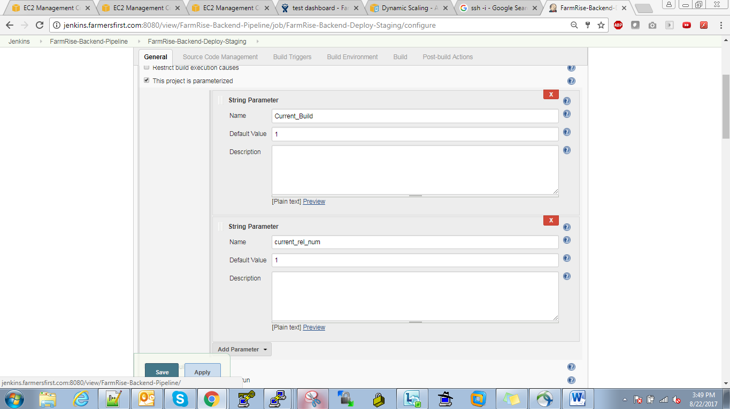

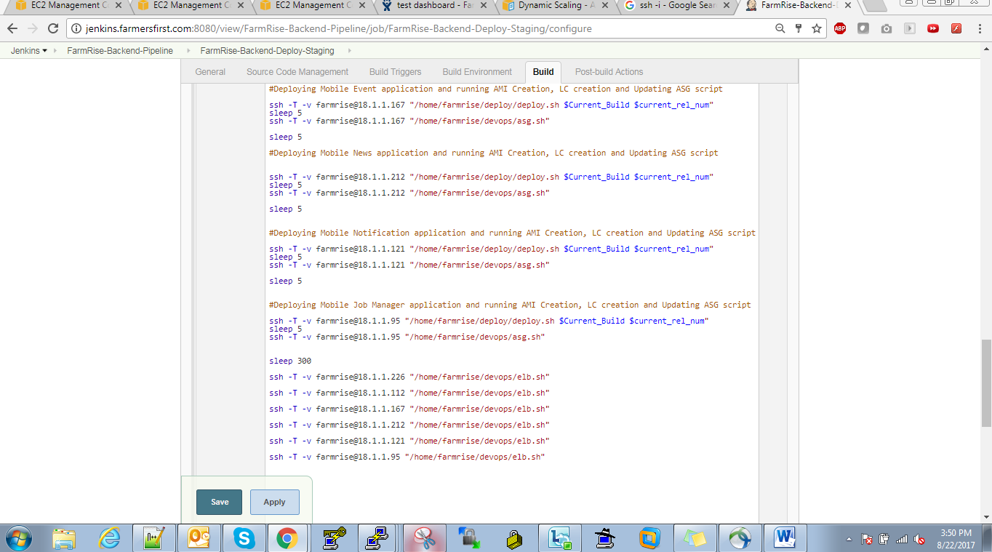

[root@Stage-FarmRiseApp-1b-01 devops]# cat asg.sh

#!/bin/bash

#Script to create ami of running instance, make launch Conf from it and than add it to Auto Scaling group

#To get the current Instance ID

wget -q -O - http://169.254.169.254/latest/meta-data/instance-id > /home/farmrise/devops/instanceID.txt

#To get the current Instance Type

wget -q -O - http://169.254.169.254/latest/meta-data/instance-type > /home/farmrise/devops/instanceType.txt

#To create a unique AMI name for this script

echo "Mobile-Backend-`date +%d%b%y%H%M`" > /home/farmrise/devops/aminame.txt

#To create a unique Launch Conf name for this script

echo "Mobile-Backend-`date +%d%b%y%H%M`" > /home/farmrise/devops/launchConf.txt

echo ""

echo "Starting the ami creation with name as `cat /home/farmrise/devops/aminame.txt`"

echo ""

#Creating AMI of current server by taking above values

aws ec2 create-image --instance-id `cat /home/farmrise/devops/instanceID.txt` --name "`cat /home/farmrise/devops/aminame.txt`" --description "Mobile-Backend-Stage auto AMI creation" --no-reboot > /home/farmrise/devops/amiID.txt

#Showing the AMI name created by AWS

echo "AMI ID is `cat /home/farmrise/devops/amiID.txt`"

#echo "waiting for 300 seconds...."

#sleep 300

#Showing the parameters which will be used while creating the Launch Conf

echo "Creating the launch config as `cat /home/farmrise/devops/launchConf.txt` with key as Stage-New-Farmrise-key Instance type `cat /home/farmrise/devops/instanceType.txt` and security group For Mobile-Backend-Stage"

echo ""

#Creating the Launch Config with defining the key name to be used and security group

aws autoscaling create-launch-configuration --launch-configuration-name `cat /home/farmrise/devops/launchConf.txt` --image-id `cat /home/farmrise/devops/amiID.txt` --instance-type `cat /home/farmrise/devops/instanceType.txt` --key-name Stage-New-Farmrise-key --security-groups sg-1131c76d --iam-instance-profile EC2_CloudWatch

echo "The launch Config created succesfully as `cat /home/farmrise/devops/launchConf.txt`"

echo ""

echo "Updating the Auto scaling Group ASG_STAGE_FR_Job_Manager with new launch Conf"

#Updating the auto scaling group with new launch Conf

aws autoscaling update-auto-scaling-group --auto-scaling-group-name ASG_STAGE_FR_APP --launch-configuration-name `cat /home/farmrise/devops/launchConf.txt`

#some happy faces after all done well :)

echo "The Auto scaling group ASG_STAGE_FR_APP is updated succesfully...:)"

#aws ec2 copy-image --source-image-id "`cat /home/farmrise/devops/amiID.txt`" --source-region us-east-1 --region us-west-1 --name "`cat /home/farmrise/devops/aminame.txt`"

[root@Stage-FarmRiseApp-1b-01 devops]# cat elb.sh

#!/bin/bash

set -x

aws elb describe-load-balancers --load-balancer-name NewMobileAppServer-STAGE-elb > load.txt

grep -oP 'i-.*' load.txt > outputfile.txt

echo Stopping Instance - `cat /home/farmrise/devops/outputfile.txt`

aws ec2 stop-instances --instance-id `cat /home/farmrise/devops/outputfile.txt`

[root@Stage-FarmRiseApp-1b-01 devops]# cat asg.sh

#!/bin/bash

#Script to create ami of running instance, make launch Conf from it and than add it to Auto Scaling group

#To get the current Instance ID

wget -q -O - http://169.254.169.254/latest/meta-data/instance-id > /home/farmrise/devops/instanceID.txt

#To get the current Instance Type

wget -q -O - http://169.254.169.254/latest/meta-data/instance-type > /home/farmrise/devops/instanceType.txt

#To create a unique AMI name for this script

echo "Mobile-Backend-`date +%d%b%y%H%M`" > /home/farmrise/devops/aminame.txt

#To create a unique Launch Conf name for this script

echo "Mobile-Backend-`date +%d%b%y%H%M`" > /home/farmrise/devops/launchConf.txt

echo ""

echo "Starting the ami creation with name as `cat /home/farmrise/devops/aminame.txt`"

echo ""

#Creating AMI of current server by taking above values

aws ec2 create-image --instance-id `cat /home/farmrise/devops/instanceID.txt` --name "`cat /home/farmrise/devops/aminame.txt`" --description "Mobile-Backend-Stage auto AMI creation" --no-reboot > /home/farmrise/devops/amiID.txt

#Showing the AMI name created by AWS

echo "AMI ID is `cat /home/farmrise/devops/amiID.txt`"

#echo "waiting for 300 seconds...."

#sleep 300

#Showing the parameters which will be used while creating the Launch Conf

echo "Creating the launch config as `cat /home/farmrise/devops/launchConf.txt` with key as Stage-New-Farmrise-key Instance type `cat /home/farmrise/devops/instanceType.txt` and security group For Mobile-Backend-Stage"

echo ""

#Creating the Launch Config with defining the key name to be used and security group

aws autoscaling create-launch-configuration --launch-configuration-name `cat /home/farmrise/devops/launchConf.txt` --image-id `cat /home/farmrise/devops/amiID.txt` --instance-type `cat /home/farmrise/devops/instanceType.txt` --key-name Stage-New-Farmrise-key --security-groups sg-1131c76d --iam-instance-profile EC2_CloudWatch

echo "The launch Config created succesfully as `cat /home/farmrise/devops/launchConf.txt`"

echo ""

echo "Updating the Auto scaling Group ASG_STAGE_FR_Job_Manager with new launch Conf"

#Updating the auto scaling group with new launch Conf

aws autoscaling update-auto-scaling-group --auto-scaling-group-name ASG_STAGE_FR_APP --launch-configuration-name `cat /home/farmrise/devops/launchConf.txt`

#some happy faces after all done well :)

echo "The Auto scaling group ASG_STAGE_FR_APP is updated succesfully...:)"

#aws ec2 copy-image --source-image-id "`cat /home/farmrise/devops/amiID.txt`" --source-region us-east-1 --region us-west-1 --name "`cat /home/farmrise/devops/aminame.txt`"

[root@Stage-FarmRiseApp-1b-01 devops]# cat elb.sh

#!/bin/bash

set -x

aws elb describe-load-balancers --load-balancer-name NewMobileAppServer-STAGE-elb > load.txt

grep -oP 'i-.*' load.txt > outputfile.txt

echo Stopping Instance - `cat /home/farmrise/devops/outputfile.txt`

aws ec2 stop-instances --instance-id `cat /home/farmrise/devops/outputfile.txt`

[root@Stage-FarmRiseApp-1b-01 devops]#