231501058

**Ex. No.: 15**

CS23231 – D a t a S t r u c t u r e s

|  |  |  |
| --- | --- | --- |
| **Sorting** | **Date: 31/5/24** |  |
|  |  |

**Write a C prog ram to take n n umbers an d sort the numbers in ascendin g orde r . Try to imple men t the same using following sorting techniques .**

1. **Quick Sort**
2. **Merge Sort**

**Code :**

#include <stdio.h>

void swap(int* a, int* b) {

int temp = *a;

*a = *b;

*b = temp;

}

int partition(int arr[], int low, int high) { int pivot = arr[low];

int i = low;

int j = high;

while (i < j) {

while (arr[i] <= pivot && i <= high - 1) {

i++;

}

while (arr[j] > pivot && j >= low + 1) {

j--;

}

if (i < j) {

swap(&arr[i], &arr[j]);

}

}

swap(&arr[low], &arr[j]);

return j;

}

void quickSort(int arr[], int low, int high) { if (low < high) {

int partitionIndex = partition(arr, low, high); quickSort(arr, low, partitionIndex - 1); quickSort(arr, partitionIndex + 1, high);

}

}

int main() {

int arr[] = { 19, 17, 15, 12, 16, 18, 4, 11, 13 }; int n = sizeof(arr) / sizeof(arr[0]);



**Dept of Artificial Intelligence and Machine Learning** | **Rajalakshmi Engineering College**

. 51

231501058 CS23231 – D a t a S t r u c t u r e s

printf("Original array: ");

for (int i = 0; i < n; i++) {

printf("%d ", arr[i]);

}

quickSort(arr, 0, n - 1);

printf("\nSorted array: ");

for (int i = 0; i < n; i++) {

printf("%d ", arr[i]);

}

return 0;

}

**OUTPUT**



**2.Merge Sort**

#include <stdio.h>

#include <stdlib.h>

void merge(int arr[], int l, int m, int r) { int i, j, k;

int n1 = m - l + 1;

int n2 = r - m;

int L[n1], R[n2];

for (i = 0; i < n1; i++)

L[i] = arr[l + i];

for (j = 0; j < n2; j++)

R[j] = arr[m + 1 + j];

i = 0;

j = 0;

k = l;

while (i < n1 && j < n2) {

if (L[i] <= R[j]) {

arr[k] = L[i];

i++;

} else {

arr[k] = R[j];

j++;



**Dept of Artificial Intelligence and Machine Learning** | **Rajalakshmi Engineering College**

. 52

231501058 CS23231 – D a t a S t r u c t u r e s

}

k++;

}

while (i < n1) {

arr[k] = L[i];

i++;

k++;

}

while (j < n2) {

arr[k] = R[j];

j++;

k++;

}

}

void mergeSort(int arr[], int l, int r) {

if (l < r) {

int m = l + (r - l) / 2;

mergeSort(arr, l, m);

mergeSort(arr, m + 1, r);

merge(arr, l, m, r);

}

}

void printArray(int A[], int size) {

int i;

for (i = 0; i < size; i++)

printf("%d ", A[i]);

printf("\n");

}

int main() {

int arr[] = { 12, 11, 13, 5, 6, 7 };

int arr_size = sizeof(arr) / sizeof(arr[0]); printf("Given array is \n"); printArray(arr, arr_size); mergeSort(arr, 0, arr_size - 1); printf("\nSorted array is \n"); printArray(arr, arr_size);

return 0;

}

**OUTPUT**

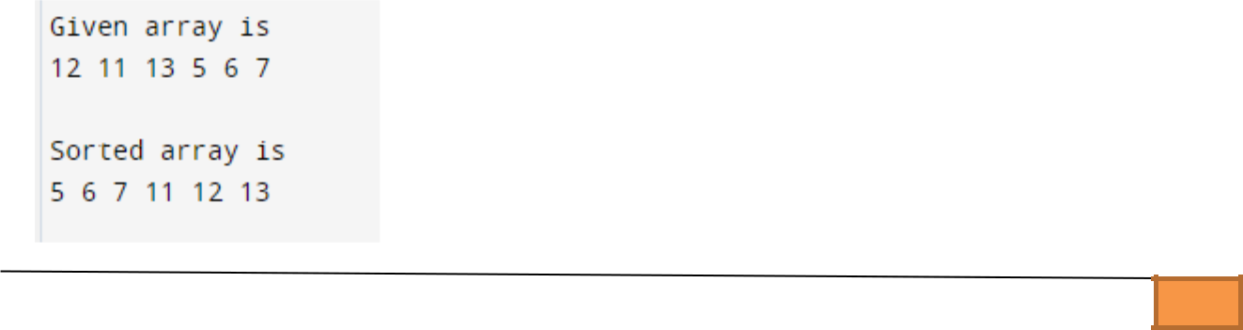

**Dept of Artificial Intelligence and Machine Learning** | **Rajalakshmi Engineering College**

. 53