.

**Dept of Artificial Intelligence and Machine Learning** | **Rajalakshmi Engineering College**

129

10 - Searching & Sorting

**Ex. No. : 10.1 Date:** 25/5/24

.

**Dept of Artificial Intelligence and Machine Learning** | **Rajalakshmi Engineering College**

130

**Register No.: 231501058 Name: M Harish**

# Merge Sort

Write a Python program to sort a list of elements using the merge sort algorithm.

## For example:

|  |  |
| --- | --- |
| **Input** | **Result** |
| 5  6 5 4 3 8 | 3 4 5 6 8 |

**PROGRAM**

a = int(input())

b = list(input().split(" ")) b.sort()

for i in b:

print(i,end=" ")

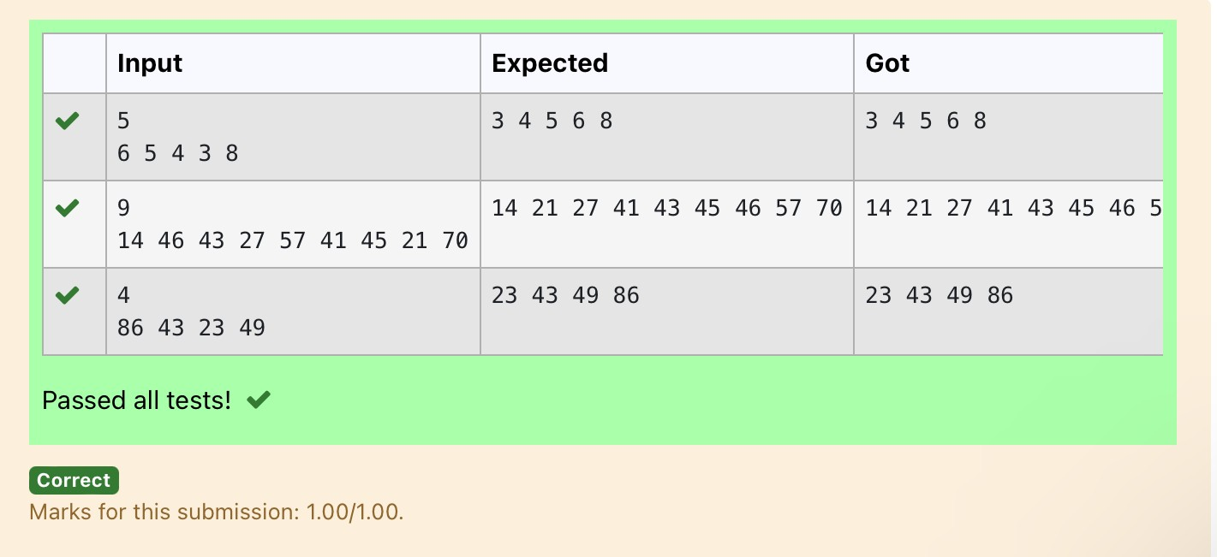

**Ex. No. : 10.2 Date:** 25/5/24

**Dept of Artificial Intelligence and Machine Learning** | **Rajalakshmi Engineering College**

131

**Register No.: 231501058 Name: M Harish**

# Bubble Sort

Given an listof integers, sort the array in ascending order using the *Bubble Sort* algorithm above. Once sorted, print the following three lines:

1. [List](http://118.185.187.137/moodle/mod/resource/view.php?id=1068) is sorted in numSwaps swaps., where numSwaps is the number of swaps that took place.
2. First Element: firstElement, the *first* element in the sorted [list](http://118.185.187.137/moodle/mod/resource/view.php?id=1068).
3. Last Element: lastElement, the *last* element in the sorted [list](http://118.185.187.137/moodle/mod/resource/view.php?id=1068).

For example, given a worst-case but small array to sort: a=[6,4,1]. It took 3 swaps to sort the array. Output would be

Array is sorted in 3 swaps. First Element: 1

Last Element: 6

## Input Format

The first line contains an integer,n , the size of the [list](http://118.185.187.137/moodle/mod/resource/view.php?id=1068) a . The second line contains n, space-separated integers a[i].

## Constraints

· 2<=n<=600

· 1<=a[i]<=2x106.

## Output Format

You must print the following three lines of output:

1. [List](http://118.185.187.137/moodle/mod/resource/view.php?id=1068) is sorted in numSwaps swaps., where numSwaps is the number of swaps that took place.
2. First Element: firstElement, the *first* element in the sorted [list](http://118.185.187.137/moodle/mod/resource/view.php?id=1068).
3. Last Element: lastElement, the *last* element in the sorted [list](http://118.185.187.137/moodle/mod/resource/view.php?id=1068).

## Sample Input 0

3

1 2 3

## Sample Output 0

[List](http://118.185.187.137/moodle/mod/resource/view.php?id=1068) is sorted in 0 swaps. First Element: 1

Last Element: 3

## For example:

.

|  |  |
| --- | --- |
| **Input** | **Result** |
| 3 | List is sorted in 3 swaps. |
| 3 2 1 | First Element: 1 |
|  | Last Element: 3 |
| 5 | List is sorted in 4 swaps. |
| 1 9 2 8 4 | First Element: 1 |
|  | Last Element: 9 |

.

**Dept of Artificial Intelligence and Machine Learning** | **Rajalakshmi Engineering College**

132

**PROGRAM**

num = 0

a = int(input())

b = input().split(" ") c = []

for i in range(len(b)): c.append(int(b[i]))

for j in range(len(c)):

for i in range(len(c)-1): if c[i] > c[i+1]:

c[i], c[i+1] = c[i+1], c[i] num += 1

print(f"List is sorted in {num} swaps.\nFirst Element: {c[0]}\nLast Element:

{c[-1]}")

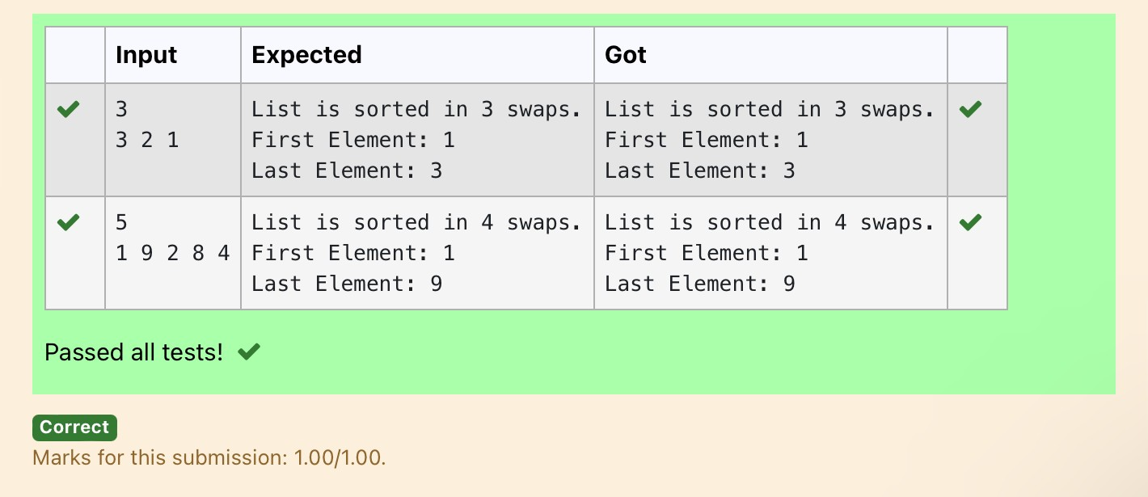

**Ex. No. : 10.3 Date:** 25/5/24

.

**Dept of Artificial Intelligence and Machine Learning** | **Rajalakshmi Engineering College**

133

**Register No.: 231501058 Name: M Harish**

# Peak Element

Given an [list](http://118.185.187.137/moodle/mod/resource/view.php?id=1068), find peak element in it. A peak element is an element that is greater than its neighbors.

An element a[i] is a peak element if

A[i-1] <= A[i] >=a[i+1] for middle elements. [0<i<n-1] A[i-1] <= A[i] for last element [i=n-1]

A[i]>=A[i+1] for first element [i=0]

**Input Format**

The first line contains a single integer n , the length of A . The second line contains n space-separated integers,A[i].

**Output Format**

**Print** peak numbers separated by space.

**Sample Input**

5

|  |  |
| --- | --- |
| **Input** | **Result** |
| 4  12 3 6 8 | 12 8 |

8 9 10 2 6

**Sample Output**

10 6

**For example:**

**PROGRAM**

n = int(input())

A = list(map(int, input().split())) if n == 1:

print(A[0]) else:

if A[0] >= A[1]:

print(A[0], end=" ") for i in range(1, n - 1):

if A[i] >= A[i - 1] and A[i] >= A[i + 1]: print(A[i], end=" ")

if A[n - 1] >= A[n - 2]:

print(A[n - 1])

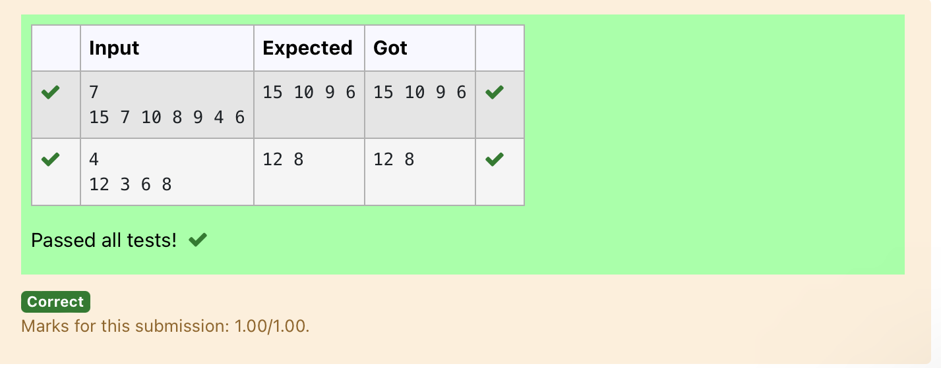

.

**Dept of Artificial Intelligence and Machine Learning** | **Rajalakshmi Engineering College**

134

**Ex. No. : 10.4 Date:** 25/5/24

.

**Dept of Artificial Intelligence and Machine Learning** | **Rajalakshmi Engineering College**

135

**Register No.: 231501058 Name: M Harish**

# Binary Search

Write a Python program for binary search.

## For example:

**PROGRAM**

|  |  |
| --- | --- |
| **Input** | **Result** |
| 1 2 3 5 8  6 | False |
| 3 5 9 45 42  42 | True |

def binary_search(arr, x):

left, right = 0, len(arr) - 1 while left <= right:

mid = (left + right) // 2 if arr[mid] == x:

return True elif arr[mid] < x:

left = mid + 1 else:

right = mid - 1 return False

arr = list(map(int, input().split(','))) x = int(input())

arr.sort()

result = binary_search(arr, x) print(result)

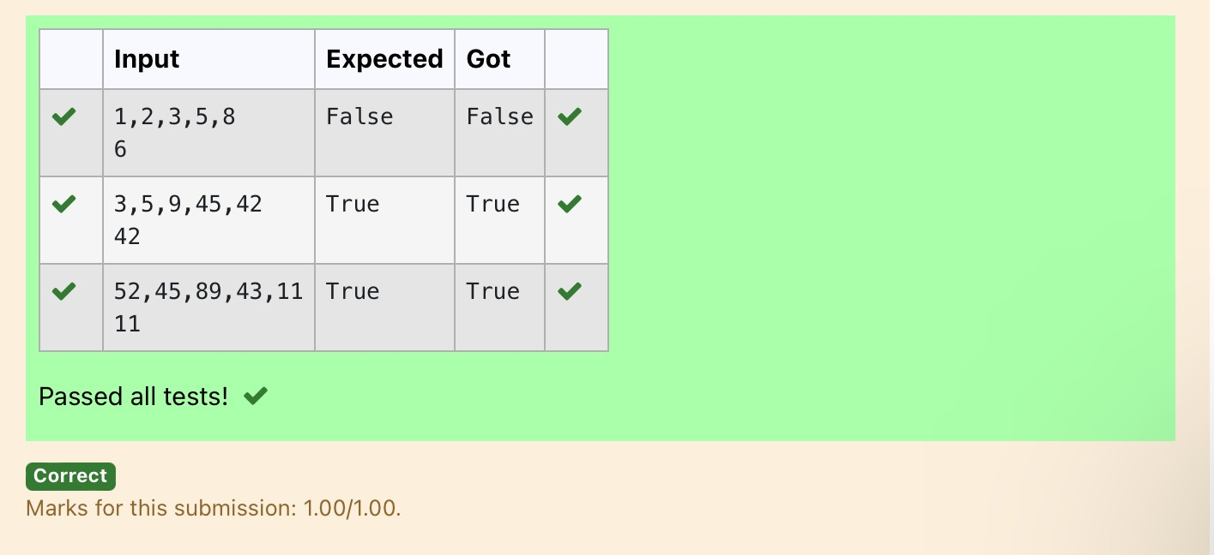

**Dept of Artificial Intelligence and Machine Learning** | **Rajalakshmi Engineering College**

136

**Ex. No. : 10.5 Date:** 25/5/24

**Register No.: 231501058 Name: M Harish**

# Frequency of Elements

To find the frequency of numbers in a list and display in sorted order.

## Constraints:

1<=n, arr[i]<=100

## Input:

1 68 79 4 90 68 1 4 5

## output:

1 2

4 2

|  |  |
| --- | --- |
| **Input** | **Result** |
| 4 3 5 3 4 5 | 3 2 |
|  | 4 2 |
|  | 5 2 |

5 1

68 2

79 1

90 1

## For example:

**PROGRAM**

numbers = input().split()

numbers = [int(num) for num in numbers] frequency = {}

for num in numbers:

if num in frequency: frequency[num] += 1

else:

frequency[num] = 1

sorted_frequency = sorted(frequency.items()) for key, value in sorted_frequency:

print(key, value)

.

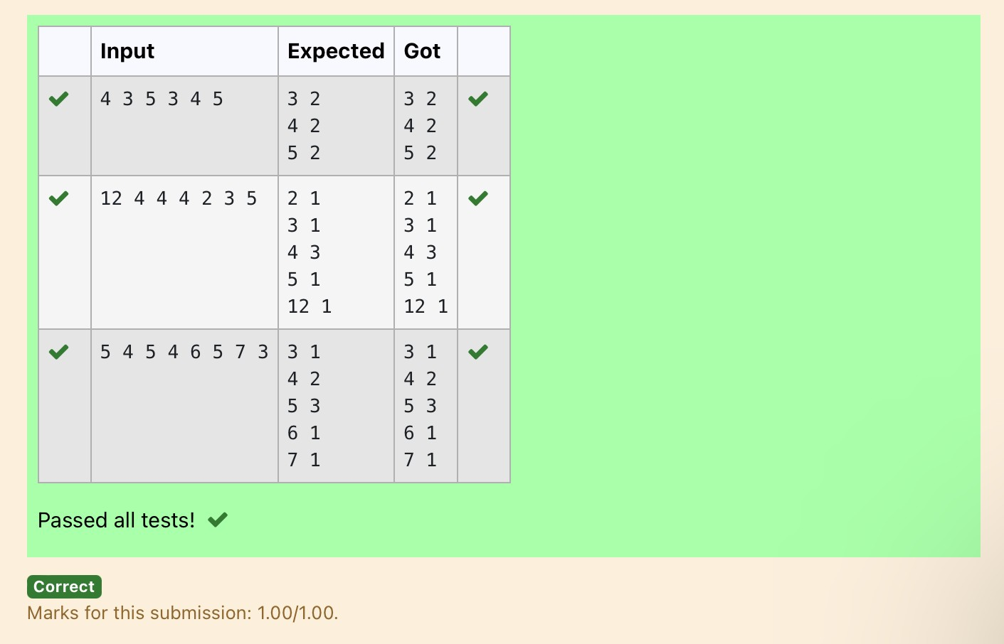

.

**Dept of Artificial Intelligence and Machine Learning** | **Rajalakshmi Engineering College**

137