**ZOHO CRM DOC:**

1. Dashboard: In dashboard we check the overall status of the project (CRM) including current and ongoing tasks. We can check the Scheduled Calls, Today Tasks, Leads, Lead sources, Invoices, customer etc.

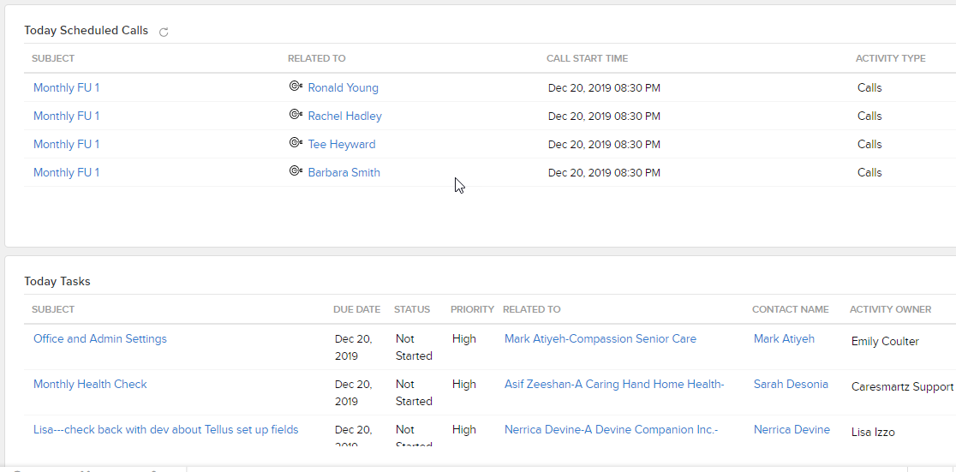

1. **Leads**: when ever any new agencies contact us we create lead for it and save in our zoho system. Leads include the agencies data including the no. of users etc. In next step we convert the Leads to the opportunities. We enter some information like Opprtunity name, amount, stage, currency no of live etc some information it already sync from the leads.While converting we make same entry in the opportunity.
2. **Opportunity**: These are our customers which are interested to buy our system.
3. **Accounts**: When Opportunity makes it final to buy our product than we update his account information and set its Type property as Customer. While we make this change simultaneously one work flow rule “Create Customer” executes which update the account information inside the CareSmartz database. In Agency table of caresmartz it makes 1 entry with account name and its Zoho Id.

**Billing Cycle**:

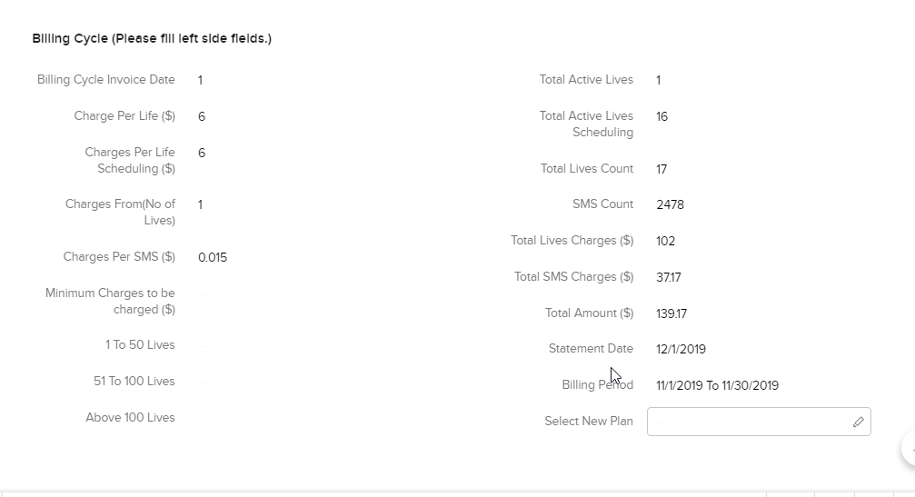

In Account section we set our customers billing cycles in multiple fields. Left side fields we need to fill manually and right side fields will calculate from the scheduler named “CareSmartz Daily Inv Scheduler”. Left side fields remain same for that account and right side fields updates every month and get the data from CareSmartz database. This data is used to generate customer invoices every month. All fields related to billing cycles are custom fields.

There are some more workflows which executes in between these process to update the data from these modules.

1. **Reports**: report section is used to show multiple types of reports regarding the different modules like Leads, Opportunity and Accounts etc. We are using some reports like Lead Source, Lead Status, Invoice Report, Visit Report, Accounts etc.
2. **Settings:** Setting page is used to control all the settings inside the CRM. Here you can add any function, workflow, modules, templates, settings etc. Most of the functions in the front part are handled by this panel. We can customize the functionality according to the requirements.

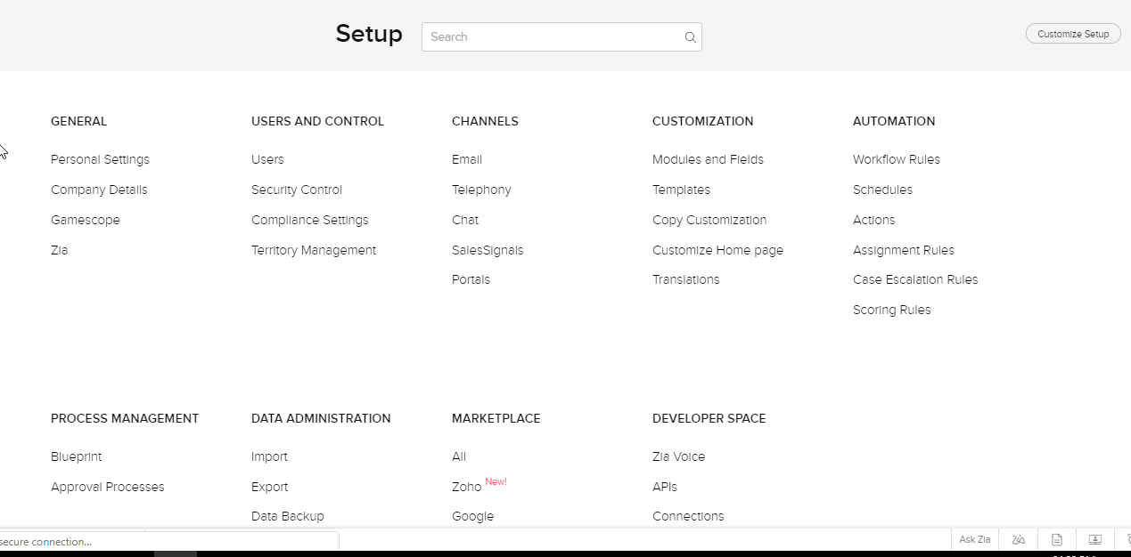

Function: Here we can write our scripts/logics which we’ve to perform in the modules. Scripts are written in the **deluge** scripting language. We can use these scripts inside the **Work Flow** rules.

**Modules:** All the modules like Leads, Accounts, and Customers etc. are managed here. We can add new custom fields, edit the existing field settings. Here we can also add new modules if we required in our applications.

**Zoho Books**

1. **Customer**: Customer data in Zoho books sync from the Zoho CRM Accounts section. This data sync every 1 hrs. Sync process is both ends From CRM to Books and from Books to CRM. Customer module also have many custom fields same as in accounts. These custom fields are used to get the updated data for the invoices. Invoices will get data from these custom fields while invoice generation.

We can also sync data manually from the accounts using the option “Fetch this contact from Zoho CRM” under more options.

Every customer is associated with different type of templates for Invoice generation, Email templates etc.

We can add customers Bank accounts here by using the features inside the more option.

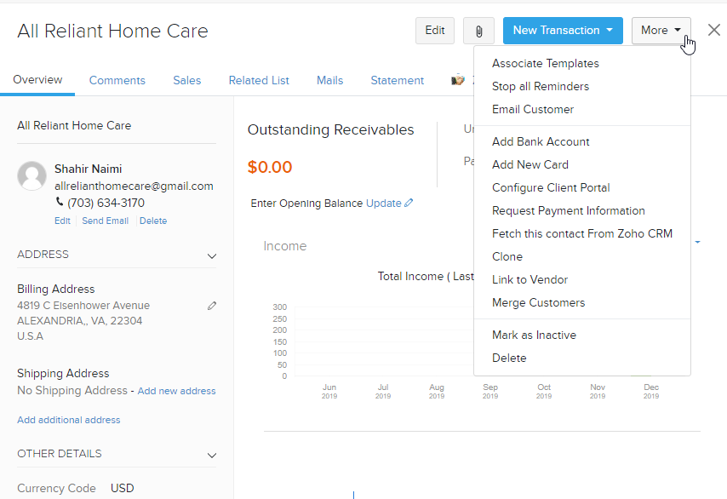

1. **Invoice**: This is the main section of the project where we generate the invoices for the agencies/clients. We are using some custom templates to generate the invoices and send to the clients.

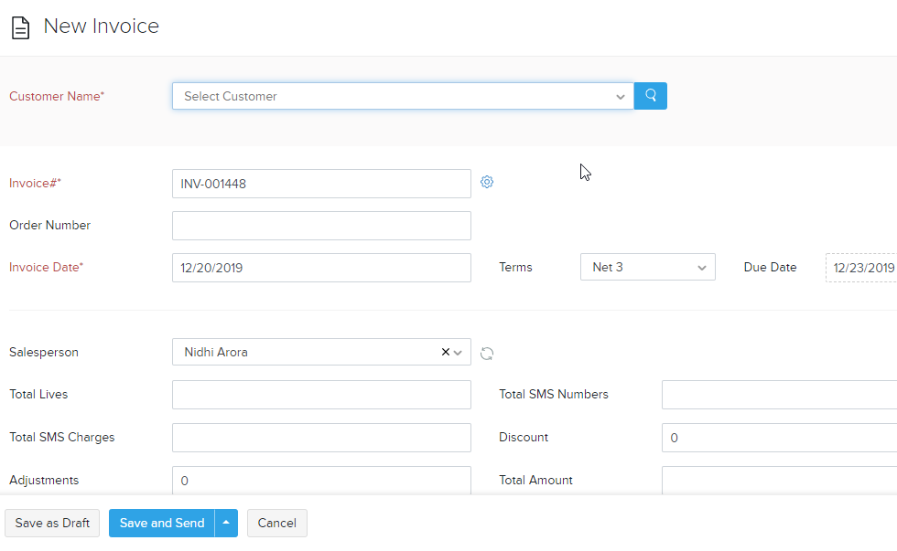

This is the screen for generating the invoices. This form contains the fields like Customer Name, Invoice date, terms, due date etc. For our regular agencies this invoice is generated automatically from the scripts. We have some custom functions, schedulers which are used to generate the invoices.

1. **Recurring Invoices**: Recurring invoices are used to generate the recurring invoices after any specific date intervals. For every customer there must be entry in the recurring invoices only then it will generate invoices for upcoming months. Process is almost same as in invoice but here we define the repeat every concept for the invoice, Start date and end date etc.

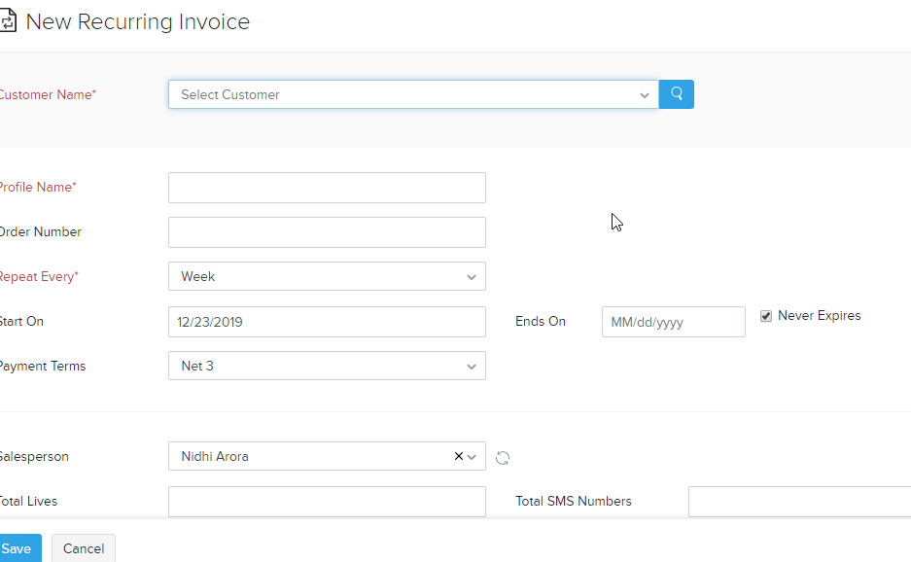

Settings:

**Integration**: Here we set the connected gateway which is linked to any particular accounts currently its linked to authorized.net account.

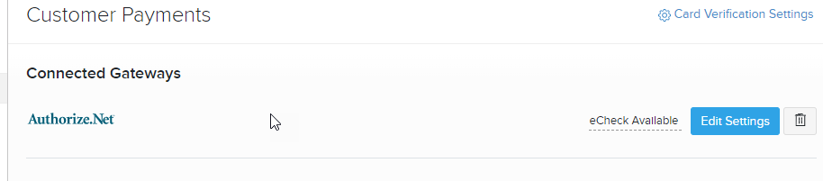

**Zoho App**: Here we set the sync process between the modules of zoho CRM and zoho Books.

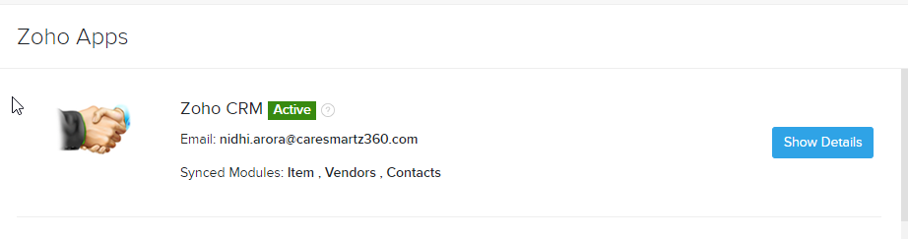

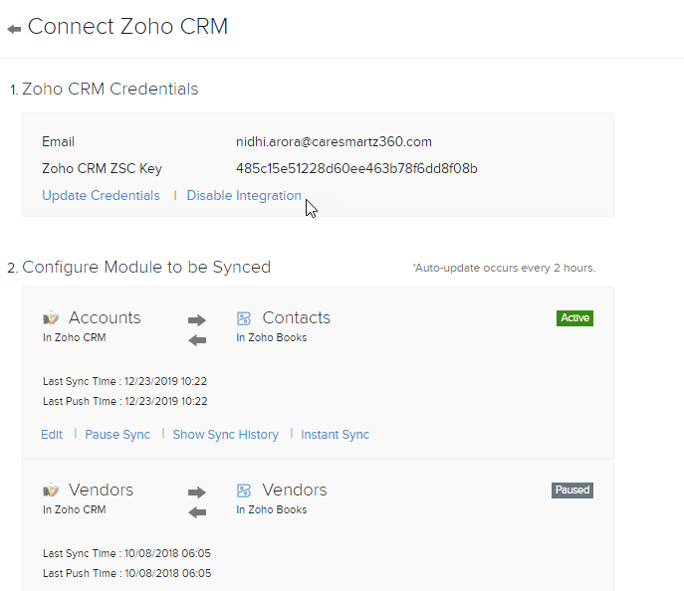

**Automation**: Here we write the custom function and bind that custom function with the workflow rules. These workflow rules executes on the specified modules on their actions.

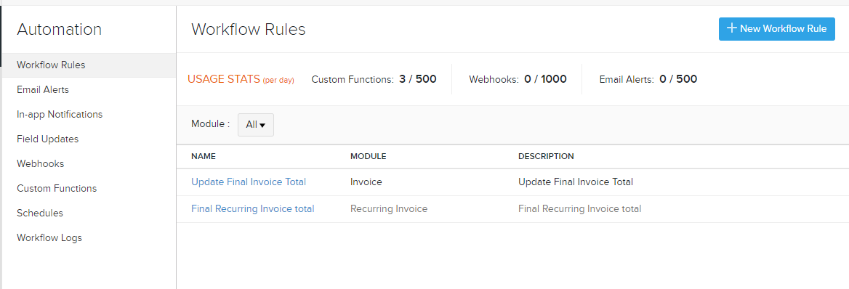

**Templates**:

Here we write the templates for Invoices and other modules. We can set multiple templates which are linked to multiple templates. Here we are using those templates only in the invoice sections.

We can set the default templates which will link to the customers as default invoice templates. Some templates are “Care Smartz invoice template, Firstlight Invoice, template for check clients etc.”

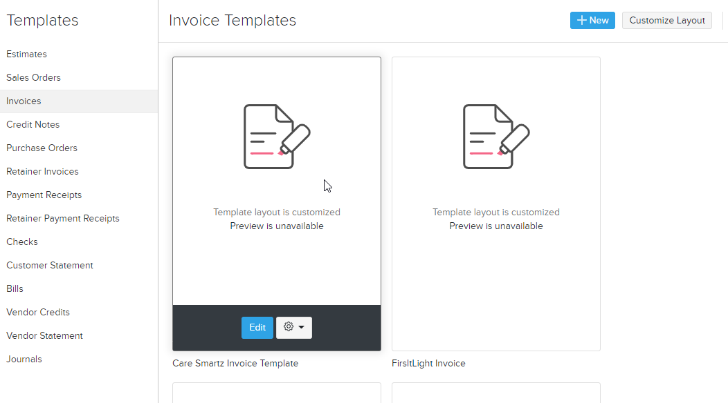

**Email Templates**:

These email templates are used with the customer emails either while sending their invoices or other info. We can also set the default email templates and linked different templates to different customers.

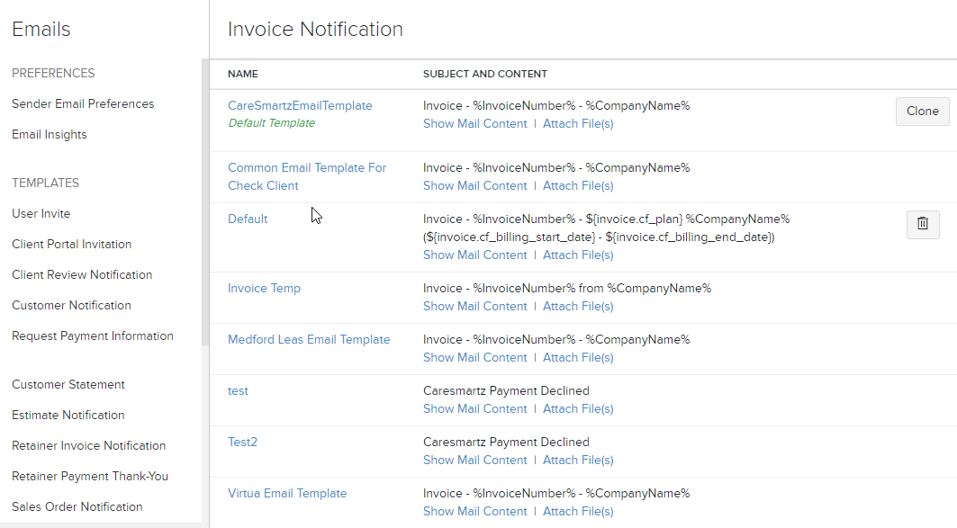

**Preferences**:

We can add custom fields to specific modules inside the preference option. Suppose we want to add the custom fields inside the invoice, customers etc then we can add it from this option.

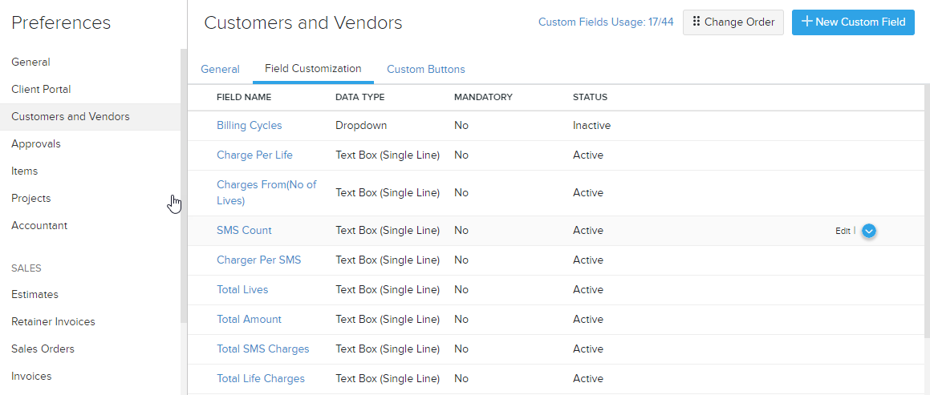

**Reminders**:

Here we can set the reminder emails for the customers. We can set the separate email templates for the customer related to their invoice dates etc.

