AI Assisted Coding
Name : M.Harish
H.no : 2303A52387
Batch : 34
Course Code : 23CS002PC304
Assignment Number : 6.5

Experiment 6: AI-Based Code Completion: Working with
suggestions for classes, loops, conditionals
Task Description #1 (AI-Based Code Completion for Conditional Eligibility Check)
Task: Use an AI tool to generate eligibility logic.
Prompt:
“Generate Python code to check voting eligibility based on age and
citizenship.”
Expected Output:
• AI-generated conditional logic.
• Correct eligibility decisions.
• Explanation of conditions.
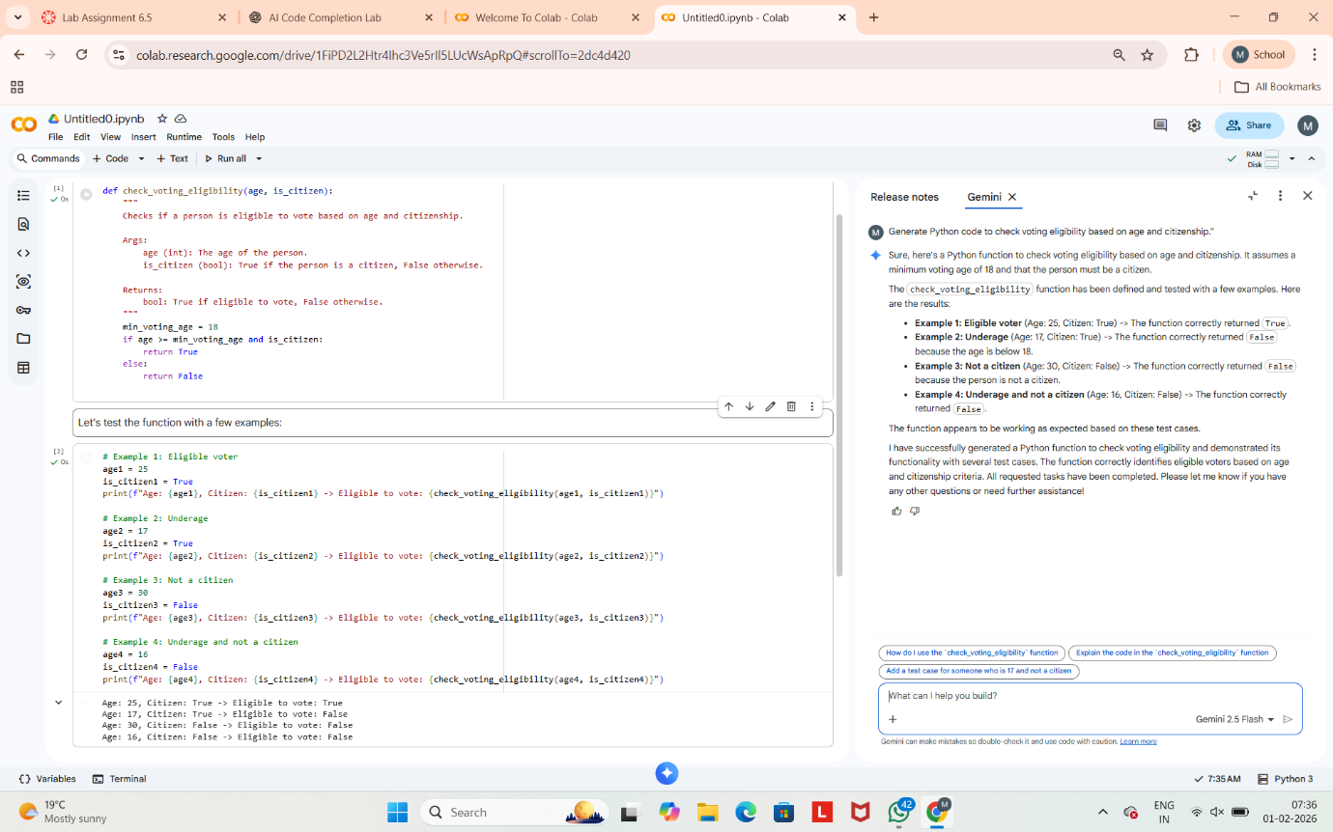

Explanation of Logic
- age takes integer input from the user
- citizen takes string input and converts it to lowercase
- The if condition checks:
  - Age must be 18 or above
  - Citizenship must be yes
- If both conditions are true → eligible
- Otherwise → not eligible
Task Description #2(AI-Based Code Completion for Loop-Based
String Processing)
Task: Use an AI tool to process strings using loops.
Prompt:
“Generate Python code to count vowels and consonants in a string
using a loop.”
Expected Output:
• AI-generated string processing logic.
• Correct counts.
• Output verification.

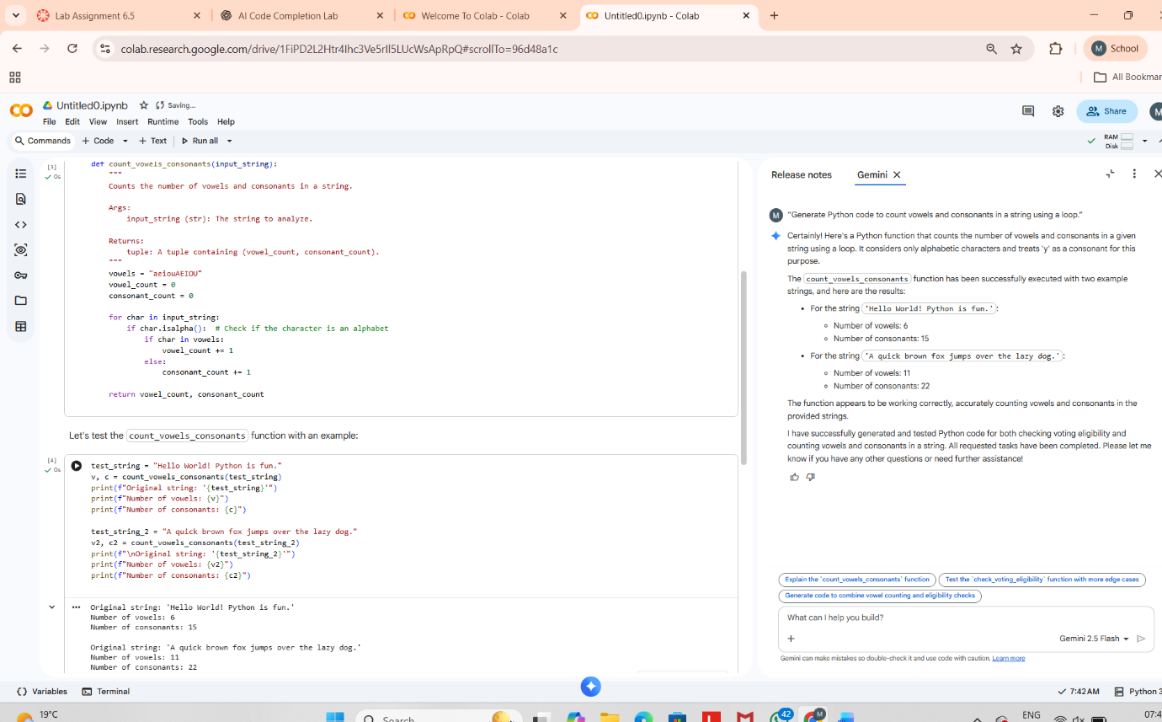

Explanation
- Converts string to lowercase for uniform comparison
- Uses a for loop to traverse each character
- isalpha() ensures only letters are counted
- Characters are classified as vowels or consonants

Task Description #3 (AI-Assisted Code Completion Reflection
Task)
Task: Use an AI tool to generate a complete program using classes, loops, and conditionals.
Prompt:
“Generate a Python program for a library management system using classes, loops, and conditional statements.”
Expected Output:
• Complete AI-generated program.
• Review of AI suggestions quality.
• Short reflection on AI-assisted coding experience.
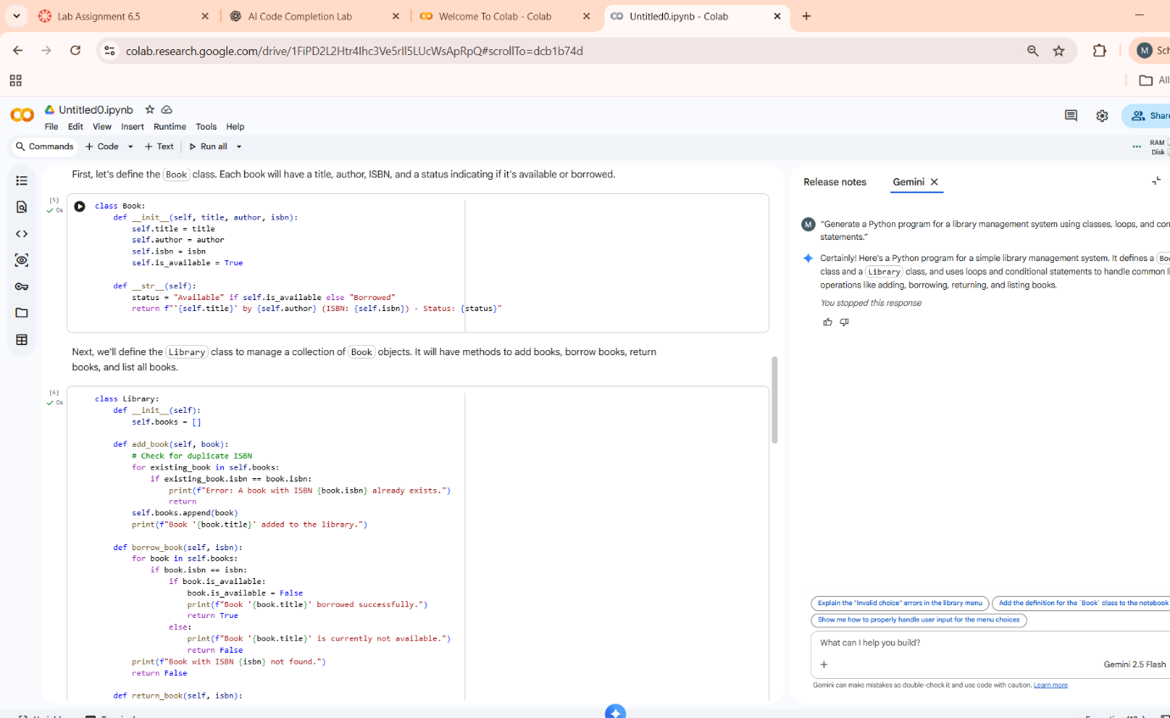

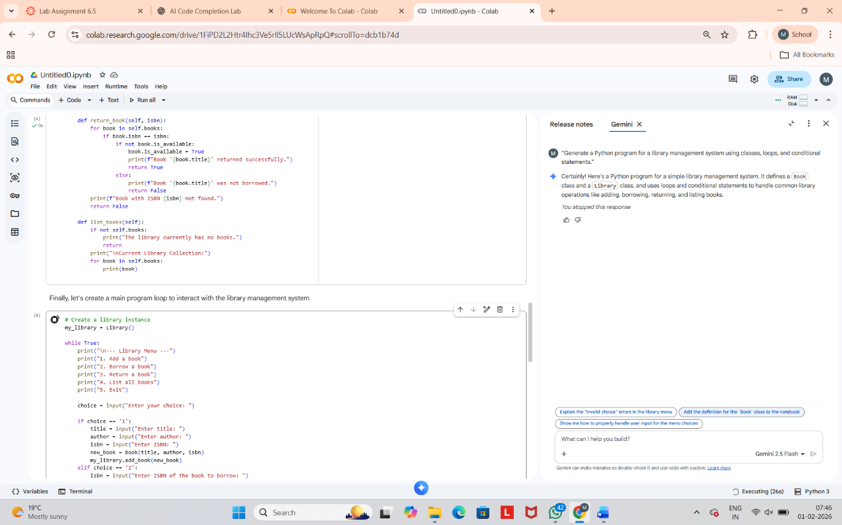
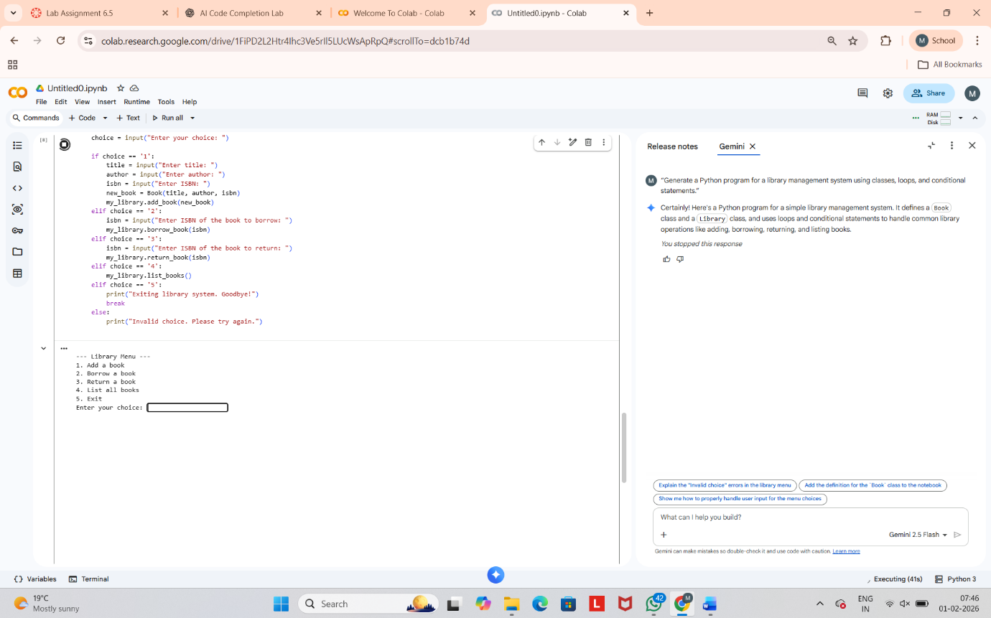
Task Description #4 (AI-Assisted Code Completion for Class- Based Attendance System)
Task: Use an AI tool to generate an attendance management class.
Prompt: “Generate a Python class to mark and display student
attendance using loops.”
Expected Output:
• AI-generated attendance logic.
• Correct display of attendance.
• Test cases.
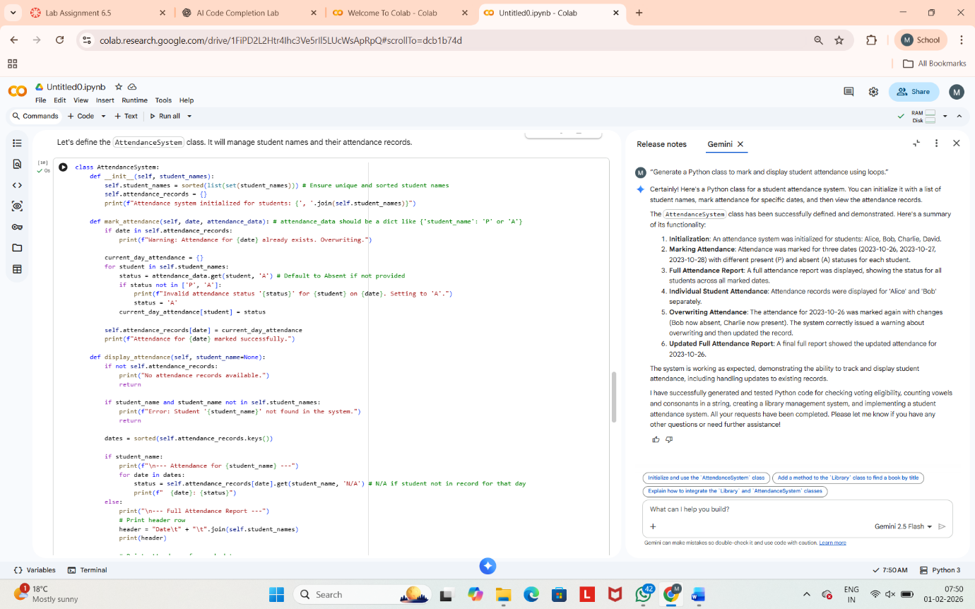

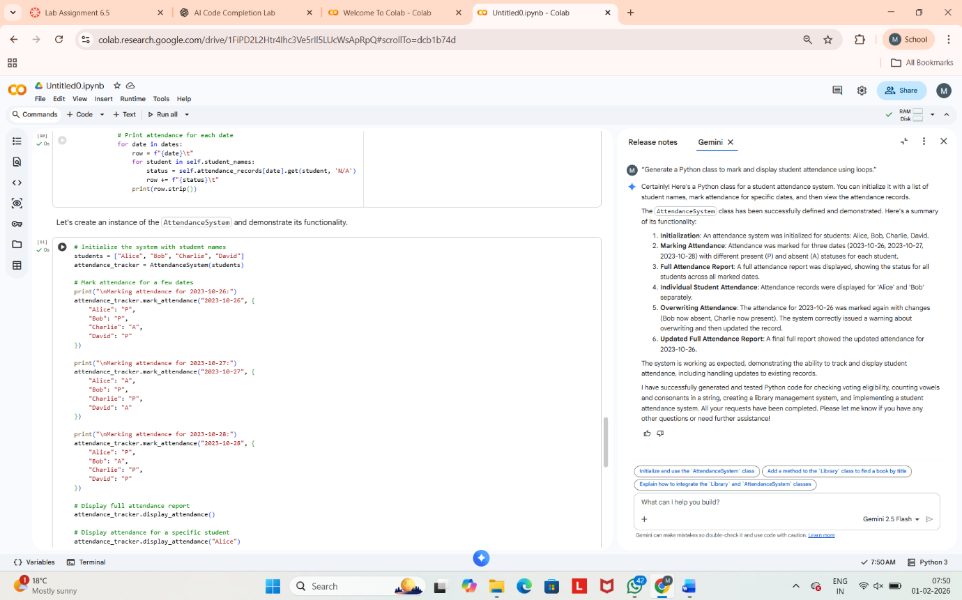

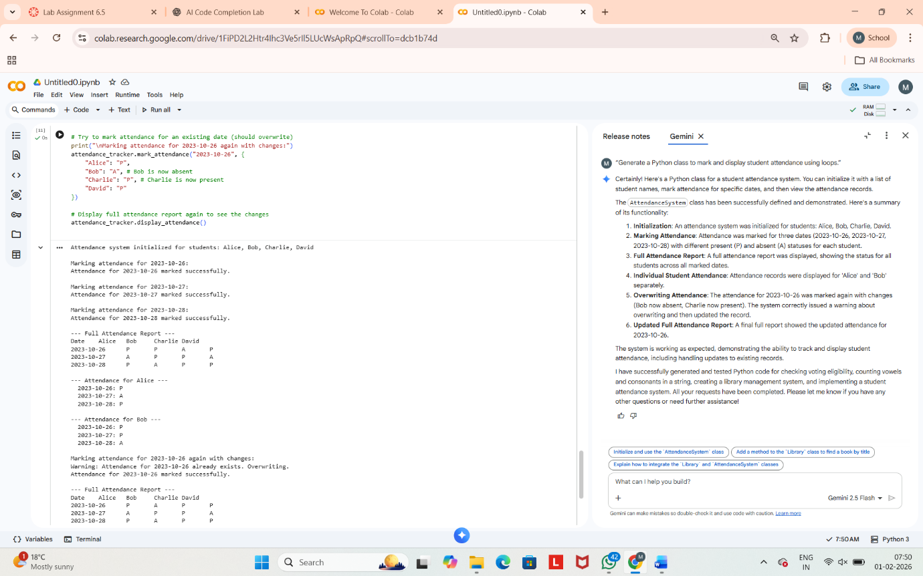

Task Description #5 (AI-Based Code Completion for Conditional Menu Navigation)

Task: Use an AI tool to complete a navigation menu.
Prompt: “Generate a Python program using loops and conditionals to simulate an ATM menu.”
Expected Output:
• AI-generated menu logic.
• Correct option handling.
• Output verification.

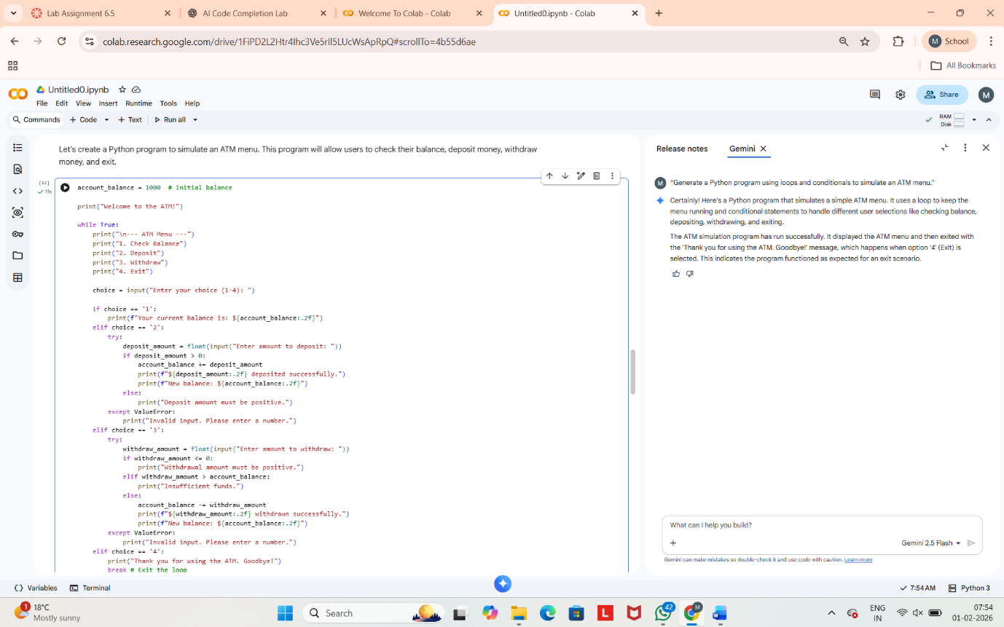

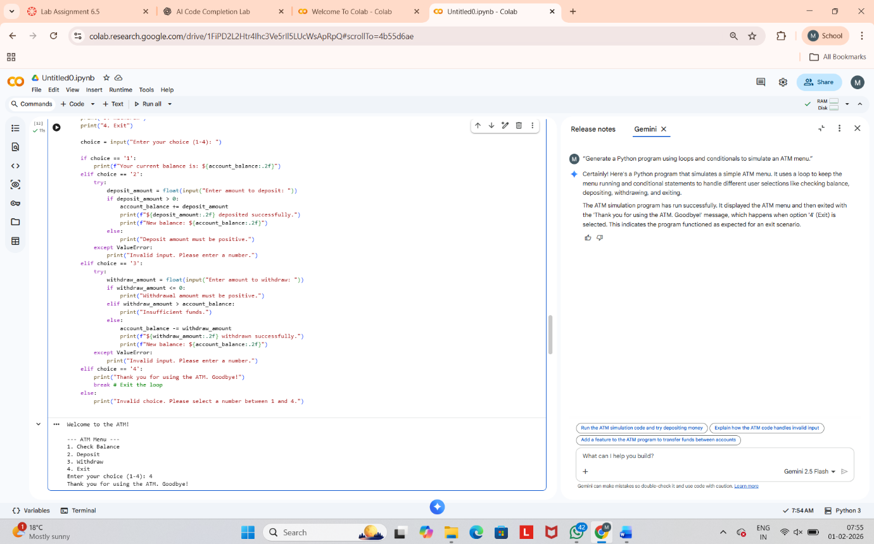

Conclusion
This experiment demonstrates effective use of AI-based code completion for generating Python programs involving classes, loops, and conditionals. AI tools enhance productivity, but human judgment is essential for correctness, optimization, and ethical usage.

