COURSE: AI Assisted Coding
NAME: M.Harish
BATCH-34
HALLTICKET.NO:2303A52387
Lab 3: Prompt Engineering: Improving prompt and context management
Objective: To explore how variations in prompt structure affect the quality, completeness, and accuracy of responses from a large language model.
Requirements:
- VS Code with GitHub Copilot or Cursor API and/or Google Colab with Gemini
- Tasks to be completed are as below.
Task 1: Conceptual Understanding in Physics
Scenario
Suppose that you are a data assistant developer for an EdTech company that uses ChatGPT to answer student queries related to introductory physics.
Tasks to be completed
- Baseline Prompt Testing
Choose 5 typical user queries, for example:
“Explain, What, Define, Why, What”
  - Run these prompts in a chat-based AI model and record the raw responses.
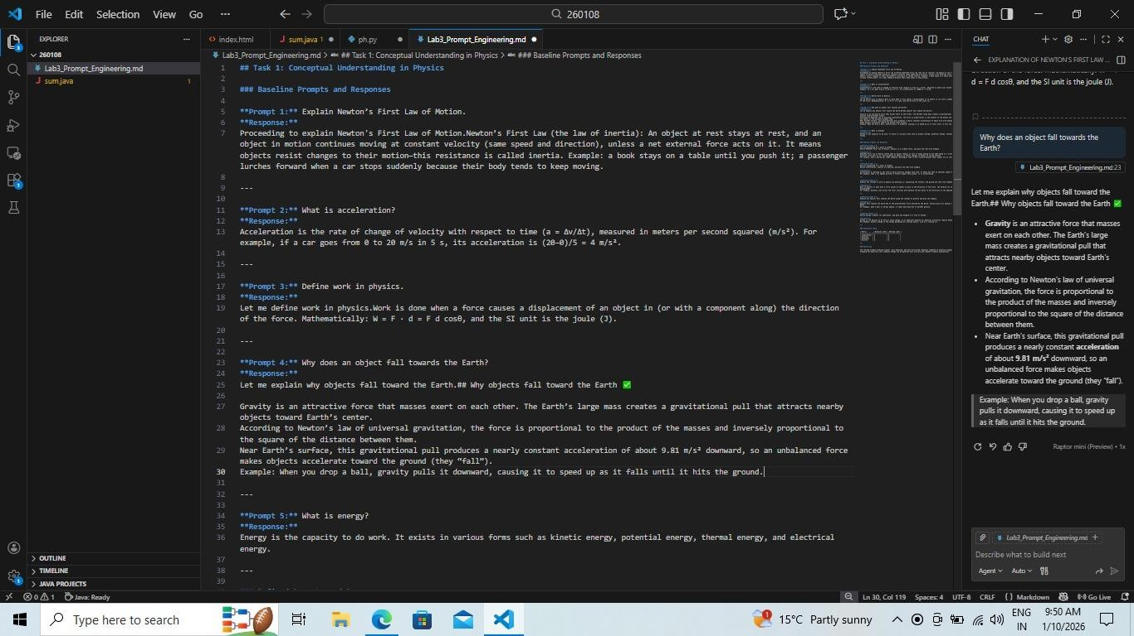
- Prompt Refinement
Rewrite each query using the following strategies:
  - Add 5 different contexts (school level, competitive exam, real-life application, mathematical focus, conceptual focus).
  - Make the task explicit (e.g., “List and explain Newton’s three laws with one real-world example each.”).
  - Break the query into subtasks (definition → explanation → example).
Run these prompts in a chat-based AI model and record the raw responses.
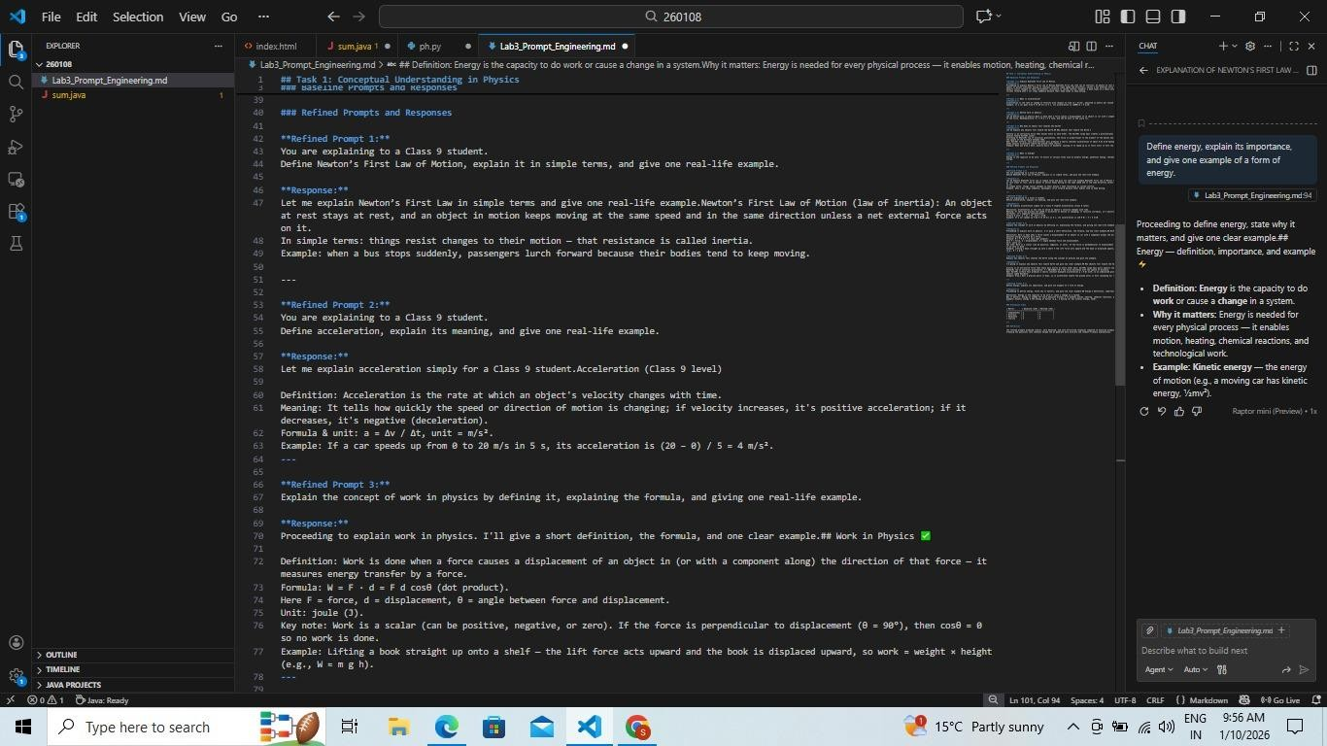
- Evaluate Outputs
Score AI responses on a scale of 1–5 using:
  - Completeness
  - Accuracy
  - Relevance
  - Clarity
Run these prompts in a chat-based AI model and record the raw responses.
Present results in a comparative table.
- Reflection
Discuss how contextual and structured prompts influenced the depth and correctness of
responses.
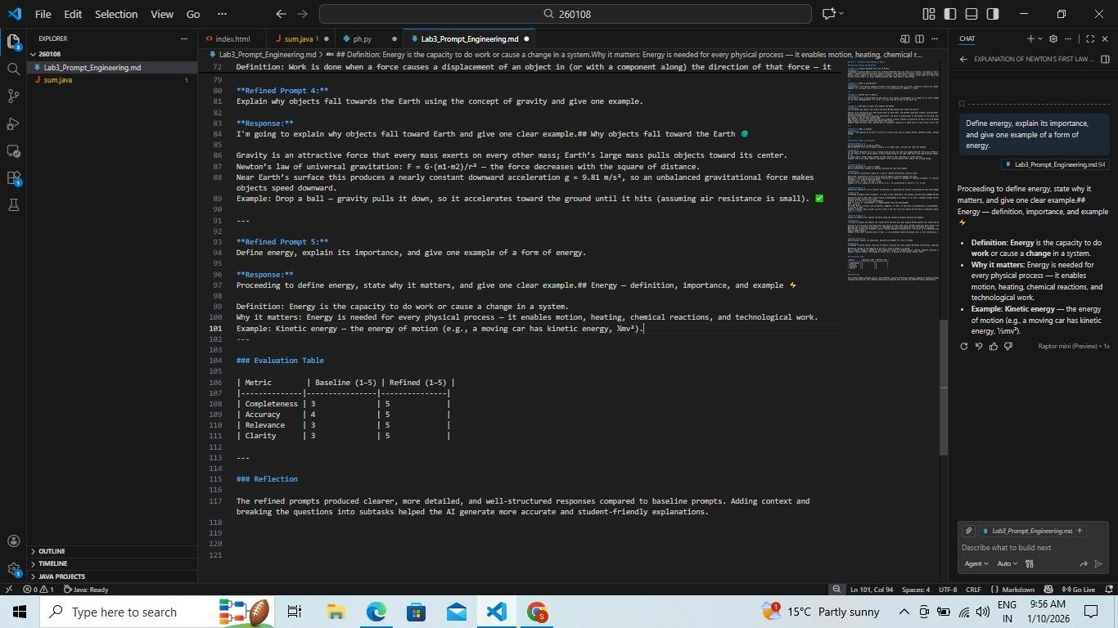
Task 2: Programming Fundamentals (Python)
Scenario
Suppose that you are a data assistant developer for an EdTech platform that supports beginner programming students. Tasks to be completed
- Baseline Prompt Testing
Choose 5 common user queries, such as:
  - “What, Explain, How, What, Difference”
Run these prompts in a chat-based AI model and record the raw responses.
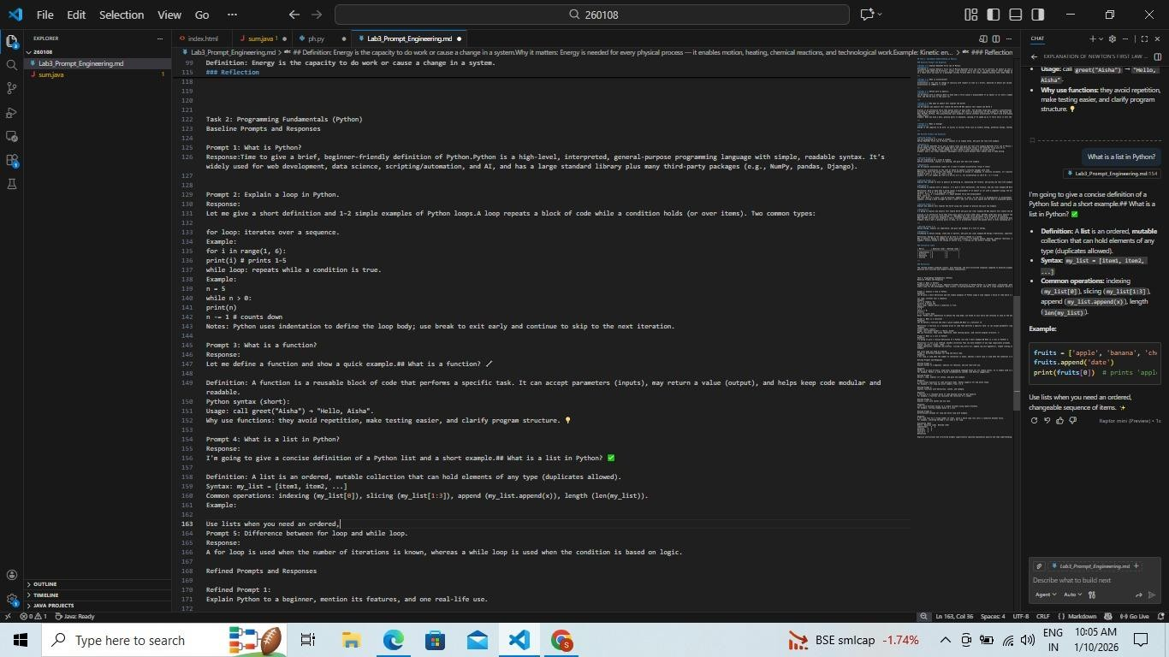
- Prompt Refinement Rewrite each query by:
  - Adding 5 contexts (beginner, exam-oriented, real-world analogy, syntax-focused, performance-focused).
  - Making instructions explicit (e.g., “Define a Python loop and show one example for forloop and while-loop.”).
  - Breaking into subtasks (definition → syntax → example → use case).
Run these prompts in a chat-based AI model and record the raw responses.
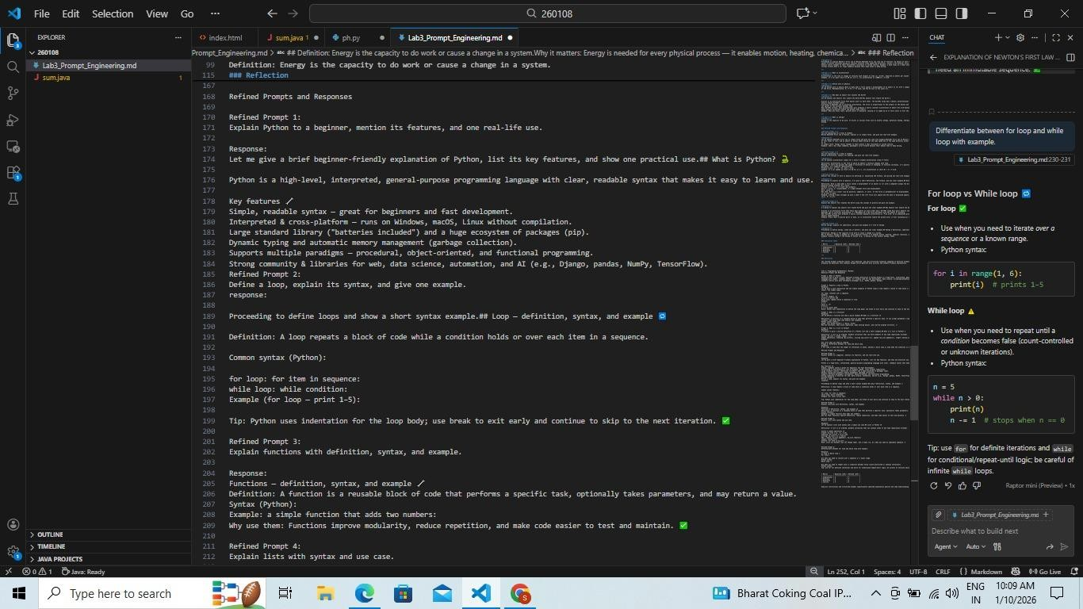
- Evaluate Outputs
  - Evaluate responses using completeness, accuracy, relevance, and clarity.
  - Summarize findings in a table.
- Reflection
Analyze, how explicit subtasks improve code correctness and explanation quality.
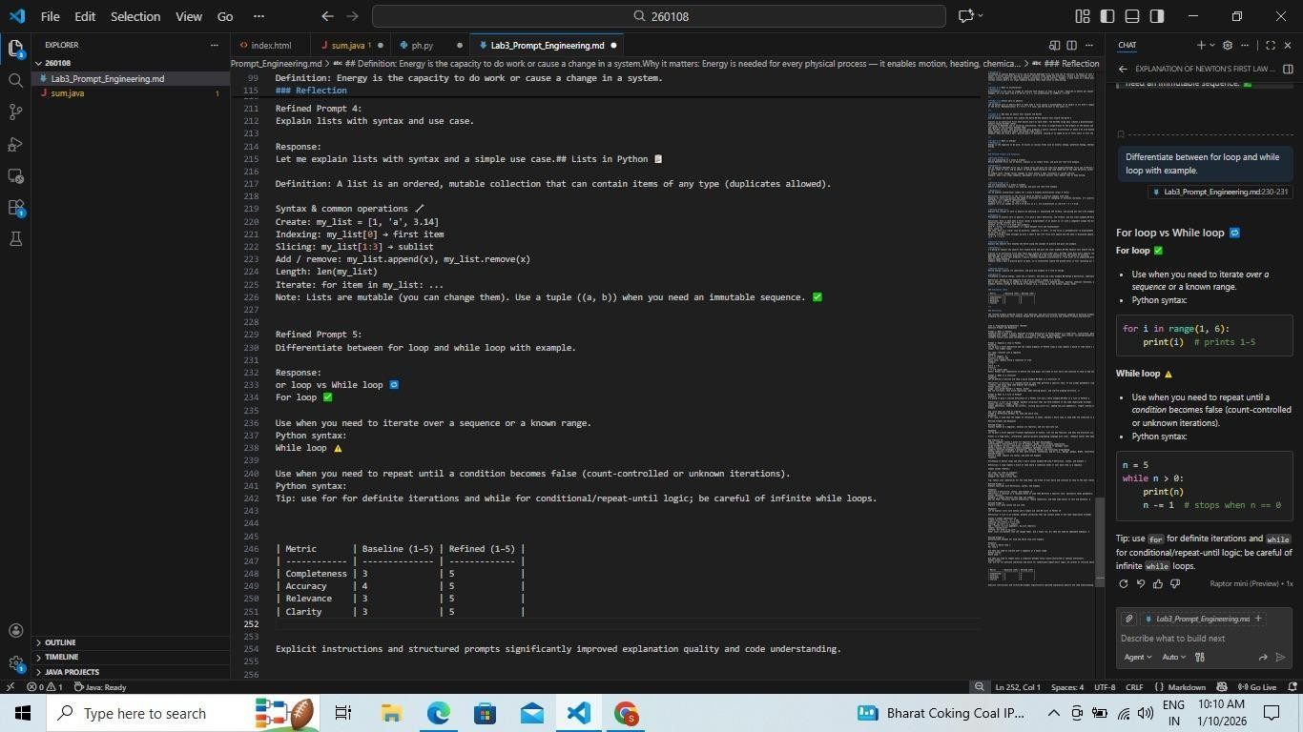
Task 3: Data Science and Machine Learning Concepts
Scenario
Suppose that you are a data assistant developer for an EdTech company offering data science courses.
Tasks to be completed
- Baseline Prompt Testing
Select 5 typical queries, for example:
  - “What, Explain, What, Define, What”
Run these prompts in a chat-based AI model and record the raw responses.
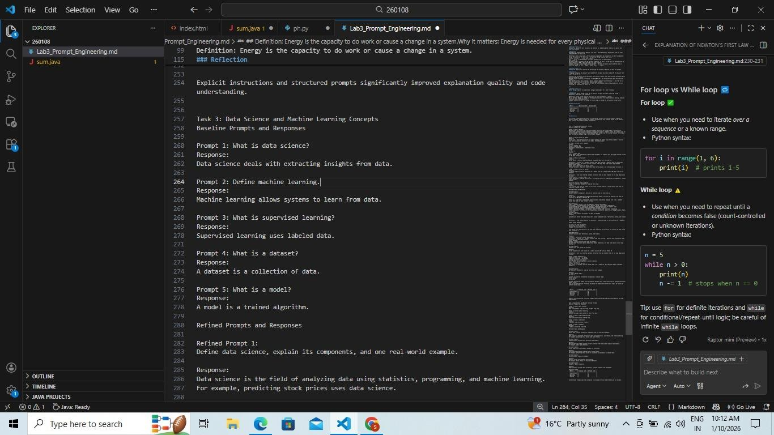
- Prompt Refinement Refine each query by:
  - Adding 5 contexts (academic, industry, beginner-friendly, mathematical, interviewfocused).
  - Making tasks explicit (e.g., “Define supervised learning and explain it with one real-world example.”).
  - Breaking into subtasks (definition → types → example → limitation).
Run these prompts in a chat-based AI model and record the raw responses.
- Evaluate Outputs
Score outputs using the given metrics and present results in a table.
- Reflection
Reflect on how context management affects conceptual clarity in technical domains.
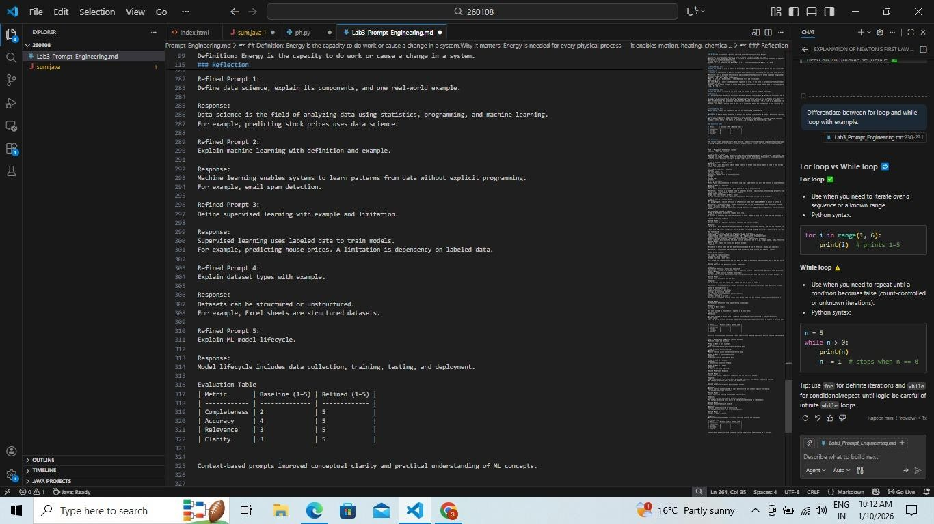
Task 4: Database and SQL Queries
Scenario
Suppose that you are a data assistant developer supporting students learning database systems.
Tasks to be completed
- Baseline Prompt Testing
Choose 5 common queries, such as:
  - “Explain, What, Difference, where, how”
Run these prompts in a chat-based AI model and record the raw responses.
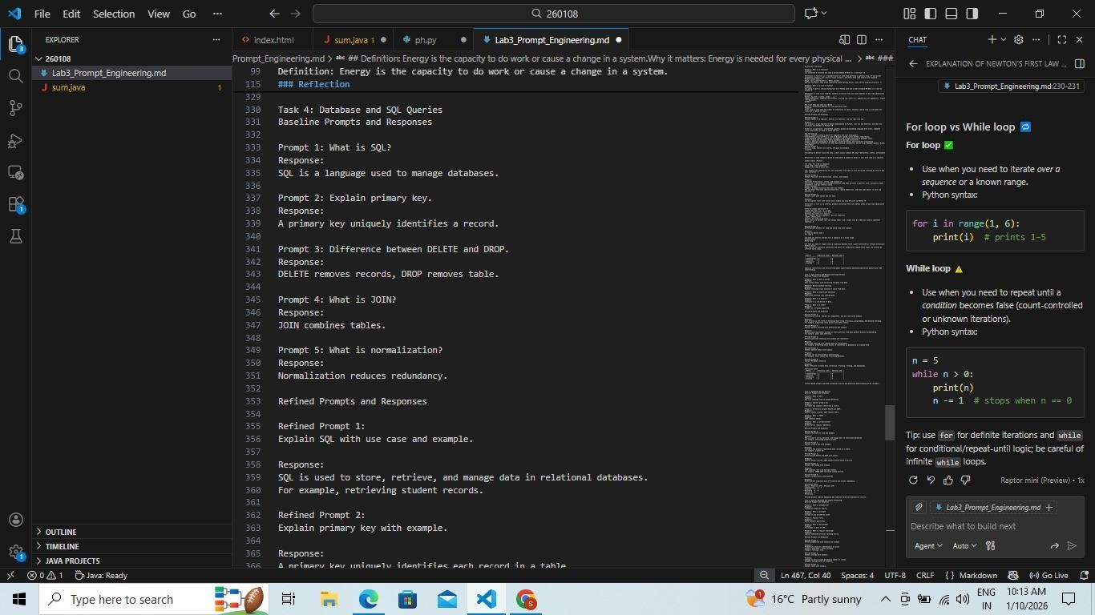
- Prompt Refinement Rewrite each prompt by:
  - Adding 5 contexts (theory exam, practical lab, interview prep, real-world database, optimization focus).
  - Making instructions explicit (e.g., “Explain SQL JOIN types with syntax and examples.”).
  - Breaking into subtasks (definition → syntax → example → use case).
Run these prompts in a chat-based AI model and record the raw responses.
- Evaluate Outputs
Evaluate responses using the four metrics and summarize results in a comparison table.
- Reflection
Discuss how refined prompts reduce ambiguity in technical explanations.
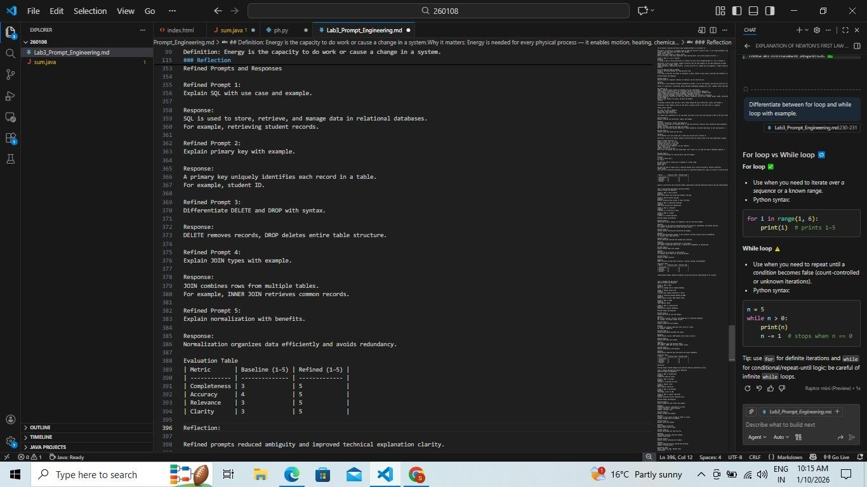
Task 5: General Aptitude and Logical Reasoning
Scenario
Suppose that you are a data assistant developer for an EdTech company focused on aptitude and competitive exam preparation. Tasks to be completed
- Baseline Prompt Testing
Select 5 user queries, for example:
  - “Explain, What, Difference, where, how”
Run these prompts in a chat-based AI model and record the raw responses.
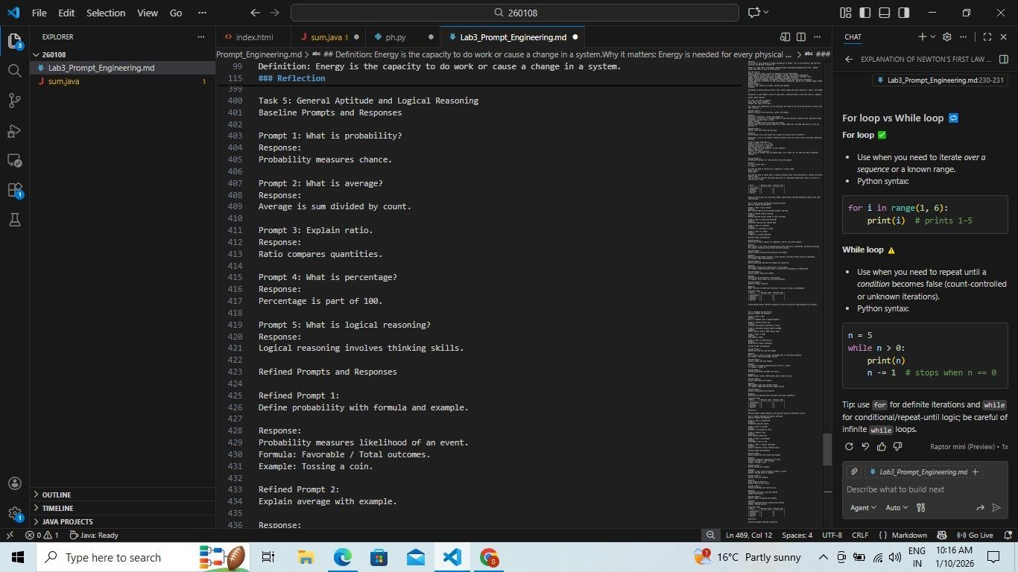
- Prompt Refinement Rewrite each query by:
  - Adding 5 contexts (school exams, competitive exams, real-life analogy, formula-based, step-by-step solving).
  - Making tasks explicit (e.g., “Define probability and solve one simple numerical example.”).
  - Breaking into subtasks (definition → formula → example → common mistakes).
Run these prompts in a chat-based AI model and record the raw responses.
- Evaluate Outputs
  - Score responses using completeness, accuracy, relevance, and clarity.
  - Present findings in a table.
- Reflection
Reflect on how structured prompts improve step-by-step reasoning and learner understanding.
