COURSE: AI Assisted Coding
NAME : M.Harish
BATCH-34
HALLTICKET.NO : 2303A52387
AIAC-ASS - 3.2

Lab 3:
Prompt Engineering – Improving Prompts and Context Management.
Task Description – 1
Progressive Prompting for Calculator Design
Objective:
To observe how AI-generated code improves as prompt clarity and context increase.
AI Output – Level 1
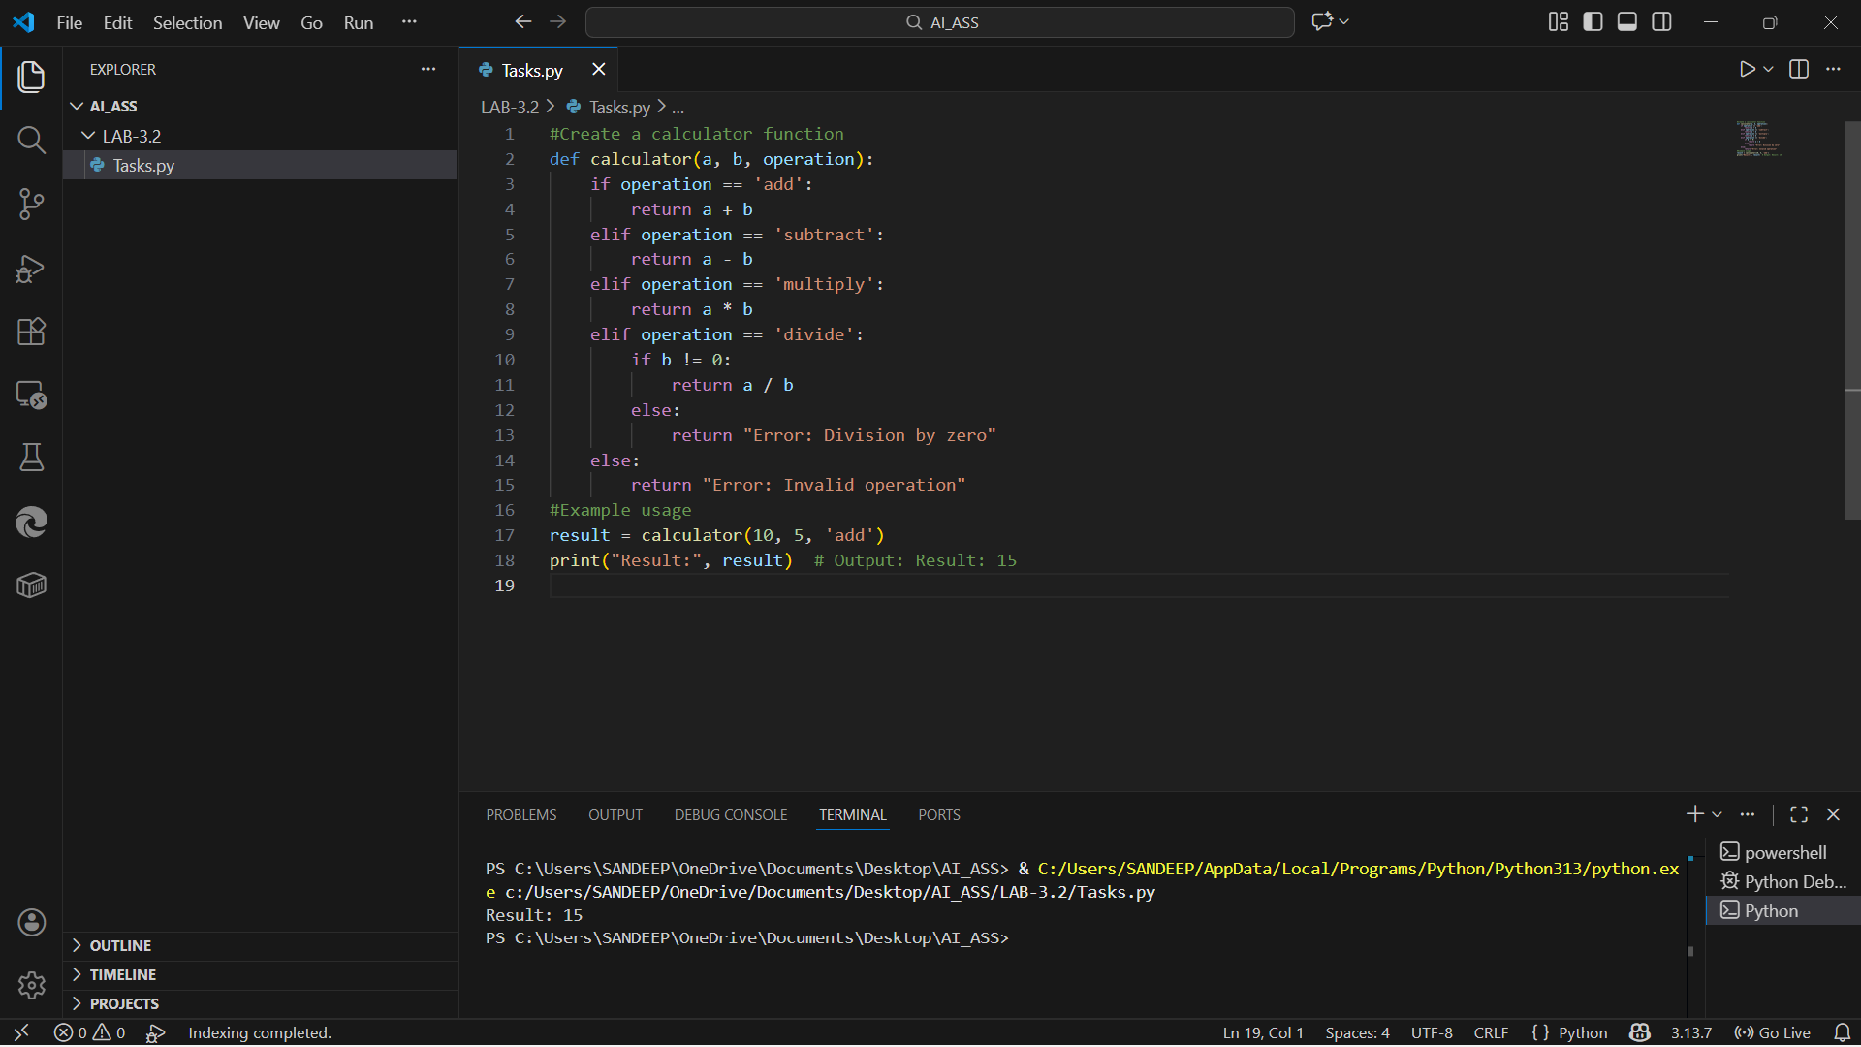
LEVEL-2:
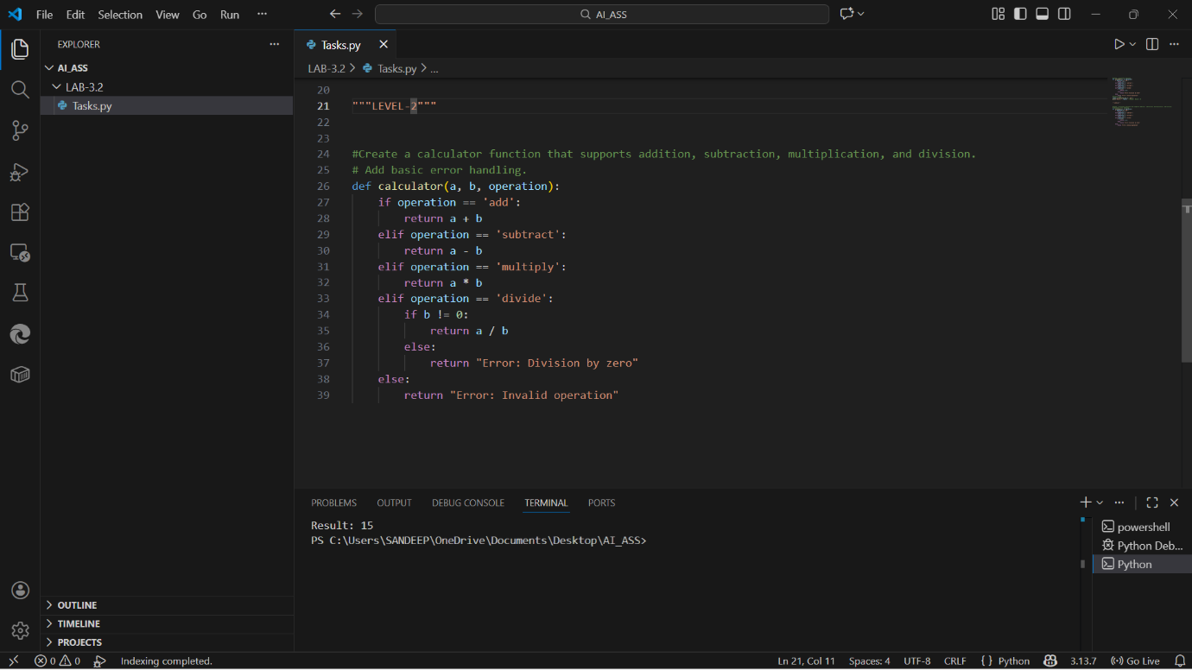
LEVEL-3:
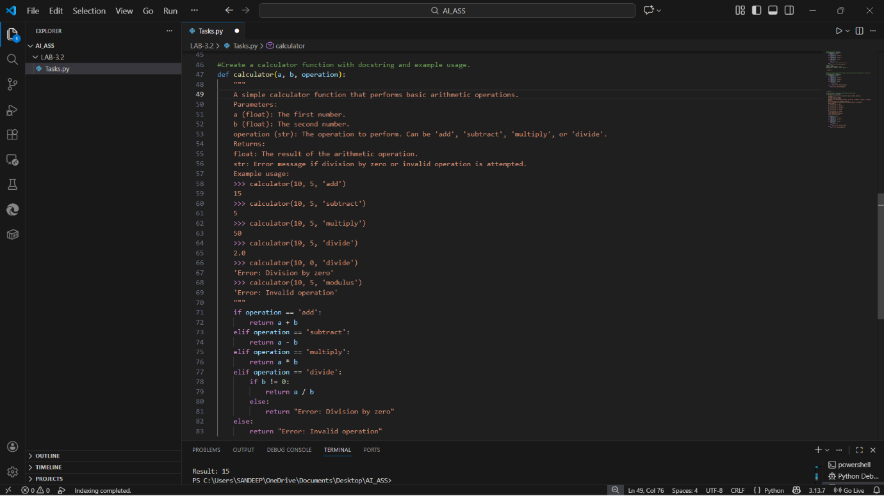

Task -2:
• Refining Prompts for Sorting Logic: Start with a vague prompt for sorting student marks, then refine it to clearly specify sorting order and constraints.
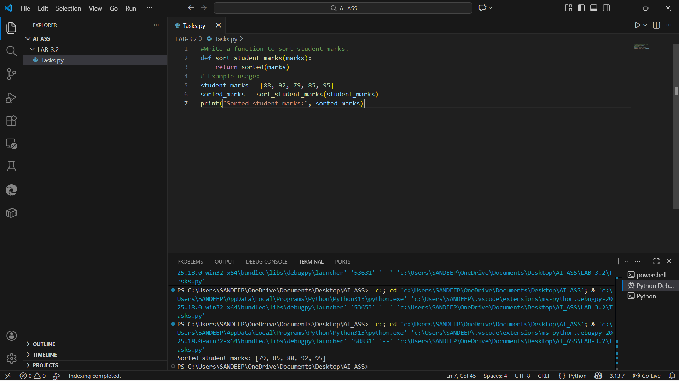
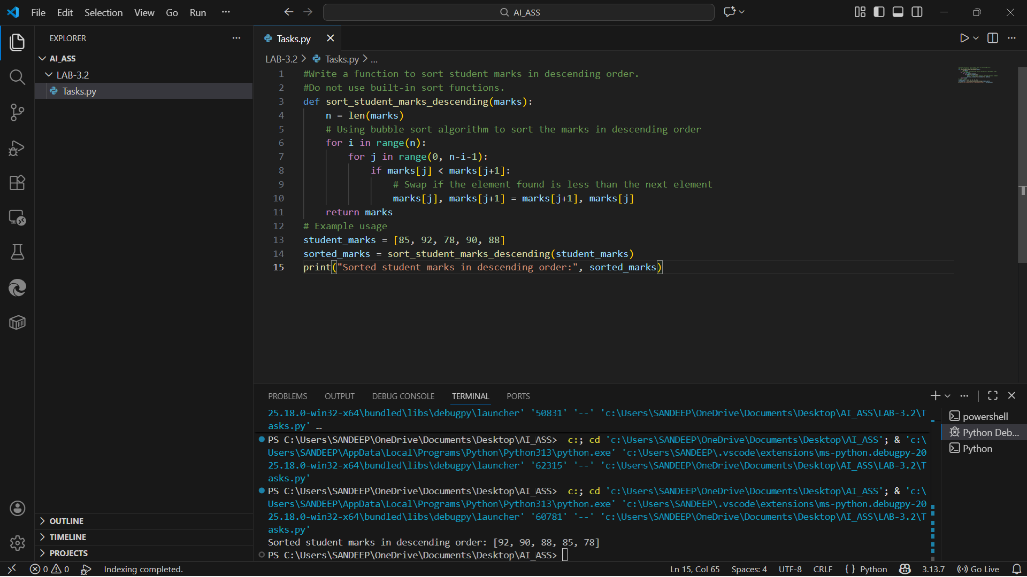

Task -3
• Few-Shot Prompting for Prime Number Validation: Provide multiple input-output examples for a function that checks whether a number is prime. Observe how few-shot
prompting improves correctness.

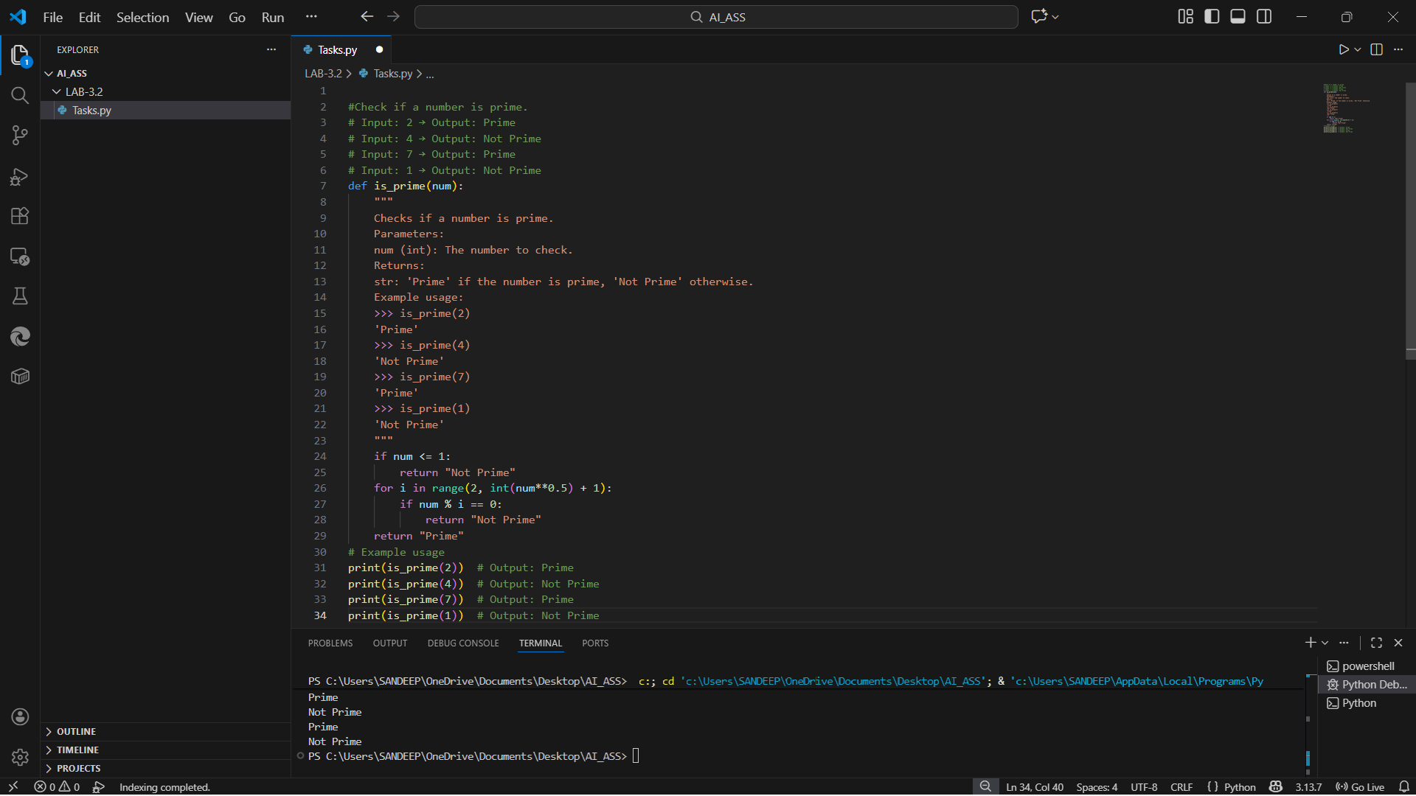
Task -4
• Prompt-Guided UI Design for Student Grading System: Create a user interface for a student grading system that calculates total marks, percentage, and grade based on user input.
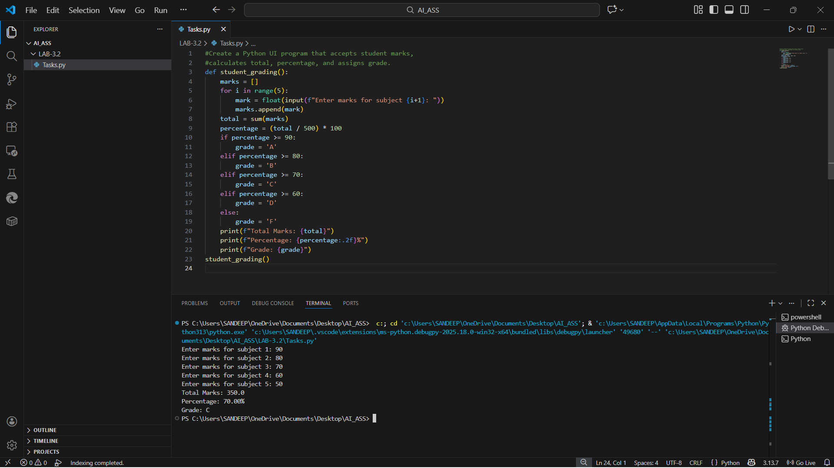

Task Description-5
• Analyzing Prompt Specificity in Unit Conversion Functions: Improving a Unit
Conversion Function (Kilometers to Miles and Miles to Kilometers) Using Clear
Instructions.
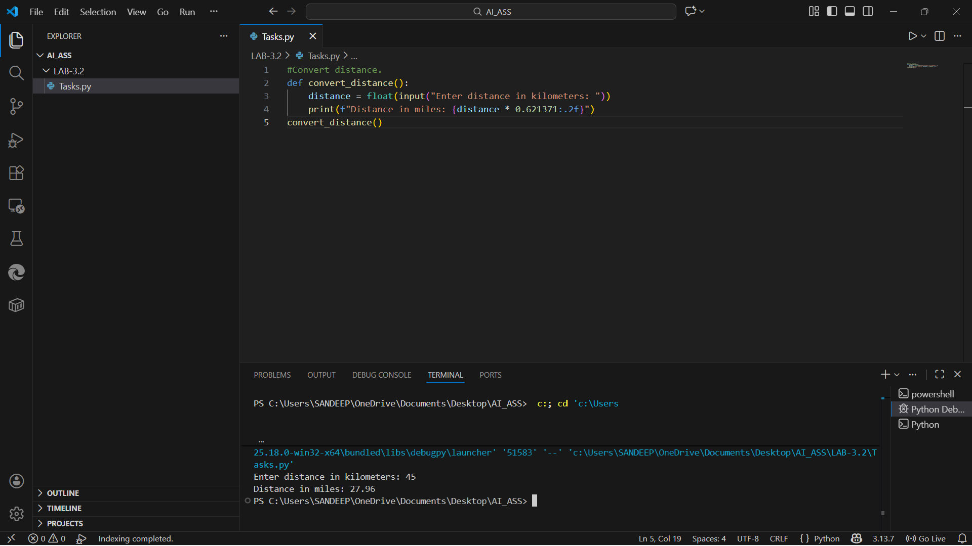

- (Kilometers to Miles and Miles to Kilometers)
