

Name : Maidamshetti Harish
H.no : 2303A52387
Batch : 34
Department : CSE
Specialization : AIML
Course : AI Assisted Coding
Assignment Number : 4.2

Lab Objectives
- To explore and apply different levels of prompt examples in AI-assisted code generation.
- To understand how zero-shot, one-shot, and few-shot prompting affect AI output quality.
- To evaluate the impact of context richness and example quantity on AI performance.
- To build awareness of prompt strategy effectiveness for different problem types.
Lab Outcomes (LOs)
After completing this lab, students will be able to:
- Use zero-shot prompting to instruct AI with minimal context.
- Use one-shot prompting with a single example to guide AI code generation.
- Apply few-shot prompting using multiple examples to improve AI responses.
- Compare AI outputs across the three prompting strategies.

- Task Description – 1
- Prompt:
"Write a Python function to determine whether a given number is prime."
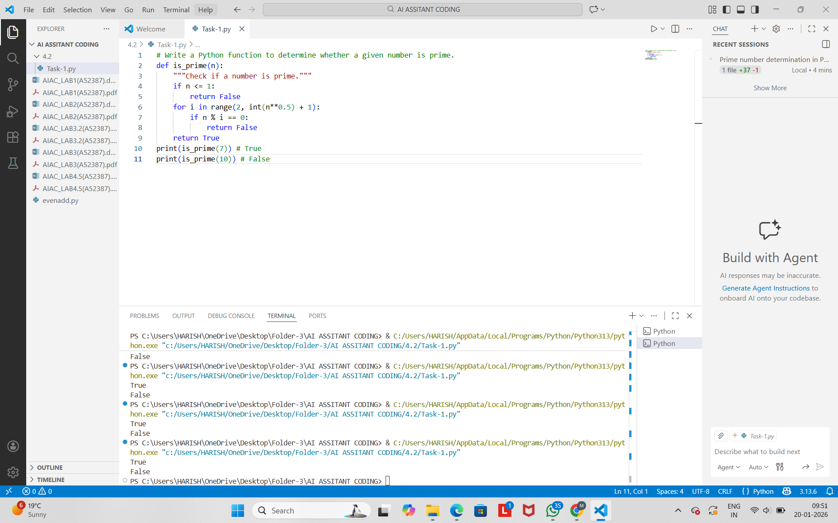
Explanation
This function checks if a number is prime by:
- Returning False for numbers less than or equal to 1.
- Iterating from 2 to the square root of the number.
- If any divisor is found, it returns False; otherwise, it returns True.
- Task Description – 2
- Prompt:
"Provide one example: Input: [1, 2, 3, 4], Output: 10. Generate a function that calculates the sum of elements in a list."
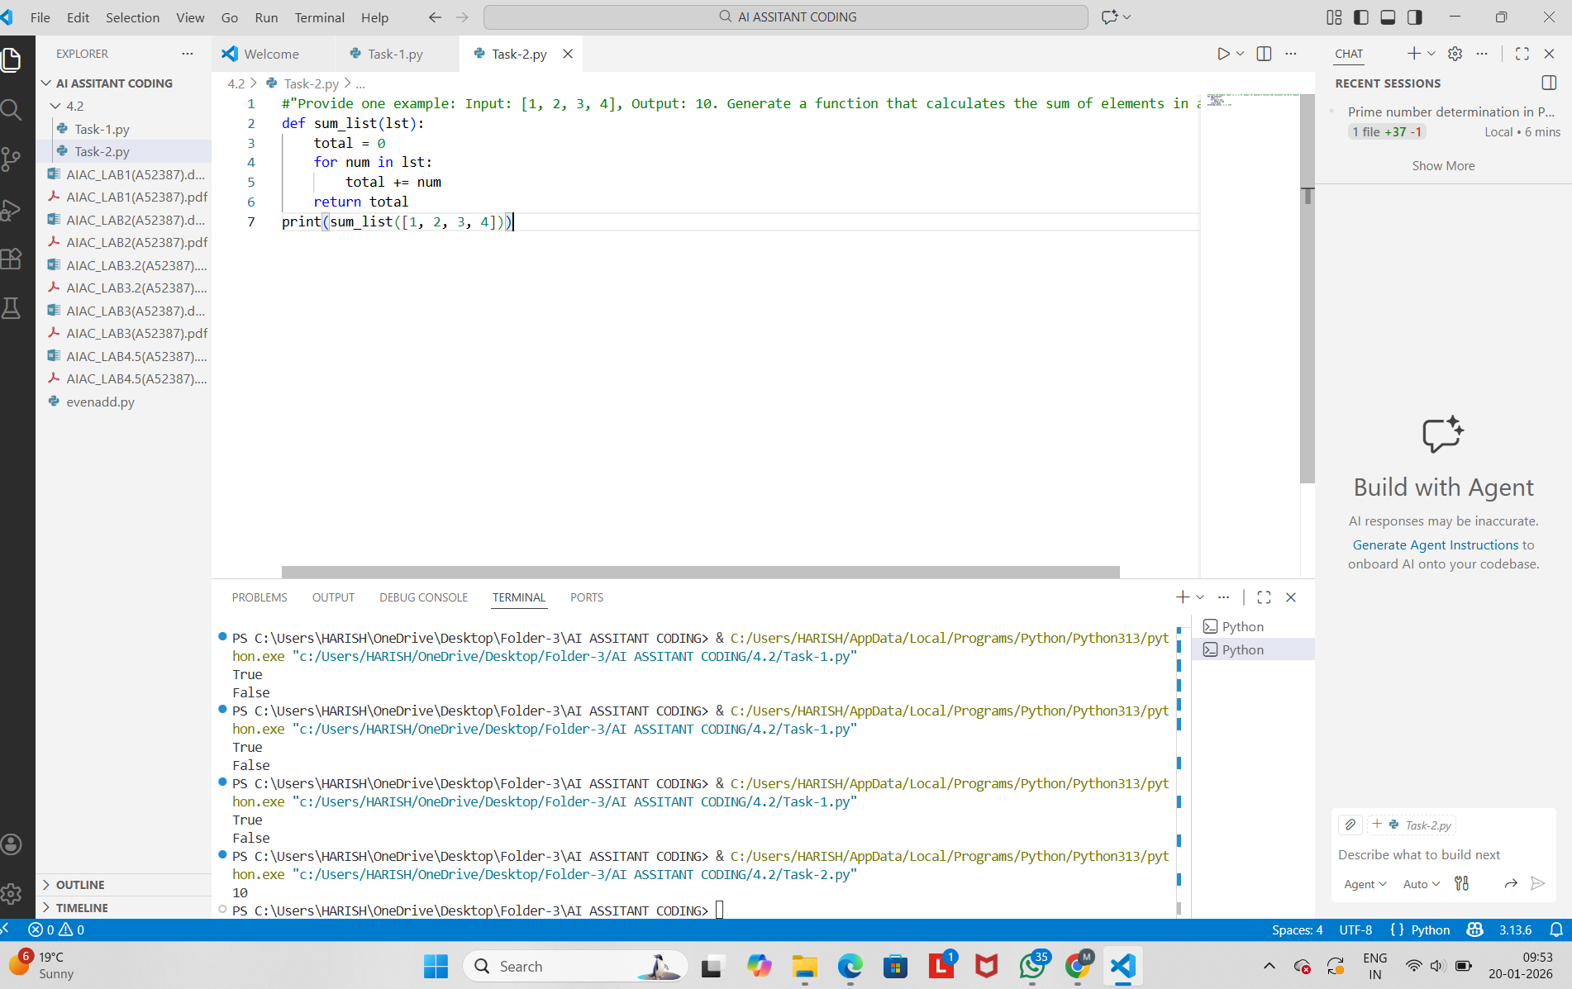
Explanation
The function:
- Initializes a variable total to 0.
- Iterates through each number in the list.
- Adds each number to total.
- Returns the final sum.
- Task Description – 3
- Prompt
"Create a function that extracts digits from an alphanumeric string."
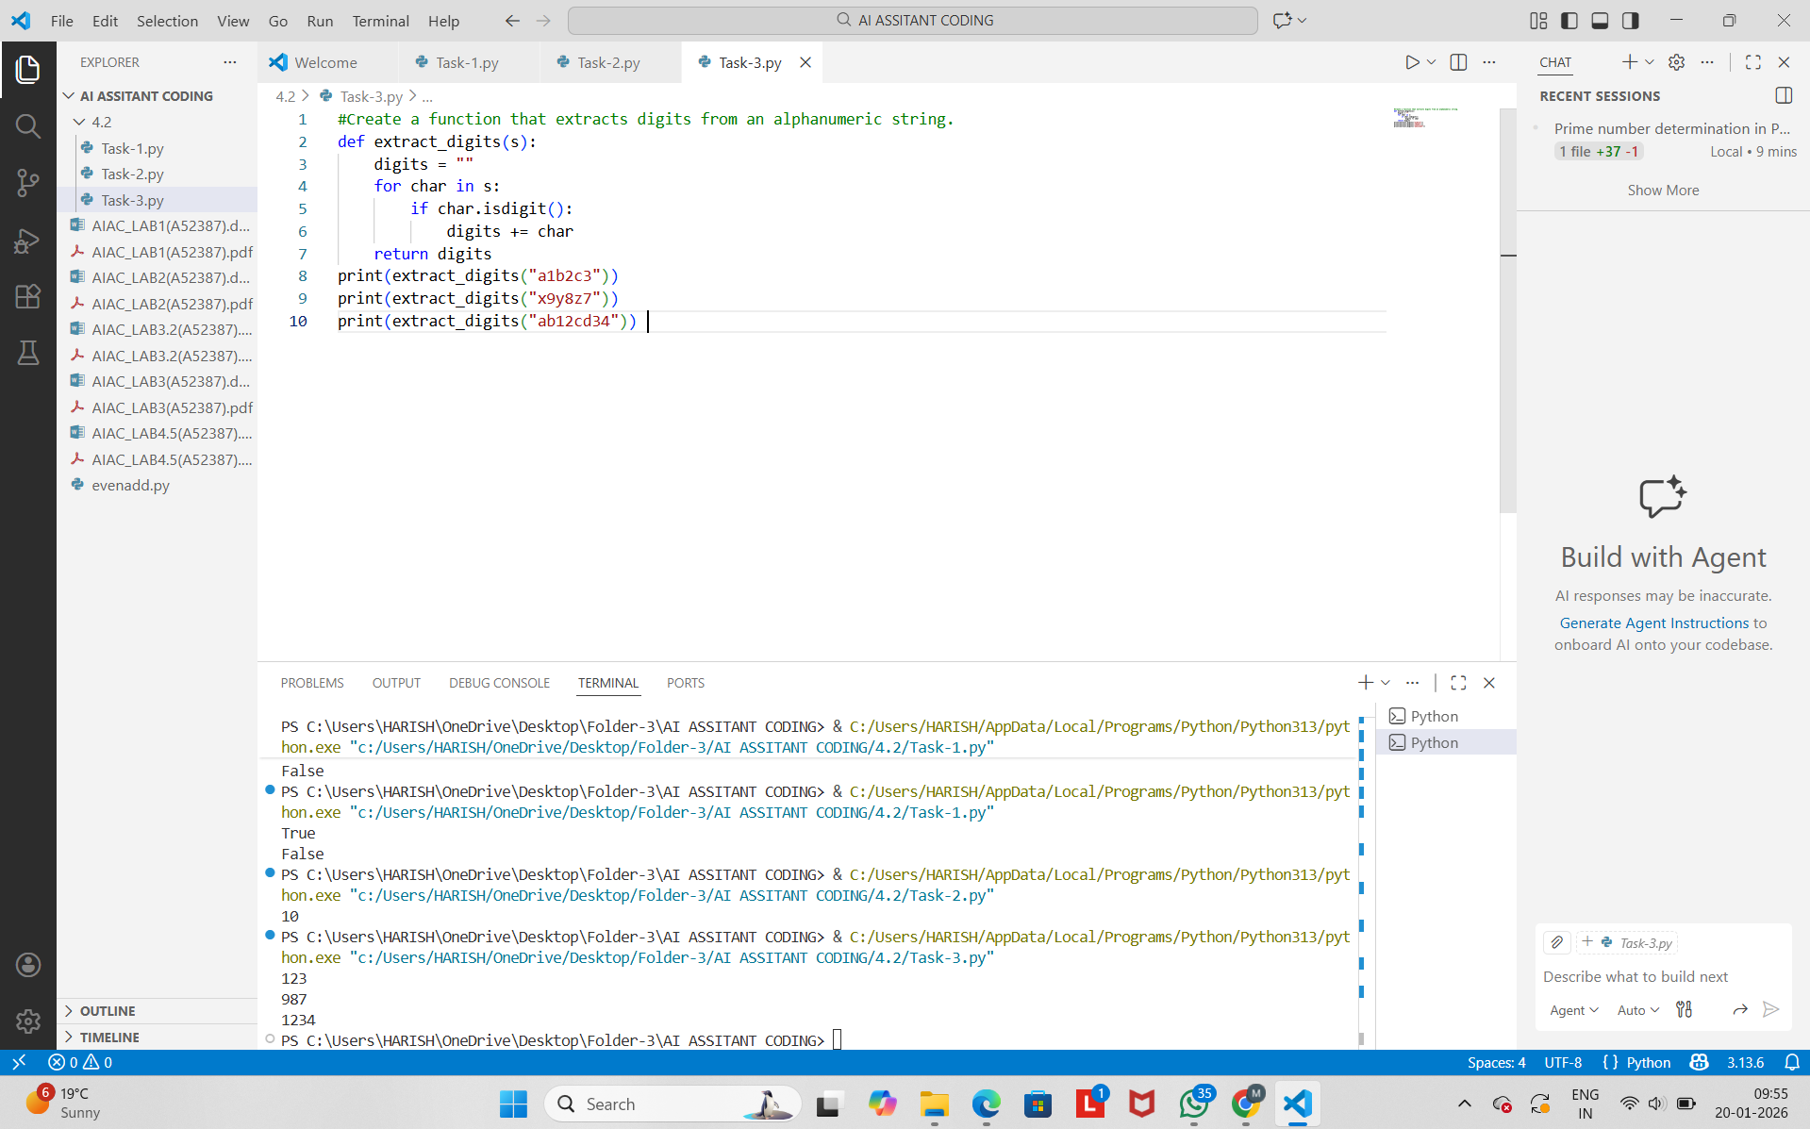
Explanation
The function:
- Initializes an empty string digits.
- Iterates through each character in the string.
- Appends the character if it is a digit.
- Returns the final digit-only string.
- Task Description – 4
- Prompt:
"Write a Python function that counts the number of vowels in a string."

-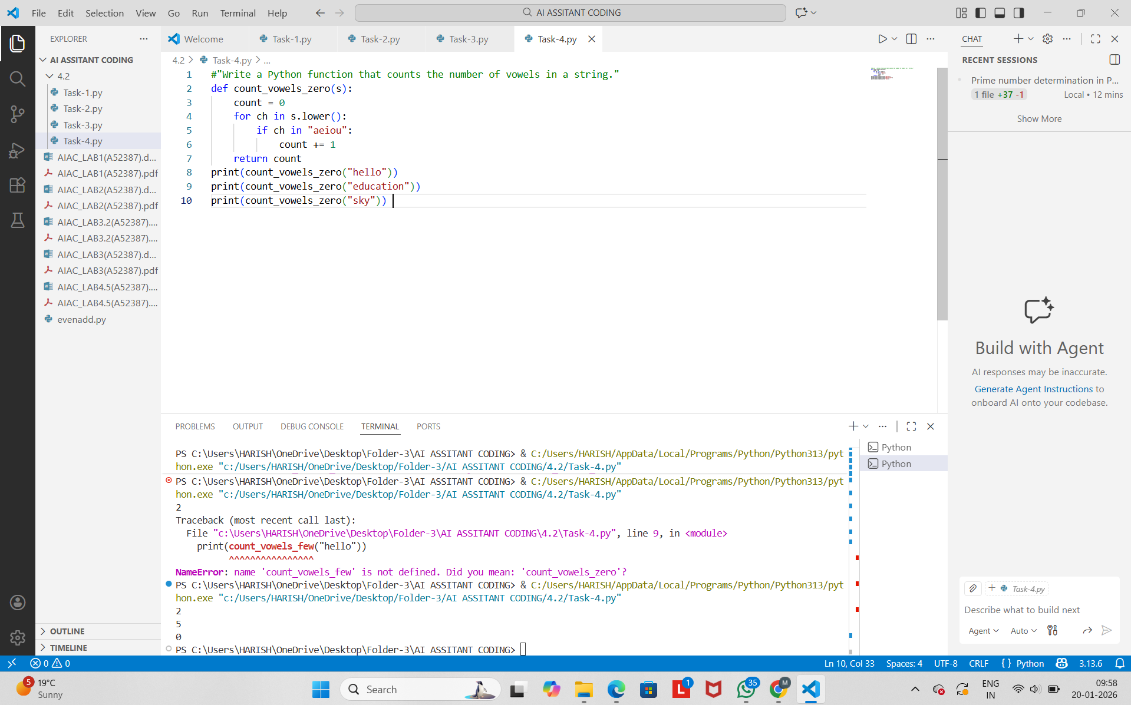
Explanation
- The zero-shot version worked correctly with minimal instruction.
- The few-shot version produced a similar solution but was slightly clearer and more structured.
- Providing examples helped reinforce correct handling of edge cases like strings with no vowels.
- Few-shot prompting improves confidence in output accuracy for more complex or ambiguous tasks.
- Task Description – 5
- "Generate a function that determines the minimum of three numbers without using the built-in min() function."

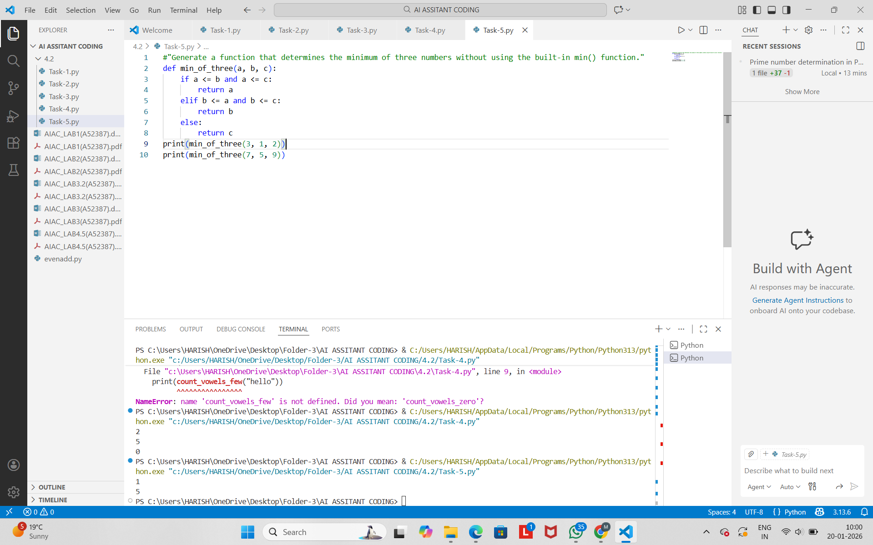
Explanation
The function:
- Compares a with b and c.
- If a is smallest, it returns a.
- Otherwise, it checks if b is smallest.
- If not, it returns c.
- This logic handles all possible cases correctly.

Conclusion
- Zero-shot prompting works well for simple and well-defined problems.
- One-shot prompting guides the AI toward the desired logic using a single example.
- Few-shot prompting significantly improves accuracy and clarity for pattern-based tasks.
- Providing examples helps the model understand edge cases and expected behavior more effectively.

