AI Assisted Coding

Name : M.Harish
H.no : 2303A52387
Batch : 34
Course Code : 23CS002PC304
Assignment Number : 5.5

Lab 5: Ethical Foundations – Responsible AI Coding Practices
Lab Objectives:
• To explore the ethical risks associated with AI-generated
Week3 - code.
• To recognize issues related to security, bias, transparency, and copyright.
• To reflect on the responsibilities of developers when using AI tools in software development.
• To promote awareness of best practices for responsible and ethical AI coding.
Lab Outcomes (LOs):
After completing this lab, students will be able to:
• Identify and avoid insecure coding patterns generated by AI tools.
• Detect and analyze potential bias or discriminatory logic in AI-generated outputs.
• Evaluate originality and licensing concerns in reused AI- generated code.
• Understand the importance of explainability and transparency in AI-assisted programming.
• Reflect on accountability and the human role in ethical AI coding practices.

Task Description #1 (Transparency in Algorithm Optimization)
Task: Use AI to generate two solutions for checking prime numbers:
• Naive approach(basic)
• Optimized approach
Prompt:
“Generate Python code for two prime-checking methods and explain how the optimized version improves performance.”

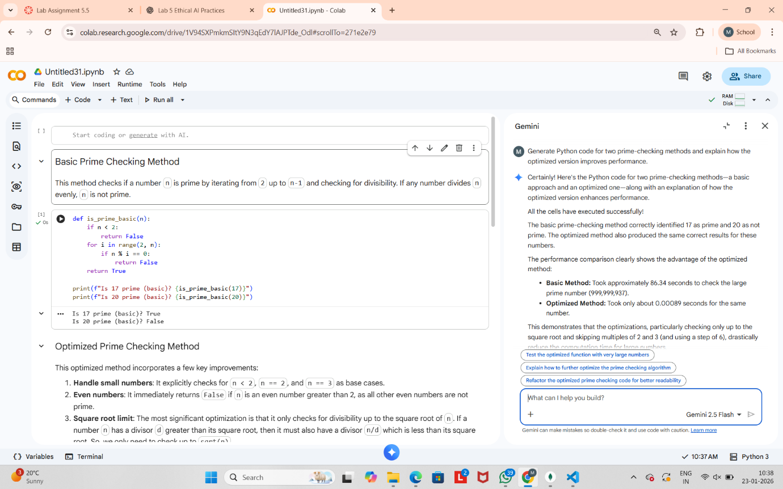

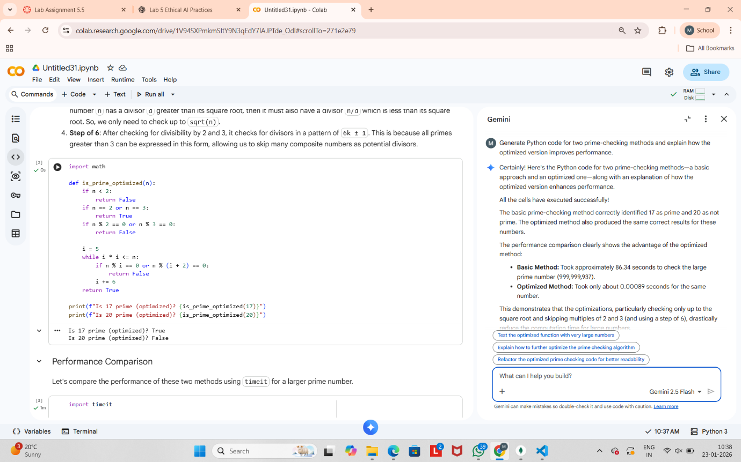

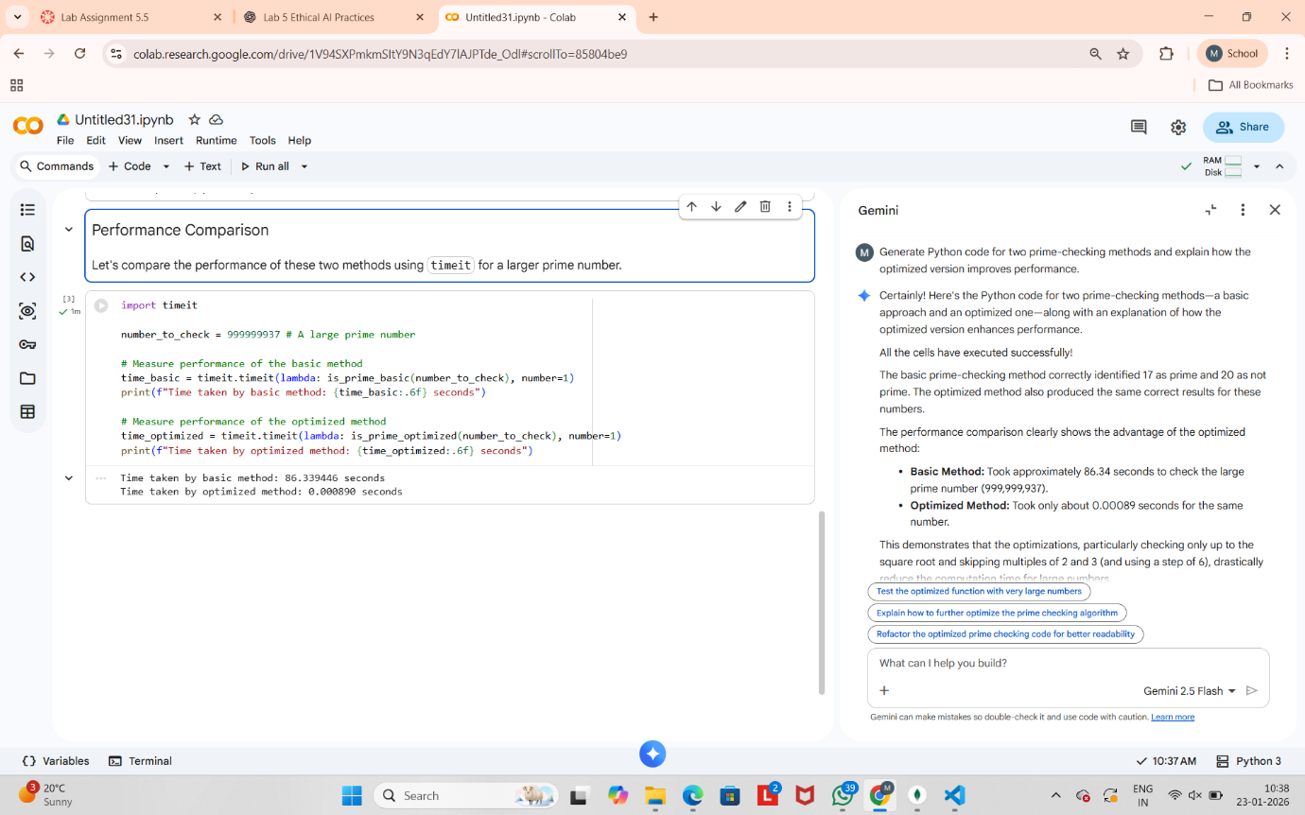

Task Description #2 (Transparency in Recursive Algorithms)
Objective: Use AI to generate a recursive function to calculate Fibonacci numbers.

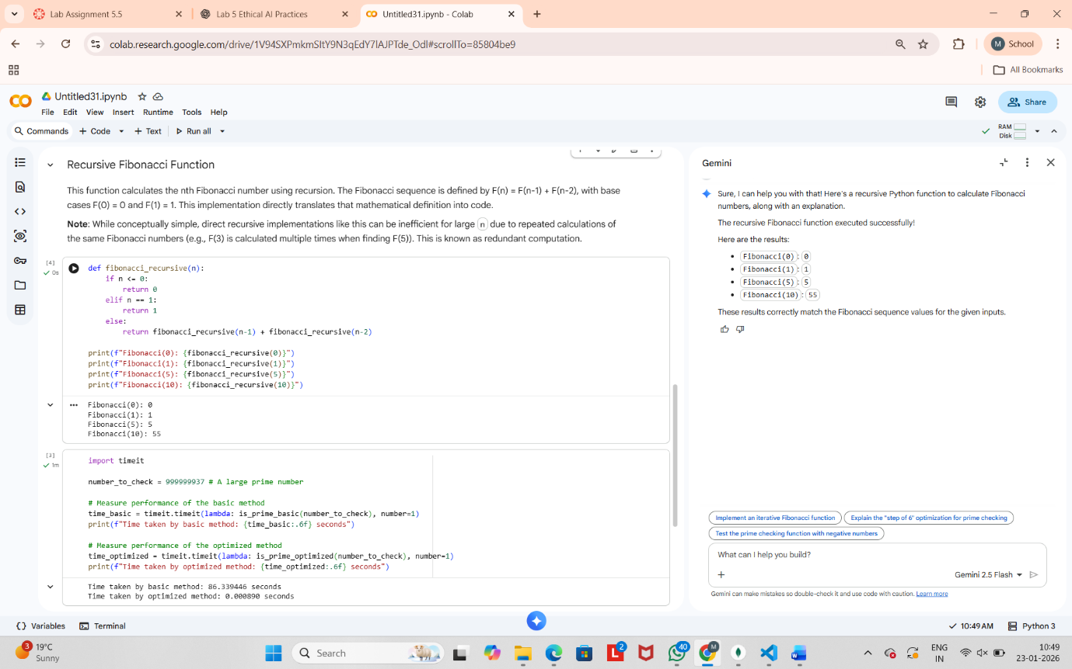

Task Description #3 (Transparency in Error Handling)
Task: Use AI to generate a Python program that reads a file and processes data.
Prompt:
“Generate code with proper error handling and clear explanations for each exception.

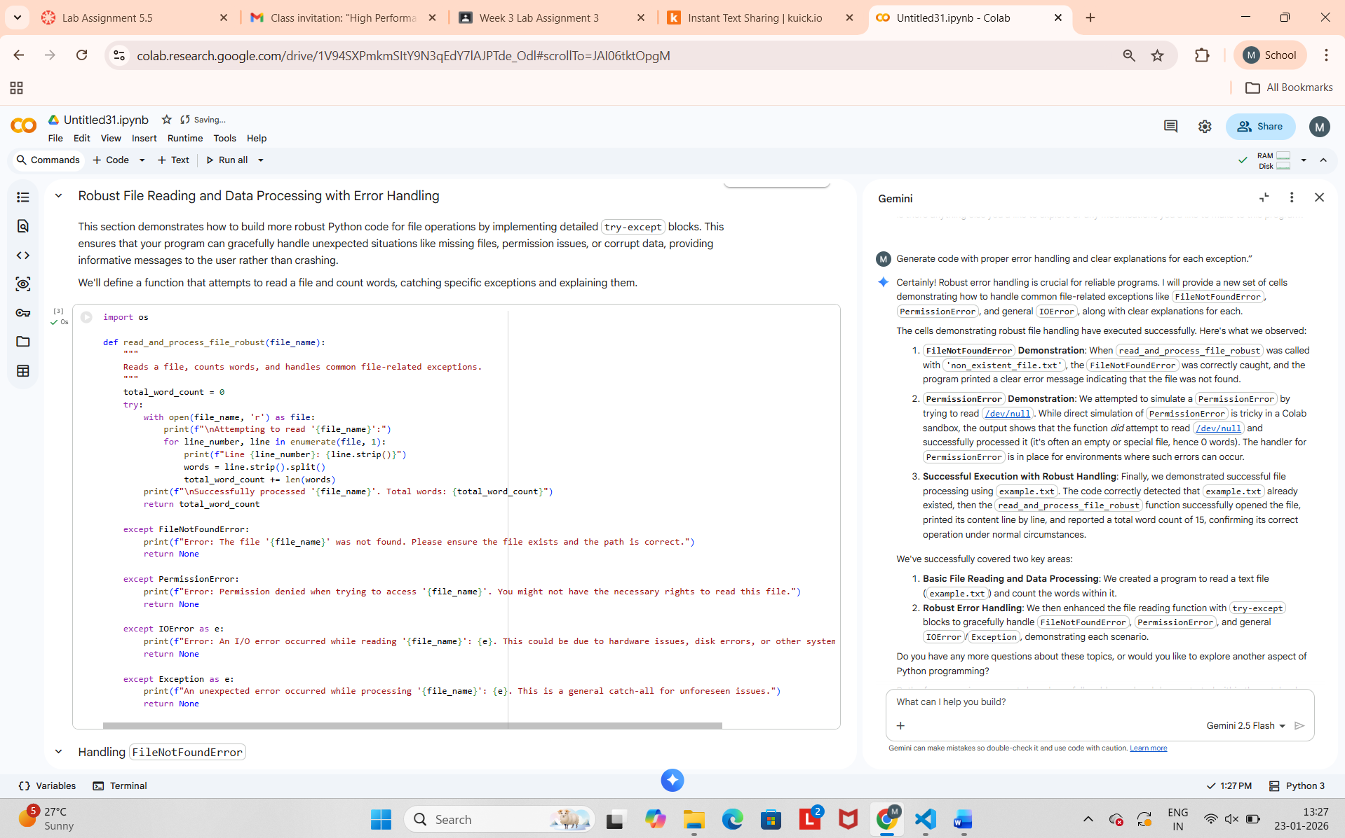

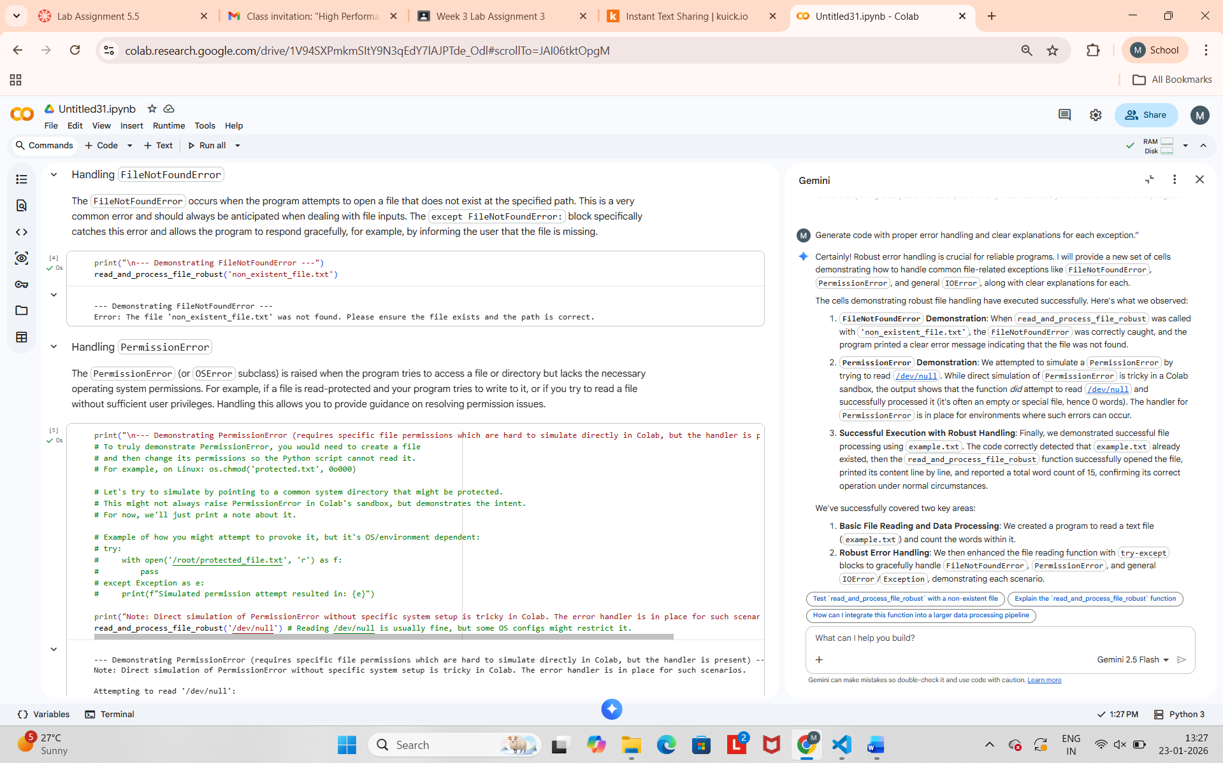

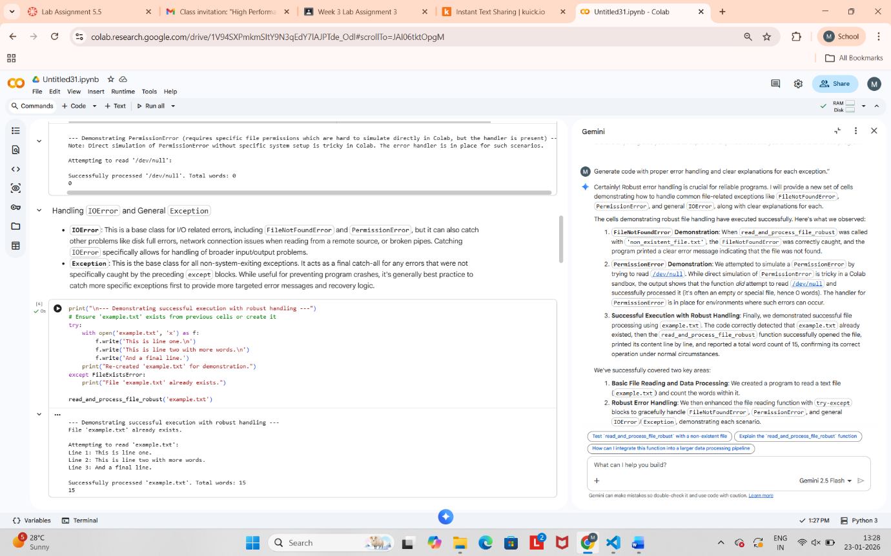

Task Description #4 (Security in User Authentication)
Task: Use an AI tool to generate a Python-based login system.
Analyze: Check whether the AI uses secure password handling
practices.

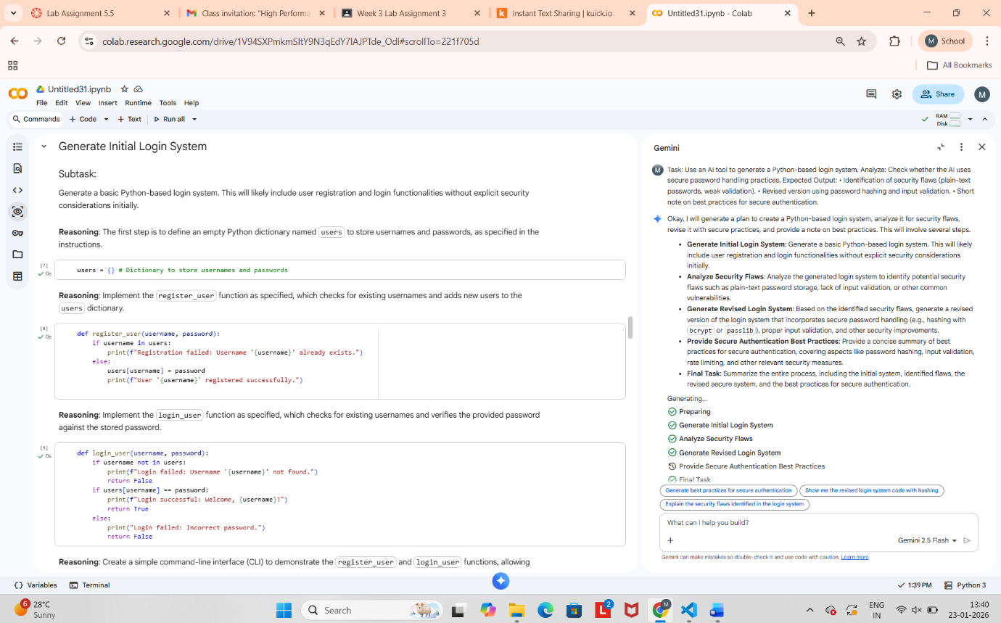

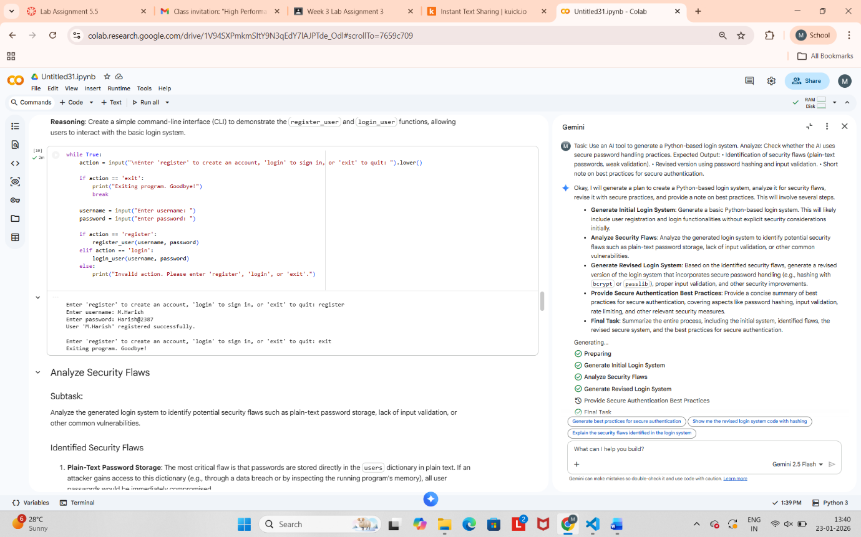

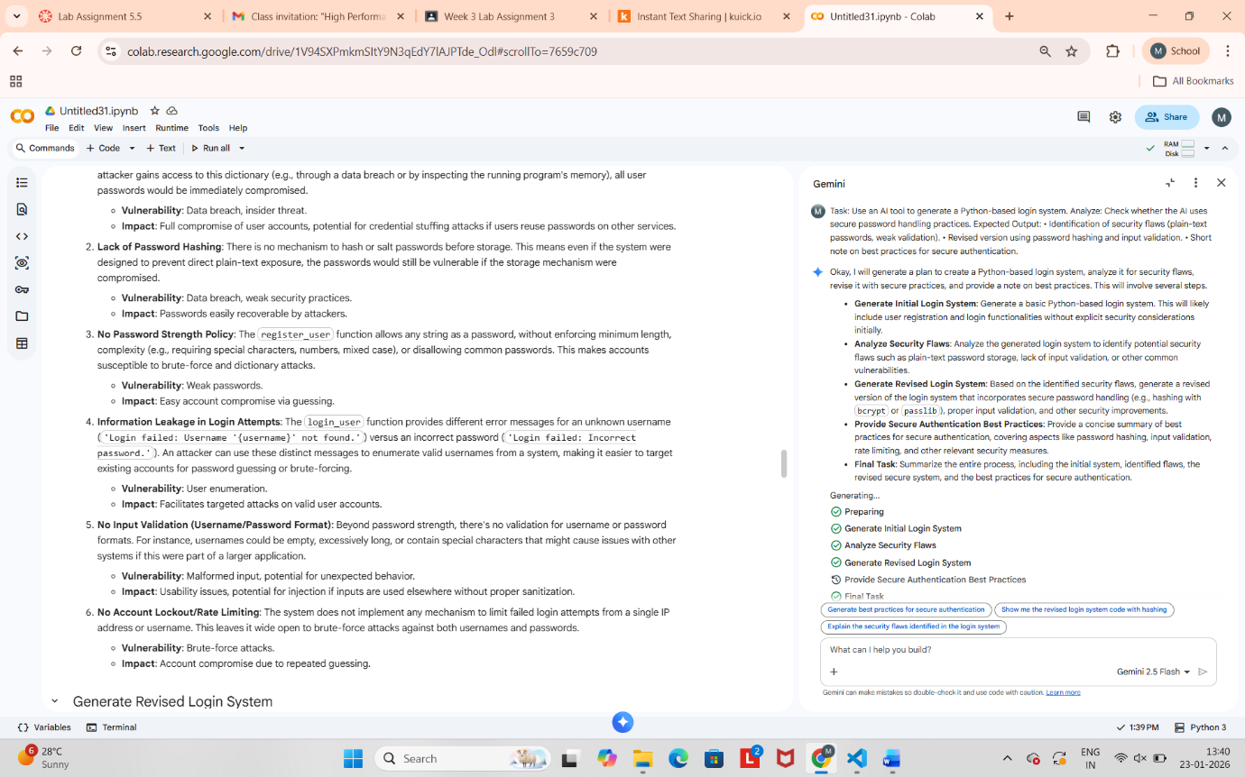



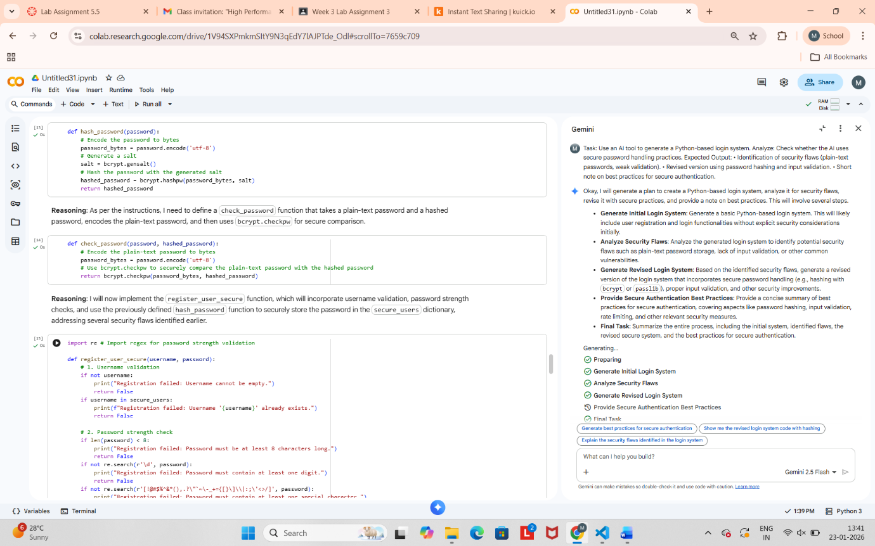

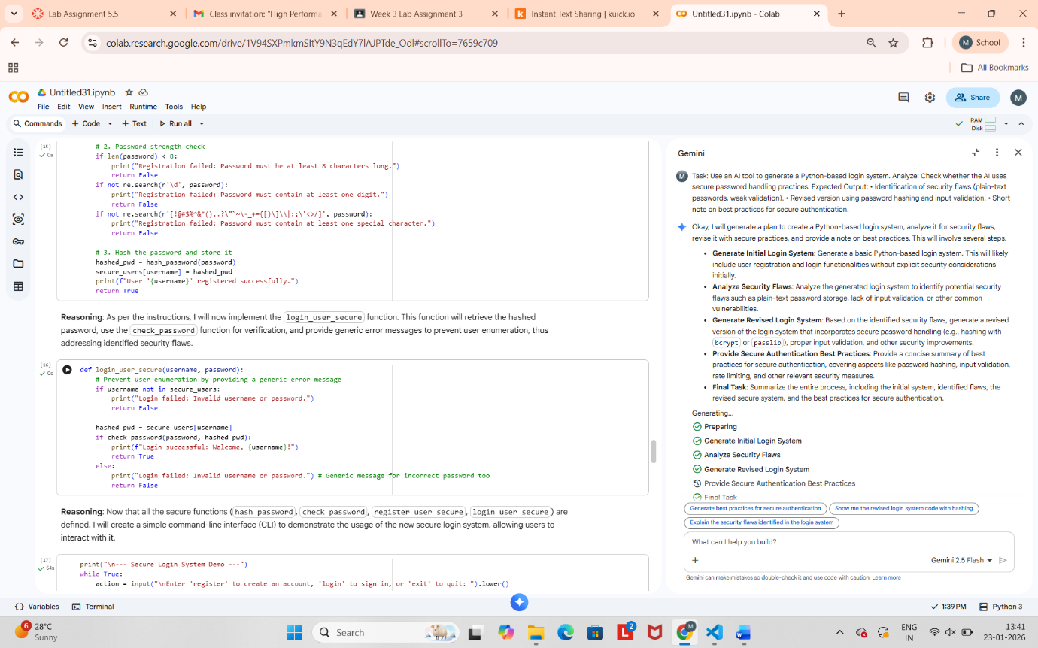

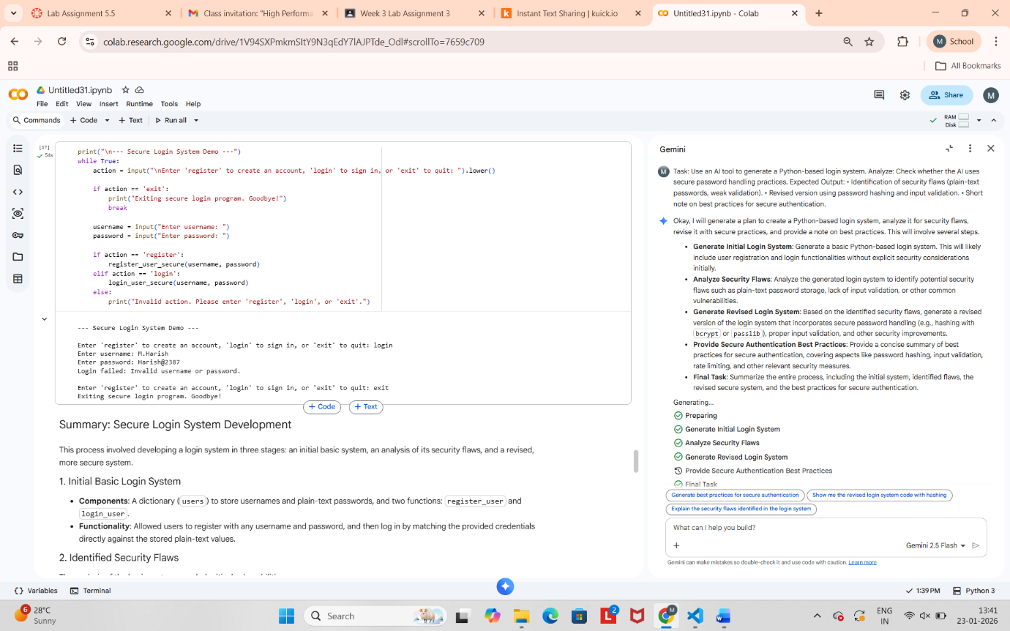



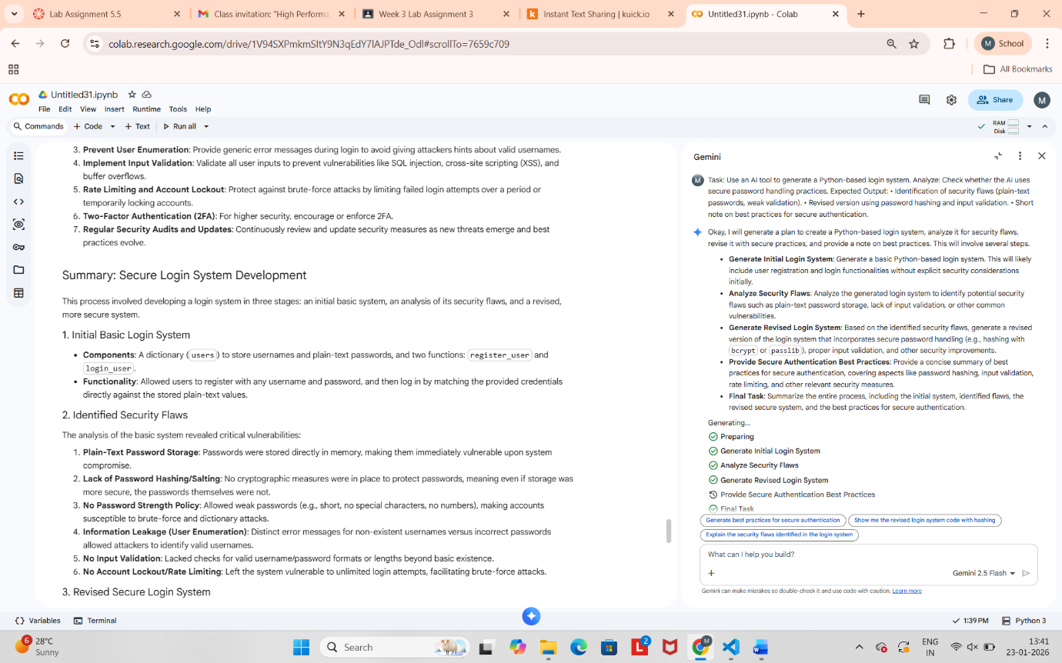



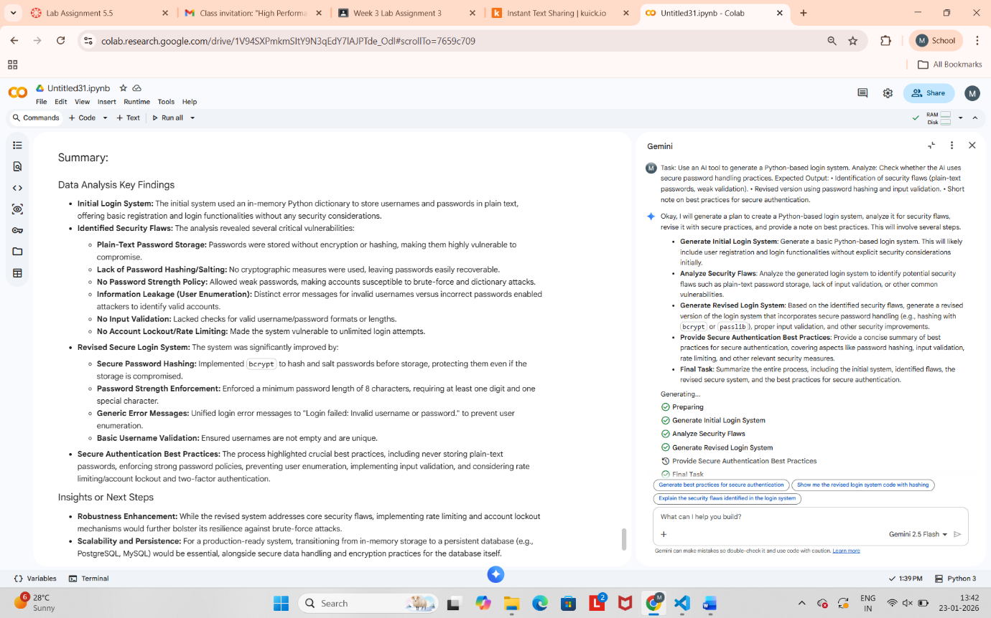

Task Description #5 (Privacy in Data Logging)
Task: Use an AI tool to generate a Python script that logs user activity (username, IP address, timestamp).
Analyze: Examine whether sensitive data is logged unnecessarily or insecurely.

