AI Assisted Coding

Name : M.Harish
H.no : 2303A52387
Batch : 34
Course Code : 23CS002PC304
Assignment Number : 11.5

Lab 11 – Data Structures with AI: Implementing Fundamental Structures

Task Description #1 – Stack Implementation
Task: Use AI to generate a Stack class with push, pop, peek, and is_empty methods.
Sample Input Code:
class Stack:
pass
Expected Output:
• A functional stack implementation with all required methods and
docstrings. 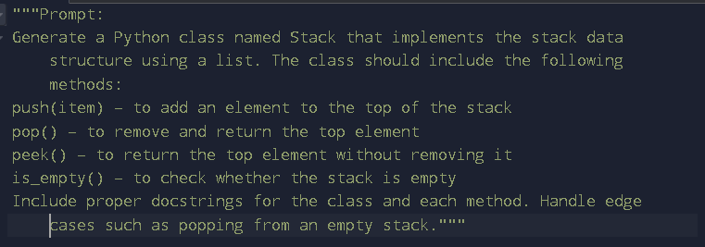

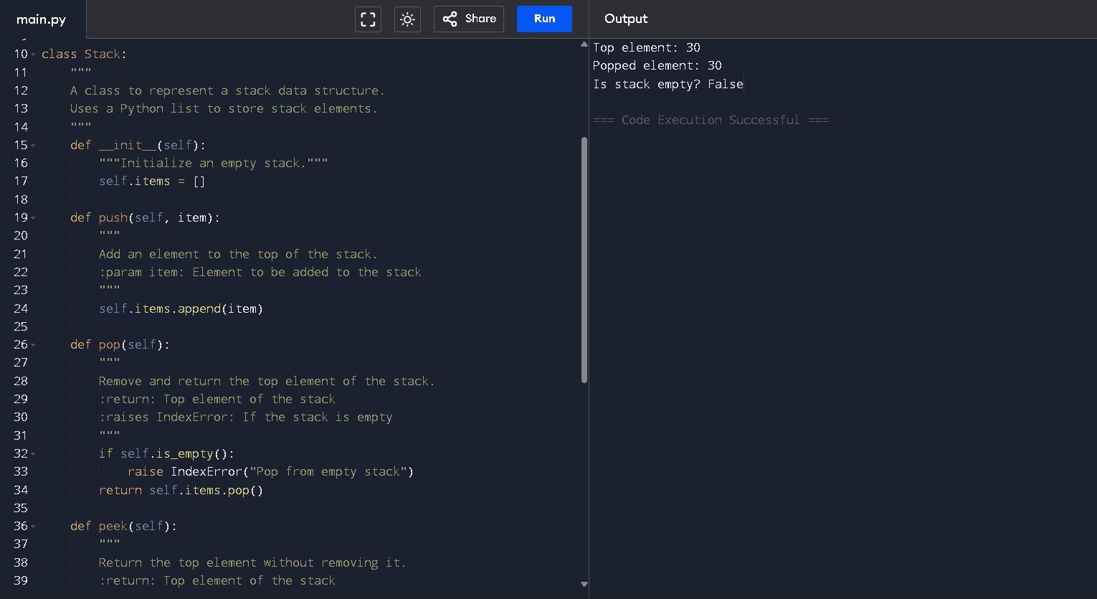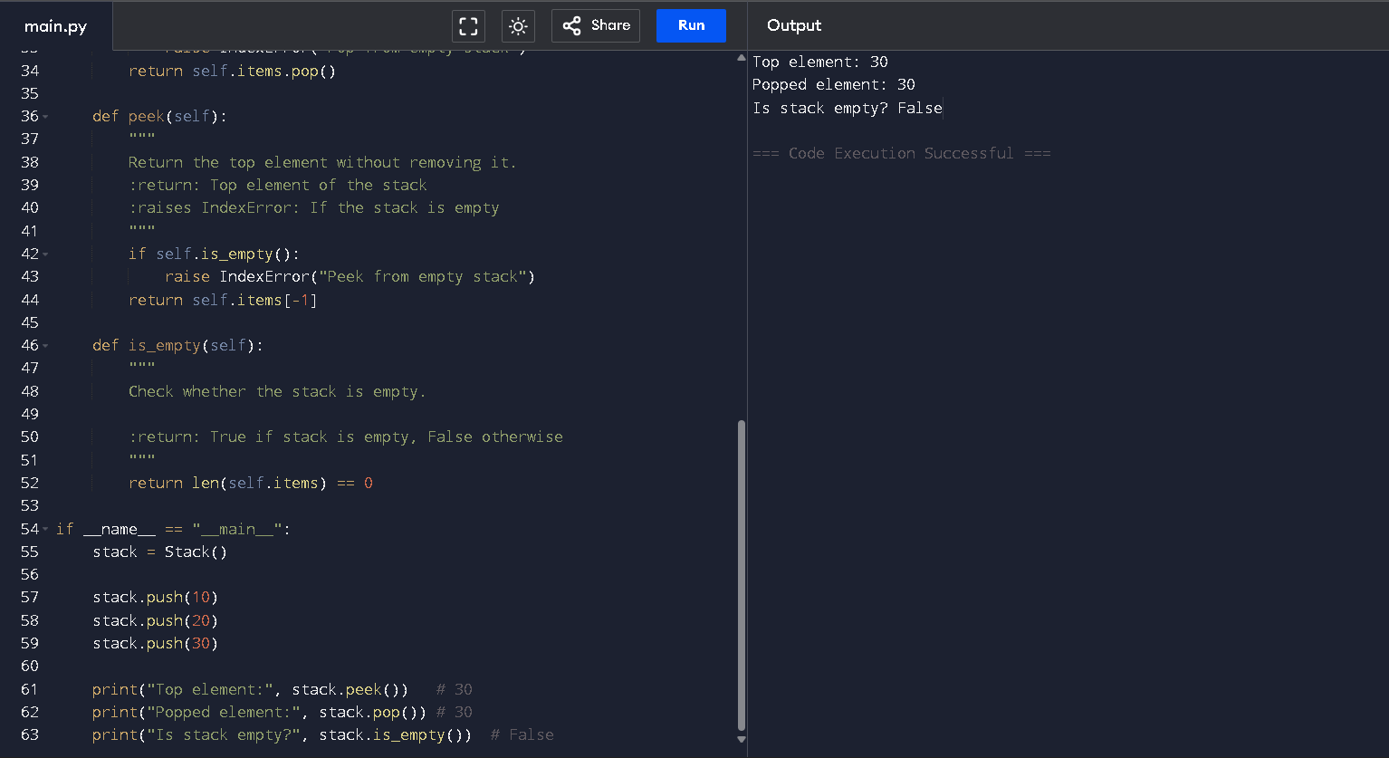
Task Description #2 – Queue Implementation
Task: Use AI to implement a Queue using Python lists.
Sample Input Code:
class Queue:
pass
Expected Output:
• FIFO-based queue class with enqueue, dequeue, peek, and size
methods.
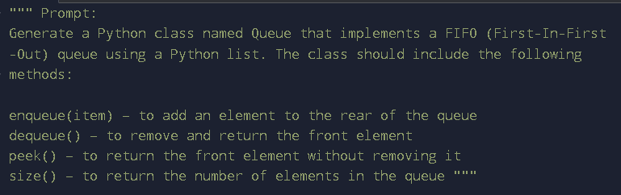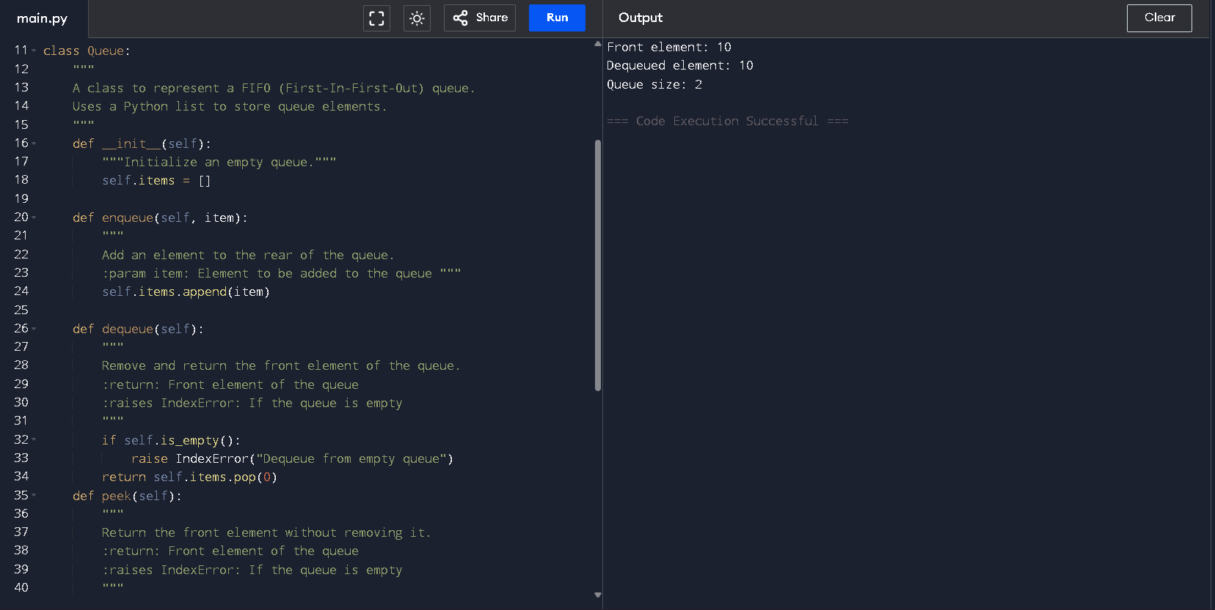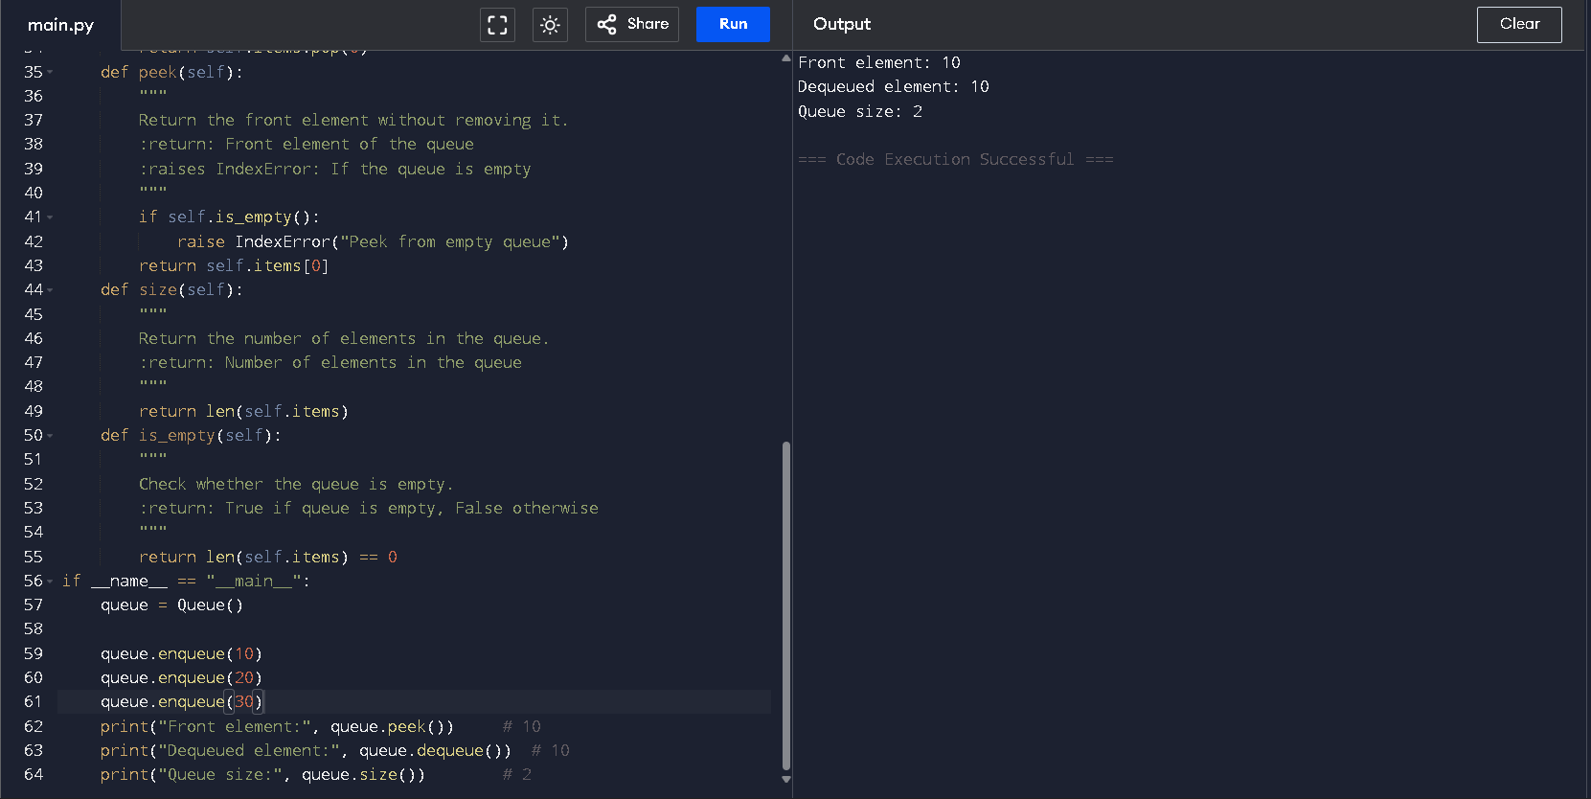
Task Description #3 – Linked List
Task: Use AI to generate a Singly Linked List with insert and displaymethods.
Sample Input Code:
class Node:
pass
class LinkedList:
pass
Expected Output:
• A working linked list implementation with clear method documentation
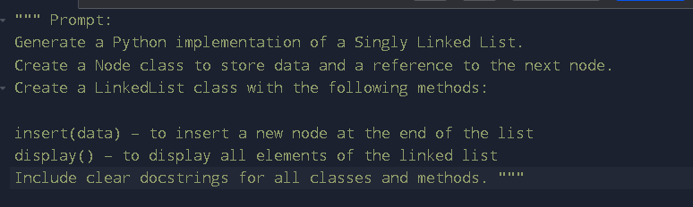
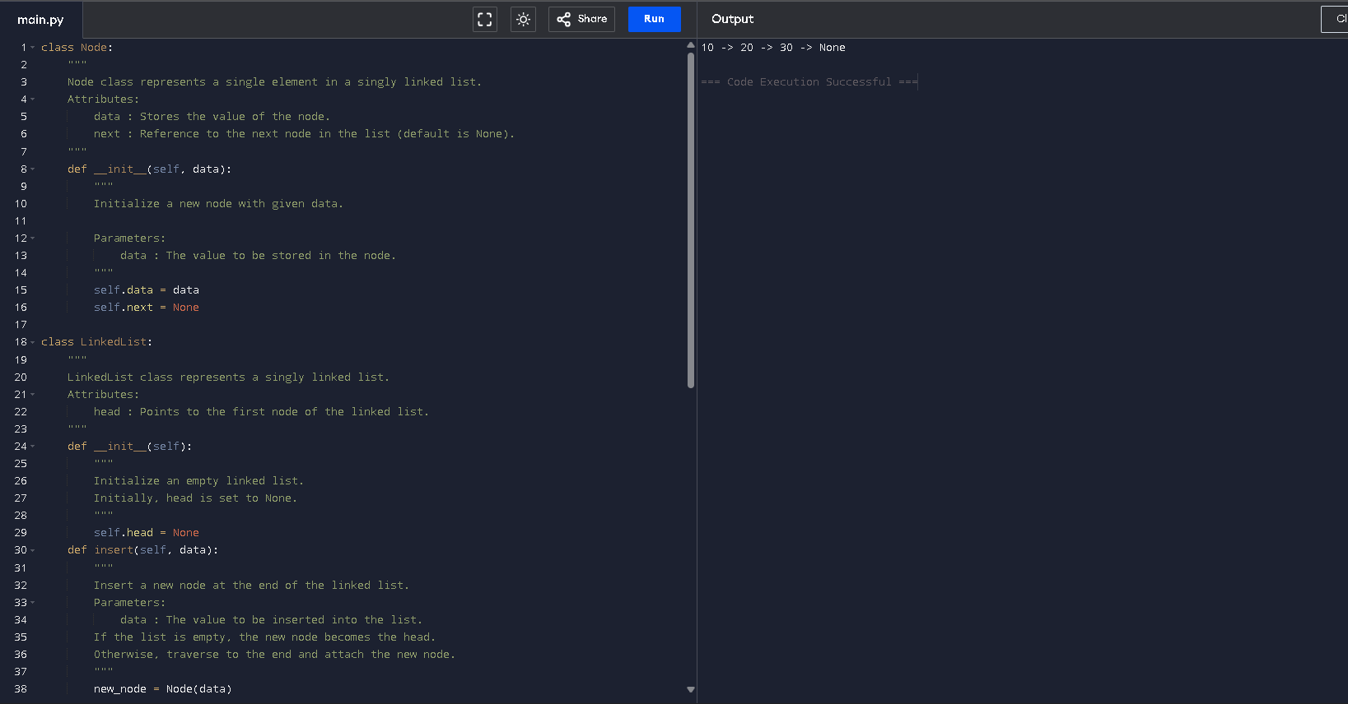

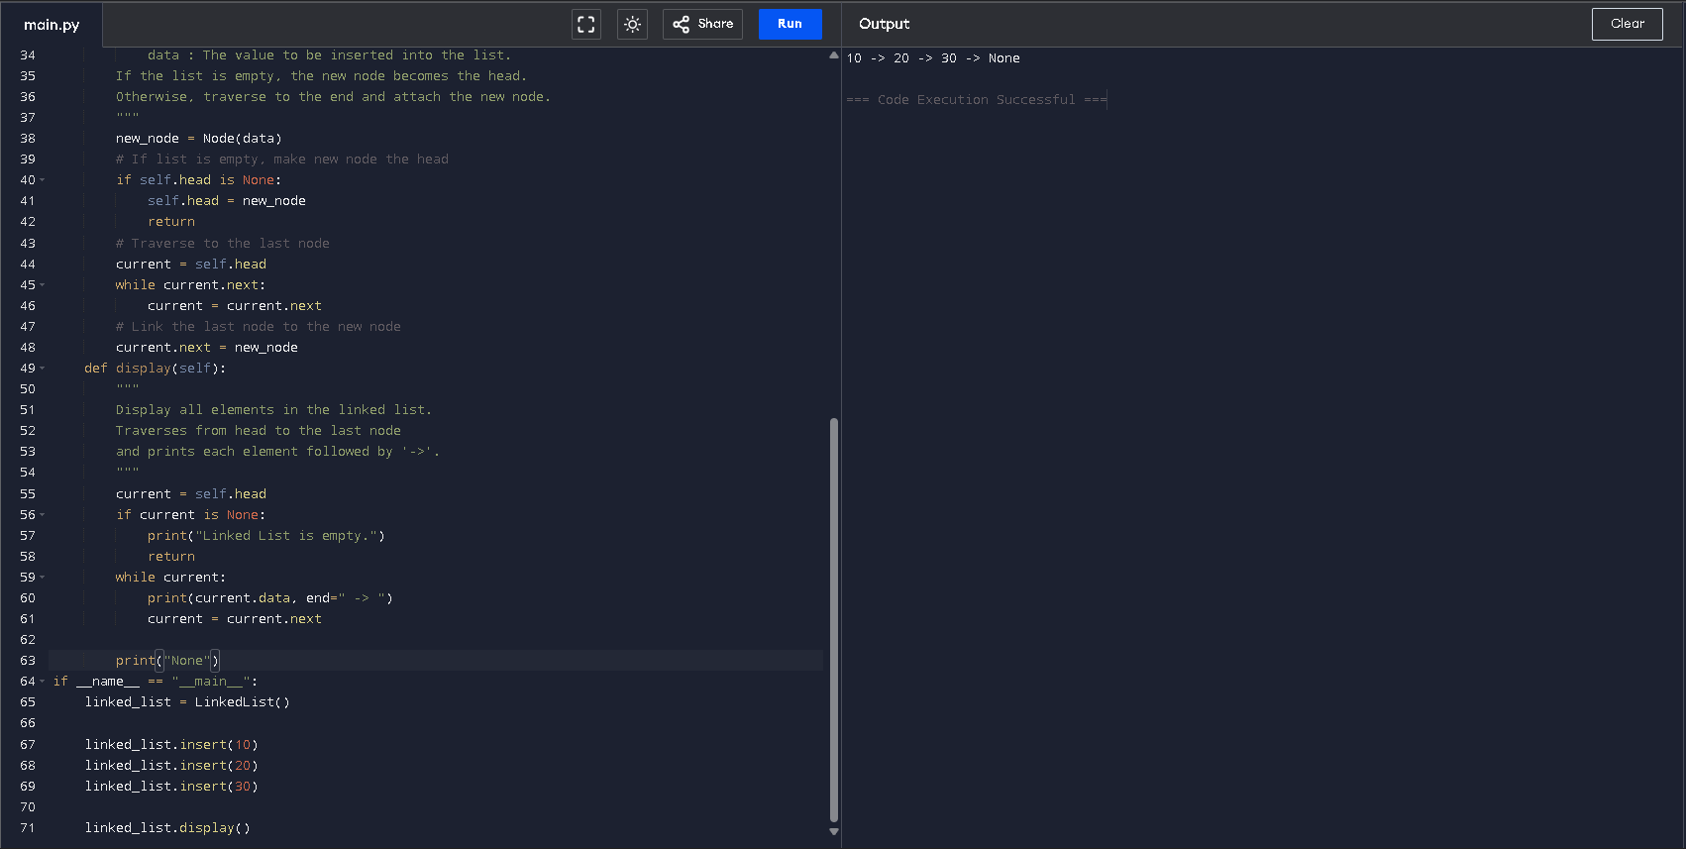

Task Description #4 – Hash Table
Task: Use AI to implement a hash table with basic insert, search, and delete methods.
Sample Input Code:
class HashTable:
pass
Expected Output:
• Collision handling using chaining, with well-commented methods

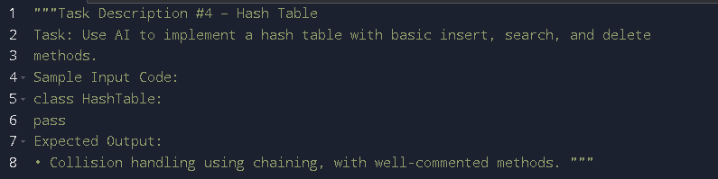

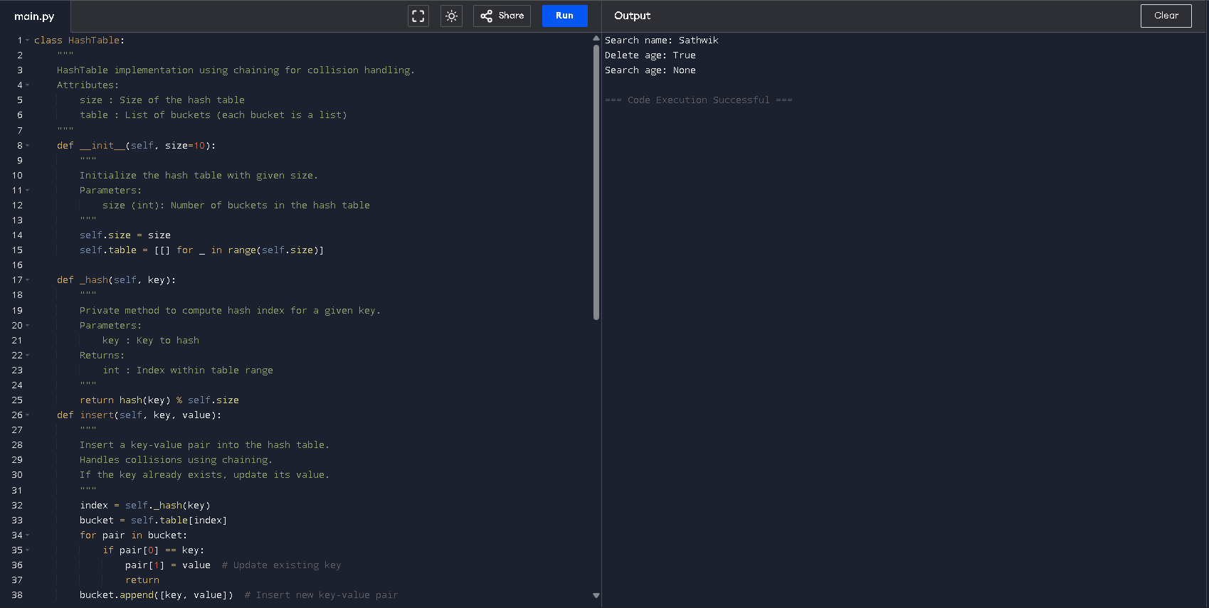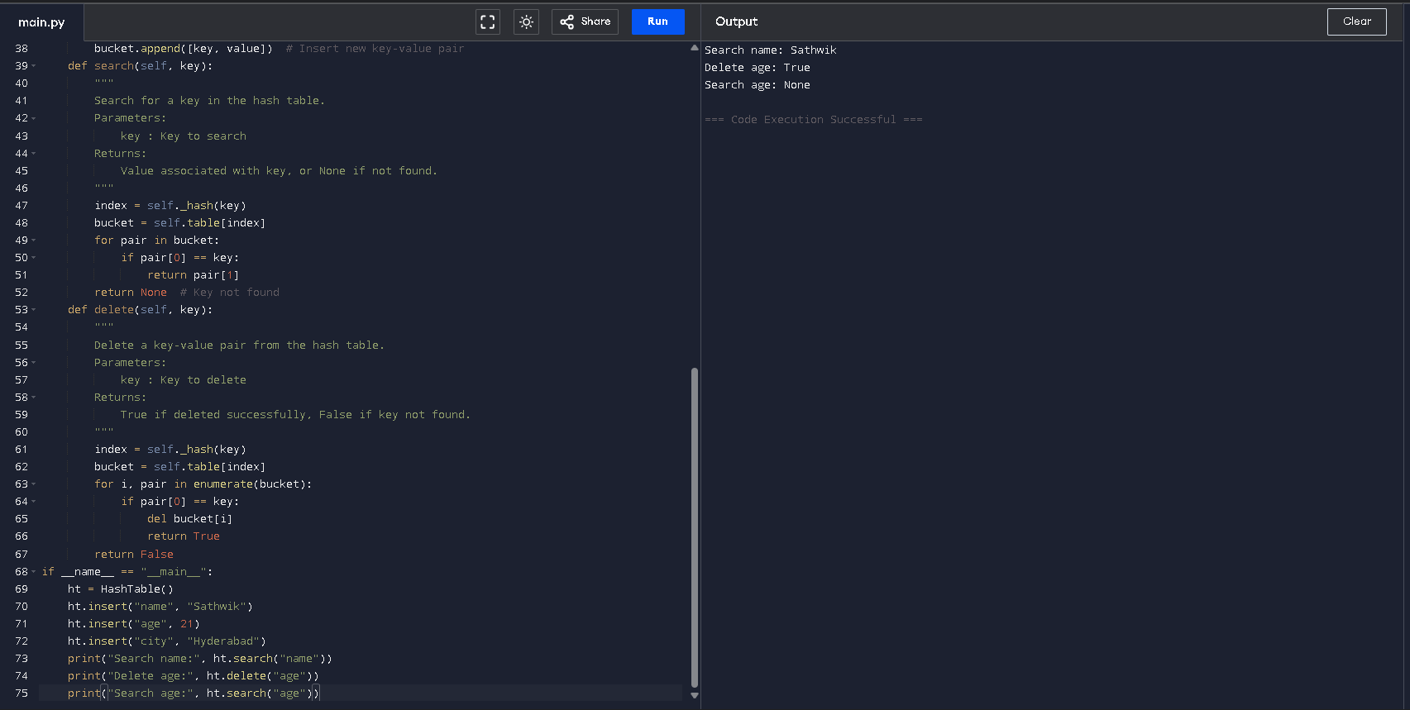

Task Description #5 – Graph Representation
Task: Use AI to implement a graph using an adjacency list.
Sample Input Code:
class Graph:
pass
Expected Output:
• Graph with methods to add vertices, add edges, and display connections.

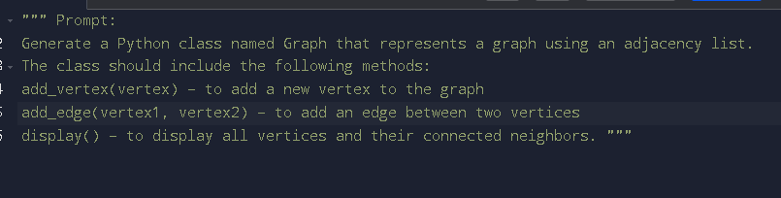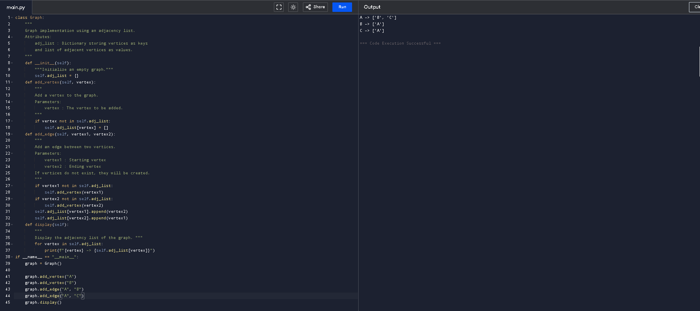

Task Description #6: Smart Hospital Management System – Data Structure Selection
A hospital wants to develop a Smart Hospital Management System that handles:
1. Patient Check-In System – Patients are registered and treated in order of arrival.
2. Emergency Case Handling – Critical patients must be treated first.
3. Medical Records Storage – Fast retrieval of patient details using ID.
4. Doctor Appointment Scheduling – Appointments sorted by time.
5. Hospital Room Navigation – Represent connections between wards and rooms.
Student Task:
• For each feature, select the most appropriate data structure from the list below:
o Stack
o Queue
o Priority Queue
o Linked List
o Binary Search Tree (BST)
o Graph
o Hash Table
o Deque
• Justify your choice in 2–3 sentences per feature.
• Implement one selected feature as a working Python program with AI-assisted code generation.

Smart Hospital Management System – Data Structure Selection

1. Patient Check-In System
Selected Data Structure: Queue
Justification:
A Queue follows the First-In-First-Out (FIFO) principle. Patients are treated in the order they arrive, ensuring fairness. Therefore, a Queue is the most suitable structure for managing regular patient check-ins.

2. Emergency Case Handling
Selected Data Structure: Priority Queue
Justification:
Emergency patients must be treated based on severity rather than arrival time. A Priority Queue allows higher-priority (critical) patients to be treated first. This ensures immediate attention to life-threatening cases.

3. Medical Records Storage
Selected Data Structure: Hash Table
Justification:
Patient records need fast retrieval using a unique patient ID. A Hash Table provides average O(1) time complexity for search, insert, and delete operations. This makes record management efficient and scalable.

4. Doctor Appointment Scheduling
Selected Data Structure: Binary Search Tree (BST)
Justification:
Appointments must be maintained in sorted order based on time. A Binary Search Tree automatically keeps elements sorted. This makes scheduling and time-based retrieval efficient.

5. Hospital Room Navigation
Selected Data Structure: Graph
Justification:
Hospital rooms and wards can be represented as nodes, and pathways as edges. A Graph effectively models connections between locations. It also supports pathfinding for navigation within the hospital.
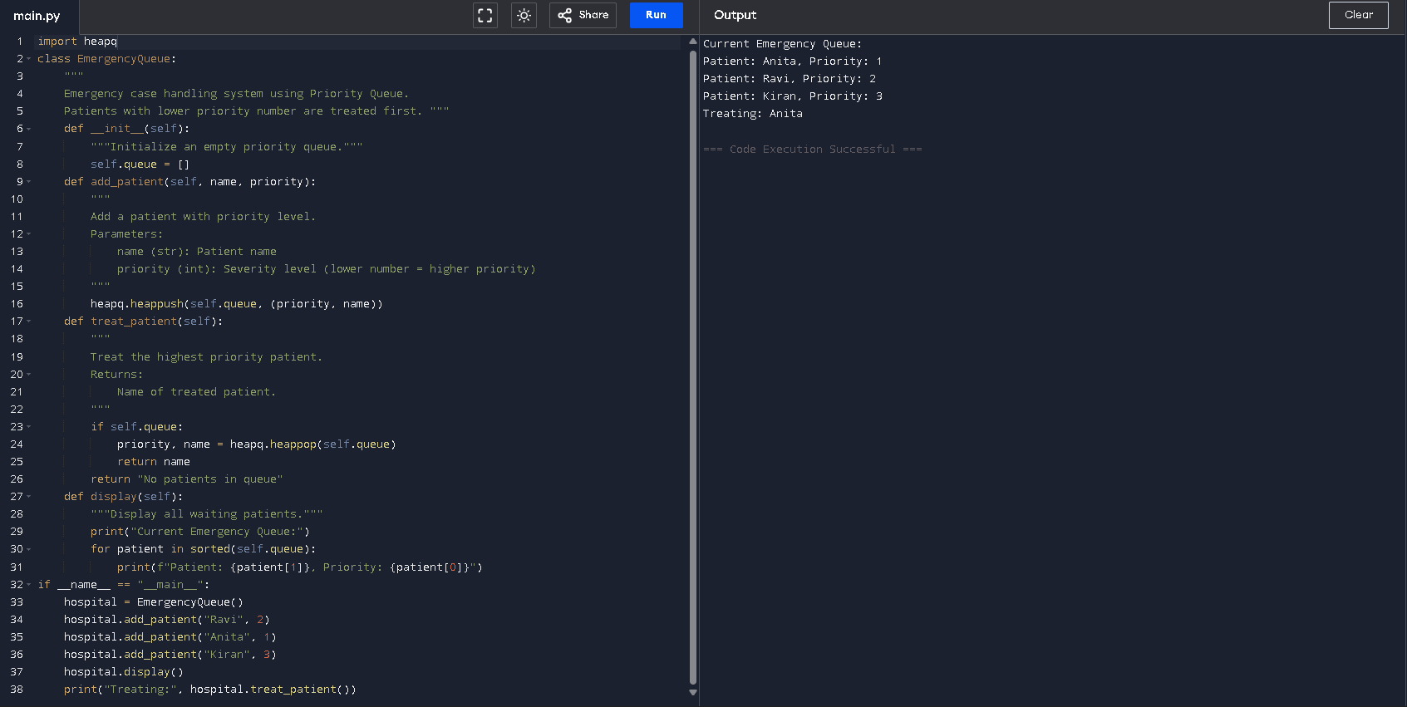

Task Description #7: Smart City Traffic Control System
A city plans a Smart Traffic Management System that includes:
1. Traffic Signal Queue – Vehicles waiting at signals.
2. Emergency Vehicle Priority Handling – Ambulances and fire trucks prioritized.
3. Vehicle Registration Lookup – Instant access to vehicle details.
4. Road Network Mapping – Roads and intersections connected logically.
5. Parking Slot Availability – Track available and occupied slots.
Student Task
• For each feature, select the most appropriate data structure from the list below:
o Stack
o Queue
o Priority Queue
o Linked List
o Binary Search Tree (BST)
o Graph
o Hash Table
o Deque
• Justify your choice in 2–3 sentences per feature.
• Implement one selected feature as a working Python program with AI-assisted code generation.
Expected Output:
• A table mapping feature → chosen data structure → justification.
• A functional Python program implementing the chosen feature with comments and docstrings.

Smart City Traffic Control System

1. Traffic Signal Queue
Selected Data Structure: Queue
Justification:
Vehicles waiting at a traffic signal follow the First-In-First-Out (FIFO) principle. The vehicle that arrives first should move first when the signal turns green. Therefore, a Queue is the most appropriate structure for managing traffic signals fairly and efficiently.

2. Emergency Vehicle Priority Handling
Selected Data Structure: Priority Queue
Justification:
Emergency vehicles such as ambulances and fire trucks must be given immediate access regardless of arrival time. A Priority Queue allows higher-priority vehicles to be processed before regular vehicles. This ensures faster emergency response and improved public safety.

3. Vehicle Registration Lookup
Selected Data Structure: Hash Table
Justification:
Vehicle details must be accessed instantly using a registration number. A Hash Table provides average O(1) time complexity for search operations. This makes it ideal for fast and efficient vehicle information retrieval.

4. Road Network Mapping
Selected Data Structure: Graph
Justification:
Roads and intersections can be represented as nodes and edges. A Graph efficiently models connections between locations and supports route-finding algorithms. This makes it suitable for navigation and traffic management systems.

5. Parking Slot Availability
Selected Data Structure: Binary Search Tree (BST)
Justification:
Parking slots can be stored in sorted order based on slot numbers. A Binary Search Tree maintains elements in sorted order and allows efficient insertion, deletion, and searching. This makes it suitable for tracking available and occupied parking slots.
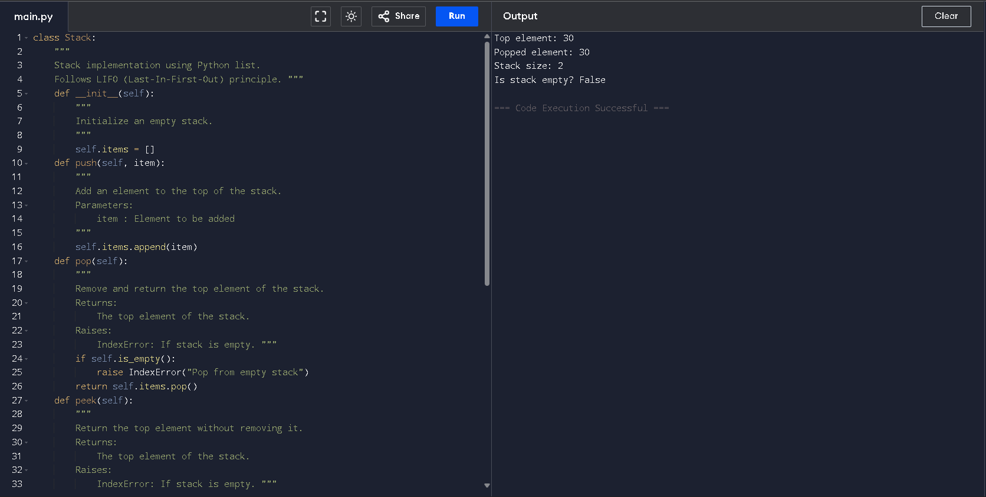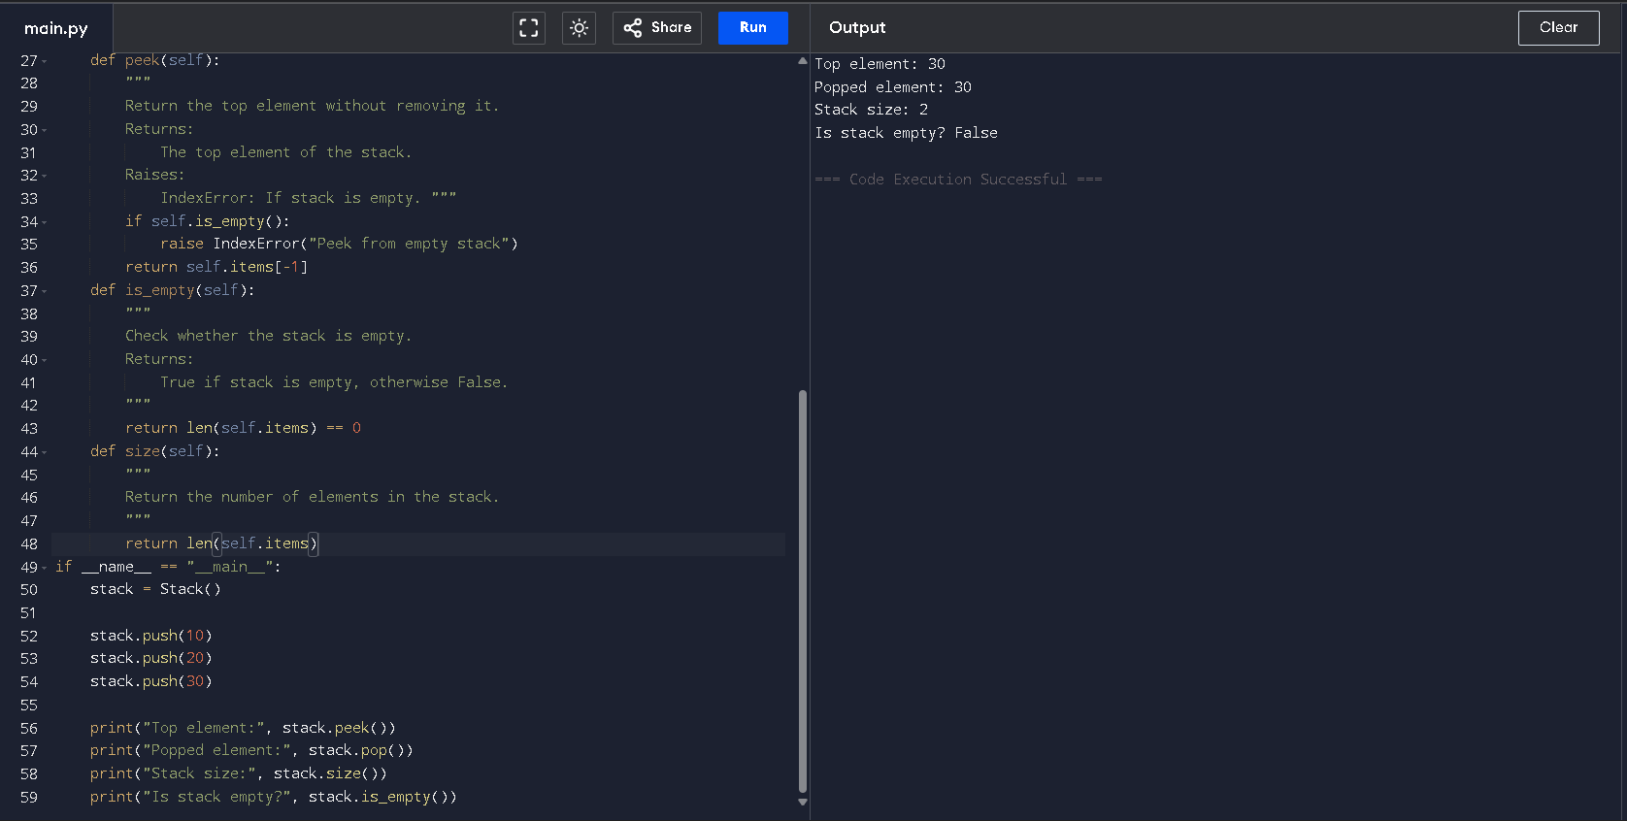

Task Description #8: Smart E-Commerce Platform – Data Structure.
Challenge
An e-commerce company wants to build a Smart Online Shopping System
with:
1. Shopping Cart Management – Add and remove products
dynamically.
2. Order Processing System – Orders processed in the order they are
Placed.
3. Top-Selling Products Tracker – Products ranked by sales count.
4. Product Search Engine – Fast lookup of products using product ID.
5. Delivery Route Planning – Connect warehouses and delivery locations.
Student Task
• For each feature, select the most appropriate data structure from
the list below:
o Stack
o Queue
o Priority Queue
o Linked List
o Binary Search Tree (BST)
o Graph
o Hash Table
o Deque
• Justify your choice in 2–3 sentences per feature.
• Implement one selected feature as a working Python program with AI-assisted code generation.
Expected Output:
• A table mapping feature → chosen data structure → justification.
• A functional Python program implementing the chosen feature with comments and docstrings.

Smart E-Commerce Platform – Data Structure Selection

1. Shopping Cart Management
Selected Data Structure: Linked List
Justification:
Products in a shopping cart are added and removed dynamically. A Linked List allows efficient insertion and deletion without shifting elements. This makes it suitable for managing frequently changing cart items.

2. Order Processing System
Selected Data Structure: Queue
Justification:
Orders must be processed in the order they are placed. A Queue follows the First-In-First-Out (FIFO) principle, ensuring fairness. Therefore, it is ideal for handling customer orders.

3. Top-Selling Products Tracker
Selected Data Structure: Priority Queue
Justification:
Products need to be ranked based on sales count. A Priority Queue allows items with higher sales to be accessed first. This ensures efficient tracking of top-selling products.

4. Product Search Engine
Selected Data Structure: Hash Table
Justification:
Products are searched using unique product IDs. A Hash Table provides average O(1) time complexity for search operations. This makes product lookup fast and efficient.

5. Delivery Route Planning
Selected Data Structure: Graph
Justification:
Warehouses and delivery locations can be represented as nodes, and roads as edges. A Graph efficiently models connections and supports shortest path algorithms. This makes it suitable for route optimization and logistics planning.

