AI Assisted Coding

Name : M.Harish
H.no : 2303A52387
Batch : 34
Course Code : 23CS002PC304
Assignment Number : 14.2

Lab 14: Web Design Application – AI-Assisted HTML/CSS/JS Generation
Lab Objectives
• Design functional, visually appealing web applications using HTML, CSS, and JavaScript with AI assistance.
• Apply responsive, accessible, and interactive design principles.
• Create practical UI components for real-world web applications.
• Use AI to optimize layout, UX, and performance.
Task Description 1 – (Landing Page Design)
• Create a simple landing page for a product or service. Include a header, hero section, and footer.
Requirements:
• Use HTML and CSS to structure the page.
• Use AI to suggest layout alignment and typography.
• Ensure the page is responsive across devices.
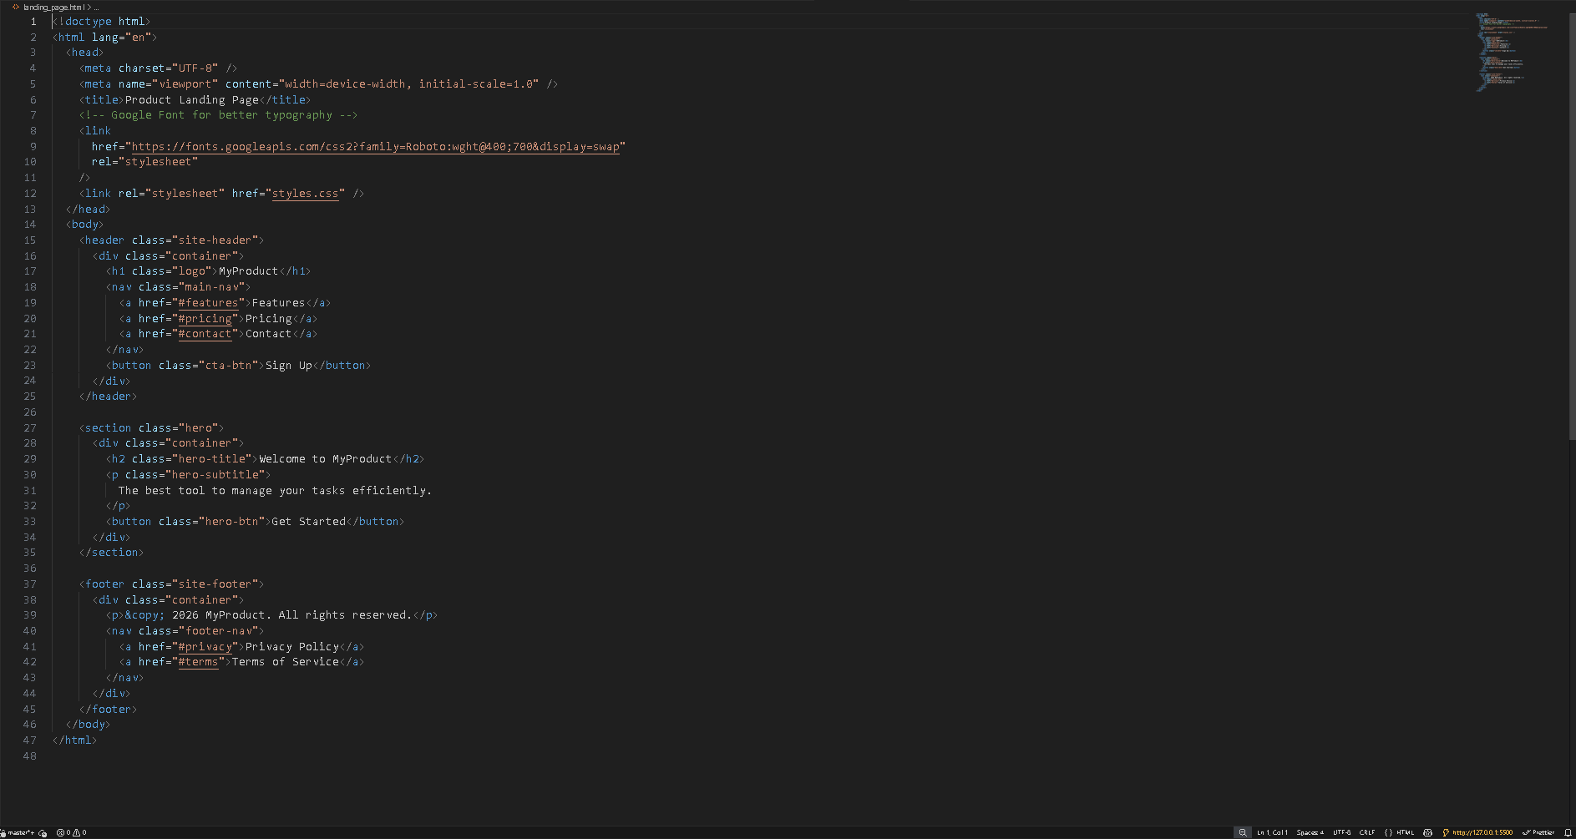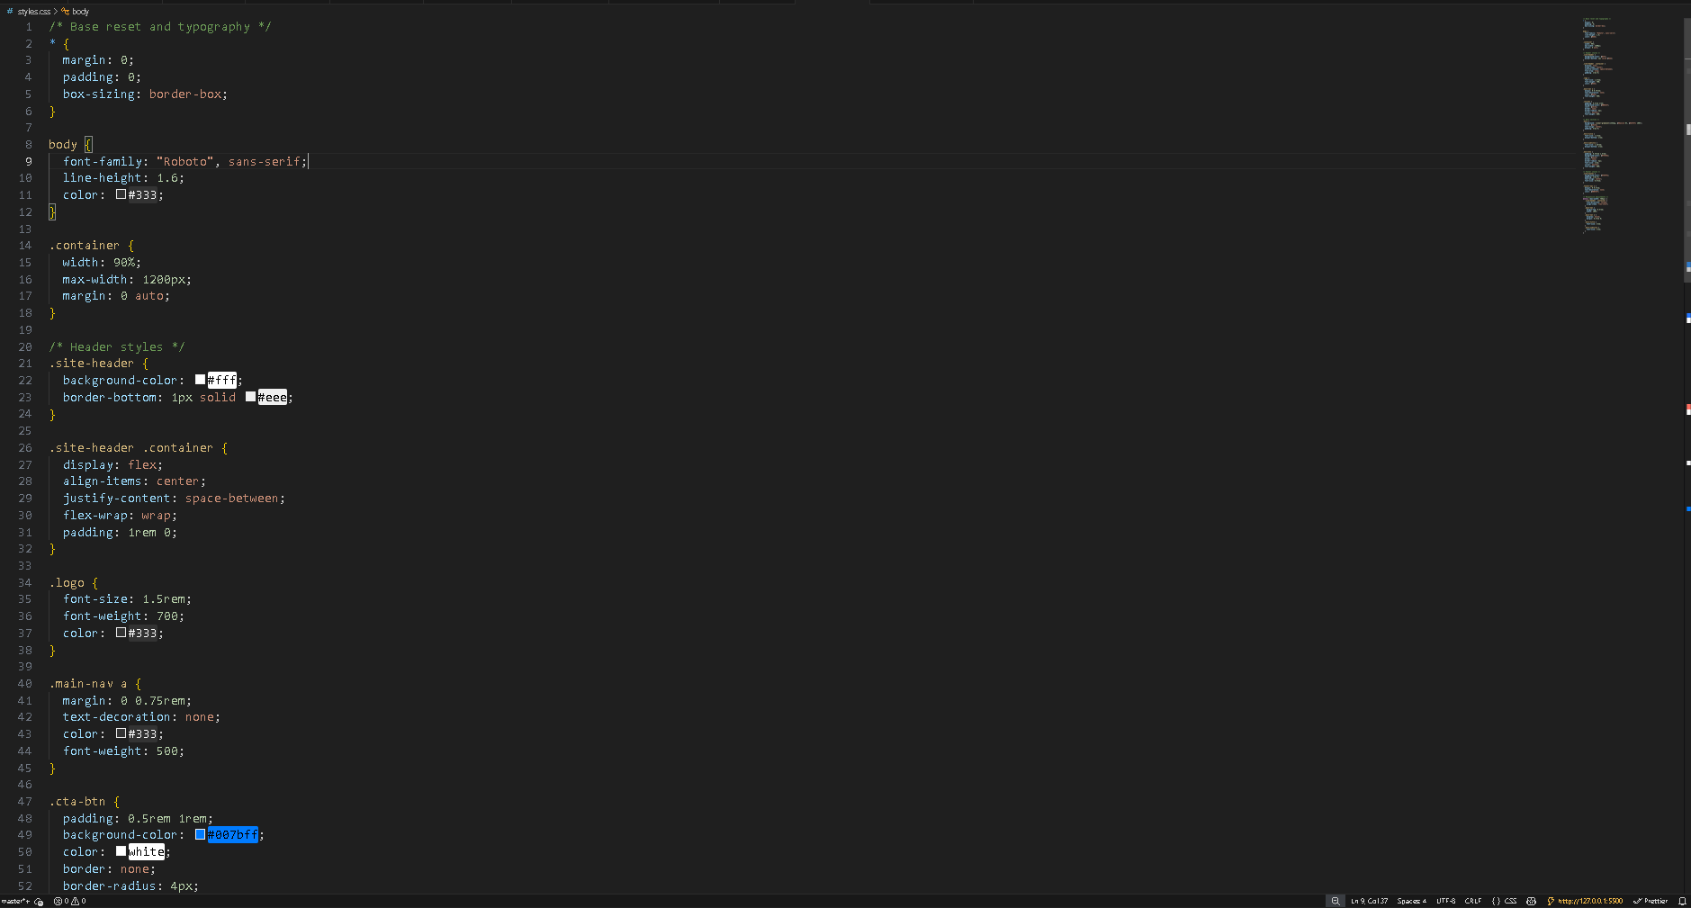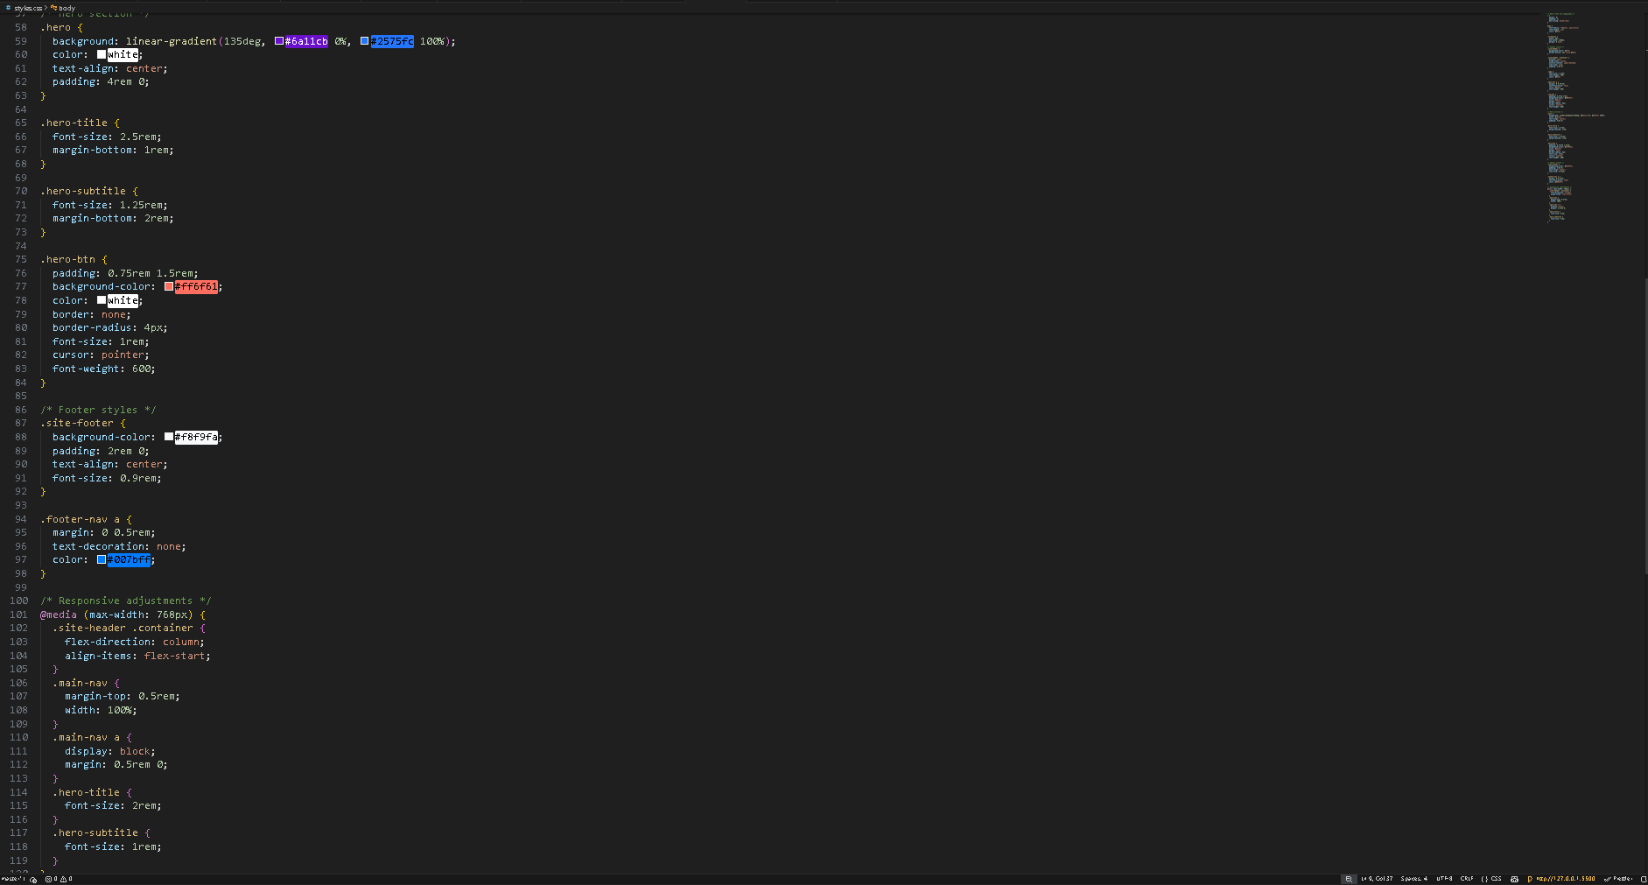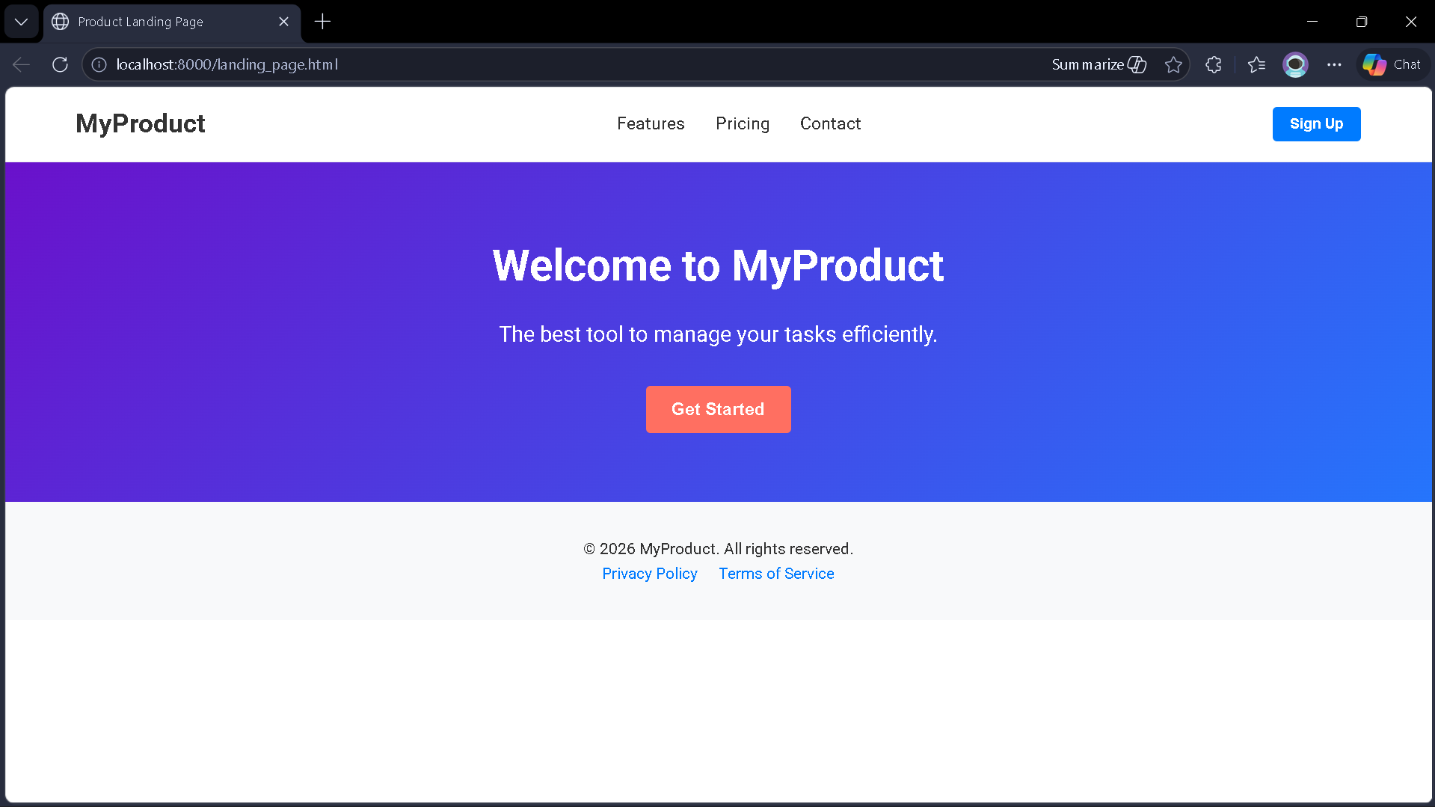
Task Description 2 – (Theme Toggle Feature)
• Provide a button to switch between light and dark themes..
Requirements:
• Use JavaScript to toggle CSS classes.
• Use AI assistance to manage color contrast and accessibility.
• Ensure theme preference applies instantly on click.

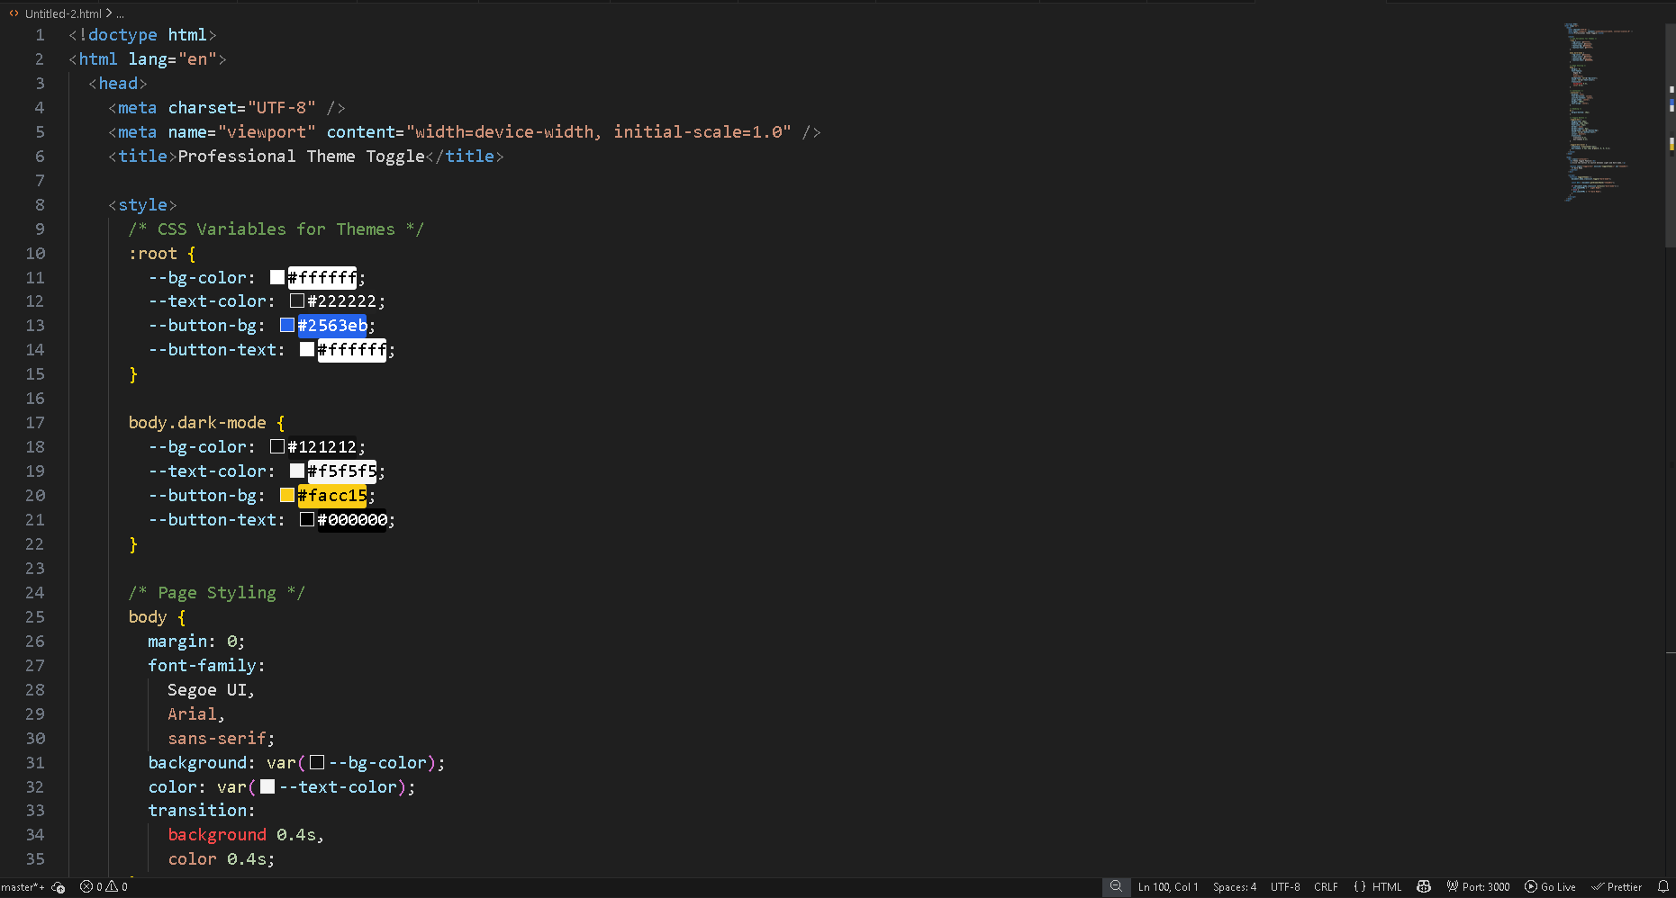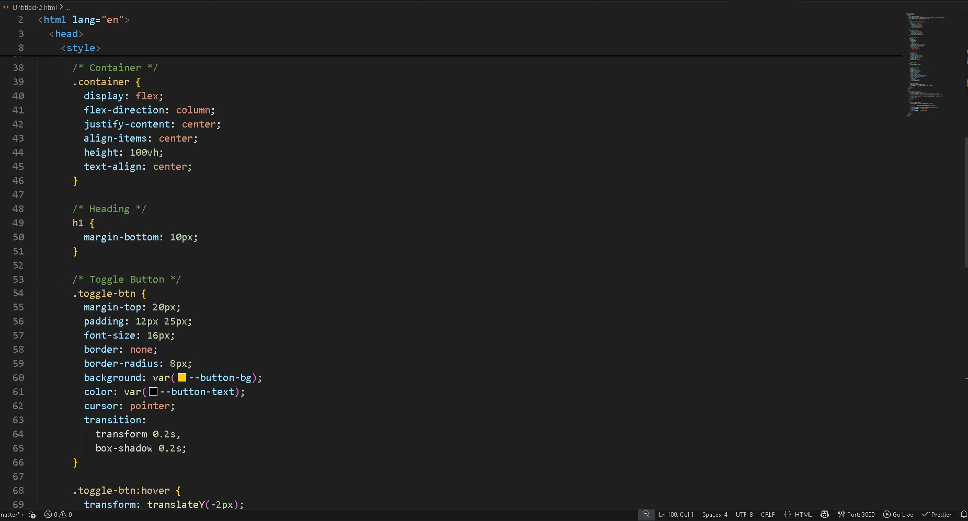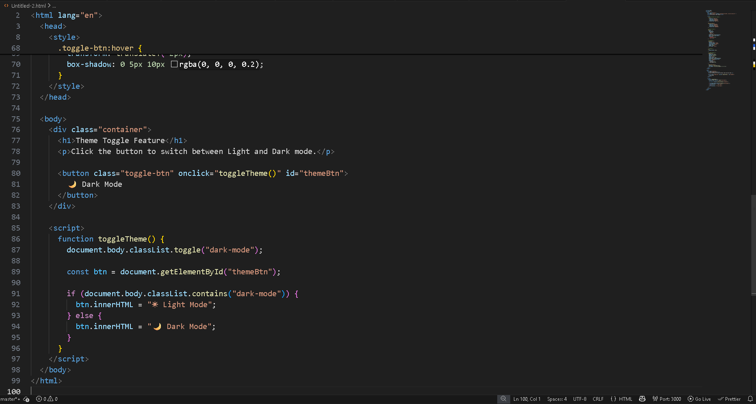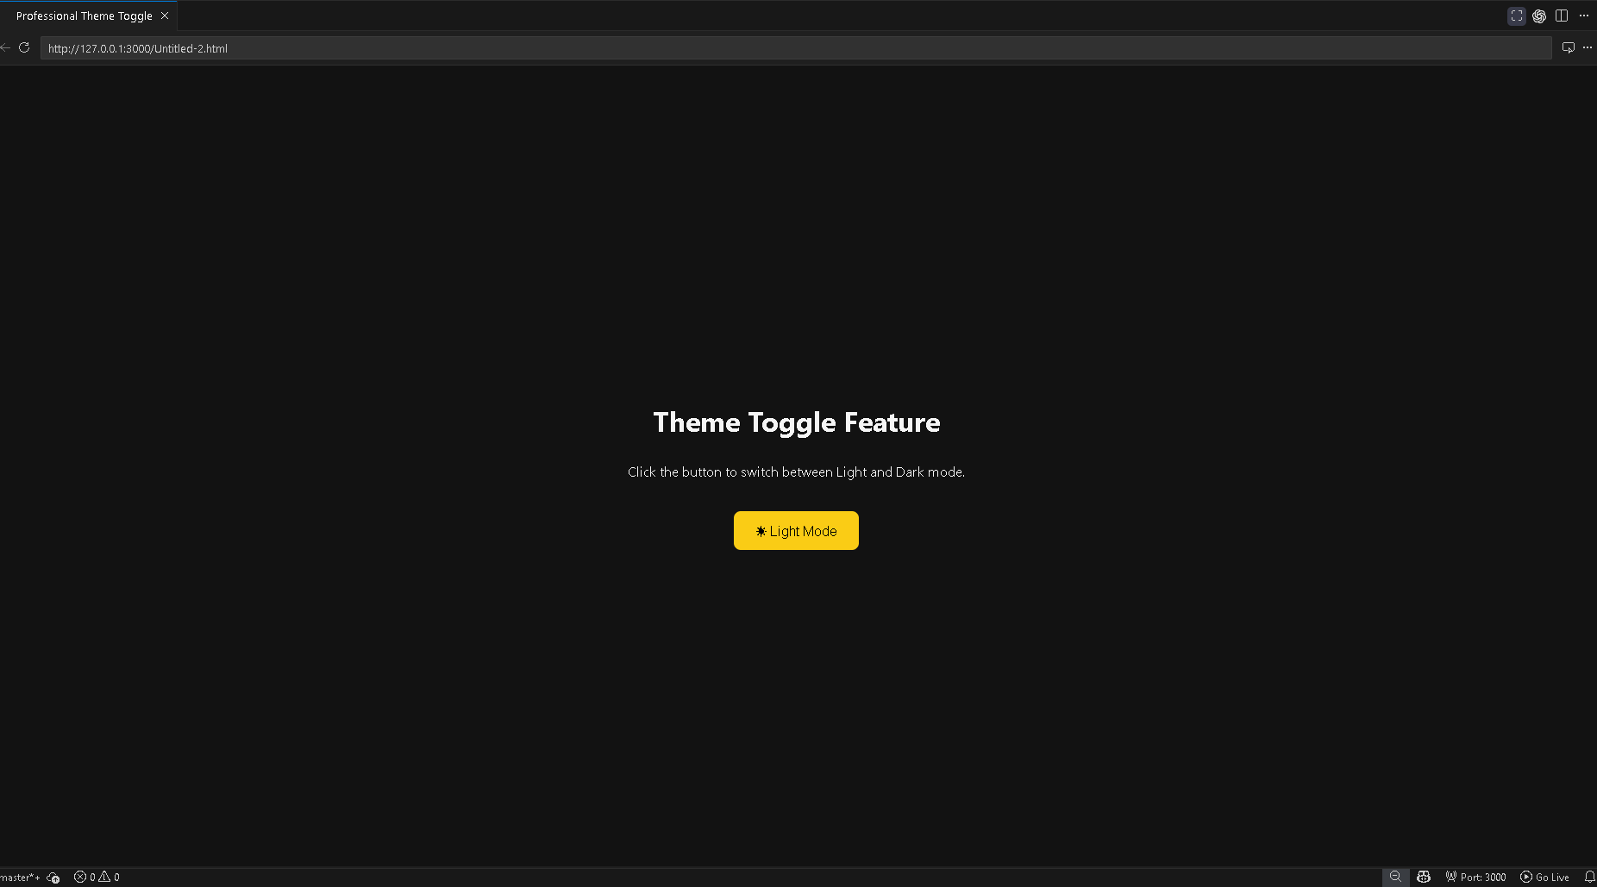
Task Description 3 – (User Feedback Form)
• Create a feedback form with fields: Username, Rating, Comments.
Requirements:
• Use JavaScript to validate required fields.
• Display success or error messages dynamically.
• Use AI to improve form usability and layout.

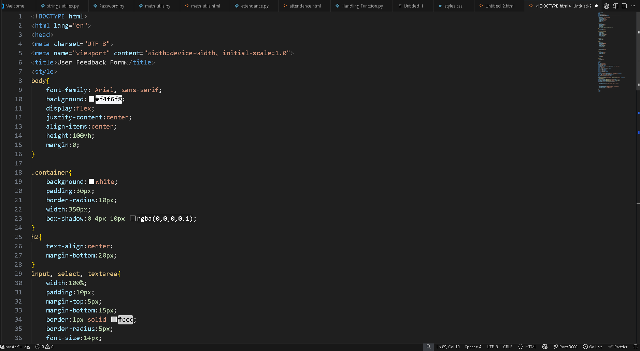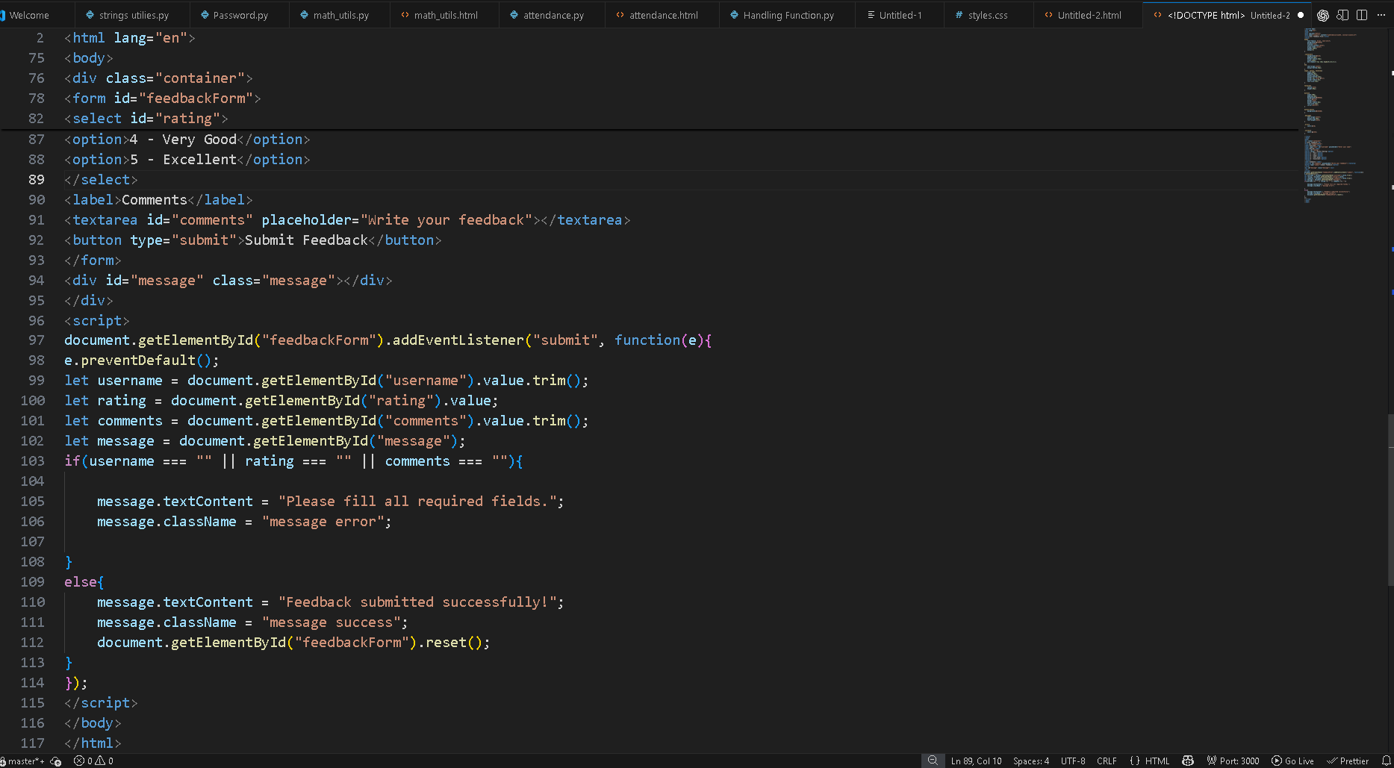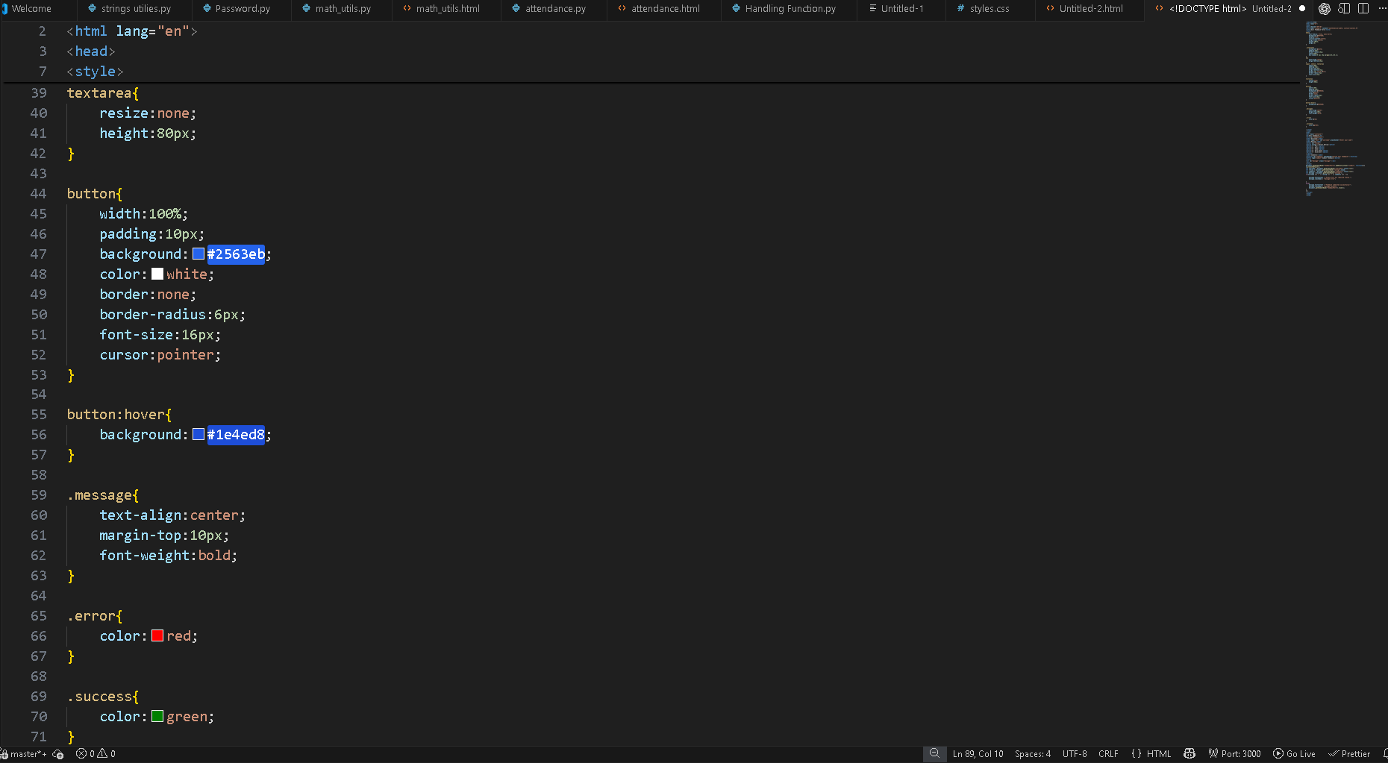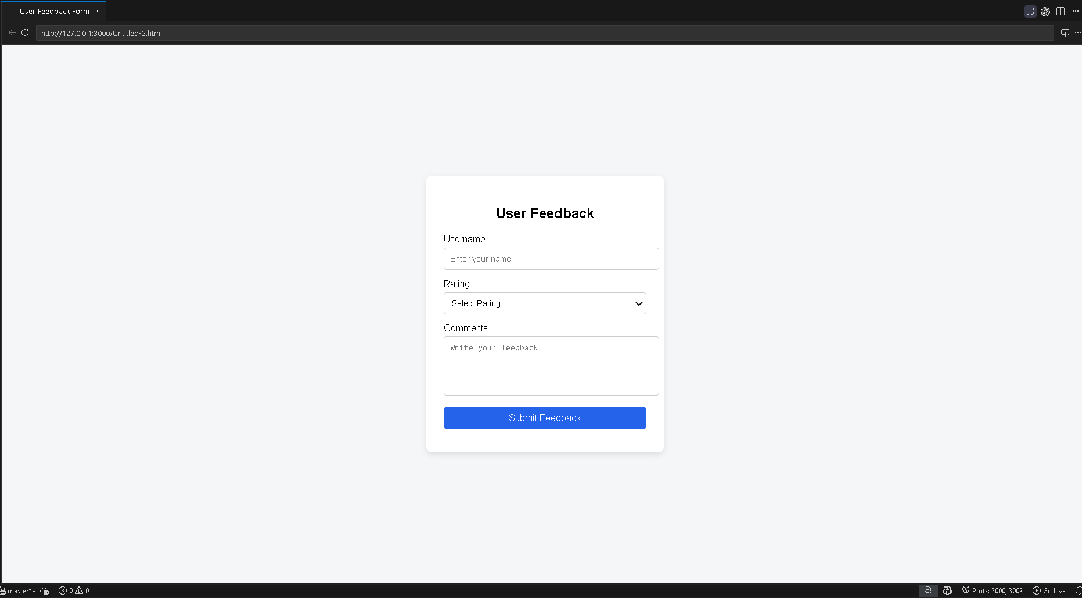

Task Description - 4 (Image Gallery with JavaScript)
• Task: Display a small image gallery on a web page.
Requirements:
• Use JavaScript to dynamically load images.
• Add next/previous navigation buttons.
• Use AI to optimize layout responsiveness.
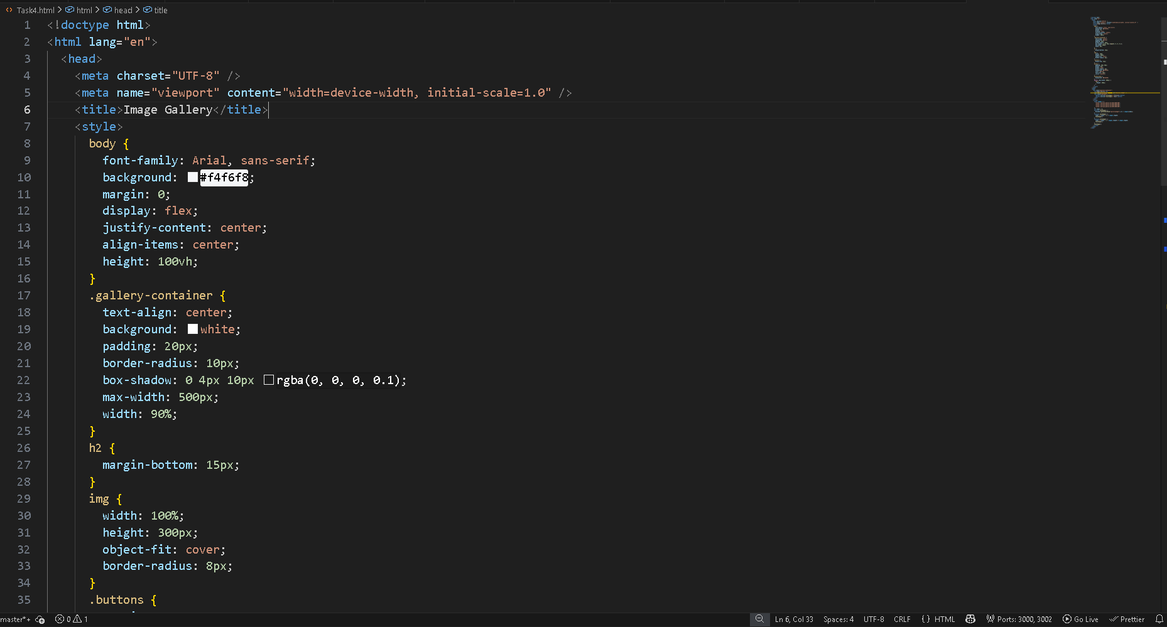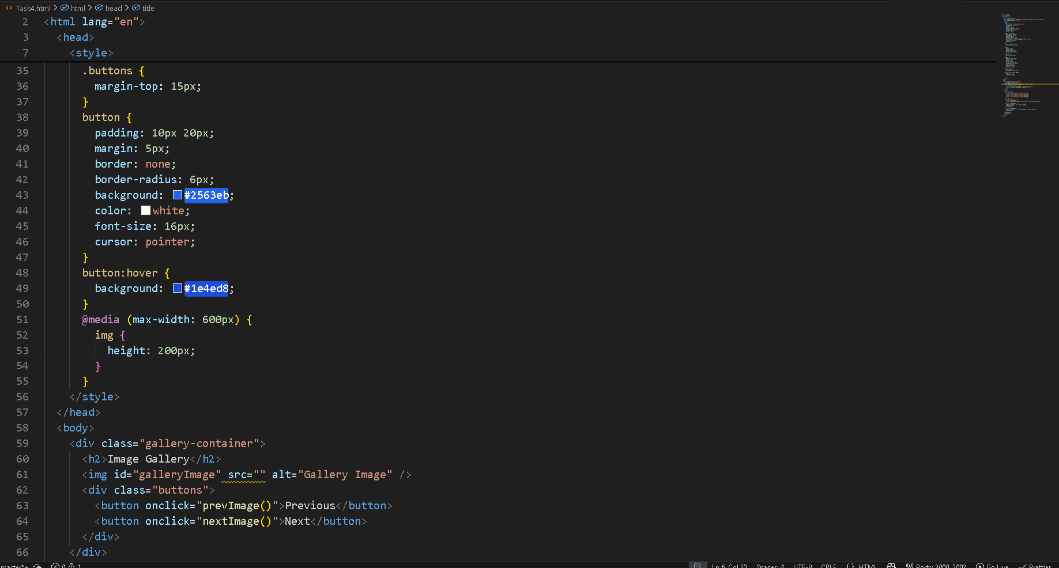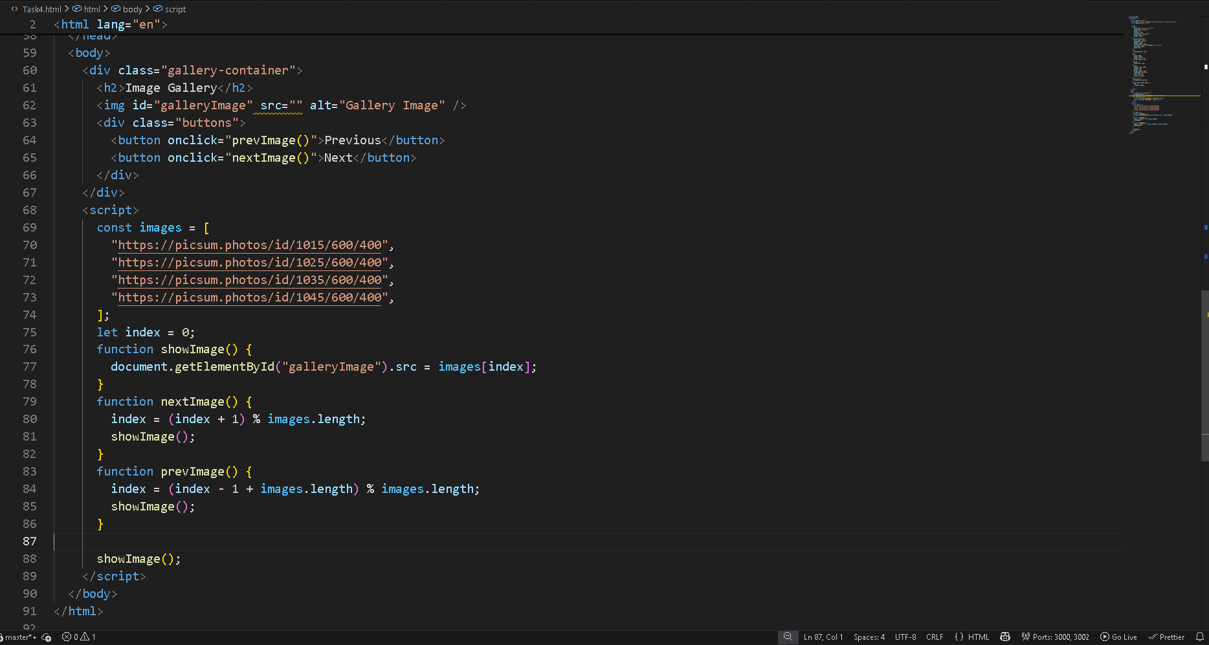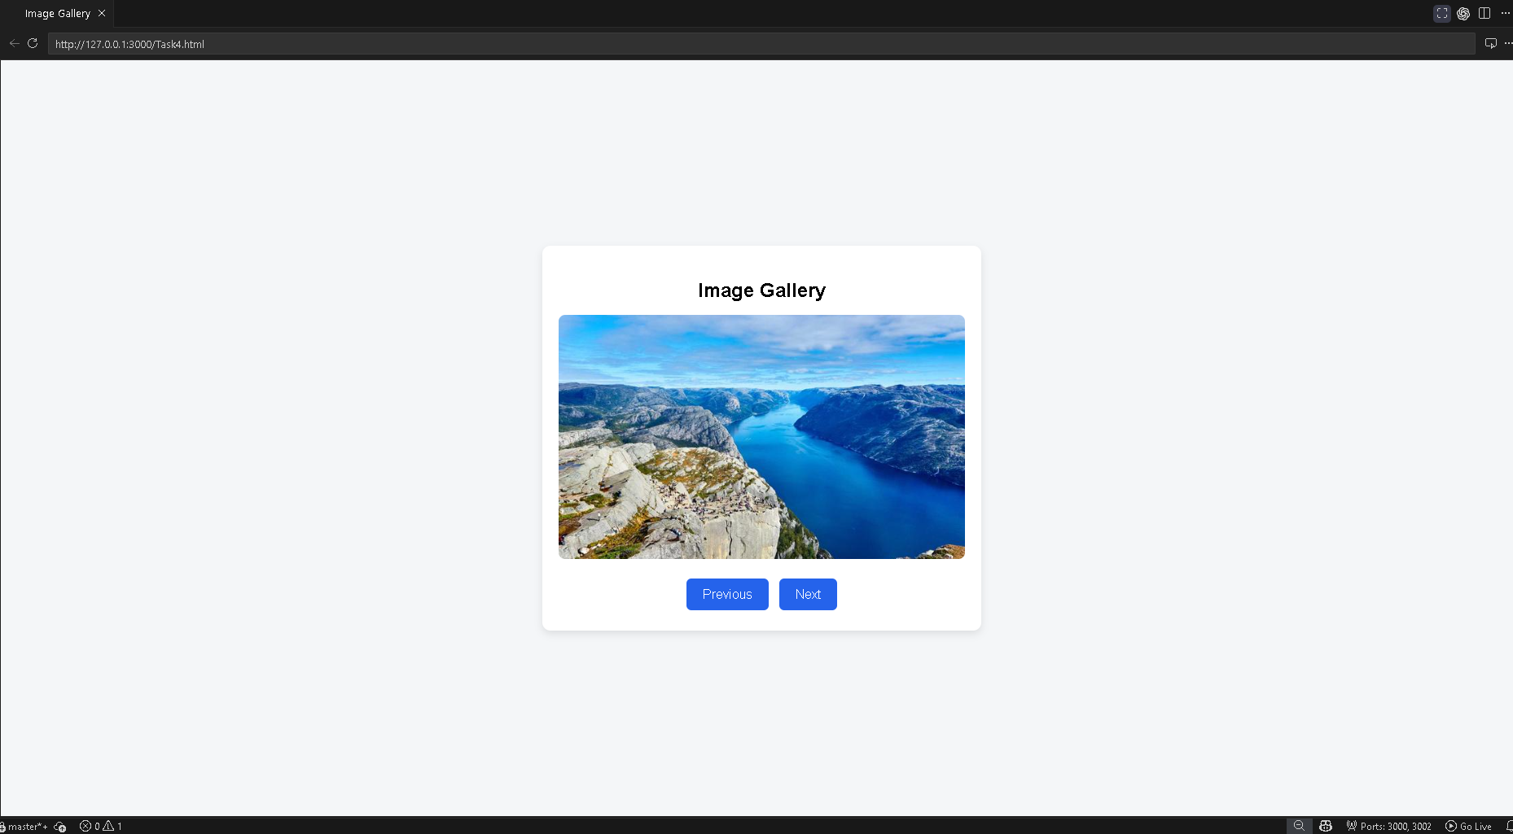
Task Description - 5: (Notification Banner)
• Display a notification banner at the top of the page.
Requirements:
• Use JavaScript to show and hide the banner.
• Style the banner using CSS.
• Use AI to ensure smooth transitions and clean UI behavior.

