AI Assisted Coding

Name : M.Harish
H.no : 2303A52387
Batch : 34
Course Code : 23CS002PC304
Assignment Number : 15.5

Lab 15 – Backend API Development: Creating RESTful services with AI
Task 1 – Student Attendance API
Task:
Create a RESTful API for student attendance tracking.
Instructions:
• Endpoints required:
o GET /attendance → View attendance records
o POST /attendance → Mark attendance
o PUT /attendance/{id} → Update attendance record
o DELETE /attendance/{id} → Remove attendance entry
• Ensure JSON-based request and response handling.
Expected Output:
• API for maintaining and updating attendance records.

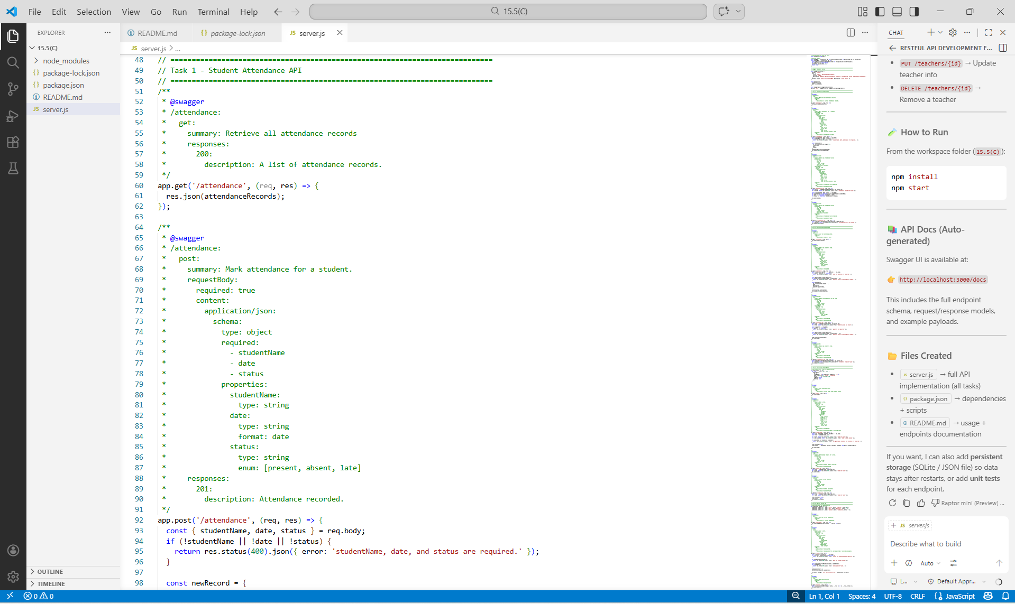

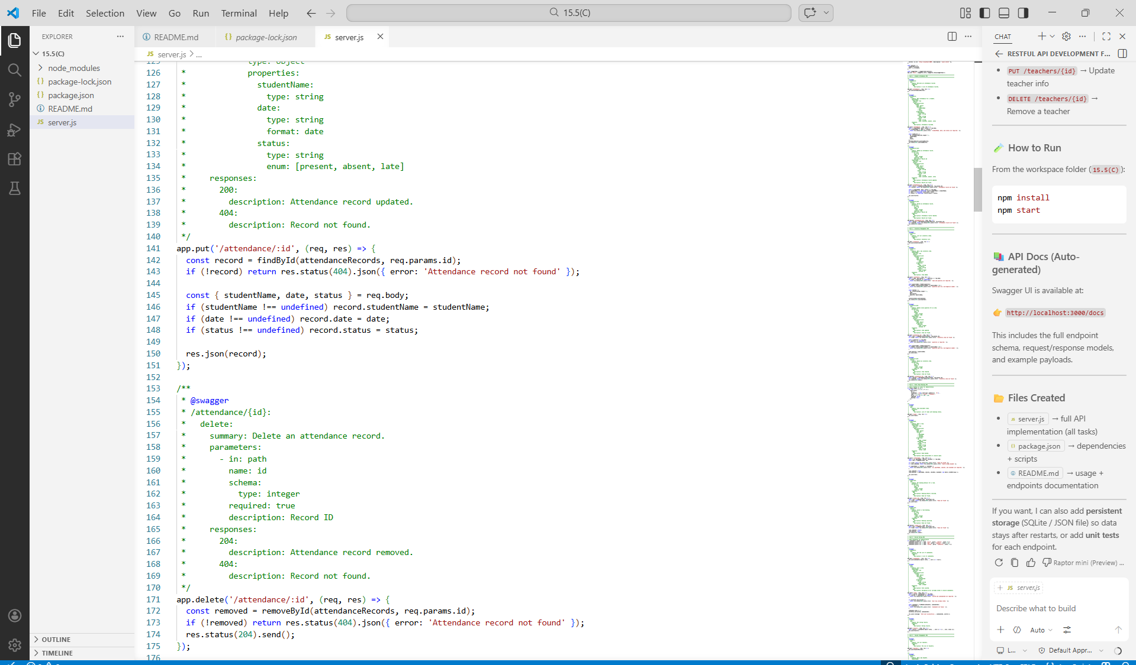

Task 2 – Inventory Management API
Task:
Develop a REST API for warehouse inventory management.
Instructions:
• Endpoints required:
o GET /inventory → List all items
o POST /inventory → Add new item
o PUT /inventory/{id} → Update stock quantity
o DELETE /inventory/{id} → Remove an item
• Implement validation for stock values.
Expected Output:
• API capable of managing inventory stock levels.

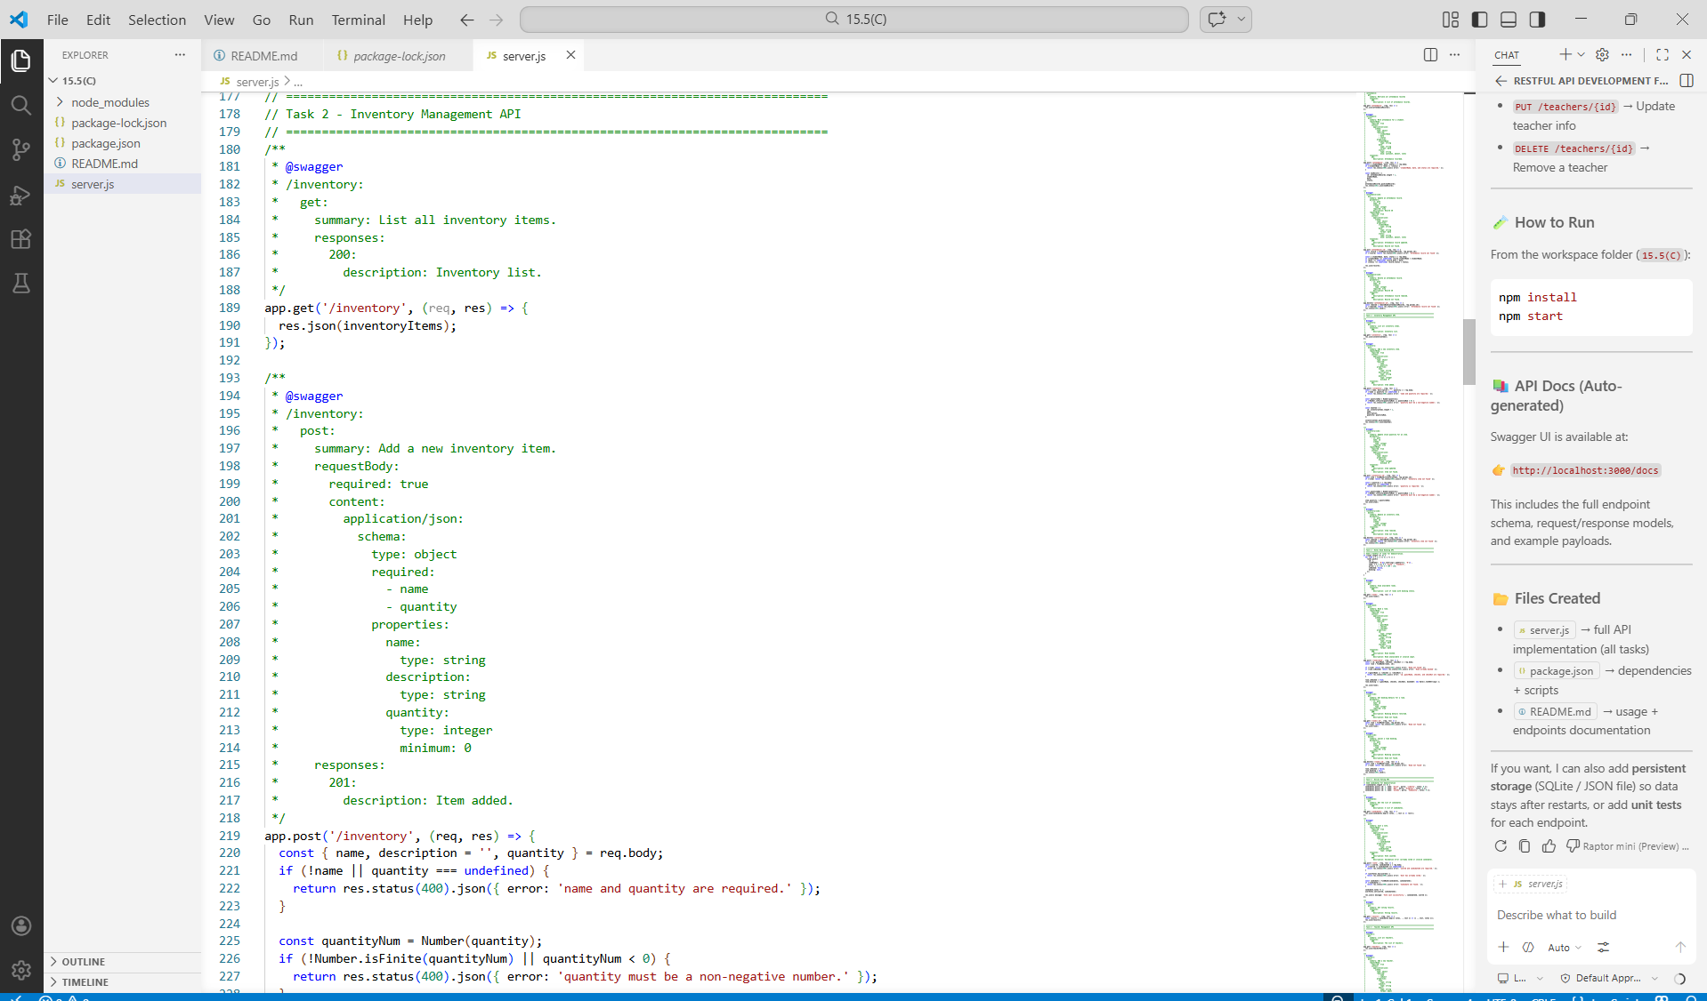

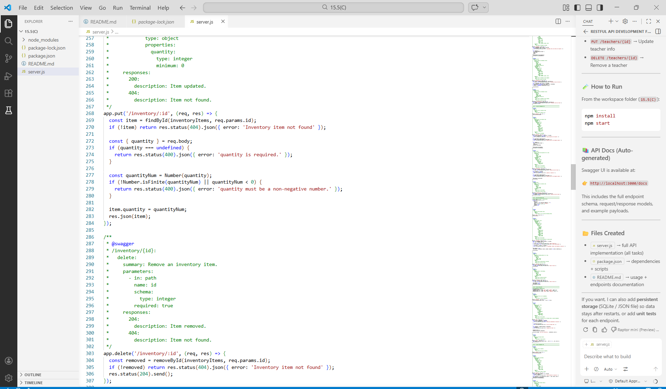

Task 3 – Hotel Room Booking API
Task:
Develop a RESTful API for hotel room booking.
Instructions:
• Endpoints required:
o GET /rooms → View available rooms
o POST /rooms/book → Book a room
o GET /rooms/{id} → View booking details
o DELETE /rooms/{id} → Cancel booking
• Implement error handling for unavailable rooms.
Expected Output:
• API simulating hotel room booking operations.
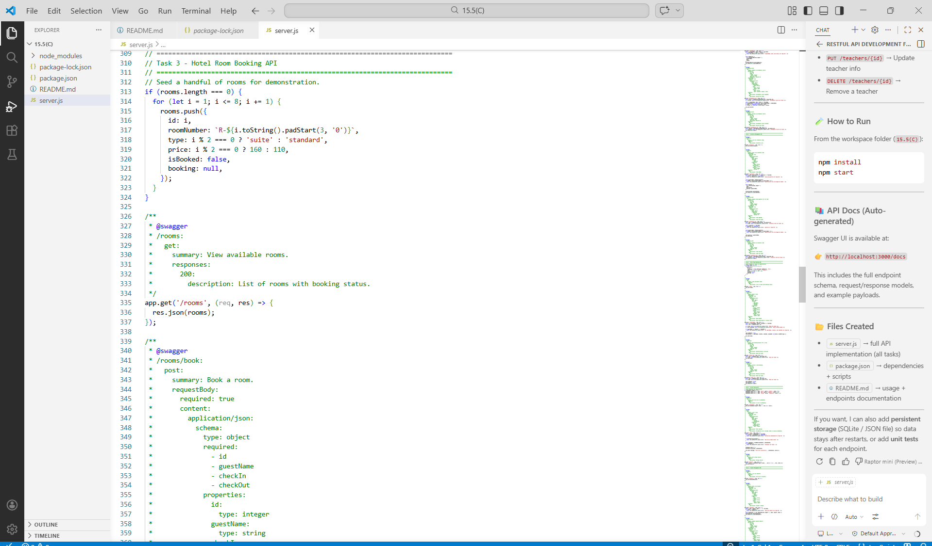

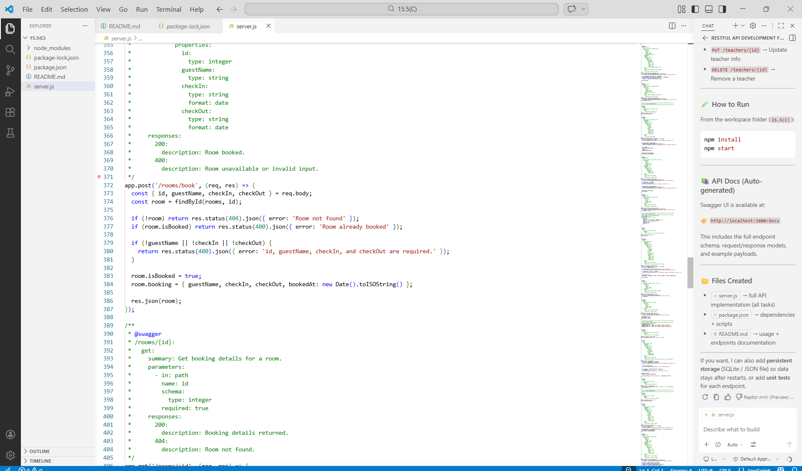

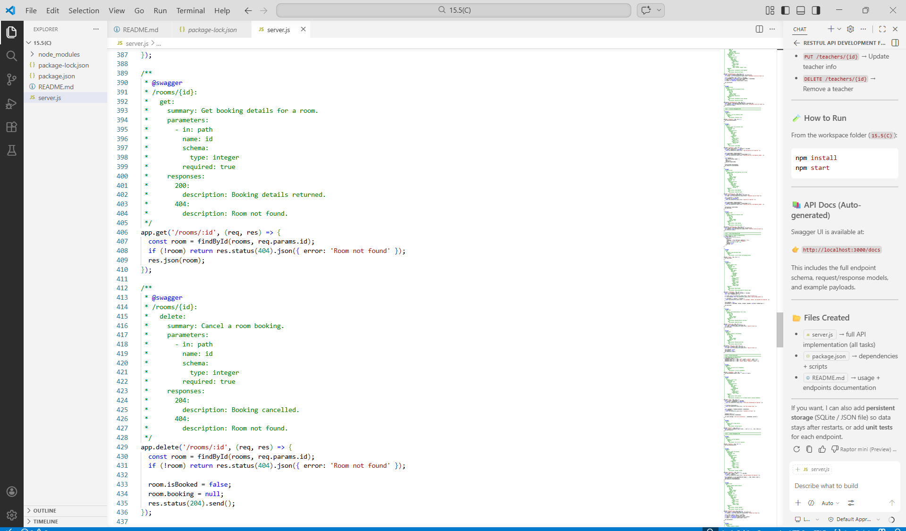

Task 4 – Online Voting API
Task:
Create a RESTful API for an online voting system.
Instructions:
• Endpoints required:
o GET /candidates → List candidates
o POST /vote → Cast a vote
o GET /results → View voting results
• Ensure one vote per user using in-memory validation.
Expected Output:
• API simulating a secure online voting process.
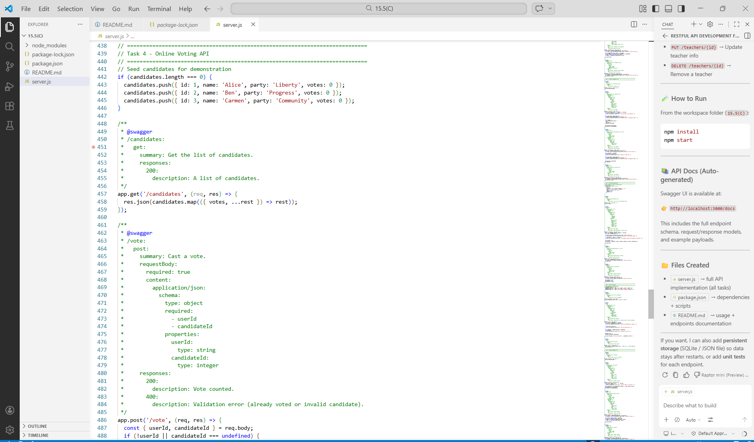

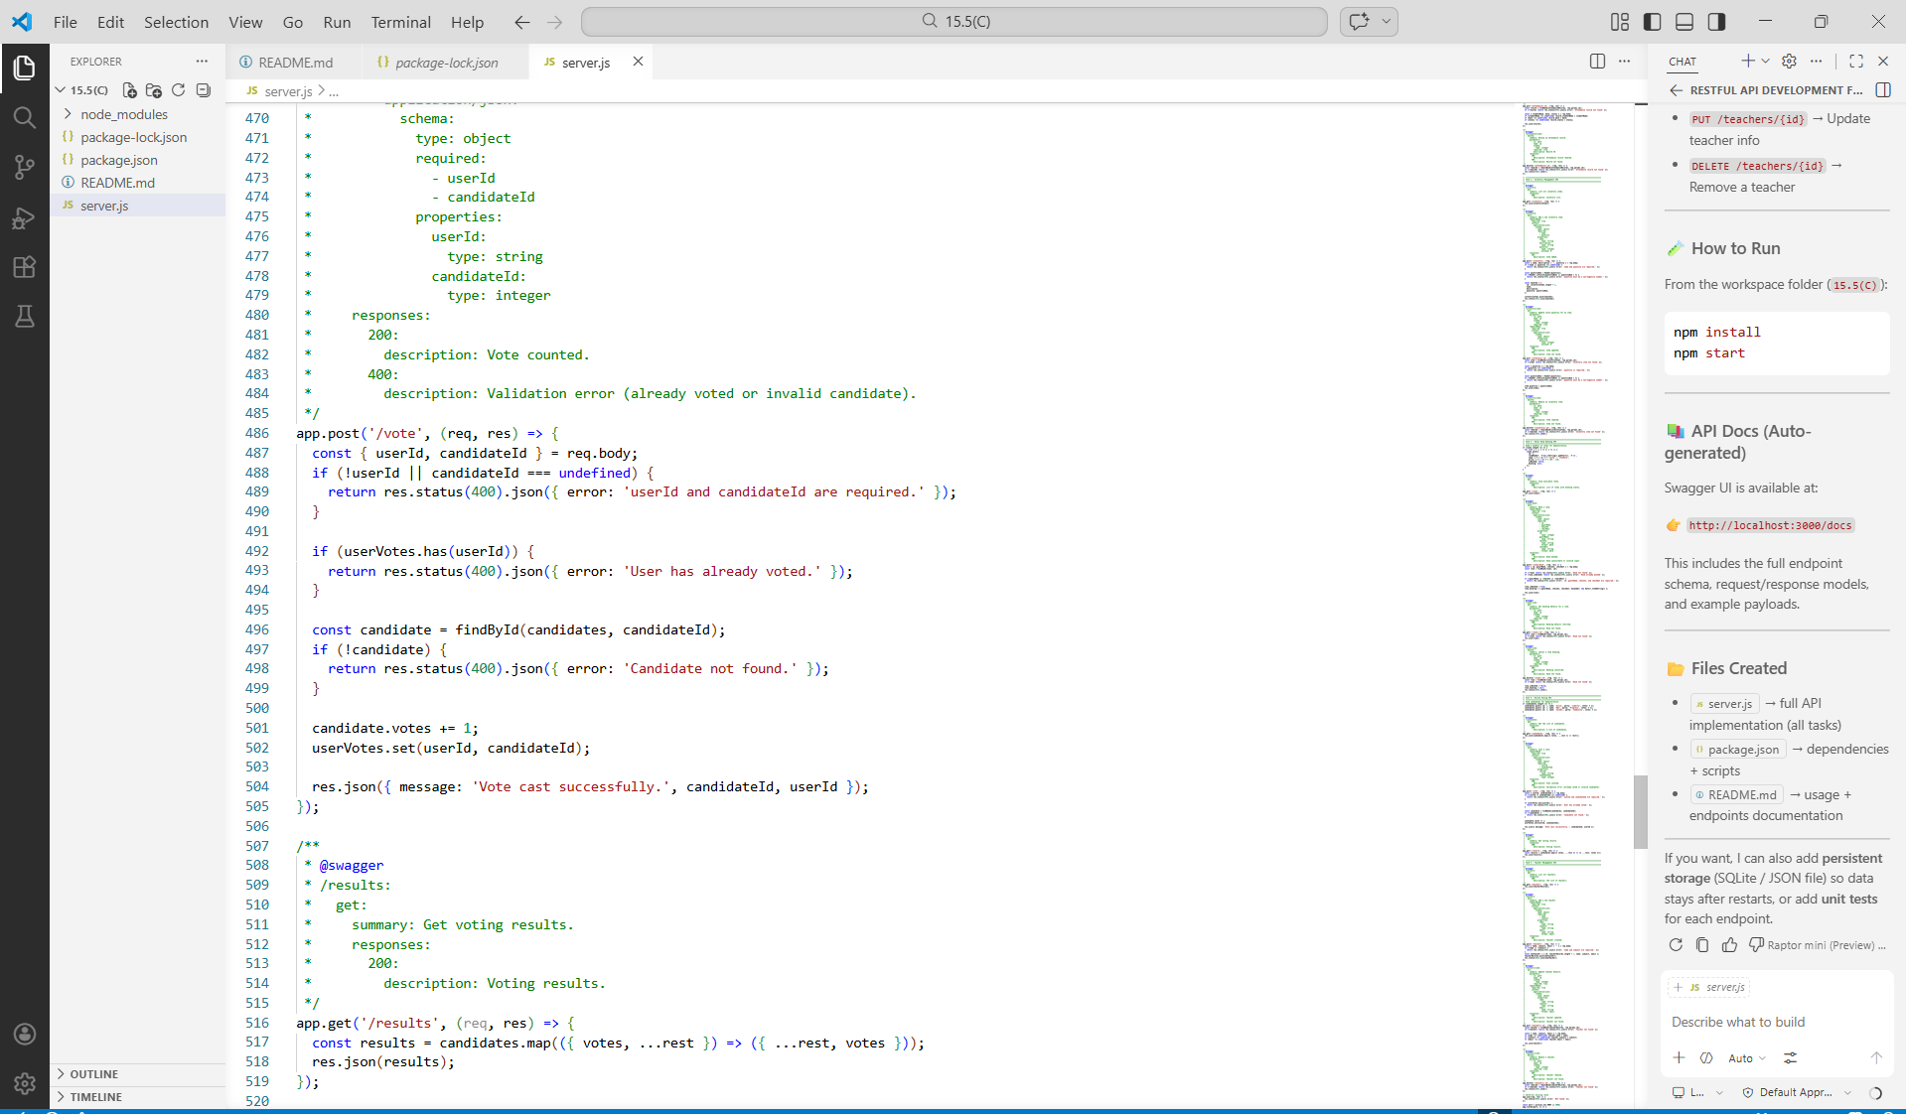

Task 5 – Teacher Management API
Task:
Develop a RESTful API to manage teacher records.
Instructions:
• Endpoints required:
o GET /teachers → List all teachers
o POST /teachers → Add a new teacher
o PUT /teachers/{id} → Update teacher details
o DELETE /teachers/{id} → Remove a teacher
• Ensure proper error handling and JSON responses.
Expected Output:
• Functional API for managing teacher information.

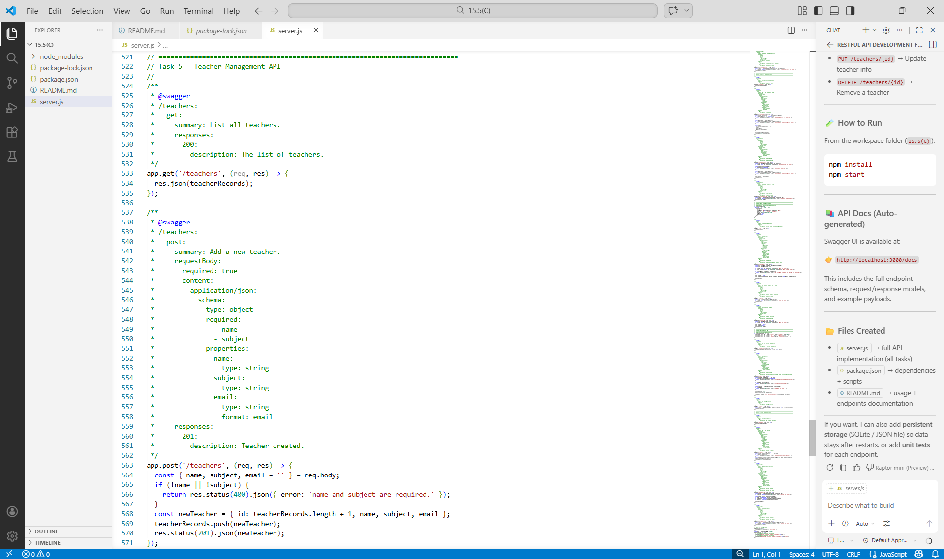

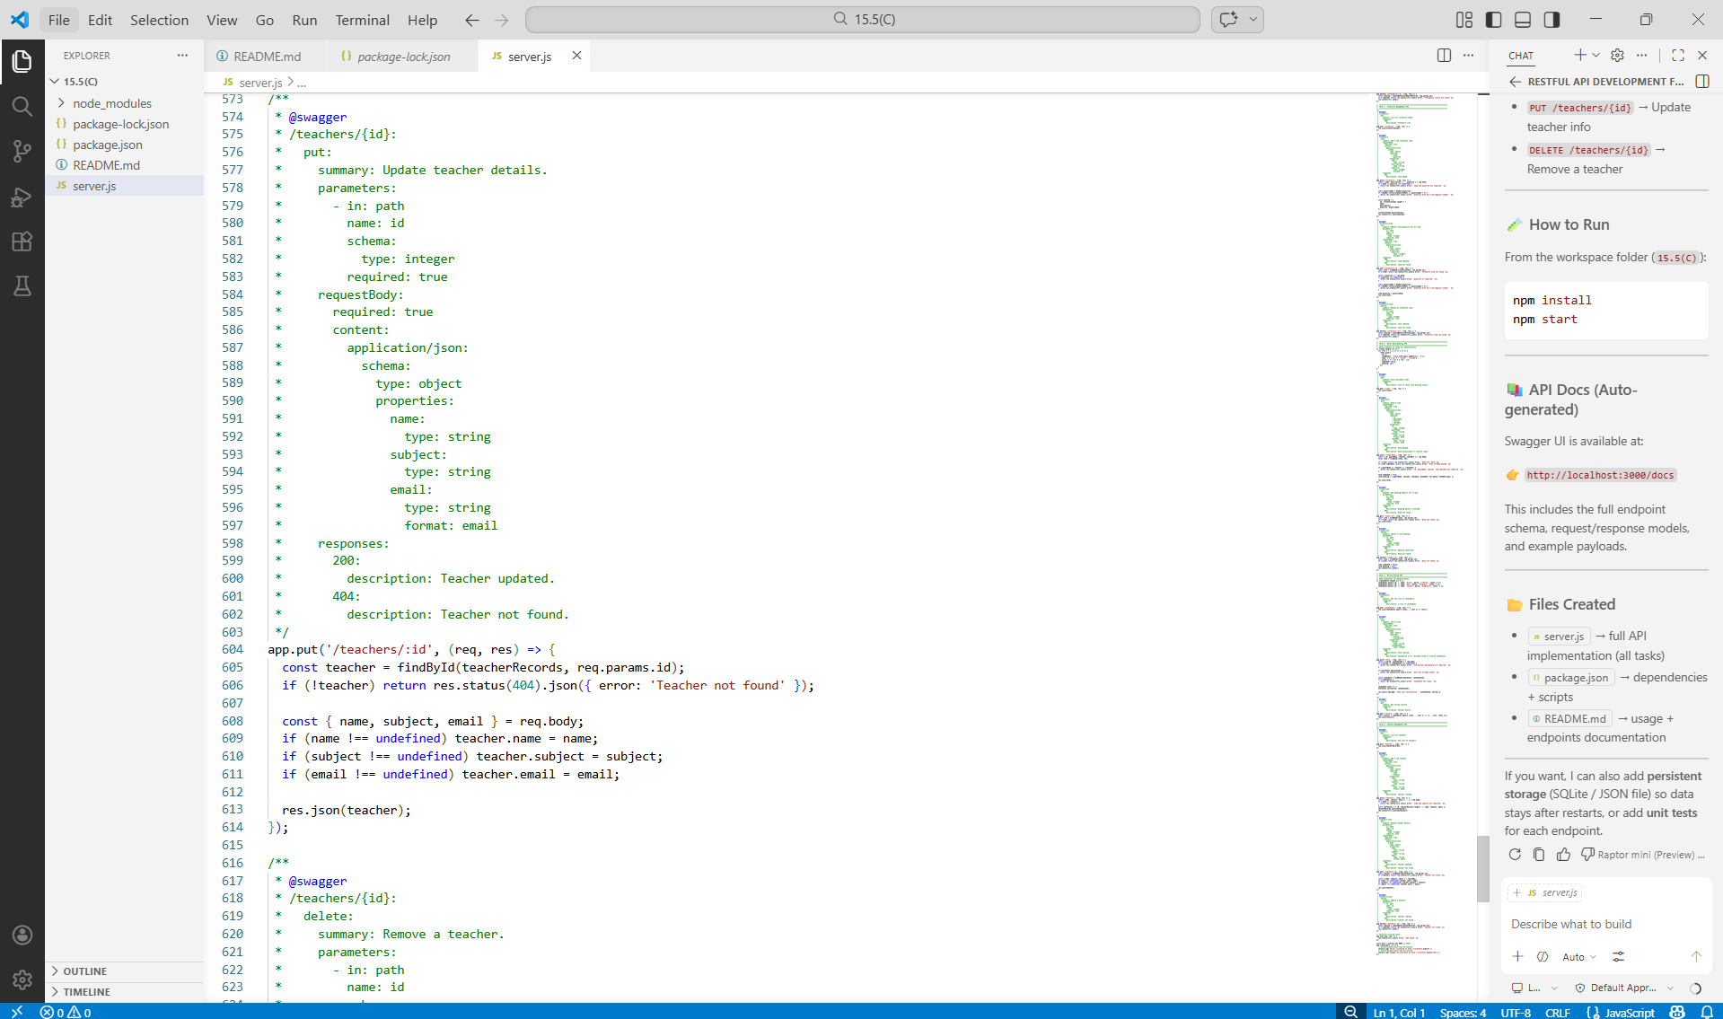

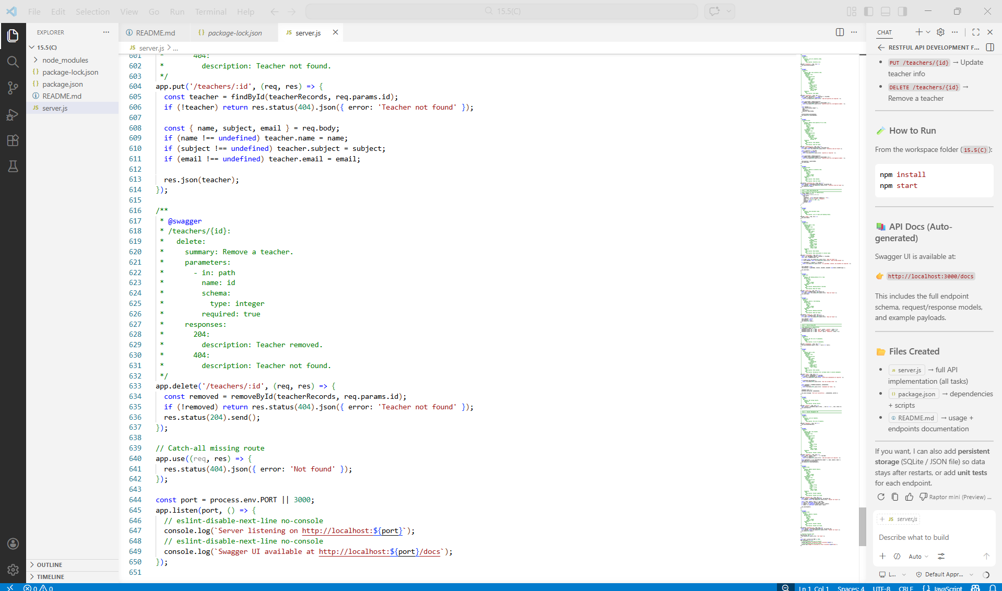

Backend API Development
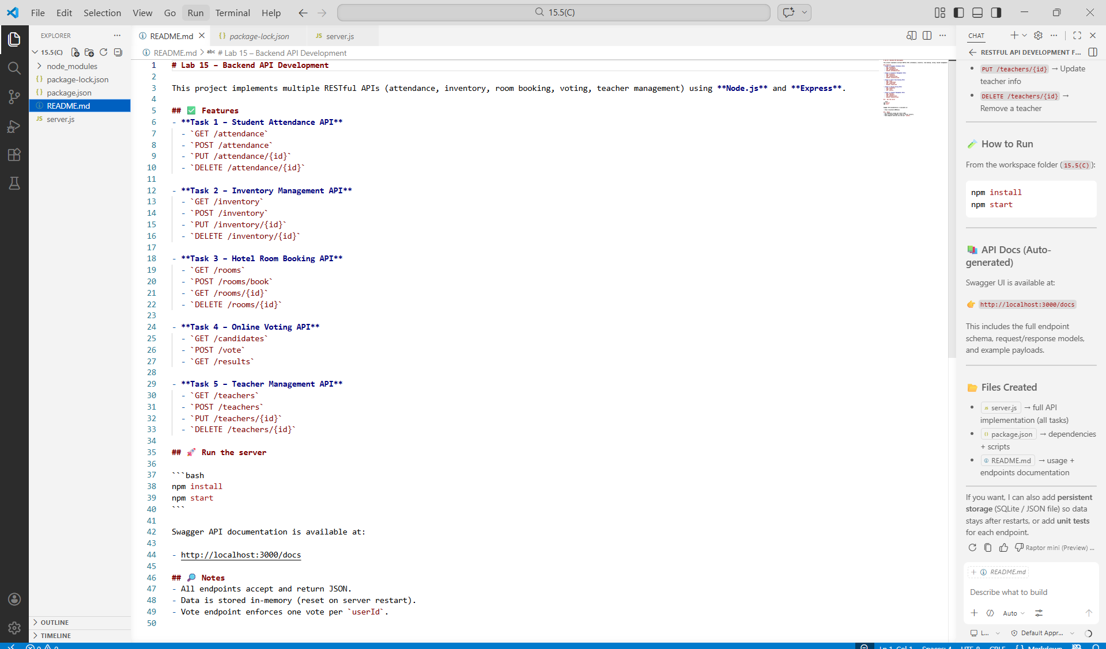

Install Project & Run the Project
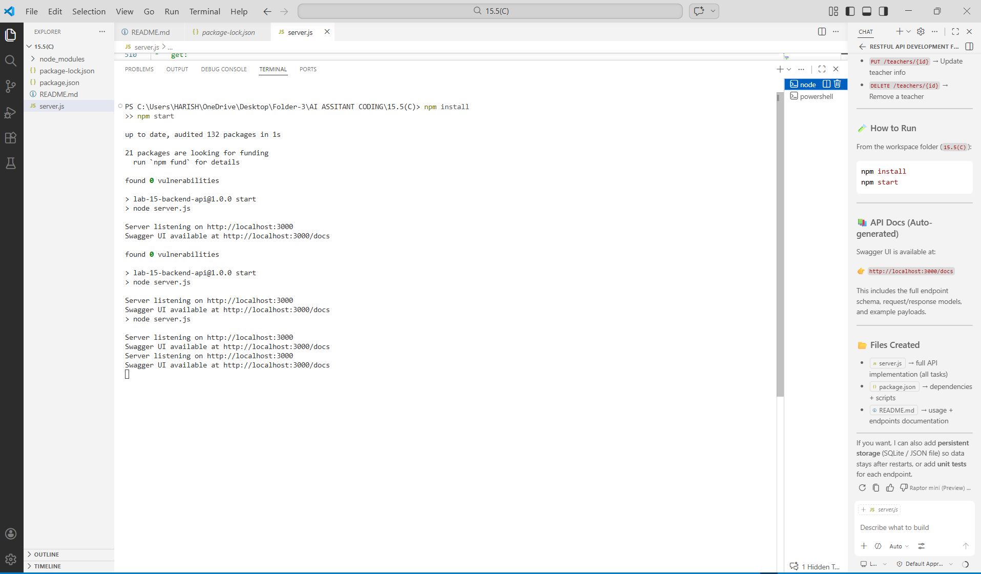

Server listening on http://localhost:3000
Swagger UI available at http://localhost:3000/docs
http://localhost:3000/docs :

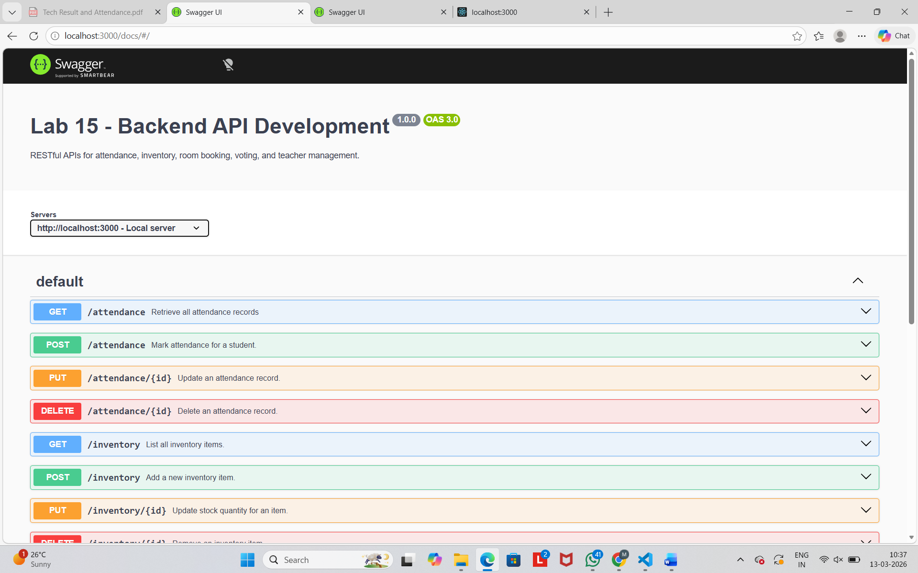

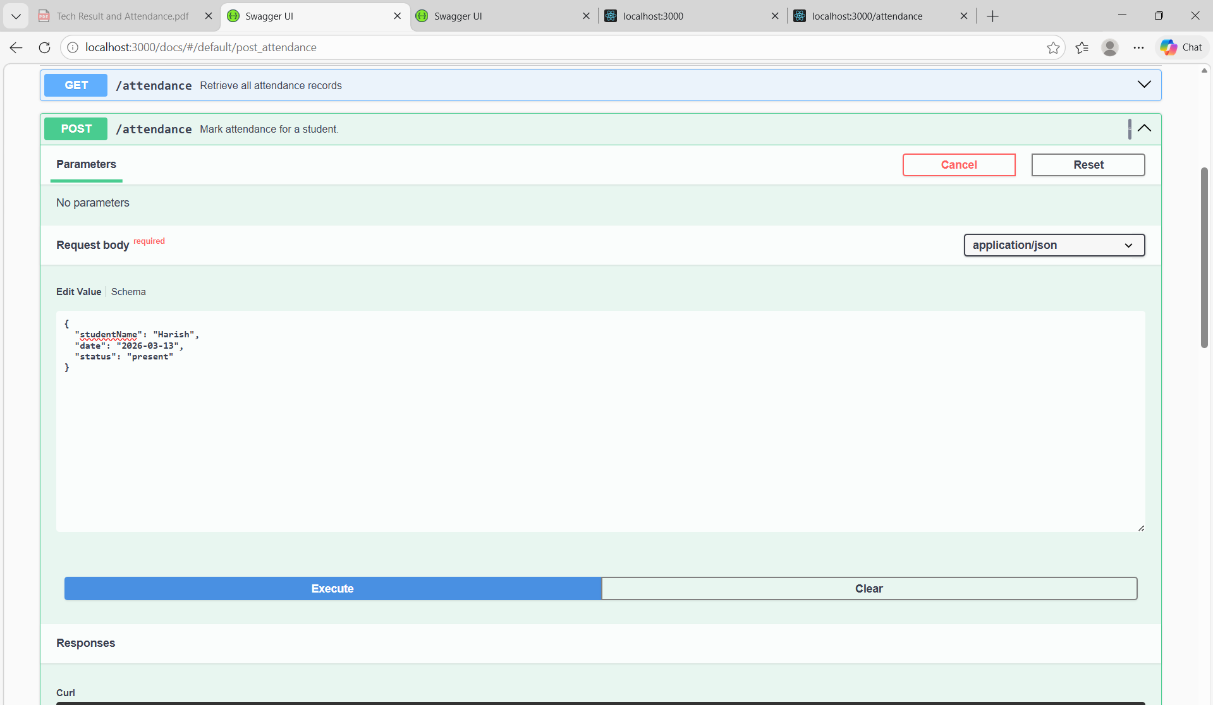

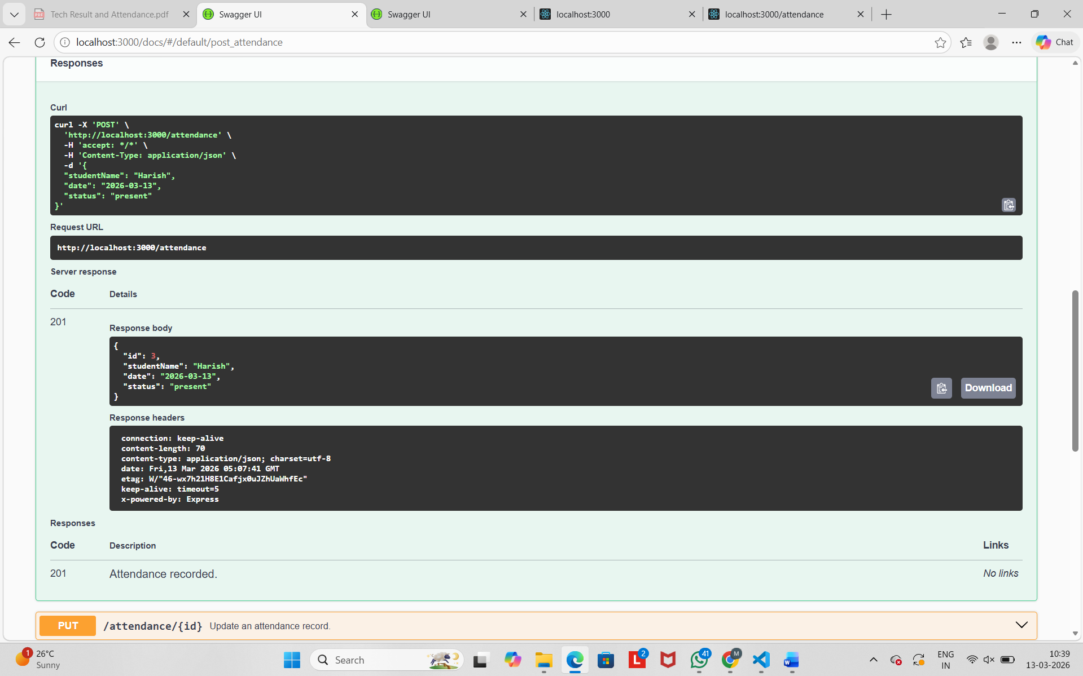

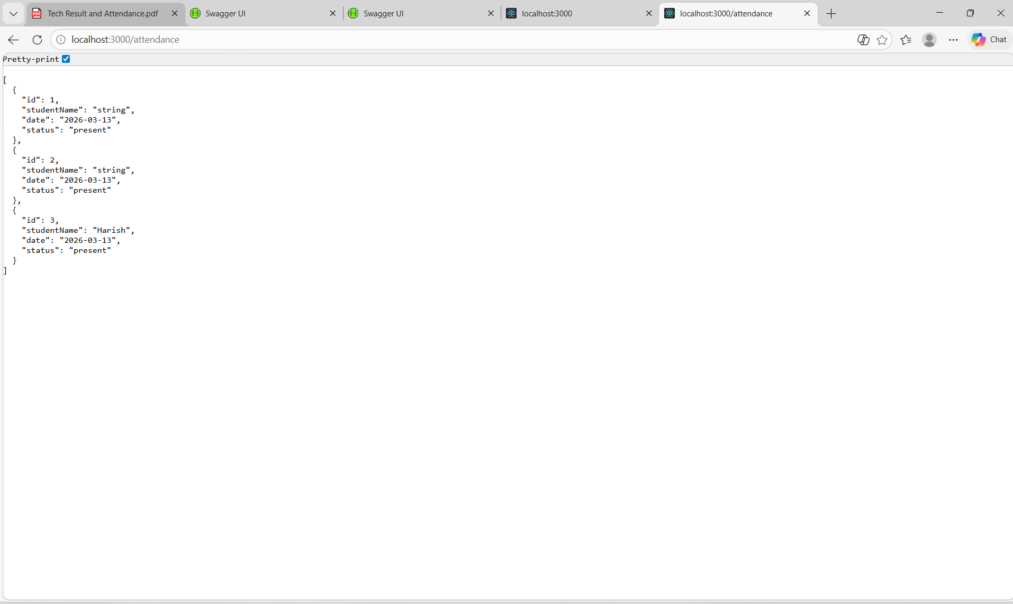

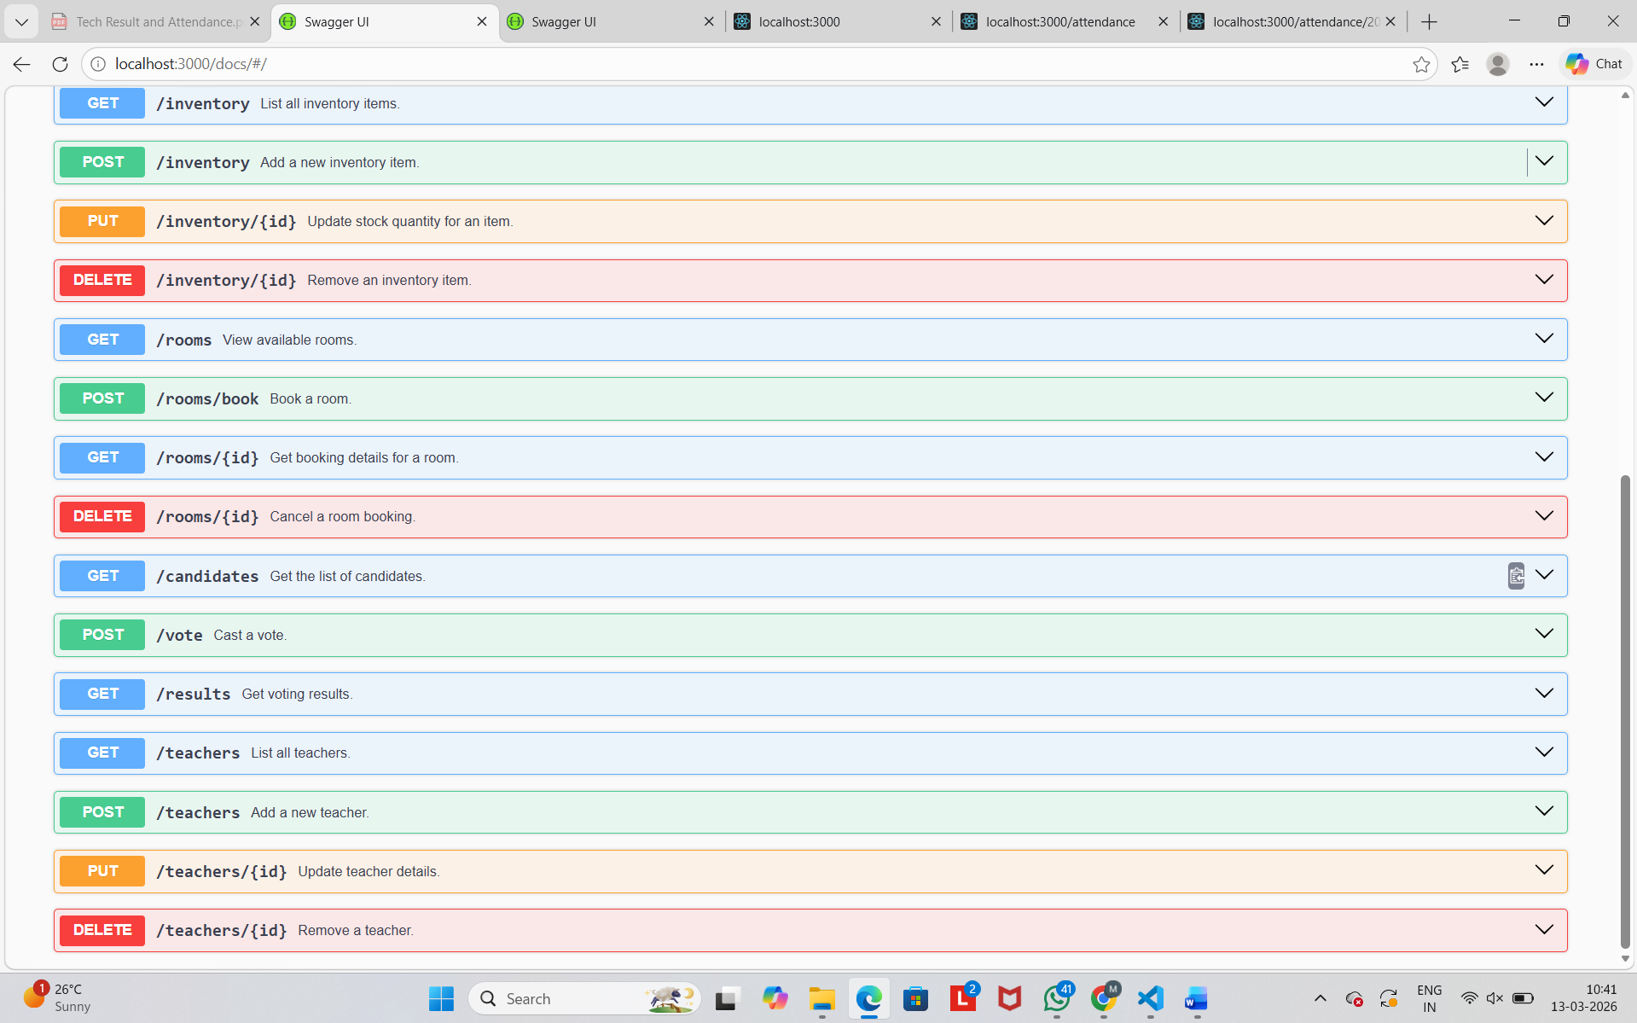

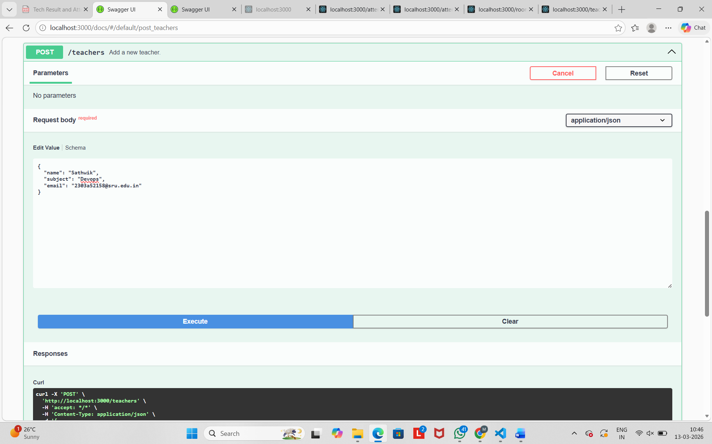

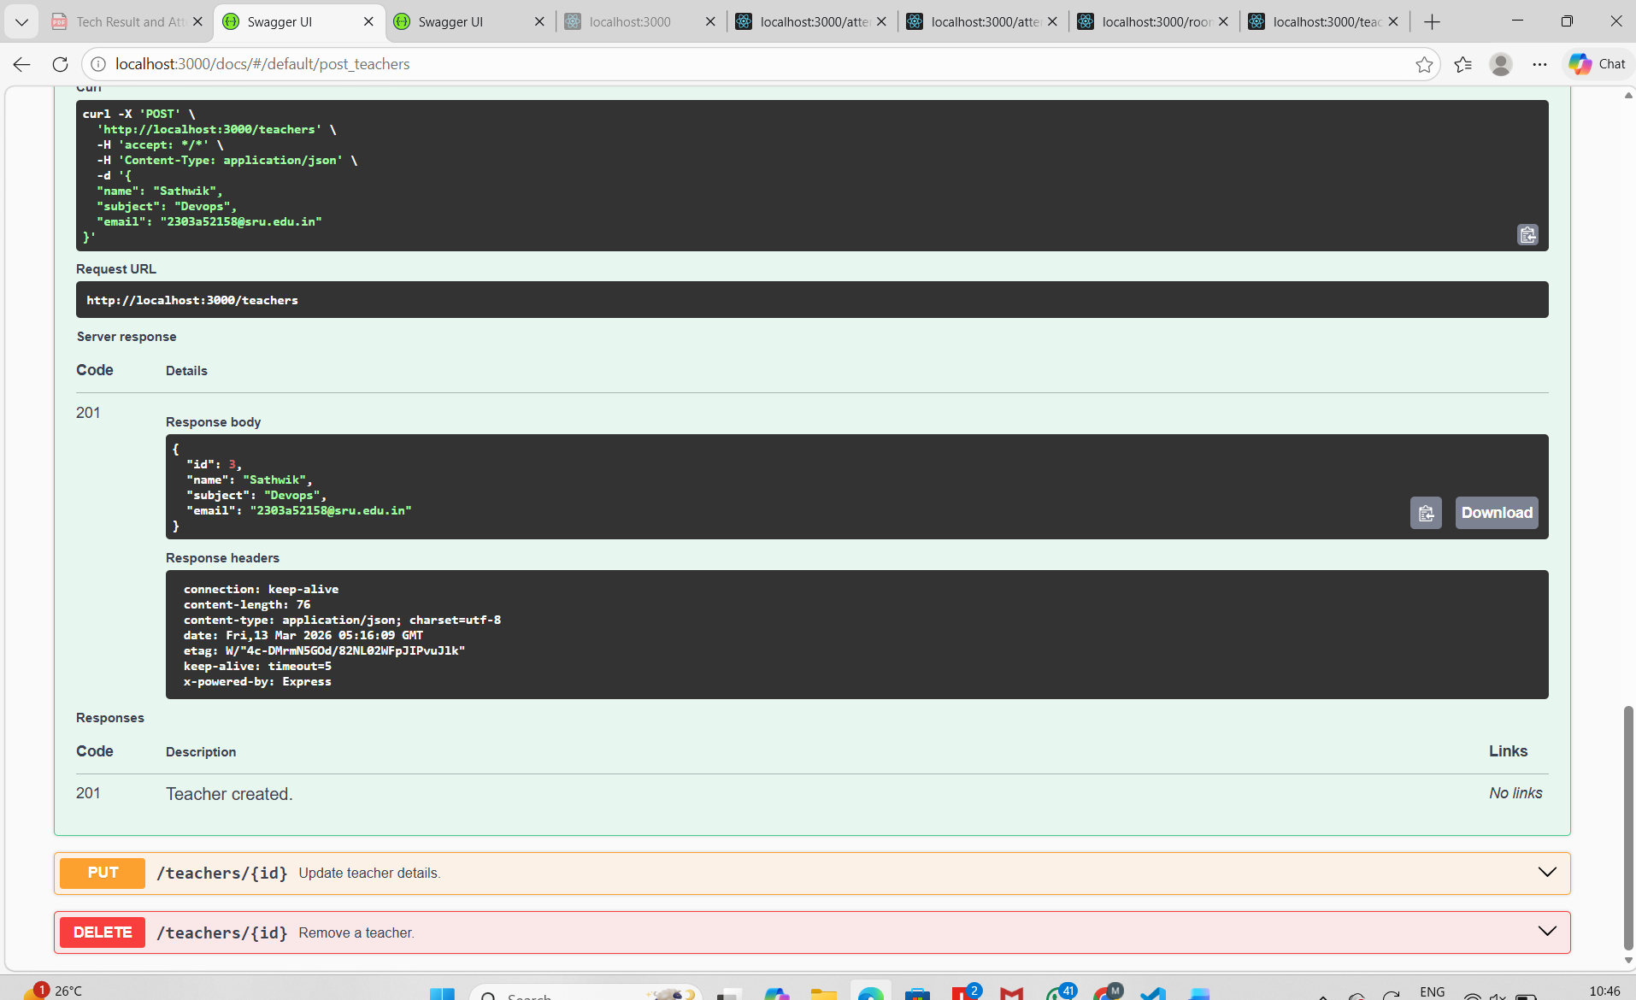
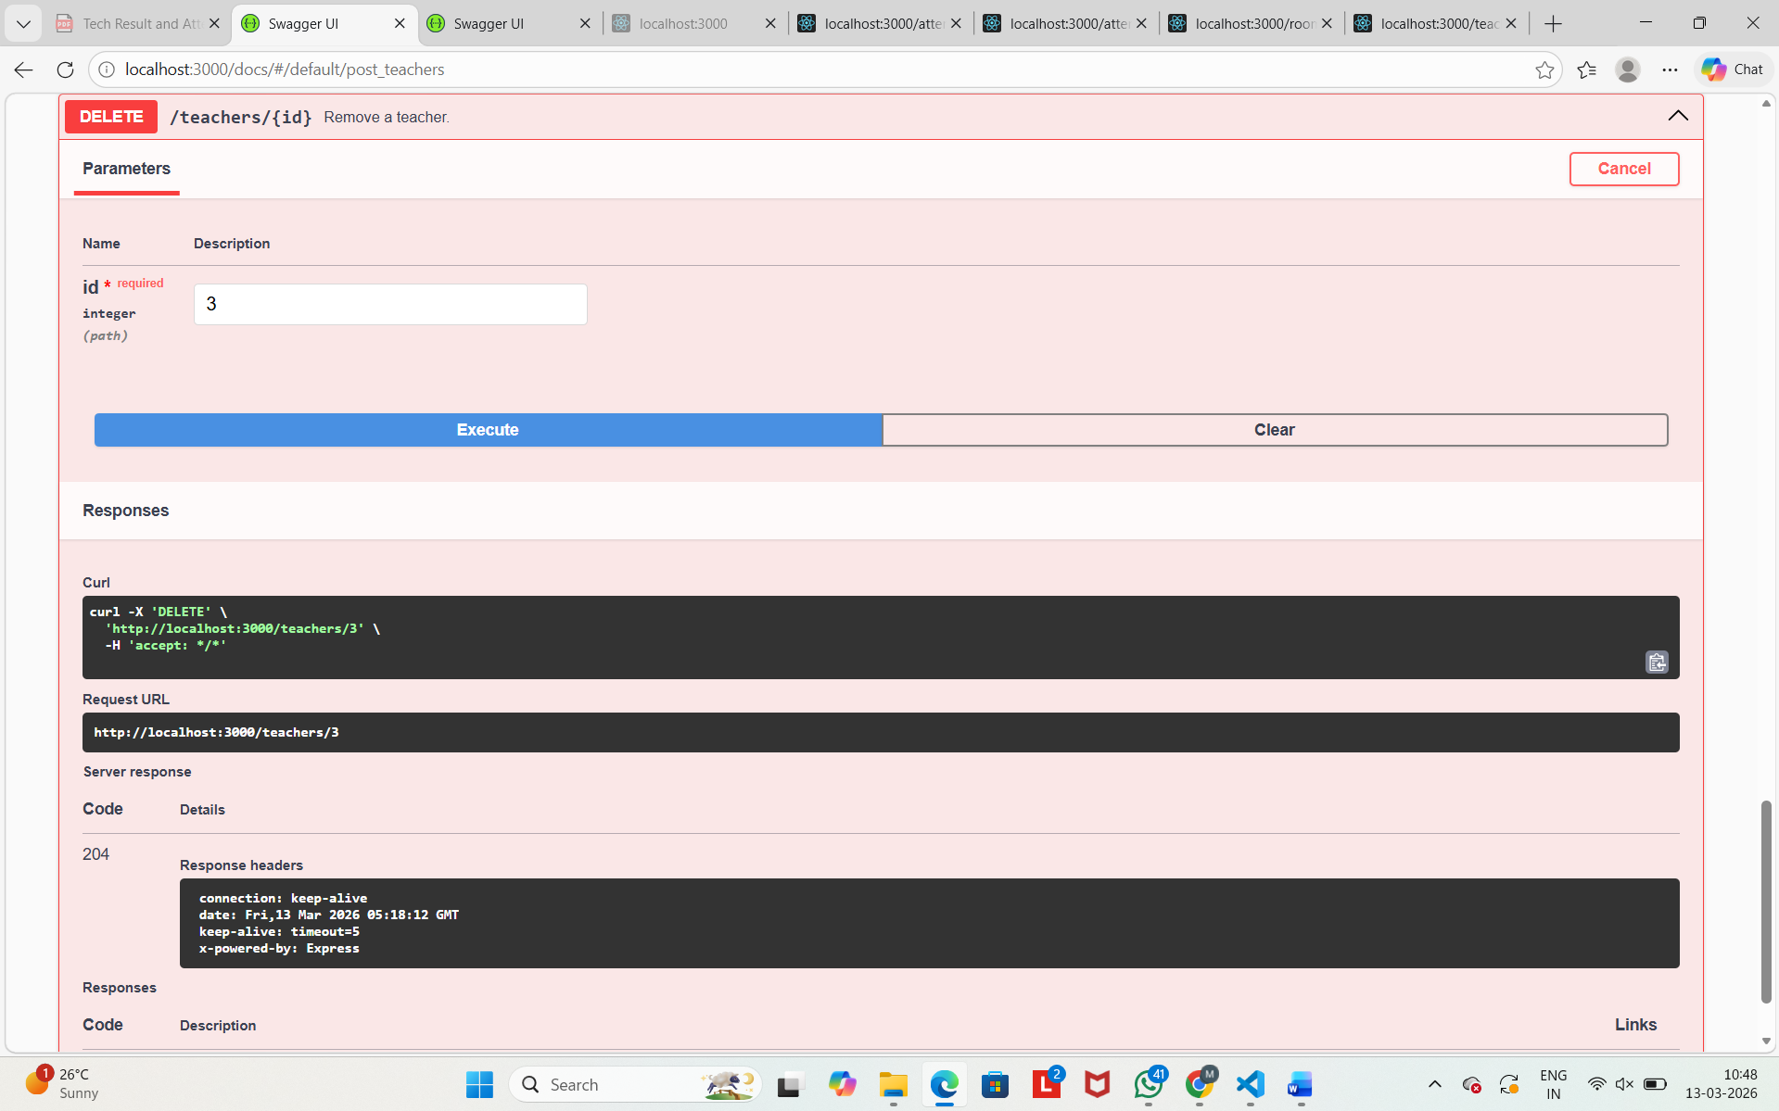

GITHUB LINK : https://github.com/2303A52387/AI-ASSISTANT-CODING/blob/main/15.zip

