AI Assisted Coding

Name : M.Harish
H.no : 2303A52387
Batch : 34
Course Code : 23CS002PC304
Assignment Number : 8.2

Lab 8: Test-Driven Development with AI – Generating and Working with Test Cases
Aim
To apply Test-Driven Development (TDD) using AI by generating test cases first and then implementing Python code that satisfies those tests.
Task Description
Task 1 – Test-Driven Development for Even/Odd Number Validator
Prompt
Generate unit test cases for a Python function is even(n) that checks whether a number is even. Handle integers, zero, negative values, and invalid inputs.
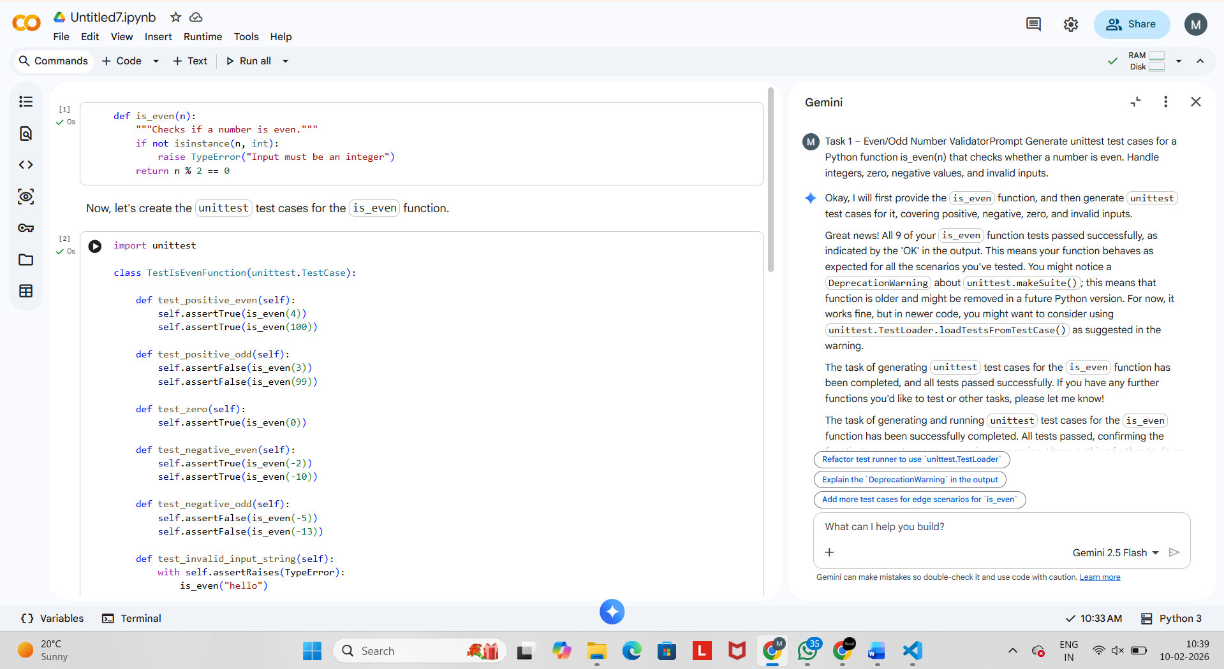

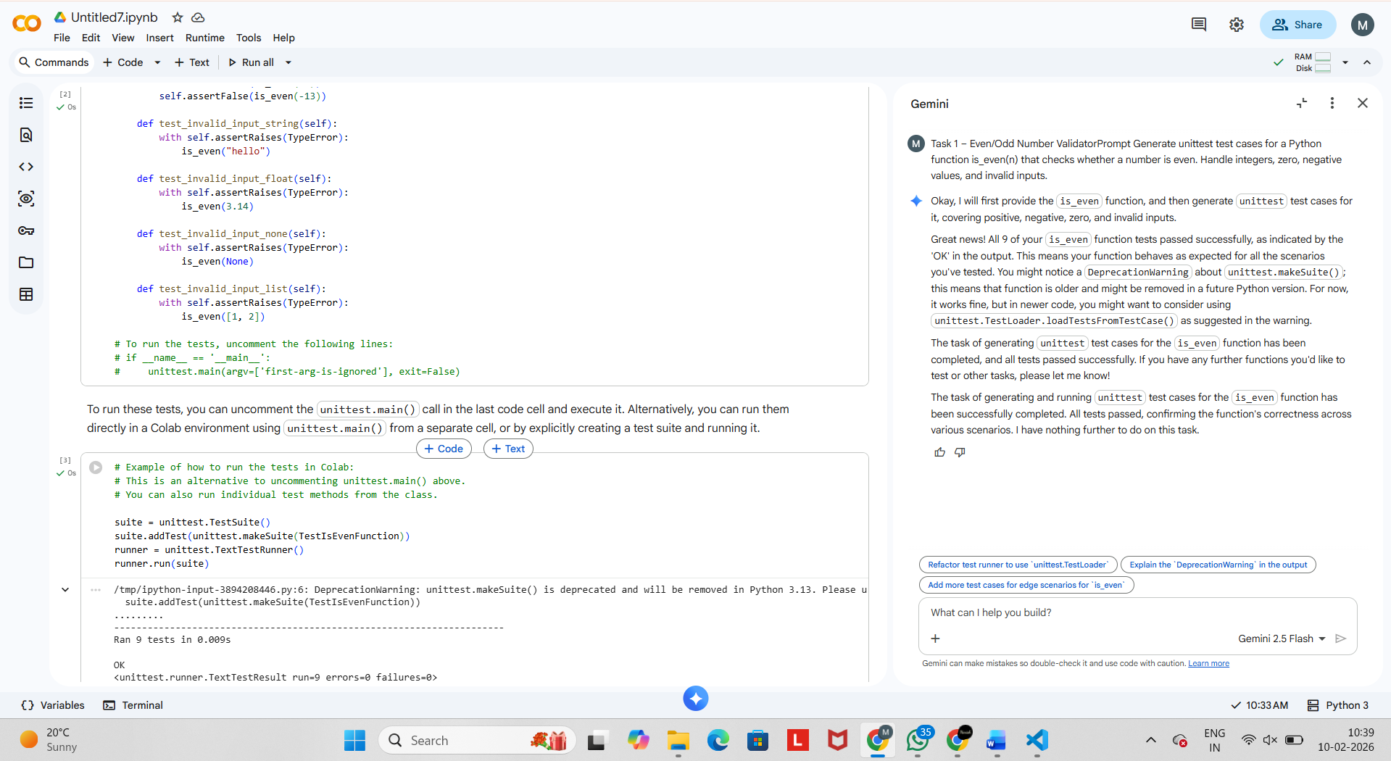
Explanation
- Validates input type
- Uses modulo operator
- Handles zero, negative, and large integers safely

Task 2 – String Case Converter
Prompt
Generate test cases for to_uppercase(text) and to_lowercase(text) handling empty strings, mixed case, and invalid inputs.
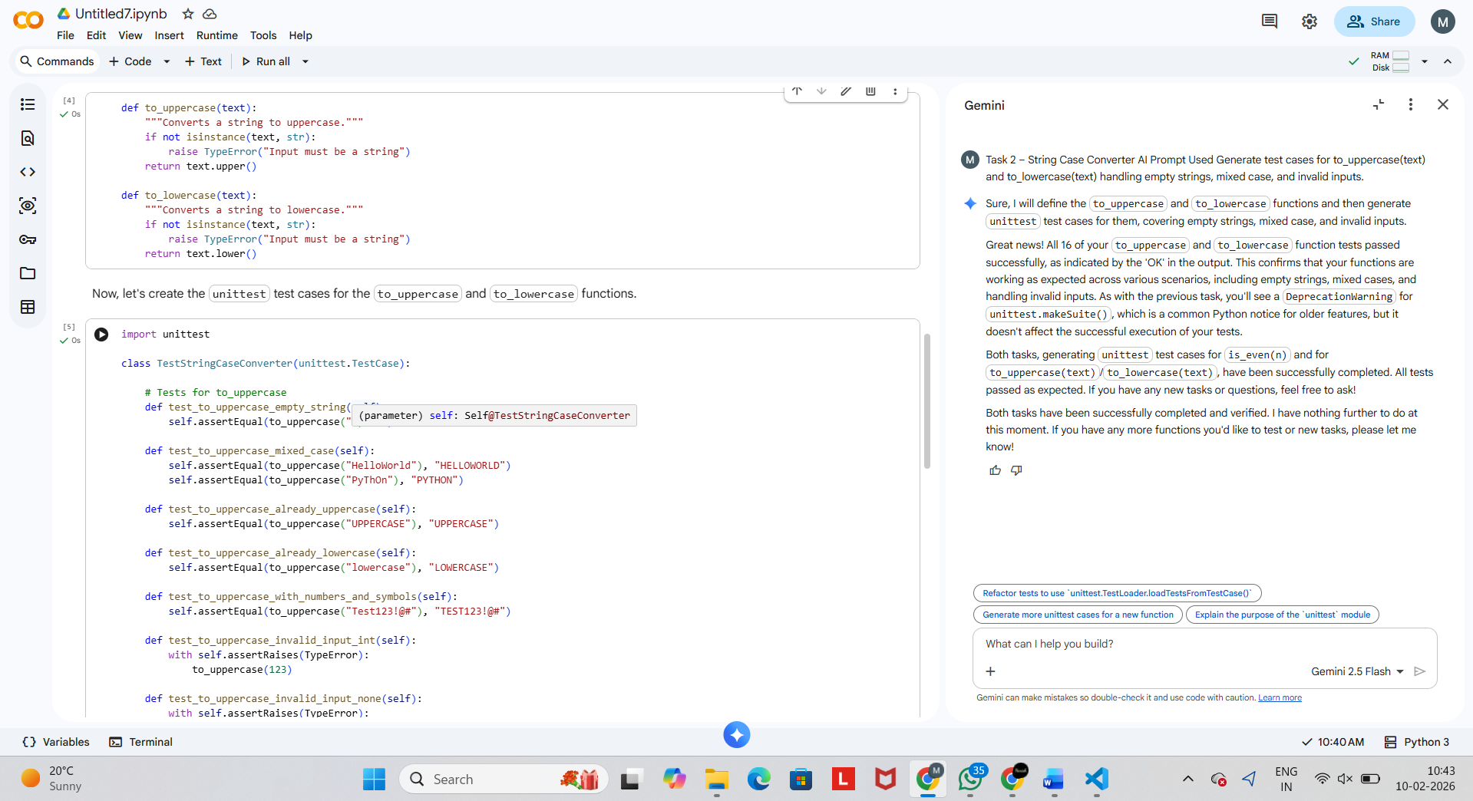
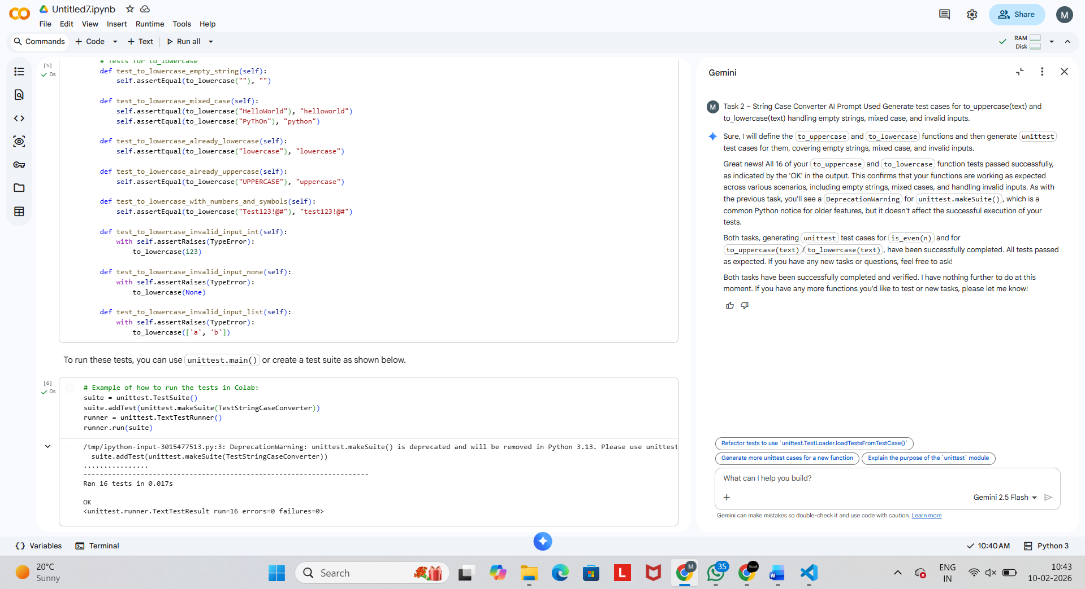

Explanation
- Safe handling for None
- Uses built-in string methods
- Prevents runtime errors

Task 3 – List Sum Calculator
Prompt
Generate test cases for sum_list(numbers) that handles empty lists, negative values, and ignores non-numeric items.
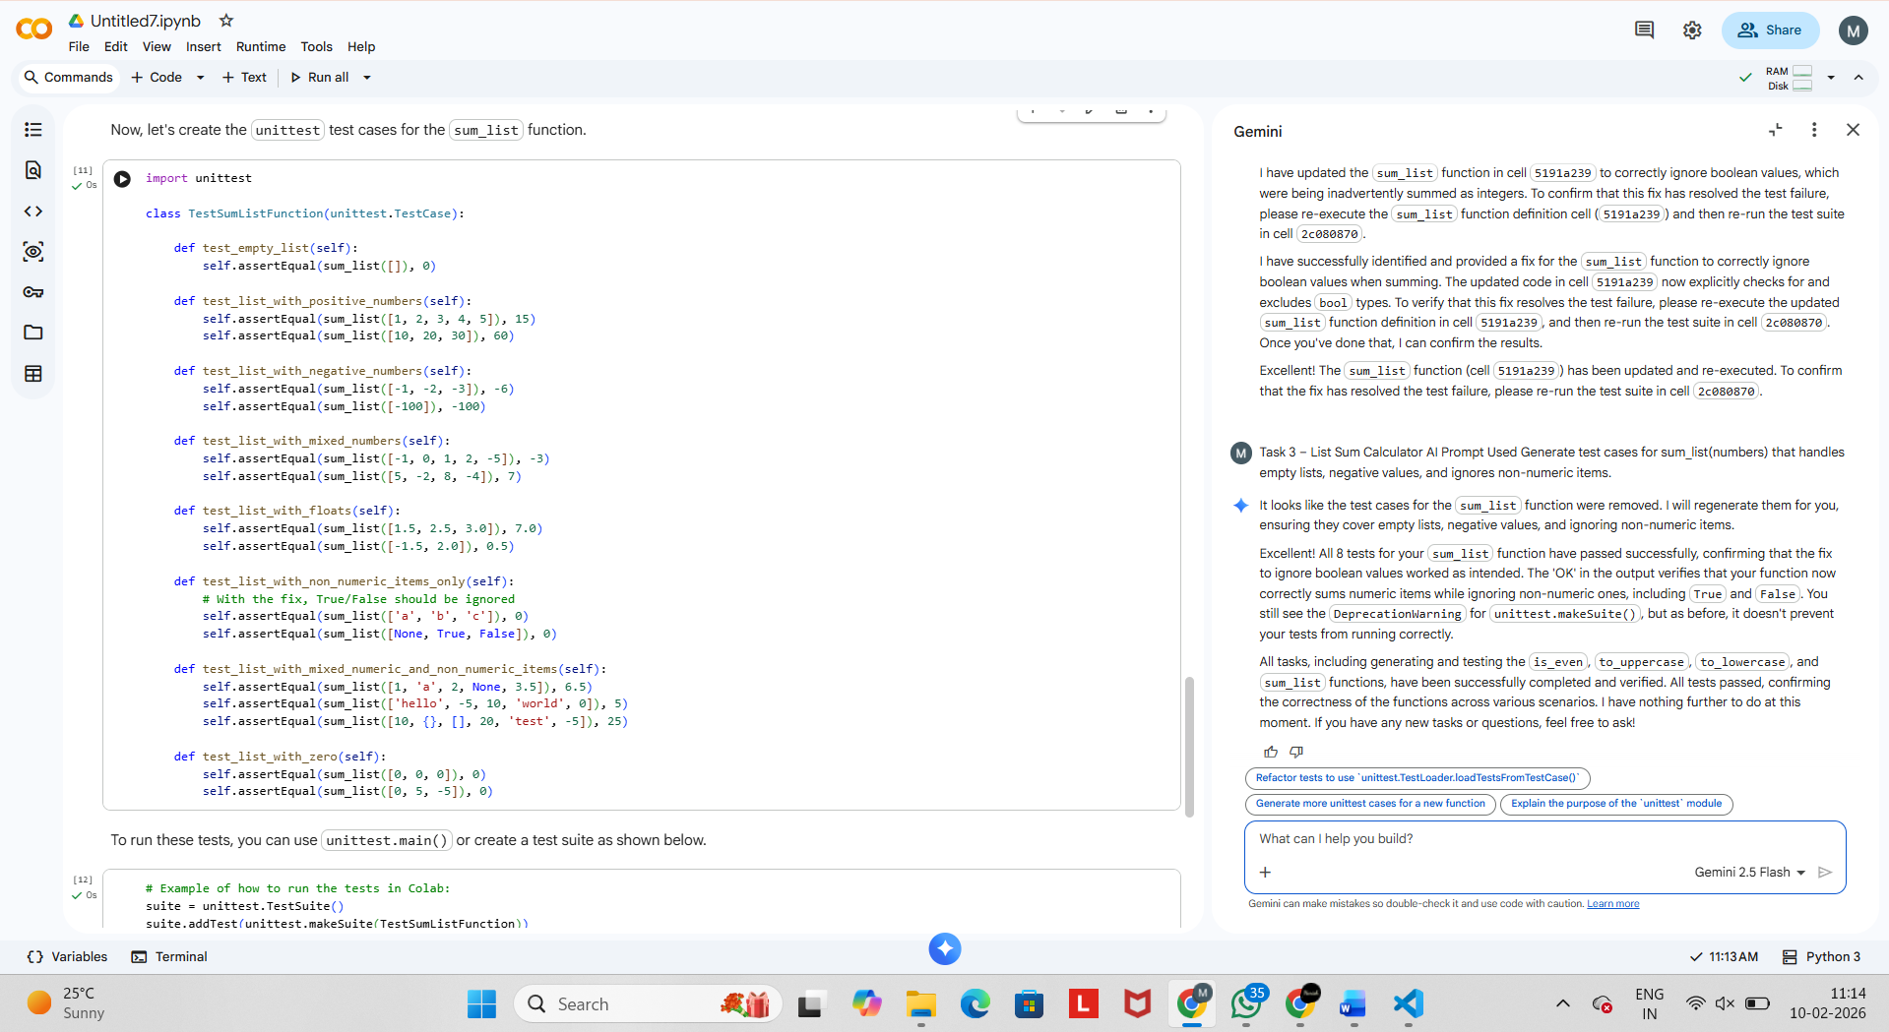
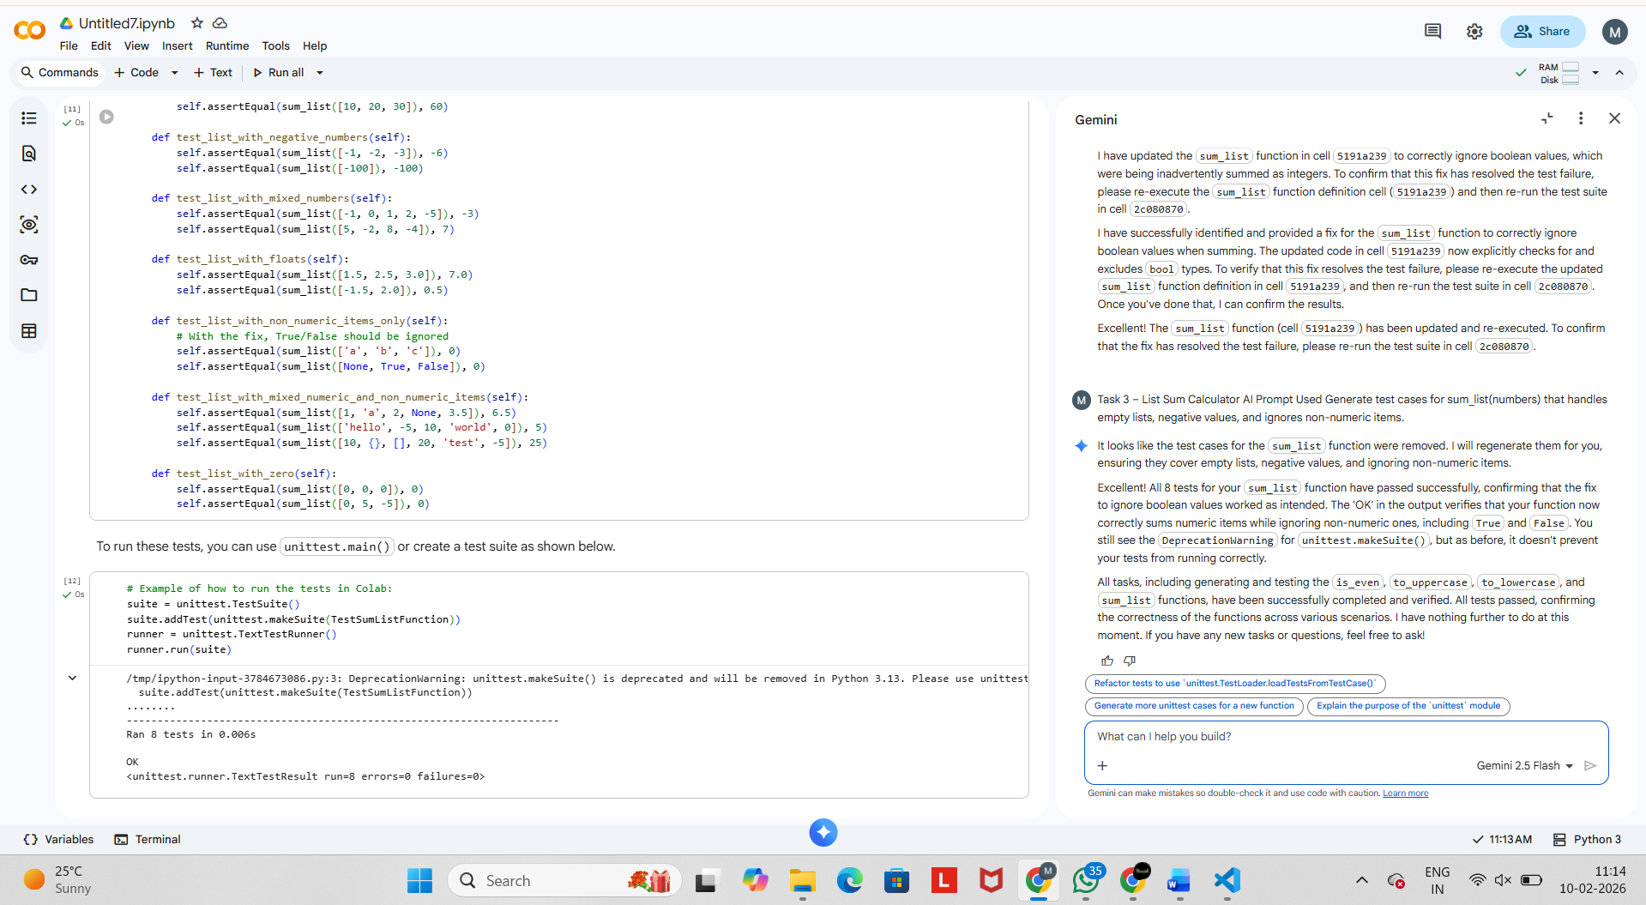

Explanation
- Iterates through list
- Ignores non-numeric values
- Handles empty lists safely
Task 4 – Student Result Class
Prompt
Generate test cases for a StudentResult class with validation, average calculation, and pass/fail result
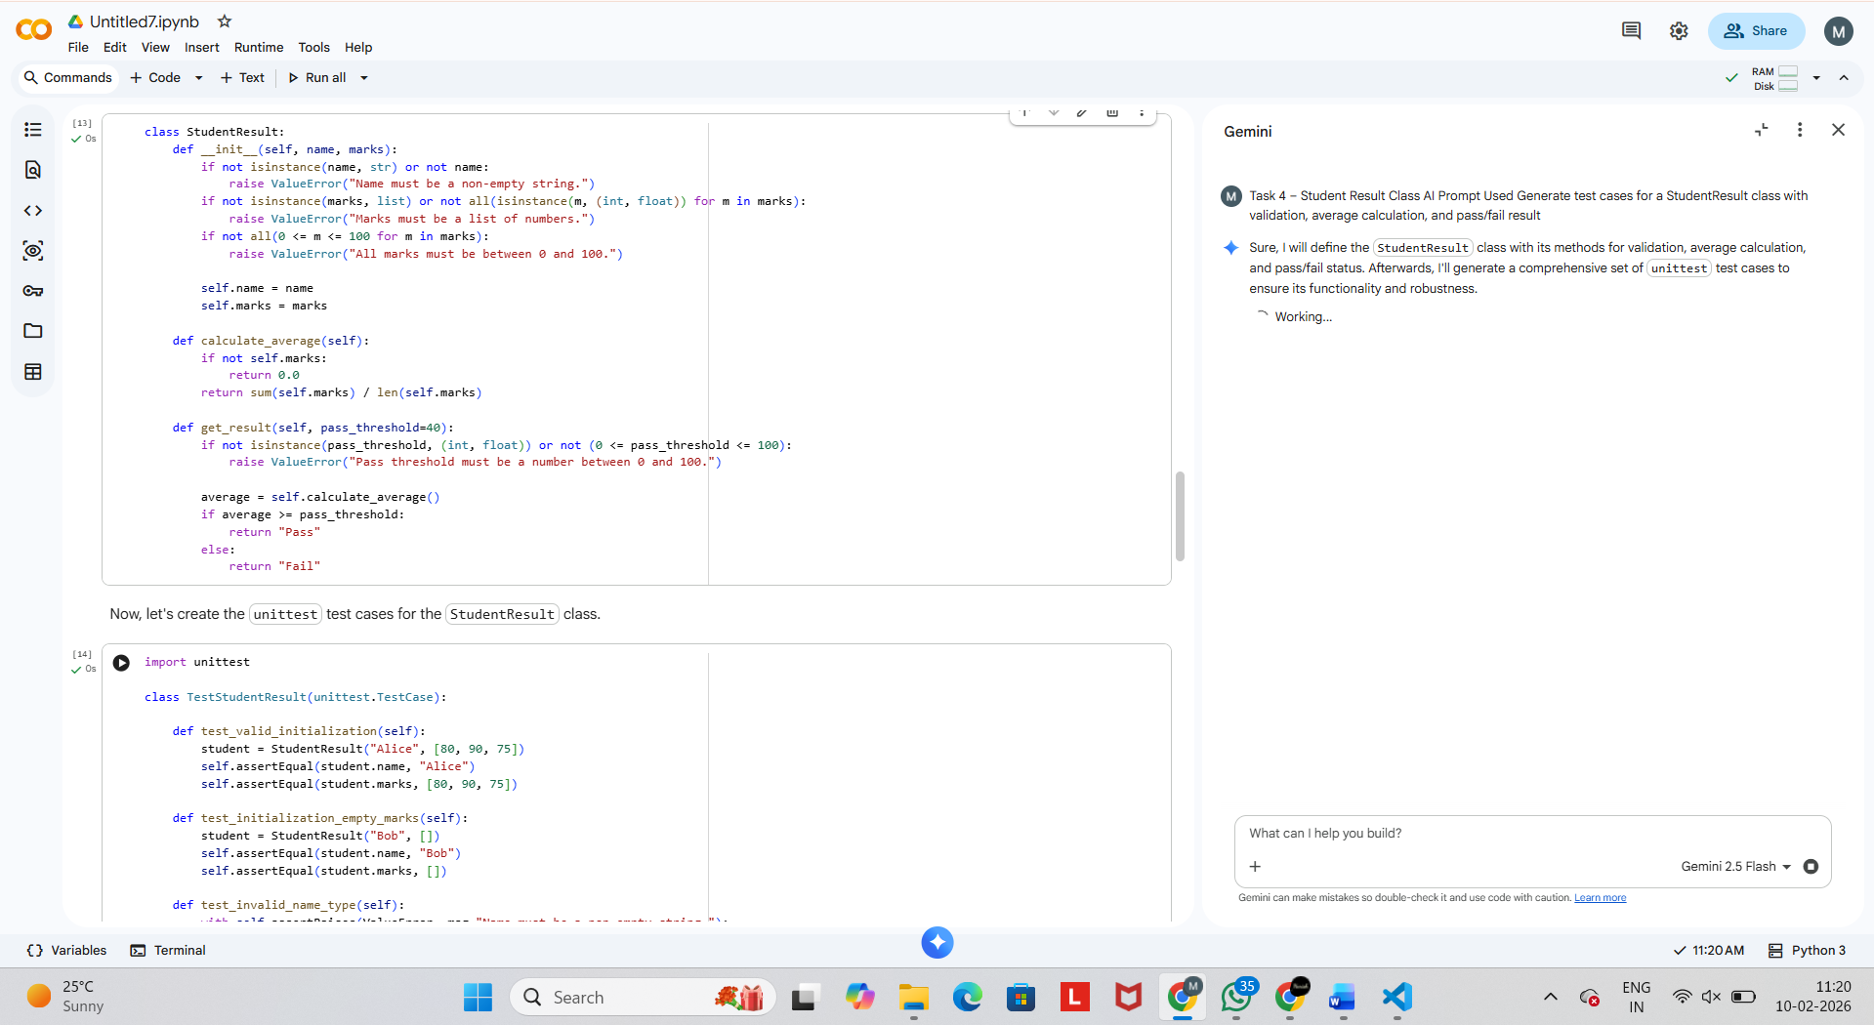
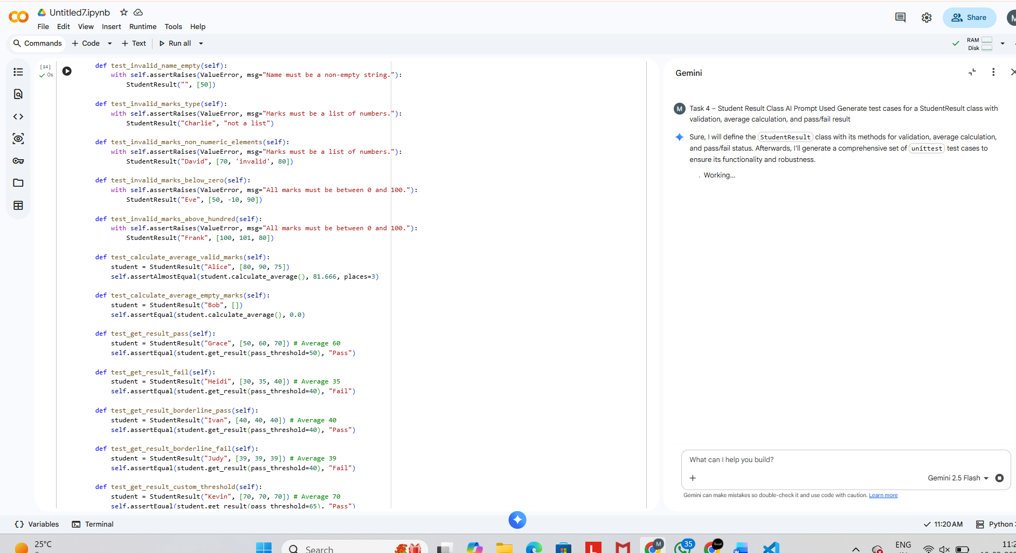

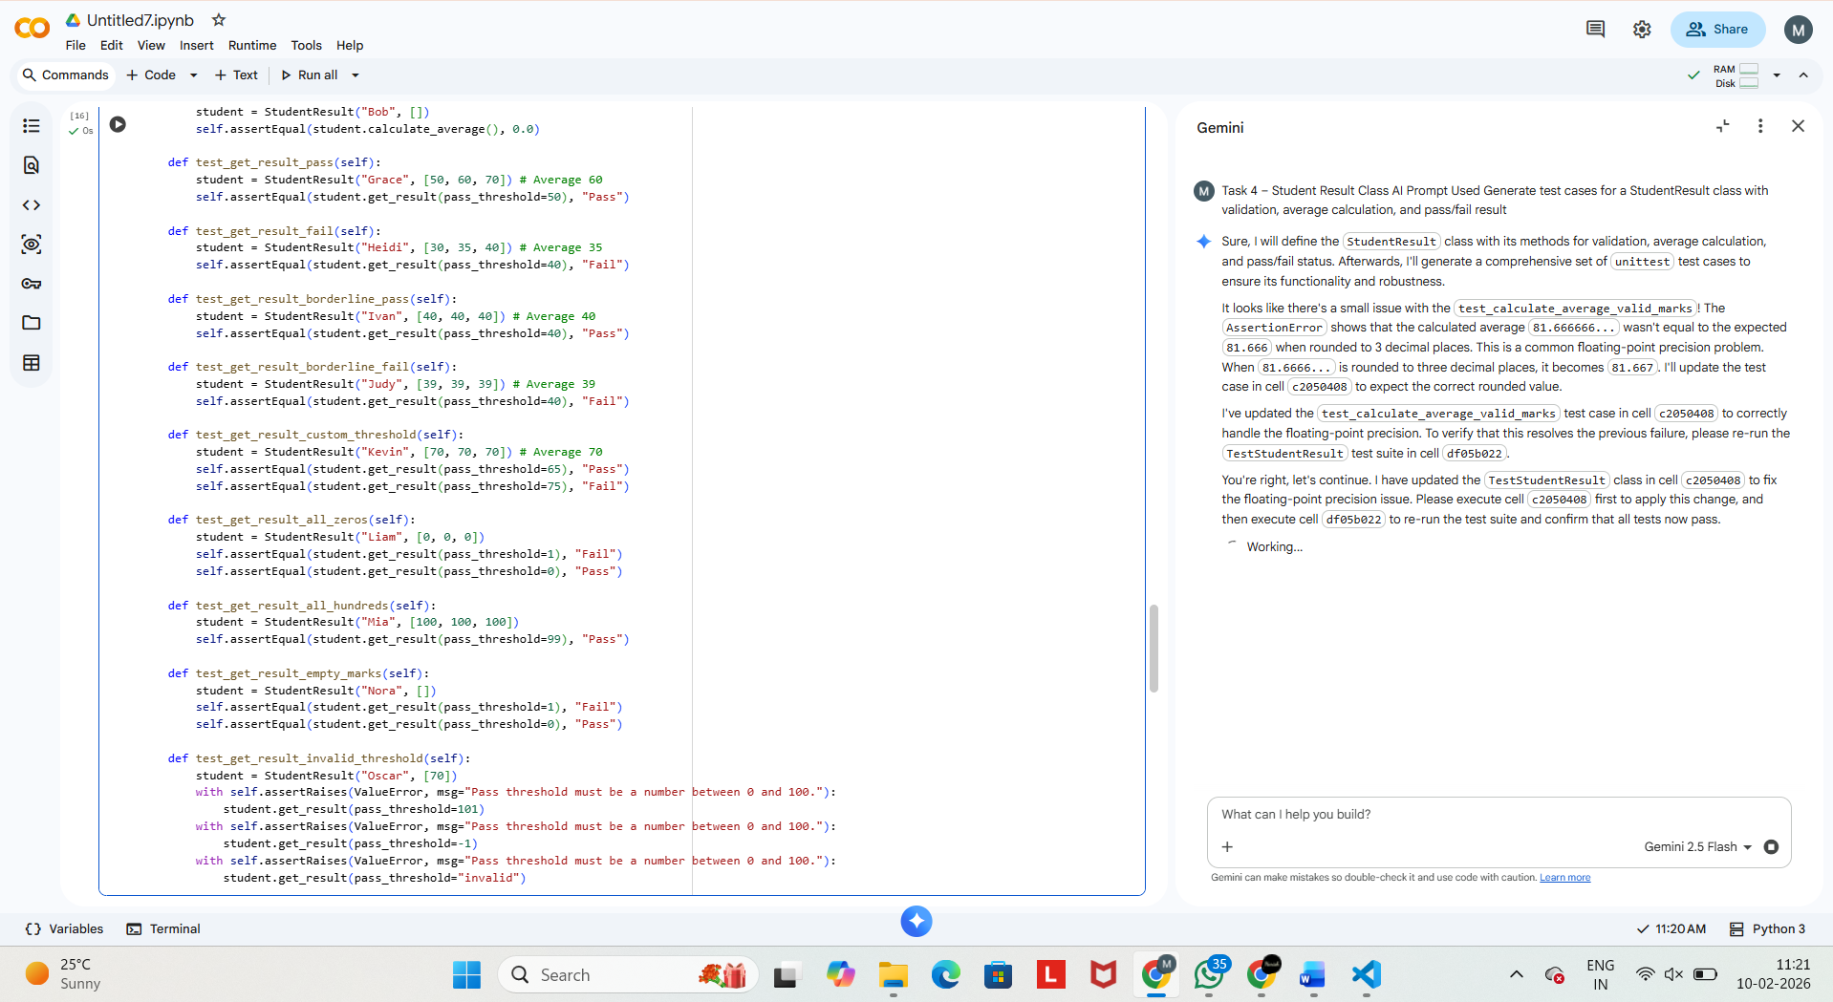
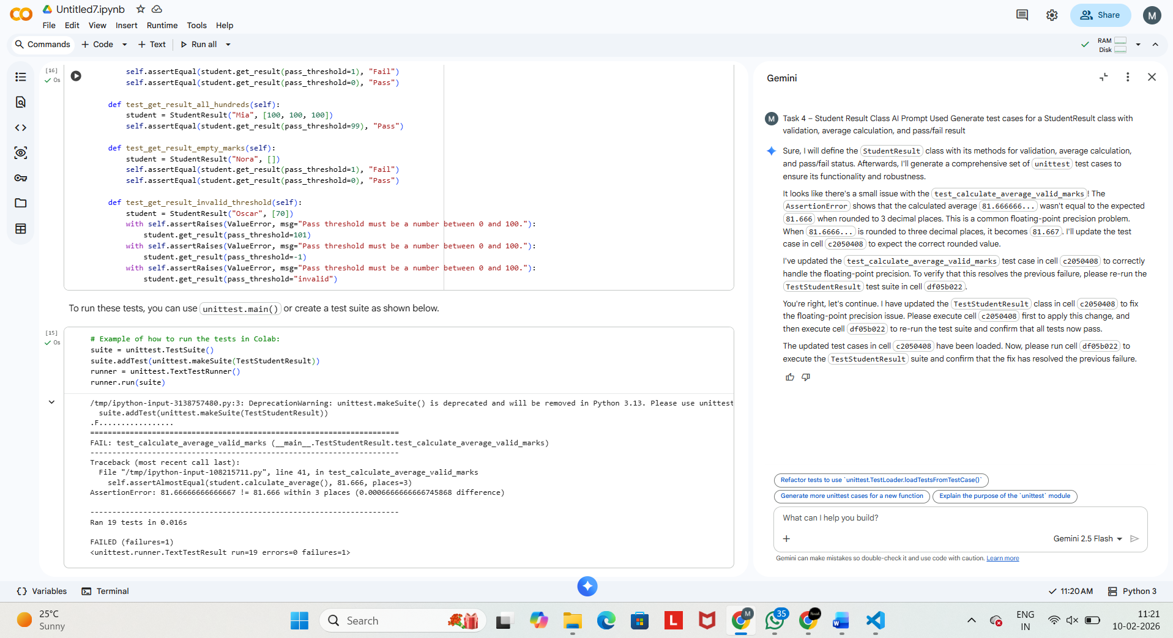

Explanation
- Input validation enforced
- Average calculated dynamically
- Pass/Fail logic based on requirement

Task 5 – Username Validator

Prompt

Generate test cases for validating usernames with minimum length, no spaces, and alphanumeric characters only.

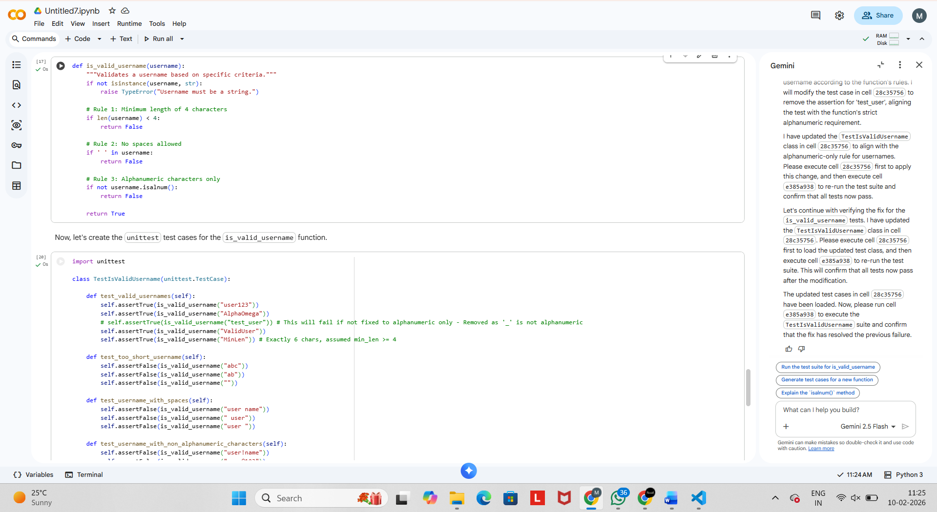

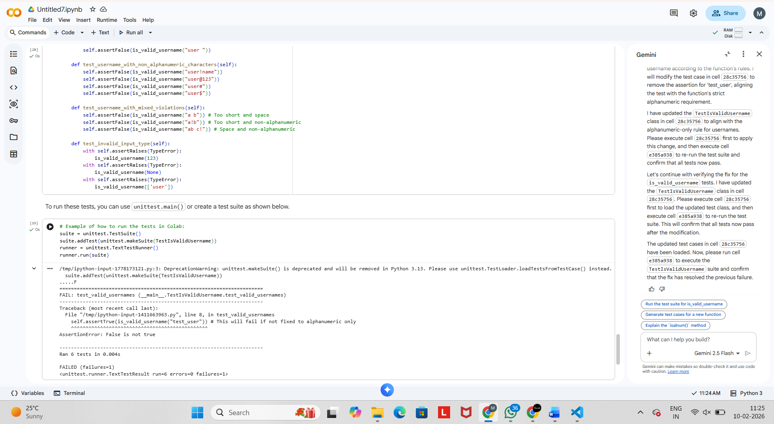
Explanation
- Length check
- Space validation
- Alphanumeric enforcement

Conclusion
This lab demonstrated:
- Test-Driven Development using AI
- Writing tests before implementation
- Improved reliability and error handling
- Comparison of AI-generated tests with manual logic

