1. Deepika tells Shraddha “Your mother’s father’s own son is the husband of my sister.” How is Deepika related to Shraddha?
a) Sister-in-law
b) Cousin
c) Aunt
d) Data inadequate
e) None of these
2. D is A’s son. C is the mother of P and wife of D. How is A related to C?
a) Father
b) Uncle
c) Father-in-law
d) Data inadequate
e) None of these
3. Pointing to the lady in the photograph, Mrinalini said, “Her son’s father is the only son-in-law of my mother”. How is Mrinalini related to the lady.
a) Sister
b) Mother
c) Cousin
d) Aunt
e) None of these
4. A is brother of R. C is mother of B. M is sister of C. How is M related to B?
a) Nephew
b) Niece
c) Aunt
d) Cannot be determined
5. R is the daughter of Q. M is the sister of B who is the son of Q. How M is related to R?
a) Cousin
b) Niece
c) Sister
d) Aunt
e) None of these
6. Pointing to a photograph of Hari, Vijay said, “The father of his sister is the husband of my wife’s mother’. How is Vijay related to Hari?
a) Brother
b) Brother-in-law
c) Uncle
d) Data inadequate
e) None of these
7. M is N’s brother. S is D’s mother and M’s aunt. How is D related to M?
a) Sister
b) Cousin
c) Aunt
d) Cannot be determined
e) None of these
8. Pointing to a paragraph, Sachin said “She is the grandmother of my father’s sister’s son”. How is the woman in the photograph related to Sachin?
a) Mother
b) Aunt
c) Cousin
d) Cannot be determined
e) None of these
9. P is father of . S is mother of N who is brother of J. B is son of S. C is sister of B. How J is related to C?
a) Data inedaquate
b) Cousin
c) Brother
d) Sister
e) None of these
10. D is brother of B. M is brother of B. K is father of M. T is wife of K. How is B related to T?a) Son
b) Daughter
c) Son or Daughter
d) Data inadequate
e) None of these
11. Pointing to a woman, Nirmal said, “she is the daughter of my wife’s grandfather’s only child”. How is the woman related to Nirmal ?
a) Wife
b) Sister-in-law
c) Sister
d) Data inadequate
e) None of these
12. X told Y, “Though I am the son of your father, you are not my brother”. How is X related to Y ?
a) Sister
b) Son
c) Daughter
d) Father
e) None of these
13. Introducing Rajesh, Neha said, his brother’s father is the only son of my grandfather. How is Neha related to Rajesh ?
a) Daughter
b) Sister
c) Mother
d) Niece
e) None of these
14. Pointing to a paragraph, Arun said, ‘she is the mother of my brother’s son wife’s daughter. ‘How is Arun related to the lady ?
a) Uncle
b) Daughter-in-law
c) Cousin
d) Brother
e) None of these
15. A boy goes to see a film and finds a man who is his relative. The man is the husband of the sister of his mother. How Is the man related to the boy ?
a) Brother
b) Nephew
c) Uncle
d) Father
e) None of these
16. Lakshmi and Meena were Rohan’s wives. Shalini is Meena’s step-daughter. How was Lakshmi related to Shalini ?
a) Sister
b) Mother-in-law
c) Mother
d) Step-daughter
e) None of these
17. Daya has a brother, Anil. Daya is the son of Chandra. Bimal is Chandra’s father. In terms of relationship, what is Anil of Bimal?
a) Son
b) Grandson
c) Brother
d) Grandfather
e) None of these
18. Anil, introducing a girl in a party, said, she is the wife of the grandson of my mother. How is Anil related to the girl?
a) Father
b) Grandfather
c) Husband
d) Father-in-law
e) None of these
19. A man said to a woman, “Your mother’s husband’s sister is my aunt.” How is the woman related to the man ?
a) Granddaughter
b) Daughter
c) Sister
d) Aunt
e) None of these
20. Introducing Ramesh, Neelam said, “His brother’s father is the only son of my grand father”. How Neelam is related to Ramesh?
a) Sister
b) Daughter
c) Mother
d) Niece
e) None of these

Answers
1. (c) | 2. (d) | 3. (e) | 4. (c) | 5. (c)
6. (b) | 7. (b) | 8. (e) | 9. (a) | 10. (c)
11. (d) | 12. (a) | 13. (b) | 14. (a) | 15. (c)
16. (c) | 17. (b) | 18. (d) | 19. (c) | 20. (a)

Q. (1 - 5) Read the information carefully and answer the questions:
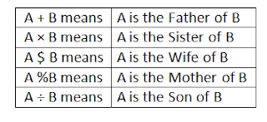
Q1. What should come in place of the question mark, to establish that J is the brother of T in the expression = J ÷ P % H ? T % L
a) ×
b) ÷
c) $
e) None of The Above
Q2. Which among the given expression indicate that M is the daughter of D:
a) L + R $ D × M × T
b) L $ R $ D + M × T
c) L + R $ D + M × T
d) None of The Above
Q3. Which among the following options is true, if the expression I + T % J × L ÷ K is definitely true:
a) L is the daughter of T
b) K is the son - in - law of I
c) I is the grandmother of L
d) J is the brother of L
e) None of The Above
Q4. Which among the following expressions is true, if Y is the son of X is definitely false:
a) W % L × T × Y ÷ X
b) W $ X + L + Y + T
c) W % X + T × Y ÷ L
d) None of The Above
Q5. What should come in place of the question mark, to establish that T is the sister - in - law of Q in the expression = R % T × P ? Q + V
a) +
b) ×
c) $
d) None of The Above

==>> Must read - Blood relations question answers

Solutions
Answer 1. (Option A)

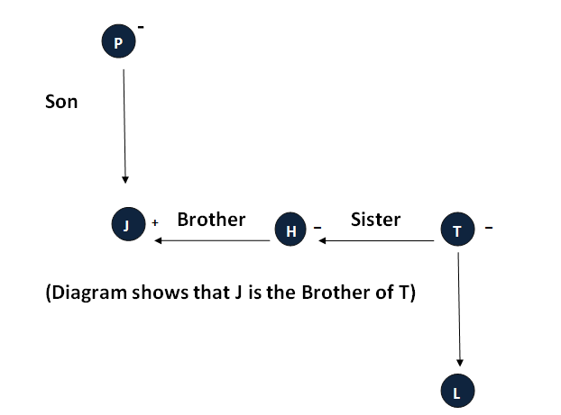

Answer 2. (Option C)
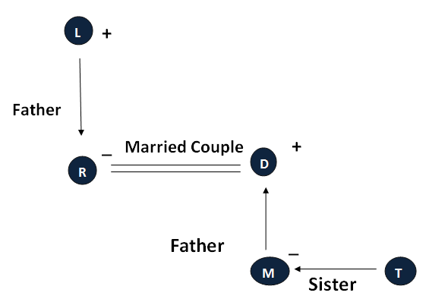
Answer 3. (Option B)
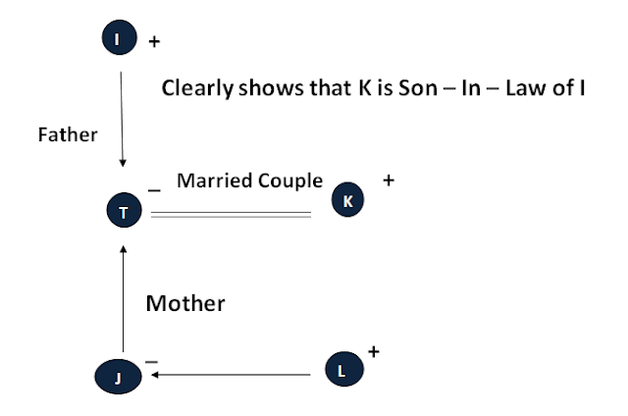

Answer 4. (Option B)
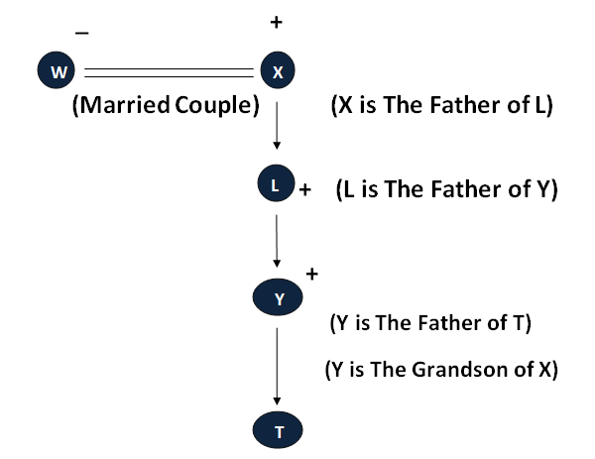
Answer 5. (Option C)
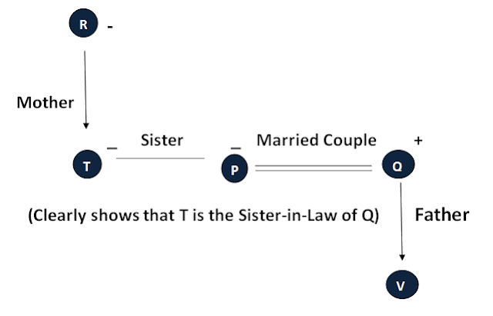
Directions (Q.1-5): Read the information given below and answer the questions that follow.
I. M, P, S, T, R, Q, O, K, U and N are the 10 members of a family.
II. P is the daughter of M and the sister of R.
III. Q is the son in law of O.
IV. M is the grandfather of T and U.
V. P is the sister in law of S.
VI. R is the maternal uncle of N and K.
VII. N is the only son of Q.
VIII. T and U are the sisters.
Q.1 How is P related to T?
A. Daughter
B. Sister
C. Aunt
D. Mother
E. None of these.
Q.2 Which of the following is true?
A. R is the sister of P.
B. K is the son of S.
C. O is the husband of M.
D. S is the daughter in law of M.
E. None of these.
Q.3 How many couples are there in the family?
A. 3
B. 4
C. 5
D. 1
E. 2
Q.4 What is R's relation with Q?
A. Son in law
B. Husband
C. Wife
D. Sister in law
E. Brother in law
Q.5 How many male members in the family?
A. 5
B. 6
C. 3
D. 2
E. 4

Answers with Solution
1. C. Aunt
2. D. S is the daughter in law of M.
3. A 3
4. E Brother-in-law
5. E 4

Solution
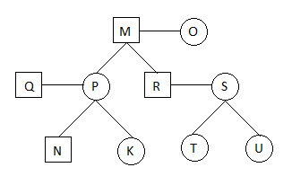

Direction(Q1-3): Q is the son of A. P is the husband of A. Q has two children S and T. S is the daughter of R. M is the sister of Q. T is the brother of S.
Q.1 How is M related to R?
A. Sister
B. Mother
C. Sister in law
D. Aunt
E. None of these
Q.2 How many females in the family?
A. 4
B. 5
C. 3
D. 2
E. None of these
Q.3 How many males in the family?
A. 4
B. 3
C. 2
D. 5
E. None of these
Direction(Q4-5): In a family there are two couples, two son and one daughter.
- C is the grandfather of S.
- S is the son of M.
- K is the grandmother of P and is the wife of C.
- P is the daughter of Q.
Q.4 How is P related to K?
A. Grandson
B. Son
C. Granddaughter
D. Daughter
E. None of these
Q.5 Which of the following is a pair of couple?
A. MQ
B. CP
C. SP
D. KQ
E. None of these

Answers With Solution:

1. Ans. C.
Solution:
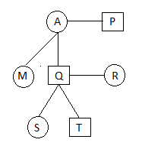

2. Ans. A.
Solution:
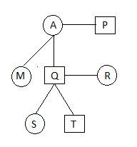

3. Ans. B.
Solution:

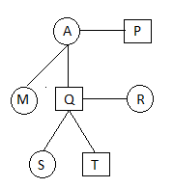

4.Ans. C.
Solution:

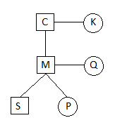

5. Ans. A.
Solution:

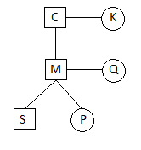

Direction:
- A$B means A is sister of B
- A@B means A is father of B
- A>B means A is wife of B
- A<B means A is son of B
- A=B means A is mother of B
1. Which of the following expressions means ‘P’ is daughter of ‘S’?
a) P<Q>S@R
b) S=Q>P<R
c) S>R@P$Q
d) P@S>R<Q
e) R@Q$S=P
2. How is ‘Q’ related to ‘R’?
P@Q=S>R<T
a) Mother
b) Son
c) Father
d) Father in law
e) Mother in law
3. How is ‘T’ related to ‘V’?
X$Y@V<U$T
a) Uncle
b) Aunt
c) Cousin sister
d) son
e) C.N.D.
4. M is the son of Q. N, M’s sister has a daughter R and a son E. Y is maternal aunt of R.
How is Y related to N? If N has only one brother.
a) Brother in law
b) Sister
c) Mother
d) Sister in law
e) Aunt
5. P is son Q. Q is mother of V. V is sister of U. U is father of X. Y is daughter of P. V is wife of N.
How is ‘Y’ related to ‘x’?
a) Sister
b) Brother
c) Cousin sister
d) Aunt
e) Mother

Answers With Solution:

1. Ans. C.
Solution:

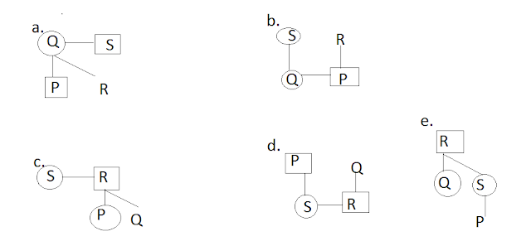

2. Ans. E.
Solution:
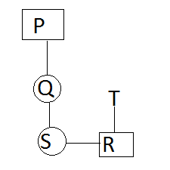

3. Ans. E.
Solution:

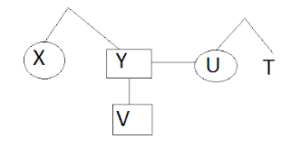

4. Ans. D.
Solution:

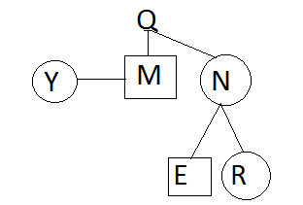

5. Ans. C.
Solution:

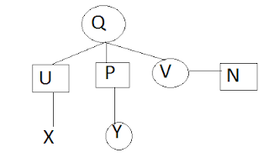

Ques 1.
Adity is Bhavi's brother, Bharat is Jayant's father. Ella is Bhavi's mother. Aditya and Jayant are brothers. What is Ella's relationship with Bharat ?
(a) Sister
(b) Mother
(c) Daughter
(d) Wife
(e) None of these
Ans: (d) The relationship chart based on problem is :
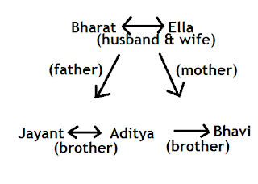

Ques 2.
A man introduced the boy coming with him as "He is son of the father of my wife's daughter". What relation did the boy bear to the man ?
(a) Son-in-law
(b) Son
(c) Brother
(d) Father
(e) None of these
Ans: (b) The relationship chart based on problem is :
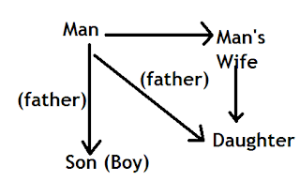

Ques 3.
A and B are two brothers. C is sister of B. D is sister of E. E is son of A. who is D's uncle ?
(a) D
(b) E
(c) B
(d) C
(e) None of these
Ans: (c) The relationship chart based on the problem is:
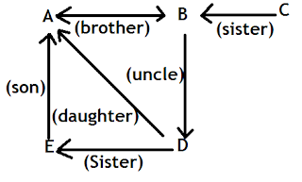

Ques 4.
Vidya is the wife of Gopi and Gopi is the brother of Akhil. Akhil is the uncle of Vijay. What is Vijay's relation with Vidya ?
(a) Son
(b) Nephew
(c) Brother-in-law
(d) Brother
(e) None of these
Ans: (b) The relationship chart based on problem is:

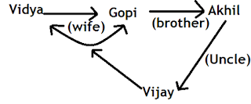

Ques 5.
A is the sister of B. B is the son of C, and E is the daughter of D, and sister of A. What is D to C ?
(a) Brother
(b) Husband
(c) Wife
(d) Data is inadequate
(e) None of these
Ans: (d) Information about 'D' and 'C' is not given as such no relation can be specified.
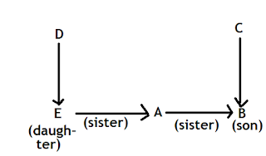

Ques 6
A man said to a lady ,"Fagu's mother is the only daughter of your father." How is the lady related t Fagu ?
(a) Daughter
(b) Sister
(b) Wife
(d) Mother
(e) None of these
Ans 6.
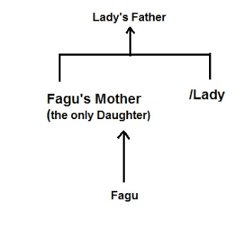
The only daughter of Lady's Father is Fagu's Mother.

Ques 7.
Pointing to a man, a woman said, " He is the only son of mu mother's mother".How is the woman related to the man ?
(a)Aunt
(b) Daughter
(c) Niece
(d) Sister
(e) None of these
Ans 7.
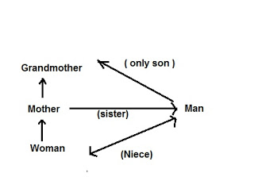
The man is the brother of the woman's mother.so, the woman is man's niece.

Ques 8.
A man and a woman are sitting in a room. Man's mother-in-law and woman's mother-in-law are mother and daughter respectively ?
(a) Father
(b) father-in-law
(c) Uncle
(d) Grandfather-in-law
(e) None of these
Ans 8.
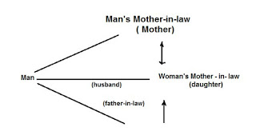
Woman's mother-in-law is the daughter opf Man's mother-in-law.so, the man is the husband of woman's mother-in-law and the father-in-law of the woman.

Ques 9.
Pointing to Suman, Amit said,"He is my sister's only brother's son ". How is Suman related to Amit ?
(a) Grandson
(b) Son
(c) Nephew
(d) Cannot be determind
(e) None of these
Ans 9.
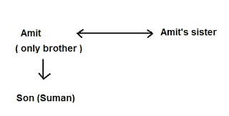
'My sister's only brother's is Amit himself and sister's only brother's son' is the son of Amit i.e. Suman is the son of Amit.

Ques 10.
Pointing to a photograph, a woman said, "she is the only daughter of my mother's father." How is the woman related to the person in the photograph ?
(a) Mother
(b) Grandmother
(c) daughter
(d) Cannot be determined
(e) None of these
Ans 10.
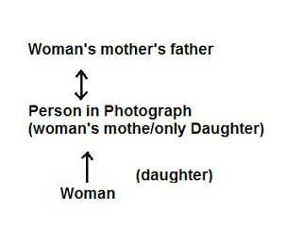
only daughter of my mother;s father' is the person in the photograph and she is also the mother of the woman. So, the woman is the daughter of the person in the photograph.

Ques 11.
Sandip's mother is the only daughter of Rekha's father .How is Rekha's husband related to Sandip?
(a) Uncle
(b) Brother
(c) Grandfather
(d) Data inadequate
(e) Father
Ans 11,
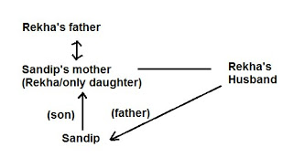
'Only daughter of Rekha's father;s is Rekha who is also sandip's mother. And so, Rekha's husband is the father of Sandip .

Ques 12.
B's mother is the only daughter of A's mother.How is A related to B ?
(a) Niece
(b) Brother
(c) Father
(d) Uncle
(e) Cannot be determined
Ans 12.
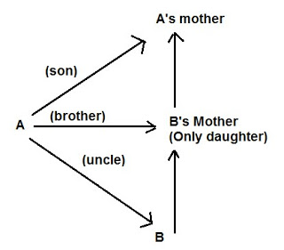
'B's' mother is the only daughter of' 'A's' mother.So "A' is the son . 'A' is aldo the brother of 'B' s' mother, he is the uncle of 'B'.

Ques 13.
A said to B that B's mother was the mother-in-law of A's mother.How is A's mother related to B's mother?
(a) Mother
(b) Daughter-in-law
(c) Daughter
(d) Cousin
(e) Aunt
Ans 13.
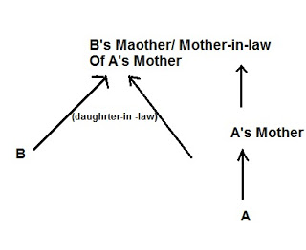
'B's mother is the mother-in-law of 'A' s' mother . so, 'A's' mother vis the daughter-in-law off 'B's mother.

Question 1. ‘X + Y’ means ‘X is the father of Y’. ‘X – Y’ means ‘X is the wife of Y’. ‘X x Y’ means ‘X is the brother of Y’, ‘X ÷ Y’ means ‘X is the mother of Y’ and ‘X = Y’ means ‘X is the sister of Y’ On the basis of this information, what does ‘X + Y – Z’ mean?
Solution: We first off need to clear the clutter with the + and – and x’s!
Simply jot down on your rough sheet like this :-
+ father of
– wife of
X brother of
÷ mother of
= sister of
Now we solve,
X + Y – Z therefore is,
X is the father of Y, and Y is the wife of Z!
That means – X is the father in law of Z.
Question 2. Pointing to a lady on the stage, Ashita said, “She is the sister of the son of the wife of my husband.” How is the lady related to Ashita?
Solution: Find who you can easily relate to and be that person – then go about creating one relation after another!
In this question – be Ashita – then start from the end of the sentence – that way it will be easier.
‘My husband’ = Ashita’s husband.
‘wife of my husband’ = is Me = Ashita!
‘son of the wife of my husband’ = My son.
‘Sister of the son of the wife of my husband’ = My son’s sister = My daughter!
‘She is the sister of the son of the wife of my husband’ = the lady on the stage = the lady being pointed out = my daughter!
Ashita + Husband
_________|__________
| |
Son Daughter
Now you solve! Time yourself and then look at the answers below!
Question 3. Miley says, “Dolly’s father Mick is the only son of my father-in-law Jagger.” Then how is Pamela, who is the sister of Dolly, related to Jagger?
Question 4. While discussing Tan’s ancestry, Lan quizzes Tan while pointing towards a man, “His mother is the only child of your father.’ How is Tan related to that person?
Question 5. Vicky who is Dinesh’s daughter, says to Irma, “Your mother Reeta is the younger sister of my father, who is the third child of Chand.” How is Chand related to Irma?
Question 6. Anand is the brother of of Bakul and Chavi. Dina is Chavi’s mother. Ernie is Anand’s father. Is Bakul Ernie’s son?
Question 7. A woman presents a man as the son of the brother of her mother. How is the man related to the woman?
Question 8. Raina, Murli, Haiden, Patel, Gony, Balaji and Morkel are seven members in a family, out of which there are three females and four males. There are two managers, two lawyers, one teacher, one engineer and one doctor. No lady is either a teacher or an engineer. Haiden is a lawyer and is married to Raina, who is a teacher. Balaji, the engineer is married to Patel, who is neither a lawyer, nor a doctor. No two ladies have the same profession. Murli is the sister of Morkel, who is a manager.
(i) What is Gony’s profession?
(ii) Who are the four males?
(iii) Who is the teacher?
(iv) Who is married to Balaji and what is the person’s profession?

Answer 3. Pamela is Jagger’s Grand-daughter.
Jagger(m, father in law of Miley)
|
Miley(f, wife)+Mick/Husband/only son of FIL
|
Dolly – Pamela (f, sister)
Answer 4. Tan is that person’s Mother.
Father ( first off – the father)
|
Tan (then - ‘mother is the only child’)
|
Son (‘His’)
Answer 5. Grandparent.
We can say Chand is Irma’s Grandparent and not Grandfather or Grandmother, because don’t know!
Simply because Chand’s gender cannot be identified from the question – we NEVER identify gender from the names!
Chand
__________________ | _________
| |
Reeta(f,mother/sister of) ---------- Dinesh (m, father of)
| |
Irma Vicky(f)
Answer 6. NO!
Because we cannot determine Bakul’s gender!
Ernie(m, father) + Dina(f, mother)
|
Anand(m, brother of) – Bakul – Chavi
Answer 7. The man is the woman’s cousin brother – ‘Mama ka ladka’ if I may say so!
Mother – Brother
| |
Woman Son
Answer 8. Most important thing is to go one sentence after another and solving the clues without getting confused of the male names!
(i) What is Gony’s profession? – Lawyer .
(ii) Who are the four males? – Raina, Balaji, Morkel, and Gony.
(iii) Who is the teacher? – Raina, male.
(iv) Who is married to Balaji and what is the person’s profession? – Patel, female, wife, Manager.

Females Males
1. Haiden + 1. Raina
2. Patel + 2. Balaji
3. Murli – 3. Morkel
4. Gony
2 managers – Patel(f), Morkel (third male)
2 Lawyers – Haiden(female), Gony ( the last/fourth male)
One teacher – only male - Raina
One doc – third female - Murli
One eng – only male - Balaji

