DIRECTIONS for questions 1 – 5: In each of the questions below are given three statements, followed by conclusions: I, II, III, IV. You have to take the given statements to be true even if they seem to be at variance from commonly known facts. Read the conclusions and then decide which of the given conclusions logically follows from the given statements disregarding commonly known facts.

- Statements: Some Cats are Rats. All bats are tables. All Rats are Bats.
Conclusion:
I. Some Cats are bats
II. All bats are rats
III. All tables are cats
IV. All bats are cats
1. Only I & II follow
2. Only II follows
3. Only I & IV follow
4. None of these
- Answer Key: 4
Explanation: 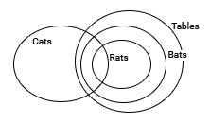 Clearly, from the diagram Conclusion I is true. So option 4.
- Statements: Some ships are boats. All boats are submarines. Some submarines are yatches.
Conclusion:
I. Some yatches are boats.
II. Some submarines are boats.
III. Some submarines are ships.
IV. Some yatches are ships
1. All follow
2. Only II and III follow
3. Only III follows
4. Only IV follows
- Answer Key: 2
Explanation: 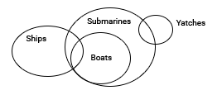 From the diagram we can infer that some submarines are boats and some submarines are ships. So 2nd option.
- Statements: All Carrots are birds. Some telephones are Carrots. All bedsheets are telephone.
Conclusion:
I. All bedsheet are birds
II. Some bedsheet are birds
III. Some birds are telephone
IV. All telephone are birds
1. Only I follows
2. Only II follows
3. Only I and III follow
4. Only III follows
- Answer Key: 4
Explanation: 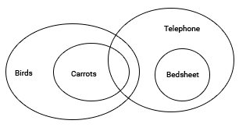 The diagram gives all the possibilities. But only conclusion III is true.
- Statements: Most CPUs are keyboards. No keyboard is a Mouse. All Mouses are CPU.
Conclusion:
I. Some keyboards are CPU
II. All CPU’s are Mouse
III. No Mouse is a keyboard
IV. Some Mouse are keyboard
1. Only I follows
2. Only II and III follow
3. Only I and III follow
4. Only II follows
- Answer Key: 3
Explanation: 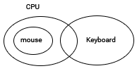 Clearly from the diagram, I and III are true.
- Statements: Samosas are Jalebi. All Jalebis are Tikki. All Tikkis are Barfi
Conclusion:
I. All Jalebis are Barfi
II. All Tikkis are Samosas
III. All Samosas are Barfi
IV. All Barfi are Jalebi
1. Only I and II follow
2. Only I and III follow
3. Only II and III follow
4. All follow
Answer Key: 2
Explanation: 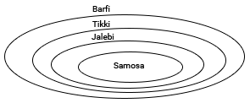 Clearly from the diagram, I and III are true.

DIRECTIONS for questions 6 – 10: In each of the questions below are given three statements followed by four conclusions numbered I, II, III and IV. You have to take the given statements to be true even if they seem to be at variance from commonly known facts. Read the conclusions and then decide which of the given conclusions logically follows from the given statements disregarding commonly known facts.
- Statements: Some eyes are ears. Some ears are lungs. All lungs are hands
Conclusion:
I. Some hands are eyes.
II. Some hands are ears
III. Some lungs are eyes
IV. No hand is eye
1. None follow
2. Only IV follows
3. Only II follows
4. Only III follows
- Answer Key: 3
Explanation: 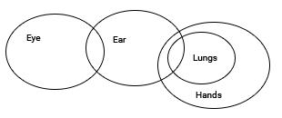 or
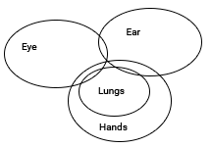 From the diagram II definitely follows.
- Statements: All liquids are solids. Some solids are gases. All gases are clouds
Conclusion:
I. Some clouds are solids
II. Some clouds are liquids
III. Some gases are liquids
IV. Some solids are clouds
1. None follows
2. Only I and II follow
3. Only III and IV follow
4. Only I and IV follow
- Answer Key: 4
Explanation: 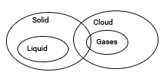 Clearly from the diagram I and IV are true.
- Statements: All Gold are Platinum. No Platinum is silver. Some Diamonds are silver.
Conclusion:
I. Some Diamonds are Gold
II. Some Diamonds are Platinum
III. Some Gold are Silver
IV. No Silver is Gold
1. Only I follows
2. Only III follows
3. Only IV follows
4. Only II and IV follow
- Answer Key: 3
Explanation: 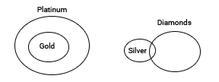 From the diagram we see all the possibilities. Clearly only IV is true for all possibilities.
- Statements: Some messages are whatsapp. All Hikes are whatsapp. All whatsapp are facebook.
Conclusion:
I. Some facebook are messages
II. All hikes are facebook
III. Some messages are hikes
IV. Some message are facebook
1. All follow
2. Only I, II and III follow
3. Only I, II and IV follow
4. Only III and IV follow
- Answer Key: 3
Explanation: 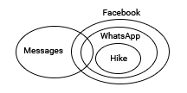 Clearly from the diagram I, II and IV are true.
- Statements: No watch is cycle. No cycle is Motorbike. Some auto are motorbike
Conclusion:
I. No Motorbike is watch
II. No motor bike is cycle
III. Some cycles are watches
IV. All Motorbikes are watches
1. None follows
2. Only I follows
3. Only I and III follow
4. None of these
Answer Key: 4
Explanation: 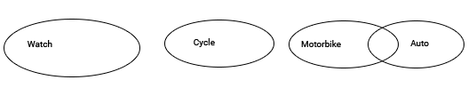 Clearly from the diagram, No Motorbike is cycle. So II follows. Hence option 4.

DIRECTIONS for questions 1-10: Given two statements, verify the conclusions and mark the answer as given below:
Mark (1) if only conclusion I follows.
Mark (2) if only conclusion II follows.
Mark (3) if both conclusions I & II follow.
Mark (4) if no conclusion follows.
1.Statements: All locks are keys.
All keys are bats.
Conclusions:
I. Some bats are locks.
II. Some locks are keys.
Answer: Option 3.
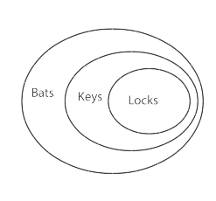 Both I & II follow. So option 3
2.Statements: Some cups are pots.
All pots are tubes.
Conclusions:
I. Some pots are cups.
II. Some tubes are cups.
Answer: Option 3.
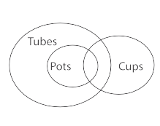 Both I & II follow. So option 3
3.Statements: All bags are books.
Some purses are bags.
Conclusions:
I. Some books are purses.
II. Some books are bags
Answer: Option 3.
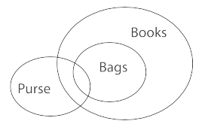 Both I & II follow. So option 3
4.Statements: Some cars are jeeps.
All pens are cars.
Conclusions:
I. No pen is jeep
II. Some jeeps are cars.
Answer: Option 2.
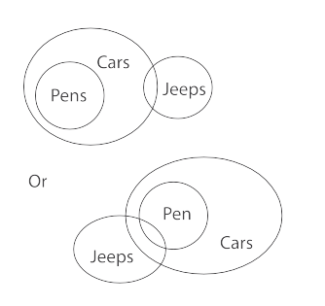 Only conclusion II follows. So option 2.
5.Statements: Some cats are dogs.
No dog is cow.
Conclusions:
I. No cow is cat.
II. No dog is cat.
Answer: Option 4.
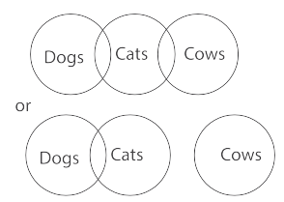 No conclusion follows. So option 4.
6.Statements: Some Goats are Birds.
All Cars are Goats.
Conclusions:
I. Some Cars are Birds.
II. No Bird is Goat.
Answer: Option 4.
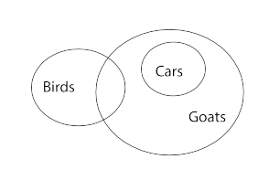 No conclusion follows. So option 4.
7.Statements: All Grapes are Bananas.
All Bananas are Potatoes.
Conclusions:
I. Some Potatoes are Bananas.
II. Some Grapes are Potatoes.
Answer: Option 3.
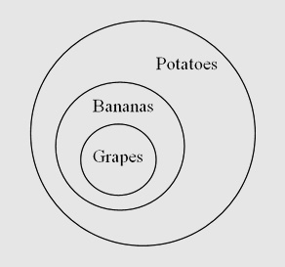
Both I & II follow. So option 3
8.Statements: Some Cats are Rats.
Some Rats are Ants.
Conclusions:
I. No Rat is Ant.
II. No Cat is Ant.
Answer: Option 4
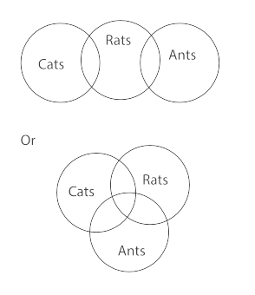 No conclusion follows. So option 4.
9.Statements: All chalks are Dusters.
Some Chalks are Boards.
Conclusions:
I. Some Dusters are Boards.
II. Some Chalks are Dusters.
Answer: Option 3.
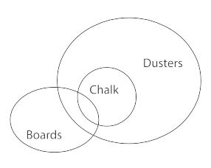 Both I & II follow. So option 3.
10.Statements: Some Bags are Books.
All Books are Boxes.
Conclusions:
I. All Bags are Boxes.
II. No Book is Boxes.
Answer: Option 4.
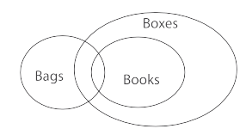 No conclusion follows. So option 4.

