**FINAL QUESTION TO START THE PHASE 2**

**We are glad to inform you that your phase 1 verification process is almost complete, before starting the phase 2 verification, we need to sure that you have understood the salary process completely to overcome any confusion in future between LSL and you.**

**To get the phase 2 verification permission, answer the following question as reply in email to** [**support@lsllp.net.in**](mailto:support@lsllp.net.in)

**Q. Describe the salary process as per the following real time salary example screenshot with in maximum 10 sentences.** **Describe each transaction in the given screenshot and mention that after completing how many packets of entry and how many reports in analysis the employee has received the respective salary in his account?**

**(Assume the amount per packet is Rs 780 and amount per report is Rs 500, You have to write the answer in your own words, this contains one screenshot of only one current employee’s State Bank of India bank statement)**

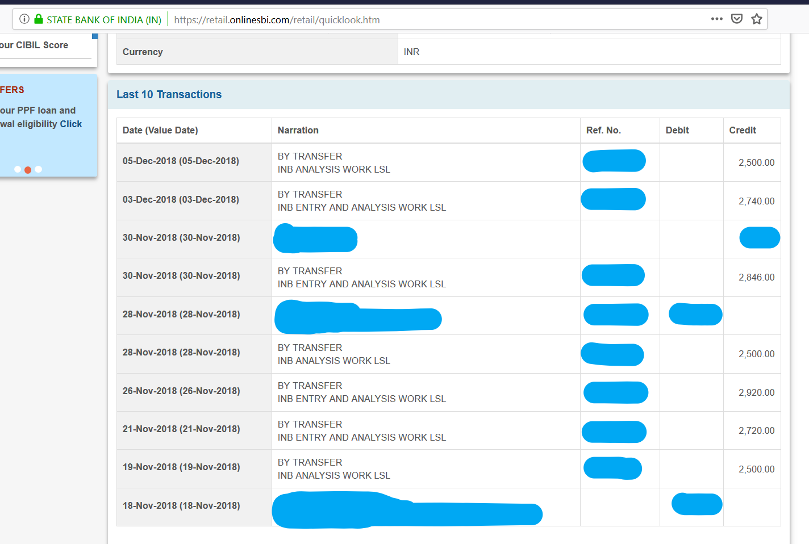

**Write the answer here:**

On Dec 5,2018 he/she has analysed 5 reports 500*5 = 2500. therefore rs.2500 has been credited to them.

On Dec 3,2018 2 and half data entry and 1 analysis has been done.

On Nov 30,2018 no work has been done.

On the same day 3 data entry and 1 analysis has been done.

On Nov 28,2018 5 Analysis work has been done.

On Nov 26,2018 2 data entry and 3 analysis has been done.

On Nov 21,2018 1 and 90% of data entry and 1 analysis has been done.

On Nov 19,2018 5 analysis Work has been done.

Payments are credited to their account based on their daily work and efforts.

So daily effort is need to gain more salary. ……………………………………………………………………………………………………………………………………………………

……………………………………………………………………………………………………………………………………………………

……………………………………………………………………………………………………………………………………………………

……………………………………………………………………………………………………………………………………………………

……………………………………………………………………………………………………………………………………………………

……………………………………………………………………………………………………………………………………………………

……………………………………………………………………………………………………………………………………………………

……………………………………………………………………………………………………………………………………………………

……………………………………………………………………………………………………………………………………………………

……………………………………………………………………………………………………………………………………………………

**N.B- If this answer is not up to the satisfactory level, then your id will be suspended and the job process will not be moved further.**