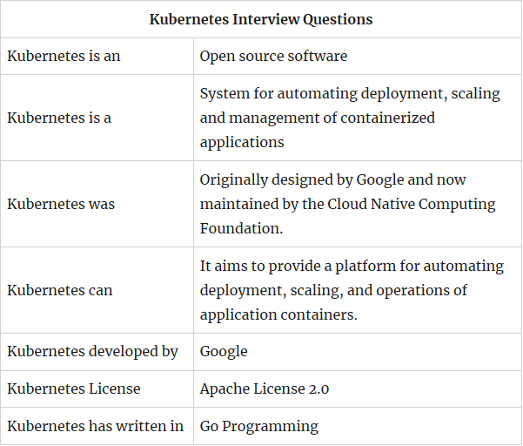

What is Kubernetes and how to use it?

Kubernetes is an open-source platform designed to automate deploying, scaling, and operating application containers. With Kubernetes, you are able to quickly and efficiently respond to customer demand: Deploy your applications quickly and predictably.

What is the meaning of Kubernetes?

Kubernetes (commonly referred to as “K8s”) is an open-source system for automating deployment, scaling and management of containerized applications that was originally designed by Google and donated to the Cloud Native Computing Foundation.

What is a docker?

Docker container is an open source software development platform. Its main benefit is to package applications in “containers,” allowing them to be portable among any system running the Linux operating system (OS).

What is orchestration in software?

Application Orchestration. Application or service orchestration is the process of integrating two or more applications and/or services together to automate a process, or synchronize data in real-time. Often, point-to-point integration may be used as the path of least resistance.

What is a cluster in Kubernetes?

These master and node machines run the Kubernetes cluster orchestration system. A container cluster is the foundation of Container Engine: the Kubernetesobjects that represent your containerized applications all run on top of a cluster.

What is a swarm in Docker?

Docker Swarm is a clustering and scheduling tool for Docker containers. With Swarm, IT administrators and developers can establish and manage a cluster ofDocker nodes as a single virtual system.

What is a namespace in Kubernetes?

Namespaces are intended for use in environments with many users spread across multiple teams, or projects. Namespaces are a way to divide cluster resources between multiple uses (via resource quota). In future versions of Kubernetes, objects in the same namespace will have the same access control policies by default.

What is a node in Kubernetes?

A node is a worker machine in Kubernetes, previously known as a minion. A nodemay be a VM or physical machine, depending on the cluster. Each node has the services necessary to run pods and is managed by the master components. The services on a node include Docker, kubelet and kube-proxy.

What is Docker and what does it do?

Docker is a tool designed to make it easier to create, deploy, and run applications by using containers. Containers allow a developer to package up an application with all of the parts it needs, such as libraries and other dependencies, and ship it all out as one package.

What is a Heapster?

Heapster is a cluster-wide aggregator of monitoring and event data. It supports Kubernetes natively and works on all Kubernetes setups, including our Deis Workflow setup.

What is a cluster of containers?

A container cluster is a set of Compute Engine instances called nodes. It also creates routes for the nodes, so that containers running on the nodes can communicate with each other. The Kubernetes API server does not run on your cluster nodes. Instead, Container Engine hosts the API server.

What is the Kubelet?

Kubelets run pods. The unit of execution that Kubernetes works with is the pod. A pod is a collection of containers that share some resources: they have a single IP, and can share volumes.

What is Minikube?

Minikube is a tool that makes it easy to run Kubernetes locally. Minikube runs a single-node Kubernetes cluster inside a VM on your laptop for users looking to try out Kubernetes or develop with it day-to-day.

What is Kubectl?

kubectl is a command line interface for running commands against Kubernetes clusters. This overview covers kubectl syntax, describes the command operations, and provides common examples. For details about each command, including all the supported flags and subcommands, see the kubectl reference documentation.

What is k8s?

Kubernetes, also sometimes called K8S (K – eight characters – S), is an open source orchestration framework for containerized applications that was born from the Google data centers.

What is KUBE proxy?

Synopsis. The Kubernetes network proxy runs on each node. Service cluster ips and ports are currently found through Docker-links-compatible environment variables specifying ports opened by the service proxy. There is an optional addon that provides cluster DNS for these cluster IPs.

Which process runs on Kubernetes master node?

Kube-apiserver process runs on Kubernetes master node.

Which process runs on Kubernetes non-master node?

Kube-proxy process runs on Kubernetes non-master node.

What is the use of kube-controller-manager?

kube-controller-manager embeds the core control loop which is a non-terminating loop that regulates the state of the system.

Kubernetes objects made up of what?

Kubernetes objects are made up of Pod, Service and Volume.

What are Kubernetes controllers?

Kubernetes controllers are Replicaset, Deployment controller.

Where Kubernetes cluster data is stored?

etcd is responsible for storing Kubernetes cluster data.

What is the role of kube-scheduler?

kube-scheduler is responsible for assigning a node to newly created pods.

Which container runtimes supported by Kubernetes?

Kubernetes supports docker and rkt container runtimes.

What are the components interact with Kubernetes node interface?

Kubectl, Kubelet, and Node Controller components interacts with Kubernetes node interface.