**GPIO LED Testing Assignment 1**

**Name:** Harish Marepalli

**CMPE 240**

**SJSU ID:** 016707314

**Email:** [harish.marepalli@sjsu.edu](mailto:harish.marepalli@sjsu.edu)

**Team Name:** Student Group_1

**Team Members:** Tirumala Saiteja Goruganthu, Debasish Panigrahi, Shahnawaz Idariya

**Target Board:** LPC1769

**INTRODUCTION:**

1. This activity is used to turn the LED ON and OFF using a push button and is controlled by a C program written in MCUXpresso.
2. If the push button is pressed, the LED turns ON and if it is released, the LED turns OFF.
3. The input pin used is p2.13 (j2-27) and the output pin used is p0.21 (j2-23).

**SCHEMATIC:**

The Schematic/Circuit on paper and in Eagle software is as follows:

**CONNECTIVITY TABLE:**

The connectivity table is as follows:

|  |  |  |
| --- | --- | --- |
| CPU Pin | J2 | Note |
| GPP/P0.21 | J2-23 | Output |
| GPP/P2.13 | J2-27 | Input |
| GND | J2-1 | GND |

**MATERIALS USED:**

1. LPC1769
2. 330 Ohms Resistor
3. LED
4. Push Button (Switch)
5. Connecting wires
6. Submitted the project zip on canvas.
7. **SOURCE CODE:**

File Name: LED_ON_SWITCH_ASSIGNMENT.c

Code:

/*

==============================================================================

Name : LED_ON_SWITCH_ASSIGNMENT.c

Author : Harish Marepalli (016707314)

Version :

Copyright : $(copyright)

Description : This program is used to turn the LED ON and OFF using a

push button. If the push button is pressed, the LED

turns ON and if it is released, the LED turns OFF. The

input pin used is p2.13 (j2-27) and the output pin used

is p0.21 (j2-23).

==============================================================================

*/

#ifdef __USE_CMSIS

#include "LPC17xx.h"

#endif

#include <cr_section_macros.h>

#include <stdio.h>

// TODO: insert other include files here

// TODO: insert other definitions and declarations here

//Initialize the port and pin as outputs.

void GPIOinitOut(uint8_t portNum, uint32_t pinNum)

{

if (portNum == 0)

{

LPC_GPIO0->FIODIR |= (1 << pinNum);

}

else if (portNum == 1)

{

LPC_GPIO1->FIODIR |= (1 << pinNum);

}

else if (portNum == 2)

{

LPC_GPIO2->FIODIR |= (1 << pinNum);

}

else

{

puts("Not a valid port!\n");

}

}

void GPIOinitInput(uint8_t portNum, uint32_t pinNum)

{

if (portNum == 0)

{

LPC_GPIO0->FIODIR |= (0 << pinNum);

}

else if (portNum == 1)

{

LPC_GPIO1->FIODIR |= (0 << pinNum);

}

else if (portNum == 2)

{

LPC_GPIO2->FIODIR |= (0 << pinNum);

}

else

{

puts("Not a valid port!\n");

}

}

void setGPIO(uint8_t portNum, uint32_t pinNum)

{

if (portNum == 0)

{

LPC_GPIO0->FIOSET = (1 << pinNum);

printf("Pin 0.%d has been set.\n",pinNum);

}

//Can be used to set pins on other ports for future modification

else

{

puts("Only port 0 is used, try again!\n");

}

}

//Deactivate the pin

void clearGPIO(uint8_t portNum, uint32_t pinNum)

{

if (portNum == 0)

{

LPC_GPIO0->FIOCLR = (1 << pinNum);

printf("Pin 0.%d has been cleared.\n", pinNum);

}

//Can be used to clear pins on other ports for future modification

else

{

puts("Only port 0 is used, try again!\n");

}

}

int main(void)

{

// Force the counter to be placed into memory

//volatile static int i = 0 ;

uint32_t switchStatus;

uint32_t switchPinNumber = 13;

//LPC_PINCON->PINMODE4 = 0x08000000;

//Set pin 0.21 as output

GPIOinitOut(0,21);

//Set pin 2.13 as input

GPIOinitInput(2,13);

while(1)

{

//Get the status of the switch

switchStatus = (LPC_GPIO2->FIOPIN >> switchPinNumber) & 0x01;

if (switchStatus == 1)

{

//Activate pin 0.21

setGPIO(0,21);

}

else

{

//Clear pin 0.21

clearGPIO(0, 21);

}

}

return 0 ;

}

1. **GPIO TESTING IMAGE:**

Images of GPIO testing result with LED ON and OFF using switch are provided below.

1. This image shows that the LED is OFF because switch is not turned ON.

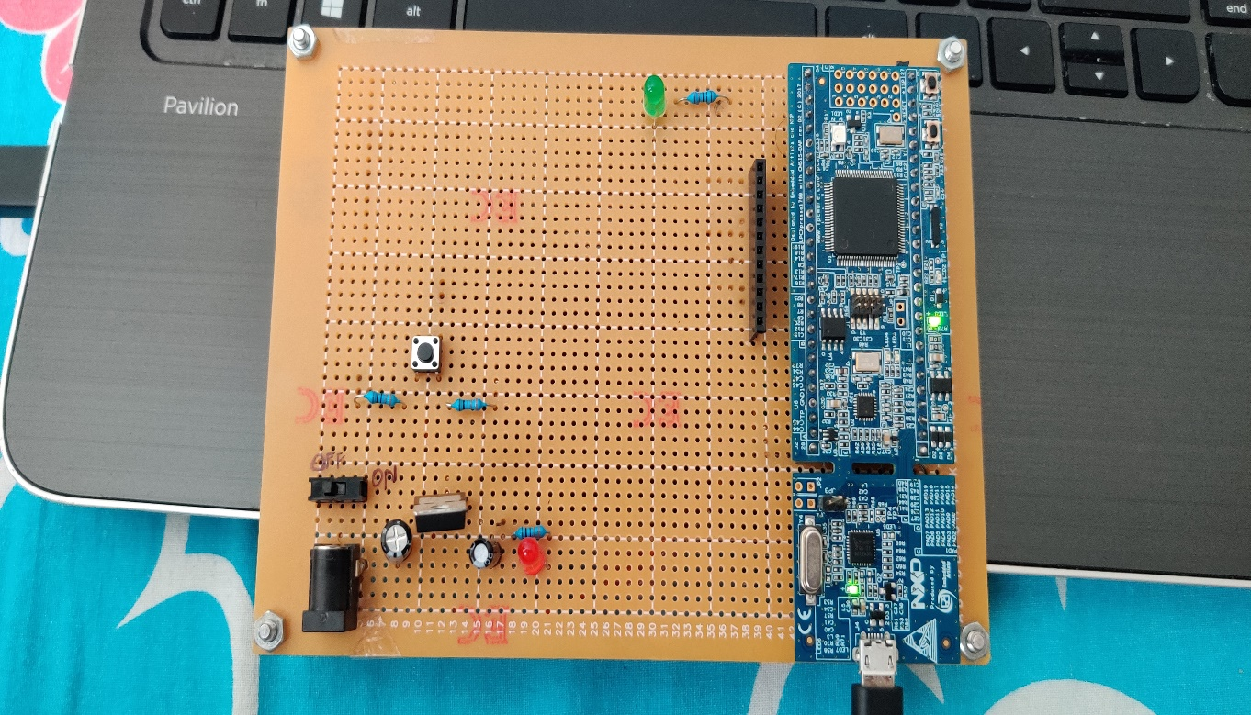

1. This image shows that the LED is ON upon pressing the button/switch.

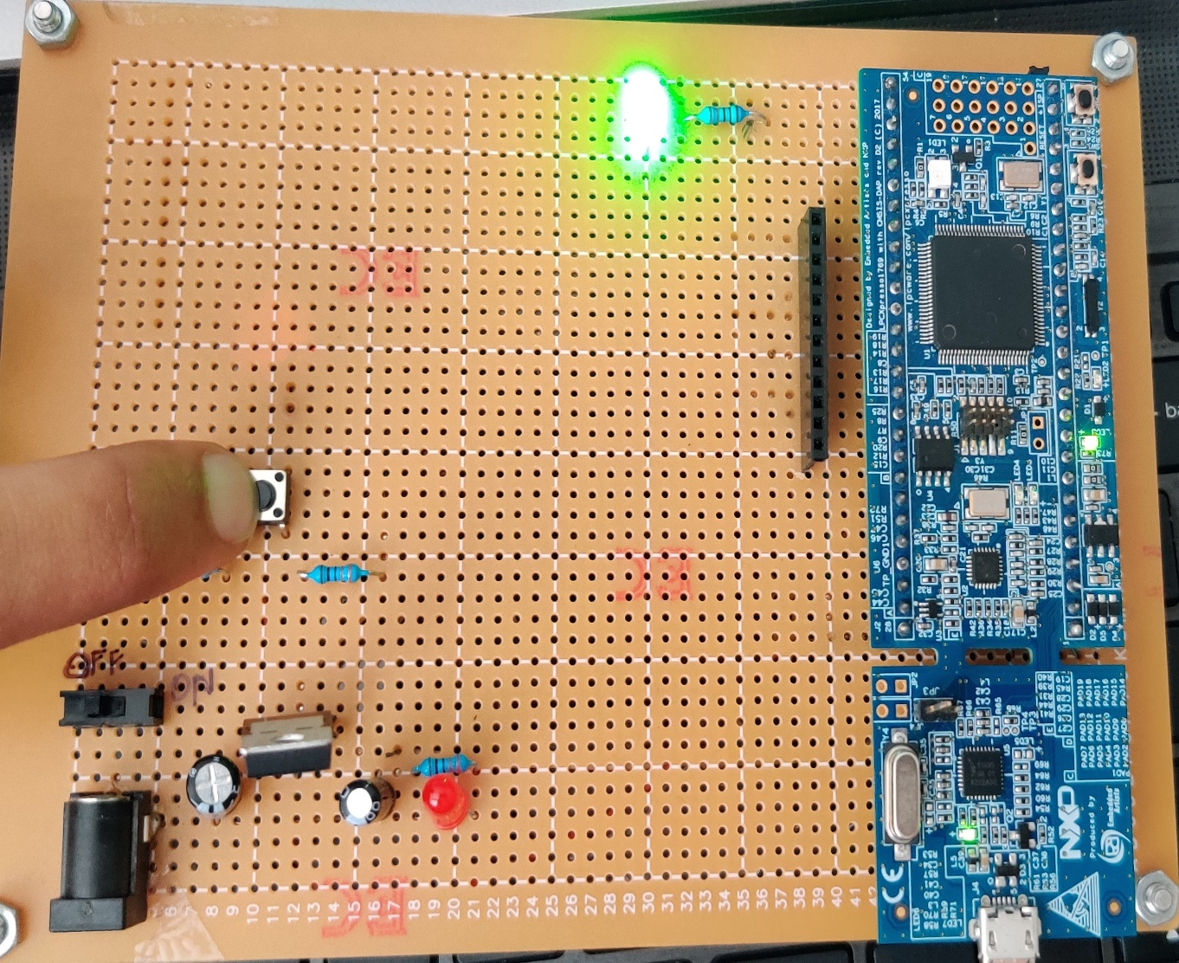

1. This image shows that the message in the console is “Pin 0.21 has been cleared.” before the switch is pressed (LED is OFF) and “Pin 0.21 has been set.” after the switch is pressed (LED is ON).

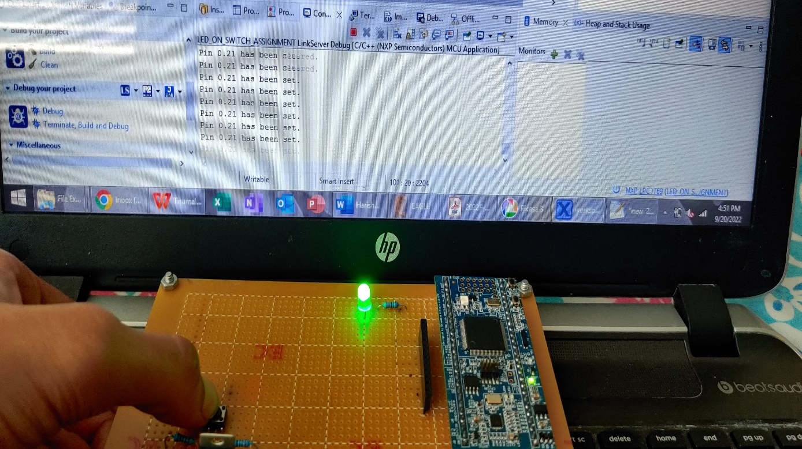

1. Submitted the assignment on canvas.

**CONCLUSION:**

In conclusion, in this activity LED is turn ON using switch. By this activity, I gained familiarity with the MCUXpresso software and LPC1769 and soldering.