**CMPE 287 – Software Quality Assurance and Testing**

**AI test Tool**

**First Name:** Harish

**Last Name:** Marepalli

**SJSU ID:** 016707314

**Professor:** Jerry Gao

Below are the steps that I had performed in the AI testing tool.

1. Figure 1 shows the login page with my username.

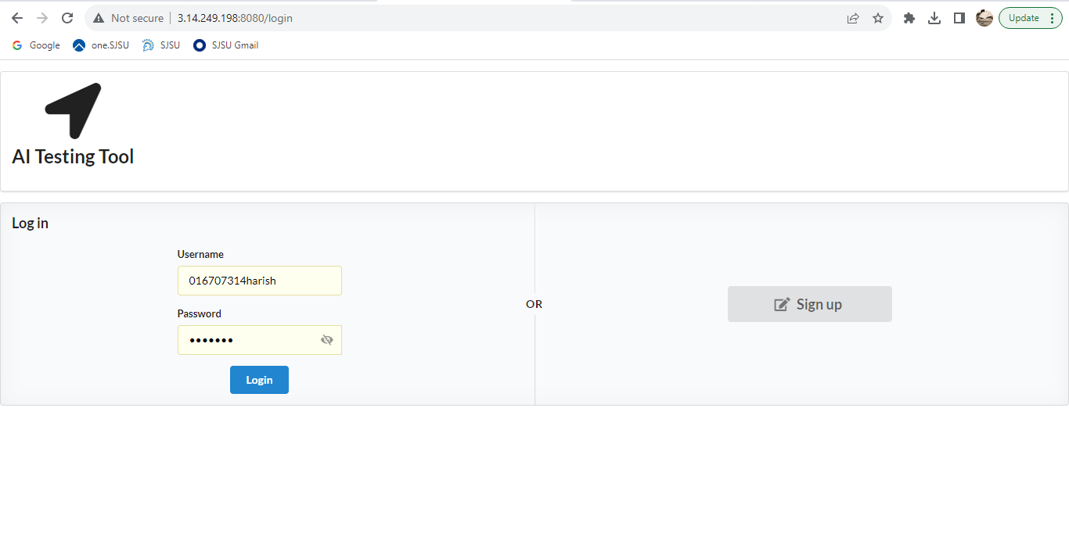

***Fig. 1. AI testing tool login page***

2. Figure 2 shows the dashboard page after logging in to the tool. Click on Add Project to create a project.

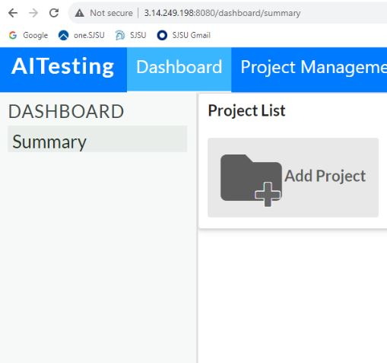

***Fig. 2. Dashboard Page***

3. Figure 3 shows the Add Project page where we can create the project with a name and function. Here, create Input, Context, and Output models.

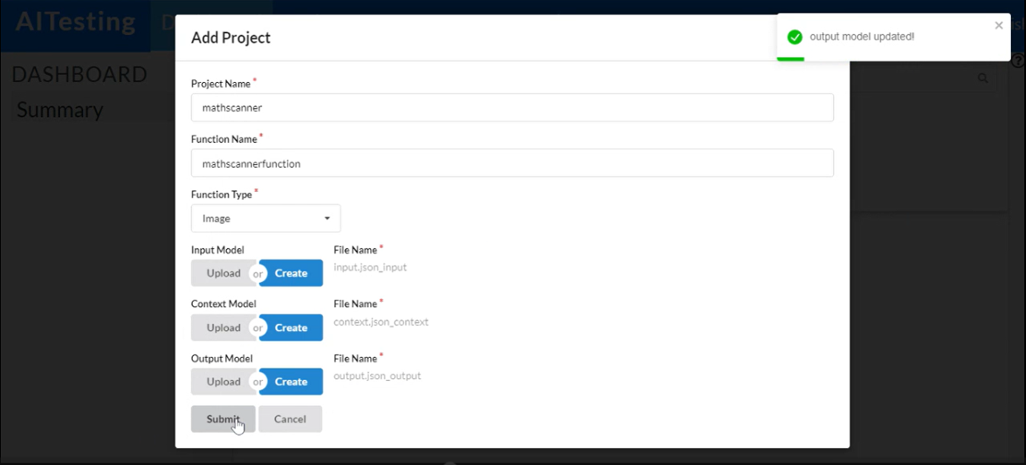

***Fig. 3. Add Project Wizard***

4. Figure 4 shows the Project List with my created mathscanner project.

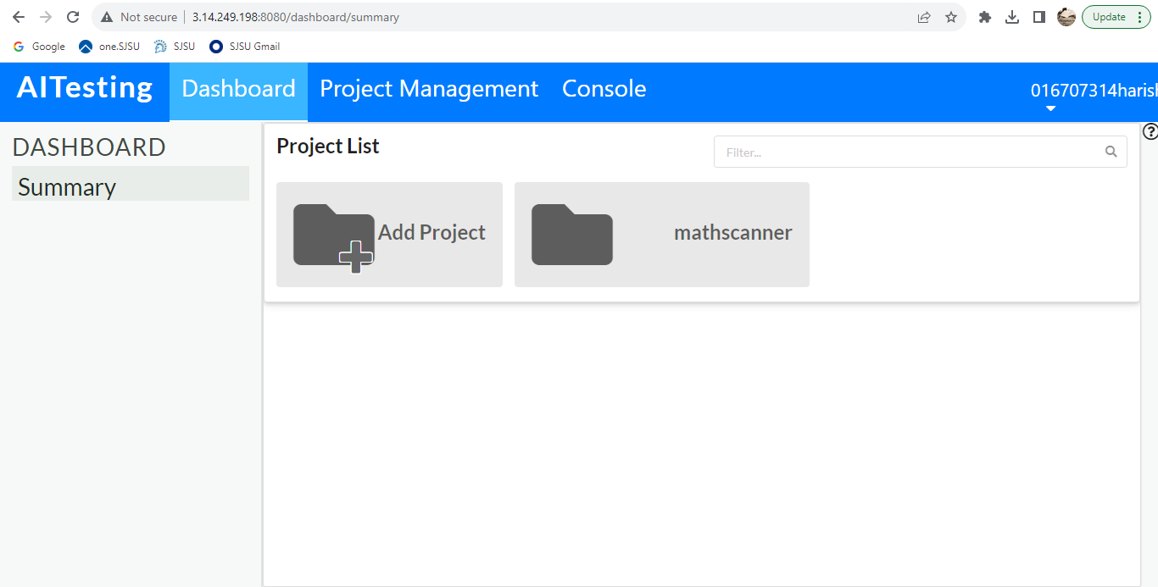

***Fig. 4. Project List***

5. Figure 5 shows the Project Management tab containing Function List with my created mathscannerfunction.

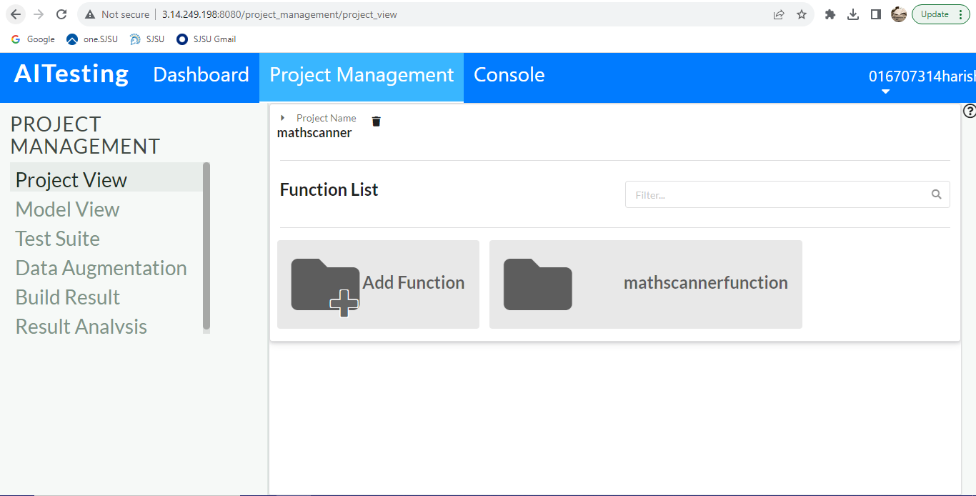

***Fig. 5. Function List***

6. Click on the created function to open the Model View. Figures 6 and 7 show the tree model of the input.

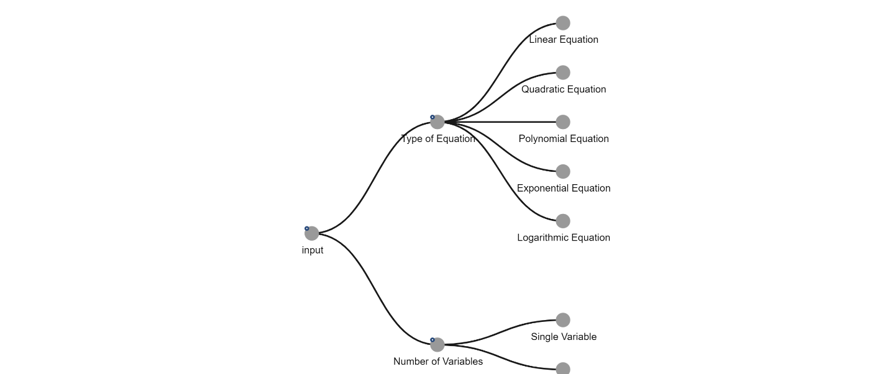

***Fig. 6. Input Tree Model***

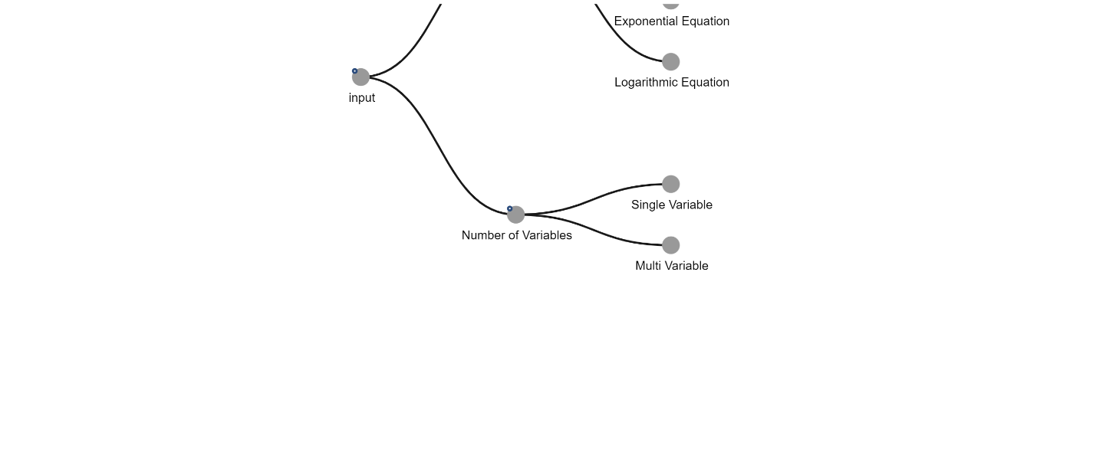

***Fig. 7. Input Tree Model***

7. Figures 8 and 9 show the input table with number of variables and type of equation as columns.

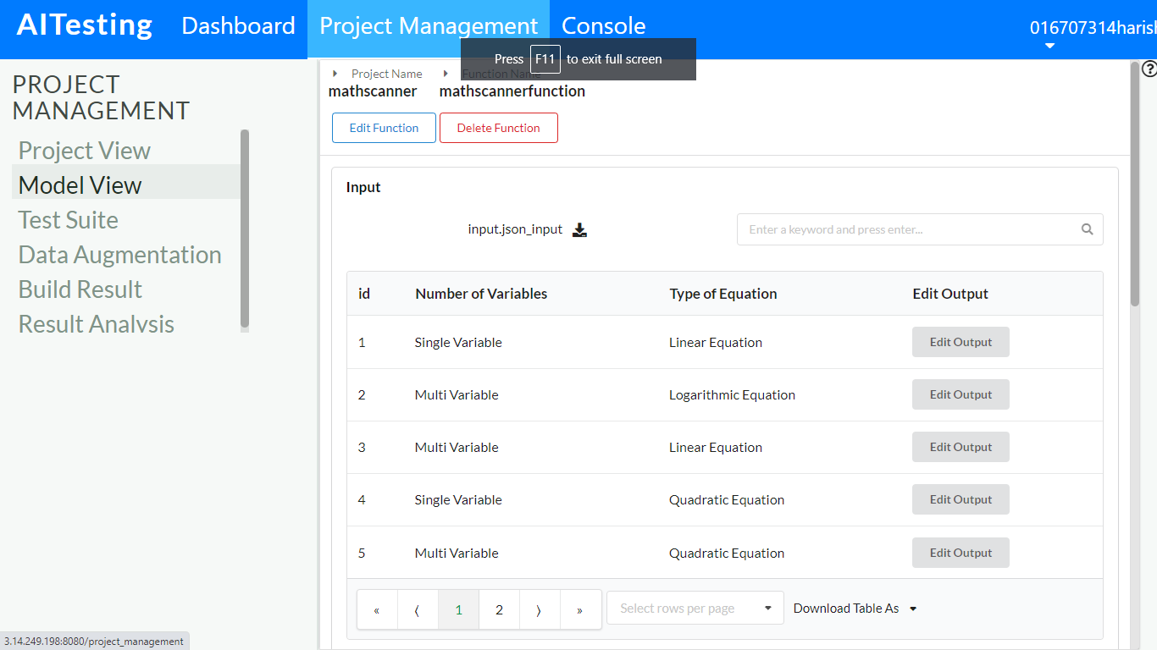

***Fig. 8. Input Table***

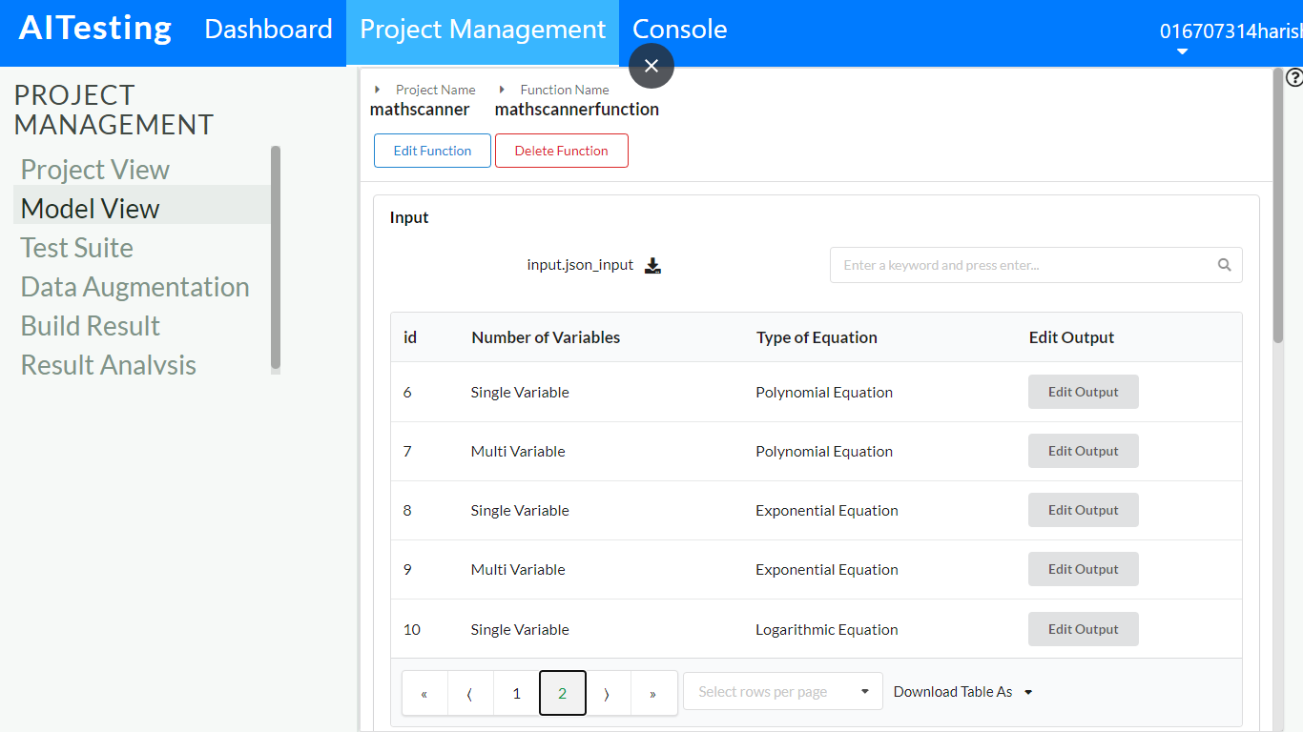

***Fig. 9. Input Table***

8. Figures 10 and 11 show the tree model of the context.

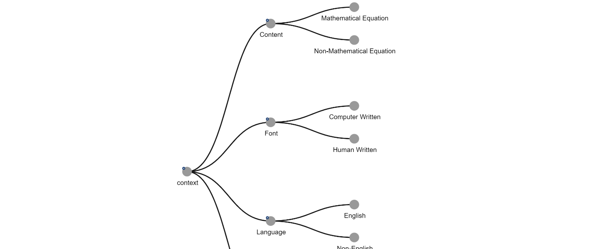

***Fig. 10. Context Tree Model***

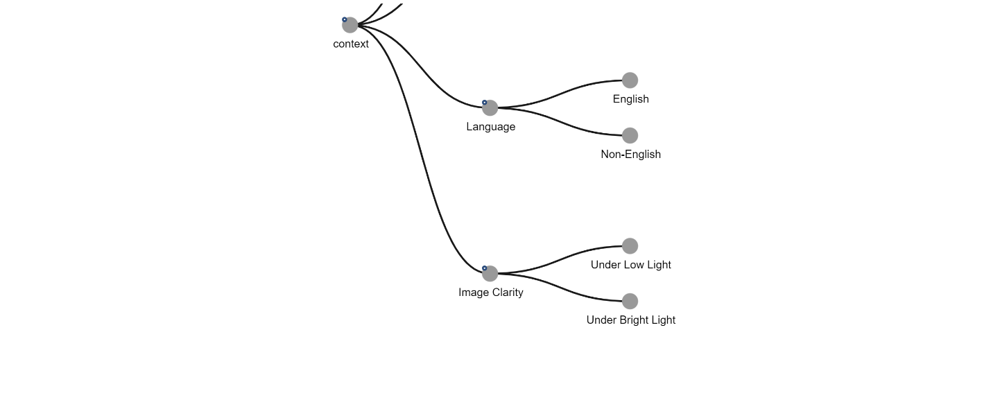

***Fig. 11. Context Tree Model***

9. Figures 12, 13, 14, and 15 show the context table with content, font, image clarity, and language as columns.

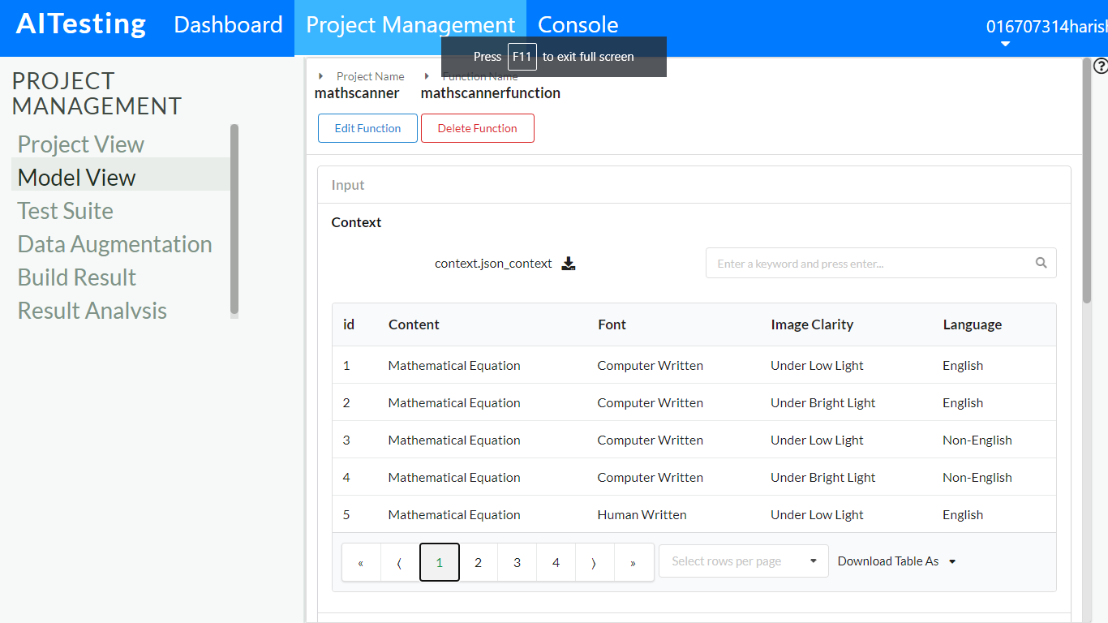

***Fig. 12. Context Table***

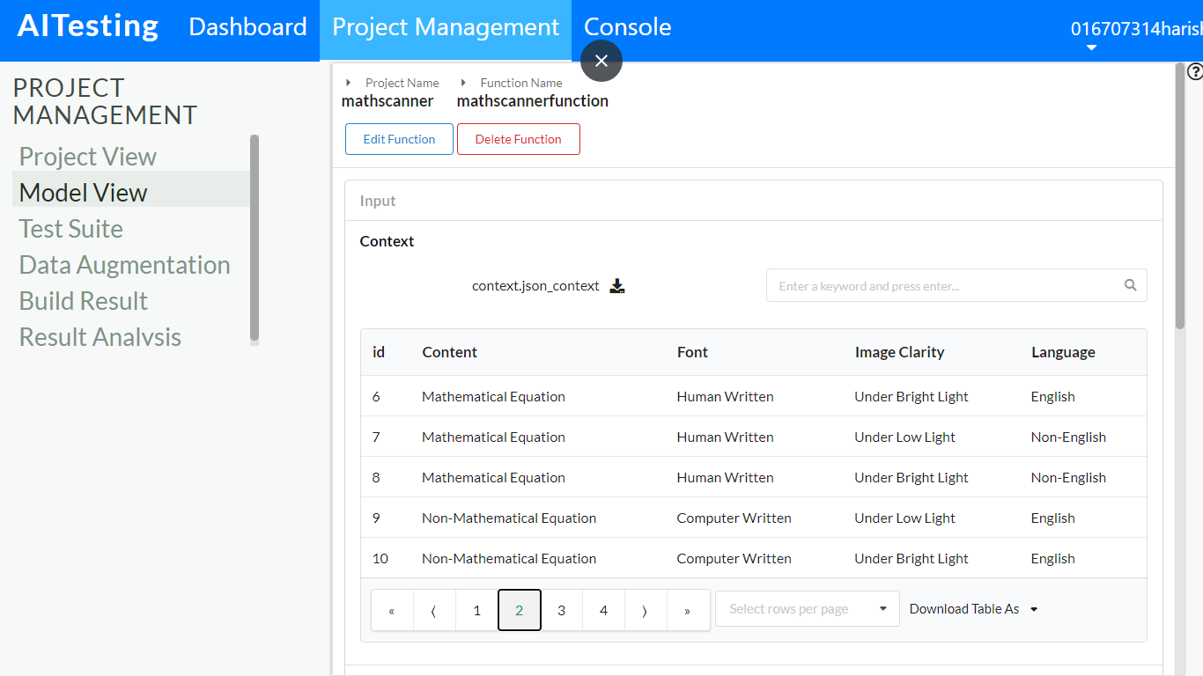

***Fig. 13. Context Table***

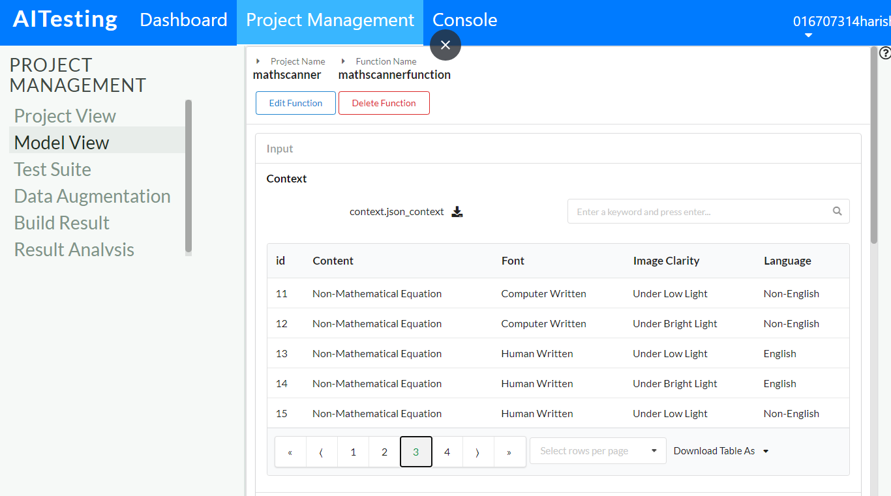

***Fig. 14. Context Table***

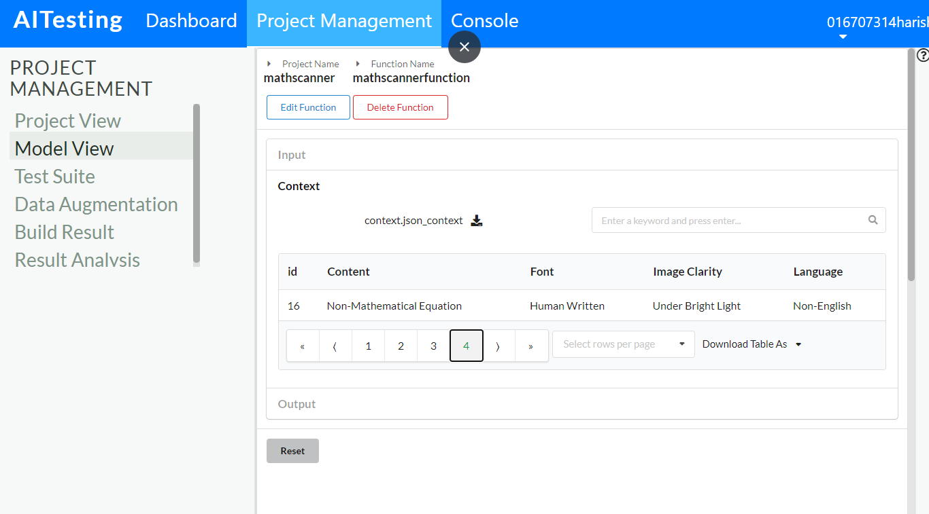

***Fig. 15. Context Table***

10. Figure 16 shows the tree model of the output.

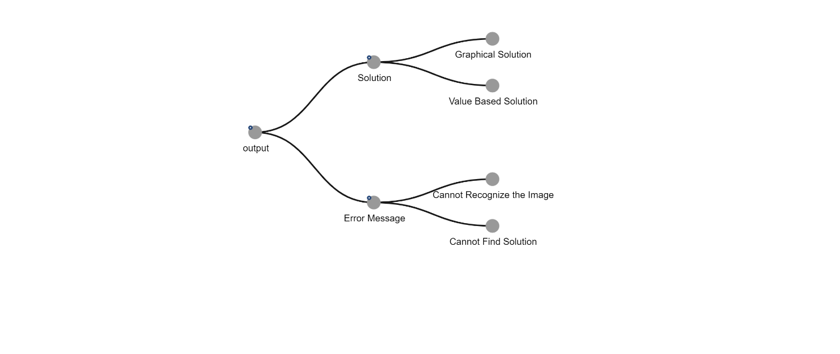

***Fig. 16. Output Tree Model***

11. Figures 17 and 18 show the output table with error message and solution.

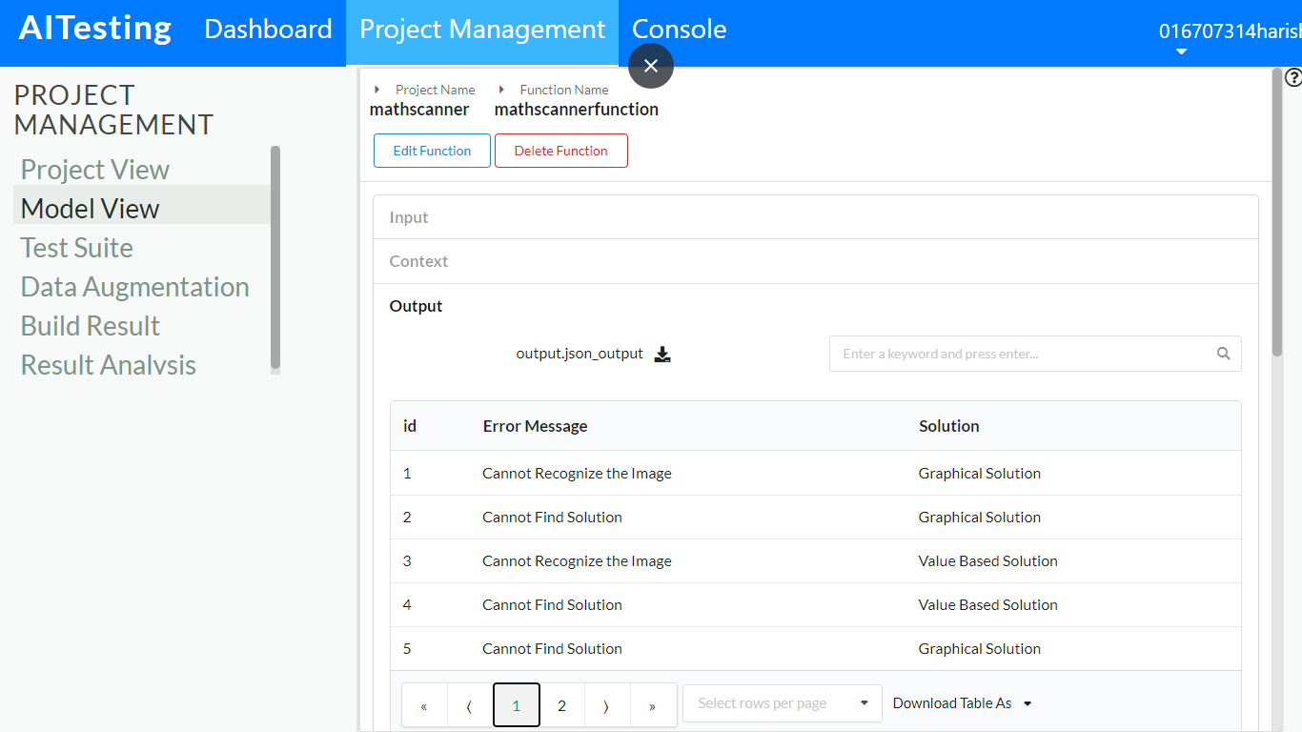

***Fig. 17. Output Table***

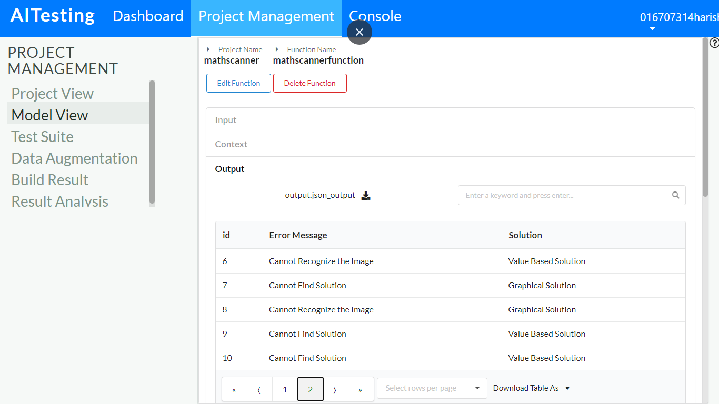

***Fig. 18. Output Table***

12. Figures 19, 20, and 21 show the decision tables.

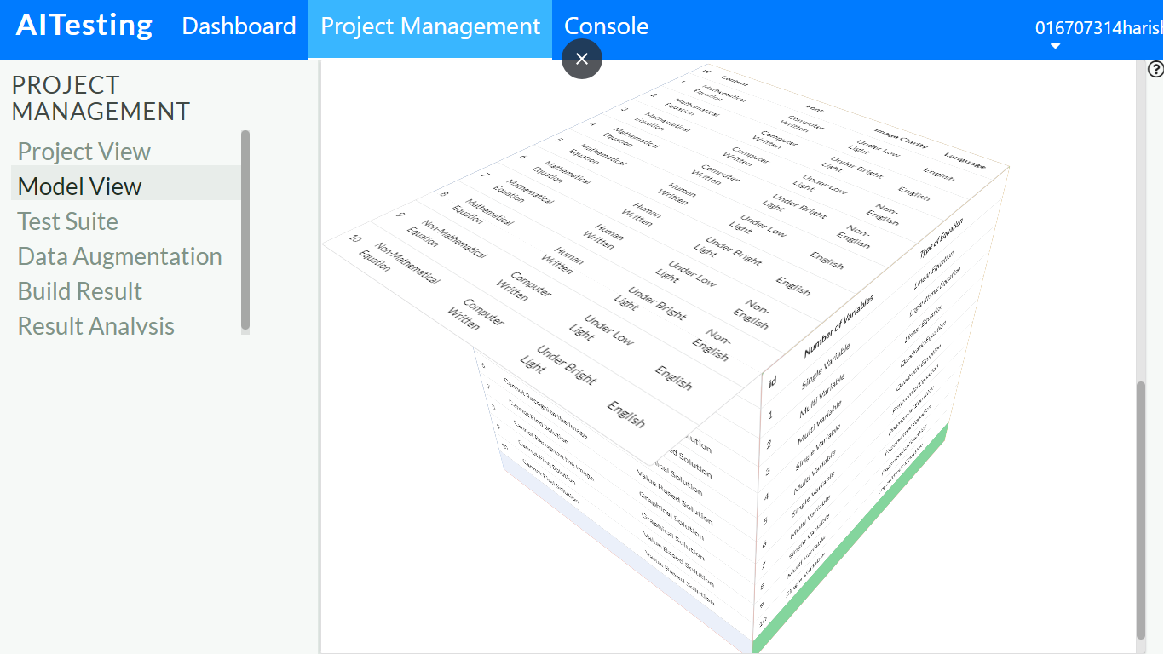

***Fig. 19. Decision Table***

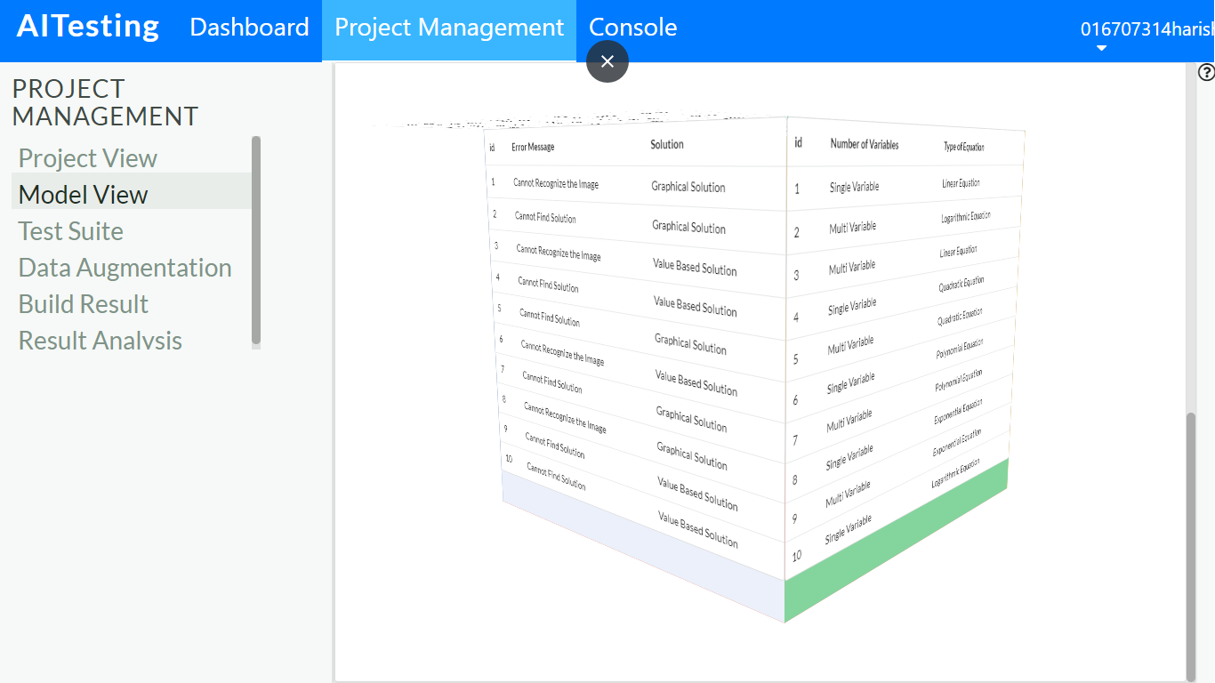

***Fig. 20. Decision Table***

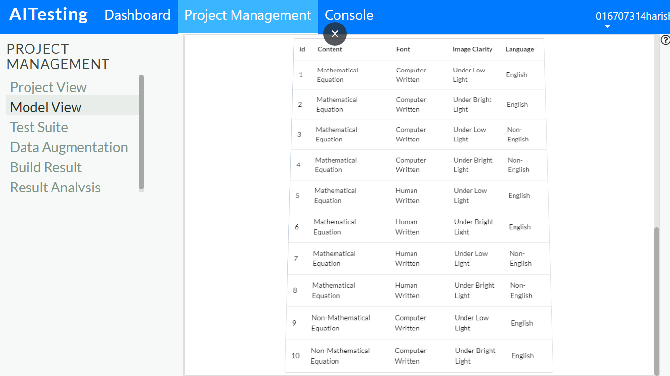

***Fig. 21. Decision Table***

13. Figures 22 and 23 show the total test cases that got generated.

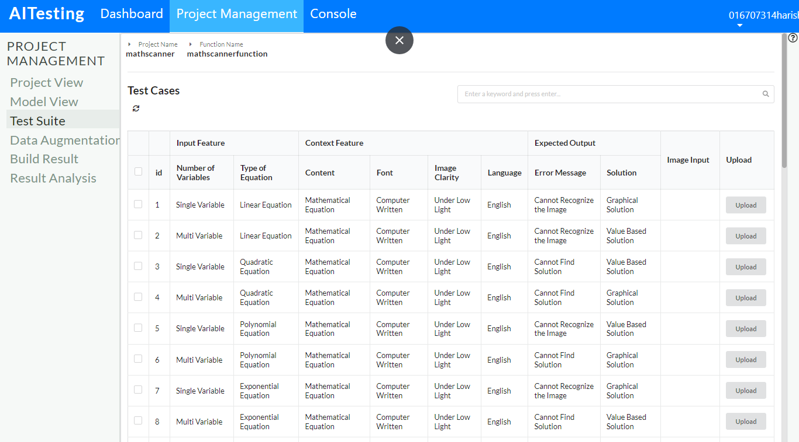

***Fig. 22. Test Cases***

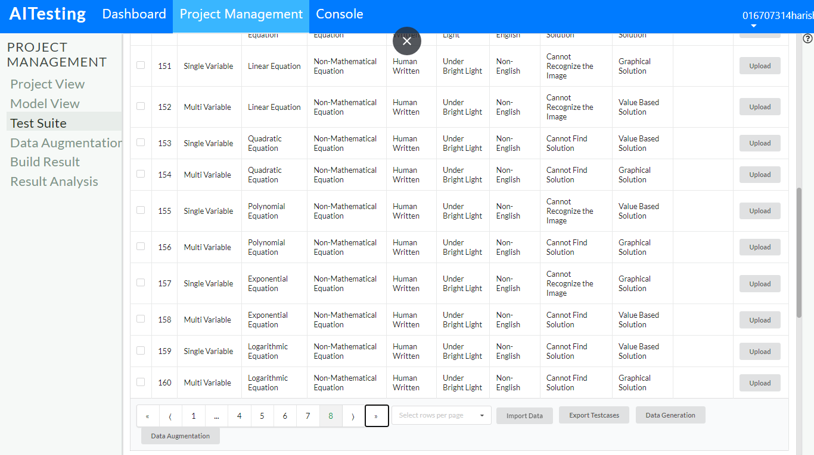

***Fig. 23. Test Cases***