**Boundary value testing method**

1. Input: 2x4 – 2x3 – 14x2 + 2x + 12 = 0

Expected Result: x = -2, x = -1, x = 1, x = 3

Actual Result:

PhotoMath:

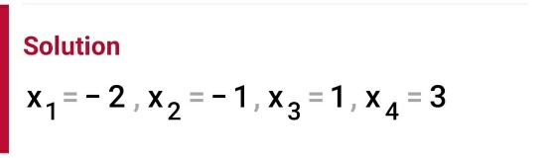

Test case result: Pass

Brainly:



Test case result: Fail

2. Input: x3 – 1 = 0

Expected Result: x = 1, x = −1/2 + (sqrt (3)/2)i, x = −1/2 - (sqrt (3)/2)i

Actual Result:

PhotoMath:

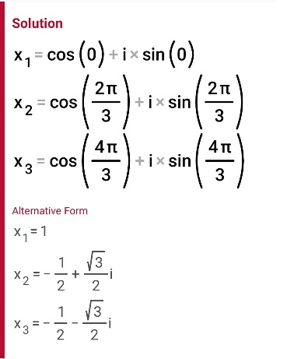

Test case result: Pass

Brainly:

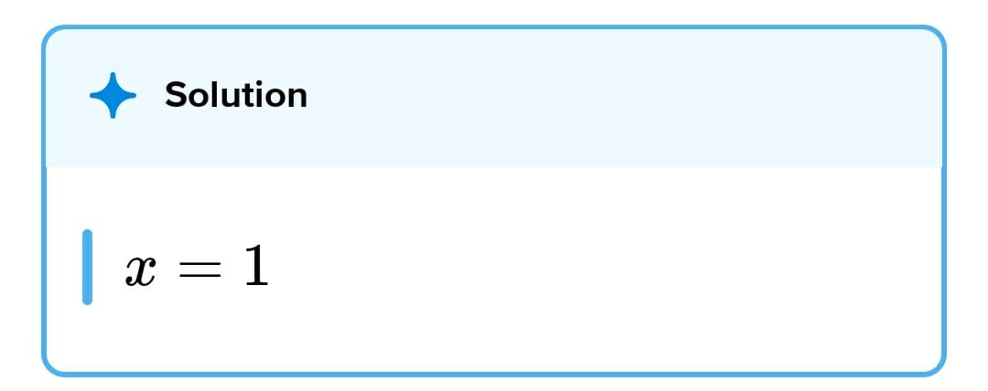

Test case result: Fail

3. x2 – 25 = 0

Expected Result: x = 5, x = -5

Actual Result:

PhotoMath:

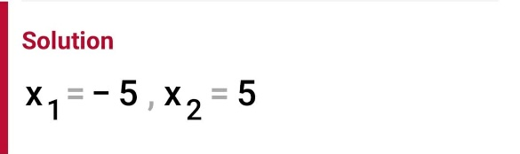

Test case result: Pass

Brainly:

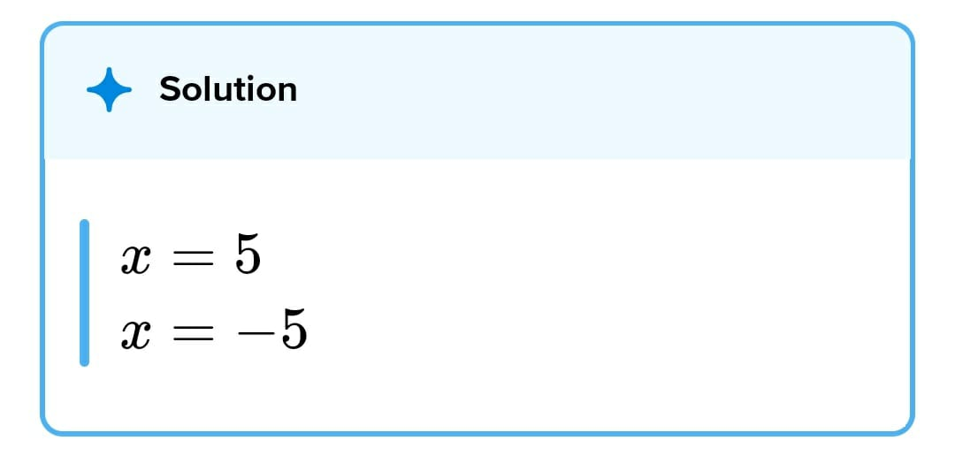

Test case result: Pass

4. Input: x4 – 4x2 + 4 = 0

Expected Result: x = -sqrt (2), x = sqrt (2)

Actual Result:

PhotoMath:

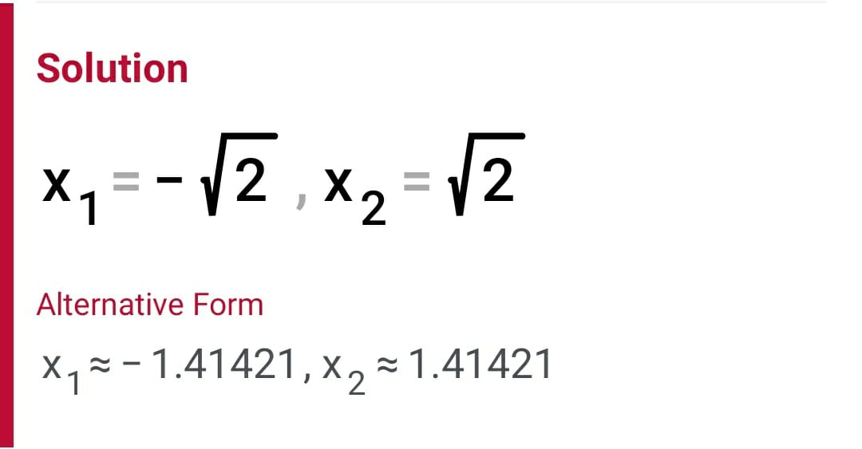

Test case result: Pass

Brainly:

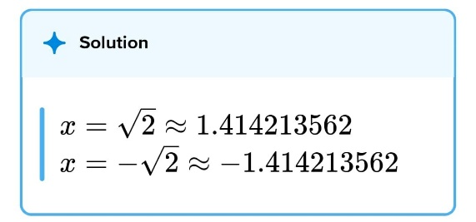

Test case result: Pass

5. Input: 2x2 + 3x + 1 = 0

Expected Result: x = -1/2, x = -1

Actual Result:

PhotoMath:

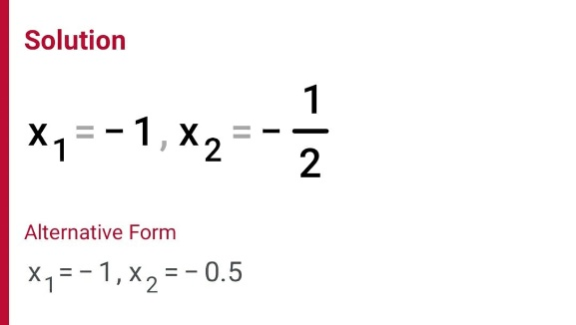

Test case result: Pass

Brainly:

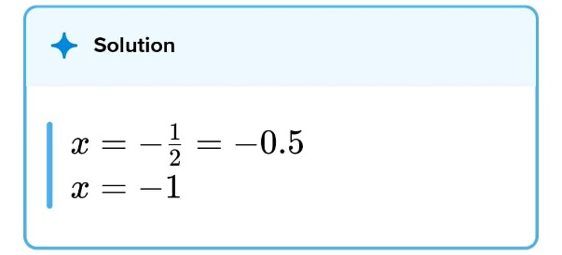

Test case result: Pass

Category Partition Based Testing:

1. Figurative:

Input: (x2 - 7x + 11)x2 – 13x + 42 = 1

Expected Result: x = 2, x = 3, x = 4, x = 5, x = 6, x = 7

Actual Result:

PhotoMath:

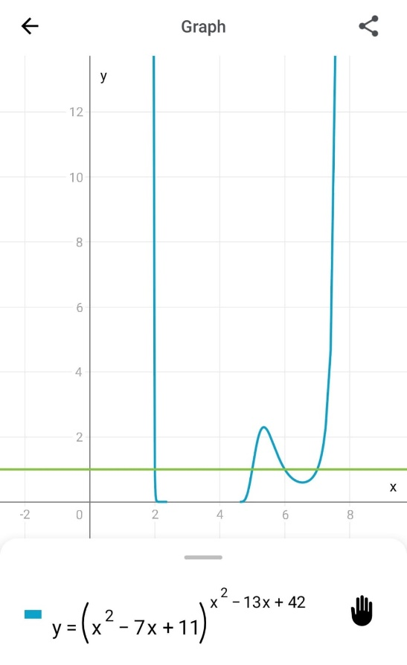

Test case result: Fail (It gives only four solutions).

2. Word problem:

Input: Find the value of a, if x – a is a factor of x3 – ax2 + 2x + a – 1

Expected Result: a = 1/3

Actual Result:

PhotoMath:

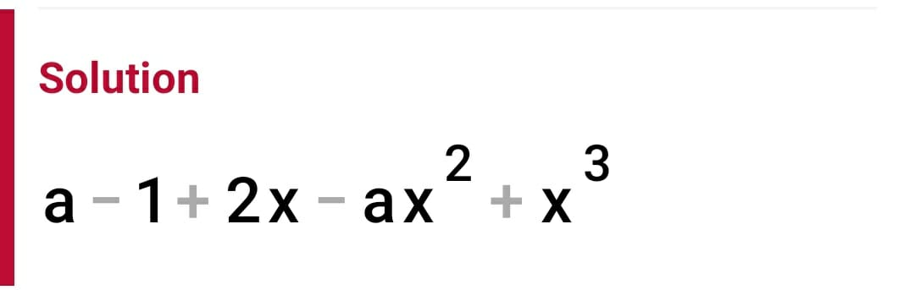

Test case result: Fail

3. Non-Mathematical:

Username + Password = Access

Expected Result: Error

Actual Result:

PhotoMath:



Test case result: Pass

4. Low clarity:

Input: x2 + x – 6 = 0

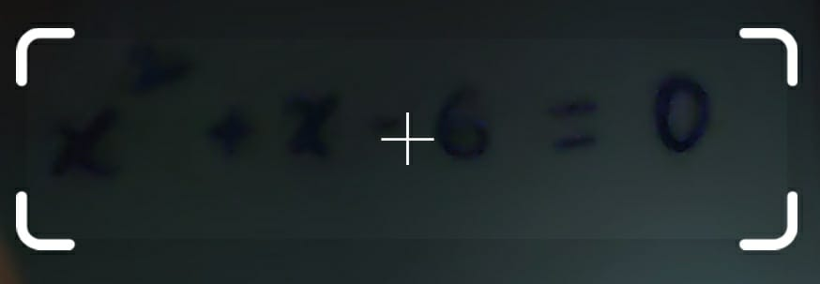

Expected Result: x = -3, x = 2

Actual Result:

PhotoMath:

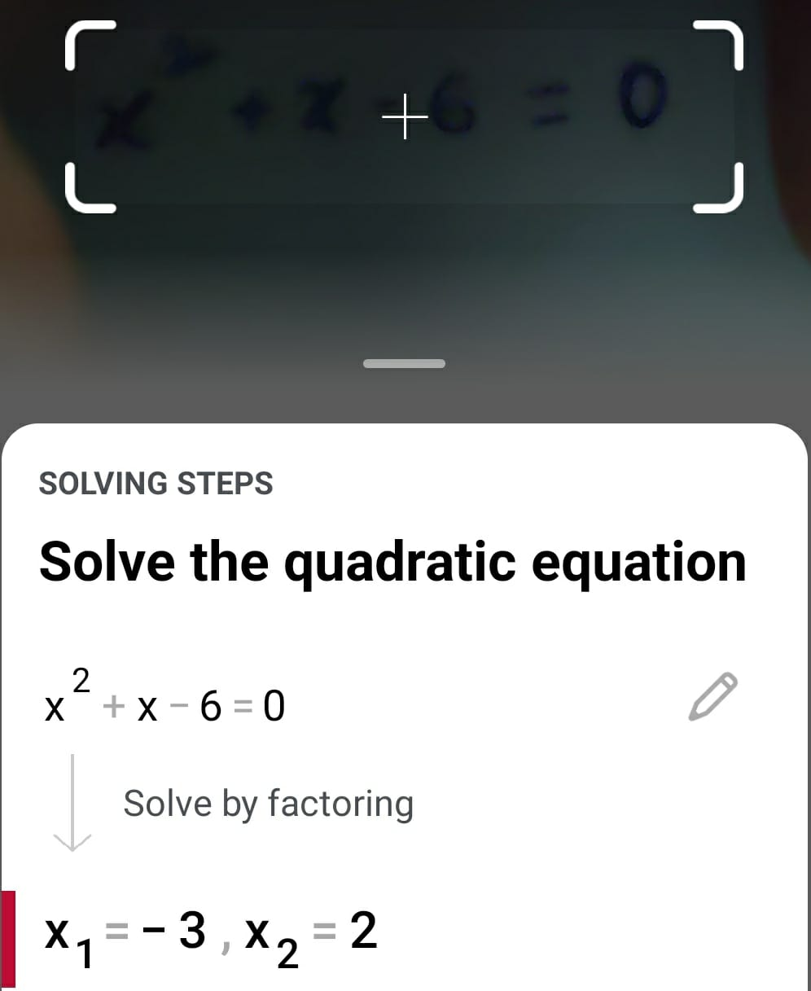

Test case result: Pass

5. High clarity:

Input: x2 + x – 6 = 0

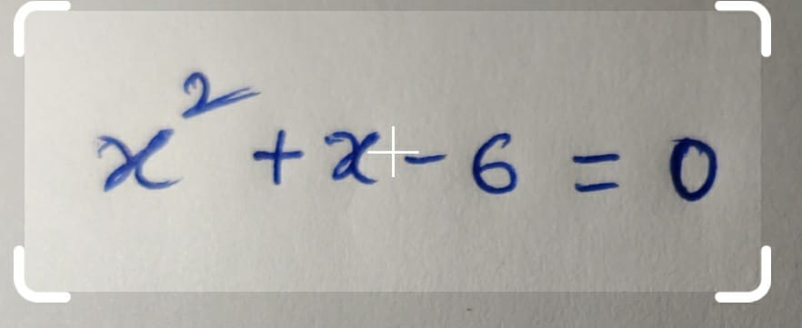

Expected Result: x = -3, x = 2

Actual Result:

PhotoMath:

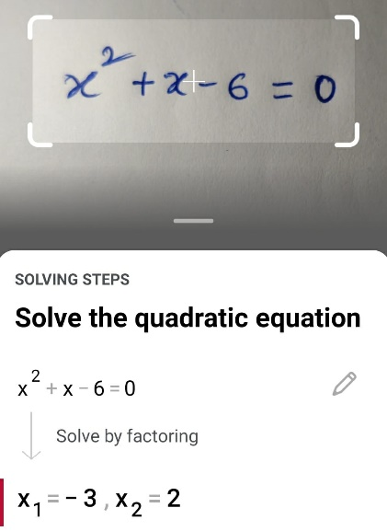

Test case result: Pass

6. Complex:

Input: (42+42i)x2 + (7+i)x + 15i + 5 = 0

Expected Result: x = (-7-i+sqrt (1728 – 3346i)) / 2(42 + 42i), x = (-7-i-sqrt (1728 – 3346i)) / 2(42 + 42i)