Name - Harish Santosh Nemade

Roll_no.-15

DBDA course

## Linux 1 Assignment

Q1. In your home directory, create sets of empty practice files

Create 6 files with names of the form songsX.mp3.

Create 6 files with names of the form snapX.jpg.

Create 6 files with names of the form filmX.avi.

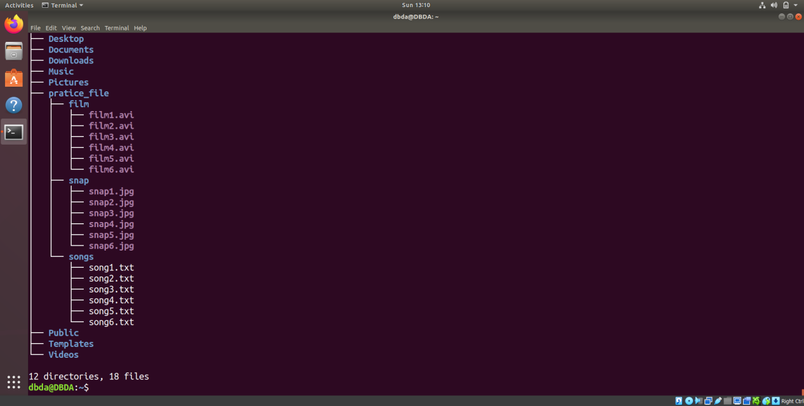

Q2.From your home directory,

Move songs file into your Music subdirectory.

Move snap file into your Pictures subdirectory.

Move your movie files into Videos subdirectory

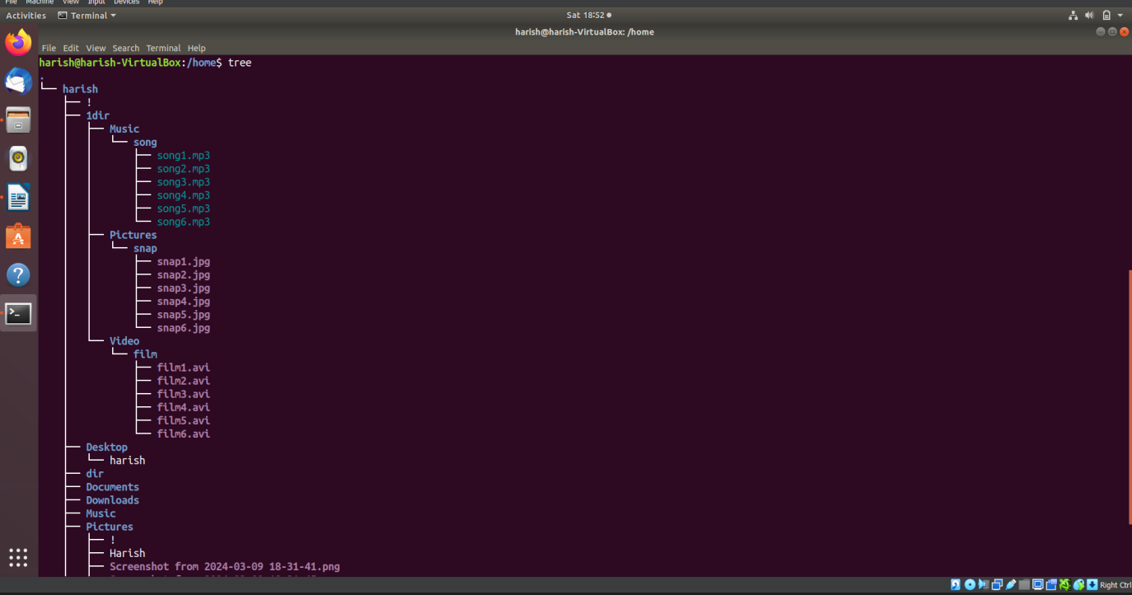

Q3.Create 3 subdirectories for organizing your files named friends,family,work

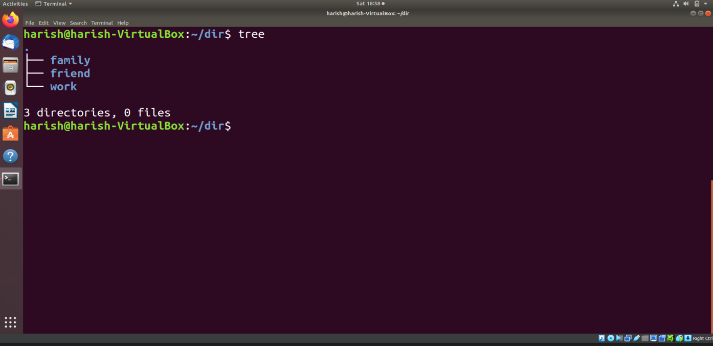

Q4. Copy files (all types ) containing numbers 1 and 2 to the friends folder.

    Copy files (all types) containing numbers 3 and 4 to the family folder.

    Copy files (all types) containing numbers 5 and 6 to the work folder.

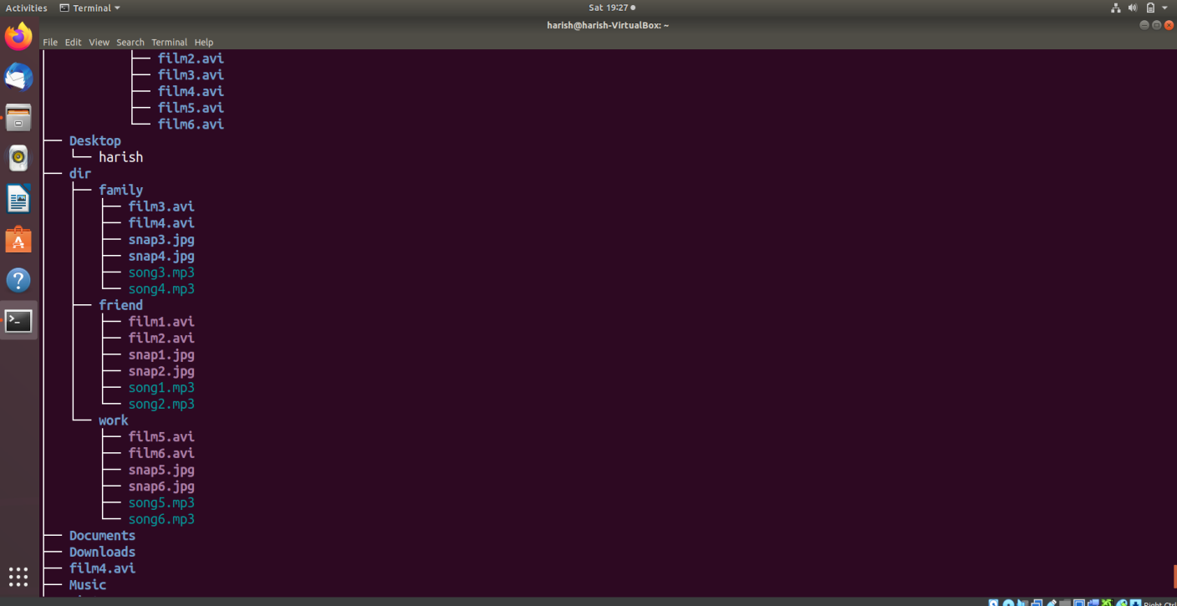

Q5.Delete Family Subdirectory

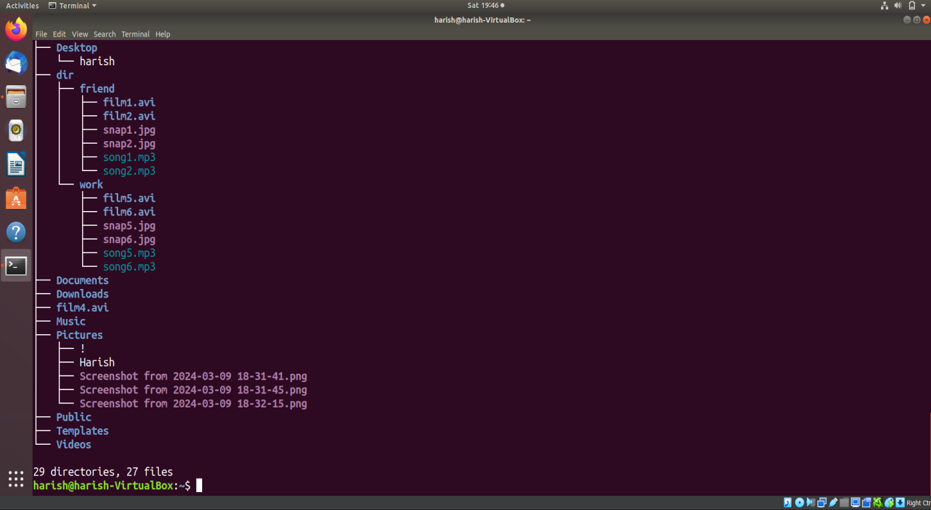

Q6.Delete Friends

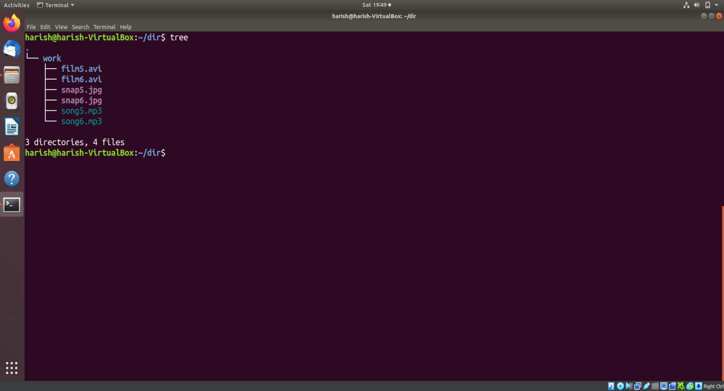

Q7 Delete Work

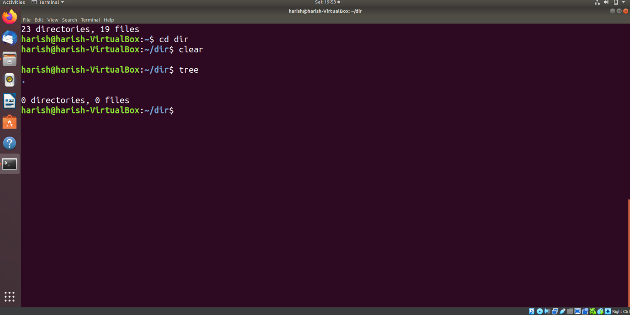

Q8

Create User tom,bob,sam,prince

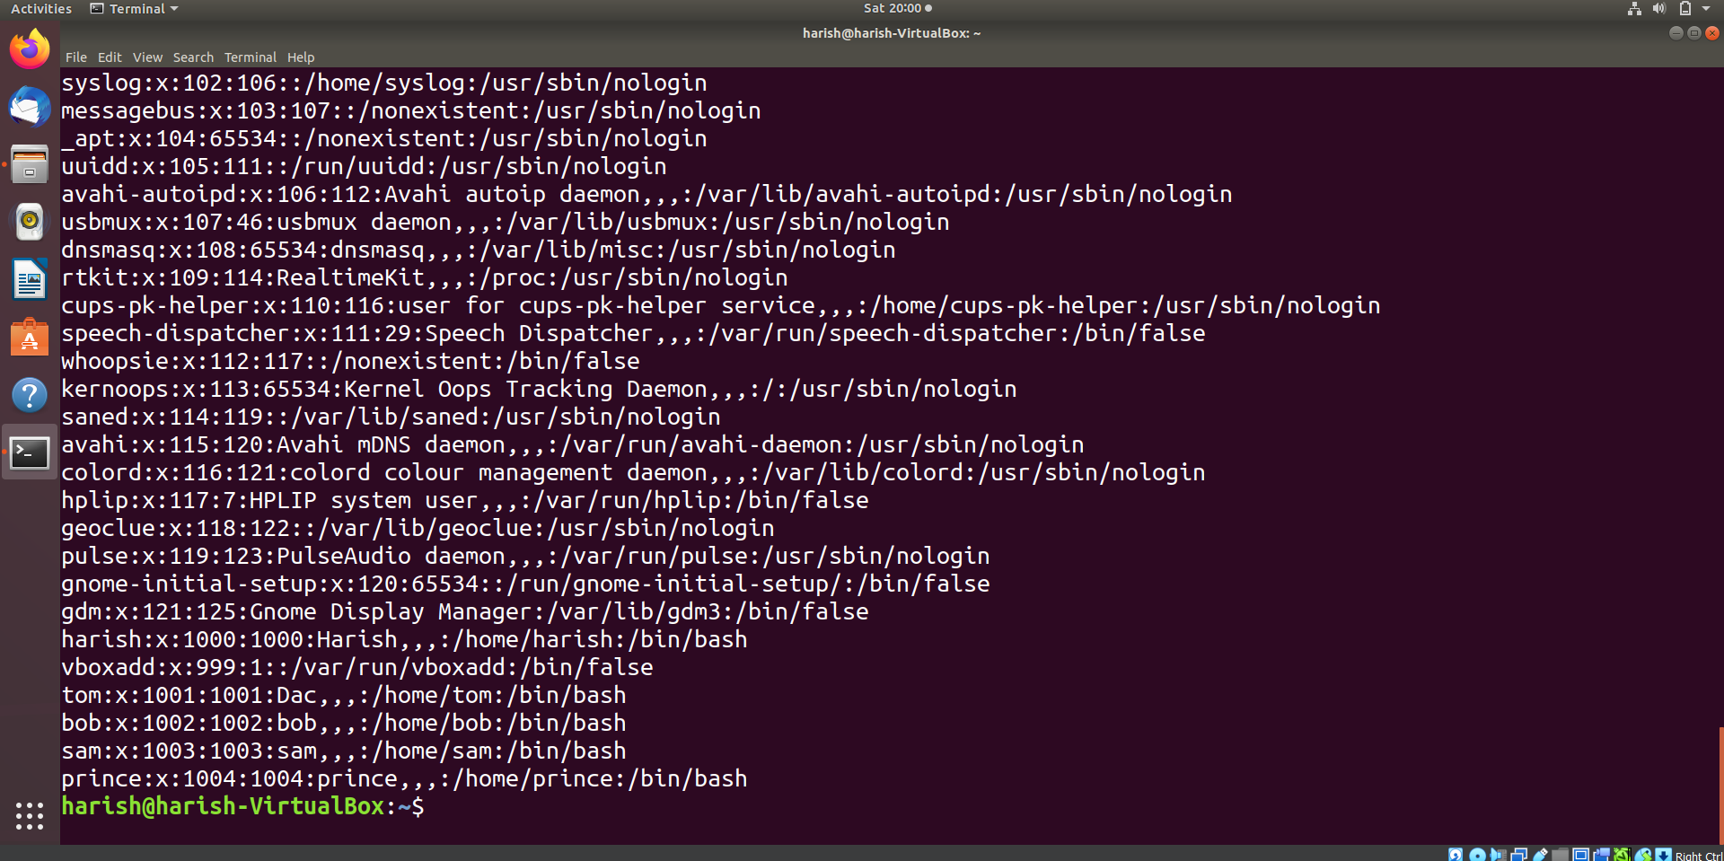

Q9 Create User dac,dbda,ditiss

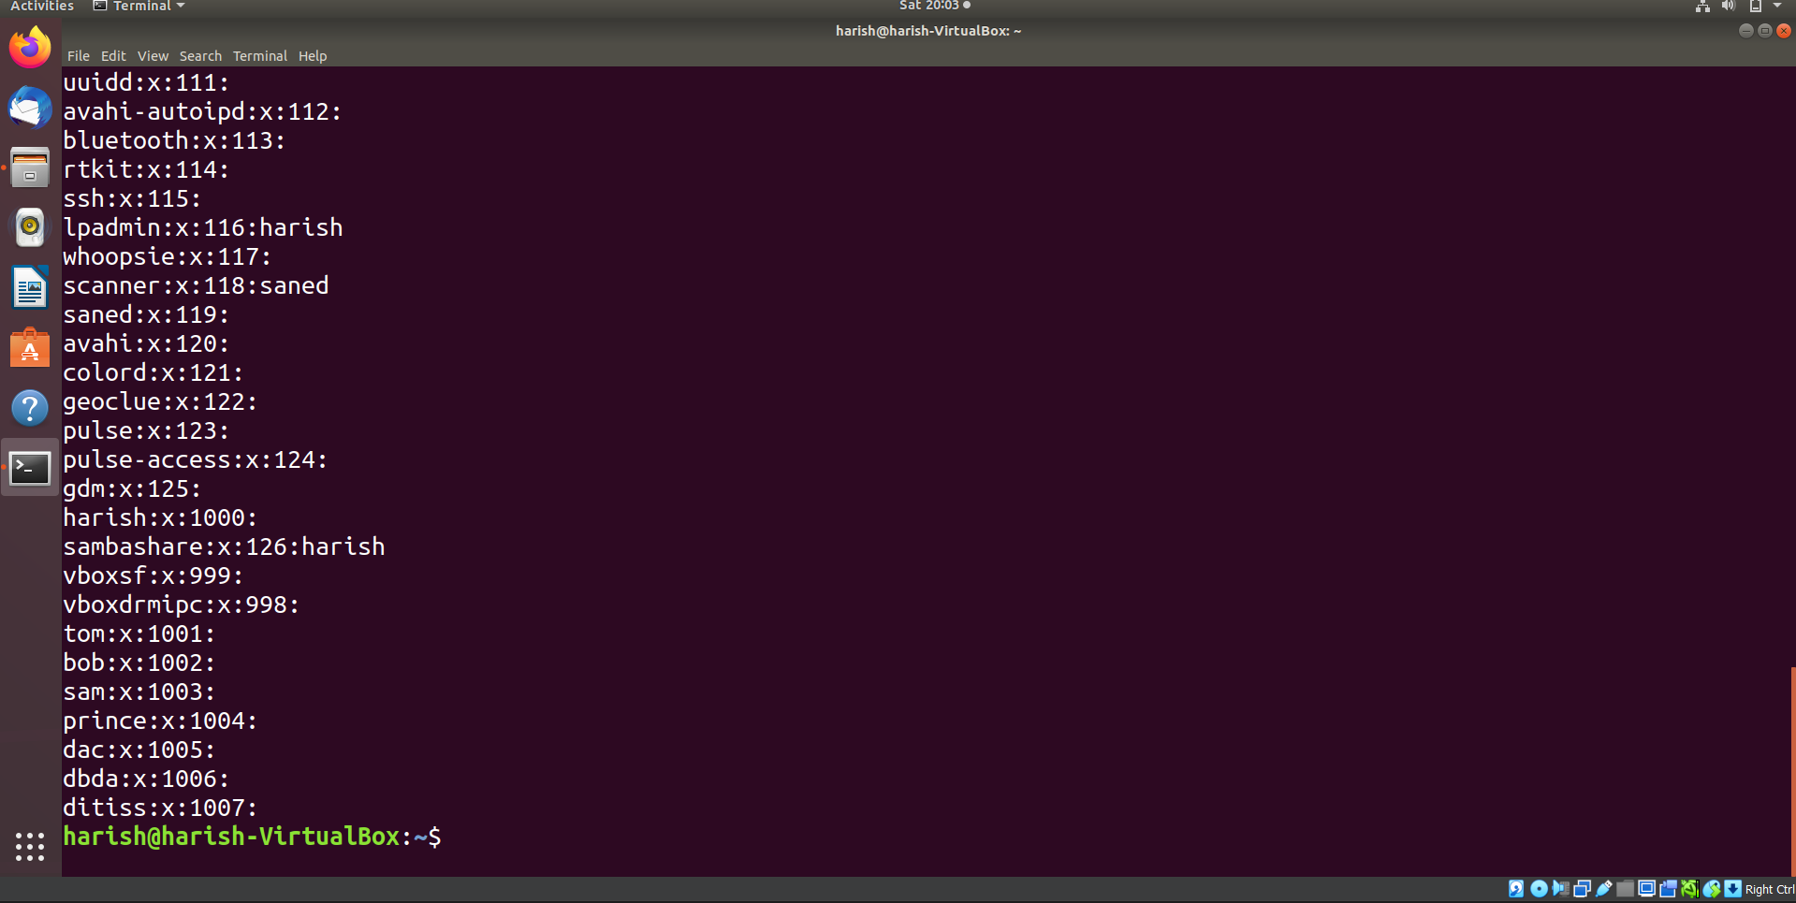

Q10 Add user in group

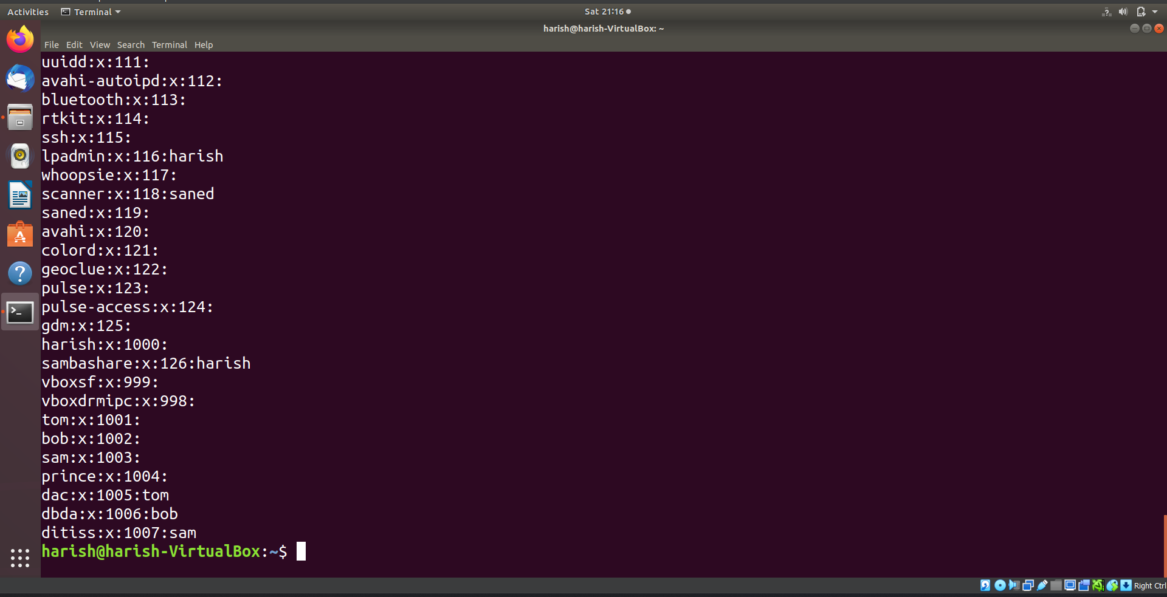

Q11 .login as prince and create iacsd directory  in /tmp and create 4 files in iacsd with name project-1 project-2 upto 4

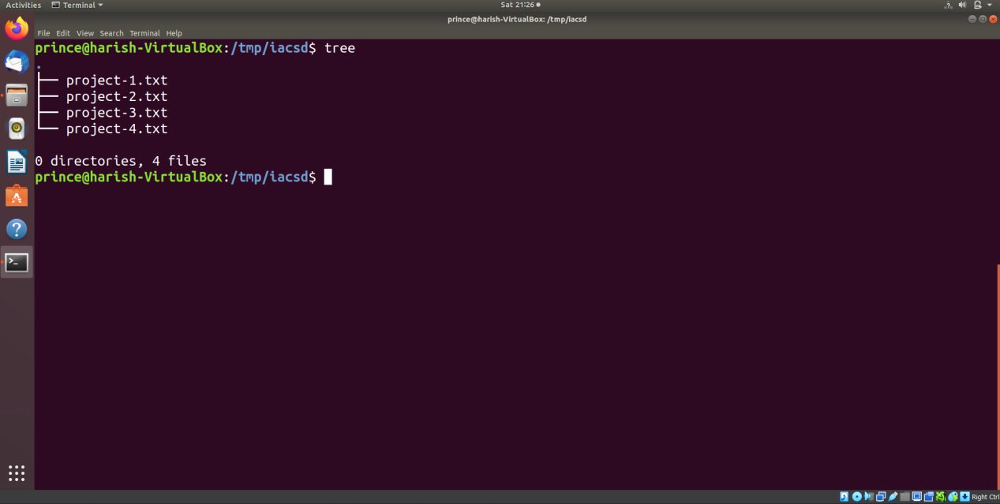

Q12.assign permissions to project files as below

Project-1 – tom should be owner of this

Project-2 – dac should be owner of this

Project-3 --- others should not have any permission but tom should have rw access

Project-4 – dbda group should have rwx permissions.

