Name - Harish Nemade

Roll no -243515

DBDA

Linux Assignment 2

Q1 Create group and user as given below.

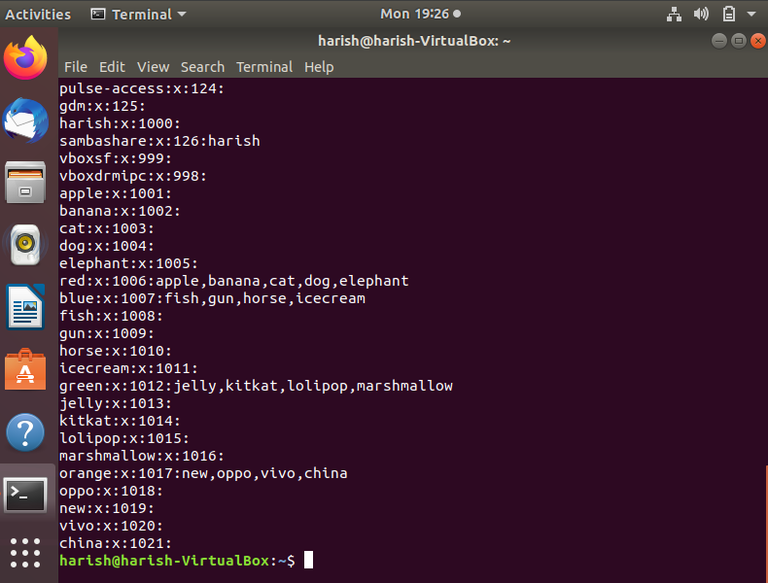

a .

. create directory named EVERYONE in /home. Give all permission to EVERYONE

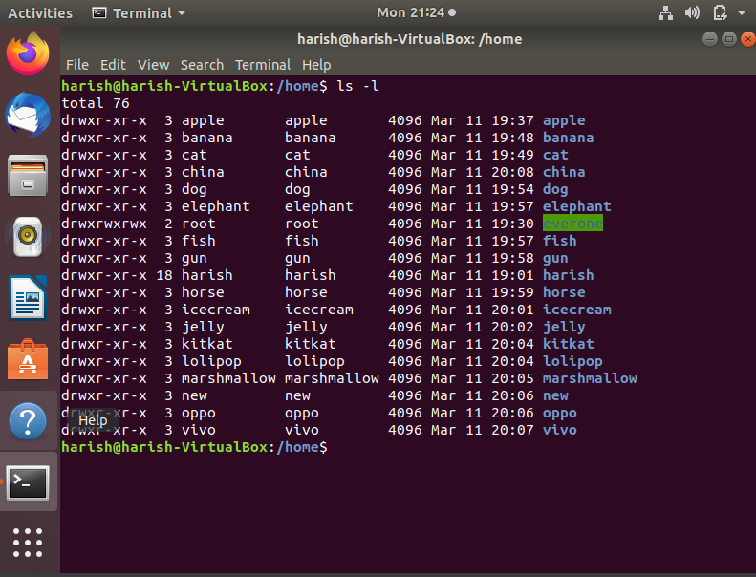

b.

 Create a file with every user (whoami >> username.txt)

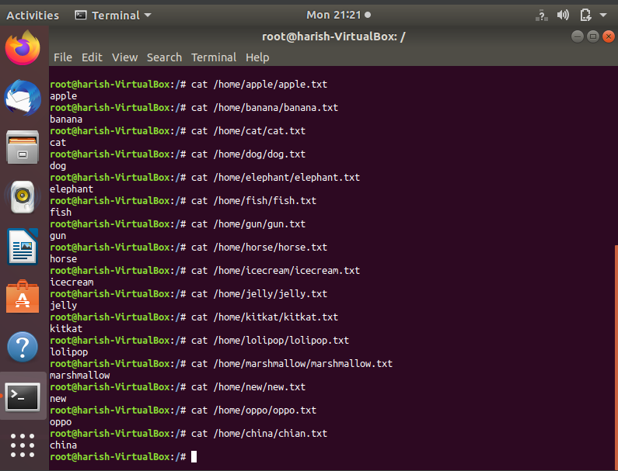

C.

oppo -> primary group change -> one

vivo -> primary group change -> two

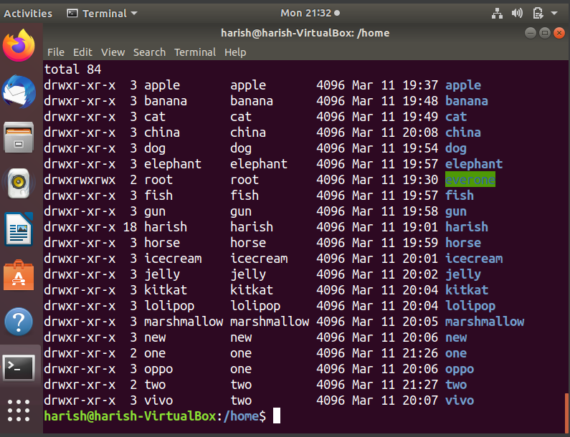

jelly,kitkat, lolipop, marshmallow -> add these users to sudo group.

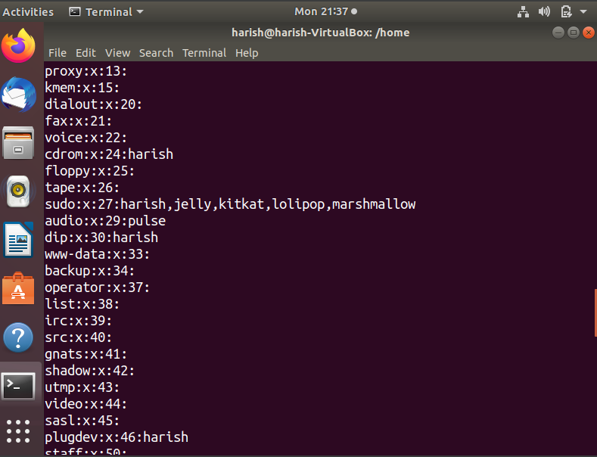

fish,gun -> add these users to one group as well (secondary group).

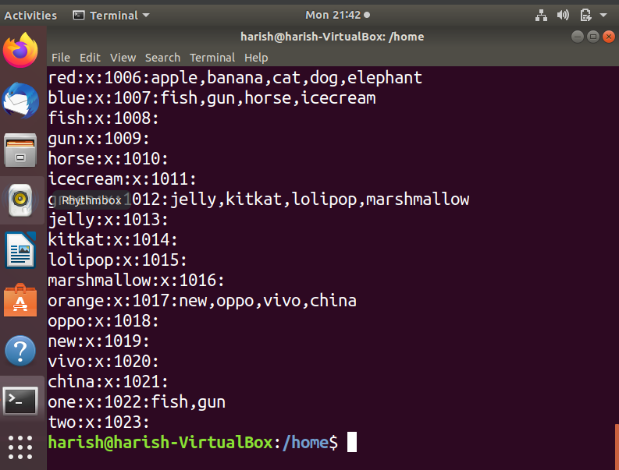

Q.2 Create Numbers.txt which will contain numbers from 1-50

a. display first 15 numbers

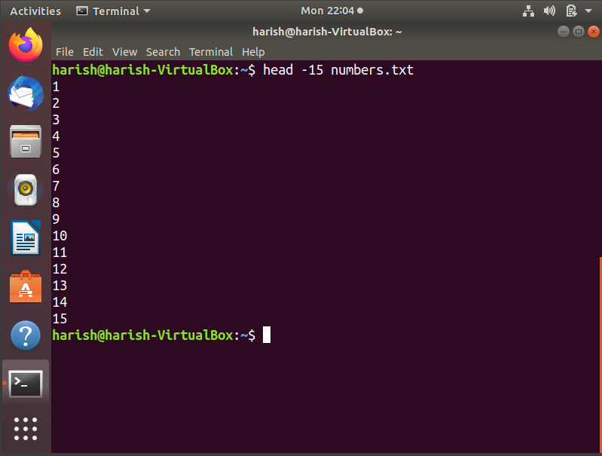

b. display last 10 numbers

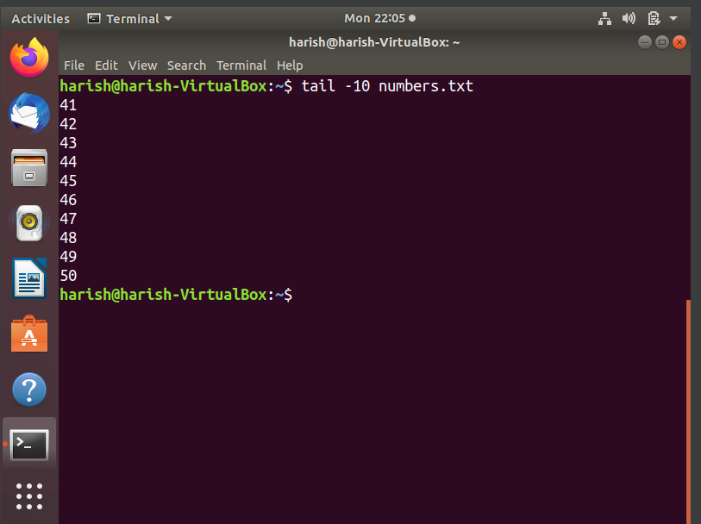

1. c. display numbers in reverse order.

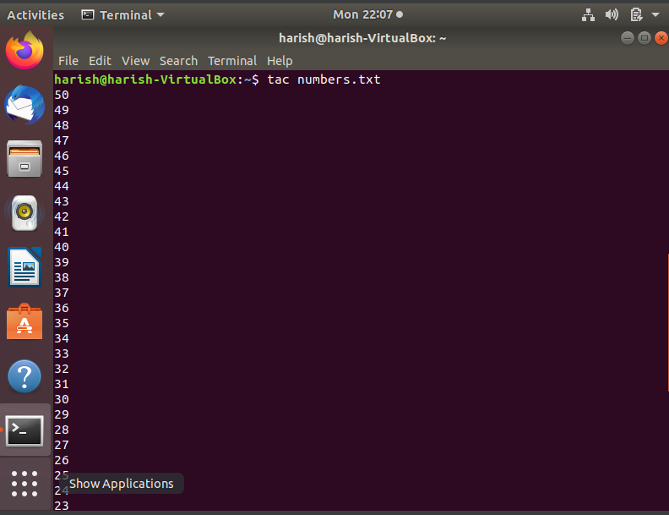

d.display numbers which includes 4 in it

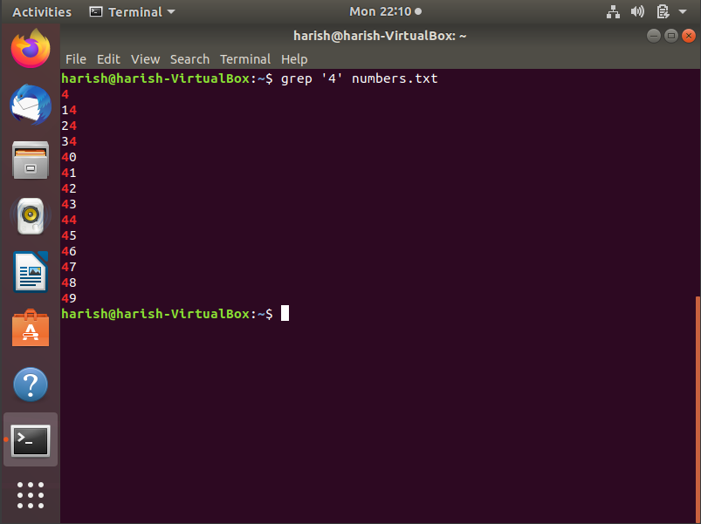

Q.3 create Student.txt file as given below

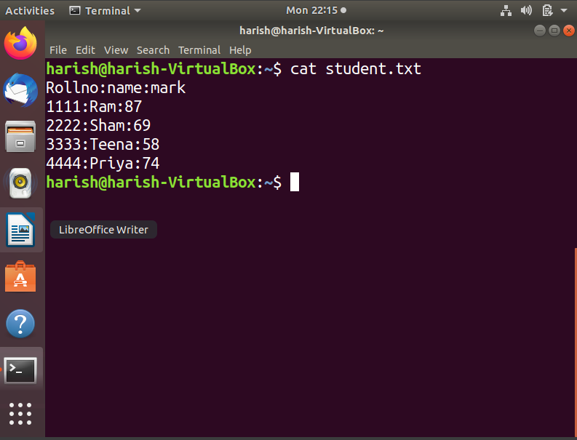

a .Display only details of sham

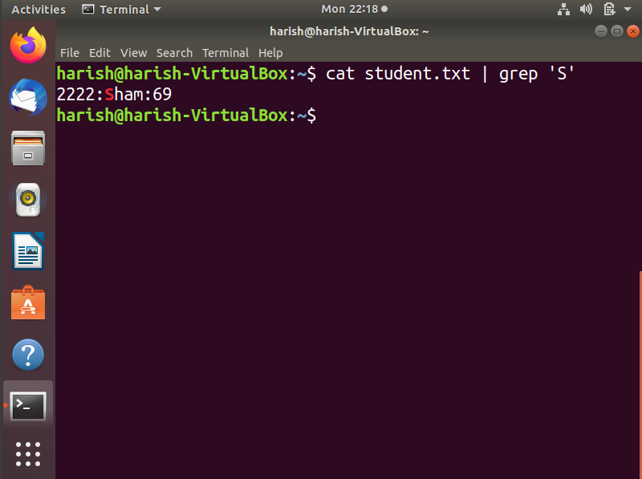

B . Display only marks of Priya

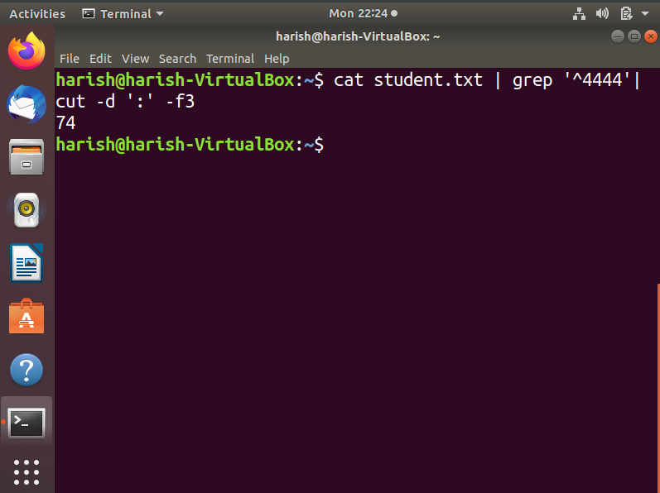

d .Display total number of lines in student.txt

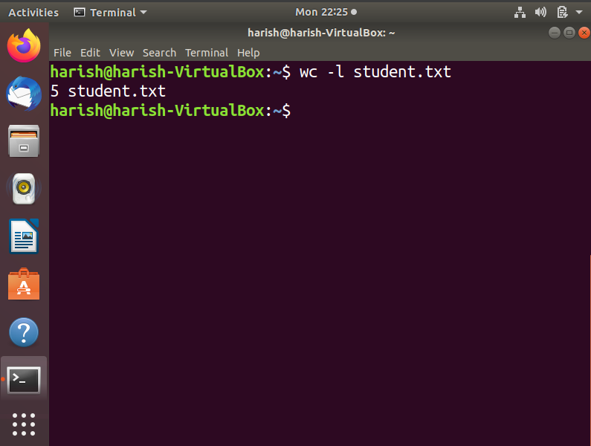

b .

c .