Nanem - Harish Santosh Nemade

Roll_no-15

Linux 4 Assignment

1) Write a shell script to print

your are logged in as which user

in which directory you are

and in which terminal you are working

total number of files and directories in current directory

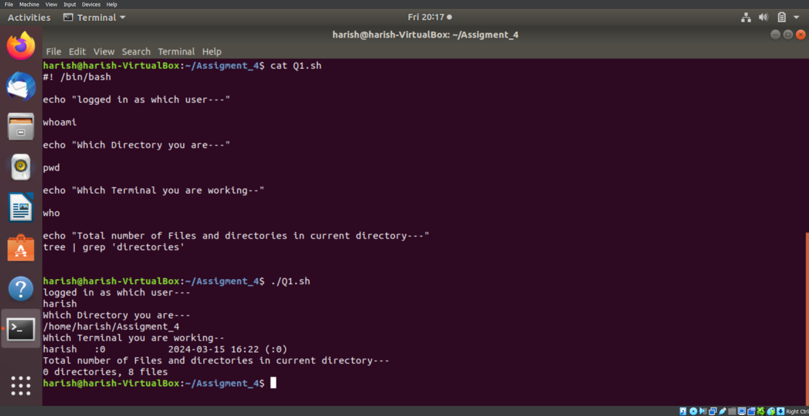

2).Write a shell script to create a menu driven program for adding, deletion or finding a record in a database. Database should have the field like rollno, name, semester and marks of three subjects. Last option of the menu should be to exit the menu.

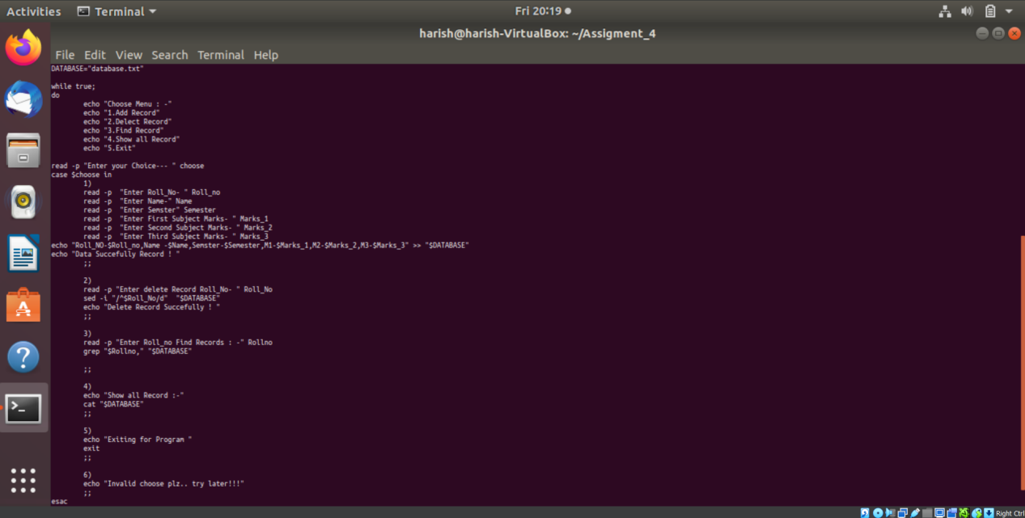

1. Write a Linux shell script to accept 10 number and tell how many are +tive, -tive and zero.

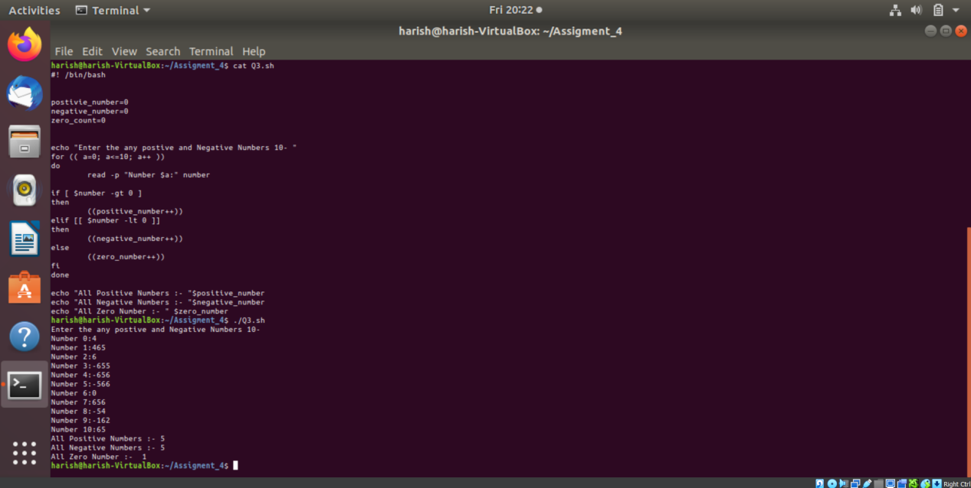

1. Write a shell script to accept five number and display max and min value.

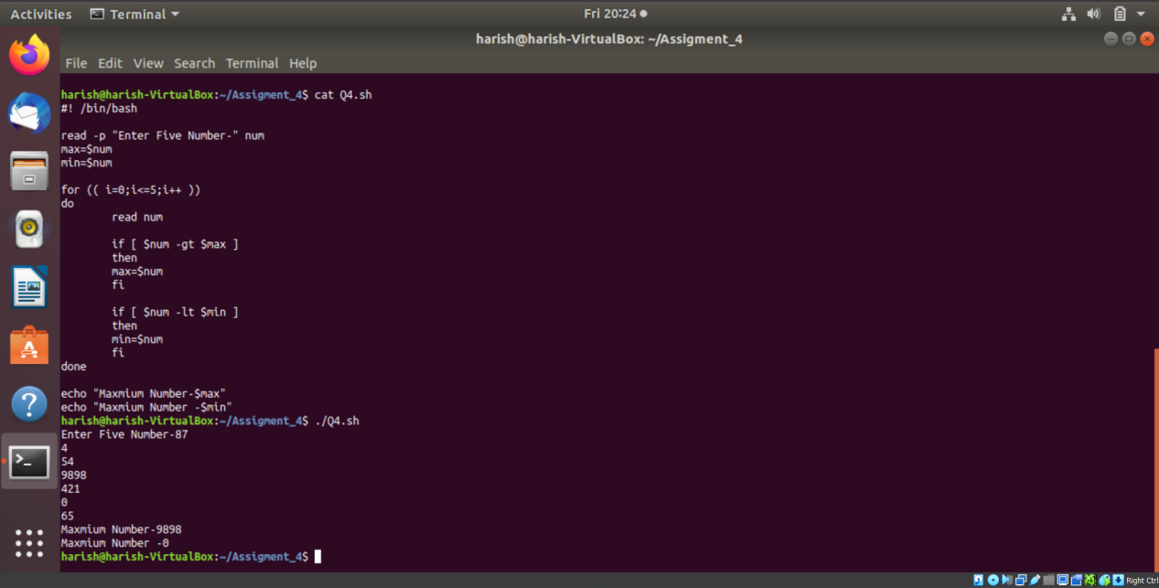

5) Write a script to find out String is palindrome or not.

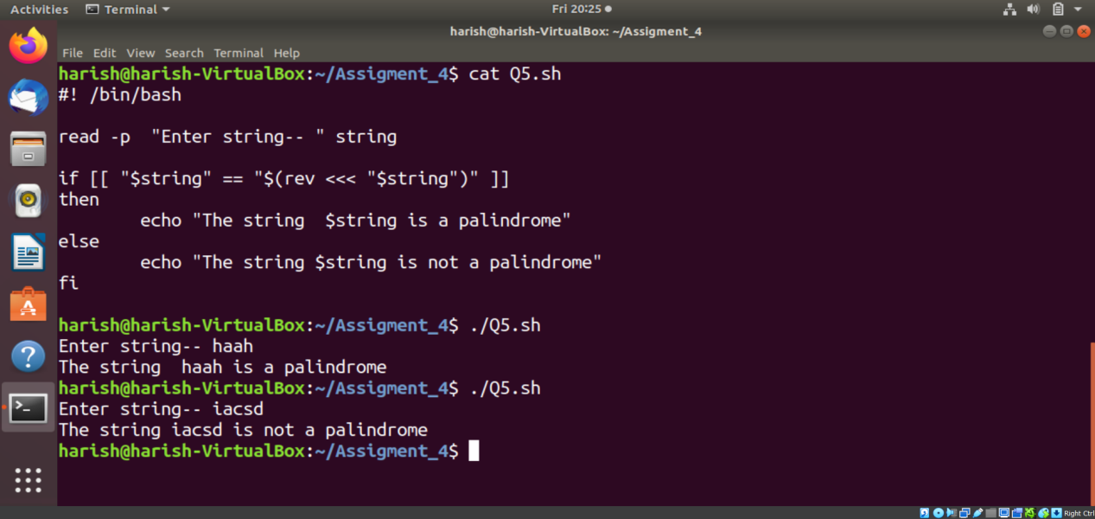

6) Write a shell script to print given number’s sum of all digits (eg. If number is 123, then it’s sum of all digits will be 1+2+3=6)

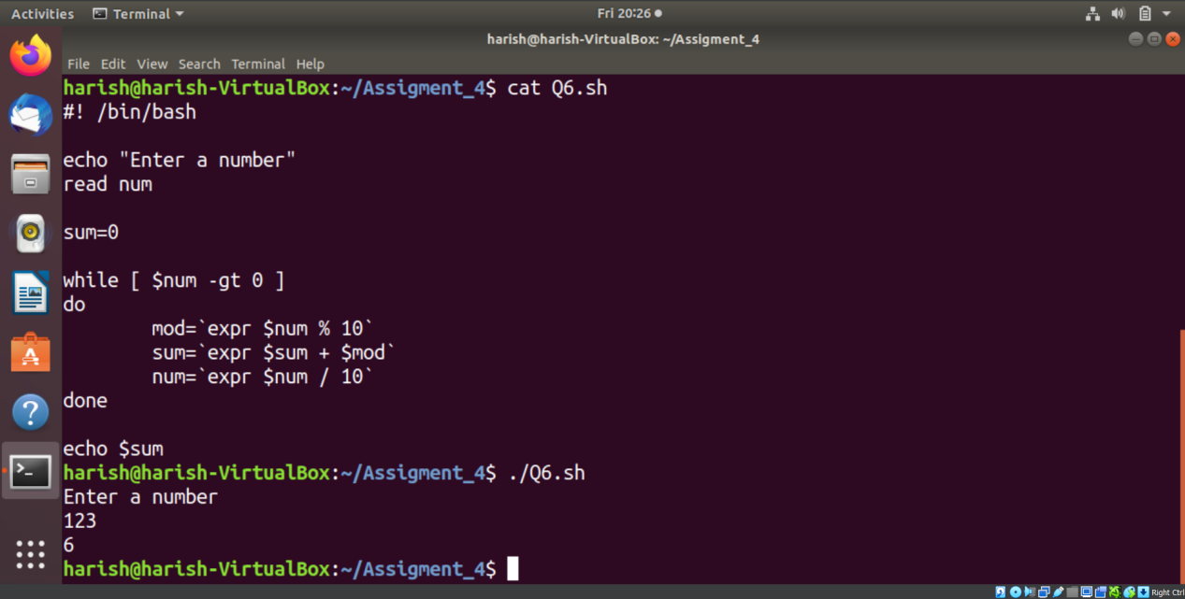

7) Create a script to

Create user , Delete user , Create group , delete Group using case

