CNC Tool Path Generation



Centre for Computational Technologies

Transforming human life by democratization of technology

<https://www.cctech.co.in>





1 Introduction

This document outlines the plan for the development of CNC Tool Path generation.

# 1.1 Purpose

To display the toolpath, which can be used by the CNC machine to do the milling operation on the stock material.

1.2 Scope

To generate a simple tool path which can be used in milling operation using drill tools.

2 System Overview

The application will consist of a graphical user interface developed using Qt framework. Opengl will be utilized for rendering purposes. Voxelization will be used to show the shape after the milling operation .

## 3 Functional Requirements

* Stock material display
* Real-time milling operation rendering
* Tool path rendering

4 Tools

* C++ programming language for application development
* OpenGL for real time 3d rendering
* Qt framework for GUI development

5 Milestones and Timeline(all the dates are in 2024)

| Sr. no. | Milestone | Date and time |
| --- | --- | --- |
| 1. | Problem statement allocation | 6th May, Mon, 3:00 pm |
| 2. | project research | 6th May, Mon, 6:00 pm |
| 3. | SRS preparation | 7th May, Tue, 12:00 am |
| 4. | SRS Approval | 7th May, Tue, 03:00 pm |
| 5. | Business Logic Development | 7th May, Tue, 10:00 am |
| 6. | GUI Development | 10th May, Thurs, 10:00 am |
| 7. | Final Submission | 12th May, Sun, 11:59 pm |
| 8. | Presentation | 13th May, Sun, 10:00 am onwards |

6 User Interface

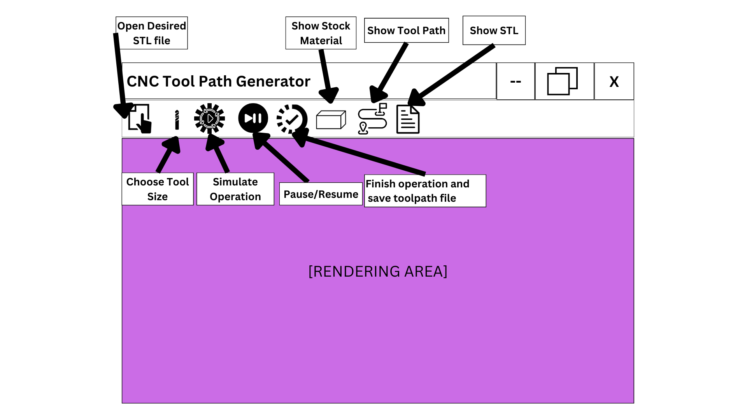

7 Conclusion

The application, CNC Tool Path Generator, is a visualization tool, which helps the user to see how exactly the milling operation will be done and stock material’s shape changes without actually do the operation.