Now lets see F_{β} score, let’s introduce something a bit more general. With an example below.
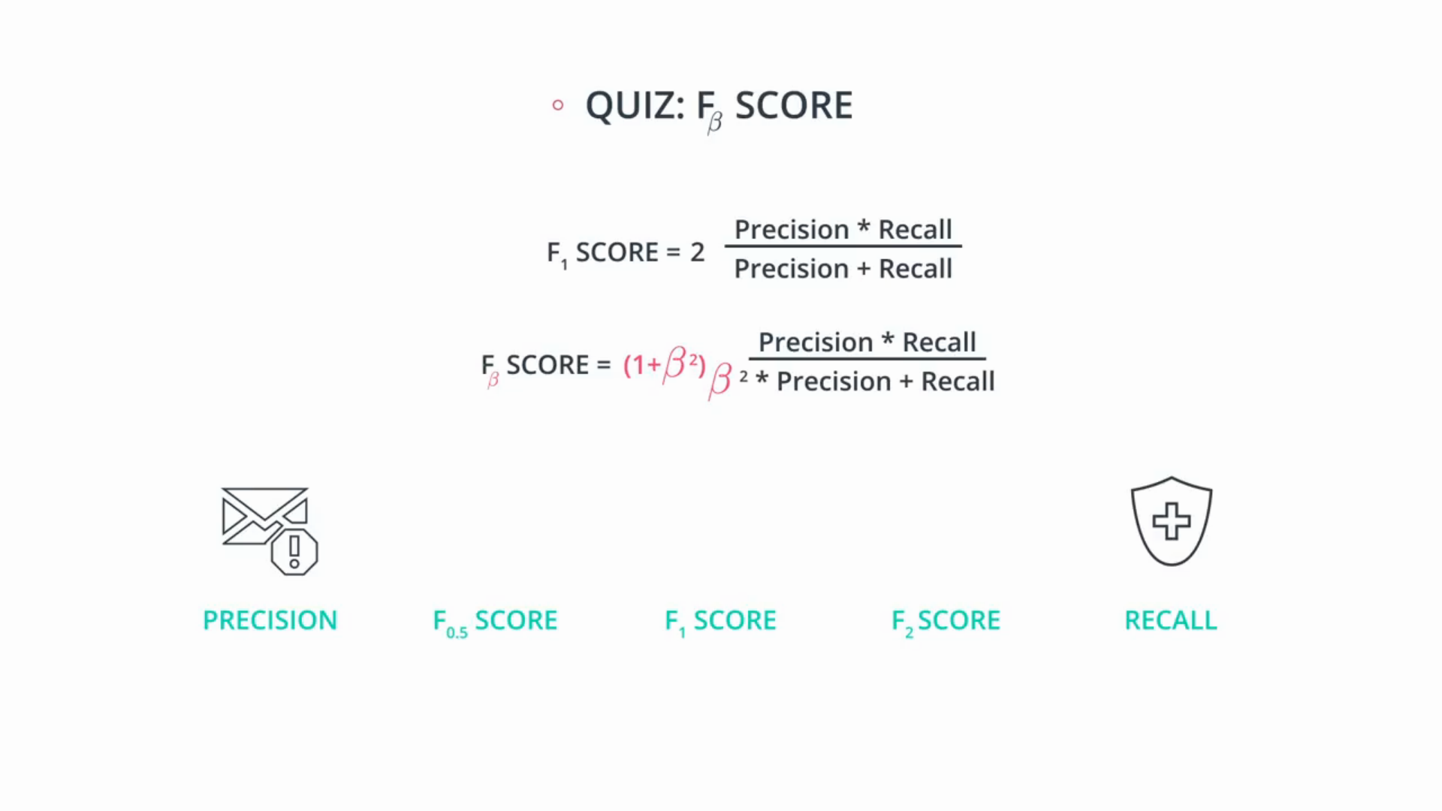
Above we have precision and recall.
Now F₁ score is somewhere around the middle which gives much importance to both, like if one of them is smaller, it raises a flag and it treats them both the same. So let’s say our model cares a bit more about precision than recall, then we want something more skewed towards precision. So we’ll say it’s F 0.5 score.

So we call that β, β is 0.5 the smaller the β, the more towards precision that we get or if we want our model to care more about the recall we pick a larger β.

let’s say β=2 so our metric is F₂, above we have the formulas for F₁ score and F_{β} , the beta you just introduce a beta over here that will skew your formula towards either one or the other one, depending on if beta is small or large.

So let’s see our previous credit card fraud detection example.
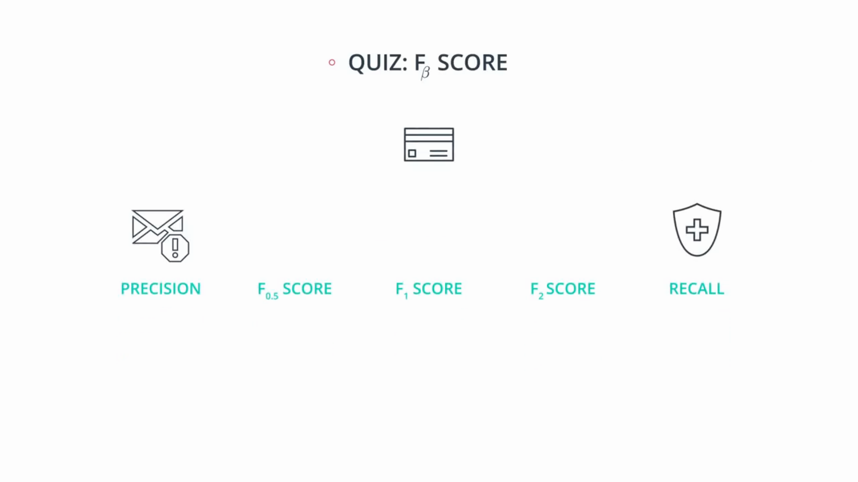
Thi credit card model needs to be high recall model, since we need to catch all the fraud cases, and it’s okay if we accidently detect and investigate some that are not, so let’s say something like F10 but then maybe we’re sacrificing too much precision, and we’re accidentally sending our customers too many notifications about their transactions without them being fraudulent, and they’re starting to get annoyed. So we can move a bit toward F2, then maybe we discover that we need to focus a bit more on recall because we really don’t want to miss too many fraudulent transactions, so we go to F5. it’s not an exact science finding a good value of beta requires a lot of intution of your data and a lot of experimentation.

