Hello!, Today i’ll try to explain another technique to evaluate a classification model called Receiver operator characteristic curve or ROC curve for short.
Lets see how it works with some examples.
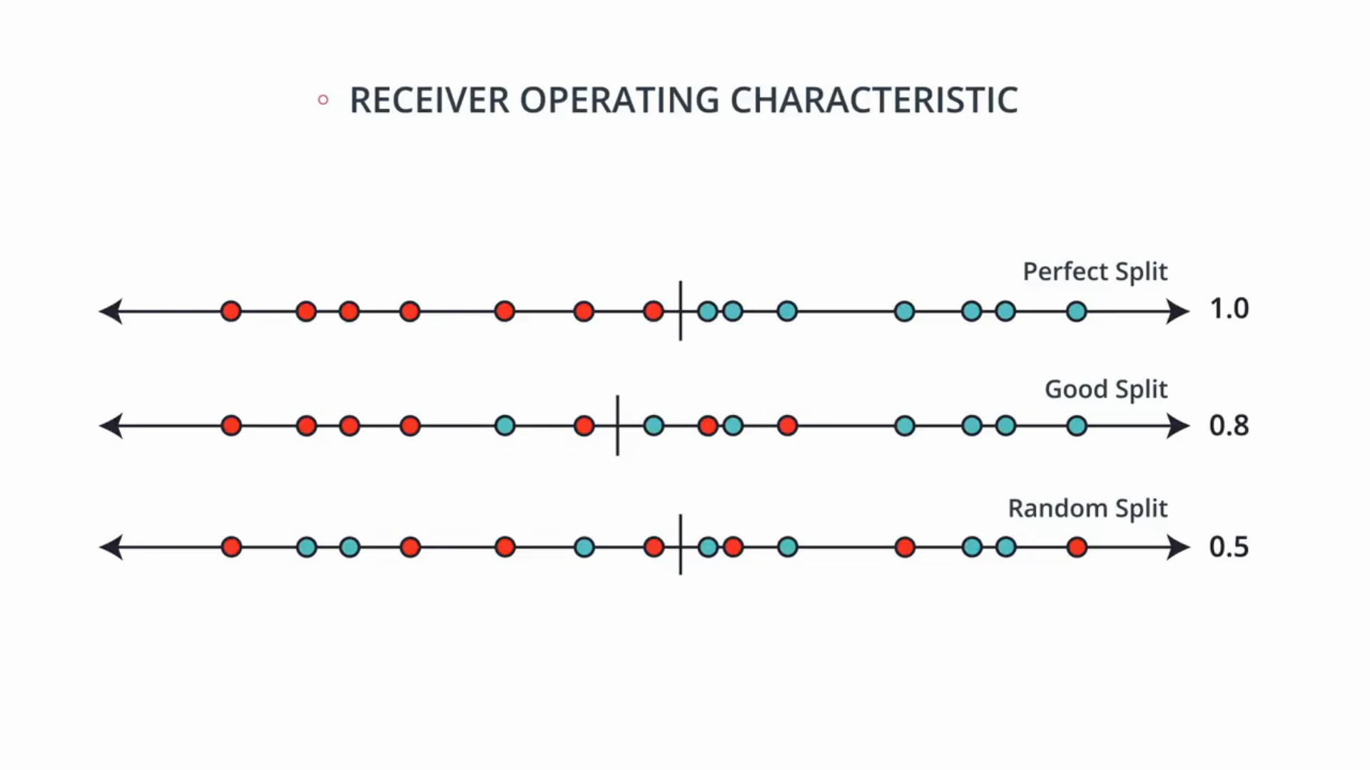
So above we have 3 different sets of data, let’s consider the above data is now one dimensional, all the red and blue points lie in one line and we want to find the correct split.

Above we have splitted the data and called them as perfect split, good split and random split, now we have to come up with a metric or some number that is high for the perfect split, medium for good split and low for the bad split or random split

So let’s take our good split and we’ll calculate two ratios i.e True Positive Rate & Flase Positive Rate.
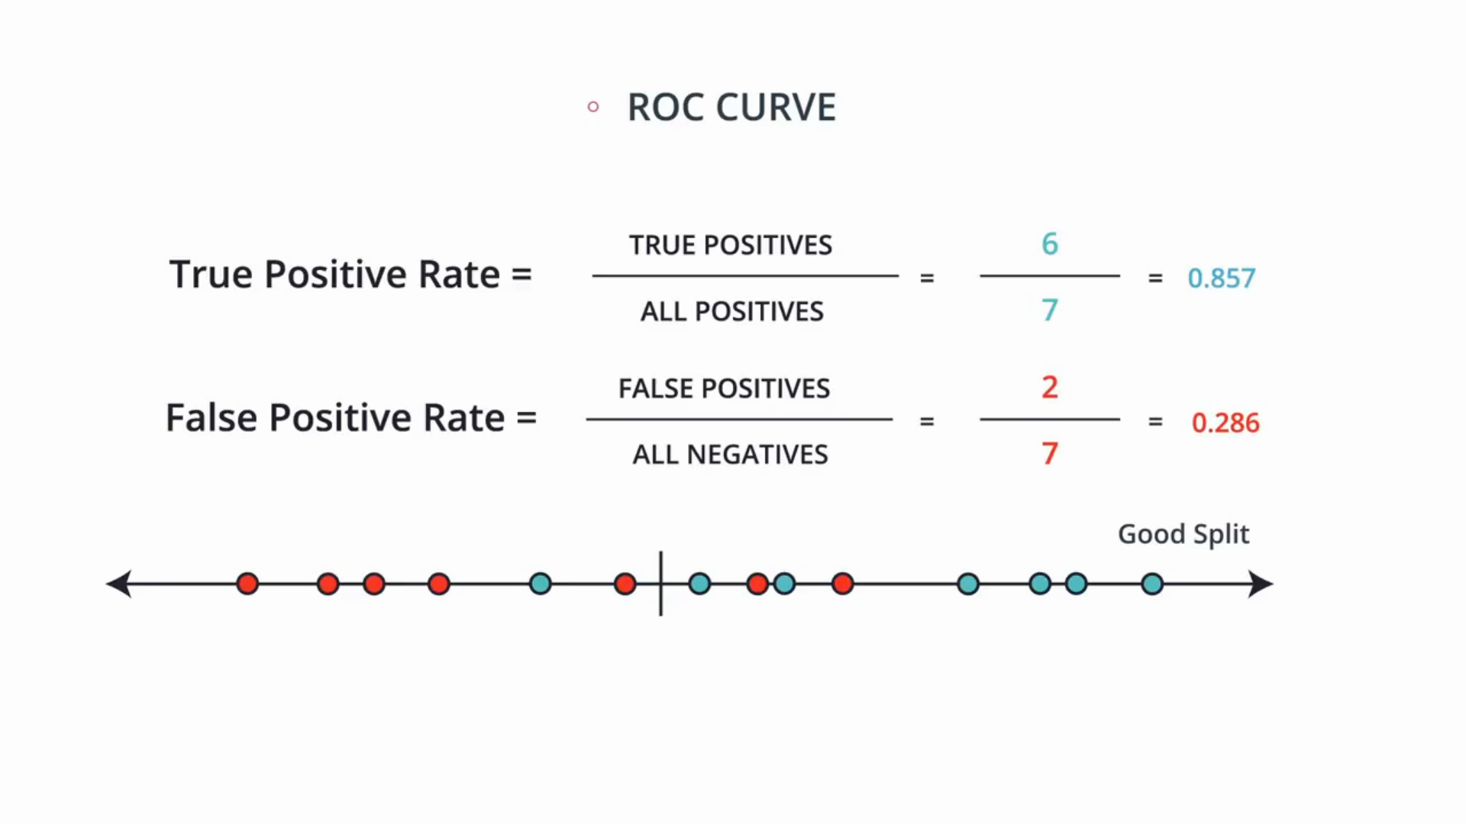
There are seven positively labelled numbers and six of them have been correctly labeled positive, so this ratio is 6/7 = 0.857. Now let’s look at the Flase positive rate which means out of all the negative points, how many of them did the model incorrectly think they were positive? So out of the seven negatively labeled points, the model thought two of them were positive. So the FPR is 2/7=0.286.
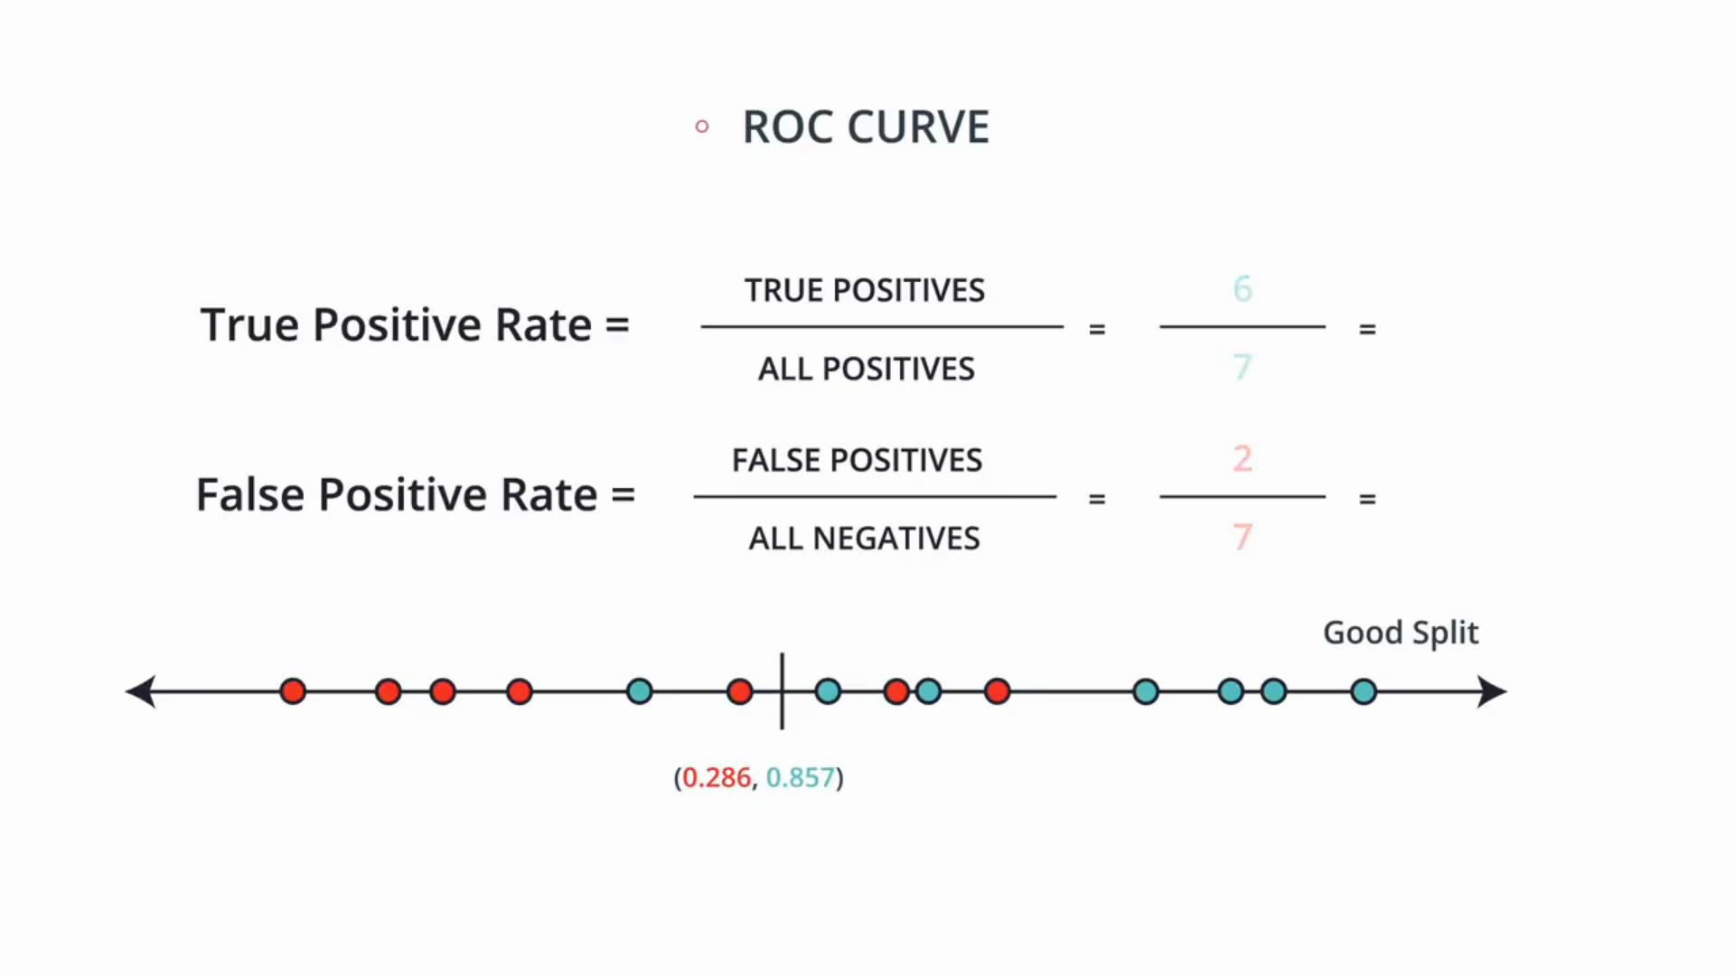
So we’ll just remember these two numbers and mark them.

Now lets move the line towards the left like below
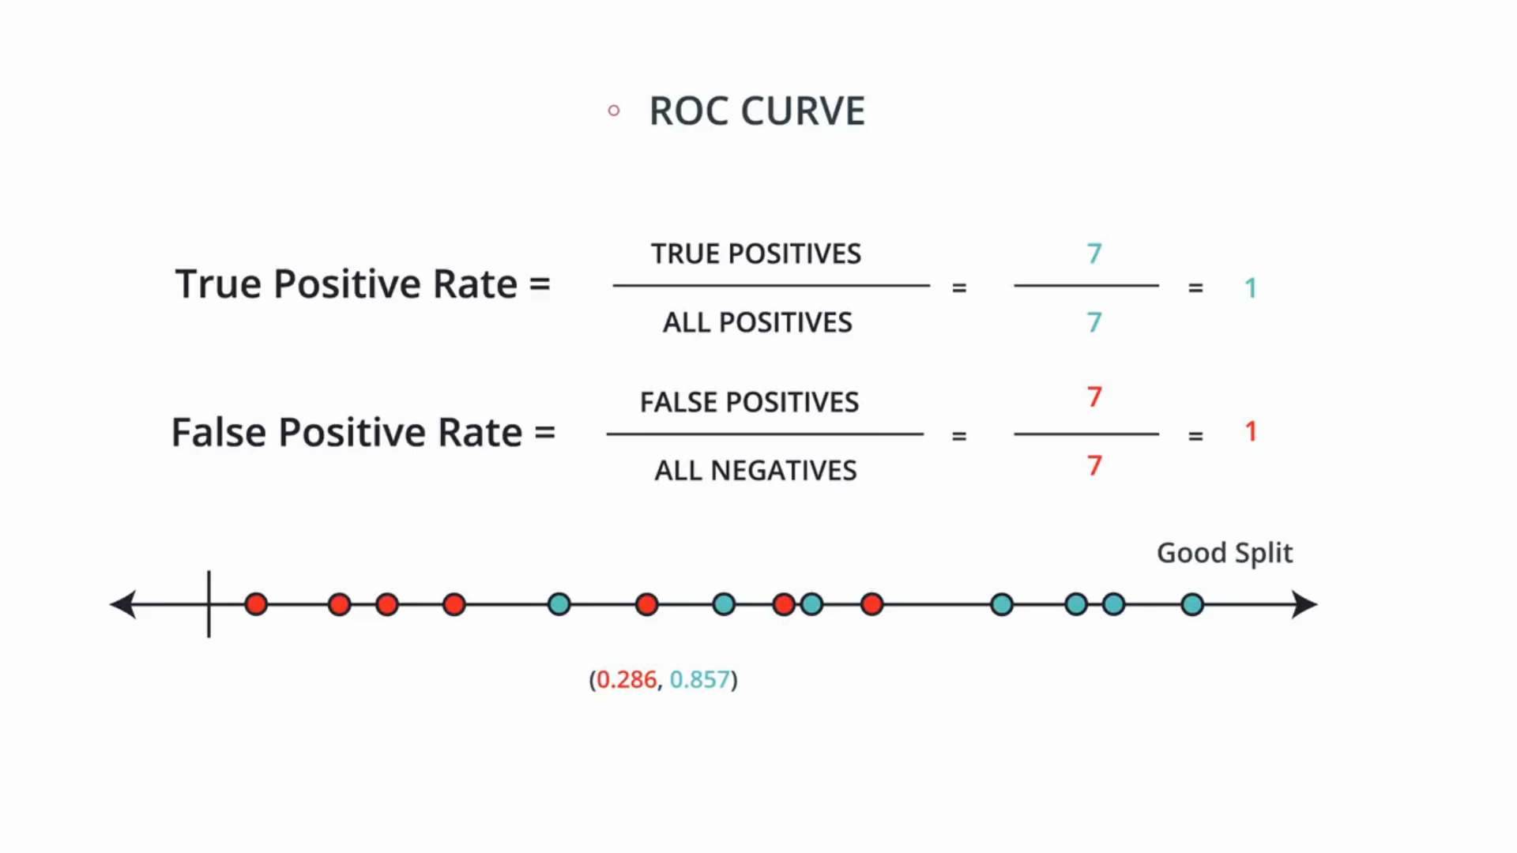
So let’s split over there, and now we have to calculate the TPR & FPR, well the model thinks everything is positive. So in particular all the positives are true positives. i.e TPR=7/7=1 and for FPR since the model thinks everything is positive then all the negatives are false positives. So the FPR=7/7=1. So again we’ll remember these two values (1,1) and mark them.
Now, lets go to the other extreme and put the line on the right and see the TPR and FPR.
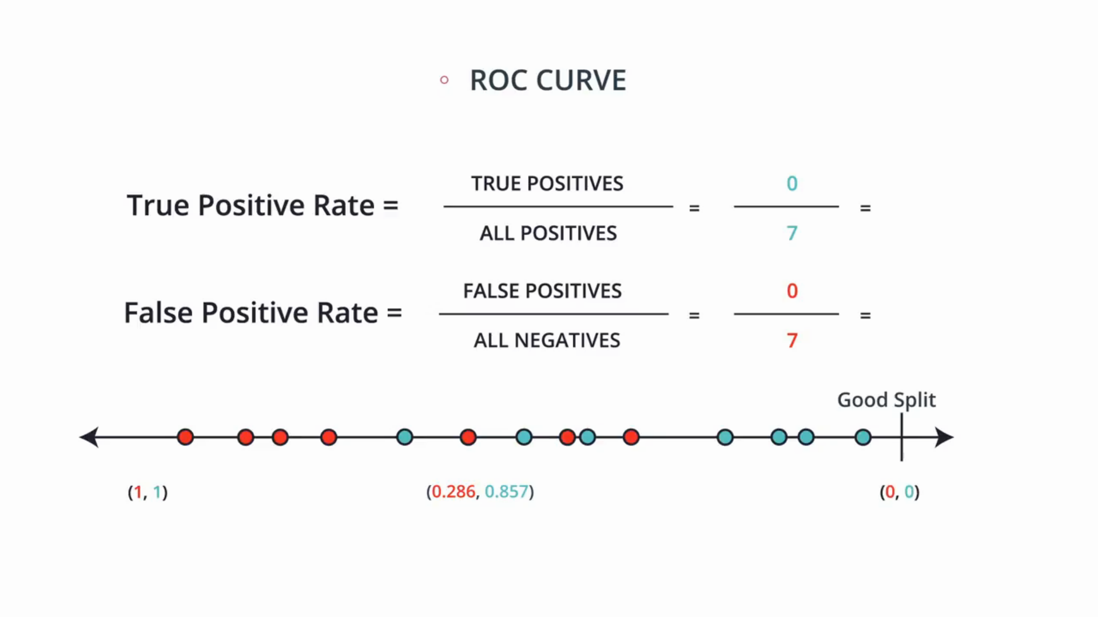
Well, the model thinks mothing is positive so in particular, there are no true positives and the ratio is TPR=0/7=0 and there are no false positives and the ratio is FPR=0/7=0, again we’ll remember these two numbers. We can see that no matter how the data looks the two extremes will always be (1,1) and (0,0).

Now we can do this for every possible split and record those numbers.
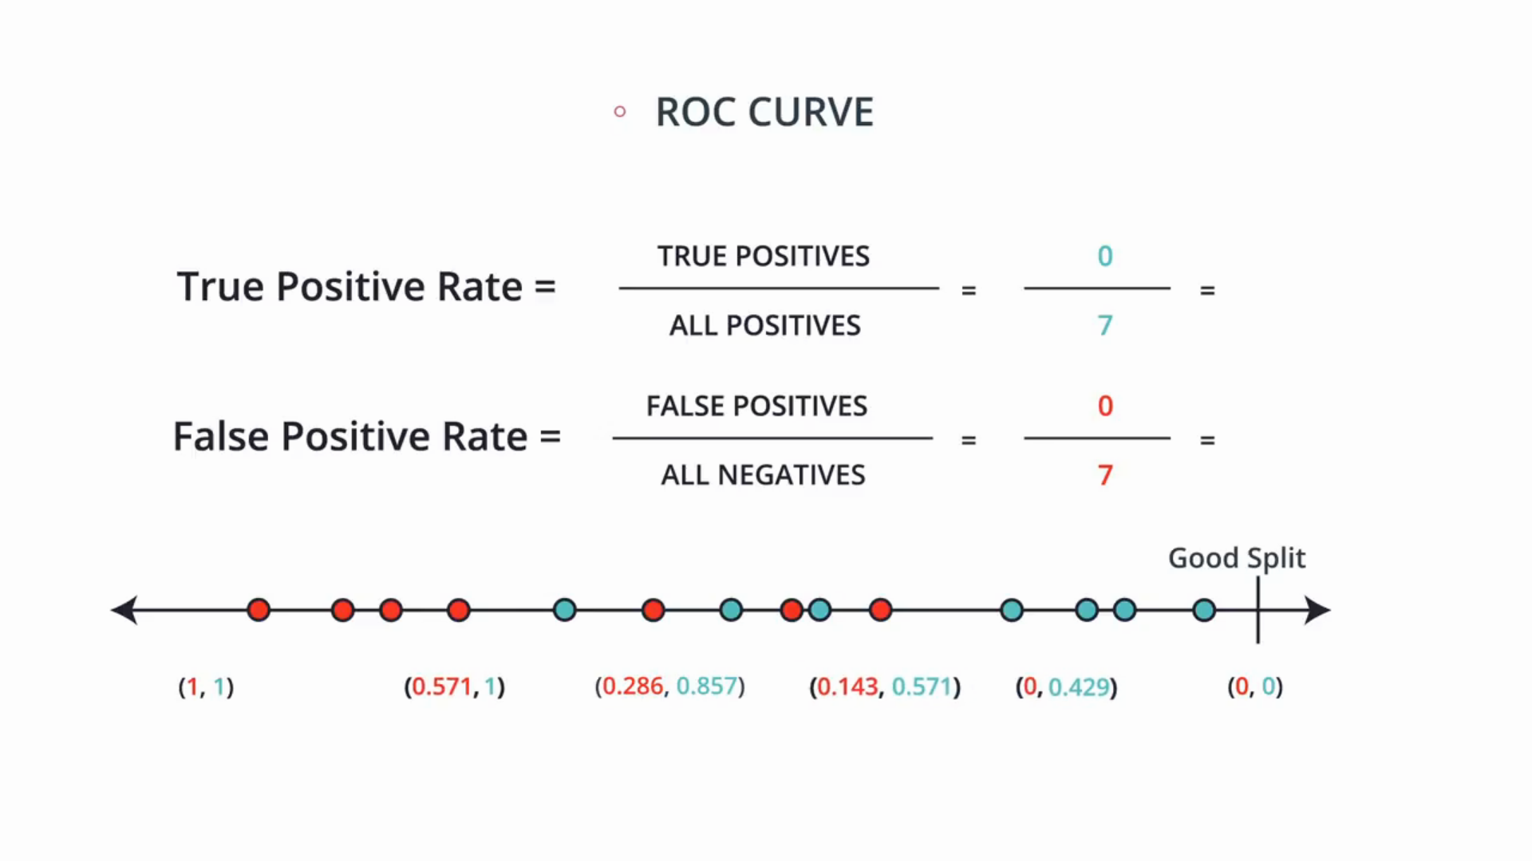
So above we have a few of them that we’ve calculated.

Now let’s see the magic, if we plot all those numbers in a plane and we get a curve like below.
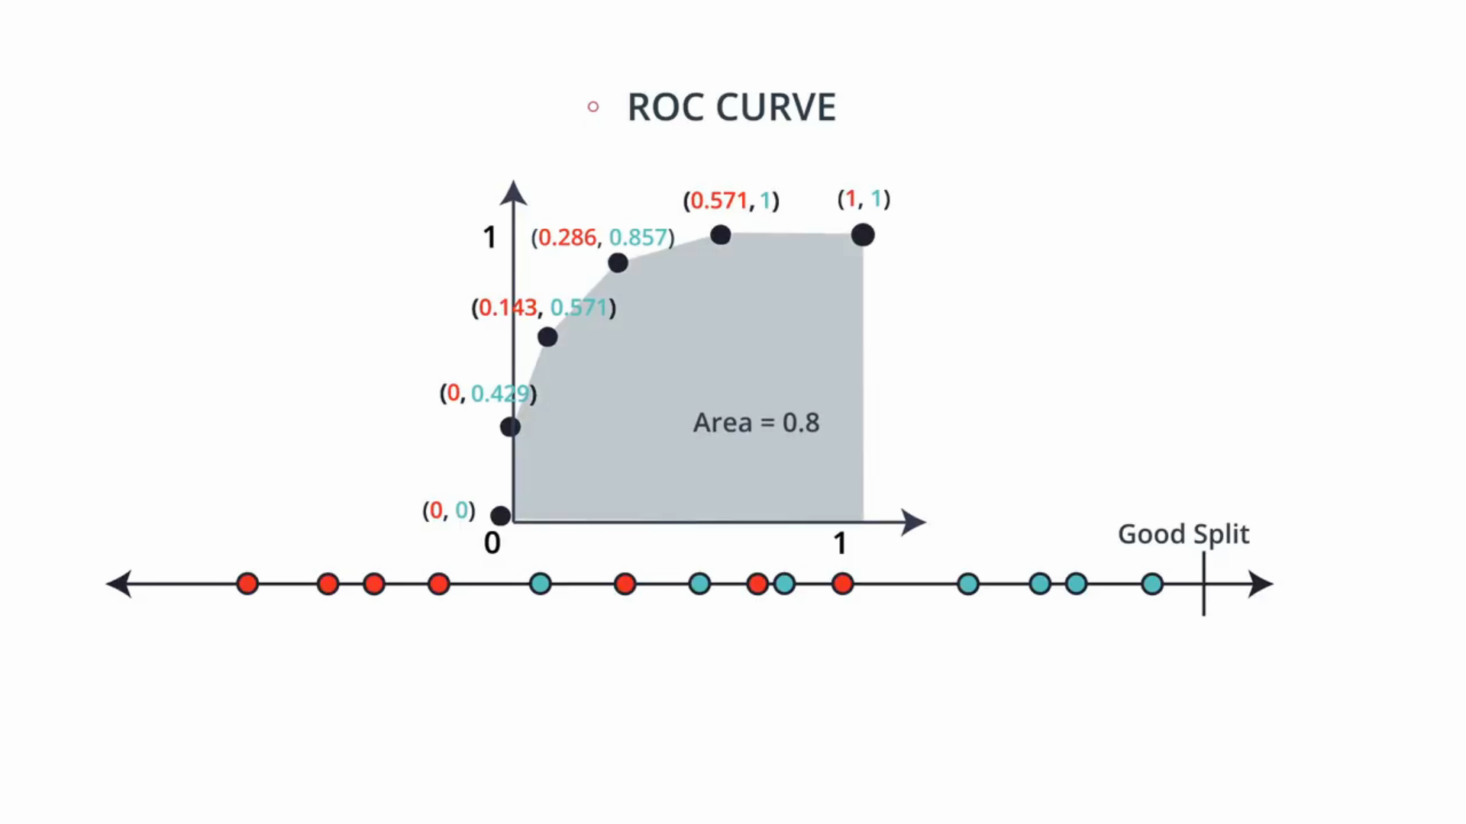
Now, if we calculate the area under the curve we get around 0.8. This is actually not accurate but it’s around there.

So now lets do the same thing for the perfect split.
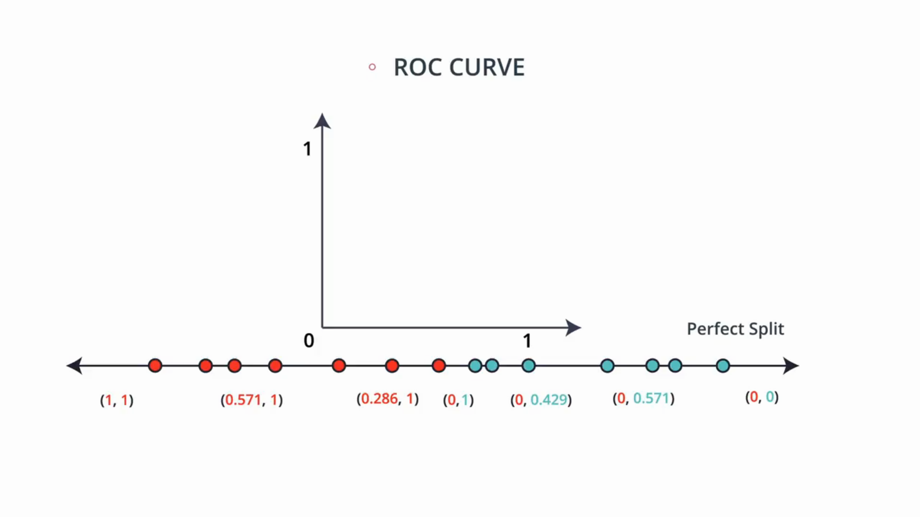
Above i have calculated all the ratios and marked, if you notice above if the boundary is on red side then the true positive ration is 1. Similarly if the boundary is on the blue side then every negative number has been predicted negative and so the False positive ratio is zero. In particular at the perfect split point, we have a (0,1). Thus when we plot these numbers the curve looks like this
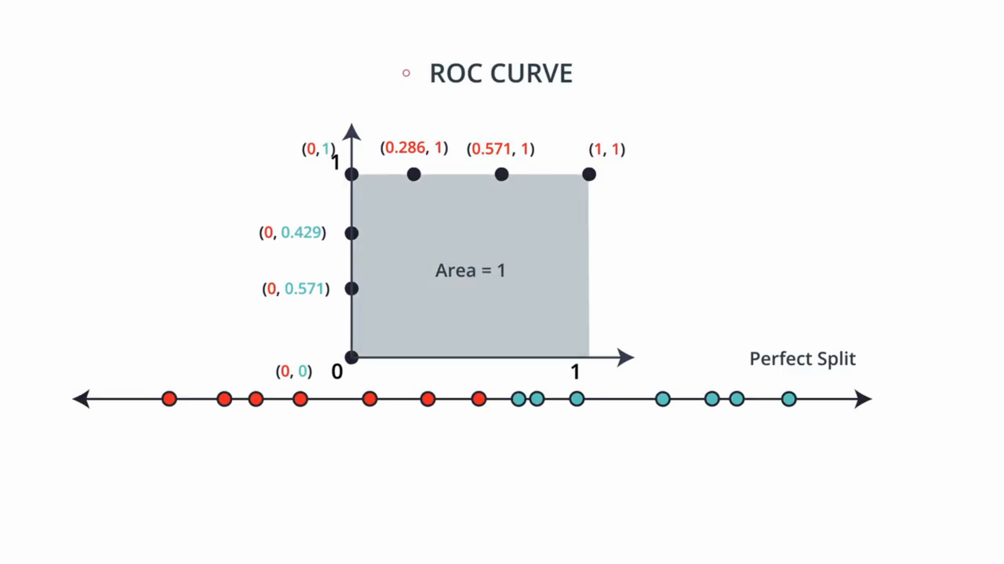
This perfect split curve looks like a square and its area is 1 which means the area under the ROC curve for the perfect split is 1.

Finally, we’ll do this for the random split or Bad split

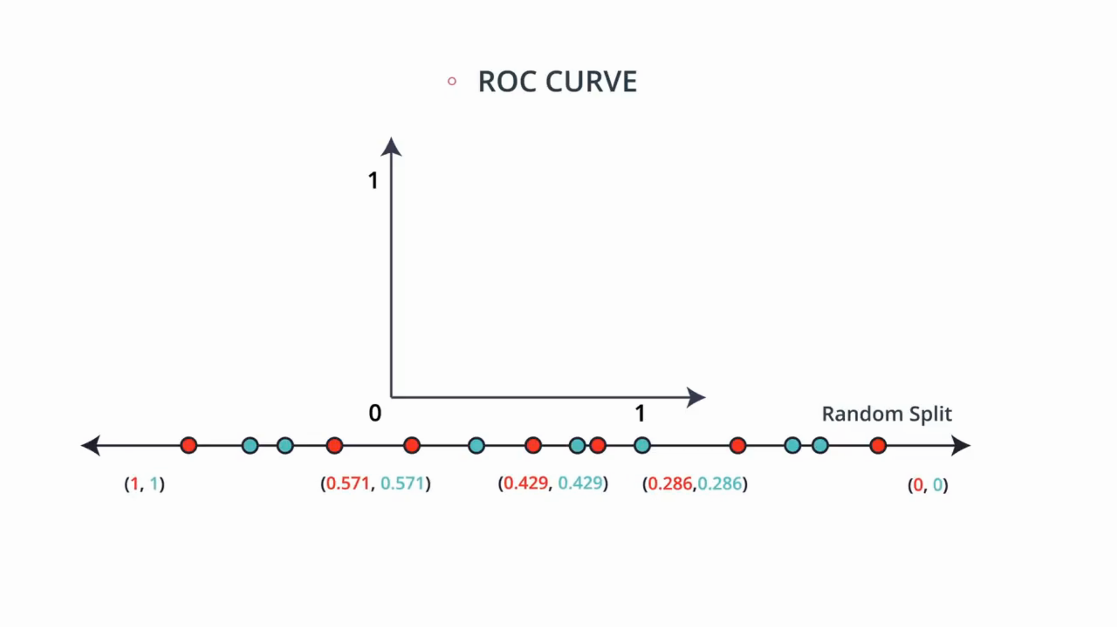
Here we can try it on our own, but basically since every split leaves on each side around half blue, half red points, then each pair of numbers will be close to each other, and the curve will be very close to being just a diagonal between 0. Like below.
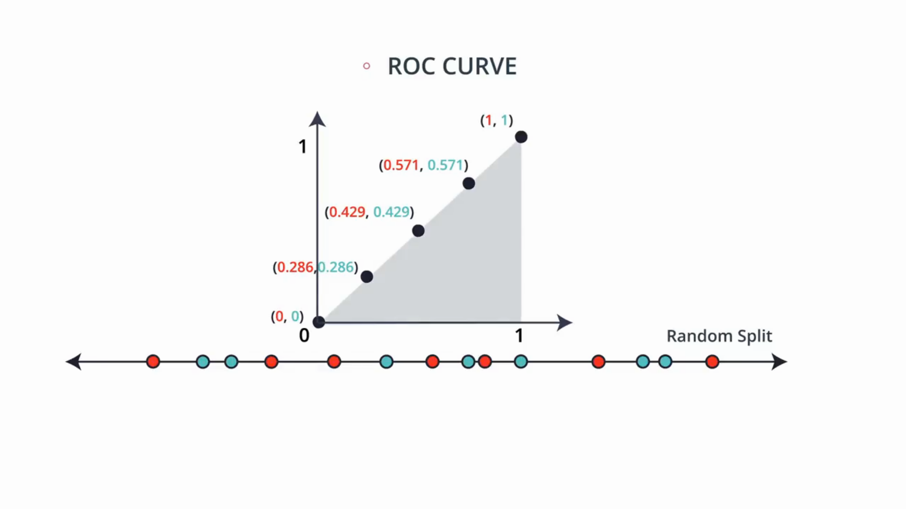
So if the model is random, then the area under the ROC curve is around 0.5.

So to summarize we have three possible scenarios some random data which is hard to split, some pretty good data which we can split with no errors. Each one is associated with a curve. The areas under the curve are close to 0.5 for the random model, somewhere close to one for good model, so aroung 0.8 and one for the perfect model.
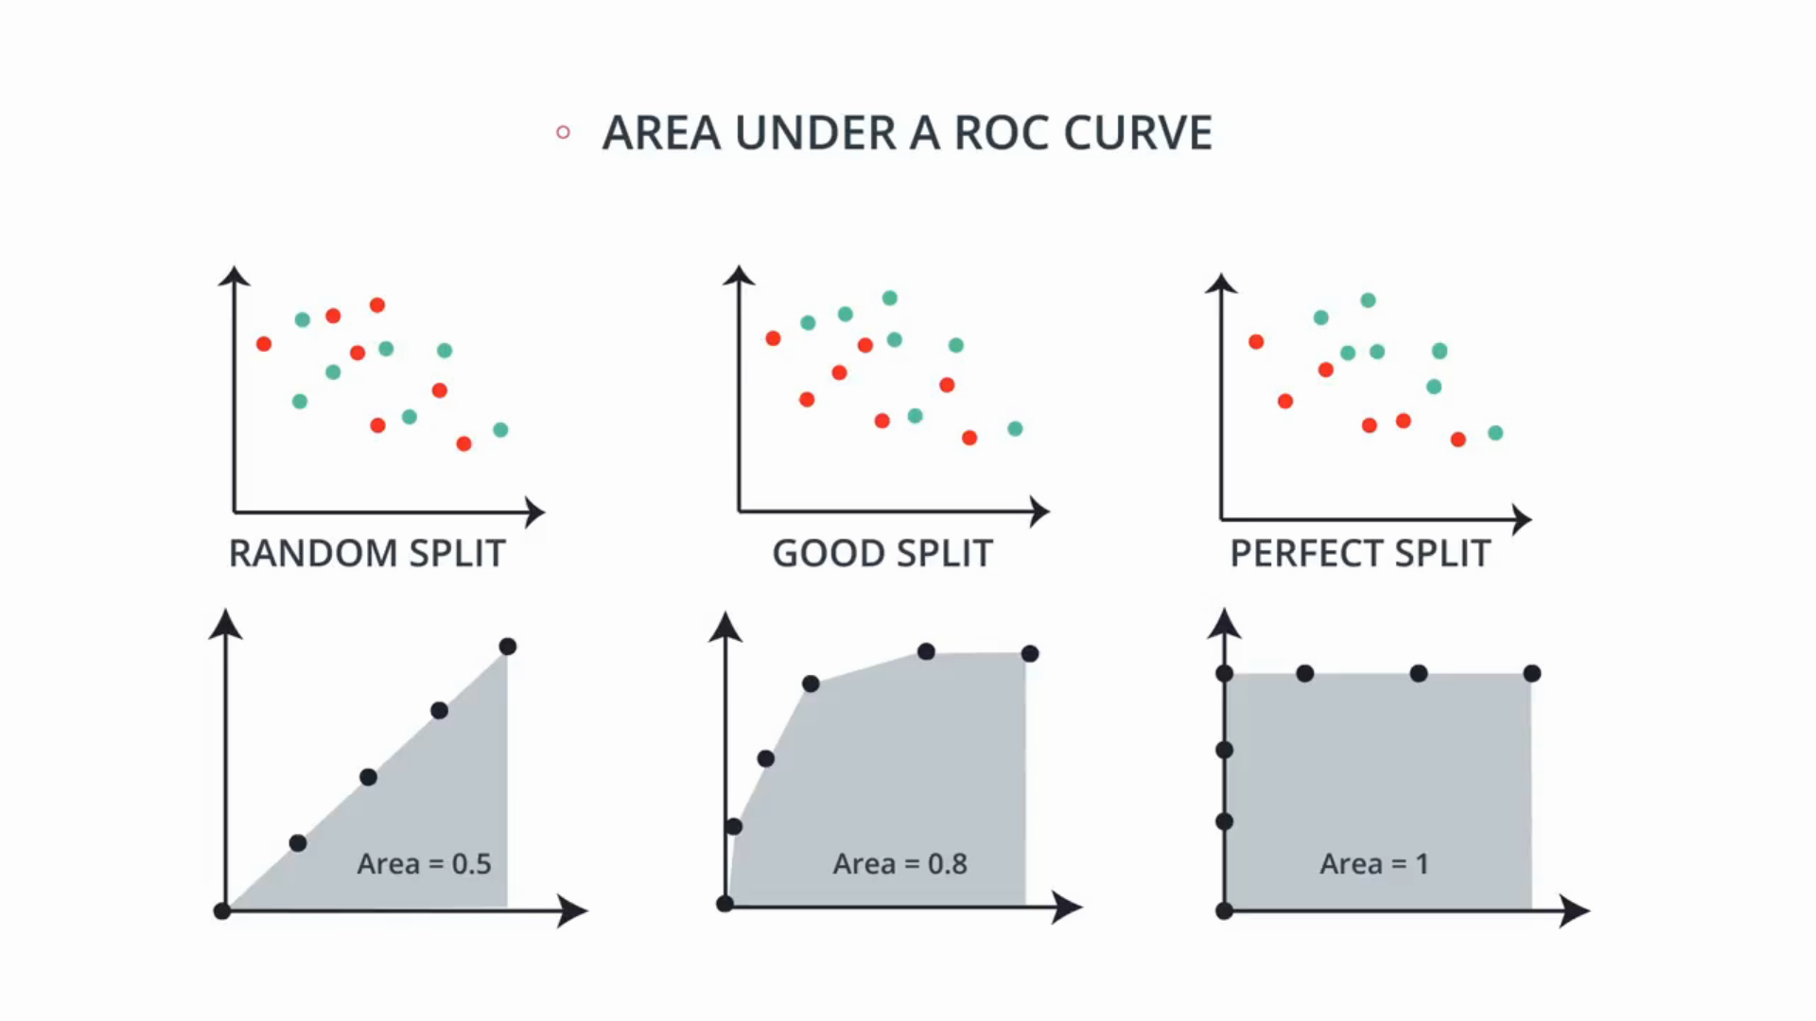

So in summary the closer your area under the ROC curve is to 1, the better your model is. Now, here is a question, can the area under the curve be less than 0.5? In fact yes it can be all the way to 0.

How would a model look if the area under the curve is 0?. well it will look more backwards. it’ll have more blue points in the red area and the red points in the blue area, so maybe flipping the data may help.

