**SMART SPEED BREAKER WITH ZEBRA CROSSING**

N.Duraimurugan 1,V.Jayadarshini ,2, Joshita Umanath,3,S.Harish Rajan

Associate Professor, Department of Computer Science and Engineering, UG Scholar,

Department of Computer Science and Engineering

duraimurugan.n@rajalakshmi.edu.in 1,210701088@rajalaksmi.edu.in

2,210701098@rajalakshmi.edu.in 3, 210701076@rajalaksmi.edu.in

**ABSTRACT**

This project introduces a novel approach to road safety by integrating intelligent technologies into speed breakers and zebra crossings. The Smart Breaker system utilizes speed sensing technology to dynamically adjust the speed breaker based on the approaching vehicle's speed. When vehicles exceed a predefined speed threshold, the speed breaker automatically elevates to effectively slow down the traffic. Furthermore, the system incorporates an advanced zebra crossing with embedded LED lights that illuminate when pedestrians stand on the crossing, enhancing their visibility to approaching vehicles. This feature significantly improves pedestrian safety, especially during low light conditions or high traffic volumes. The Smart Breaker system is designed to promote responsible driving behavior by providing real-time feedback to motorists and encouraging compliance with speed limits. Additionally, it prioritizes pedestrian safety by ensuring that they are easily discernible to drivers, thereby reducing the risk of accidents at zebra crossings. Key features of the system include speed sensing technology, variable height adjustment mechanisms, LED-equipped zebra crossings, and integration with pedestrian detection systems. These elements work synergistically to create a safer and more efficient road environment for both motorists and pedestrians.

Keywords- Arduino UNO boards, Real-time feedback, RF module, IR sensor

# I. Introduction

In today's fast-paced world, road safety remains a critical concern as traffic congestion and pedestrian-related accidents continue to pose significant challenges in urban environments. To address these issues, innovative solutions are imperative, and one promising approach is the integration of smart technologies into road infrastructure. The Smart Breaker system represents a groundbreaking advancement in this regard, combining dynamic speed management with enhanced pedestrian safety features. At the heart of the Smart Breaker system lies its ability to adapt in real-time to changing traffic conditions. Through the utilization of speed sensors embedded in the road surface, the system continuously monitors the speed of approaching vehicles. When vehicles exceed a predefined speed threshold, the Smart Breaker's height adjustment mechanism is activated, effectively slowing down traffic and reducing the risk of accidents caused by speeding.

At the heart of the Smart Breaker system lies its ability to adapt in real-time to changing traffic conditions. Through the utilization of speed sensors embedded in the road surface, the system continuously monitors the speed of approaching vehicles. When vehicles exceed a predefined speed threshold, the Smart Breaker's height adjustment mechanism is activated, effectively slowing down traffic and reducing the risk of accidents caused by speeding.

In summary, the Smart Breaker system represents a comprehensive solution to the complex challenges of urban road safety. As cities continue to evolve and grow, investments in smart infrastructure like the Smart Breaker will be essential in building safer and more sustainable transportation networks for the future.

II. Literature Survey

In [1] paper explains about poor visibility conditions during foggy winters or nighttime driving as leading causes of road accidents in India. The primary contributor to such accidents is often attributed to drivers' unintentional oversight of speed breakers, either due to their inability to detect them promptly or due to vehicles traveling at excessive speeds. In response to this pressing issue, this paper proposes the concept of an intelligent speed breaker system aimed at preventing such accidents

[2] This paper introduces a novel approach to enhancing public safety through the implementation of a flexible speed breaker system. The primary objective of this project is to mitigate road accidents by regulating vehicle speeds, particularly when vehicles surpass their speed limits. This innovative technology employs an Arduino UNO microcontroller interfaced with a servo motor and an IR (Infrared Ray) sensor to monitor vehicle speeds. The key feature of this system is its adaptability, with the speed breaker dynamically adjusting its size based on vehicle speed.

[3] This paper explains the development of an innovative speed breaker system aimed at improving public safety on roadways. In alignment with this objective, various studies have emphasized the pressing need for proactive measures to mitigate road accidents, particularly those caused by speeding vehicles and inadequate road infrastructure. Research indicates that traditional static speed breakers often fail to effectively regulate vehicle speeds, leading to a heightened risk of accidents. Furthermore, studies have underscored the importance of flexible road infrastructure in adapting to dynamic traffic conditions and enhancing overall road safety.

[4] This paper talks about the role of adaptable road infrastructure in promoting safer road environments. By incorporating technologies like servo motors, IR sensors, and microcontrollers, the proposed flexible speed breaker system represents a proactive step towards enhancing road safety. Its ability to dynamically adjust in response to changing traffic conditions not only addresses the limitations of traditional static speed breakers but also aligns with the broader goal of creating more responsive and efficient transportation networks innovative solutions.

[5] This paper emphasizes the pressing need for more adaptive and responsive solutions to address road safety concerns. Traditional static speed breakers have been found to be inadequate in effectively regulating vehicle speeds and can lead to discomfort for drivers and congestion on roads. In response, recent research has focused on developing dynamic speed breaker systems that utilize advanced technologies such as hydraulic actuators and pneumatic systems to adjust their height and position in real-time.

[6] Recent studies in the field of road safety have underscored the significance of innovative solutions to address the challenges posed by traditional static speed breakers. Static speed breakers, while serving as important traffic calming measures, often present limitations in adaptability and effectiveness. Research has shown that these conventional speed breakers can lead to discomfort for drivers and contribute to traffic congestion, particularly in urban areas with heavy traffic.

# III Limitations in Existing System

The existing Speed breaker Systems and Smart Specs have significantly enhanced mobility and independence for public. However, these systems often come with a set of limitations such as,

1. Range limitations
2. Environmental Adaptability
3. Battery life
4. User interface complexity
5. Cost Accessibility

These are few limitations faced in real-time and to address these issues, we propose a model that consolidates all essential features into a single, more affordable system, providing a comprehensive solution for people.

The existing infrastructure for road safety, particularly speed breakers and zebra crossings, faces significant challenges in effectively managing vehicle speeds and ensuring pedestrian safety. Traditional speed breakers lack adaptability, often causing discomfort to drivers and inadequate traffic flow regulation, while conventional zebra crossings may fail to provide sufficient visibility to pedestrians, leading to increased risks of accidents, especially in low light or high traffic conditions. Addressing these challenges requires the development of a comprehensive system that integrates smart technologies to create a more responsive and efficient road environment, ultimately reducing accidents and enhancing overall safety for both motorists and pedestrians..

# IV. Proposed System

The proposed system is to design and implement a Smart Breaker system that integrates advanced technologies to effectively manage vehicle speeds and enhance pedestrian safety at zebra crossings. The objectives include developing a dynamic speed management mechanism for the speed breaker, integrating LED lighting for improved pedestrian visibility, implementing a responsive control system, and conducting comprehensive testing to ensure the system's effectiveness in reducing accidents and promoting safer road interactions between vehicles and pedestrians.

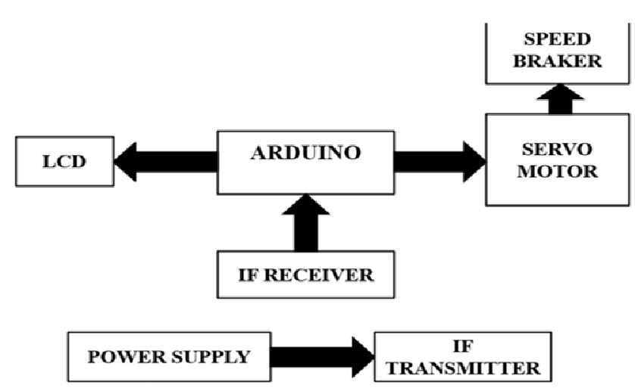

## Figure 1: System Architecture

It utilizes an Arduino for processing and an array of sensors (ultrasonic sensors, servo motor) for data collection and potential speed control.The code written in Arduino C++ language controls the hardware components and performs calculations. The system integrates WiFi for uploading data to ThingSpeak, allowing for remote monitoring and analysis.

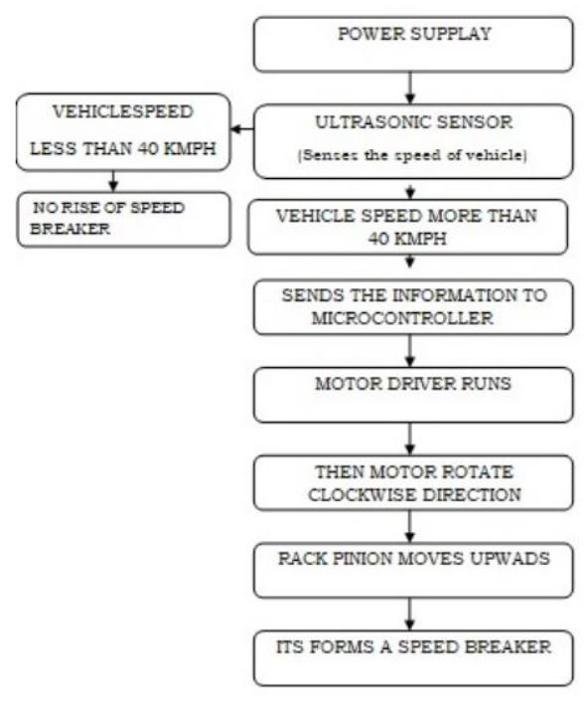

**Figure 2: Data Flow Diagram**

V. Work Process

# 1. Sensor Technology:

This project focuses on building a speed monitoring system using an Arduino microcontroller.It utilizes two ultrasonic sensors to calculate the time it takes an object to travel between them. This time, along with the known distance between the sensors, allows for speed calculation.

The system displays the calculated speed on a Liquid Crystal Display (LCD) screen. The code uses the ThingSpeak platform to send the measured speed data wirelessly to the cloud for storage and potential visualization.

The code includes a servo motor that could be used to deploy a speed bump mechanism if a speeding object is detected. However, the logic for activating the servo motor based on speed isn't fully implemented.

# 2. Arduino UNO Board Setup:

Once the sensors are in place, attention turns to the implementation of the Arduino UNO board, a powerful microcontroller that serves as the central processing unit of the smart shoe. Engineers program the Arduino board to receive input from the sensors, process this data using sophisticated algorithms, and make autonomous decisions based on the detected obstacles. This intelligent processing capability enables the smart shoe to operate seamlessly and respond promptly to potential hazards.

The Arduino UNO board serves as the central processing unit within the smart shoe and specs due to its versatility, reliability, and computational power.

# 3. Bluetooth Connectivity:

The integration of Bluetooth technology in the smart speed breaker serves a crucial purpose in enhancing user experience and safety. By establishing a wireless connection with a companion smartphone app, these devices enable seamless communication and data exchange. This connectivity enables to transmit real-time information about detected obstacles directly to the user's smartphone, ensuring prompt awareness of the surroundings.

The Bluetooth connection works by establishing a short-range wireless link between the smart speed breaker and the smartphone. Once paired, the devices can exchange data efficiently and effectively. When the sensors detect obstacles in close proximity, they send signals to the microcontroller, which then relays this information to the smartphone via Bluetooth. The companion app interprets these signals and generates alerts or notifications to alert the user about the detected obstacles.

This technology works by utilizing radio waves to transmit data over short distances, typically up to 30 feet. Bluetooth operates on the 2.4 GHz frequency band and employs frequency hopping to minimize interference and ensure secure communication. By leveraging Bluetooth connectivity, the smart shoe and specs provide users with real-time updates about their environment, empowering them to navigate safely and confidently.

4. Companion Smartphone App

The Companion Smartphone App functions as a centralized hub for users to interact with their smart speed breaker, enhancing their navigation experience and overall safety. Upon downloading and installing the dedicated app on their smartphone, users initiate the pairing process, establishing a connection between their mobile device and the smart speed breaker ,Once paired, the app continuously receives real-time data and alerts from the smart speed breaker regarding detected obstacles in the user's surroundings. This information is relayed to the app via Bluetooth connectivity, ensuring prompt updates and notifications.The app's intuitive interface allows users to customize settings according to their preferences, such as adjusting alert frequencies or modifying notification preferences. Additionally, users can access detailed information about detected obstacles, including their location and proximity to the user.Through the app, users can receive informative alerts in various formats, such as audible notifications or visual indicators. These alerts provide users with vital insights into their surroundings, empowering them to navigate safely and confidently.

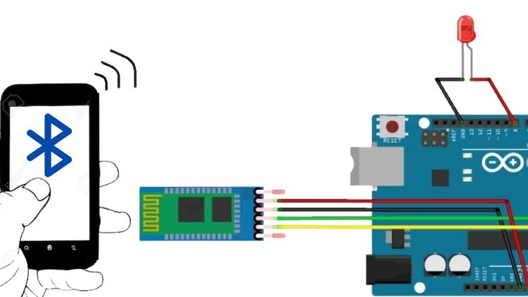

**Figure 3: Bluetooth configuration**

# VI. Future Enhancements

The smart speed breaker system presents a promising solution to address road safety concerns, particularly in mitigating accidents caused by speeding vehicles and inadequate visibility conditions. By leveraging advanced technologies such as IR sensors, RF modules, and servo motors, the system effectively detects speeding vehicles and adjusts the height of the speed breaker accordingly to regulate vehicle speeds. The integration of LED lights and wireless communication further enhances the system's effectiveness by providing timely warnings to drivers and improving visibility at night or in adverse weather conditions. Through the implementation of this system, significant strides can be made towards creating safer road environments and reducing the risk of accidents for both motorists and pedestrians.

# VII. Result

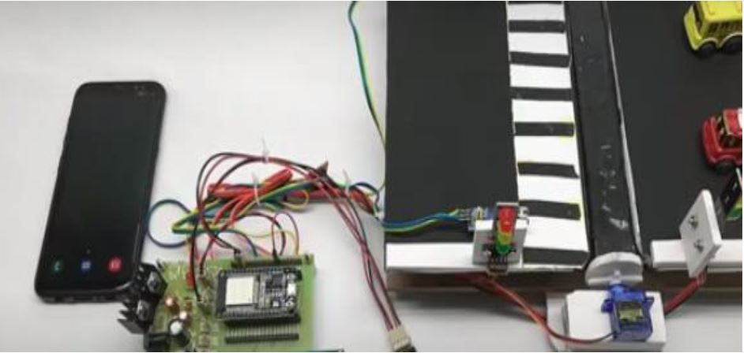

## Figure 4: Implementation

# VIII. Conclusion

In conclusion, the smart speed breaker system presents a significant advancement in road safety technology by effectively addressing the challenges posed by speeding vehicles and poor visibility conditions. While the current implementation demonstrates promising results in regulating vehicle speeds and enhancing driver awareness, further enhancements can be explored to maximize its effectiveness. These include integrating machine learning algorithms for predictive analysis, enhancing communication capabilities, adapting to environmental factors, implementing data analytics for informed decision-making, and integrating with existing smart city infrastructure. Through continuous innovation and collaboration, the smart speed breaker system has the potential to significantly reduce road accidents and contribute to the development of safer and smarter transportation networks.

# IX. References

[1] Fan X.H., Zhang Y.L. A Design of bi verification vehicle access intelligent control system based on RFID. Proceedings of the Ninth

[2] International Conference on Electronic Measurement & Instruments (ICEMI’2009);

Beijing, China. August 16–19, 2009.

[3]https://www.slideshare.net/IshantGautam/advanced-speed-breaker-61292731/

[4]<https://www.researchgate.net/publication/261455958_Introducing_speed_breaker_a> s_a_power_generation_unit_ for_minor_needs

[5] Pandhare, K. K. (June 2017). Electric Power Generation System from Speed Breaker by using Rack and Pinion Mechanism. International Journal of Current Engineering

and Technology.

[6] Patel, H. K., Dutta, S. K., & Das, P. S. (2015). Production of Electricity by the Method of Road Power. International Journal of Research (IJR).