# Exp: 5

**Aim:**

# Installation of Hive

To Download and install Hive, Understanding Startup scripts, Configuration files.

# Procedure:

## Step 1: Download and extract it

Download the Apache hive and extract it use tar, the commands given below:

$wgethttps://downloads.apache.org/hive/hive-3.1.2/apache-hive-3.1.2-bin.tar.gz

$ tar –xvf apache-hive-3.1.2-bin.tar.gz

## Step 2: Place different configuration properties in Apache Hive

In this step, we are going to do two things o Placing Hive Home path in bashrc file

$nano .bashrc

And append the below lines in it

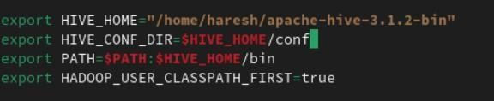

2. Exporting Hadoop path in Hive-config.sh (To communicate with the Hadoop eco system we are defining Hadoop Home path in hive config field) Open the hiveconfig.sh as shown in below

$cd apache-hive-3.1.2-bin/bin

$cp hive-env.sh.template hive-env.sh

$nano hive-env.sh

Append the below commands on it

export HADOOP_HOME=/home/Hadoop/Hadoop

export HIVE_CONF_DIR=/home/Hadoop/apache-hive-3.1.2/conf

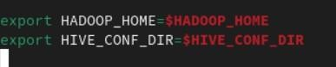

## Step 3: Install mysql

1. Install mysql in Ubuntu by running this command:

$sudo apt update

$sudo apt install mysql-server

1. Alter username and password for MySQLby running below commands:

$sudo mysql

Pops command line interface for MySQLand run the below SQL queries to change username and set password

mysql> SELECT user, host, plugin FROM mysql.user WHERE user = 'root';

mysql> ALTER USER 'root'@'localhost' IDENTIFIED WITH 'mysql_native_password' BY 'your_new_password';

mysql> FLUSH PRIVILEGES;

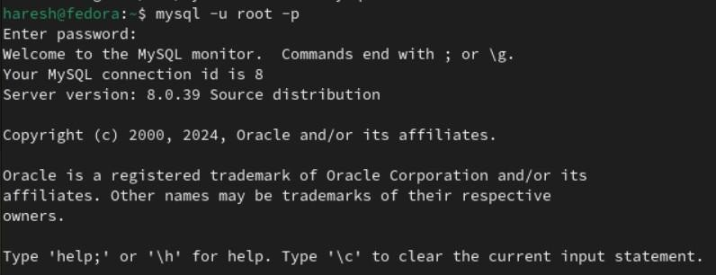

## Step 4:Config hive-site.xml

Config the hive-site.xml by appending this xml code and change the username and password according to your MySQL.

$cd apache-hive-3.1.2-bin/bin

$cp hive-default.xml.template hive-site.xml

$nano hive-site.xml Append these lines into it

Replace root as your username of MySQL Replaceyour_new_password as with your password of MySQL

<configuration>

<property>

<name>javax.jdo.option.ConnectionURL</name>

<value>jdbc:mysql://localhost/metastore?createDatabaseIfNotExist=true</value>

</property>

<property>

<name>javax.jdo.option.ConnectionDriverName</name>

<value>com.mysql.cj.jdbc.Driver</value>

</property>

<property>

<name>javax.jdo.option.ConnectionUserName</name>

<value>root</value>

</property>

<property>

<name>javax.jdo.option.ConnectionPassword</name>

<value>your_new_password</value>

</property>

<property>

<name>datanucleus.autoCreateSchema</name>

<value>true</value>

</property>

<property>

<name>datanucleus.fixedDatastore</name>

<value>true</value>

</property>

<property>

<name>datanucleus.autoCreateTables</name>

<value>True</value>

</property>

</configuration>

## Step 5: Setup MySQL java connector:

First, you'll need to download the MySQL Connector/J, which is the JDBC driver for

MySQL. You can download it from the below link https://drive.google.com/file/d/1QFhB7Kvcat7a4LzDRe6GcmZva1yAxKz-

/view?usp=drive_link

Copy the downloaded MySQL Connector/J JAR file to the Hive library directory. By default, the Hive library directory is usually located at/path/to/apache-hive-3.1.2/lib/on Ubuntu. Use the following command to copy the JAR file:

$sudo cp /path/to/mysql-connector-java-8.0.15.jar /path/to/apache-hive-3.1.2/lib/ Replace /path/to/ with the actual path to the JAR file.

## Step 6:Initialize the Hive Metastore Schema:

Run the following command to initialize the Hive metastore schema:

$$HIVE_HOME/bin/schematool -initSchema -dbTypemysql

## Step 7: Start hive:

You can test Hive by running the Hive shell: Copy code hive You should be able to run Hivequeries, and metadata will be stored in your MySQL database.

$hive

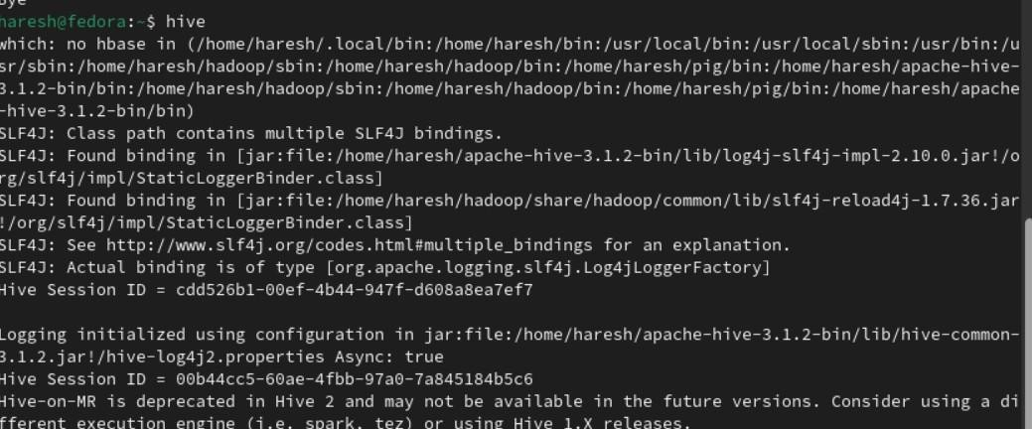

# Result:

Thus, the Apache Hive installation is completed successfully.