# Exp no: 5a

**Design and test various schema models to optimize data storage and retrieval using Hive**

# Aim:

To Design and test various schema models to optimize data storage and retrieval Using Hbase.

# Procedure:

## Step 1: Start Hive

Open a terminal and start Hive by running:

$hive

## Step 2: Create a Database

Create a new database in Hive:

hive>CREATE DATABASE financials;

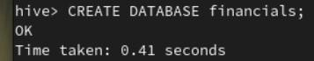

## Step 3: Use the Database:

Switch to the newly created database:

hive>use financials

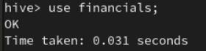

## Step 4: Create a Table:

Create a simple table in your database:

hive>CREATE TABLE finance_table( id INT, name STRING );

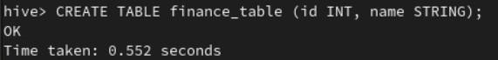

## Step 5: Load Sample Data:

You can insert sample data into the table:

hive>INSERT INTO finance_tableVALUES (1, 'Alice'), (2, 'Bob'), (3, 'Charlie');

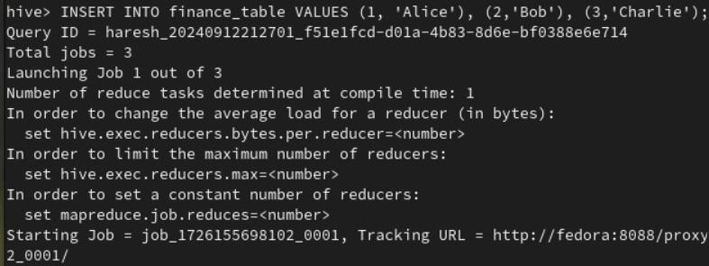

## Step 6: Query Your Data

Use SQL-like queries to retrieve data from your table:

hive>CREATE VIEW myview AS SELECT name, id FROM finance_table;



## Step 7: View the data:

To see the data in the view, you would need to query the view hive>SELECT*FROM myview;

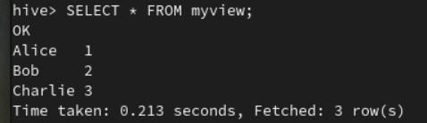

## Step 8: Describe a Table:

You can describe the structure of a table using the DESCRIBE command: hive>DESCRIBE finance_table;

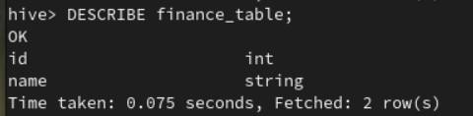

## Step 9: Alter a Table:

You can alter the table structure by adding a new column: hive>ALTER TABLE finance_table ADD COLUMNS (age INT);

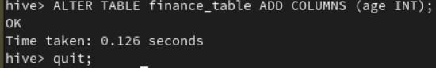

## Step 10: Quit Hive:

To exit the Hive CLI, simply type:

hive>quit;

# Result:

Thus, the usage of various commands in Hive has been successfully completed