BE1 Report

Hydrogen Combustion Simulation with OpenFoam

**Centrale Innovation, Ecully, France**

***Practised at* : Laboratoire Mécanique de Fluides et Acoustique, I11**

**Ecole Centrale de Lyon**

**Ecully, France**

Student: **Harish REYYA**

Supervisor: **Paollo Errante** Combustion Dpt, LMFA, ECL

Date of Submission: 15th October 2022

Contents

1 Introduction 3

2 Marinov et al. Chain Reaction 4

3 Numerical Analysis of Initial Temperature and Pressure Effects on the Chemical Kinetics 5

3.1 End Time 0.001sec 5

3.2 End Time 0.1sec 7

4 Conclusion 9

5 References 10

# Introduction

The combustion of hydrogen is suitable and widely conducted these days rather than bio fuel. This is due to the fact the heat quotient of hydrogen is very high, its availability is easy (found in air and water) and its control is quite simple.

There are various research’s done to look into chemical kinetics of the chain reaction of burning *H2 in* various environmental conditions to attain an optimal energy output with stable flames.

In this numerical simulation work, we evaluate the chain reaction of hydrogen combustion as described by *Marinov et al.* The variation of initial temperature and pressure for the rate of combustion and the products temperature with relation to reaction rate and to the flame profile.

The limits are of great interest to investigate, as beneath it there will be no chemical kinetics and combustion will not take place.

The Open Foam is an open source code use to simulate flows and specifically chemical kinetics. This is very useful in combustion researches and development of combustion chambers as well as cooling systems. Schemes are mostly Euler and Jameson and the special modal solutions are found by Finite Elements or Finite Volume methods. This enables to solve simple phase elementary reactions or even series of chain reactions.

The mesh as well as the source code is provided from $FOAMTUTORIALS and the code was set to run.

The study of evolution of such system is studied and the relations to temperature and pressure to the kinetics will be analysed

# Marinov et al. Chain Reaction

The reaction where studied experimentally in a molecular level. The combustion of hydrogen gas with air is a thermal self-excited reaction with very long chains.





Figure 2‑1: Complete chain reaction for the Hydrogen gas Combustion

As can be observed in each elementary reaction, there is either formation of free radicals or release of heat energy to follow up with the *Arrhenius Law* of reaction rate.

The first group represents a chain initiations of reactions. An energy greater than activation energy has to be given in order make the process self-sustain. Note that the *Eact* of breaking oxygen gas to oxygen radical and hydroxide is much greater than the one for breaking hydrogen gas to hydrogen radicals. Hence this is a major control to prevent oxidization of walls made of metals.

This chain reaction to take place as discussed above, the initial temperature and pressure should be sufficient enough to create such an energy greater than activation energy *Eact* to initiate the chain. What is interesting is that, from the Arrhenius equation, these parameters should be proportional. But in real case, they make a limit boundary like a bow depending on their effects to the kinetics of the molecules.

The code is given with all credentials and exe to run for attaining the results.

# Numerical Analysis of Initial Temperature and Pressure Effects on the Chemical Kinetics

The change of initial temperature and pressure hence environmental conditons has major effects on the chemical kinetics of the reaction and the heat to be generated. The following results were obtained after ranging the inputs at an ***end time* of 0.001sec**. This shows the chain reaction is very rapid and the combustion is in a split second.

## End Time 0.001sec

The simulation was performed by randomly choosing 4 initial pressures of at each to the 10n with n ϵ [2,6], ranging the temperature inlet to investigate the combustion limits.

Starting with Pressure of *202680Pa,* temperature was set to *700K.* The results are seen in *figure 3-1* where there is no increase in temperature for the time given. Hence no reaction.

The temperature was altered for different temperatures increasing its value. As seen in *figure 3-2,* the critical temperature for reaction to take place was found to be *980K.*

The delaying time of ignition, before the reaction and attaining the adiabatic temperature *Tad*  is observed to increase as you decrease the initial temperature approaching 980*K.* The higher the initial temperature, the shorter is the time of molecules to bombard and collide between one another with energy greater than *Eact.*



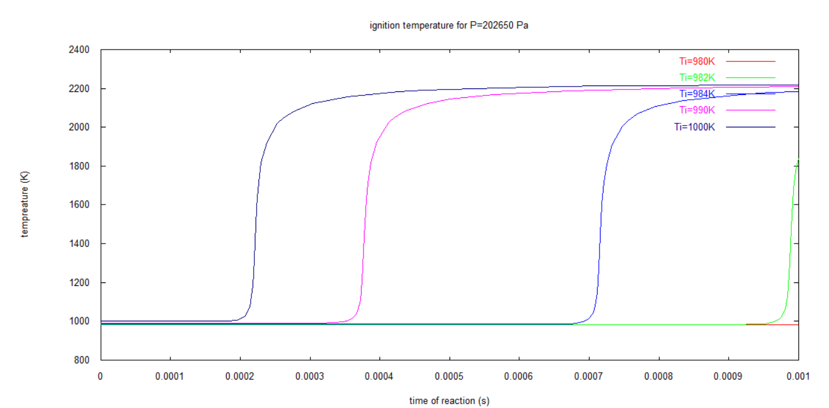

Figure 3‑2: Temperature vs time of reaction for various Tin higher than 980K

Figure 3‑1: Temperature vs time for Ti=700K

Notice a straight red line for *Ti* =980K hence showing the critical temperature.

When the pressure was changed to 104 values, the reaction slope was not as sharp as the one above as seen in *figure below.* This is due to the decrease in molecular energy and hence the radicals don’t form easily.



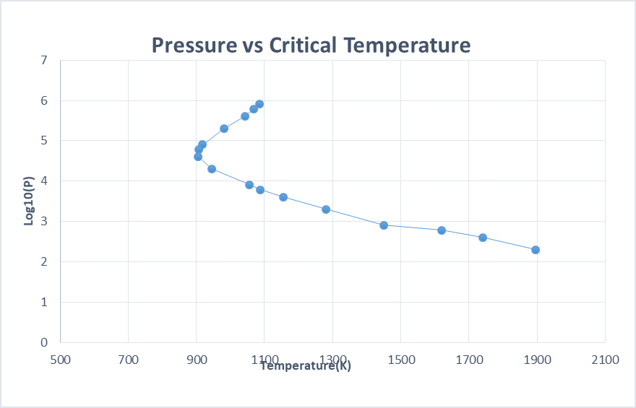With other initial pressures lesser than 104 the results were the same. After plotting the values obtained for pressure and critical temperature as seen in *figure 3-3.* The result was far from that obtained practically.

Figure 3‑3: Plot of Critical initial Temperature for end time reaction time of 0.001sec

Due to this observation, the end time of reaction plays a critical factor in determining the boundary of made by initial temperature for the reaction rate.

## End Time 0.1sec

The end time was changed to 0.1sec and this allowed the reaction to take a longer ignition delay time scale to produce products.

The same process was done for the precious section, and results are now intriguing with very little discrepancy to the experimental results obtained from [1].

*Figure 3-5* containing both the results from this numerical study and the previous experimental results.

It can be observed that there are three limits as expected seen where the first is inverse proportional, the making a bow turn to the next with direct proportionality ending with the last one which regain inverse proportionality relation between pressure and critical temperature. The numerical results do not show precisely the points of inflexion changing the limits of the combustions. They are rather interpolated.

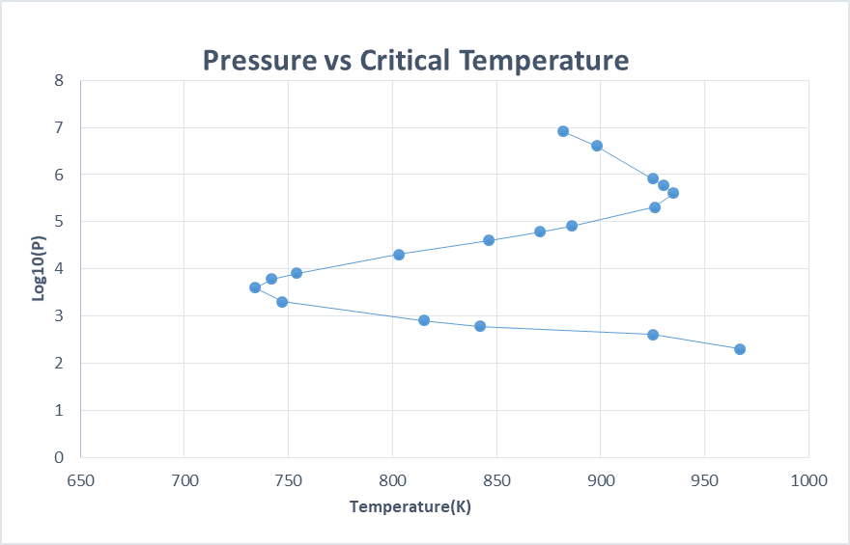

Figure 3‑5: Plots of Pressure vs Critical Initial Temperature for Numerical Results(top) and Experimental Results(bottom)

# Conclusion

The first limit is in the range of pressure *log10P > 4.5.* In this category the higher the pressure the lower is the critical initial temperature with very high slopes of chemical reaction rates. This is due to the fact that there is an easy formation of *OH--* from the reaction and less diffusion of molecules on the walls. This results to the high reaction rates.

The second regime lies on the same phenomenon, but here the *H+* are produced in a higher rate than *O2-* with very less energy. The first regime is the slowest of all, with very low pressure resulting to the hydrogen radicals going to the wall and recombine to form hydrogen gas. Also the heat released by the flame is very low and the rest goes to produce thermal stress to the walls of the combustor.

The end time of observation of reaction plays a major role in classifying the critical inlet temperature. The ignition delay time is prolonged when temperature is lower in the third regime, hence one can obtain different critical temperatures with different time scale of observation.

If the desired goal is to have a very fast burning process, then the pressure of the chamber should be higher to the values of *106* which is indeed a challenge to obtain this at high altitudes.

# References

|  |  |
| --- | --- |
| [1] | S. ChangweiJi, »Experimental study on combustion and emissions performance of a hybrid hydrogen–gasoline engine at lean burn limits,« 2009. |