Report

Partial Stirred Reactor

**Centrale Innovation, Ecully, France**

***Practised at* : Laboratoire Mécanique de Fluides et Acoustique, I11**

**Ecole Centrale de Lyon**

**Ecully, France**

Student: **Harish REYYA**

Supervisor: **Paollo Errante** Combustion Dpt, LMFA, ECL

Date of Submission: 15th November 2022

Contents

1 Introduction 3

2 Numerical Setup and Problem Configuration 4

3 Results and Analysis 5

3.1 Velocities at 100 m/s magnitude 5

3.2 Velocities at 101 m/s 8

3.3 Velocities at 102 m/s 10

4 Conclusion 12

# Introduction

The partial stirred reactor is an old technology which was one of the pioneer of the combustion in the turbojet. It involved a premixed flame, meaning the fuel is mixed with air in a certain proportion before it has been burnt. The air enters first in the wide inlet and then its flow is governed in such a way it has optimum kinetic properties to mix with the fuel which is injected through narrow tubes with a desired speed. The gas mixture then explodes on a certain pressure and produces hot products through the flame.

The reactants are assumed as perfectly mixed before explosion in the numerical studies, but this in practise is not the case. Due to various effects such as collisions of molecules to the walls which hinder the mixing process. However models have been created and give results very close to the experimental regardless the effect.

This numerical study is performed by *OpenFoam* an open source for simulation of flows and chemical kinetics.

The 2D mesh provided is made from fluent and then converted by a simple code to openfoam format, with adiabatic walls and inviscid conditions.

The aim for this study is to investigate the effect of inlet velocities of both oxidizer in this case air at *293K* initial temperature and fuel in this case is the methane *CH4* given at an initial temperature *800K* both at 1atm pressure to the products properties. Meaning the evolution of concentrations of elements at whole time of reaction at the outlet, the heat energy released by the whole process of combustion and mainly the total pressure and temperature at the outlet which then enters the turbine.

Also this numerical study aims to look in keen if there are effects on either fuel or oxidizer has a higher temperature than the other will affect the kinetics of the reaction and change any physical phenomenon.

This is indeed very important as it gives the insight of the design of the reactor with specific geometrised injectors and the walls to be created to counteract the effect of heat diffusion and thermal stresses. It gives an insight on the amount of fuel needed to give a certain amount of heat to create enough power for thrust and this optimises the cost of the plane at large.

Another importance of this numerical study on the design of a combustion chamber is to give the optimum outlet temperature which should be safely for the turbine rotor blades.

# Numerical Setup and Problem Configuration

The problem as said in the previous section is first solved by creating a mesh from the Ansys Fluent and then convert it to the openfoam format.

**Looking at the chemical equation of the reaction as seen below;

The mass ratio between the fuel and air is half meaning 50% contribution to the mixture. We have five elements and each has its own respective properties from the reactant stage to the product stage.



Figure 2‑1: 2D Geomoerty of Partial Stirred Reactor

The reactor as seen in *figure 2-1* has a symmetric inlet in the x axis and exit in the y axis with cells split in non-reacting and reacting zones. As described above the fuel is injected at the middle through small orifice injectors and the mixture is formed before the explosion. The codes to initialise the run are given with described chemistry properties, combustion properties where laminar is used, thermophysical properties set to a perfect gas and Sutherland transport equations.

The simulation is set altering the inlet velocities of air and fuel varying values of 101 to 103 at both fixed inlet pressure and temperature and operating temperature of 298K and 1atm pressure. The results are post processed by *Paraview* software for better analysis. The energy released is calculated by integrating the power over the time reaction by Simpson’s rule.

# Results and Analysis

The results here are analysed based on the time scale of reaction 120seconds. Analysis is solely done at the outlet where indeed the main target of the combustion chamber is. Using *Paraview* software the parameters are first integrated on the 2D sliced surface at the exit, then the mean value for each time step is calculated. After that any convenient method of integration over time is used to calculate the whole composition.

The surface is simply obtained by dividing the obtained slice integrated values of either *N2* composition or Temperature at 0sec. *N2* composition is equal to 1 initially, so when integrated over the surface, **30.0076** is obtained which indeed is the surface area at the outlet. Also the operating temperature initially set to 298K, can be seen to be 8942.27K which indeed is 30.0076*298K.

Also the evolution of mean outlet properties over time at the outlet is very important in describing the combustion rate and phenomenon of thermal conductivity. This will be done but only for velocities of interest.

## Velocities at 100 m/s magnitude

The inlet velocity of fuel was fixed to *3m/s* while that of air was altered from 1*,* 3then lastly 6m/s. This covers all three possible scenarios, when fuel velocity is less, equal and more compared to the air.

The evolutions of parameters such as outlet mean tempearature, thermal power and gas compositions at the outlet for the three cases above are as seen in *figure 3-1,2,3* respectively*.* At these low velocities the fuel injection is sufficient enough to form a perfect mixture with air.

When the fuel velocity was higher than that of air, the *CH4* composition at the outlet was higher as seen in *figure 3-1A* compared to the contrary case as seen in *figure 3-1B,C* with the time of reaction decreasing rapidly. Also the nitrogen concentration after the burning of methane to form Nox kept a plateau of about 0.8 but was slow for the first case compared to others.

The temperature at the outlet also observed in *figure 3-2A* had a slow increase attaining a max value at very late stage for the first case compared to the second case, while third case was more faster and have more than one peak.

Same goes for the power at the output, it’s evolution for the first case as seen in *figure 3-3A* very slow attaining a max value at late stages compared to the second case. What is interesting to notice is that the third case as seen in *figure 3-3C* attained a peak very rapid with various peaks but has not got a value higher than that of the second case.

The results are summarised in the table below.

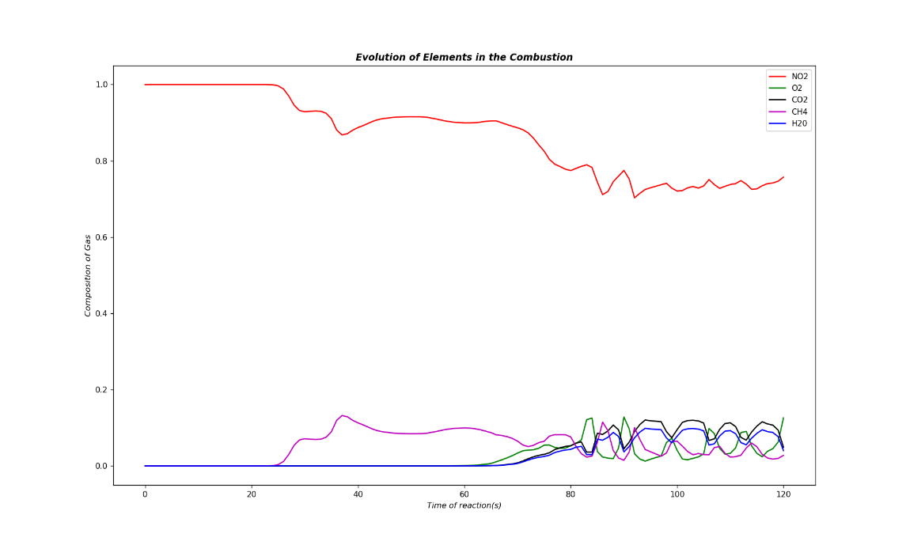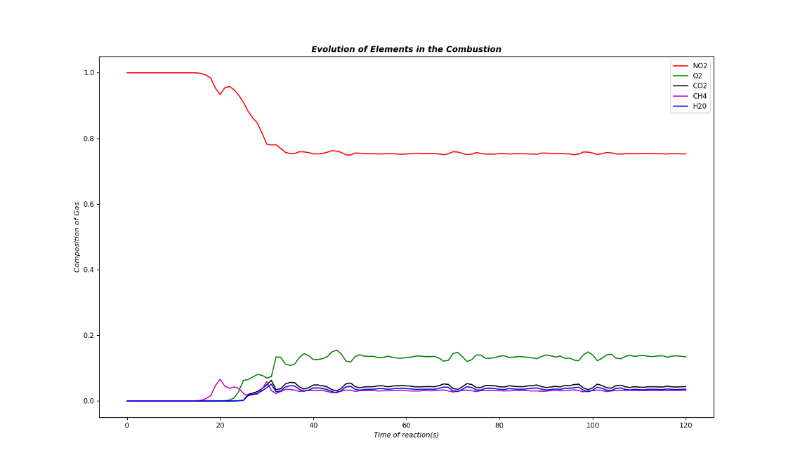From the table, energy is observed to be maximum at the second case where two inlet velocities are equal of 3m/s and the rate of reaction was the fastest. However the Nox formation is also maximised since the oxygen is left.

Figure 3‑1B; Air Veocity=3m/s Fuel Velocity=3m/s

Figure 3‑1A; Air Veocity=1m/s Fuel Velocity=3m/s

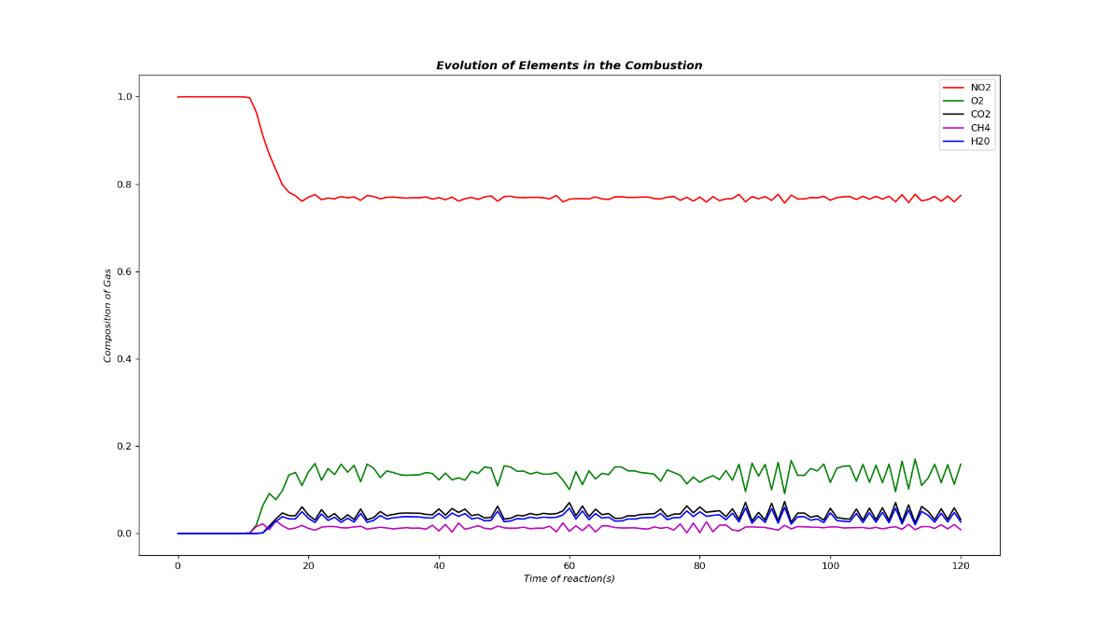

Figure 3‑1C; Air Veocity=6m/s Fuel Velocity=3m/s

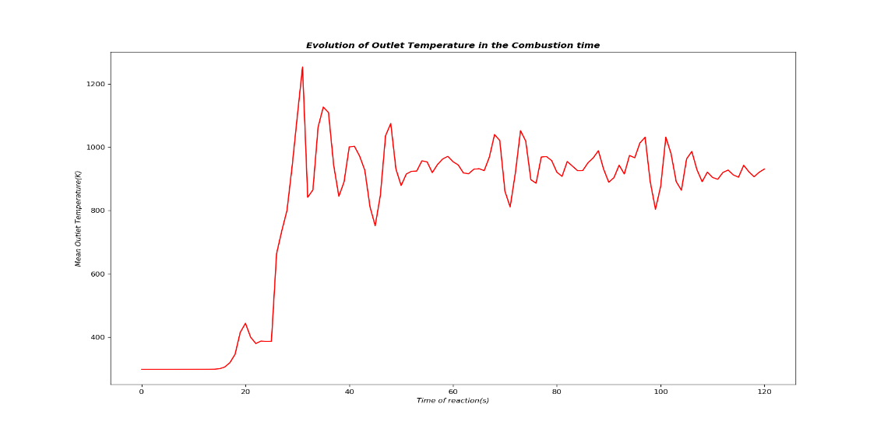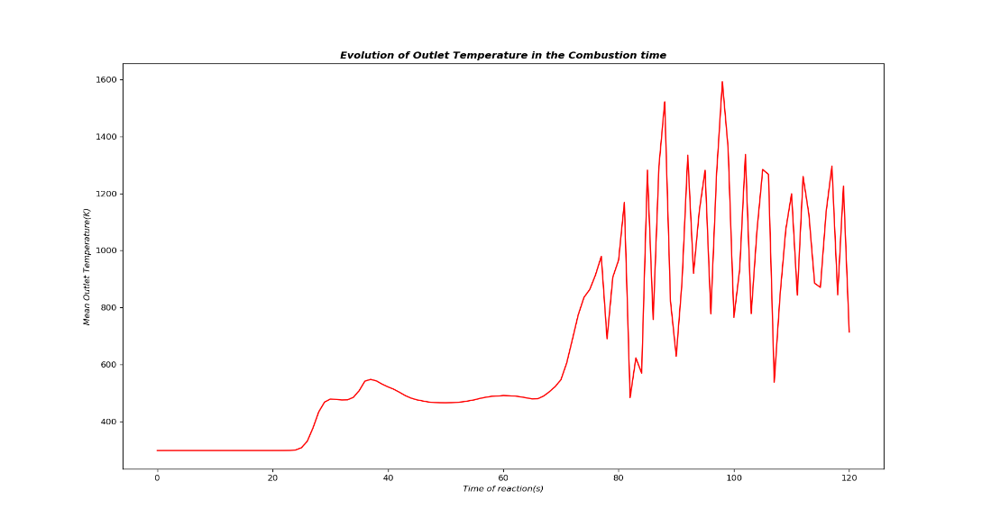

Figure 3‑2B; Air Veocity=3m/s Fuel Velocity=3m/s

Figure 3‑2A; Air Veocity=1m/s Fuel Velocity=3m/s

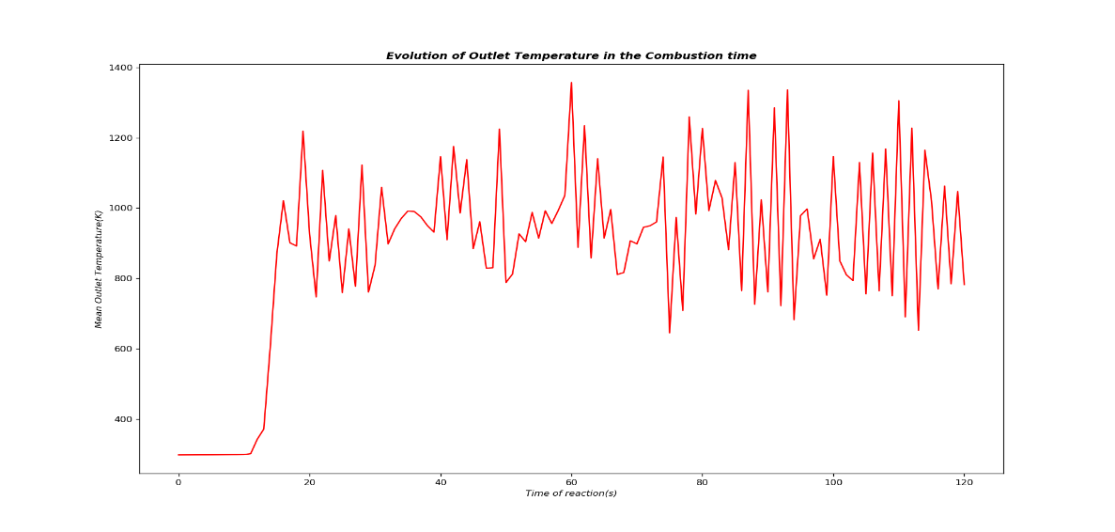

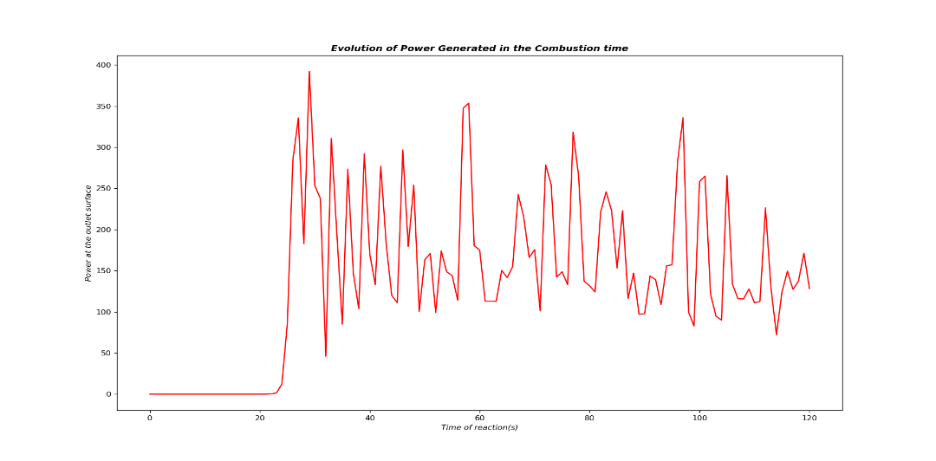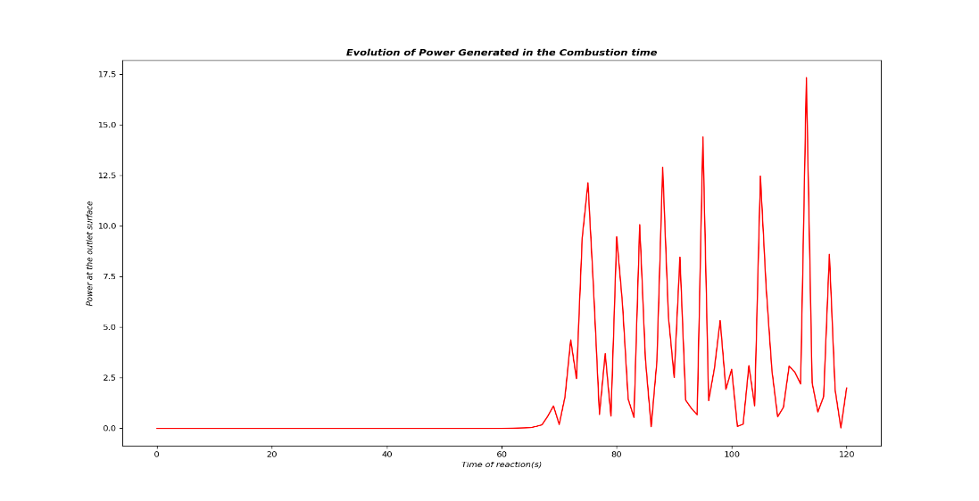

Figure 3‑3B; Air Veocity=3m/s Fuel Velocity=3m/s

Figure 3‑3A; Air Veocity=1m/s Fuel Velocity=3m/s

Figure 3‑2C; Air Veocity=6m/s Fuel Velocity=3m/s

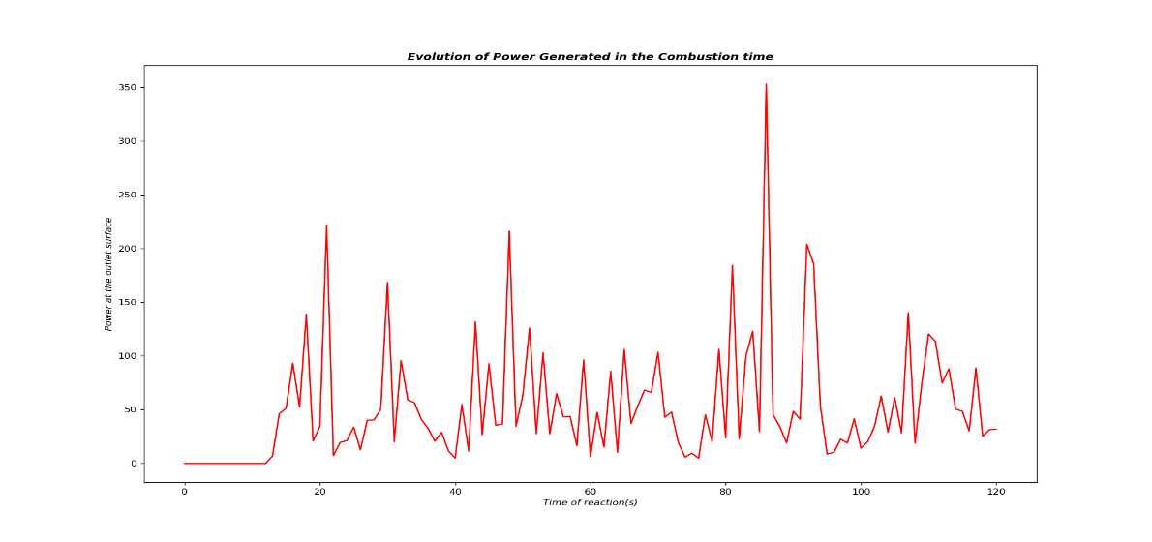

Figure 3‑3C; Air Veocity=6m/s Fuel Velocity=3m/s

## Velocities at 101 m/s

The inlet velocity of fuel was fixed to *15m/s* while that of air was altered from 5*,* 15then lastly 30m/s. This covers again all three possible scenarios, when fuel velocity is less, equal and more compared to the air.

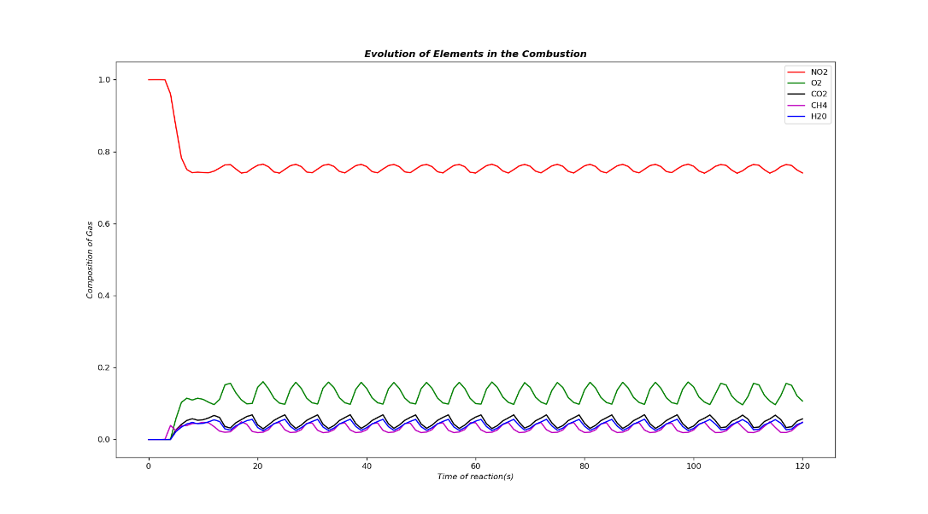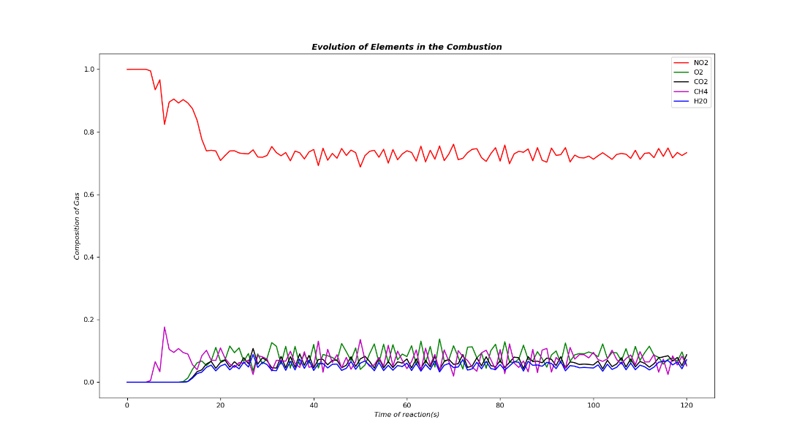Also the evolutions of parameters such as outlet mean tempearature, thermal power and gas compositions at the outlet for the three cases above are as seen in *figure 3-4, figure 3-5, figure 3-6*.

Figure 3‑4B; Air Veocity=15m/s Fuel Velocity=15m/s

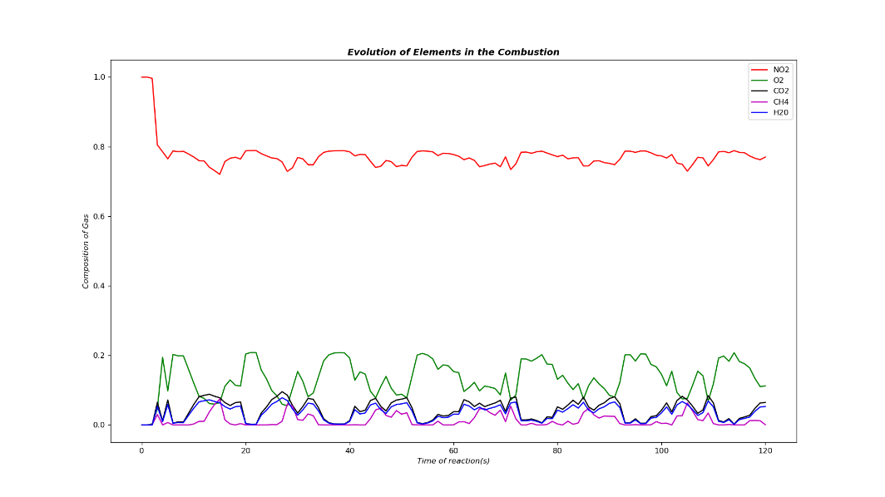

Figure 3‑4A; Air Veocity=5m/s Fuel Velocity=15m/s

Figure 3‑4C; Air Veocity=30m/s Fuel Velocity=15m/s

The composition of the elements are observed as before, but this time with hgiher values of oxygen and methane upto 0.2. N2 for the first case seems lowest since air is injected with lower velocity hence the burning is again not efficient.

Methane can be observed to start as usual from 0 initially, then varies but at the end should be zero for a complete burning process expected. This is observed more likely at the third case where air is burning the fuel at a high speed.

The temperature for the third case has higher values at very low stage of the combustion as compared to the first case, a very rapid burning process.

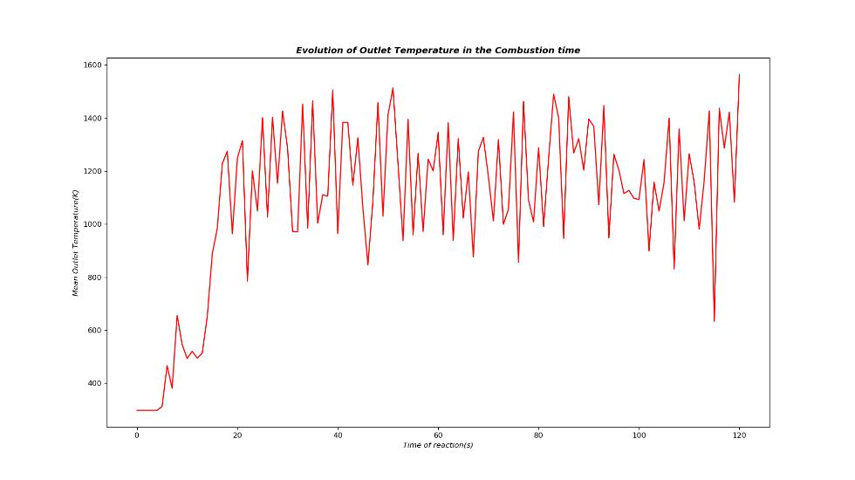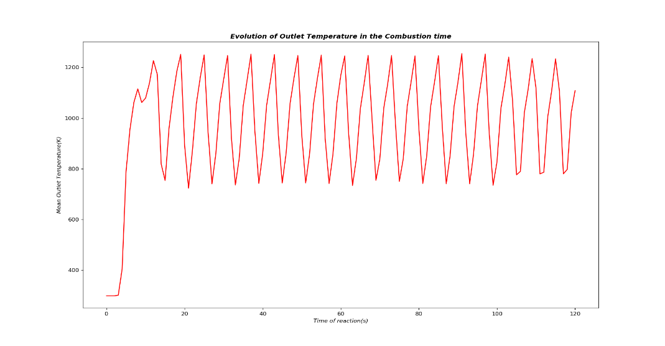In *figure 3-5C* the maximum values are attained very quickly compared to the other cases. The same with the power evolution where the third case seem to have two peaks with the highest values.

Figure 3‑5B; Air Veocity=15m/s Fuel Velocity=15m/s

Figure 3‑5A; Air Veocity=5m/s Fuel Velocity=15m/s

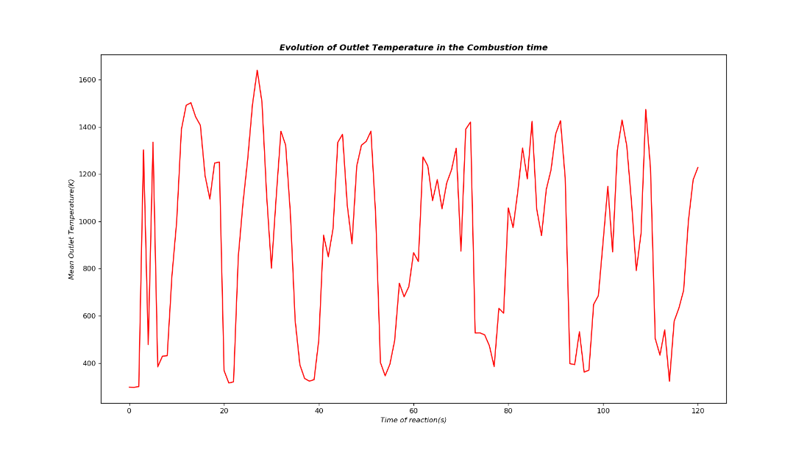

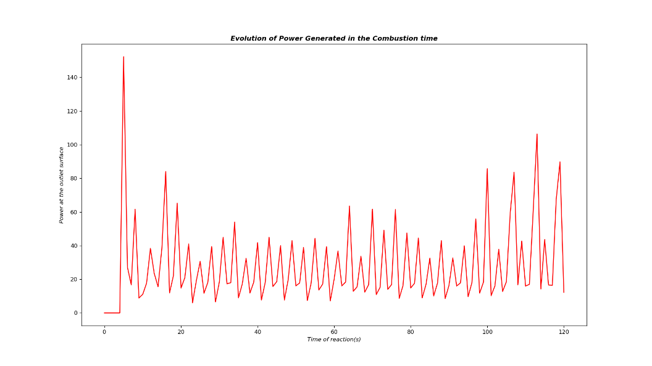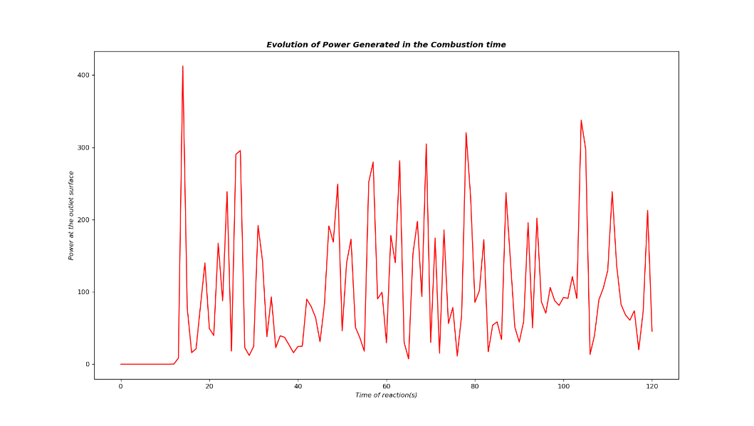

Figure 3‑6A; Air Veocity=15m/s Fuel Velocity=15m/s

Figure 3‑5C; Air Veocity=30m/s Fuel Velocity=15m/s

Figure 3‑6B; Air Veocity=15m/s Fuel Velocity=15m/s

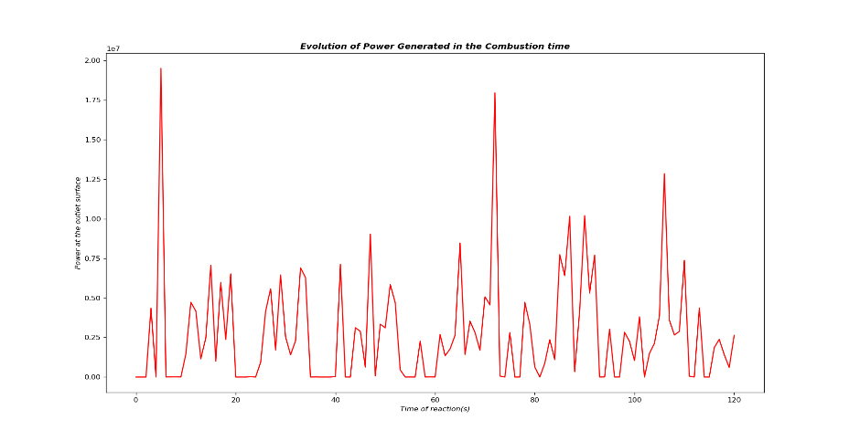

Figure 3‑6C; Air Veocity=30m/s Fuel Velocity=15m/s

The temperature evoultion and the power have the same nature especially in the second case where the velocities are equal attaining only a high peak at very low stage of combustion.

The results are summarised in a *Table 2* . Energy at the outlet which is indeed the main goal of the combustion process is oberved to be very high in the third case with a value of 5.32*107 J. This is attained at the third case where the air inlet velocity is 30m/s and that of fuel is half of it.

 Table 2; Energy observed at every case with it’s variable

## Velocities at 102 m/s

The inlet velocity of fuel was fixed to *150m/s* ten times than that of the previous chapter while that of air was altered from 50*,* 150then lastly 300m/s. This covers again all three possible scenarios, when fuel velocity is less, equal and more compared to that of air.

With this scenario, the first case converged but the code execution time is about 3 minutes and a very low rate of convergence. For the second and third cases, the simulation did not converge and the values were not being able to be computed. The change of maximum courant number changed to 0.1 value very low value so as to obtain the small time steps. Nevertheless the result was the same, no convergence and the simulation was not ending after 10 minutes of execution.

Only for air inlet of 50m/s and fuel inlet of 150m/s, the observation is made. The composition of gas as seen in *figure 3-7A* has the same evolution as the case above, but this time the fuel has very high enthalpy it maintains a certain high value at the end of the reaction. The Nox formation is indeed very fast and oxygen as well as the water vapour seems to have high values too.

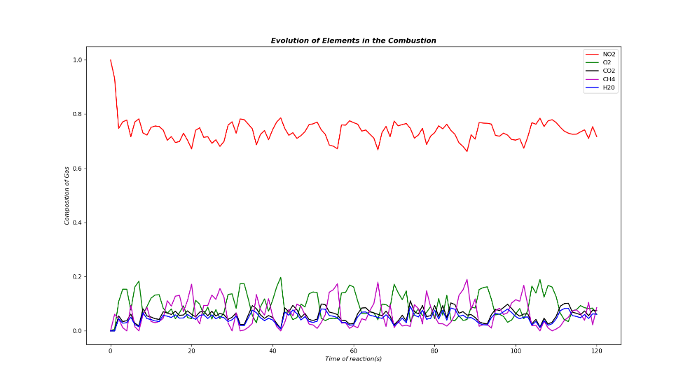The temperature as seen in *figure 3-7B* evolves much faster and attains high values throughout the combustion process and have a maximum value higher than the previous chapters. The same evolution observed for the power but this time the highest value is lower than that of air velocity inlet 30m/s. However the values are kept high throughout the combustion process.

Figure 3‑7A; Air Veocity=50m/s Fuel Velocity=150m/s

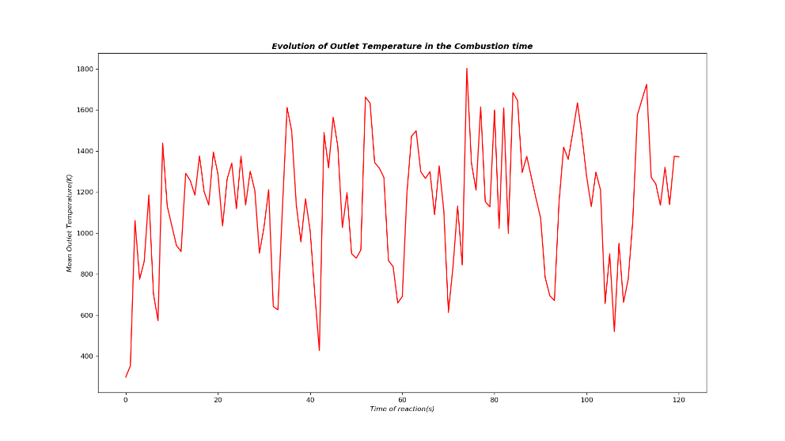

Figure 3‑7B; Air Veocity=50m/s Fuel Velocity=150m/s

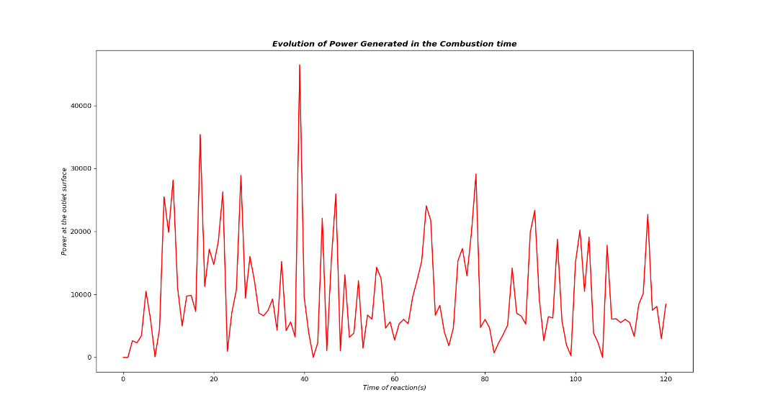

Figure 3‑7C; Air Veocity=50m/s Fuel Velocity=150m/s

The Energy together with other observed crucial results are given in the table below.

The thermal energy observed is of the order 105 quite a high value but not higher compared to 107 observed when air inlet velocity was 30m/s.

# Conclusion

The effect of altering inlet velocities is indeed crucial in thermal energy delivered at the outlet and the outlet temperature as well as the gas phase composition.

The time of combustion of 120 seconds, the simulated optimum energy at the outlet delivered is defined with our velocities in order 102 is of order 106 and when the air veloctiy is higher than that of fuel. This is due to efficient and faster burning process resulted to high calorifique output.

The fuel and air velocity inlet even when increased to higher values, will not result to increase in energy. However there is a slight increase in maximum temperature at the outlet and the rate of reaction being soo rapid attaining maximum values at a very low stage.

In this simulation, indeed the initial enthalpy of the fuel is larger since it’s temperature is much higher than that of air. This is the reason why the case were the inlet fuel is larger resulted to high energy output and a moderate reaction since the enthalpy of air approached that of the fuel initially. Hence the combustion process to be optimum, the initial enthalpy of the reactants before the reactions should approximately be equal. [M.A. LESCHZINER

Department of Engineering, Queen Mary and Westfield College, University of London,

London E1 4NS, U.K.]