

**Phishing Attack Domain Detection**

## Overview

In this section we’ll see the architectural design of the software we have built. We’ll see how the Rest API, Web Interface interact with each other and we’ll also see the Wireframe for the web Interface.

# Made by Deepesh Mhatre



2

## Software Architecture

The simplest way to deploy a machine learning model is to create a Web Microservice like an REST API. But to make it more acessable,such that even Non-technical people can interact with the model,we’ll also be creating a Web Interface for it.

Below diagram describes the architecture of the system after deployment,it describes how both the developer and a user exchange data with the ML model.

# Made by Deepesh Mhatre



3

## REST API Architecture

The below diagram defines how the REST api will behave to any data response.

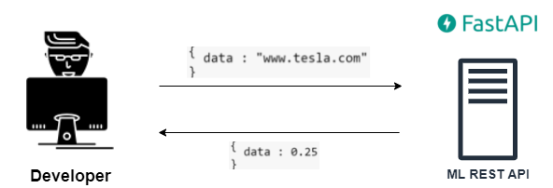

The API takes the input URL inside the JSON format and returns ea

Made by Deepesh Mhatr

probability value (between 0-1) indicating if the given URL is malicious or not.



Made by Deepesh Mhatre

4

## Web Interface Wireframe

Mostly the developers will be using the Rest API,but in order to increase the model’s accessibility such that anyone can interact with it we also created a Web Interface. Below is the UI wireframe for the Interface to be made using ReactJS Javascript framework.

