QUANTUM RANDOM NUMBER GENERATOR (QRNG)
Project Overview
Built a Quantum Random Number Generator that uses quantum simulation to create real random numbers and shows the results through an interactive web app.

Problem Statement
Challenge
Classical pseudo-random number generators (PRNGs) are deterministic and can be predicted if the algorithm and seed are known. This creates vulnerabilities in:
- Cryptographic applications
- Secure communications
- Statistical simulations requiring true randomness
- Gaming and lottery systems

Quantum Solution
Quantum mechanics provides inherent randomness through:
- Superposition: Qubits exist in multiple states simultaneously
- Measurement collapse: Observing a qubit produces truly random outcomes
- Unpredictability: Results are fundamentally non-deterministic, not computationally limited

Theoritical Knowledge:

⚛️ Classical vs Quantum
In classical computing, data is stored in bits that can be either 0 or 1.
Quantum computing uses qubits, which can exist in both 0 and 1 states simultaneously due to superposition — enabling much higher computational possibilities.

Qubits
A qubit (quantum bit) is the basic unit of quantum information.
Unlike a classical bit, it can represent 0, 1, or a combination of both until it is measured.

Number of Shots
In quantum simulation, shots refer to the number of times a quantum circuit is executed to collect measurement results.
More shots provide better statistical accuracy for the outcome distribution.

Hadamard Gate
The Hadamard (H) gate creates superposition by transforming a qubit from a definite state (0 or 1) into an equal probability mix of both states.
It is the foundation for generating randomness in quantum circuits.

Superposition
Superposition allows a qubit to exist in multiple states at once — both 0 and 1 — until measured.
This property enables the generation of unpredictable outcomes.

Measurement and Collapse
When a qubit is measured, it collapses from its superposed state into a definite value — either 0 or 1.
This collapse introduces the element of true randomness in quantum results.

🔗 Entanglement
Entanglement is a quantum phenomenon where two or more qubits become correlated — the state of one instantly affects the other, even when separated.
It’s essential for quantum communication and secure key generation.

🔐 Quantum Randomness
Quantum randomness comes from the inherent uncertainty of quantum measurements.
Since outcomes are determined by probability rather than patterns, they are truly unpredictable and non-reproducible.

⚖️ Quantum vs Classical Randomness
Aspect | Classical Randomness | Quantum Randomness
Source | Algorithms or physical noise | Quantum measurement outcomes
Predictability | Pseudo-random, can be reproduced | Truly random, cannot be predicted
Generation | Deterministic logic or hardware noise | Quantum superposition and collapse
Quality | Depends on algorithm | Fundamentally unpredictable

Problem Tackling Approach
- Study quantum superposition and measurement principles
- Analyze existing QRNG implementations
- Understand Qiskit framework and quantum circuit design
- Design quantum circuits for random bit generation
- Design user interface for accessibility
- Develop quantum circuits using Qiskit
- Implement backend logic for number generation
- Create frontend interface with Streamlit
- Perform statistical randomness tests
- Validate against classical RNG outputs
- User acceptance testing
- Complete technical documentation
- Deploy application

Libraries And Their Uses

🧱 Streamlit
import streamlit as st
- Used to build the web interface for your Quantum Random Number Generator (QRNG).
- It helps you create buttons, sliders, text, and visual outputs easily in a browser.

⚛️ Qiskit
from qiskit import QuantumCircuit, transpile
- QuantumCircuit: Used to create and design quantum circuits (e.g., applying Hadamard gates, measurements, etc.).
- transpile: Optimizes your circuit so it can run efficiently on a quantum simulator or real quantum device.

🧠 Qiskit Aer Simulator
from qiskit_aer import AerSimulator
- Provides a quantum simulator backend to run your quantum circuits without needing a real quantum computer.
- Useful for testing and generating random results locally.

📊 Qiskit Visualization
from qiskit.visualization import plot_histogram, plot_bloch_multivector
- plot_histogram: Displays the measurement outcomes (e.g., 000, 101, 111) as a histogram.
- plot_bloch_multivector: Shows the quantum state of a qubit on the Bloch sphere — helps visualize superposition.

🧮 Statevector
from qiskit.quantum_info import Statevector
- Used to represent and analyze the quantum state of your circuit before measurement.
- Helps understand how qubits are behaving in superposition.

📈 Matplotlib
import matplotlib.pyplot as plt
- Used for custom plotting and visualization (fallback if Qiskit’s built-in plotting fails).
- Helps display charts like the quantum state distribution.

🔢 NumPy
import numpy as np
- Helps with mathematical calculations (like probabilities, normalization, or random value scaling).
- Often used to process the results of quantum measurements.

📋 Pandas
import pandas as pd
- Used to store and display results (like binary outcomes, counts, and probabilities) in table format.
- Makes your Streamlit app output clean and organized.

🔠 String
import string
- Helps in generating random passwords or alphanumeric keys using random letters, digits, and symbols.

🧩 Typing
from typing import Dict, Tuple, List
- Used for type hints — helps make your code cleaner and easier to understand (e.g., specifying that a function returns a Dict or List).

Solution Design Archietecture
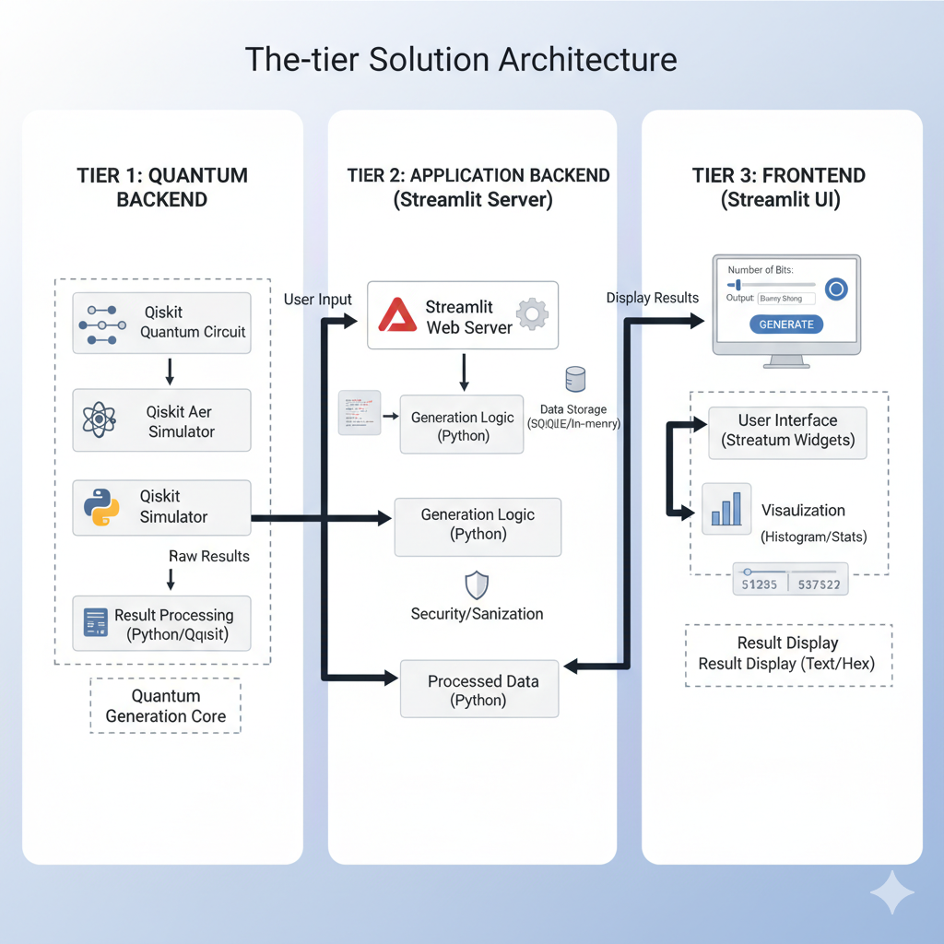

Tech Stack
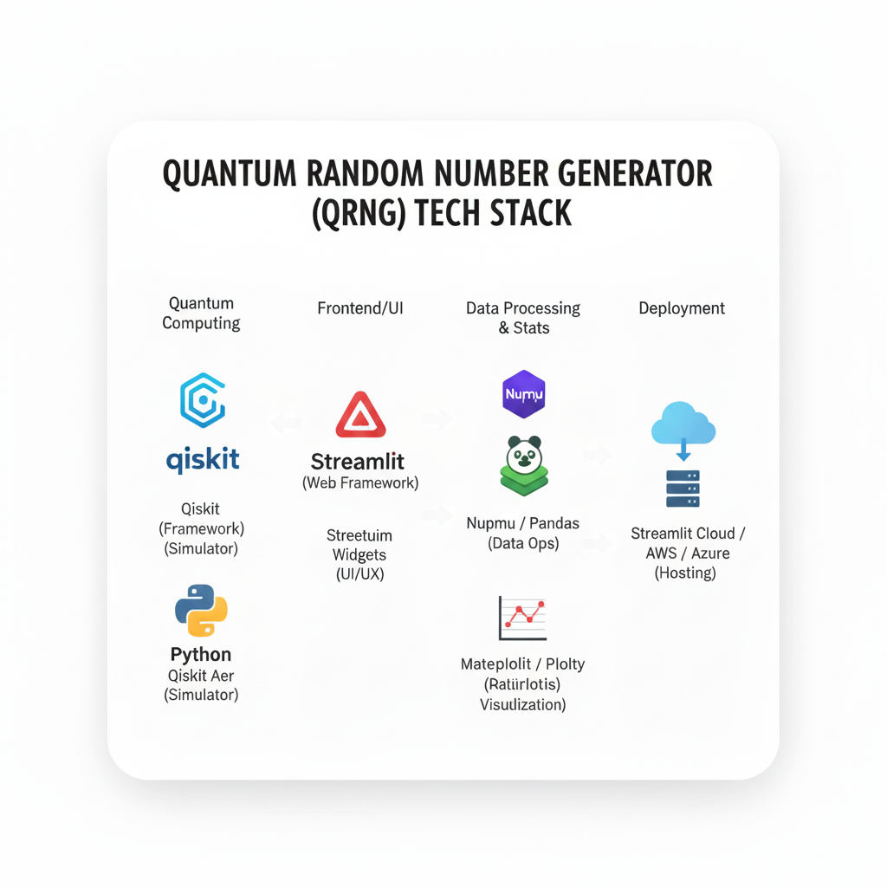

Quantum Circuit:
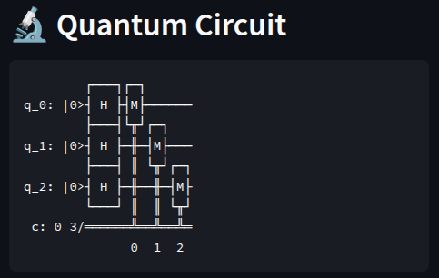

Distribution Analysis:
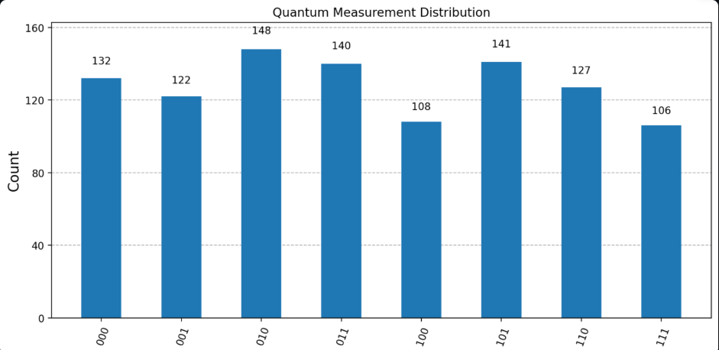

Statistical Analysis:
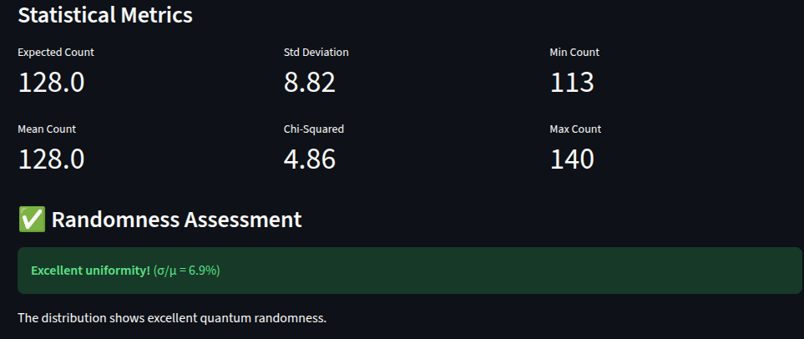

Applications:
1.Quantum random color generator
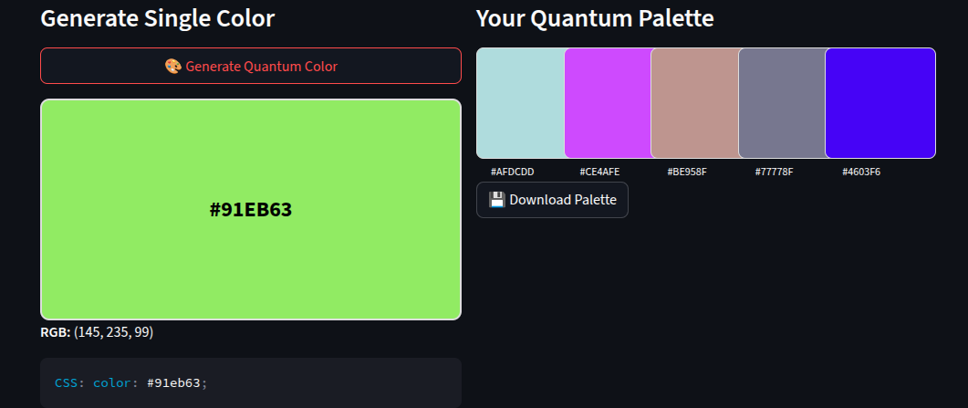

2.Quantum random password generator
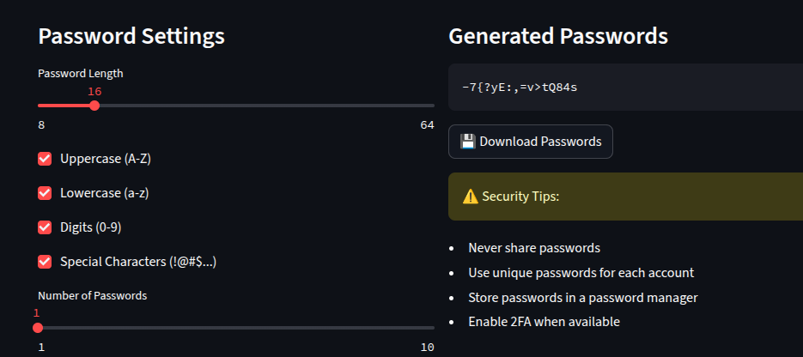

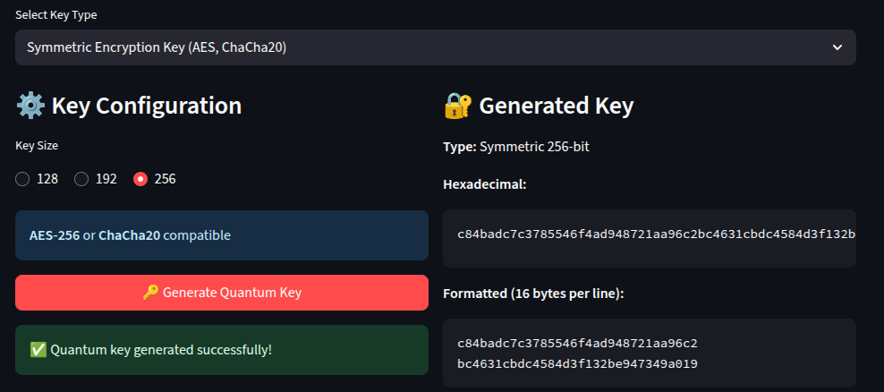
3.Quantum Cryptographic key generator

🚀 8️⃣ Deployment
ibm-quantumhackathon.streamlit.app/
Briefly note how it can be run or hosted:
“This project is deployed using Streamlit Community Cloud and runs on a simulated quantum backend via Qiskit Aer.”

💡 9️⃣ Future Enhancements
Show vision — evaluators love this section:
- Integration with IBM Quantum hardware
- Real-time quantum entropy source
- Adding API endpoints for randomness services

🧾 🔟 References
List references you used:
- Qiskit documentation
- IBM Quantum tutorials
- Research papers or articles on QRNG

