IT Ticket Resolution Suggestion Engine
Module: NLP Engine
Test File: test_nlp.py
Framework: Pytest
Status: All Tests Passed (4/4)

Unit Test 1: Text Preprocessing - Normal Case
Objective: Verify that text preprocessing normalizes and cleans input strings correctly.
Result: PASSED

Unit Test 2: Text Preprocessing - Empty Input
Objective: Ensure empty or None inputs return an empty string safely.
Result: PASSED

Unit Test 3: AI Resolution Generation - Valid API Response
Objective: Validate that AI-generated JSON responses are parsed correctly.
Result: PASSED

Unit Test 4: AI Resolution Generation - Fallback Handling
Objective: Ensure system handles API failure gracefully.
Result: PASSED

Test Execution Evidence (Screenshots)

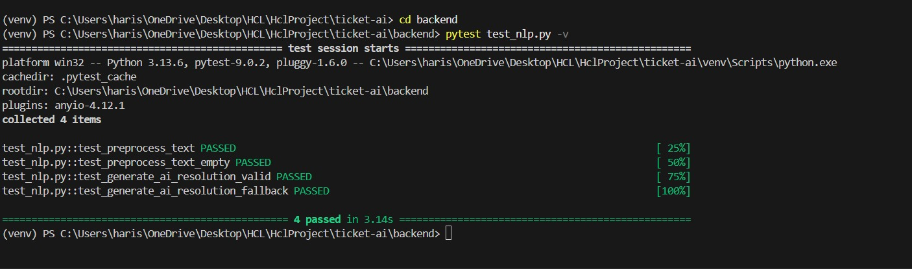

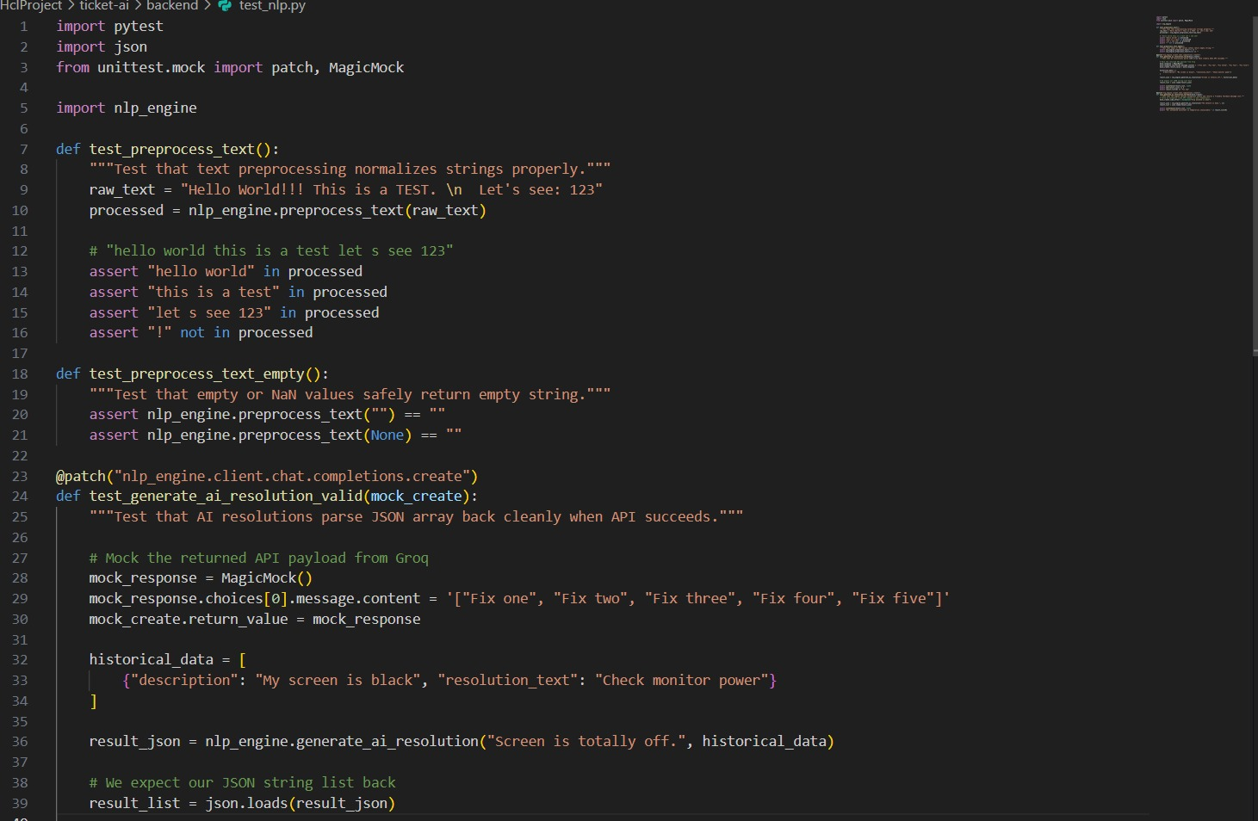

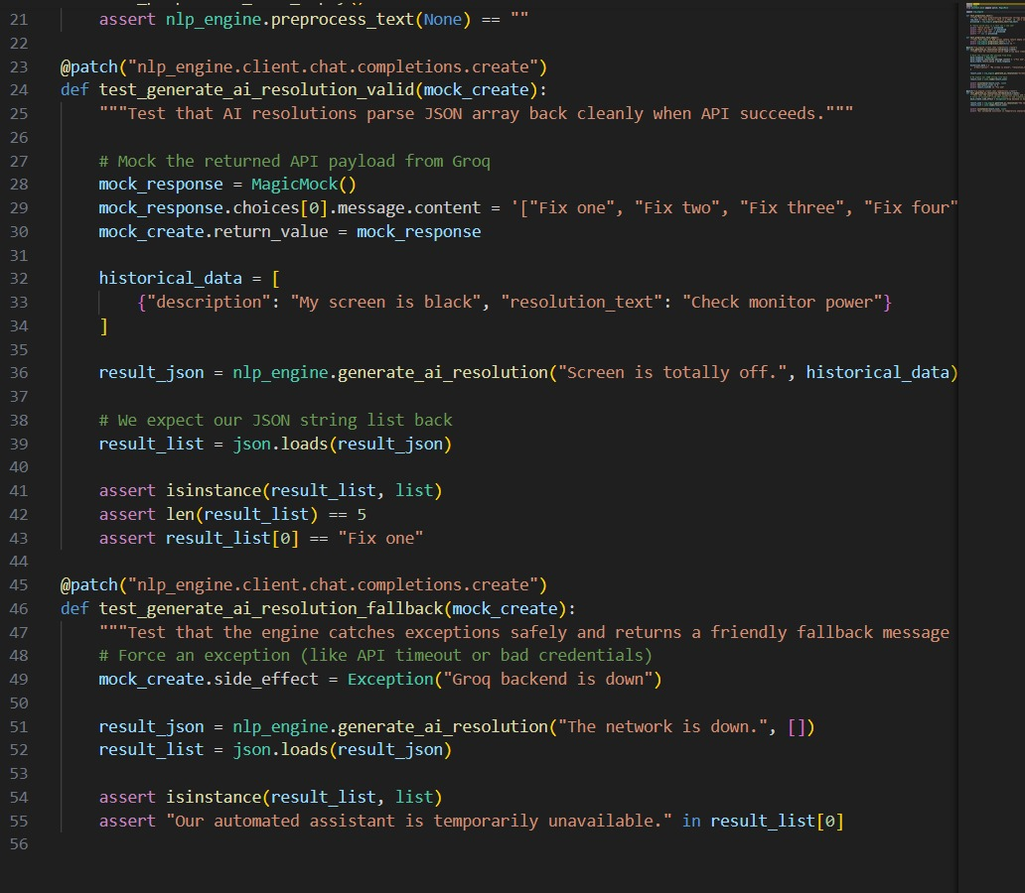

Conclusion
All unit tests executed successfully using pytest.
The NLP engine preprocessing and AI resolution logic are validated and ready for integration.

