- Problem Statement:
Task
• Please try to configure Chrome Browser and navigate to https://spicejet.com .
• Select Round trip starting from Chennai to Bangalore dated on Dec 5, 2018 and return date on
Dec 7, 2018.
• Select two adult passengers and select currency as USD
• Click on search and verify whether it is giving proper search results or not.

NOTE: Since Chrome Browser is not working for me, I am using the Firefox Browser
  - Source Code: file name –
package seleniumpackage;

import java.util.List;
import java.util.concurrent.TimeUnit;

import org.openqa.selenium.By;
import org.openqa.selenium.WebDriver;
import org.openqa.selenium.WebElement;
import org.openqa.selenium.chrome.ChromeDriver;
import org.openqa.selenium.firefox.FirefoxDriver;
import org.openqa.selenium.support.ui.Select;

public class spicejet {

public static void main(String[] args) throws InterruptedException {
/*System.setProperty("webdriver.chrome.driver", "./Drivers/chromedriver.exe");
WebDriver driver=new ChromeDriver();*/
System.setProperty("webdriver.gecko.driver", "./Drivers/geckodriver.exe");
WebDriver driver =new FirefoxDriver();
driver.manage().timeouts().implicitlyWait(30,TimeUnit.SECONDS);
driver.manage().window().maximize();
//opening https://spicejet.com in the driver
driver.get("http://spicejet.com");
//selecting the RoundTrip
WebElement roundEle=driver.findElement(By.xpath("//*[@id='ctl00_mainContent_rbtnl_Trip_1']"));
roundEle.click();
//Finding the Origin and passing to the WebElement
WebElement oriEle = driver.findElement(By.id("ctl00_mainContent_ddl_originStation1_CTXT"));
oriEle.click();
//Selecting the Origin
WebElement oriSel=driver.findElement(By.xpath("//a[@value='MAA']"));
oriSel.click();
//Finding the Destination and passing to the WebElement
WebElement destEle=driver.findElement(By.id("ctl00_mainContent_ddl_destinationStation1_CTXT"));
destEle.click();
//Selecting the Destination
WebElement destSel=driver.findElement(By.xpath("(//a[@value='BLR'])[2]"));
destSel.click();
//selecting the Journey From Date
WebElement fromCalEle=driver.findElement(By.xpath("(//table[@class='ui-datepicker-calendar']/tbody/tr[2]/td[4])[2]"));
fromCalEle.click();
//Finding the Return Date Calendar and passing to the WebElement
WebElement returnDateEle=driver.findElement(By.xpath("//input[@id='ctl00_mainContent_view_date2']"));
returnDateEle.click();
//Selecting the Return date
WebElement toCalEle=driver.findElement(By.xpath("(//table[@class='ui-datepicker-calendar']/tbody/tr[2]/td[6])[1]"));
toCalEle.click();
//finding the passengers and passing to the WebElement
WebElement passEle=driver.findElement(By.xpath("//div[@id='divpaxinfo']"));
passEle.click();
//Selecting the Adult Passengers
WebElement adultEle=driver.findElement(By.xpath("(//*[@class='pax-add pax-enabled'])[1]"));
adultEle.click();
//confirming the passengers selection
WebElement doneEle=driver.findElement(By.xpath("//input[@id='btnclosepaxoption']"));
doneEle.click();
//Finding the currency dropdown and passing to the WebElement
WebElement currEle=driver.findElement(By.xpath("//*[@id='ctl00_mainContent_DropDownListCurrency']"));
currEle.click();
//selecting the Currency from the dropdown
Select currSelect=new Select(currEle);
currSelect.selectByVisibleText("USD");
Thread.sleep(5000);
//Finding on the Search button and passing to the WebElement
WebElement searchEle=driver.findElement(By.xpath("//*[@id='ctl00_mainContent_btn_FindFlights']"));
searchEle.click();

}

}

  - Output Screenshots:

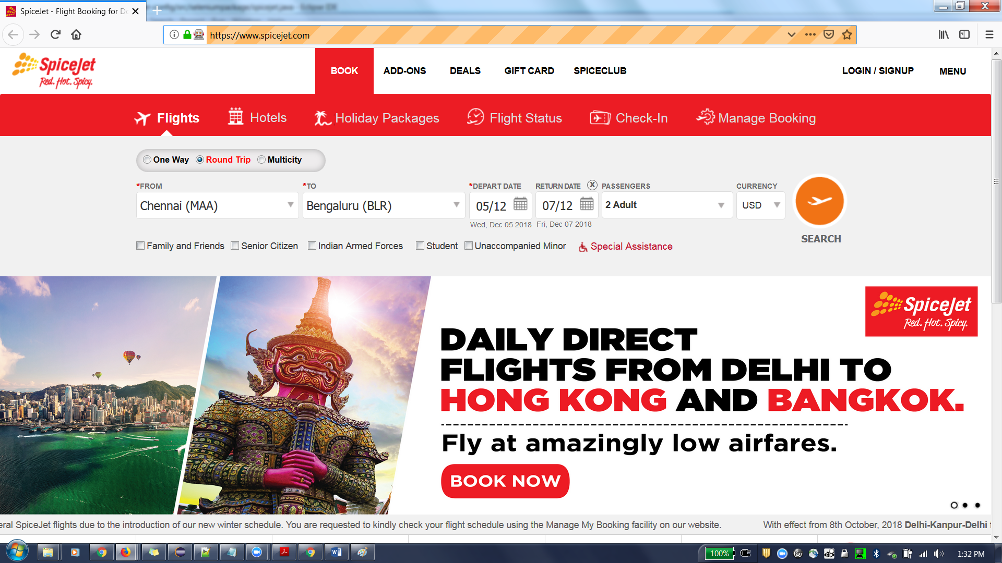

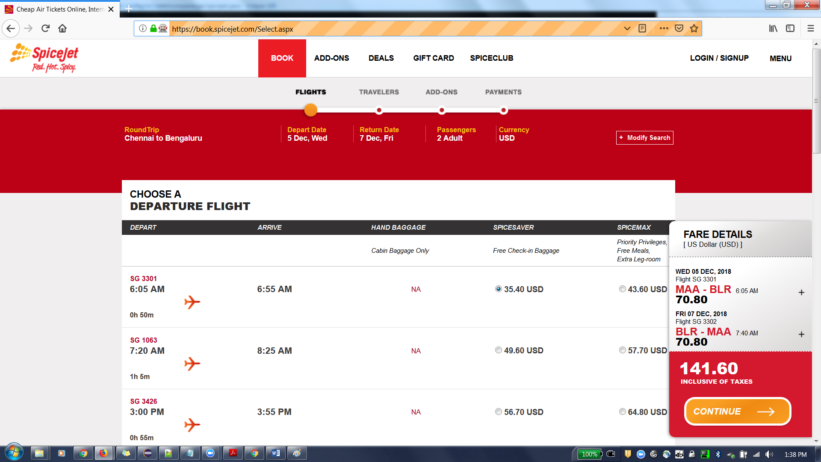
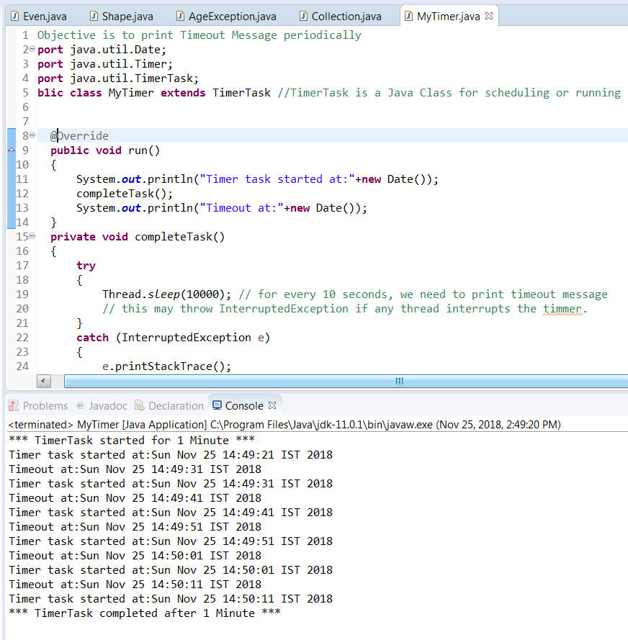
2. Problem Statement: Write a program to build any collection containing duplicates. Create its copy with all duplicates removed
  - Source Code: file name – Collection.java
import java.util.ArrayList;
import java.util.LinkedHashSet;
import java.util.List;
import java.util.Set;

public class Collection{

public static void main(String args[]){

// Declaring a type of collection - list - ArrayList with String datatype
System.out.println("*** Collection with duplicates ***");
List<String> names = new ArrayList<String>();
//Adding values to ArrayList
names.add("Subbarao");
names.add("Harisha");
names.add("Vedansh");
names.add("Rishika");
names.add("Jahnavi");
names.add("Vedansh");
names.add("Anusha");
names.add("Jyothi");
names.add("Rishika");
names.add("Jahnavi");
List<Integer> num=new ArrayList<Integer>();
num.add(2);
num.add(4);
num.add(2);
num.add(6);
num.add(3);
num.add(8);
num.add(5);
num.add(5);
// Printing the ArrayList
System.out.println("List of the Names : " +names);
System.out.println("List of the Numbers : " +num);
//objective is to remove the duplicates from the collection.
// let us use LinkedHashSet for this. As this set will not allow to insert the duplicates
// and also the order of the list provided will be same.
System.out.println("*** Collection without duplicates ***");
Set<String> namesWithoutDup = new LinkedHashSet<String>(names); //copied the arraylist into LinkedHashSet
names.clear();// clear the arraylist
names.addAll(namesWithoutDup); //copying the values without duplicates into ArrayList
Set<Integer> numWithoutDuplicates=new LinkedHashSet<Integer>(num);
num.clear();
num.addAll(numWithoutDuplicates);
System.out.println("list of Names without duplicates :");
for(int i=0;i<names.size();i++)
System.out.println(names.get(i)+"");
System.out.println("list of Numberes without duplicates :");
for(int i=0;i<num.size();i++)
System.out.println(num.get(i)+"");
}
}

  - Output:
*** Collection with duplicates ***
List of the Names : [Subbarao, Harisha, Vedansh, Rishika, Jahnavi, Vedansh, Anusha, Jyothi, Rishika, Jahnavi]
List of the Numbers : [2, 4, 2, 6, 3, 8, 5, 5]
*** Collection without duplicates ***
list of Names without duplicates :
Subbarao
Harisha
Vedansh
Rishika
Jahnavi
Anusha
Jyothi
list of Numberes without duplicates :
2
4
6
3
8
5

  - Output Screenshots:
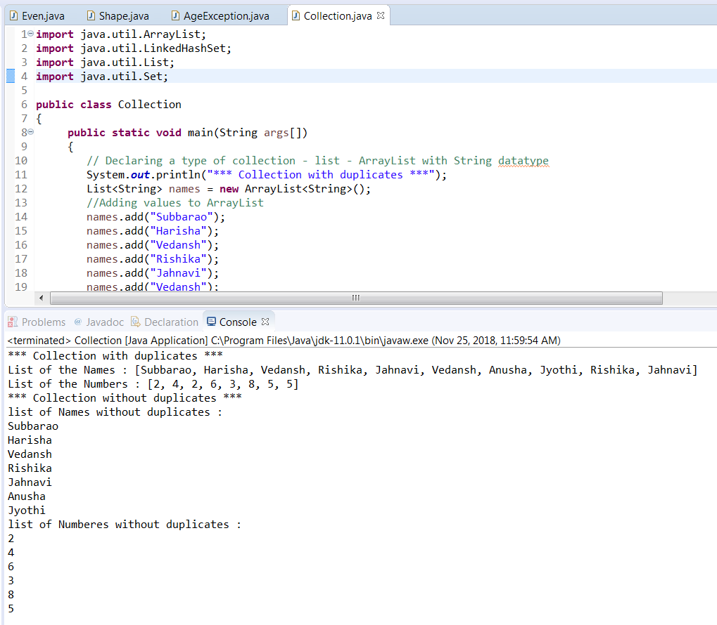

**END OF DOCUMENT**

