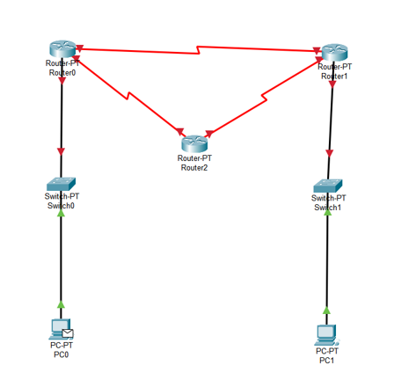

Dynamic Routing (OSPF)