EFS

EFS provide serverless, fully elatic storage so that you can share the file data without provisioning and managing storage capacity and performance.

EFS supports NFS (network file system) protocal and port number is 2049.

It is built to scale on demand to petabytes without braking application, growing and shrinking automatically as you add are remove files.

**Create EFS and attach EFS to 3 different instances in 3 different availability zones?**

First login to aws console.

Before creating EFS we will create security group first.

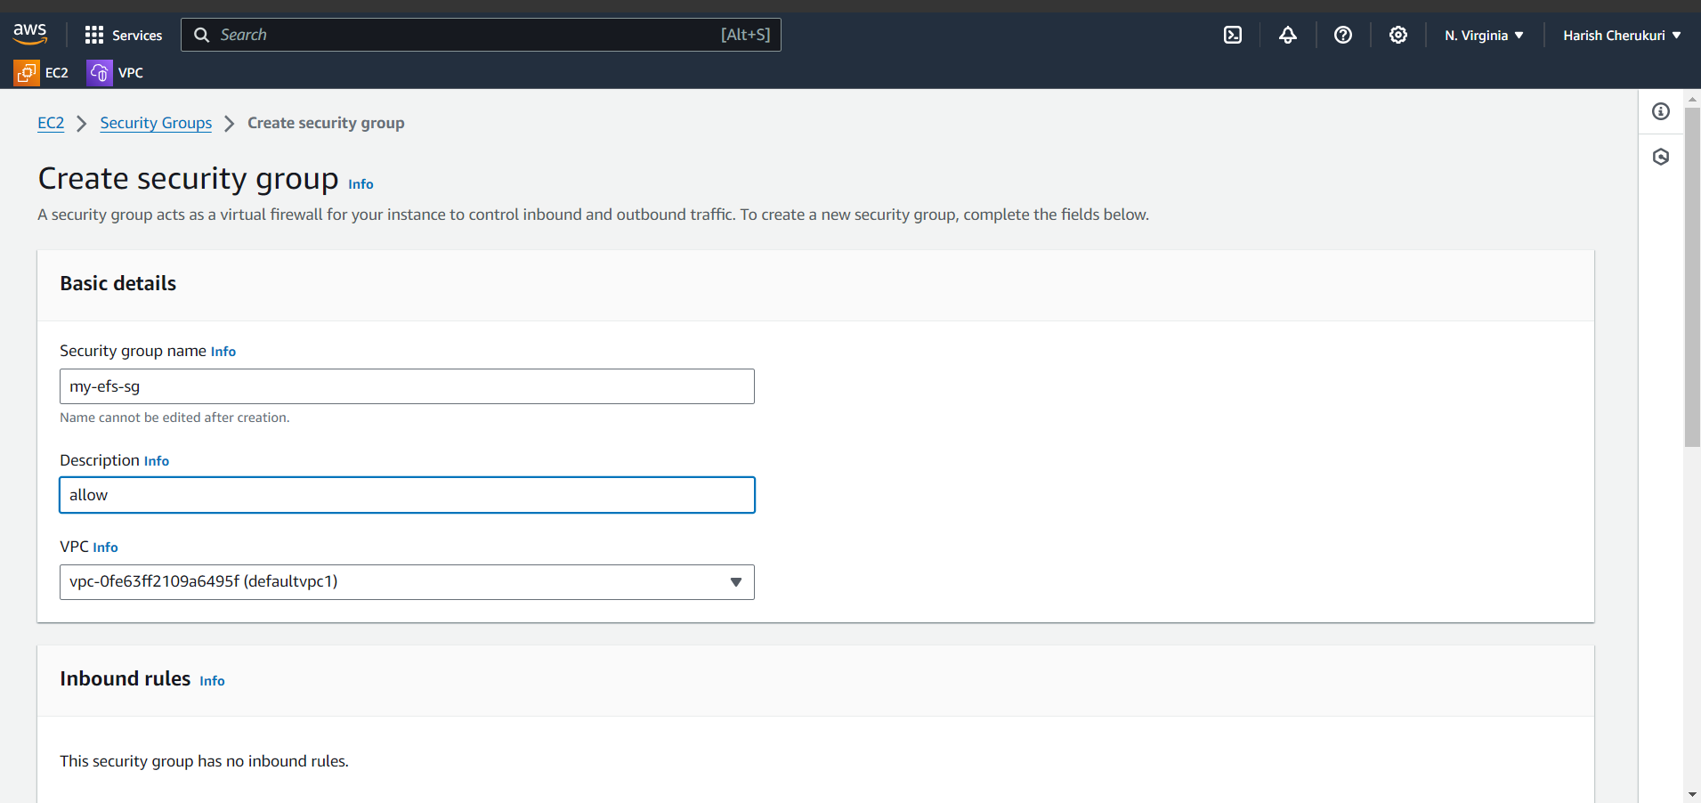

Give efs name and give allow in description.

Next add inbound rule.

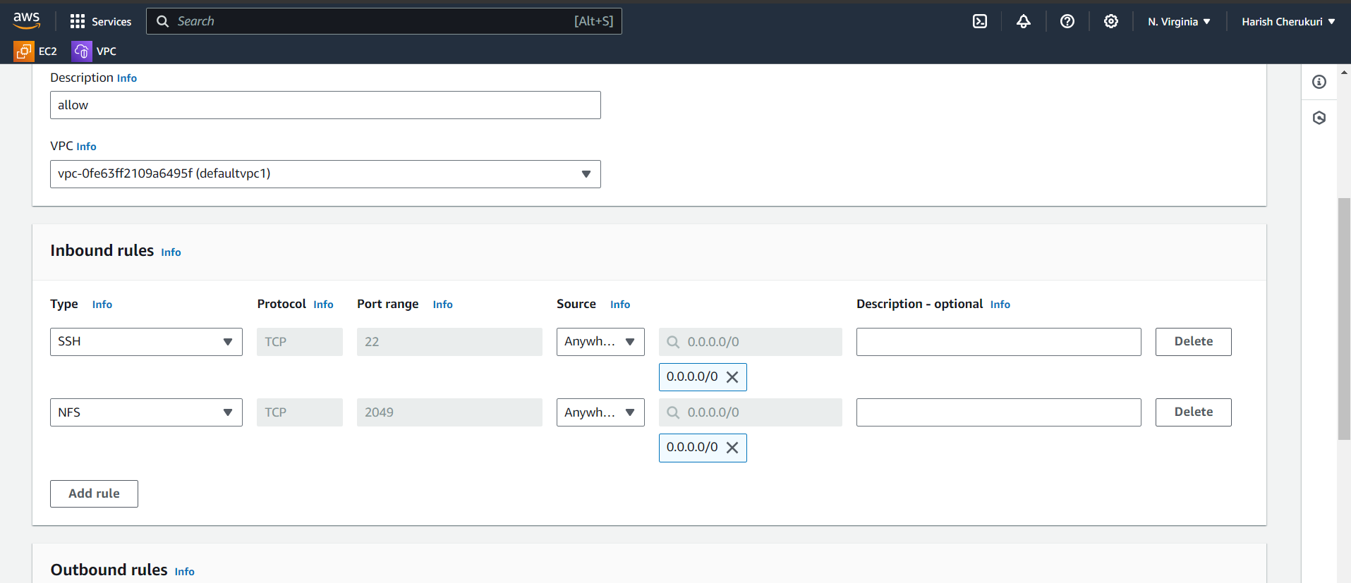

Add ssh and nfs in inbound rules.

Click on create security group.

Security is created.

Next we will create the efs.

Go to efs.

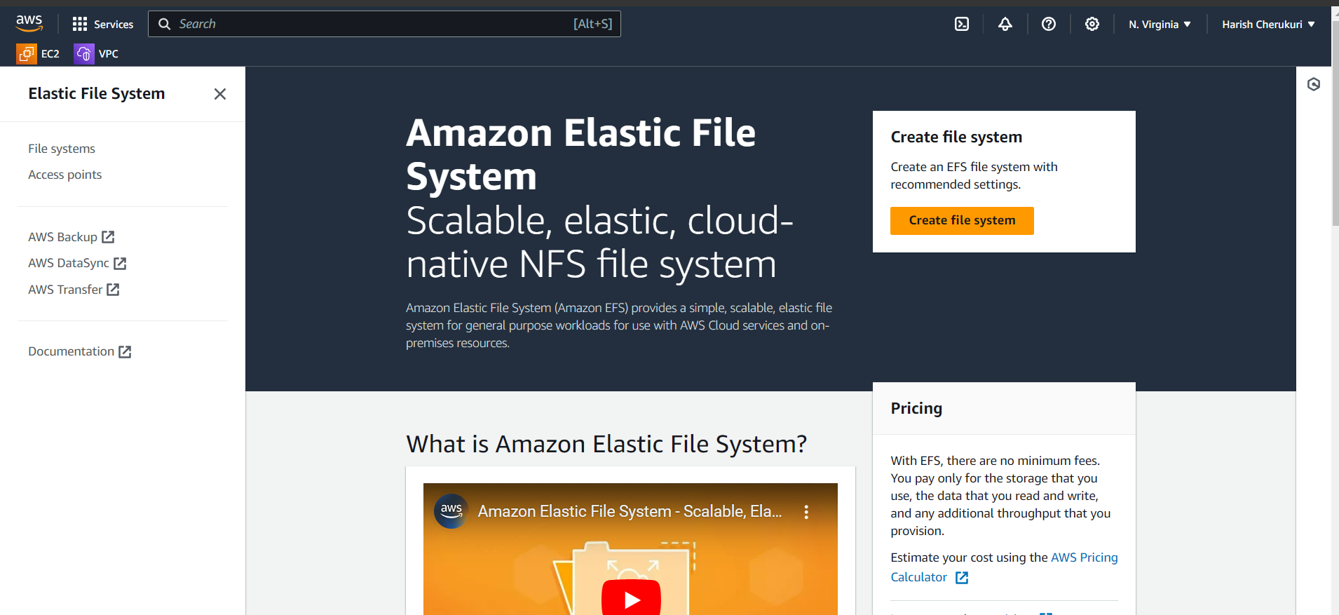

Click on create file system.

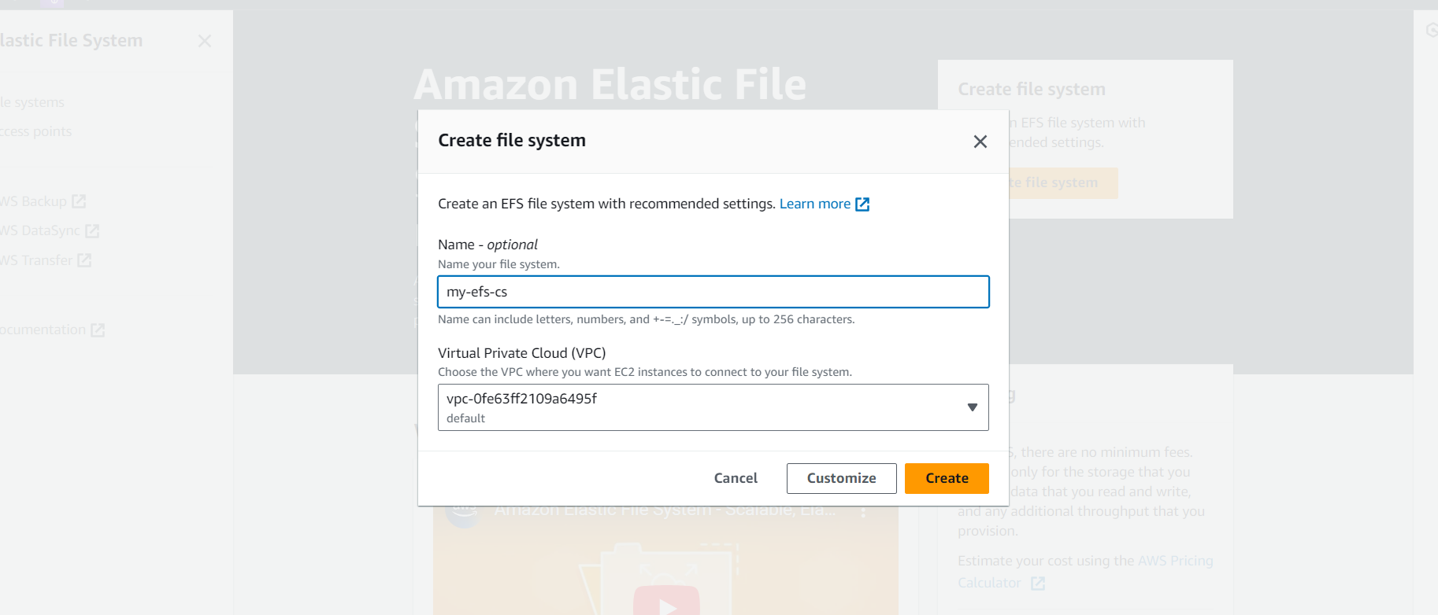

Give file name and vpc will be default.

Do not click on create click on customize. If click on create the aws will provide default option if we click on customize we can change the options.

S0, click on customize.

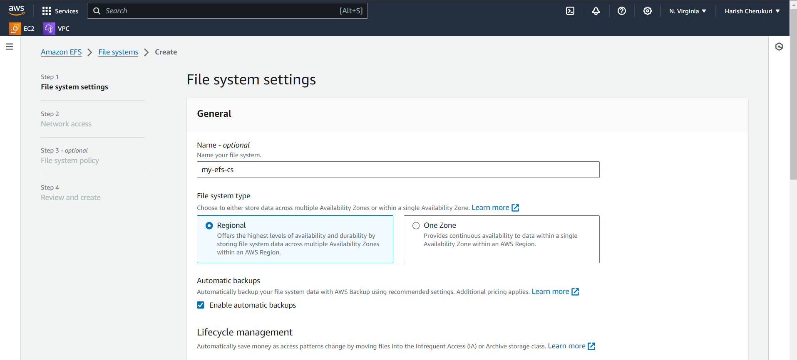

Select the regional, because we are going attach to 3 different instances.

Click on next.

Add mount tragets in this we are going to adding the which AZ to attach efs and select the security group for all az.

Click on next.

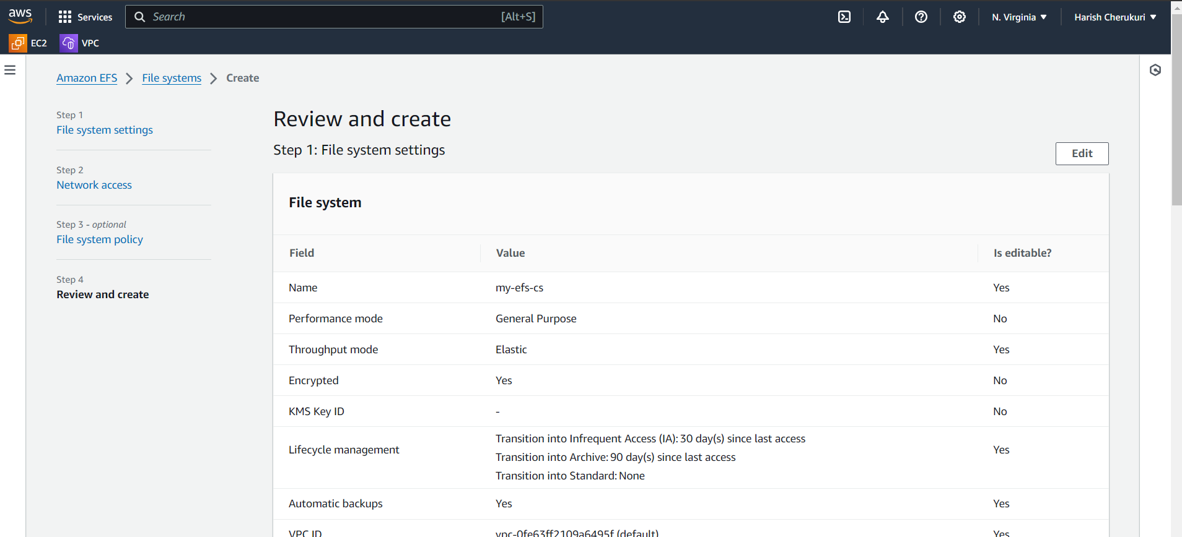

Review and create.

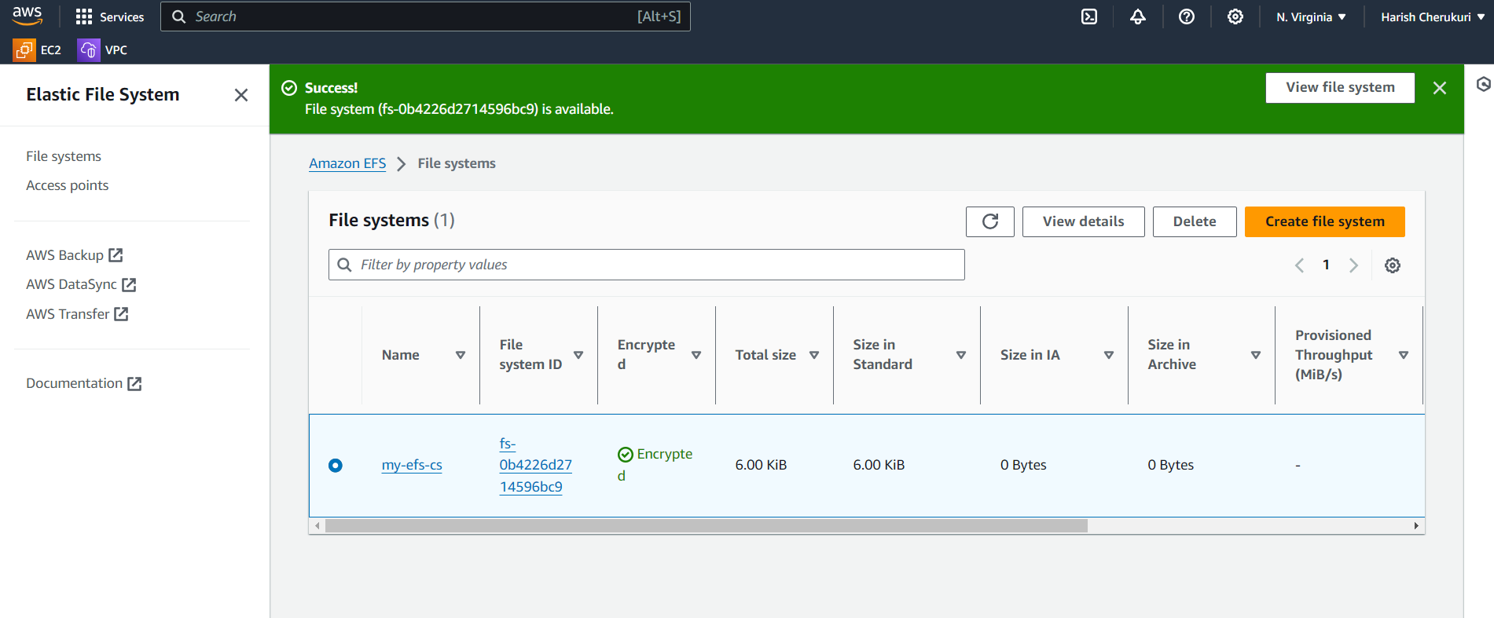

The EFS is created.

Now go to ec2 create ec2 instance.

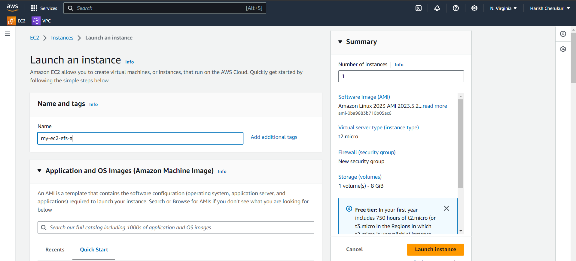

Give the ec2 name.

Select the ami and key pair and also security group.

In networks select the subnet-a.

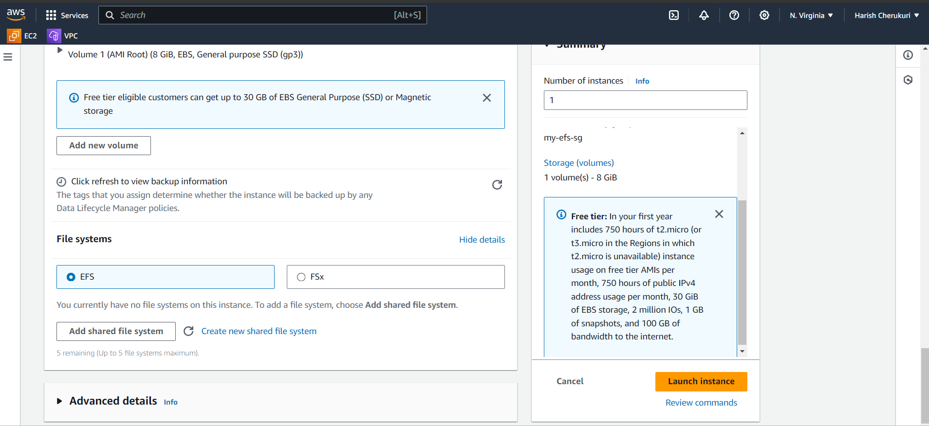

Click on add share file system.

Select the our efs which we created before.

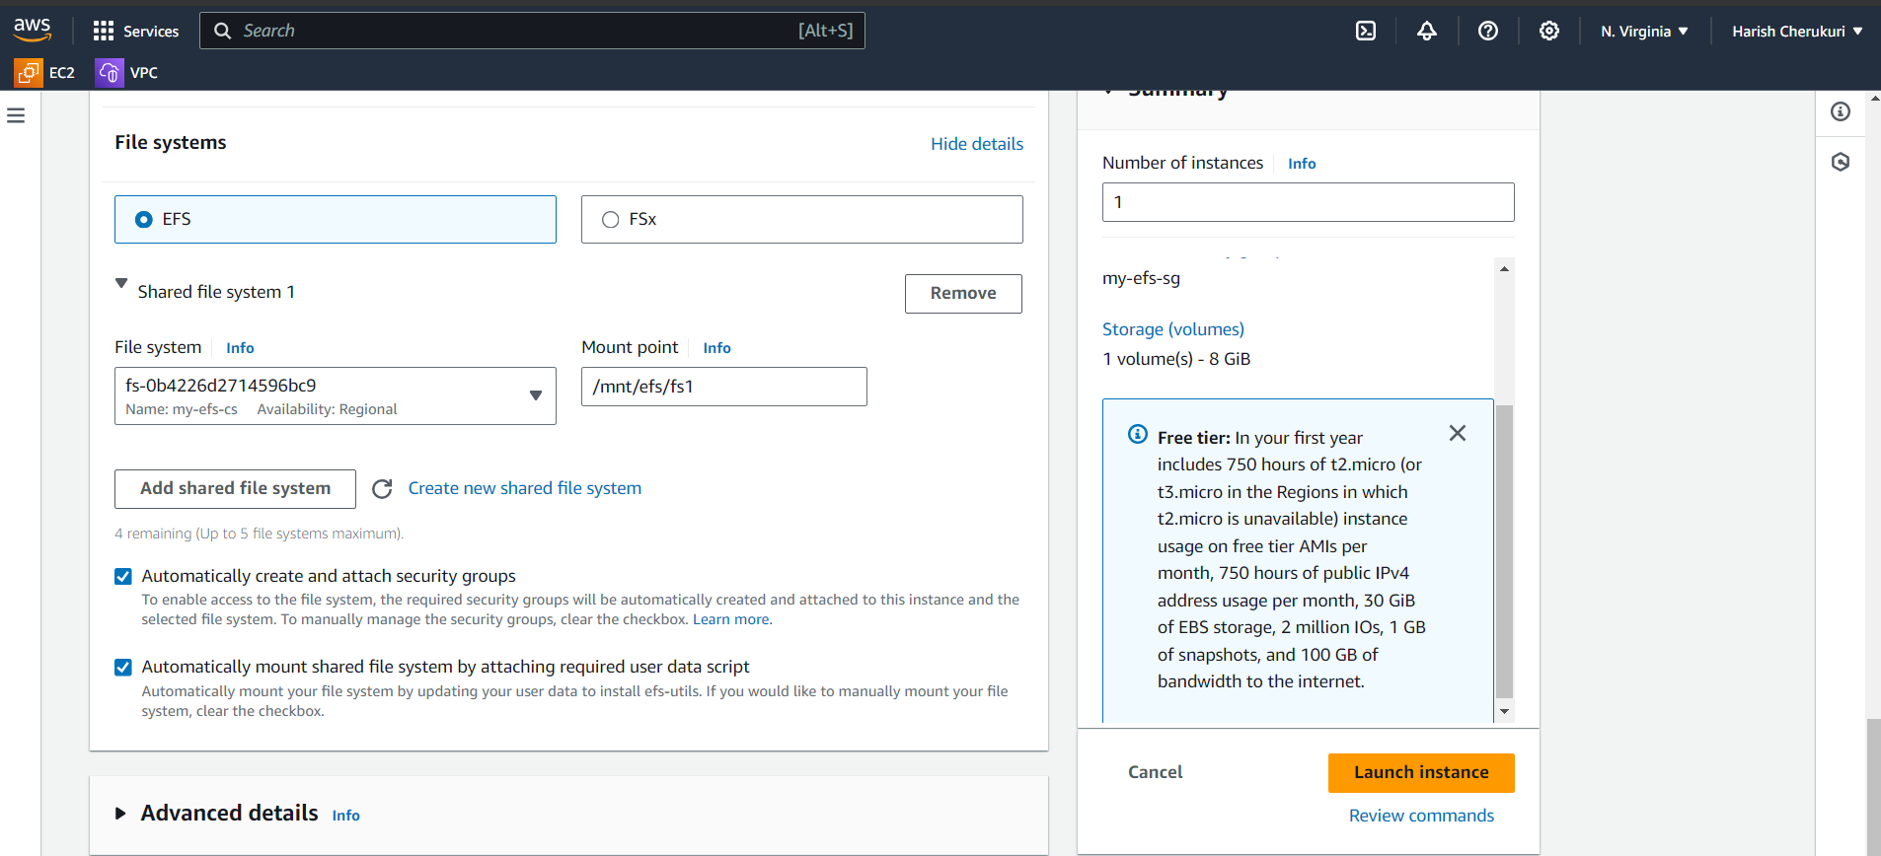

Click on launch instance.

After launching the instance connect to instance using ssh.

After connecting to server change to normal user to root user.

Go to mount point of efs using /mnt/efs/fs1.

Cd /mnt/efs/fs1.

Create file in fs1.

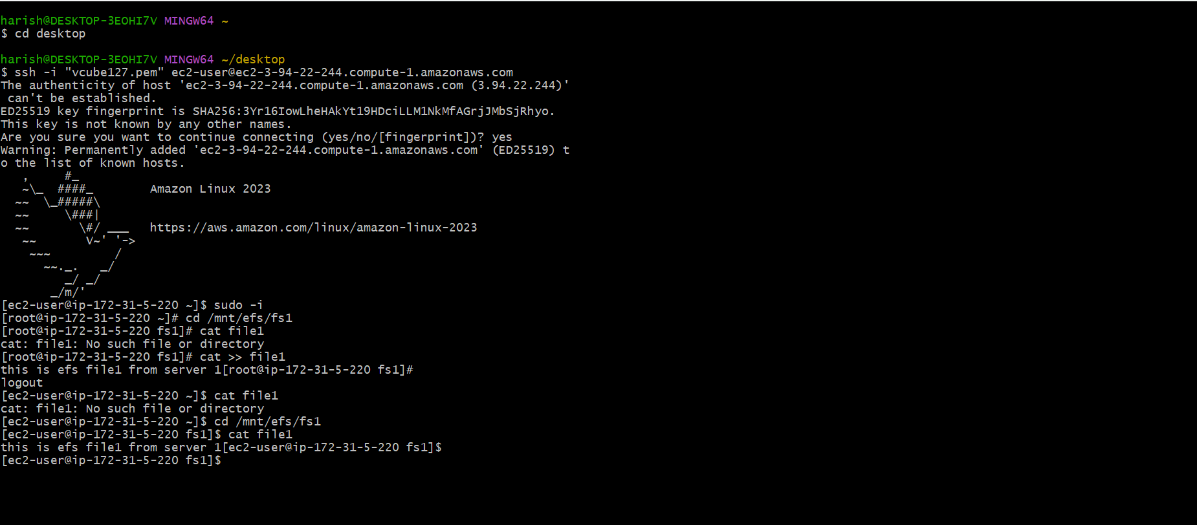

We added file in fs1 and also we added the data in file1.

Give top command in first server so your server can not be hangout.

Now create the remaining to instances.

As did like first instance.

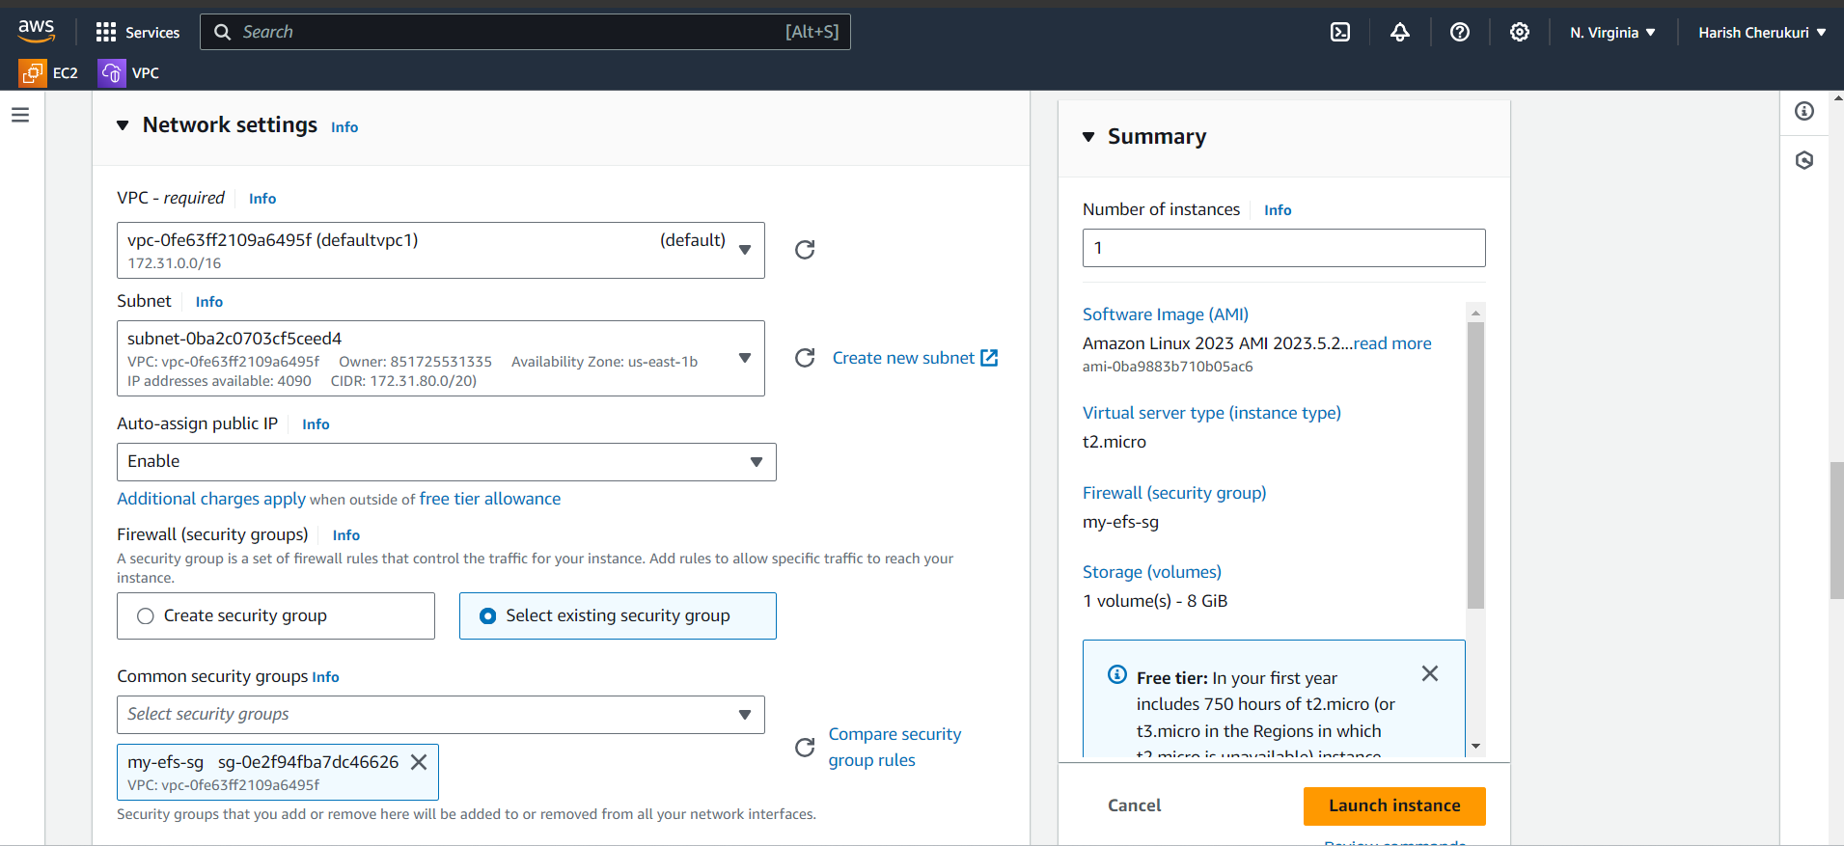

Select the 1b az in subnet.

Click on launch instance.

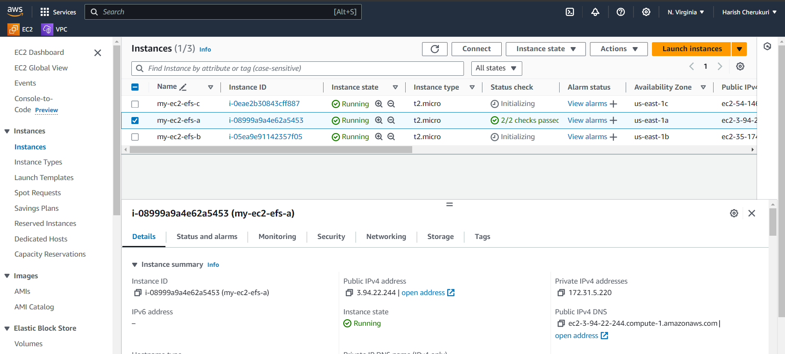

3 instances is created in 3 different AZ.

Now connect to both instances using ssh.

After connecting change to efs by using mount point.

Cd /mnt/efs/fs1.

See if we created is file1 is present are not.

In both servers.

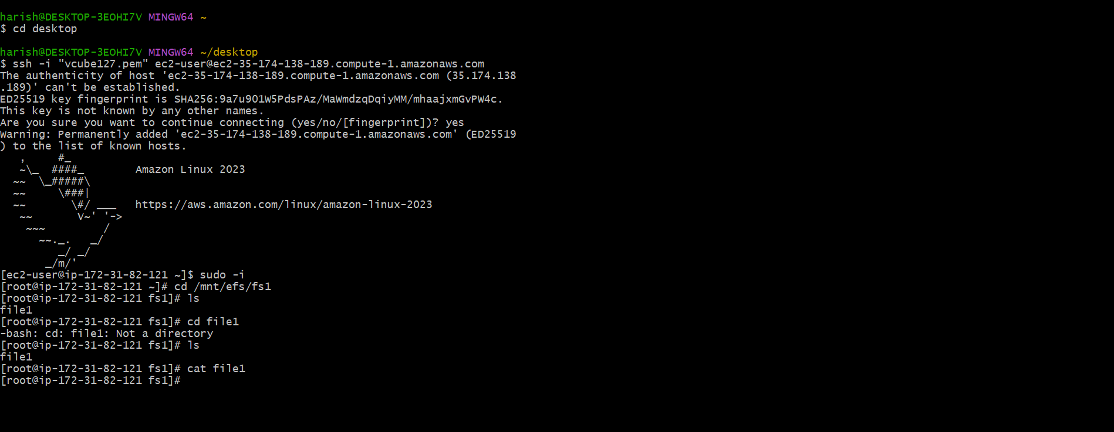

In server 2 of AZ-1b the file is present and also data in it.

Now connect to 3 server.

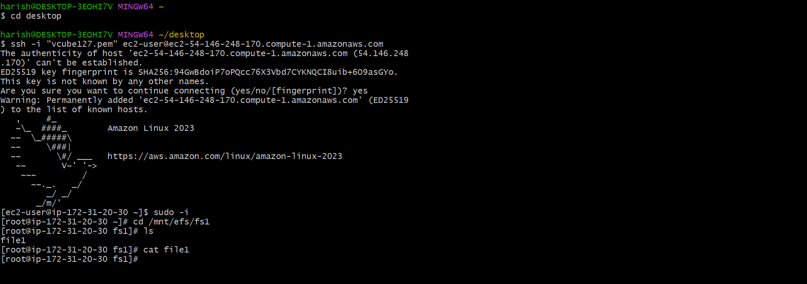

In 3 server also the file is shared.

**Conclusion**

By using EFS we can share file on server to another server.