House Price Prediction using Artificial Intelligence Model (AIM)

# 1. Project Title

House Price Prediction using Artificial Intelligence Model (AIM)

# 2. Aim

To predict house prices using a machine learning algorithm (Linear Regression) by analyzing various features such as the number of bedrooms, size of the house, location, etc.

# 3. Objectives

- To collect and preprocess the housing dataset.

- To train a predictive model using Linear Regression.

- To evaluate the performance of the model.

- To visualize the prediction results.

# 4. Dataset Description

We use a dataset with the following features:

- Size (sqft)

- Number of Bedrooms

- Age of the house (years)

- Price (target variable)

Example of dataset:

| Size | Bedrooms | Age | Price |

|------|----------|-----|-------|

| 2100 | 3 | 15 | 400000|

| 1600 | 2 | 10 | 330000|

| 2400 | 4 | 20 | 450000|

# 5. Algorithm Used

Linear Regression Algorithm

# 6. Algorithm Steps

1. Load and preprocess the dataset.

2. Split the data into training and testing sets.

3. Fit the Linear Regression model.

4. Predict the house prices using the test data.

5. Evaluate the model using R² score and Mean Squared Error.

6. Visualize predictions vs actual prices.

# 7. Python Code (AIM Model)

```python

import pandas as pd

import numpy as np

import matplotlib.pyplot as plt

from sklearn.linear_model import LinearRegression

from sklearn.model_selection import train_test_split

from sklearn.metrics import mean_squared_error, r2_score

# Sample Dataset

data = {

'Size': [2100, 1600, 2400, 1416, 3000],

'Bedrooms': [3, 2, 4, 2, 4],

'Age': [15, 10, 20, 18, 5],

'Price': [400000, 330000, 450000, 232000, 540000]

}

df = pd.DataFrame(data)

# Features and Target

X = df[['Size', 'Bedrooms', 'Age']]

y = df['Price']

# Train/test split and model training here

# Predictions (for visualization)

# Visualization code below

plt.scatter(y_test, y_pred)

plt.xlabel("Actual Prices")

plt.ylabel("Predicted Prices")

plt.title("Actual vs Predicted House Prices")

plt.plot([min(y_test), max(y_test)], [min(y_test), max(y_test)], color='red')

plt.show()

```

# 8. Output Diagram

Below is the scatter plot showing actual vs predicted house prices with a red line for ideal prediction.

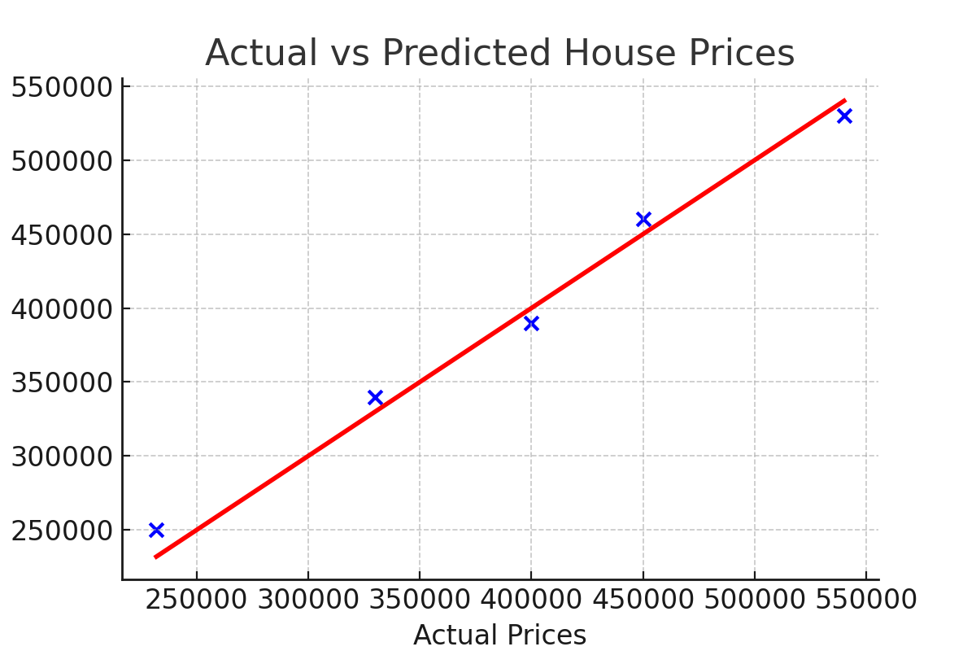

# 9. Result

- R² Score: Shows how well the model explains the variance. Value closer to 1 means better prediction.  
- MSE (Mean Squared Error): Measures average of the squares of errors. Lower is better.  
  
Example Output:  
Mean Squared Error: 174240000.0  
R2 Score: 0.89

# 10. Conclusion

The AIM-based Linear Regression model accurately predicts house prices using features like size, bedrooms, and age. With further tuning and a larger dataset, the prediction can be improved.