SOFTWARE REQUIREMENTS SPECIFICATION
(SRS Document)
Citizen Application Document Checklist Generator

A Web-Based Public Service Assistance System for
Personalized Government Document Requirement Checklists

Submitted in partial fulfilment of the requirements for the degree of
Bachelor of Technology
in Artificial Intelligence and Data Science

Submitted by:
HARISH M(7376242AD176)
GOKULA KRISHNAN D(7376242AD167)

1. Introduction
Citizens applying for government services often face difficulty identifying the required, conditional, and optional supporting documents. This leads to incomplete applications, repeated visits, and delays in service delivery.
The Citizen Application Document Checklist Generator is a public-access web application that provides personalized document checklists for various government services. Citizens can select a service, answer a few questions, and instantly receive a checklist categorized as Required, Conditional, Optional, or Missing.
The system requires no citizen registration or login. A secure Admin login is provided to manage services, documents, questions, and requirement rules. The system aims to reduce confusion, improve application completeness, and make public service delivery more efficient.

2. Problem Statement
- Citizens often struggle to identify the complete documents required for government services.
- Document requirements may vary based on age, category, income, residency, employment, and family status.
- Citizens may miss mandatory or supporting documents during application.
- Incomplete applications can cause rejections, delays, and repeated visits to service centers.
- Citizens often depend on multiple sources, phone calls, or in-person visits to verify requirements.
- This process is time-consuming, inconvenient, and confusing, especially for first-time applicants.
- There is a need for a centralized and personalized document checklist system.
- Citizens can select a service and answer a few questions to receive the required document checklist.
- The system categorizes documents as Required, Conditional, Optional, and Missing.

3. Proposed System
The Citizen Application Document Checklist Generator is a public-access web application that helps citizens identify the documents required for government and public services. It provides a personalized checklist based on the service selected and the citizen’s answers, without requiring registration or login.

Key Features:

- Public access with no citizen login or registration.
- Selection of the required government/public service.
- Dynamic questions based on the selected service.
- Rule-based analysis of applicant responses.
- Documents classified as Required, Conditional, Optional, or Missing.
- Checklist can be viewed, downloaded, and printed.
- Reset option to check another service.
- Secure Admin Login for managing services, documents, questions, and rules.
- Admin dashboard with management and basic analytics.
- Supports services such as certificates, scholarships, pensions, and welfare schemes.

4. Objectives
The main objective of the Citizen Application Document Checklist Generator is to simplify and improve the process of identifying documents required for government services.
- Provide easy public access to document requirements.
- Eliminate citizen registration and login.
- Generate personalized document checklists based on applicant responses.
- Classify documents as Required, Conditional, Optional, or Missing.
- Reduce incomplete applications and repeat visits.
- Minimize citizen confusion and application delays.
- Provide a centralized platform for managing requirements.
- Enable administrators to maintain accurate and updated information.
- Improve citizen preparedness before service application.
- Provide a foundation for future AI and multilingual support.

5. System Workflow
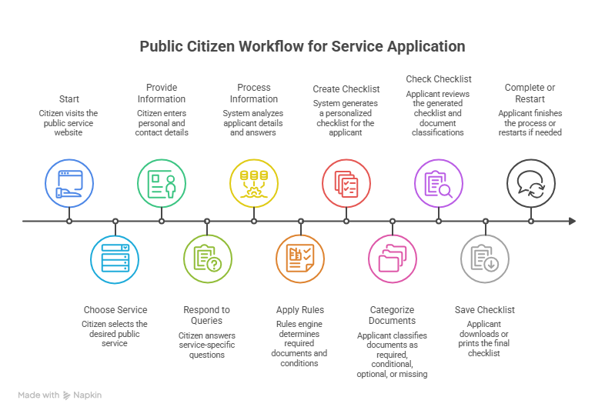

6. Technology Stack
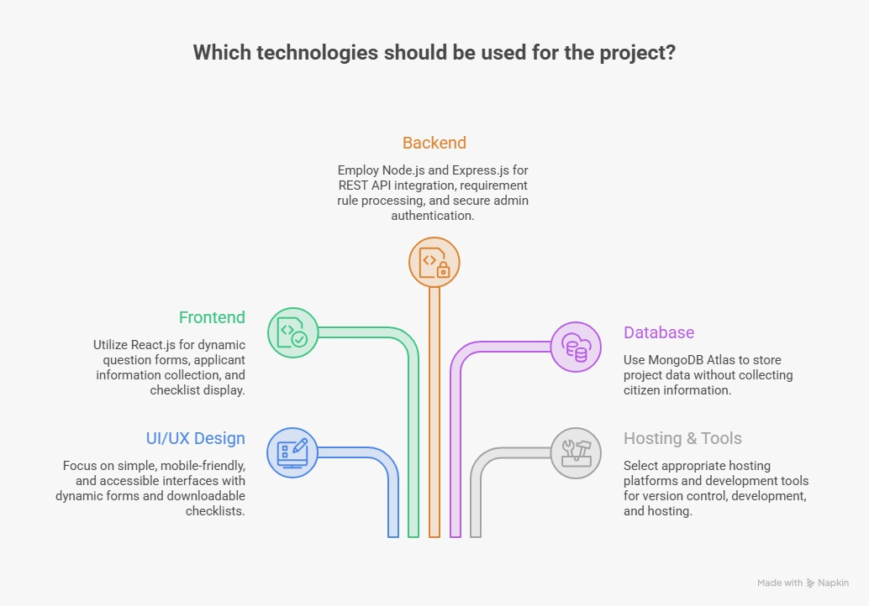

7. Target Users
User Type | Description
Citizens / Applicants | Members of the public who access the website to determine the documents required for a specific service, without registering or logging in.
Students | Students applying for scholarships, bonafide certificates, educational benefits, and related services.
Senior Citizens | Older citizens who benefit from a simple, guided system for understanding documentation requirements.
Public Service Centers | Operators at common service centers or e-governance kiosks who assist citizens in preparing applications.
Government / Administrative Staff | Authorized personnel who verify and, where applicable, inform the administrator about updates to requirements.
System Administrator | The only authenticated user, responsible for maintaining services, documents, questions, and requirement rules.

8. Functional Requirements
The system's functional requirements are clearly separated into Public User Functions, which require no authentication, and Administrator Functions, which are restricted to authenticated administrators.
Public User Functions (No Login Required) | Administrator Functions (Login Required)
• Access the website without registration. | • Log in to the administrator dashboard.
• Access the website without login. | • Undergo administrator authentication.
• View the list of available public services. | • Access the administrator dashboard.
• Select a public service. | • Add, edit, delete, or deactivate public services.
• Answer service-specific questions. | • Add, edit, delete, or deactivate documents.
• Submit applicant information. | • Add, edit, or delete service-specific questions.
• Generate a personalized document checklist. | • Create, edit, or delete requirement rules.
• View documents classified as Required. | • Manage document categories.
• View documents classified as Conditional. | • Update general website information.
• View documents classified as Optional. | • View reports and analytics related to system usage.
• Identify documents classified as Missing. | • Log out of the administrator session.
• Review the generated checklist.
• Download the checklist.
• Print the checklist.
• Restart the checklist generation process.
• Select and check requirements for another service.

9. Non-Functional Requirements
Requirement | Description
Security | Administrator access is protected through JWT-based authentication and bcrypt password hashing; citizen access requires no credentials.
Performance | Checklist generation should complete within a short, near-instant response time after applicant information is submitted.
Scalability | The system architecture should support an increasing number of services, documents, and concurrent public users.
Availability | The public checklist generator should remain accessible with minimal downtime.
Usability | The interface should be simple and intuitive for citizens with varying levels of digital literacy.
Accessibility | The interface should follow basic accessibility practices to accommodate a wide range of users.
Reliability | The system should consistently produce accurate checklists based on the configured rules and data.
Maintainability | The modular architecture should allow administrators and developers to update services, documents, and rules with minimal effort.
Data Privacy | The system should avoid collecting unnecessary personal information from citizens, consistent with its no-login design.
Responsive Design | The interface should adapt to desktop, tablet, and mobile screen sizes.
Fast Checklist Generation | The requirement rules engine should process applicant responses efficiently to minimize wait time.
Secure Administrator Access | Administrator-only functionality should be protected against unauthorized access at all times.

10. System Modules
The system is organized into the following functional modules:
# | Module | Purpose
1 | Public Access Module | Provides open, unauthenticated access to the checklist generator.
2 | Service Selection Module | Presents the list of available public services to citizens.
3 | Applicant Information Module | Collects basic, non-identifying applicant details.
4 | Dynamic Question Module | Renders service-specific questions configured by the administrator.
5 | Requirement Analysis Module | Evaluates applicant responses against configured rules.
6 | Document Requirement Engine | Determines which documents apply based on rule evaluation.
7 | Personalized Checklist Generator | Compiles the final checklist for the citizen.
8 | Checklist Display Module | Presents the categorized checklist to the citizen.
9 | Download and Print Module | Enables PDF download and printing of the checklist.
10 | Administrator Authentication Module | Manages secure administrator login.
11 | Administrator Dashboard Module | Provides the central interface for administrative operations.
12 | Service Management Module | Supports adding, editing, and deactivating services.
13 | Document Management Module | Supports adding, editing, and deactivating documents.
14 | Question Management Module | Supports management of service-specific questions.
15 | Requirement Rules Module | Supports creation, editing, and deletion of requirement rules.
16 | Website Content Management Module | Supports updates to general website information.
17 | Reports and Analytics Module | Provides administrators with basic usage statistics.

11. Security Requirements
Since the system is designed for public, unauthenticated citizen access, security measures are focused primarily on protecting administrator access and the integrity of the underlying requirement data. Security requirements include:
Authentication & Access Control | Data & Endpoint Protection
• Secure administrator authentication using JWT-based sessions. | • Secure API endpoint design to prevent unauthorized access.
• Bcrypt-based password hashing for administrator credentials. | • Protection against unauthorized modification of core data.
• Role-based access control for administrative functions. | • Secure database access controls on MongoDB Atlas.
• Restriction of management APIs to authenticated administrators only. | • Proper token and session management for administrator logins.
• Input validation on all citizen- and administrator-submitted data. | • Protection of administrator credentials at rest and in transit.

Citizens do not require authentication of any kind, as the checklist generator is intentionally designed for open public access. No citizen data is stored in a manner that requires account-level security, since no citizen accounts exist.

12. Expected Outcome
The Citizen Application Document Checklist Generator is expected to provide a simple, publicly accessible platform through which citizens can select a service, provide relevant information, and receive a personalized document checklist that they can review, download, or print. The overall process can be summarized as follows: Select a Service → Provide Relevant Information → Generate a Personalized Checklist → Review the Checklist → Download or Print.
The system is expected to deliver the following outcomes:
- No citizen registration is required at any stage.
- No citizen login is required at any stage.
- No citizen account or profile is created or maintained.
- Public access to checklist generation is available to any visitor.
- Only administrators are able to edit service, document, question, and rule information.
- Service and document requirement information is centrally managed and kept consistent.
- Confusion regarding documentation requirements is reduced for citizens.
- The number of incomplete applications submitted at service centers is reduced.
- Citizens are better prepared before submitting an application, reducing delays and repeat visits.
Overall, the proposed system offers a practical, scalable, and citizen-friendly solution to a widespread administrative problem, while also establishing a foundation for future enhancements such as AI-based requirement analysis and multilingual support.

13. Conclusion
The Citizen Application Document Checklist Generator provides a simple public platform that helps citizens identify the documents required for different public services. By selecting a service and providing relevant details, users can quickly receive a personalized checklist of required, conditional, optional, and missing documents.

The system reduces confusion, incomplete applications, and unnecessary visits to service centers, while allowing the administrator to securely manage and update service requirements. It provides an efficient foundation for future enhancements such as AI-based assistance and multilingual support.

