ITA0601-ML
LAB PROGRAM
B HARISH BALAJI
192424386

EXP.16:
CODE:
# 16. Comparison of Classification Algorithms
from sklearn.datasets import load_iris
from sklearn.model_selection import train_test_split
from sklearn.tree import DecisionTreeClassifier
from sklearn.neighbors import KNeighborsClassifier
from sklearn.metrics import accuracy_score, classification_report

# Load Iris dataset
iris = load_iris()

X = iris.data
y = iris.target

# Split dataset
X_train, X_test, y_train, y_test = train_test_split(
X,
y,
test_size=0.3,
random_state=42
)

# 1. Decision Tree Classifier
# ------------------------------------------------

decision_tree = DecisionTreeClassifier(
random_state=42
)

decision_tree.fit(X_train, y_train)

dt_pred = decision_tree.predict(X_test)

dt_accuracy = accuracy_score(
y_test,
dt_pred
)

# ------------------------------------------------
# 2. KNN Classifier
# ------------------------------------------------

knn = KNeighborsClassifier(
n_neighbors=3
)

knn.fit(X_train, y_train)

knn_pred = knn.predict(X_test)

knn_accuracy = accuracy_score(
y_test,
knn_pred
)

print("CLASSIFICATION ALGORITHM COMPARISON")
print("------------------------------------")

print("\nDecision Tree Accuracy:",
dt_accuracy)

print("KNN Accuracy:",
knn_accuracy)

# Classification reports

print("\nDecision Tree Classification Report:")
print(
classification_report(
y_test,
dt_pred,
target_names=iris.target_names
)
)

print("\nKNN Classification Report:")
print(
classification_report(
y_test,
knn_pred,
target_names=iris.target_names
)
)

# ------------------------------------------------
# Compare Algorithms
# ------------------------------------------------

if dt_accuracy > knn_accuracy:
print("\nBest Algorithm: Decision Tree")

elif knn_accuracy > dt_accuracy:
print("\nBest Algorithm: KNN")

else:
print("\nBoth algorithms have the same accuracy.")

OUTPUT:
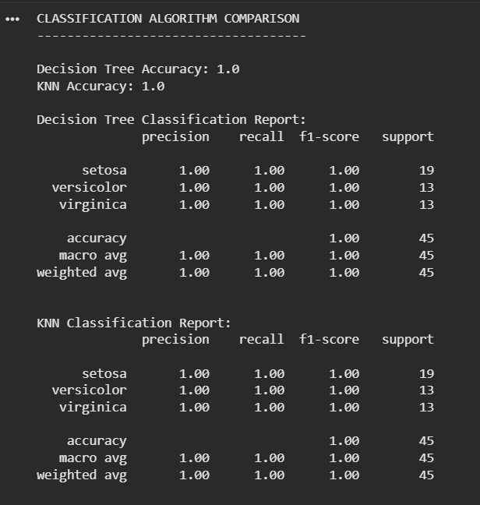

EXP17:

CODE:
# 17. Mobile Price Prediction
# Using Linear Regression

import pandas as pd
from sklearn.linear_model import LinearRegression

# Create dataset
data = {
"Antutu_Score": [
450000, 500000, 550000, 600000, 650000,
700000, 750000, 800000, 850000, 900000
],

"Battery": [
4000, 4200, 4500, 4800, 5000,
5200, 5500, 5800, 6000, 6500
],

"Camera": [
48, 50, 64, 64, 108,
108, 108, 200, 200, 200
],

"Price": [
25000, 30000, 35000, 40000, 50000,
60000, 70000, 85000, 100000, 120000
]
}

# Create DataFrame
df = pd.DataFrame(data)

print("Mobile Price Dataset:")
print(df)

# Input features
X = df[["Antutu_Score", "Battery", "Camera"]]

# Target variable
y = df["Price"]

# Create Linear Regression model
model = LinearRegression()

# Train model
model.fit(X, y)

# Display coefficients
print("\nModel Coefficients:")
print(model.coef_)

print("\nModel Intercept:")
print(model.intercept_)

# New mobile sample
new_mobile = [[750000, 6000, 108]]

# Predict price
prediction = model.predict(new_mobile)

print("\nNew Mobile Details:")
print("Antutu Score :", 750000)
print("Battery :", 6000, "mAh")
print("Camera :", 108, "MP")

print("\nPredicted Mobile Price:",
round(prediction[0], 2))

OUTPUT:
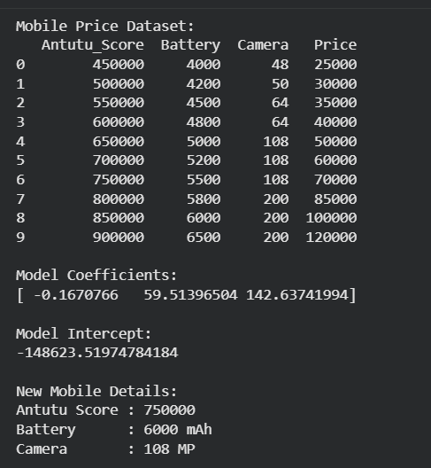

CODE 18:
# 18. Perceptron Based Iris Classification

from sklearn.datasets import load_iris
from sklearn.model_selection import train_test_split
from sklearn.linear_model import Perceptron
from sklearn.metrics import accuracy_score, classification_report

# Load Iris dataset
iris = load_iris()

X = iris.data
y = iris.target

# Split dataset
X_train, X_test, y_train, y_test = train_test_split(
X,
y,
test_size=0.3,
random_state=42
)

# Create Perceptron model
model = Perceptron(random_state=42)

# Train the model
model.fit(X_train, y_train)

# Predict test data
y_pred = model.predict(X_test)

# Display actual and predicted values
print("Actual Values:")
print(y_test)

print("\nPredicted Values:")
print(y_pred)

# Calculate accuracy
accuracy = accuracy_score(y_test, y_pred)

print("\nAccuracy:", accuracy)

# Classification report
print("\nClassification Report:")
print(
classification_report(
y_test,
y_pred,
target_names=iris.target_names,
zero_division=0
)
)

# Predict a new Iris flower
new_flower = [[5.1, 3.5, 1.4, 0.2]]

prediction = model.predict(new_flower)

print("\nNew Flower Features:")
print("Sepal Length = 5.1 cm")
print("Sepal Width = 3.5 cm")
print("Petal Length = 1.4 cm")
print("Petal Width = 0.2 cm")

print("\nPredicted Iris Flower:",
iris.target_names[prediction[0]])
OUTPUT:
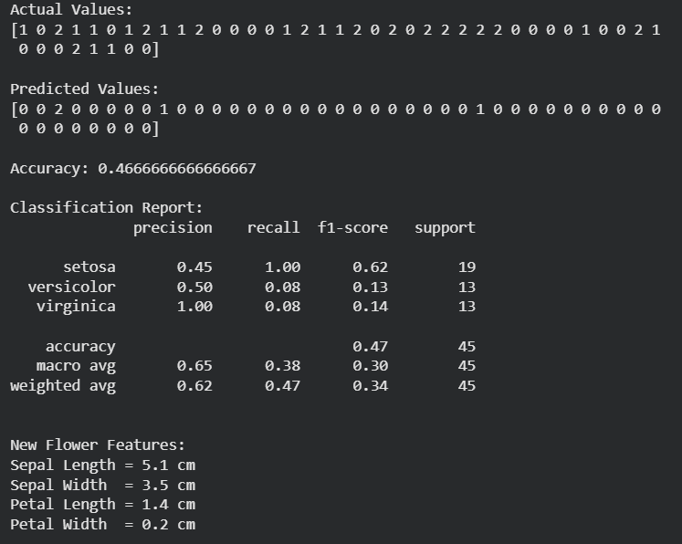

EXP19:

CODE:
# 19. Naive Bayes Classification
# Bank Loan Prediction

import pandas as pd

from sklearn.model_selection import train_test_split
from sklearn.naive_bayes import GaussianNB
from sklearn.preprocessing import LabelEncoder
from sklearn.metrics import accuracy_score, confusion_matrix

# Create dataset
data = {
"Annual_Income": [
12, 10, 9, 7, 6,
5, 4, 8, 11, 14
],

"Credit_Score": [
820, 790, 760, 700, 680,
650, 620, 720, 780, 830
],

"Loan_Amount": [
5, 6, 7, 8, 9,
10, 11, 7, 5, 4
],

"Loan_Status": [
"Approved",
"Approved",
"Approved",
"Approved",
"Rejected",
"Rejected",
"Rejected",
"Approved",
"Approved",
"Approved"
]
}

# Create DataFrame
df = pd.DataFrame(data)

print("Bank Loan Dataset:")
print(df)

# Input features
X = df[
[
"Annual_Income",
"Credit_Score",
"Loan_Amount"
]
]

# Target variable
y = df["Loan_Status"]

# Convert target labels to numbers
encoder = LabelEncoder()
y_encoded = encoder.fit_transform(y)

# Split dataset
X_train, X_test, y_train, y_test = train_test_split(
X,
y_encoded,
test_size=0.3,
random_state=42
)

# Create Gaussian Naive Bayes model
model = GaussianNB()

# Train model
model.fit(X_train, y_train)

# Predict test data
y_pred = model.predict(X_test)

# Display actual and predicted values
print("\nActual Values:")
print(encoder.inverse_transform(y_test))

print("\nPredicted Values:")
print(encoder.inverse_transform(y_pred))

# Calculate accuracy
accuracy = accuracy_score(y_test, y_pred)

print("\nAccuracy:", accuracy)

# Confusion matrix
cm = confusion_matrix(y_test, y_pred)

print("\nConfusion Matrix:")
print(cm)

# Predict a new loan application
new_loan = [[11, 790, 6]]

prediction = model.predict(new_loan)

print("\nNew Loan Details:")
print("Annual Income : ₹11 Lakhs")
print("Credit Score : 790")
print("Loan Amount : ₹6 Lakhs")

print("\nPredicted Loan Status:",
encoder.inverse_transform(prediction)[0])

OUTPUT:
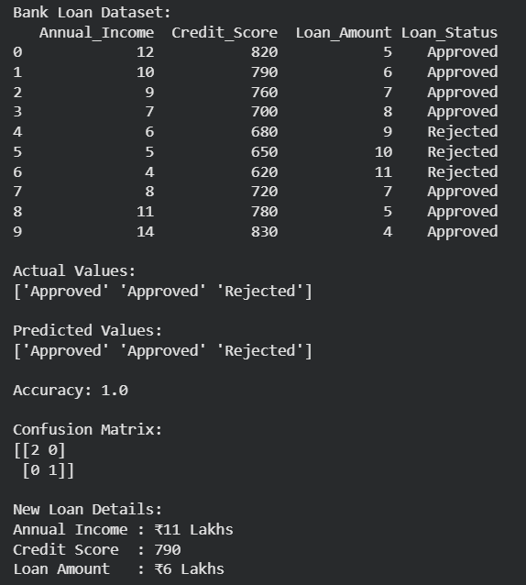

EXP20:

CODE:
# 20. Future Sales Prediction
# Using Linear Regression

import pandas as pd
from sklearn.linear_model import LinearRegression

# Create dataset
data = {
"Advertising_Budget": [
20, 25, 30, 35, 40,
45, 50, 55, 60, 65, 70, 75
],

"Salespersons": [
2, 2, 3, 3, 4,
4, 5, 5, 6, 6, 7, 7
],

"Monthly_Sales": [
250, 290, 340, 390, 450,
510, 580, 650, 720, 800, 890, 980
]
}

# Create DataFrame
df = pd.DataFrame(data)

print("Monthly Product Sales Dataset:")
print(df)

# Input features
X = df[[
"Advertising_Budget",
"Salespersons"
]]

# Target variable
y = df["Monthly_Sales"]

# Create Linear Regression model
model = LinearRegression()

# Train the model
model.fit(X, y)

# Display model parameters
print("\nModel Coefficients:")
print(model.coef_)

print("\nModel Intercept:")
print(model.intercept_)

# New sample
# Advertising Budget = 58
# Salespersons = 6
new_sample = [[58, 6]]

# Predict future sales
prediction = model.predict(new_sample)

print("\nNew Input:")
print("Advertising Budget :", 58, "₹ Thousands")
print("Number of Salespersons :", 6)

print("\nPredicted Future Sales:",
round(prediction[0], 2), "Units")
OUTPUT:
