ITA0601-ML
LAB PROGRAM
B HARISH BALAJI
192424386

EXP1:
import pandas as pd

data = pd.DataFrame({
'Sky':['Sunny','Sunny','Rainy','Sunny'],
'AirTemp':['Warm','Warm','Cold','Warm'],
'Humidity':['Normal','High','High','High'],
'Wind':['Strong','Strong','Strong','Strong'],
'Water':['Warm','Warm','Warm','Cool'],
'Forecast':['Same','Same','Change','Same'],
'EnjoySport':['Yes','Yes','No','Yes']
})

print(data)

OUTPUT:
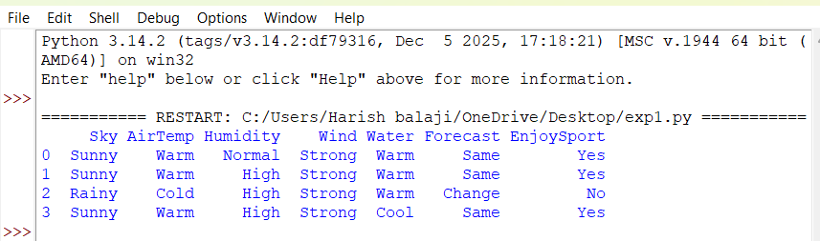
EXP-2:

CODE:
import pandas as pd

data = pd.DataFrame({
'Sky':['Sunny','Sunny','Rainy','Sunny'],
'AirTemp':['Warm','Warm','Cold','Warm'],
'Humidity':['Normal','High','High','High'],
'Wind':['Strong','Strong','Strong','Strong'],
'Water':['Warm','Warm','Warm','Cool'],
'Forecast':['Same','Same','Change','Same'],
'EnjoySport':['Yes','Yes','No','Yes']
})

print(data)

OUTPUT:
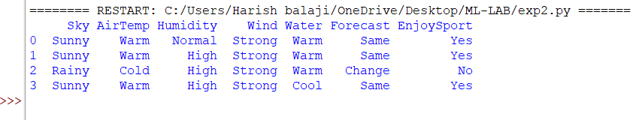

EXP-3

CODE:
import pandas as pd

data = pd.DataFrame({
'Outlook':['Sunny','Sunny','Overcast','Rain','Rain','Rain','Overcast',
'Sunny','Sunny','Rain','Sunny','Overcast','Overcast','Rain'],
'Temperature':['Hot','Hot','Hot','Mild','Cool','Cool','Cool',
'Mild','Cool','Mild','Mild','Mild','Hot','Mild'],
'Humidity':['High','High','High','High','Normal','Normal','Normal',
'High','Normal','Normal','Normal','High','Normal','High'],
'Wind':['Weak','Strong','Weak','Weak','Weak','Strong','Strong',
'Weak','Weak','Weak','Strong','Strong','Weak','Strong'],
'PlayTennis':['No','No','Yes','Yes','Yes','No','Yes',
'No','Yes','Yes','Yes','Yes','Yes','No']
})

print(data)

OUTPUT:
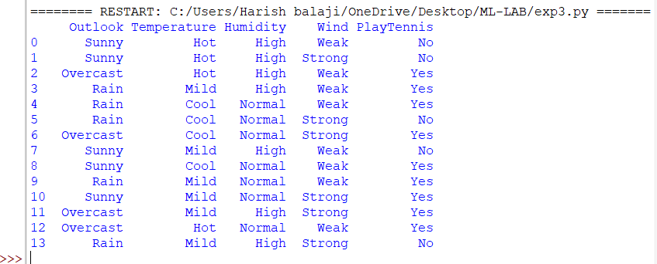

EXP-4

CODE:

from sklearn.datasets import load_iris

iris = load_iris()

X = iris.data
y = iris.target

print(X[:5])
print(y[:5])

OUTPUT:
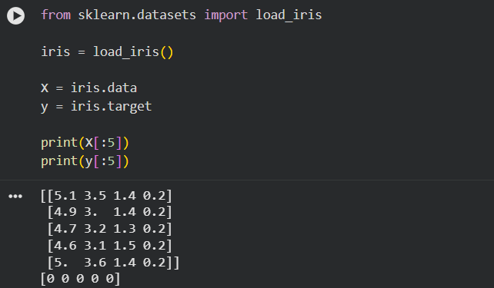

EXP-5

CODE:

from sklearn.datasets import load_iris
from sklearn.model_selection import train_test_split
from sklearn.neighbors import KNeighborsClassifier
from sklearn.metrics import accuracy_score, confusion_matrix

# Load dataset
iris = load_iris()
X = iris.data
y = iris.target

# Split dataset
X_train, X_test, y_train, y_test = train_test_split(
X, y, test_size=0.3, random_state=42
)

# Create model
model = KNeighborsClassifier(n_neighbors=3)

# Train model
model.fit(X_train, y_train)

# Predict
y_pred = model.predict(X_test)

# Display results
print("Actual Values:")
print(y_test)

print("\nPredicted Values:")
print(y_pred)

print("\nAccuracy:")
print(accuracy_score(y_test, y_pred) * 100)

print("\nConfusion Matrix:")
print(confusion_matrix(y_test, y_pred))

OUTPUT:
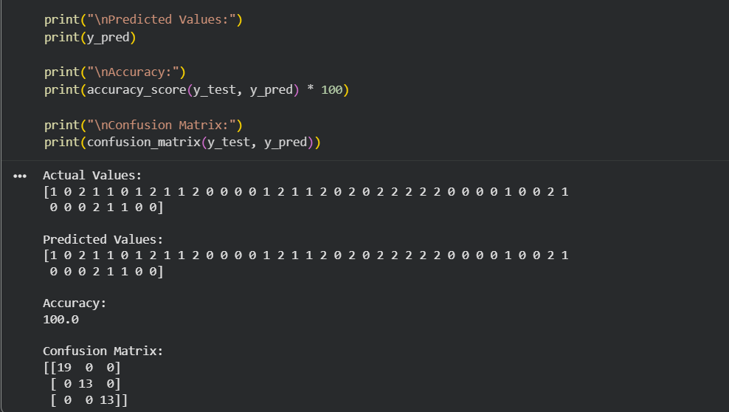
EXP-6

CODE:
from sklearn.datasets import load_breast_cancer
from sklearn.model_selection import train_test_split
from sklearn.naive_bayes import GaussianNB
from sklearn.metrics import confusion_matrix, accuracy_score

# Load dataset
dataset = load_breast_cancer()
X = dataset.data
y = dataset.target

# Split dataset
X_train, X_test, y_train, y_test = train_test_split(
X, y, test_size=0.3, random_state=42
)

# Create Naive Bayes model
model = GaussianNB()

# Train model
model.fit(X_train, y_train)

# Predict
y_pred = model.predict(X_test)

# Display results
print("Actual Values:")
print(y_test)

print("\nPredicted Values:")
print(y_pred)

print("\nConfusion Matrix:")
print(confusion_matrix(y_test, y_pred))

print("\nAccuracy:")
print(round(accuracy_score(y_test, y_pred) * 100, 2), "%")

OUTPUT:

