Amazon Automation
Selenium Web Automation – Python

1. Automation Objective
This automation uses Selenium with Python to open Amazon India, sign in, search for a water bottle, open the selected product, add it to the cart, open the cart, and proceed toward checkout.

2. Automation Flow
1. Open Amazon India
2. Open Account & Lists and select Sign in
3. Enter mobile number and continue
4. Enter password and sign in
5. Search for WaterBottle
6. Select the Stoga 750 ml Protein Shaker Bottle
7. Open the product page
8. Add the product to the cart
9. Go to cart
10. Click Proceed to Buy

3. Selenium Automation Code
from selenium import webdriver
from selenium.webdriver.common.by import By
from selenium.webdriver.support.ui import WebDriverWait
from selenium.webdriver.support import expected_conditions as EC
import time
driver=webdriver.Chrome()
driver.get("https://www.amazon.in/")
wait=WebDriverWait(driver,10)
driver.maximize_window()
login=wait.until(
EC.element_to_be_clickable(
(By.XPATH,'//*[@id="nav-link-accountList"]/button')
)
)
driver.execute_script(
"arguments[0].scrollIntoView({block: 'center'});",
login
)
driver.execute_script(
"arguments[0].click();",
login
)
print("login clicked success")
signin=wait.until(
EC.element_to_be_clickable(
(By.XPATH,'//*[@id="nav-flyout-ya-signin"]/a/span')
)
)
driver.execute_script(
"arguments[0].scrollIntoView({block: 'center'});",
signin
)
driver.execute_script(
"arguments[0].click();",
signin
)
print("signin success")
mobile=wait.until(
EC.element_to_be_clickable(
(By.ID,"ap_email_login")
)
)
mobile.click()
mobile.send_keys("6385230080")
button=wait.until(
EC.element_to_be_clickable(
(By.XPATH,'//*[@id="continue"]/span/input')
)
)
button.click()
print("success")
password=wait.until(
EC.element_to_be_clickable(
(By.ID,'ap_password')
)
)
password.send_keys("Harish")
signin=wait.until(
EC.element_to_be_clickable(
(By.ID,"signInSubmit")
)
)
signin.click()
print("Login Successfully")
searchbox=wait.until(
EC.element_to_be_clickable(
(By.ID,"twotabsearchtextbox")
)
)
searchbox.send_keys("WaterBottle")
searchbox.click()
searchicon=wait.until(
EC.element_to_be_clickable(
(By.ID,"nav-search-submit-button")
)
)
searchicon.click()
print("Product Shown Success")
driver.execute_script("window.scrollBy(0,500);")
productPage = wait.until(
EC.element_to_be_clickable(
(
By.XPATH,
'//a[contains(@href, "/sspa/click")][.//h2[contains(@aria-label, "Stoga 750 ml Protein Shaker Bottle")]]'
)
)
)
driver.execute_script(
"arguments[0].scrollIntoView({block: 'center'});",
productPage
)
productPage.click()
print("Product clicked")
wait.until(lambda d: len(driver.window_handles) > 1)
driver.switch_to.window(driver.window_handles[-1])
print("Product page opened")
print("Current URL:", driver.current_url)
cartbutton=wait.until(
EC.element_to_be_clickable(
(By.XPATH,'//input[@id="add-to-cart-button"]')
)
)
print("cart added success")
cartbutton.click()
gotocart=wait.until(
EC.element_to_be_clickable(
(By.XPATH,'//*[@id="sw-gtc"]/span/a')
)
)
gotocart.click()
print("gotocart success")
proceed=wait.until(
EC.element_to_be_clickable(
(By.XPATH,'//*[@id="sc-buy-box-ptc-button"]/span/input')
)
)
proceed.click()
time.sleep(30)

4. Important Notes
- The script uses WebDriverWait and Expected Conditions instead of relying only on fixed delays.
- JavaScript click and scrollIntoView are used for elements that may be difficult to click normally.
- Amazon's page structure can change, so XPath locators may need updating.
- Do not hard-code real passwords in production automation. Use environment variables or a secure secrets manager.
- Login, OTP, CAPTCHA, and anti-bot checks may require manual interaction depending on Amazon's current security flow.

5. Execution Screenshots
Screenshot 1 – Amazon home page
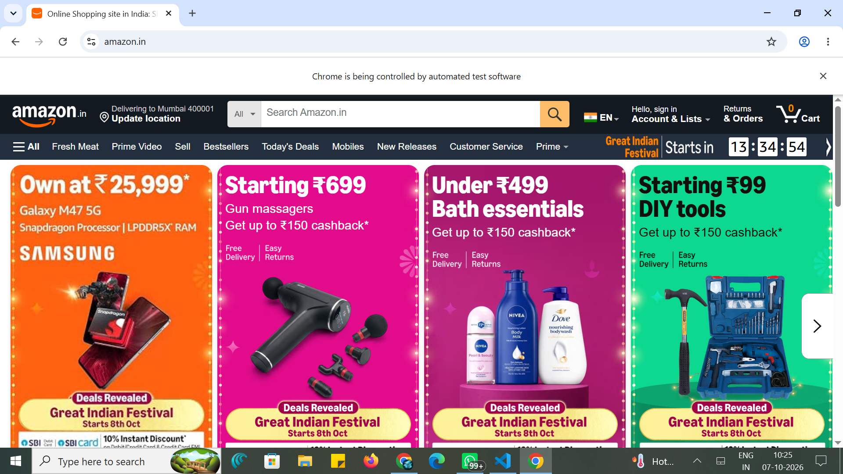

Screenshot 2 – Account & Lists sign-in menu
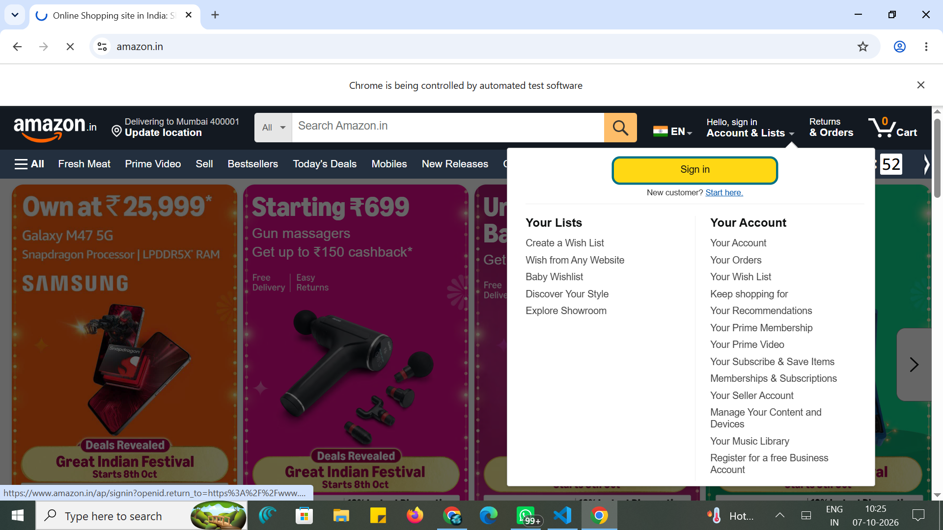

Screenshot 3 – Amazon sign-in page
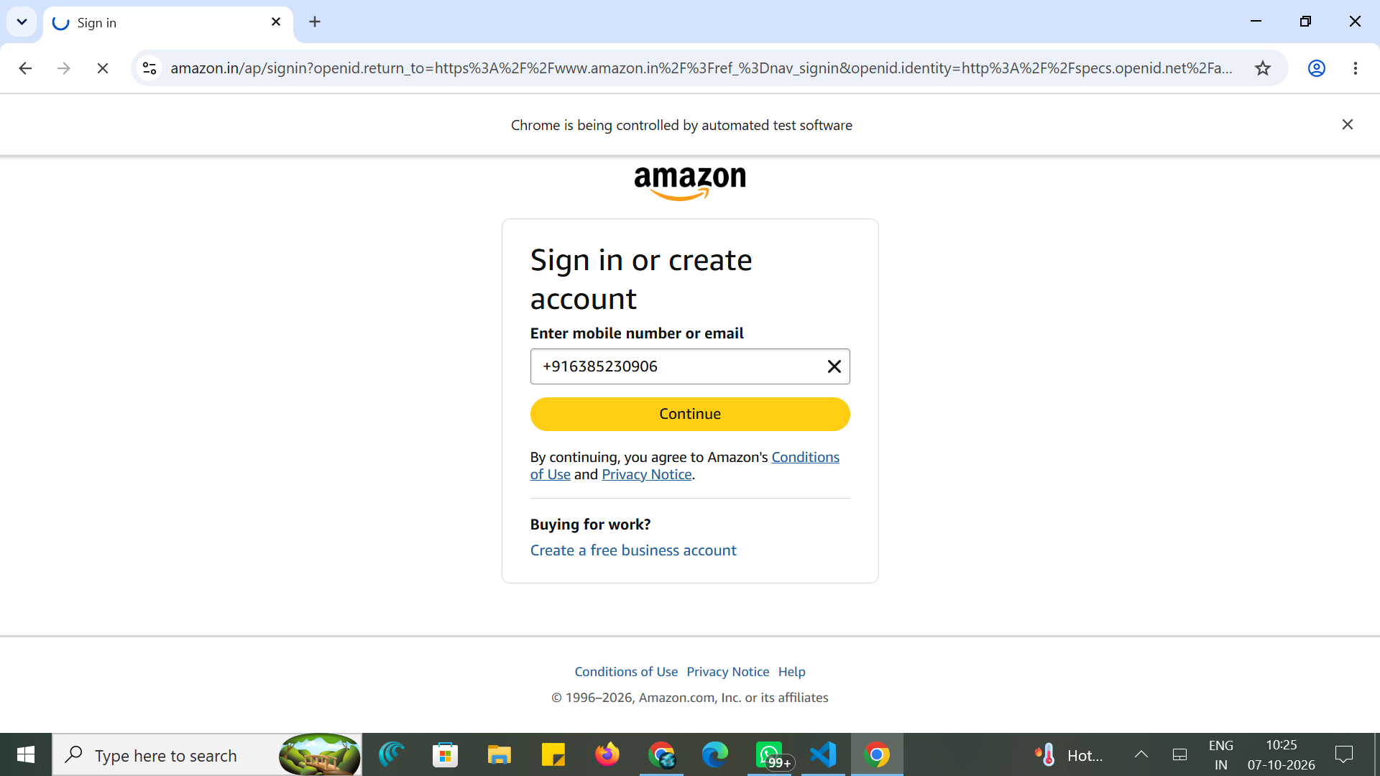

Screenshot 4 – Amazon product search
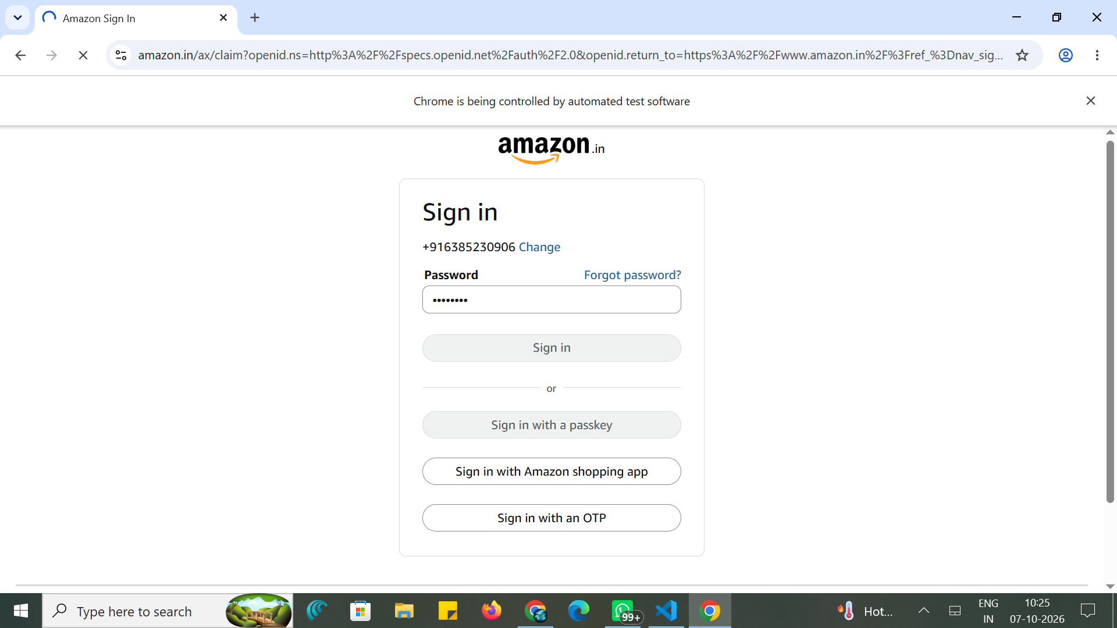

Screenshot 5 – Amazon automation execution
