DESIGN AND ANALYSIS OF
ALGORITHM

LAB WORK
DONE BY: HARISH.R
ROLL NO: CH.SC.U4CSE24163

- SUM OF NUMBERS:
CODE:
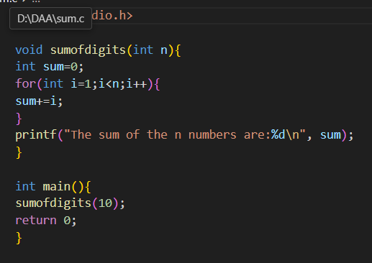
OUTPUT:
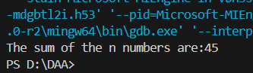

- SUM OF SQUARES OF NUMBERS:
Code:
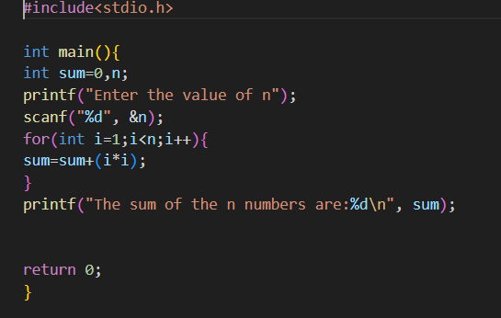

Output:
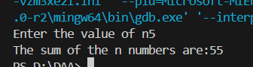

- SUM OF CUBE:
Code:
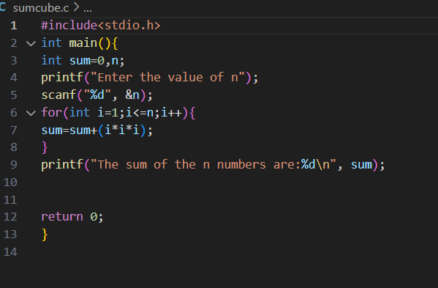
C

Output:
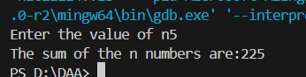

- Factorial using recursion:
Code:
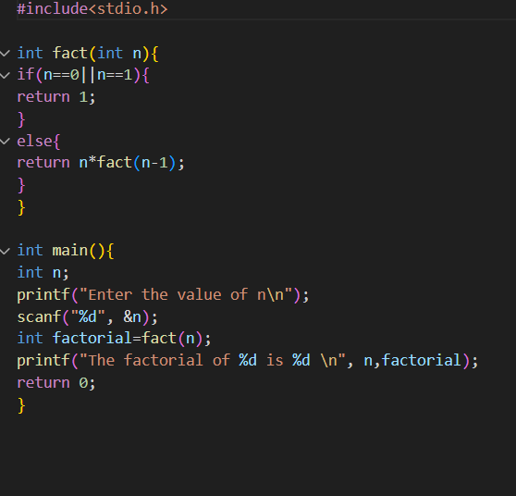
Output:
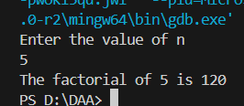
- Transpose of a matrix:
Code:
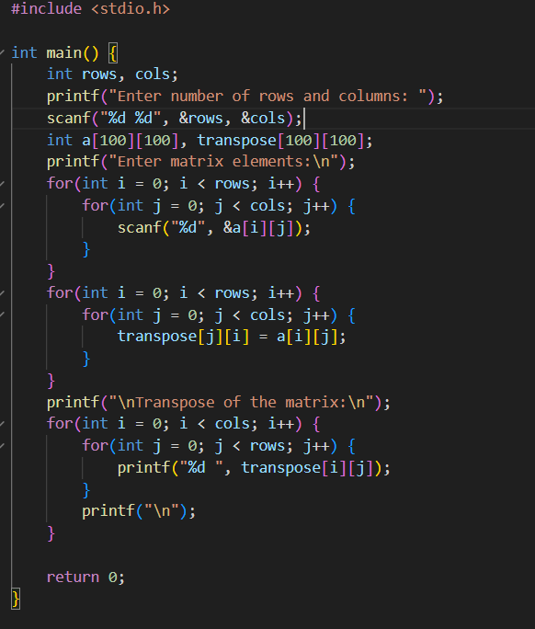
Output:
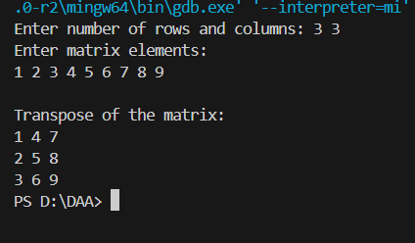

- Fibonacci Series:
Code:
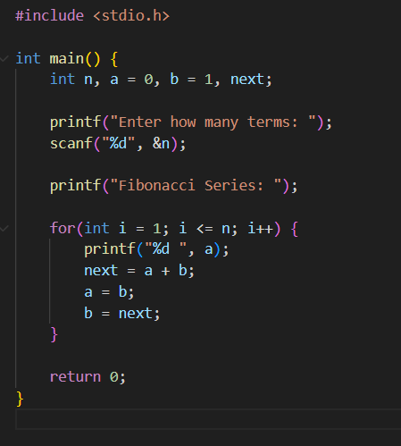
Output:
