**ARUDINO BASED WEATHER STATION WITH IOT**

**PROJECT REPORT 2023-2024**

**PROJECT SUBMITTED BY**



22311879 HARISHKANNA R

22311885 POOVARASAN M

22311886 PRADEEP KUMAR R

22396058 DHARANESH S

22396059 LOKESHWARAN T

22396075 SUDHAKAR S

**Under The Guidance Of**

**ANBARASAN R. S. LECTURE**.,

***Submitted in partial fulfillment of the requirement for the***

***Award of***

**“DIPLOMA IN ELECTRICAL & ELECTRONICS**

**ENGINEERING”**

***By the state board of technical education government of***

***Tamilnadu, Chennai.***



DEPARTMENT OF ELECTRICAL & ELECTRONICS ENGINEERING . 912 - SRI MOOGAMBIGAI POLYTECHNIC COLLEGE MADHAMPATTI, PALACODE.

**912, SRI MOOGAMBIGAI POLYTECHNIC COLLEGE**

***HYDRO POWER GENERATION FROM FLOW OF WATER IN BUILDINGS***



**MADHAMPATTI, PALACODE.**



**DEPARTMENT OF**

**ELECTRICAL & ELECTRONICS ENGINEERING**

BONAFIDE CERTIFICATE

*Certified that this report is a bonafide record of project work done*

*by*

*in his*

*final semester of Diploma course during the*

*Academic year of 2023 2024*

*-*

*.*

Head of the department

Project Guide

*Submitted for the board of Examination held on________________*

Internal Examiner External Examiner

# ACKNOWLEDGEMENT

First of all where thanks to God to make our project successful and effectively.

Project is a venture which involves the guidance and inspiration of many People. So become our bounden duty to express our thanks to the Persons Involved in our project.

Our sincere thanks to our Hon. Chairman **Shri** **K.Govindaraj** had been a source of inspiration and guidance to us all through our work.

We express our thanks to our Secretary **Prof.S.Madhanmohan B.E.,M.B.A., M.I.S.T.E.,** and Director **Shri** **C.Mathulampoo M.A.,M.Ed.,M.PEd.,** For their Inspiring support.

We wish to express our heartiest and sincere thanks to our Principal **Prof. P.S. Saravanan M.E.,M.I.S.T.E.,** his unflinching support and valuable Advise during the course of project.

We are indeed grateful to our respected Head of the Department and Project Coordinator **Mr.R.Sakthivel M.E.,** who have his valuable help to complete our project work for rendering his valuable support.

We bestow our sincere and humble thanks to our guide **Mr.ANBARASAN R. S** for this kind co-operation and valuable help to complete the project successfully.

It is to be placed on record the tremendous encouragement and Assistance received from on our **ELECTRICAL & ELECTRONICS DEPARTMENT Staff**

**Members and LAB Assistants** for rendering their great support.

Table of contents

|  |  |  |
| --- | --- | --- |
| **Chapter** | **Titles** | **Page no.** |
| **I** | Abstract | 6 |
| **II** | List of figures | 7 |
| **III** | List of abbreviations | 7 |
| 1. | Introduction OVERVIEW 1.2 Literature review | 8 |
| 2. | Theory & Block diagram  2.1 IOT  2.1.1 IOT keyfeatures  2.1.4 IOT software  2.1.2 Technology & protocols  2.2 .1Block diagram  2.2.2 Block diagram description | 14  17  18  19  20  21  22 |
| 3. | Circuit diagram  3.1 Circuit diagram  3.2 Circuit description | 23  24  24 |
| 4. | **Proposed System and Hardware Architecture**  **4.1. Features of purposed system**  **4.2. Purposed Hardware Architecture**  4.3 Circuit diagram  4.4 List of hardware componete  4.5 Details of hardware compontes  4.6 Rain sensor  4.7 LCD Display | 7  8  10  13  14  16  18  20  21  22  24  35 |
| 5. | **Algorithm**  5.1 Flow of chart of system  5.2 Source code | 36 |
| 6. | Advantage &future scope | 43 |
| 7. | Application | 46 |
| 8. | Conclusion | 48 |
| 9. | Bibliography | 52 |
| 10. | Cost analysis | 54 |

Abstract

An Arduino weather station with IoT capabilities is a project that involves creating a device to monitor and collect weather-related data using Arduino microcontrollers and sensors, and then transmitting this data to the Internet for remote access and analysis. The combination of Arduino and IoT technology allows for the creation of a versatile weather monitoring system.

# The goal of this project is to make a temperature/humidity/Air pressure/Wind monitor that wirelessly logs the temperature, humidity, Air pressure and Wind to a remote server. We will use an Arduino Uno a DHT11, an ESP8266, and ThingSpeak.com for this project.

# The working of an Arduino weather station with IoT involves the integration of various components to measure weather parameters, read data from sensors, and transmit this information to an online platform for remote monitoring. It is equipped with environmental sensors used for measurements at any particular place and report them in real time on cloud. To accomplish this, we used Arduino Uno and different environmental sensors like DHT11, soil moisture sensor and rain drop sensor.

# The sensors constantly sense the weather parameters and keeps on transmitting it to the online webserver over a wifi connection. The weather parameters are uploaded on the cloud and then provides the live reporting of weather information. This paper also focuses on the IOT application in the new generation of environmental information and provides a new paradigm for environmental monitoring in future.

## **List of Figures**

|  |  |  |
| --- | --- | --- |
| **Serial No.** | **Figure Name** | **Figure No.** |
| 1. | Arduino UNO | 1 |
| 2. | BMP180 with Arduino | 2 |
| 3. | DHT11 with Arduino | 3 |
| 4. | Rain sensor with Arduino | 4 |
| 5. | Arduino UNO | 5 |
| 6. | ESP8266 WiFi | 6 |
| 7. | Hardware Circuit | 7 |
| 8. | LCD Display | 8 |

List of abbreviations

1. IoT – Internet of Things
2. DHT- Digital Humidity and Temperature
3. LCD – Liquid Crystal Display
4. BMP – Barometric Pressure
5. LED – Light Emitting Diode
6. SDA – Serial Data
7. SCL – Serial Clock
8. A.I – Analog Input
9. D.I – Digital Input
10. GND – Ground
11. TX – Transmitting Pin
12. RX – Receiving Pin
13. VCC – Common Collector Voltage

# Chapter -1

# Introduction

**Introduction**

Here we introduce a smart weather reporting system over the Internet. Our introduced system allows for weather parameter reporting over the Internet. It allows the people to directly check the weather states online without the need of a weather forecasting agency. System uses temperature, humidity as well as rain with humidity sensor to monitor weather and provide live reporting of the weather statistics. The system constantly monitors temperature using temperature sensor, humidity using humidity sensor and also for rain. Weather monitoring system deals with detecting and gathering various weather parameters at different locations which can be analysed or used for weather forecasting. The aim of this system is achieved by technologies such as Internet of Things (IOT) and Cloud. The idea of internet of things is to connect a device to the internet and to other required connected devices. Using Internet the information from the IOT device can easily be transferred to the cloud and then from the cloud to the end user. Weather Monitoring is an essential practical implementation of the concept of Internet of Things, it involves sensing and recording various weather parameters and using them for alerts, sending notifications, adjusting appliances accordingly and also for long term analysis. Also we will try to identify and display trends in parameters using graphical representation. The devices used for this purpose are used to collect, organize and display information. It is expected that the internet of things is going to transform the world by monitoring and controlling the phenomenon of environment by using sensors/devices which are able to capture, process and transmit weather parameters. Cloud is availability of computer system resources like data storage, computing power without direct active management of user. The data captured is transmitted to the cloud so that the data could be further displayed. Besides this, the system consists of components such as Arduino UNO board which is a microcontroller board consisting of 14 digital pins, a USB connection and everything used to support microcontroller; DHT11 is Temperature and humidity sensor which is used for detecting these mentioned parameters; WIFI module is used to convert the data collected from the sensors and then send it to the web server. So, in this way weather conditions of any location can be monitored from any remote location in the world. The system constantly transmits this data to the micro controller which now processes this data and keeps on transmitting it to the online web server over a wifi connection. This data is live updated to be viewed on the online server system. Also system allows user to set alerts for particular instances. In today’s world many pollution monitoring systems are designed by different environmental parameters. Existing system model is presented IOT based Weather monitoring and reporting system where you can

collect, process, analyze, and present your measured data on web server. Wireless sensor network management model consists of end device, router, gateway node and management monitoring center. End device is responsible for collecting wireless sensor network data, and sending them to parent node, then data are sent to gateway node from parent node directly or by router. After receiving the data from wireless sensor network, gateway node extracts data after analyzing and packaging them into Ethernet format data, sends them to the server. Less formally, any device that runs server software.

### 1.1. OVERVIEW: -

Assemble all system as per circuit diagram. Program the NodeMCU using Arduino IDE. You will get confirmation on your screen once The NodeMCU is a programable controller which has inbuilt wi-fi module

We connect three sensors 1) BMP180 2) DHT11 and 3) Rain Sensor to NodeMCU. By using these three sensors, we can collect the required weather data for monitoring purpose. This pooled data is stream over the Internet to display it or read it from anywhere. After the successfully programmed hardware, the NodeMCU get one IP address. We can browse this IP address from any of WEB browser like Chrome, Firefox, Internet Explorer etc.so we display the required live data which fetched by sensors in beautiful Graphical User Interface format. The weather parameters that we monitor are Temperature, Pressure, Humidity and Rain. Also, you can check whether data through anywhere using Internet as we hosted this server publicly. We developed an android application for easy access to our weather monitoring system.

### 1.2. Literature Review

In this paper, the author elaborates how the weather prediction system is becoming a crucial challenge in every Weather extreme event that causes an adverse effect of the system on lives and property as well. Hence the accuracy of weather data is being one of the critical challenges to enhance the weather prediction skills and build up the resilience to effect of detrimental weather report condition. The author describes that Uganda and various other developing countries have looked challenges in developing timely & accurate weather data due to scarce weathers observation. The scarce weather monitoring is a part of the high cost of developing automatic weather situations. The restricted funding is available to national meteorological services of the respective countries. In this proposed system the author firstly takes care of the problems and then applies them. The author proposed an Automatic weather monitoring Station based on a wireless sensor network. The planning of the author is to develop three generations of Automatic weather stations or AWS prototypes. In this research, the author evaluates the 1st-generation AWS prototype to improve the 2nd generation depending upon the need and generation. The author provides a suggestion to improve the nonfunctional requirement such a power consumption, data accuracy, reliability, and data transmission in order to have an Automatic Weather Station. The non-functional requirement collapsed with cost reduction in order to produce a robust and affordable Automatic Weather Station (AWS) Therefore the proposed work, like developing countries like Uganda will be able to acquire the AWS in suitable quantities. So that it can improve the weather forecasting The author in [2], presents an IoT-based weather monitoring system.

In this research, the environmental parameter can be retrieved through sensors. The author uses a different sensor to scale the various parameter like humidity, temperature, pressure, rain value & the LDR sensor is used. The system also calculates the dew point value from the temperature prototype. The temperature sensor can be used to measure the value of the particular area, room, or any place. With the help of the LDR sensor, the light intensity can be used as described by the author. The author in this used an additional functionality of the weather monitoring as SMS alert system based on the exceed the value of the sensing parameters as temperature, humidity, pressure, light intensity, and rain value. The author also adds an email and tweet post alerting system. The author in this system uses node MCU 8266, and various sensors. In this paper [3], the author represents a low-cost live weather monitoring system using OLED display, in which the author displays the various fields where the IoT has produced innovative things in the system. The author described A new revolutionary system. Which measures the real-time Weather's condition. The monitoring weather situation is very much helpful for everyone either for farmer or industry or daily working people or for school as well. So, the author by developing a live weather monitoring system reduced the difficulty level for farmers and industry as well. In this paper, the author uses an OLED display that will display the weather conditions and In the proposed model, the author uses an ESP8266-EX microcontroller-based WeMos D1 board executed on Arduino, that retrieved the data from the cloud. WeMos D1 is a wifi module that is developed on ESP- 8266EX microcontroller. It has a 4MB flash memory. It one of the Excellent which is programmed with node MCU and Arduino ide. In this paper Author uses only two gadgets to measure the weather conditions i.e., Wemos and OLED, After the connection, it will store the data on the cloud for storing data a thingspeak website is used to display the data regarding weather. The system displays the data on OLED and thing speak cloud. The author's aim is to obtain live information on weather conditions on OLED display. The author in [4], proposed a system that monitors and predicts the weather condition by which anyone can plan for our day-to-day life. This activity became helpful in every field either in agriculture or industry. So as to achieve monitoring and predicting weather info, the author uses 2 stages of the weather management system. In which they amalgamated the information from the sensors, bus mobility, and deep learning technology is used to allow a weather reporting system in stations and buses in real-time. Forecasting of weather is achieved through the friction model. Depending upon the sensing measurement from vehicles like buses, the work incorporates the strength of local information processing. The author talks about in stage-I, sensing of weather’s condition, multilayer perception model and long-term memory are trained and then it will verify using temperature data, humidity, air pressure of test environment. In Stage-II, the training is applied to learn the time series of weather information. To get accurate data or not, to check the system performance, the author comparing the predicted weather data and actually obtained data from the environment Protection Administrator and central Baeuro of Taichung observation system that calculate the prediction of accuracy. The author finally talks about the proposed system has reliable performance on monitoring of weather. And this model also proposed a one-day weather forecast or prediction via the training model. So finally, the author demonstrates that this system presents a real-time weather monitoring and prediction system using bus information management. The author represents 4 basic components 1- Information management. 2- Interactive bus stop 3- Machine learning predictive model 4- weather information platform. In this, information shown via dynamic chart. The author [5], implement an IoT-based weather monitoring system, in this research paper, the author describes that how with the help of IoT technology, the weather can be monitored. And which provide the info of climate-changing conditions. With the help of this project, people can be aware of the climate condition changes. It gives an accurate and efficient output and the algorithm as the swarm is used to implement for further improving the accuracy. So, in this project, the author aims to make a weather monitoring with the help of IoT. In this project, the hardware and software are used which makes it easy to implement. In the project, the author uses a different sensor to collect the information of the climate and stored it in the cloud. For this storage, the website www.thingspeak.com is commonly used for Internet of things projects. And from the cloud storage space, it extracts the whole weather data and uploads it to the android mobile application using an API key. Tools which detect the rain drops, is called rain sensor. Once the plague reveals the raindrops on the strips and the voltage is considered from that.

# Chapter - 2 Theory and Block diagram

**THEORY**

### 2.1 IoT (Internet of Things)

IoT (Internet of Things) is an advanced automation and analytics system which exploits networking, sensing, big data, and artificial intelligence technology to deliver complete systems for a product or service. These systems allow greater transparency, control, and performance when applied to any industry or system.

IoT systems have applications across industries through their unique flexibility and ability to be suitable in any environment. They enhance data collection, automation, operations, and much more through smart devices and powerful enabling technology.

**2.1.1 IoT − Key Features**

The most important features of IoT include artificial intelligence, connectivity, sensors, active engagement, and small device use. A brief review of these features is given below

* **AI** − IoT essentially makes virtually anything “smart”, meaning it enhances every aspect of life with the power of data collection, artificial intelligence algorithms, and networks. This can mean something as simple as enhancing your refrigerator and cabinets to detect when milk and your favourite cereal run low, and to then place an order with your preferred grocer.
* **Connectivity** − New enabling technologies for networking and specifically IoT networking, mean networks are no longer exclusively tied to major providers. Networks can exist on a much smaller and cheaper scale while still being practical. IoT creates these small networks between its system devices.
* **Sensors** − IoT loses its distinction without sensors. They act as defining instruments that transform IoT from a standard passive network of devices into an active system capable of realworld integration.
* **Active Engagement** − Much of today's interaction with connected technology happens through passive engagement. IoT introduces a new paradigm for active content, product, or service engagement.
* **Small Devices** − Devices, as predicted, have become smaller, cheaper, and more powerful over time. IoT exploits purpose-built small devices to deliver its precision, scalability, and versatility.

**2.1.1 IoT – Advantages**

The advantages of IoT span across every area of lifestyle and business. Here is a list of some of the advantages that IoT has to offer.

* **Improved Customer Engagement** − Current analytics suffer from blind spots and significant flaws in accuracy; and as noted, engagement remains passive. IoT completely transforms this to achieve richer and more effective engagement with audiences.
* **Technology Optimization** − The same technologies and data which improve the customer experience also improve device use, and aid in more potent improvements to technology. IoT unlocks a world of critical functional and field data.
* **Reduced Waste** − IoT makes areas of improvement clear. Current analytics give us superficial insight, but IoT provides real-world information leading to more effective management of resources.
* **Enhanced Data Collection** − Modern data collection suffers from its limitations and its design for passive use. IoT breaks it out of those spaces and places it exactly where humans really want to go to analyse our world. It allows an accurate picture of everything.

**2.1.1 IoT – Disadvantages**

Though IoT delivers an impressive set of benefits, it also presents a significant set of challenges. Here is a list of some its major issues.

* **Security** − IoT creates an ecosystem of constantly connected devices communicating over networks. The system offers little control despite any security measures. This leaves users exposed to various kinds of attackers.
* **Privacy** − The sophistication of IoT provides substantial personal data in extreme detail without the user's active participation.
* **Complexity** − Some find IoT systems complicated in terms of design, deployment, and maintenance given their use of multiple technologies and a large set of new enabling technologies.
* **Flexibility** − Many are concerned about the flexibility of an IoT system to integrate easily with another. They worry about finding themselves with several conflicting or locked systems.
* **Compliance** − IoT, like any other technology in the realm of business, must comply with regulations. Its complexity makes the issue of compliance seem incredibly challenging when many consider standard software compliance a battle.

#### 2.1.4 IoT Software

IoT software addresses its key areas of networking and action through platforms, embedded systems, partner systems, and middleware. These individual and master applications are responsible for data collection, device integration, real-time analytics, and application and process extension within the IoT network. They exploit integration with critical business systems (e.g., ordering systems, robotics, scheduling, and more) in the execution of related tasks.

### • Data Collection

This software manages sensing, measurements, light data filtering, light data security, and aggregation of data. It uses certain protocols to aid sensors in connecting with real-time, machineto-machine networks. Then it collects data from multiple devices and distributes it in accordance with settings. It also works in reverse by distributing data over devices. The system eventually transmits all collected data to a central server.

### • Device Integration

Software supporting integration binds (dependent relationships) all system devices to create the body of the IoT system. It ensures the necessary cooperation and stable networking between devices. These applications are the defining software technology of the IoT network because without them, it is not an IoT system. They manage the various applications, protocols, and limitations of each device to allow communication.

### • Real-Time Analytics 

These applications take data or input from various devices and convert it into viable actions or clear patterns for human analysis. They analyze information based on various settings and designs in order to perform automation-related tasks or provide the data required by industry.

### • Application and Process Extension 

These applications extend the reach of existing systems and software to allow a wider, more effective system. They integrate predefined devices for specific purposes such as allowing certain mobile devices or engineering instruments access. It supports improved productivity and more accurate data collection.

### 2.1.2. Internet of Things - Technology and Protocols

IoT primarily exploits standard protocols and networking technologies. However, the major enabling technologies and protocols of IoT are RFID, NFC, low-energy Bluetooth, low-energy wireless, low-energy radio protocols, LTE-A, and WiFi-Direct. These technologies support the specific networking functionality needed in an IoT system in contrast to a standard uniform network of common systems.

* **NFC and RFID**

RFID (radio-frequency identification) and NFC (near-field communication) provide simple, lowenergy, and versatile options for identity and access tokens, connection bootstrapping, and payments.

RFID technology employs 2-way radio transmitter-receivers to identify and track tags associated with objects. 

NFC consists of communication protocols for electronic devices, typically a mobile device and a standard device. 

* **Low-Energy Bluetooth**

This technology supports the low-power, long-use need of IoT function while exploiting a standard technology with native support across systems.

* **Low-Energy Wireless**

This technology replaces the most power hungry aspect of an IoT system. Though sensors and other elements can power down over long periods, communication links (i.e., wireless) must remain in listening mode. Low-energy wireless not only reduces consumption, but also extends the life of the device through less use.

#### • Radio Protocols

ZigBee, Z-Wave, and Thread are radio protocols for creating low-rate private area networks. These technologies are low-power, but offer high throughput unlike many similar options. This increases the power of small local device networks without the typical costs.

#### • LTE-A

LTE-A, or LTE Advanced, delivers an important upgrade to LTE technology by increasing not only its coverage, but also reducing its latency and raising its throughput. It gives IoT a tremendous power through expanding its range, with its most significant applications being vehicle, UAV, and similar communication.

#### • WiFi-Direct

WiFi-Direct eliminates the need for an access point. It allows P2P (peer-to-peer) connections with the speed of WiFi, but with lower latency. WiFi-Direct eliminates an element of a network that often bogs it down, and it does not compromise on speed or throughput.

### 2.1.3. Internet of Things - Common Uses

IoT has applications across all industries and markets. It spans user groups from those who want to reduce energy use in their home to large organizations who want to streamline their operations. It proves not just useful, but nearly critical in many industries as technology advances and we move towards the advanced automation imagined in the distant future.

#### • Engineering, Industry, and Infrastructure

Applications of IoT in these areas include improving production, marketing, service delivery, and safety. IoT provides a strong means of monitoring various processes; and real transparency creates greater visibility for improvement opportunities.

The deep level of control afforded by IoT allows rapid and more action on those opportunities, which include events like obvious customer needs, nonconforming product, malfunctions in equipment, problems in the distribution network, and more.

#### • Government and Safety

IoT applied to government and safety allows improved law enforcement, defense, city planning, and economic management. The technology fills in the current gaps, corrects many current flaws, and expands the reach of these efforts. For example, IoT can help city planners have a clearer view of the impact of their design, and governments have a better idea of the local economy.

#### • Home and Office

In our daily lives, IoT provides a personalized experience from the home to the office to the organizations we frequently do business with. This improves our overall satisfaction, enhances productivity, and improves our health and safety. For example, IoT can help us customize our office space to optimize our work.

#### • Health and Medicine

IoT pushes us towards our imagined future of medicine which exploits a highly integrated network of sophisticated medical devices. Today, IoT can dramatically enhance medical research, devices, care, and emergency care. The integration of all elements provides more accuracy, more attention to detail, faster reactions to events, and constant improvement while reducing the typical overhead of medical research and organization.

### 2.2. Block Diagram

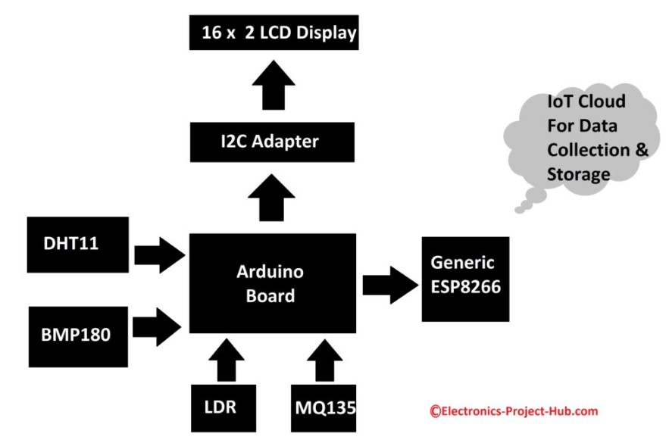

Block diagram with Arduino

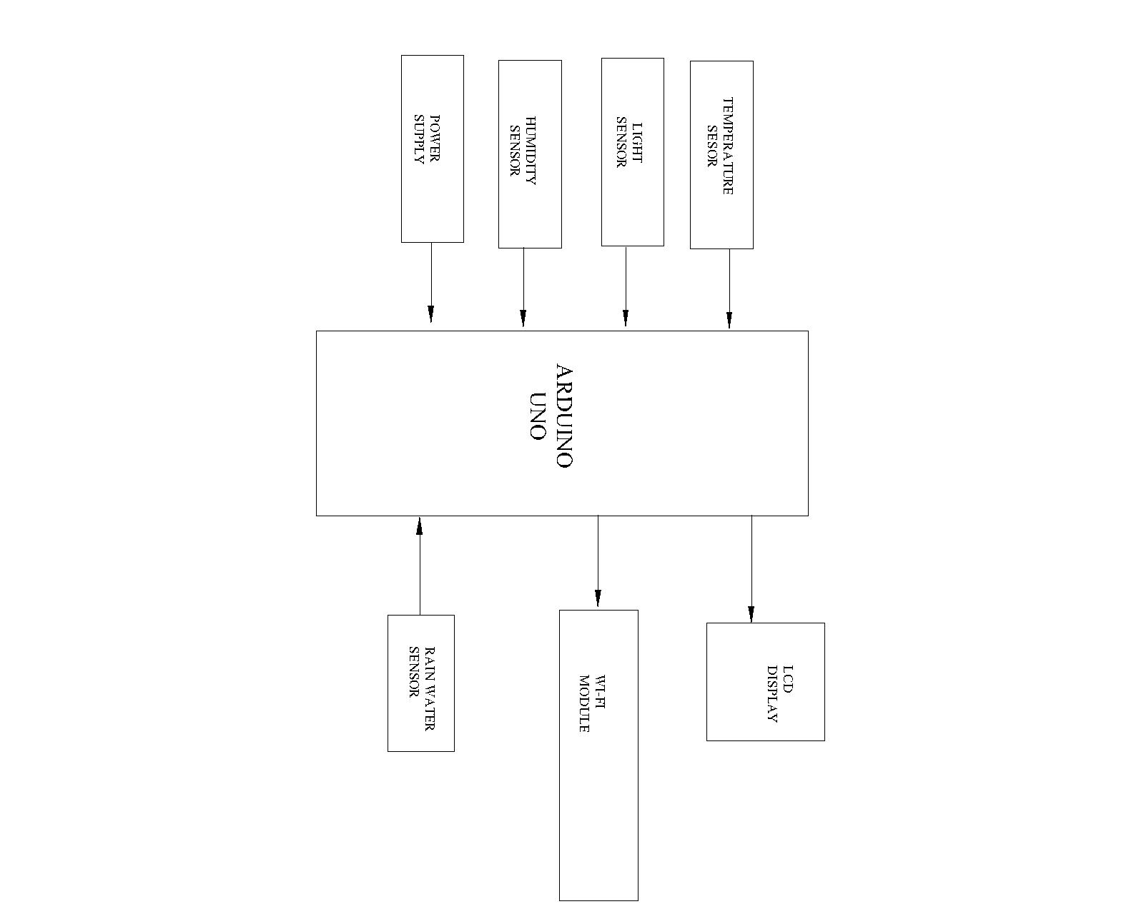

Block diagram of Ardunio UNO

### 2.3. Advantages of Proposed System

* Decreased field damaging conditions
* Improved safety and security
* High-quality receiving data
* Less power consumption
* Accuracy is High
* Smart way to monitor Environment
* The low cost and efforts are less in this system

**Chapter-3**

**Circuit diagram**

**3.1Blockdiagram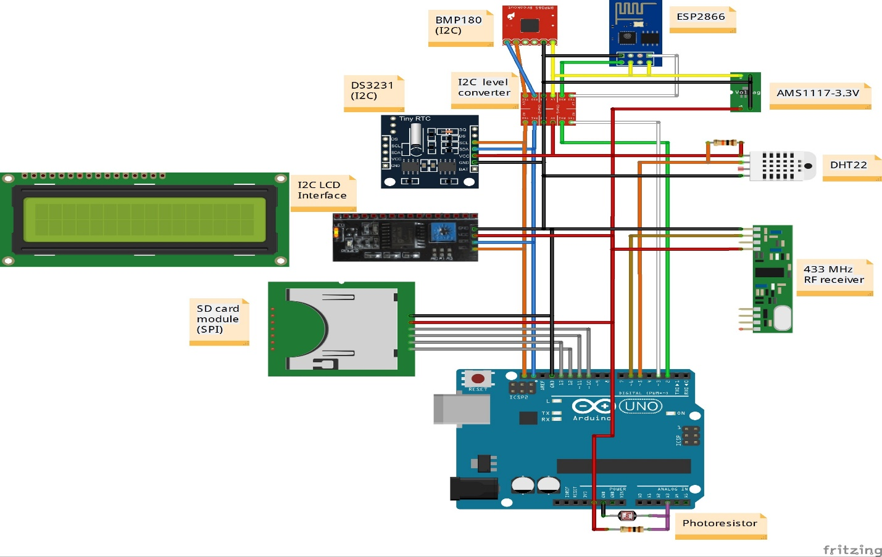3.2 Block diagram description**In IOT enabled weather monitoring system project, Arduino Uno measures 4 weather parameters using respective 4 sensors. These sensors are a temperature sensor, humidity sensor, light sensor, and rain level sensor. These 4 sensors are directly connected to Arduino Uno since it has an inbuilt Analog to digital converter. The weather monitoring system gives high accuracy and reliability for weather monitoring and climate changing. It uses the renewable energy source like solar panel for charging the connected battery. Through the web, it access real time weather information and data. This system can be communicated over general packet radio service (GPRS) network. Low maintenance is required for end users. It is capable for storing data and providing it to the users as required.

# Chapter - 4

## **Proposed System and Hardware Architecture**

### 4.1. Features of purposed system

In IOT enabled weather monitoring system project, Arduino Uno measures 4 weather parameters using respective 4 sensors. These sensors are a temperature sensor, humidity sensor, light sensor, and rain level sensor. These 4 sensors are directly connected to Arduino Uno since it has an inbuilt Analog to digital converter. The weather monitoring system gives high accuracy and reliability for weather monitoring and climate changing. It uses the renewable energy source like solar panel for charging the connected battery. Through the web, it access real time weather information and data. This system can be communicated over general packet radio service (GPRS) network. Low maintenance is required for end users. It is capable for storing data and providing it to the users as required.

### 4.2. Purposed Hardware Architecture

The implemented system consists of a microcontroller (ESP8266) as a main processing unit for the entire system and all the sensor and devices can be connected with the microcontroller. The sensors can be operated by the microcontroller to retrieve the data from them and it processes the analysis with the sensor data and updates it to the internet through Wi-Fi module connected with via blynk app then we can measure temperature, humidity, pressure and rain fall.

### 4.3. Circuit Diagram

Fig – 1 Circuit diagram of

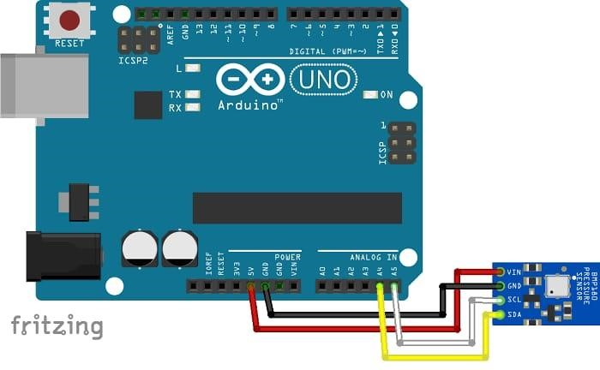

Fig – 2 Circuit diagram of BMP180 with Arduino

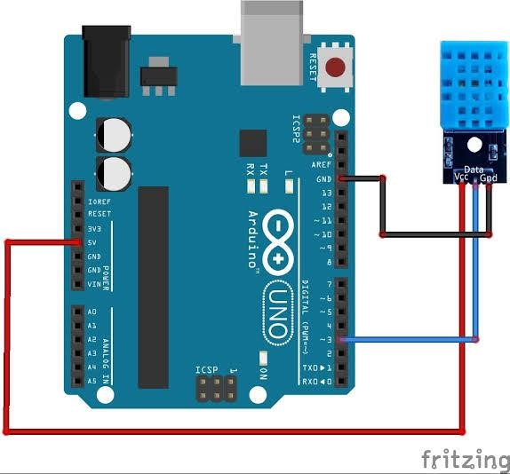

Fig – 3 Circuit diagram of DHT11 with Arduino

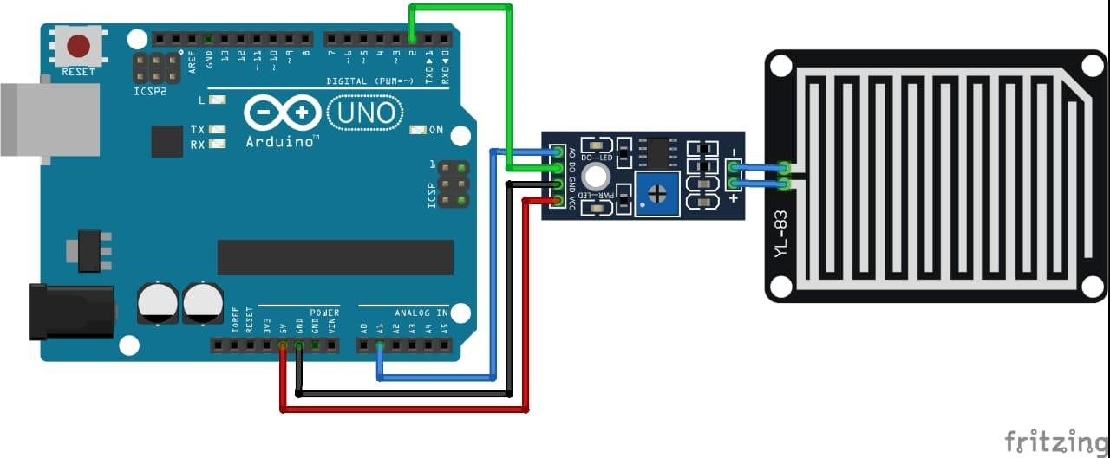

Fig – 4 Circuit diagram of Rain sensor with Arduino

### 4.5. List of required hardware components

#### Serial No. Name of the components

1. Arduino UNO
2. ESP8266 WiFi Module
3. DHT11
4. BMP180
5. Rain Sensor
6. 16*2 LCD Display
7. Beard Board
8. Jumper Wire
9. Data Cable

### 4.6. Details of Hardware Component

#### 4.6.1. Arduino UNO

Arduino Uno is a microcontroller board based on the ATmega328P (datasheet). It has 14 digital input/output pins (of which 6 can be used as PWM outputs), 6 analog inputs, a 16 MHz ceramic resonator (CSTCE16M0V53-R0), and a USB connection, a power jack, an ICSP header and a reset button. It contains everything needed to support the microcontroller; simply connect it to a computer with a USB cable or power it with an AC-to-DC adapter or battery to get started.. You can tinker with your Uno without worrying too much about doing something wrong, worst case scenario you can replace the chip for a few dollars and start over again. "Uno" means one in Italian and was chosen to mark the release of Arduino Software (IDE) 1.0. The Uno board and version 1.0 of Arduino Software (IDE) were the reference versions of Arduino, now evolved to newer releases. The Uno board is the first in a series of USB Arduino

boards, and the reference model for the Arduino platform; for an extensive list of current, past or outdated boards see the Arduino index of boards.

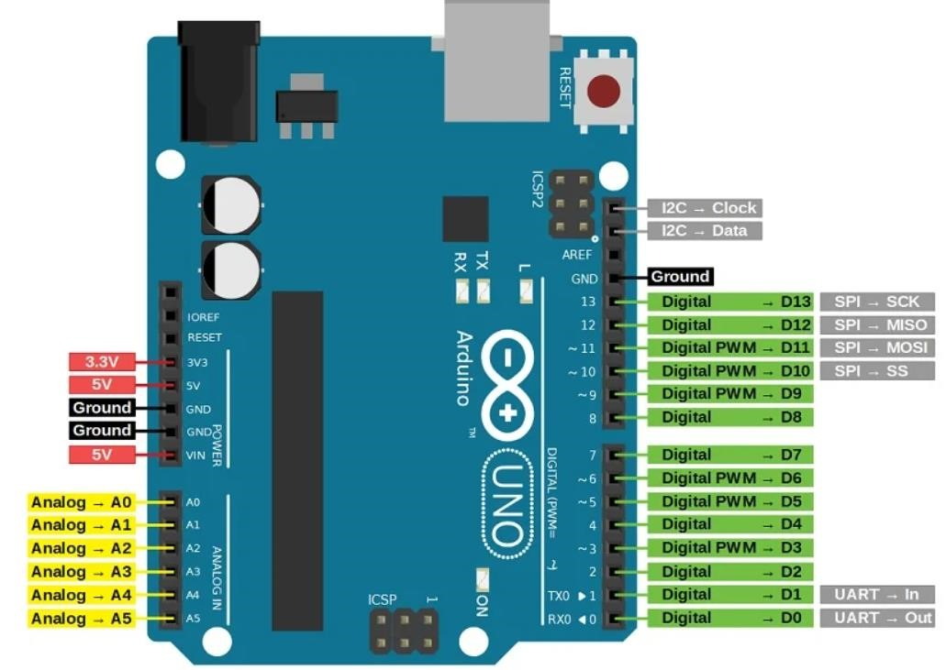

Fig

–

5

Arduino Uno

* **Pin Configuration of Arduino UNO**
* **Vin -** This is the input voltage pin of the Arduino board used to provide input supply from an external power source.
* **5V -** This pin of the Arduino board is used as a regulated power supply voltage and it is used to give supply to the board as well as onboard components.
* **3.3V -** This pin of the board is used to provide a supply of 3.3V which is generated from a voltage regulator on the board.
* **GND -** This pin of the board is used to ground the Arduino board.
* **Reset -** This pin of the board is used to reset the microcontroller. It is used to Resets the microcontroller.
* **Analog Pins -** The pins A0 to A5 are used as an analog input and it is in the range of 0-5V.
* **Digital Pins -** The pins 0 to 13 are used as a digital input or output for the Arduino board.
* **Serial Pins -** These pins are also known as a UART pin. It is used for communication between the Arduino board and a computer or other devices. The transmitter pin number 1 and receiver pin number 0 is used to transmit and receive the data resp.
* **External Interrupt Pins -** This pin of the Arduino board is used to produce the External interrupt and it is done by pin numbers 2 and 3.
* **PWM Pins -** These pins of the board is used to convert the digital signal into an analog by varying the width of the Pulse. The pin numbers 3,5,6,9,10 and 11 are used as a PWM pin.
* **SPI Pins -** This is the Serial Peripheral Interface pin, it is used to maintain SPI communication with the help of the SPI library. SPI pins include:

1. SS: Pin number 10 is used as a Slave Select
2. MOSI: Pin number 11 is used as a Master Out Slave In
3. MISO: Pin number 12 is used as a Master In Slave Out
4. SCK: Pin number 13 is used as a Serial Clock

* **LED Pin:** The board has an inbuilt LED using digital pin-13. The LED glows only when the digital pin becomes high.
* **AREF Pin:** This is an analog reference pin of the Arduino board. It is used to provide a reference voltage from an external power supply.

#### 4.6.2. ESP8266 – Wi-Fi Module

The ESP8266 WiFi Module is a self-contained SOC with in an integrated TCP/IP protocol stack that can give any microcontroller access to your WiFi network. The ESP8266 is capable of either hosting an application or offloading all Wi-Fi networking functions from another application processor. Each ESP8266 module comes pre-programmed with an AT command set firmware, meaning, you can simply hook this up to your Arduino device and get about as much WiFi-ability as a WiFi Shield offers (and that’s just out of the box)! The ESP8266 module is an extremely cost-effective board with a huge, ever -growing, community.

.

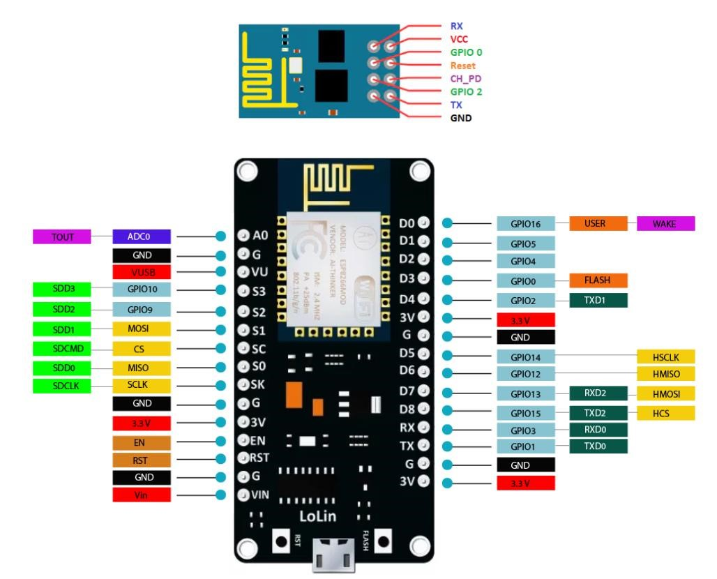

Fig – 6 ESP8266 WiFi Module

##### 4.2.1. Pin Configuration

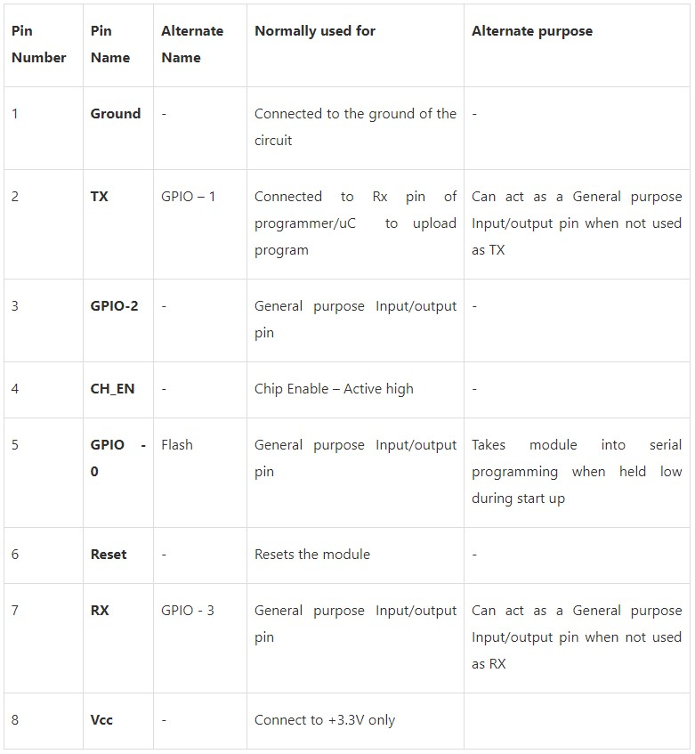

**4.2.2. Some features of ESP8266**

* Low cost, compact and powerful Wi-Fi Module
* Power Supply: +3.3V only
* Current Consumption: 100mA
* I/O Voltage: 3.6V (max)
* I/O source current: 12mA (max)
* Built-in low power 32-bit MCU @ 80MHz
* 512kB Flash Memory
* Can be used as Station or Access Point or both combined0
* Supports Deep sleep (<10uA)
* Supports serial communication hence compatible with many development platform like Arduino
* Can be programmed using Arduino IDE or AT-commands or Lua Script

### 4.3. DHT11(Temperature & Humidity sensor)

The DHT-11 Digital Temperature and Humidity Sensor is a basic, ultra-low-cost digital temperature and humidity sensor. It uses a capacitive humidity sensor and a thermistor to measure the surrounding air and spits out a digital signal on the data pin (no analog input pins needed).

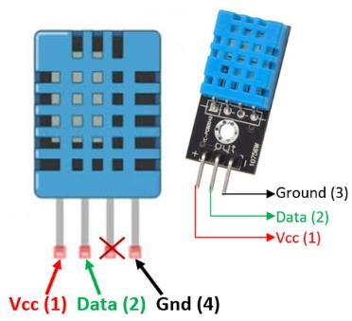

Fig – 7 DHT11(Temperature & Humidity Sensor)

**4.3.1. Pin Configuration of DHT11**

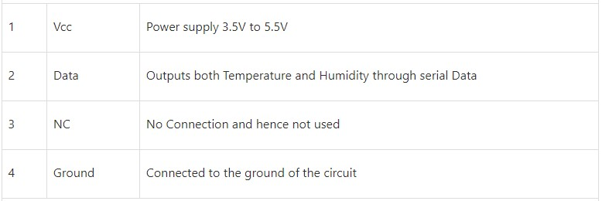

**4.3.2. DHT11 Specifications**

* Operating Voltage: 3.5V to 5.5V
* Operating current: 0.3mA (measuring) 60uA (standby)
* Output: Serial data
* Temperature Range: 0°C to 50°C
* Humidity Range: 20% to 90%
* Resolution: Temperature and Humidity both are 16-bit • Accuracy: ±1°C and ±1%

### 4.4. BMP180 (Pressure Sensor)

BMP180 is one of sensor of BMP XXX series. They are all designed to measureBarometric Pressure **or** Atmospheric pressure. BMP180 is a high precision sensor designed for consumer applications. Barometric Pressure is nothing but weight of air applied on everything. The air has weight and wherever there is air its pressure is felt. BMP180 sensor senses that pressure and provides that information in digital output. Also, the temperature affects the pressure and so we need temperature compensated pressure reading. To compensate, the BM180 also has good temperature sensor.

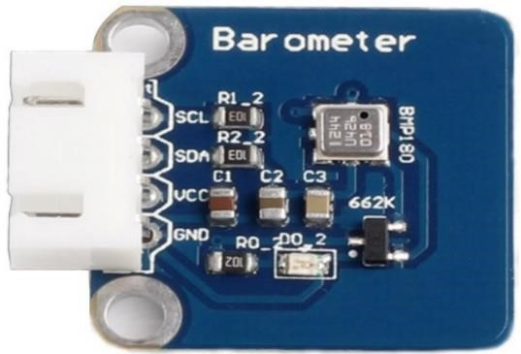

Fig – 8 BMP180

#### 4.4.1. Pin Configuration

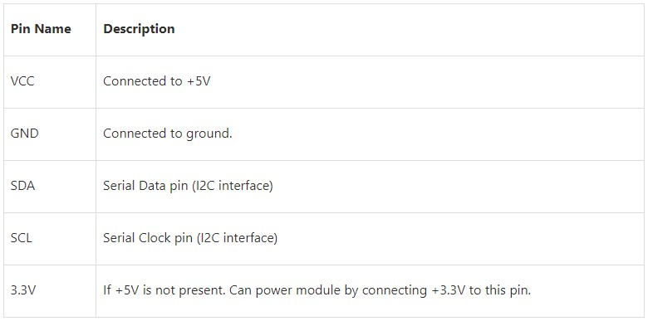

#### 4.4.2. Some features of BMP180 Module

* Can measure temperature and altitude.
* Pressure range: 300 to 1100hPa
* High relative accuracy of ±0.12hPa
* Can work on low voltages
* 3.4Mhz I2C interface
* Low power consumption (3uA)
* Pressure conversion time: 5msec
* Potable size

#### 4.4.2. Specification of BMP180 Module

* Operating voltage of BMP180: 1.3V – 3.6V
* Input voltage of BMP180MODULE: 3.3V to 5.5V
* Peak current: 1000uA
* Consumes 0.1uA standby
* Maximum voltage at SDA , SCL : VCC + 0.3V • Operating temperature: -40ºC to +80ºC

#### 4.5. Rain Sensor

A rain sensor is one kind of switching device which is used to detect the rainfall. It works like a switch and the working principle of this sensor is, whenever there is rain, the switch will be normally closed.

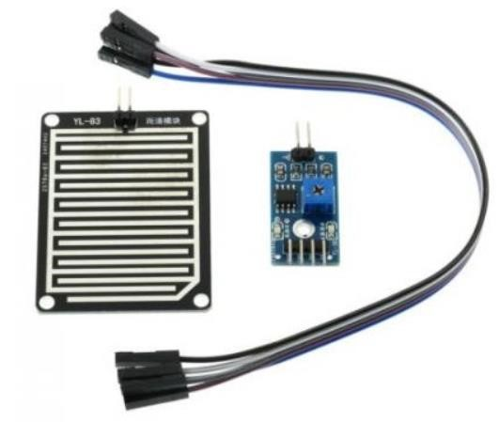

Fig – 9 Rain Sensor with Module

##### 4.5.1. Rain Sensor Module

The rain sensor module/board is shown below. Basically, this board includes nickel coated lines and it works on the resistance principle. This sensor module permits to gauge moisture through analog output pins & it gives a digital output while moisture threshold surpasses. This module is similar to the LM393 IC because it includes the electronic module as well as a PCB. Here PCB is used to collect the raindrops. When the rain falls on the board, then it creates a parallel resistance path to calculate through the operational amplifier.

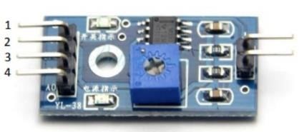

Fig – 10 Rain Module

##### 4.5.2. Pin Configuration

The pin configuration of this sensor is shown below. This sensor includes four pins which include the following.

* Pin1 (VCC): It is a 5V DC pin
* Pin2 (GND): it is a GND (ground) pin
* Pin3 (DO): It is a low/ high output pin
* Pin4 (AO): It is an analog output pin

##### 4.5.2. Specification of Rain Sensor

* This sensor module uses good quality of double-sided material.
* Anti-conductivity & oxidation with long time use
* The area of this sensor includes 5cm x 4cm and can be built with a nickel plate on the side
* The sensitivity can be adjusted by a potentiometer
* The required voltage is 5V
* The size of the small PCB is 3.2cm x 1.4cm
* For easy installation, it uses bolt holes
* It uses an LM393 comparator with wide voltage
* The output of the comparator is a clean waveform and driving capacity is above 15mA.

#### 4.6. LCD Display

A Liquid Crystal Display commonly abbreviated as LCD is basically a display unit built using Liquid Crystal technology. When we build real life/real world electronics - based projects, we need a medium/device to display output values and messages. The most basic form of electronic display available is 7 Segment displays – which has its own limitations. The next best available option is Liquid Crystal Displays which comes in different size specifications. Out of all available LCD modules in market, the most commonly used one is 16×2 LCD Module which can display 32 ASCII characters in 2 lines. To establish a good communication between human world and machine world, display units play an important role. And so, they are an important part of embedded systems. Display units - big or small, work on the same basic principle. Besides complex display units like graphic displays and 3D display, one must know working with simple displays like 16x1 and 16x2 units.

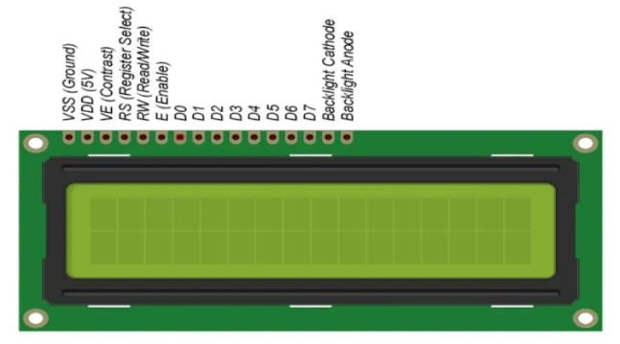

Fig – 11 16*2 LCD Display

# Chapter - 5

## **Algorithm**

### 5.1.Flowchartofthesystem

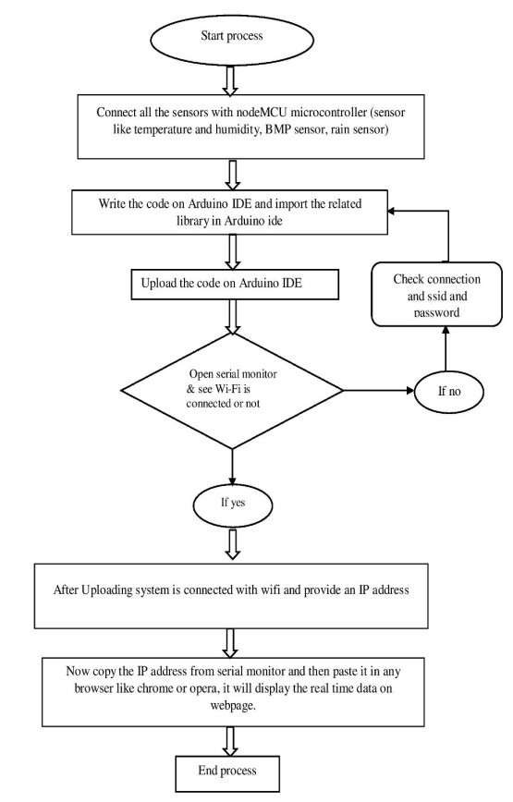

### 5.2. Source Code

#### 5.2.1. DHT11 with Arduino

#include <SimpleDHT.h>

// for DHT11,

// VCC: 5V or 3V

// GND: GND // DATA: 3 int pinDHT11 = 3;

SimpleDHT11 dht11(pinDHT11); void setup() {

// start working...

Serial.println("Temperature and Humidity Data");

Serial.begin(9600);

} void loop() {

// read without samples. byte temperature = 0; byte humidity = 0; int err = SimpleDHTErrSuccess;

if ((err = dht11.read(&temperature, &humidity, NULL)) != SimpleDHTErrSuccess) {

Serial.print("Read DHT11 failed, err="); Serial.print(SimpleDHTErrCode(err)); Serial.print(","); Serial.println(SimpleDHTErrDuration(err)); delay(1000); return;

}

Serial.print((int)temperature); Serial.print(" *C, ");

Serial.print((int)humidity); Serial.println(" H"); // DHT11 sampling rate is 1HZ.

delay(1500);

}

#### 5.1.2. Rain Sensor With Arduino void setup() {

// initialize serial communication at 9600 bits per second:

Serial.begin(9600);

}

// the loop routine runs over and over again forever: void loop() {

// read the input on analog pin 0: int sensorValue = analogRead(A0); // print out the value you read: Serial.println(sensorValue); delay(1); // delay in between reads for stability

}

#### 5.1.3. BMP180 (Pressure)

#include <Wire.h>

#include <Adafruit_Sensor.h>

#include <Adafruit_BMP085_U.h>

/* This driver uses the Adafruit unified sensor library (Adafruit_Sensor), which provides a common 'type' for sensor data and some helper functions.

To use this driver you will also need to download the Adafruit_Sensor library and include it in your libraries folder.

You should also assign a unique ID to this sensor for use with the Adafruit Sensor API so that you can identify this particular sensor in any data logs, etc. To assign a unique ID, simply provide an appropriate value in the constructor below (12345 is used by default in this example).

Connections

===========

Connect SCL to analog 5

Connect SDA to analog 4

Connect VCC to 3.3V DC

Connect GROUND to common ground

History

=======

2013/JUN/17 - Updated altitude calculations (KTOWN)

2013/FEB/13 - First version (KTOWN)

*/

Adafruit_BMP085_Unified bmp = Adafruit_BMP085_Unified(10085);

/**************************/

/*

Displays some basic information on this sensor from the unified sensor API sensor_t type (see Adafruit_Sensor for more information) */

/**************************/ void displaySensorDetails(void)

{ sensor_t sensor; bmp.getSensor(&sensor);

Serial.println("------------------------------------");

Serial.print ("Sensor: "); Serial.println(sensor.name);

Serial.print ("Driver Ver: "); Serial.println(sensor.version);

Serial.print ("Unique ID: "); Serial.println(sensor.sensor_id);

Serial.print ("Max Value: "); Serial.print(sensor.max_value); Serial.println(" hPa");

Serial.print ("Min Value: "); Serial.print(sensor.min_value); Serial.println(" hPa");

Serial.print ("Resolution: "); Serial.print(sensor.resolution); Serial.println(" hPa");

Serial.println("------------------------------------"); Serial.println(""); delay(250);

}

/**************************/

/*

Arduino setup function (automatically called at startup)

*/

#### 5.1.4. ESP8266 with Rain Sensor via Blynk

#include <SoftwareSerial.h>

#define BLYNK_PRINT Serial

#include <ESP8266WiFi.h> #include <BlynkSimpleEsp8266.h> char auth[] = "P4pODDBKIyHrzw2YJW5g6Bfc8-H1bWqa"; char ssid[] = "ASUS_X00TD"; char pass[] = "suvadip1998";

BlynkTimer timer;

void moisture() { int rainSensor = analogRead(A0); rainSensor = map(rainSensor, 0, 1023, 0, 350);

Blynk.virtualWrite(V5, rainSensor);

Serial.println(rainSensor);

} void setup() { Serial.begin(9600); Blynk.begin(auth, ssid, pass); timer.setInterval(350, moisture);

} void loop() { Blynk.run(); timer.run();

#### 5.1.5. ESP8266 with BMP180 via Blynk App

#include <Wire.h>

#include <Adafruit_BMP085.h>

#include <Blynk.h>

#include <ESP8266WiFi.h>

#include <BlynkSimpleEsp8266.h>

Adafruit_BMP085 bmp;

float temp, pressure, Altitude, Sealevel;

char auth[] = "8LU16RepIbHVm0gt7-9-XMz9l-rwXjsS";

char ssid[] = "Dlink"; char pass[] = "Pabitra1999";

void setup()

{

Serial.begin(115200);

WiFi.begin(ssid, pass);

Serial.print("Connecting.....");

while(WiFi.status() != WL_CONNECTED)

{ delay(500);

Serial.print("Waiting to connect WiFi\n");

}

Serial.print("WiFi is connected \n");

Serial.print(WiFi.localIP());

Blynk.begin(auth, ssid, pass);

if (!bmp.begin())

{

Serial.println("Could not find a valid BMP085 sensor, check wiring!"); while (1)

{

}

}

}

void loop() {

Blynk.run();

temp = bmp.readTemperature(); pressure = bmp.readPressure(); Sealevel = bmp.readSealevelPressure();

Altitude = bmp.readAltitude();

Blynk.virtualWrite(V6, temp);

Blynk.virtualWrite(V7, pressure);

Blynk.virtualWrite(V8, Sealevel);

Blynk.virtualWrite(V9, Altitude);

Serial.print("Temperature = ");

Serial.print(bmp.readTemperature());

Serial.println(" *C");

Serial.print("Pressure = ");

Serial.print(bmp.readPressure());

Serial.println(" Pa");

Serial.print("Altitude = ");

Serial.print(bmp.readAltitude());

Serial.println(" meters");

Serial.print("Pressure at sealevel (calculated) = "); Serial.print(bmp.readSealevelPressure());

Serial.println(" Pa");

Serial.println();

}

#### 5.1.6. ESP8266 with DHT11 via Blynk App

#define BLYNK_TEMPLATE_ID "TemplateID"

#define BLYNK_DEVICE_NAME "Temperature Alert"

#define BLYNK_AUTH_TOKEN "Auth Token"

#define BLYNK_PRINT Serial

#include <ESP8266WiFi.h>

#include <BlynkSimpleEsp8266.h>

#include <DHT.h>

char auth[] = BLYNK_AUTH_TOKEN;

char ssid[] = "WiFi Username"; // type your wifi name char pass[] = "WiFi Password"; // type your wifi password

#define DHTPIN 2 // Mention the digital pin where you connected

#define DHTTYPE DHT11 // DHT 11

DHT dht(DHTPIN, DHTTYPE);

BlynkTimer timer;

void sendSensor(){ float h = dht.readHumidity();

float t = dht.readTemperature(); // or dht.readTemperature(true) for Fahrenheit if (isnan(h) || isnan(t)) {

Serial.println("Failed to read from DHT sensor!");

return;

}

Serial.println(t);

Blynk.virtualWrite(V6, h);

Blynk.virtualWrite(V5, t);

Serial.print("Temperature : ");

Serial.print(t);

Serial.print(" Humidity : ");

Serial.println(h);

if(t > 30){

// Blynk.email("shameer50@gmail.com", "Alert", "Temperature over 28C!");

Blynk.logEvent("temp_alert","Temp above 30 degree");

}

}

void setup(){ Serial.begin(115200); Blynk.begin(auth, ssid, pass); dht.begin();

timer.setInterval(2500L, sendSensor);

}

void loop(){ Blynk.run(); timer.run();

}

**CHAPTER – 6**

**ADVANTAGES AND FUTURE SCOPE**

**Advantages**

* Real time data collection
* Higher accuracy
* Wider coverage
* Reduced response time
* Cost effectiveness
* Incresed safety

**Future Scope**

One can implement a few more sensors and connect it to the satellite as a global feature of this system. Adding more sensors to monitor other environmental parameters such as CO2, Pressure and Oxygen Sensor. In aircraft, navigation and the military there is a great scope of this real-time system. It can also be implemented in hospitals or medical institutes for the research & study in “Effect of Weather on Health and Diseases”, hence to provide better precaution alerts.

***CHAPTER -7***

***Application***

* ***Weather forecasting***
* ***Home automation***
* ***Heathcare***
* ***Education***
* ***Agriculture***
* ***Travel & Tourism***

CHAPTER 8

**CONCLUSION**

* *An Arduino weather station with IoT capabilities is a project that involves creating a device to monitor and collect weather-related data using Arduino microcontrollers and sensors, and then transmitting this data to the Internet for remote access and analysis.*
* *The combination of Arduino and IoT technology allows for the creation of a versatile weather monitoring system.*

CHAPTER 9

Bibliography

[1]. Mary Nsabagwaa, Maximus Byamukamab, Emmanuel Kondelaa, “Towards a robust and affordable Automatic Weather Station “, journal homepage:

www.elsevier.com/locate/deveng.

[2]. Ravi Kishore Kodali and Snehashish Mandal “IoT Based Weather Station” 2016 International Conference on Control, Instrumentation, Communication and Computational Technologies (ICCICCT) 978-1-5090- 5240-0/16/$31.00, IEEE, (2016).

[3]. Ravi Kishore Kodali and Archana Sahu “An IoT based Weather Information Prototype

Using WeMos” 2016 2nd International Conference on Contemporary Computing and

Informatics (ic3i), 978-1-5090-5256- 1/16/$31.00, IEEE, (2016)

[4]. Zi-Qi Huang, Ying-Chih Chen and Chih-Yu Wen, “Real-Time Weather Monitoring and

Prediction Using City Buses and Machine Learning”, Vols. 3 to 21 Published 10 September (2020)

[5]. Kavya Ladi, A V S N Manoj, G V N Deepak, “IOT Based Weather Reporting System to

Find Dynamic Climatic Parameters”, International Conference on Energy, Communication,

Data Analytics and Soft Computing (ICECDS-2017)

[6]. P. Susmitha, G. Sowmyabala “Design and Implementation of Weather Monitoring and

Controlling System”, International Journal of Computer Applications (0975 – 8887) Volume 97– No.3, (July 2014)

[7]. Tanmay Parashar1, Shobhit Gahlot2, Akash Godbole3, Y.B. Thakare4 “Weather

Monitoring System Using Wi-Fi”, (IJSR) ISSN (Online): 2319-7064 Index Copernicus Value (2015): 78.96, 2015

CHAPTER 10

Cost analysis

**COST ANALYSIS:**

**Particulars**

**Cost**

Circuit Designing

Rs. 8

00.00

Other Components

Rs. 42

00.00

Project Report Expenses

Rs. 2400.00

Traveling Expenses

Rs. 300.00

Miscellaneous

Rs.

8

00.00

**TOTAL**

**Rs. 85**

**00.00**

**S. No**

1.

2.

3.

4.

5.